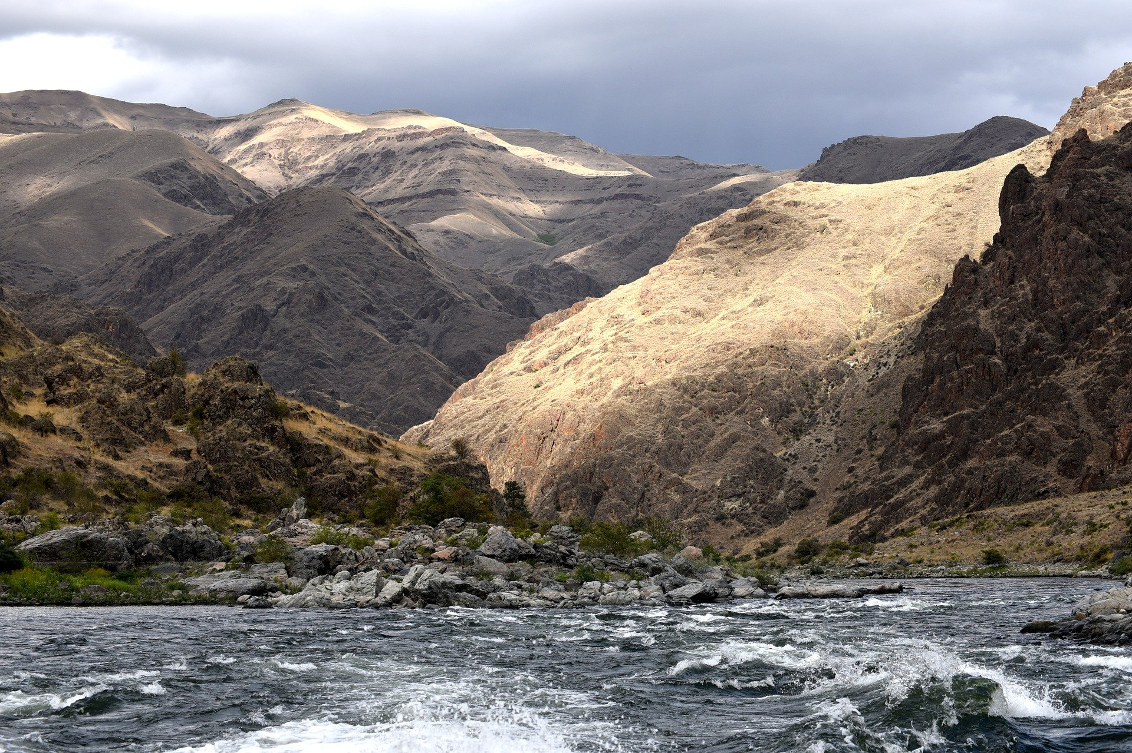
vvvvvvvvvvvvvvvvvvvvvvvvvvvvvvvvvvvvvvvvvvvvvvvvvvvv

