Assignment no 1

//1:write program to test Hello World.
#include <iostream>
using namespace std;
int main()
{
cout<<"Hello world..!"<< endl;
}
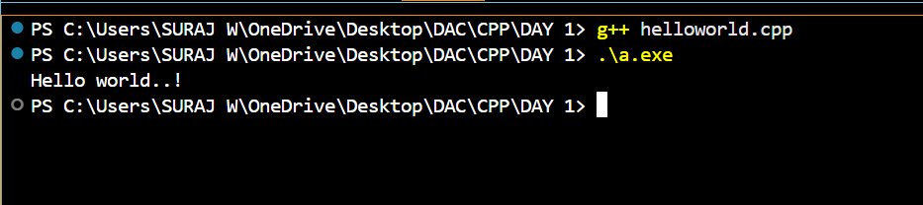

//2:Write a program to adddition of two numbers
#include<iostream>
using namespace std;
int main()
{
int a,b;
cout <<" Enter two number:"<< endl;
cin>>a;
cin>>b;
int c;
c=a+b;
cout << "addition of "<<a<< "+ "<<b<< " is "<< c;
return 0;
};
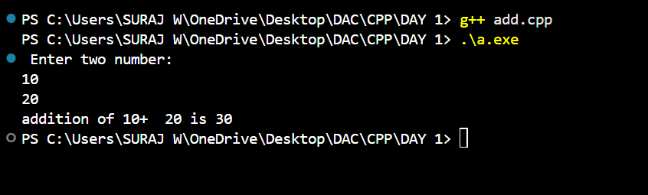

//3:Write a program to swap two numbers.
#include <iostream>
using namespace std;
int main()
{
int a,b,temp;
cout<<" Enter the tow number :"<< endl;
cin>>a>>b;
cout<<"Number before swap :"<<endl<<"a= "<<a<<"\tb= "<<b<<endl;
temp=a;
a=b;
b=temp;
cout<<"Number after swap :"<<endl<<"a= "<<a<<"\tb= "<<b;
return 0;
};
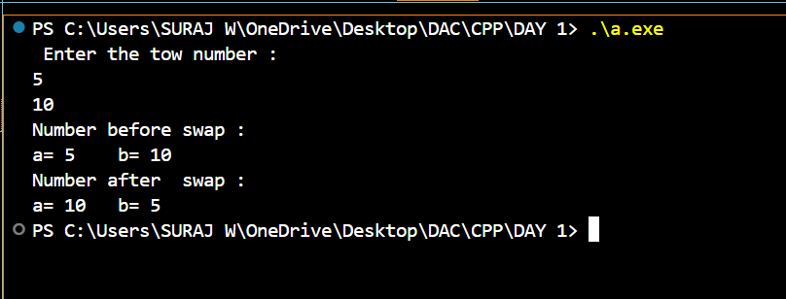

//4. Write a program to accept an integer and check if it is even or odd.

#include<iostream>
using namespace std;
int main()
{
int n;
c
out<<" enter number :";
cin>>n;
if(n%2==0)
{
cout<<n<<" is even number.";
}
else
cout<<n<<" is odd number.";
return 0;
};
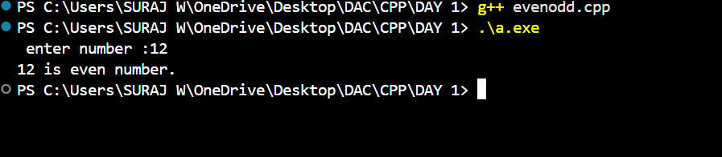

//5. Write a program to accept a number and check if it is divisible by 5 and 7.

#include <iostream>
using namespace std;
int main()
{
int n;
cout << "ERnter tne number :";
cin>>n;
if(n%5==0 && n%7==0)
{
cout<<n<<" is divisible by 5 & 7.";
}else
{
cout<<n<<" is not divisible by 5 & 7.";
}
return 0;
};
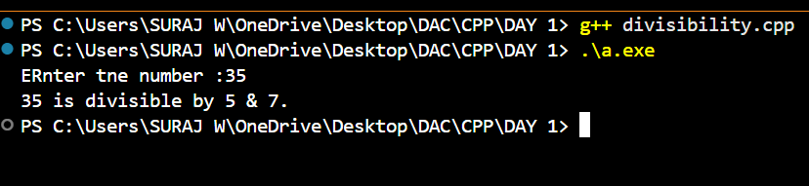

// 6. Write a program, which accepts annual basic salary of an employee and calculates and displays the Income tax as per the following rules. Basic: < 1, 50,000 Tax = 0 1, 50,000 to 3,00,000 Tax = 20% > 3,00,000 Tax = 30%

#include<iostream>
using namespace std;
int main()
{
double basic_salary, tax;
cout<<" Enter Annual Basic salary :";
cin>>basic_salary;
if(basic_salary < 150000)
{
cout<<" The tax on salary is 0.";
}else if(basic_salary < 300000)
{
tax=basic_salary*0.20;
cout<<" The tax on salary is "<<tax<<".";
}else if(basic_salary > 300000)
{
tax=basic_salary*0.30;
cout<<" The tax on salary is "<<tax<<".";
}
return 0;
}
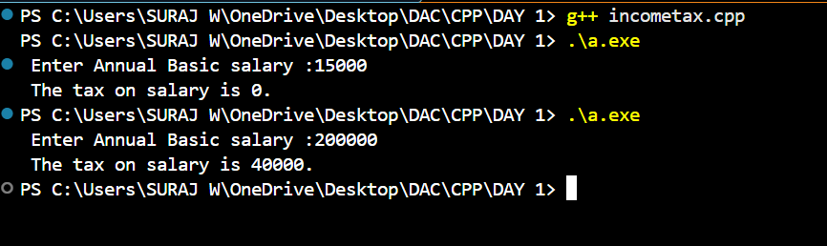

//7. Accept a lowercase character from the user and check whether the character is a vowel or consonant. (Hint: a, e, i, o, u are vowels)

#include<iostream>
using namespace std;
int main()
{
char ch;
cout<<"Enter the character:";
cin>>ch;
if(ch=='a' || ch=='e' || ch=='i' || ch=='o' || ch=='u')
{
cout<<ch<<" is vowel character .";
}else{
cout<<ch<<" is consonant character .";
}
return 0;
};
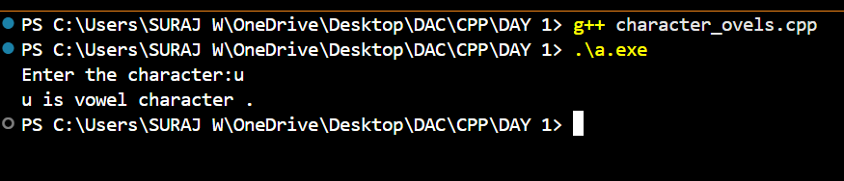

//8. Write a program to input angles of a triangle and check whether triangle is valid or not.

#include<iostream>
using namespace std;
int main()
{
int a,b,c;
cout<<"Enter Angles of triangle:"<<endl;
cin>>a>>b>>c;
if((a+b+c)==180)
{
cout<<"Tringle is valid";
}else
{
cout<<"Tringle is invalid";
}
return 0;
};
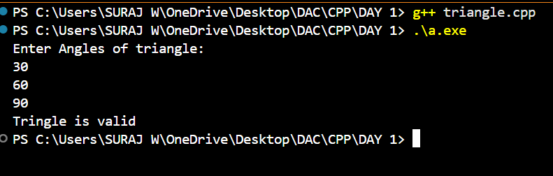

//9. Write a program to find factorial of a given number. ex:no5 fact=5*4*3*2*1=120

#include<iostream>
using namespace std;
int main()
{
int num,i,fact=1;
cout<<"Enter number:"<<endl;
cin>>num;
for(i=1;i<=num;i++)
{
fact=fact*i;
}
cout<<"Factorial of "<<num << " is "<<fact;
return 0;
};

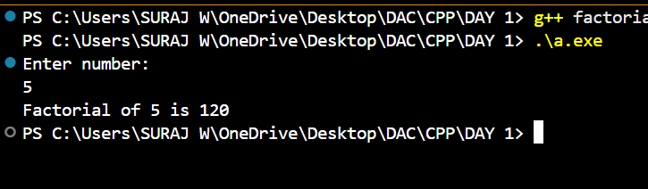
//10:Write a program to find m to the power n. m=3 and n=4 so 3*3*3*3

#include<iostream>
using namespace std;
int main()
{
int num,power,i;
cout<<"Enter the number:";
cin>>num;
cout<<"Enter tne power:";
cin>>power
int result=num;
for(i=1;i<power;i++) //i=2;i<=power;i++
{
result*=num;
}
cout<<"a "<<num<<" to the power "<<power<< " is equal to "<<result
return 0;
};
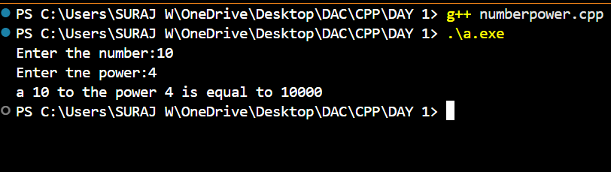

//11:Check if number is a prime number or not.:
#include<iostream>
using namespace std;
int main()
{ int num,counter=0 ;
cout<<"Enter the number :";
cin>>num;
if(num<1)
{ cout<<num<<" is not prime number.";
}else
{
for(int i=1;i<=num;i++)
{ if(num%i==0)
counter++;
}
if(counter>2)
{
cout<<num<<" is not prime number.";
}else
{
cout<<"is prime number ";
}
}
return 0;
};
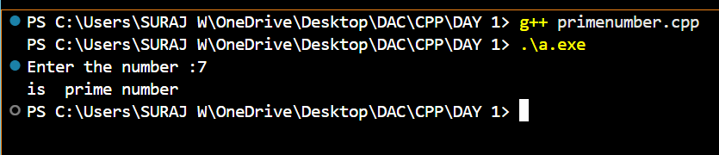

// 12:Sum of series : 1+2+3+….+n

#include<iostream>
using namespace std;
int main()
{
int n,sum=0;
cout<<"Enter last number of series :";
cin>>n;
for(int i=1;i<=n;i++)
{
sum=sum+i;
}
cout<<"the sum of 1st "<<n<<" natural number is "<<sum;
return 0;
};
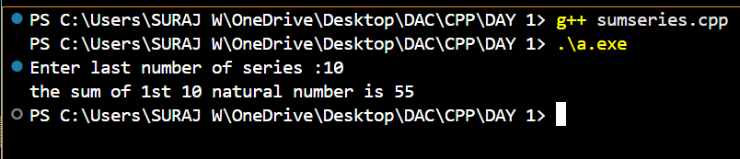
// 13:Check whether the number is palindrome or not?

#include<iostream>
using namespace std;
int main()
{
int num,reverse=0;
cout<<"Enter number :";
cin>>num;
int n=num;
while(n!=0)
{
int reminder=n%10;
reverse=(reverse*10)+reminder;
n/=10;
}
if(num==reverse)
{
cout<<num<<" is palindrome.";
}else
{
cout<<num<<" is not palindrome.";
}
return 0;
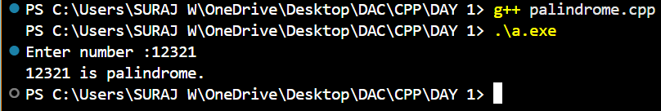
};

//14:Write a program to find sum of all even and odd numbers between 1 to n.

#include<iostream>
using namespace std;
int main()
{
int n,i=1,evensum=0,oddsum=0;
cout<<"Enter the range:";
cin>>n;
for(i;i<=n;i++)
{
if(i%2==0)
{
evensum=evensum+i;
}else
{
oddsum=oddsum+i;
}
}
cout<<"sum of even number between 1 to "<<n<<" is "<<evensum<<endl;
cout<<"sum of odd number between 1 to "<<n<<" is "<<oddsum;
return 0;
};
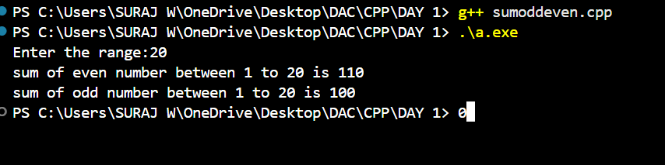

//15: Write a program to enter a number and print its reverse.
#include<iostream>
using namespace std;
int main()
{
int num,reverse=0;
cout<<"Enter number :";
cin>>num;
int n=num;
while(n!=0)
{
int reminder=n%10;
reverse=(reverse*10)+reminder;
n/=10;
}
cout<<" the reverse of "<<num<<" is "<<reverse;
return 0;
};
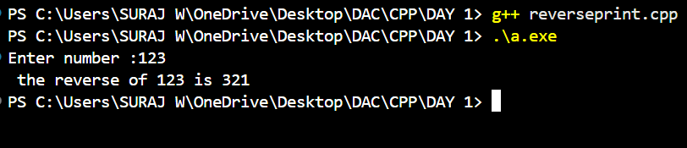

//16. Write a program to print all prime numbers between 1 to n

#include <iostream>
using namespace std;
int main() {
int n;
cout << "Enter the value of n: ";
cin >> n;
cout << "Prime numbers between 1 and " << n << " are: ";
for (int i = 2; i <= n; i++)
{
bool flag = true;

for (int j = 2; j < i; j++)
{
if (i % j == 0) {
flag = false;
break;
}
}
if (flag)
{
cout << i << " ";
}
}
return 0;
};
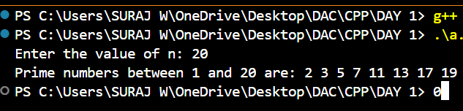

//17:Write a program to check entered number is Armstrong number or not.

#include <iostream>
using namespace std;
int main()
{
int num, originalnum, remainder, result = 0, n = 0;
cout << "Enter a number: ";
cin >> num;
originalnum = num;
while (originalnum != 0) // for to calculatr number of digits(power)
{
originalnum /= 10;
++n;
}
originalnum = num;
while (originalnum != 0) // sum
{
remainder = originalnum % 10;
int power = 1;
for (int i = 0; i < n; ++i)
{
power *= remainder;
}
result += power;
originalnum /= 10; // next digit
}
if (result == num)
cout << num << " is an armstrong number." << endl;
else
cout << num << " is not an armstrong number." << endl;
return 0;
};
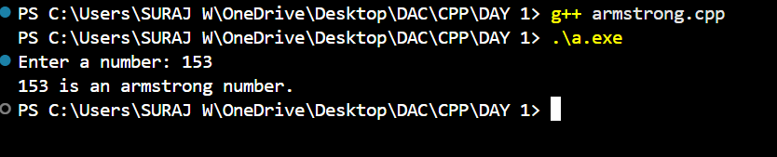
//18:Write a program to find greatest of three numbers using nested if-else.

#include <iostream>
using namespace std;
int main()
{
int n1,n2,n3;
cout << "Enter a numbers: "<<endl;
cin >> n1>>n2>>n3;
if(n1>n2)
{
if(n1>n3)
{
cout<<n1<<" is greter";
}else
{
cout<<n3<<" is greter.";
}
}else if(n2>n3)
{
cout<<n2<<" is greter.";
}else
{
cout<<n3<<" is greter.";
}
return 0;
};

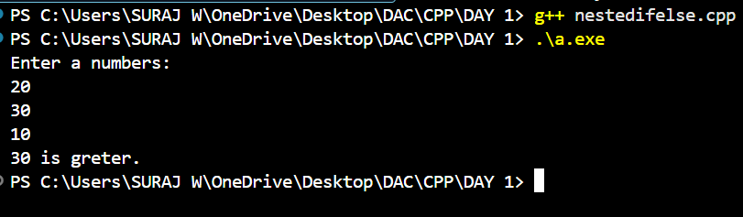

19:Create menu driven program for Pizza Shop.And display total amount

#include <iostream>
using namespace std;
int main() {
int choice, quantity;
double total = 0;
cout<<"-----------welcome------------"<<endl;
do {
cout << "\tMenu:\n";
cout << "1. Margherita - 350 RS"<<endl;
cout << "2. Pepperoni - 399 RS"<<endl;
cout << "3. BBQ Chicken - 499 RS"<<endl;
cout << "4. Veggie - 250 RS"<<endl;
cout << "5. Cheese Burst - 299 RS"<<endl;
cout << "0. Show bill "<<endl;

cout << "\nEnter your choice: ";
cin >> choice;
if (choice == 0)
break;
cout << "\nEnter quantity : ";
cin >> quantity;
switch(choice)
{
case 1:
total+=350*quantity;
break;
case 2:
total+= 399*quantity;
break;
case 3:
total+= 499*quantity;
break;
case 4:
total+= 250*quantity;
break;
case 5:
total+= 299*quantity;
break;
default:
cout << "Invalid choice."<<endl;
}
}while(choice!=0);
cout<<"\t-------bill---------"<<endl;
cout << "\tTotal Amount: " << total <<"RS"<< endl;
cout << "\tThank you !"<<endl;
cout << "\tHave a nice day...!";
};

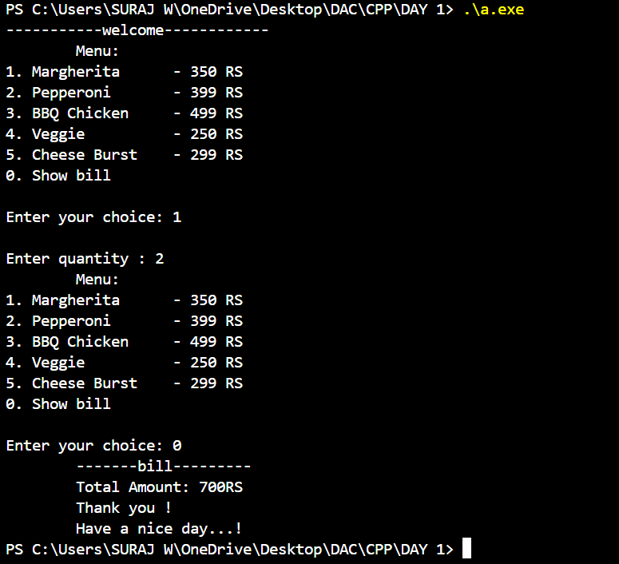

//20:Accept a single digit from the user and display it in words. For example, if digit entered is 9, display Nine.

#include <iostream>
using namespace std;
int main() {
int digit;
cout << "Enter a single digit (0-9): ";
cin >> digit;
if (digit >= 0 && digit <= 9)
{
switch (digit) {
case 0: cout << "Zero" << endl; break;
case 1: cout << "One" << endl; break;
case 2: cout << "Two" << endl; break;
case 3: cout << "Three" << endl; break;
case 4: cout << "Four" << endl; break;
case 5: cout << "Five" << endl; break;
case 6: cout << "Six" << endl; break;
case 7: cout << "Seven" << endl; break;
case 8: cout << "Eight" << endl; break;
case 9: cout << "Nine" << endl; break;
}
} else {
cout << "Invalid input! Please enter a digit between 0 and 9." << endl;
}
return 0;
};
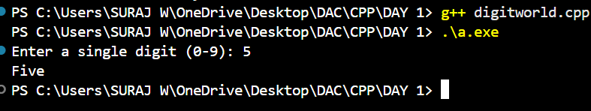

//21. Write a program, which accepts two integers and an operator as a character (+ - * / ), performs the corresponding operation and displays the result.

#include <iostream>
using namespace std;
int main()
{
int n1,n2,choice;
cout << "Enter a two number: ";
cin >>n1>>n2;
do{
cout<<"0:exit"<<endl<<"1:Addition"<<endl<<"2:substitin"<<endl<<"3:multipication"<<endl<<"4:division"<<endl;
cout<<"Enter the choice:";
cin>>choice;
switch(choice)
{
case 1:
cout<<"sum ="<<n1+n2<<endl;
break;
case 2:
cout<<"sub="<<n1-n2<<endl;
break;
case 3:
cout<<"mul ="<<n1*n2<<endl;
break;
case 4:
cout<<"div="<<n1/n2<<endl;
break;
default:
cout<<"invalid choice";
}
}while(choice!=0);
return 0;
};

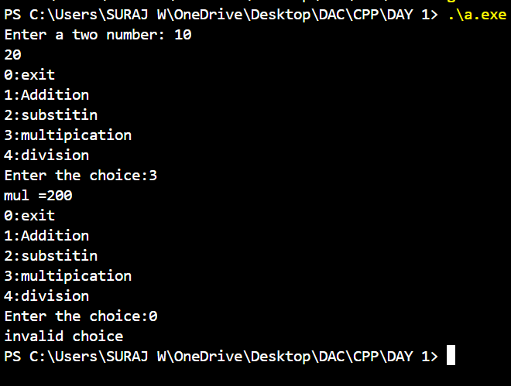

Assignment no 2
//1:Write a program that accepts numbers continuously as long as the number is positive and prints the sum of the given numbers.
#include <iostream>
using namespace std;
int main()
{
int number;
int sum = 0;
while (true)
{
cout << "Enter number: ";
cin >> number;
if (number > 0)
{
sum += number;
} else
{
break;
}
}
cout << "Sum of the entered positive numbers: " << sum << endl;
return 0;
};
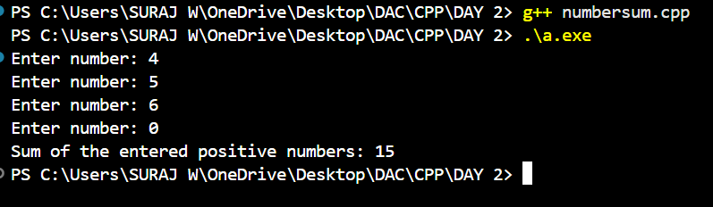
//2. Write a program to accept two integers x and n and compute x raised to n.

#include<iostream>
using namespace std;
int main()
{
int x,n;
int result=1;
cout<<"Enter the number:";
cin>>x;
cout<<"Enter the power:";
cin>>n;
for(int i=1;i<=n;i++)
{
result*=x;
}
cout<<"the "<<x<<" raised to "<<n<<" is "<<result;
return 0;
};
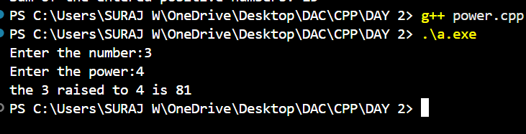

//3. Write a program to accept a character, an integer n and display the next n characters.

#include <iostream>
using namespace std;
int main()
{
char ch;
int n;
cout << "Enter a character: ";
cin >> ch;
cout << "Enter how many next characters to display: ";
cin >> n;
cout << "Next " << n << " characters after '" << ch << "': ";
for (int i = 1; i <= n; ++i) {
cout << char(ch + i)<< " ";
}
cout << endl;
return 0;
};
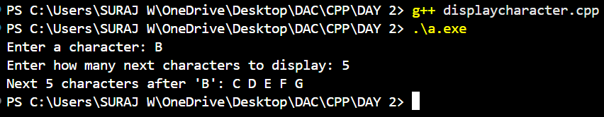

//4. Write a program to calculate factorial of a number. For e.g. factorial of 5 = 5! = 5 *4*3*2*1 = 120

#include <iostream>
using namespace std;
int main() {
int n;
int factorial = 1;
cout << "Enter number: ";
cin >> n;
if (n < 0) {
cout << "Factorial is not defined for negative numbers." << endl;
} else {
for (int i = 1; i <= n; ++i) {
factorial *= i;
}
cout << "Factorial of " <<n<< " is "<< factorial<<endl;
}
return 0;
};
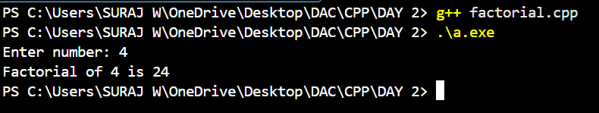

//5. Write a program to calculate factors of a given number.

#include <iostream>
using namespace std;
int main()
{
int num;
cout << "Enter a positive integer: ";
cin >> num;
if (num <= 0) {
cout << "Please enter a number greater than 0." << endl;
return 1;
}
cout << "Factors of " << num << " are: ";
for (int i = 1; i <= num; ++i) {
if (num % i == 0) {
cout << i << " ";
}
}
return 0;
};
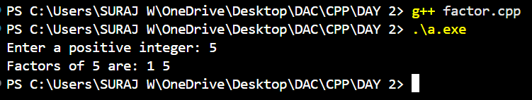

6. Accept two numbers and calculate GCD of them.

#include <iostream>
using namespace std;
int main()
{
int a, b;
cout << "Enter two numbers: ";
cin >> a >> b;
while (b != 0)
{
int temp = b;
b = a % b;
a = temp; }
cout << "GCD is: " << a << endl;
return 0;
};
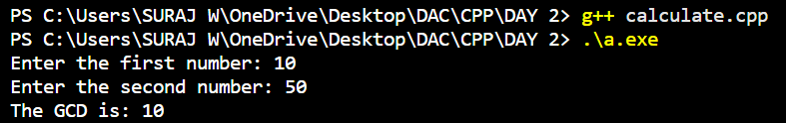
/*7. Write a menu driven program to do following operations :
a) Compute area of circle
b) Compute area of rectangle
c) Compute area of triangle
d) Exit
Display menu, ask choice to the user, depending on choice accept the parameters and perform the
operation. Continue this process until user selects exit option.
*/
#include <iostream>
using namespace std;
int main()
{
int choice;
float radius, length, breadth, base, height, area;
do {
cout << "\n===== Area Calculator Menu =====\n";
cout << "1. Compute area of Circle\n";
cout << "2. Compute area of Rectangle\n";
cout << "3. Compute area of Triangle\n";
cout << "4. Exit\n";
cout << "Enter your choice (1-4): ";
cin >> choice;
switch(choice) {
case 1:
cout << "Enter radius of the circle: ";
cin >> radius;
area = 3.14159 * radius * radius;
cout << "Area of Circle = " << area << endl;
break;
case 2:
cout << "Enter length and breadth of the rectangle: ";
cin >> length >> breadth;
area = length * breadth; // l * b
cout << "Area of Rectangle = " << area << endl;
break;
case 3:
cout << "Enter base and height of the triangle: ";
cin >> base >> height;
area = 0.5 * base * height;
cout << "Area of Triangle = " << area << endl;
break;
case 4:
cout << "Exiting program. Goodbye!" << endl;
break
default:
cout << "Invalid choice! Please select from 1 to 4." << endl;
}
} while(choice != 4);
return 0;
};
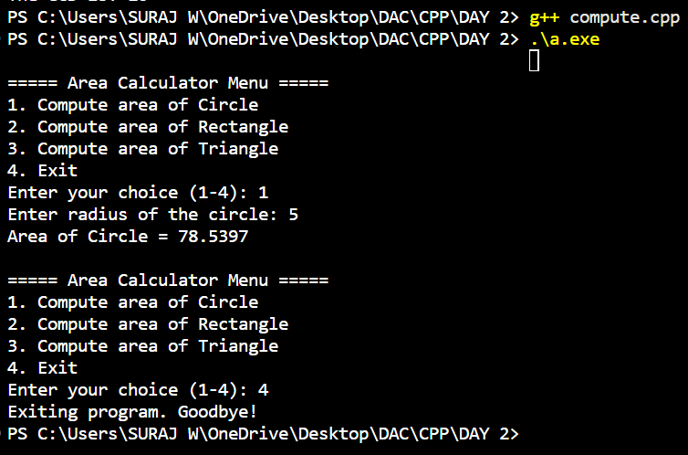

//8. Write a program to print all prime numbers between 1 to n
#include <iostream>
using namespace std;

int main() {
int n;
cout << "Enter the value of n: ";
cin >> n;
cout << "Prime numbers between 1 and " << n << " are: ";
for (int i = 2; i <= n; i++)
{
bool flag = true;
for (int j = 2; j < i; j++)
{
if (i % j == 0) {
flag = false;
break;
}
}
if (flag)
{
cout << i << " ";
}
}
return 0;
}
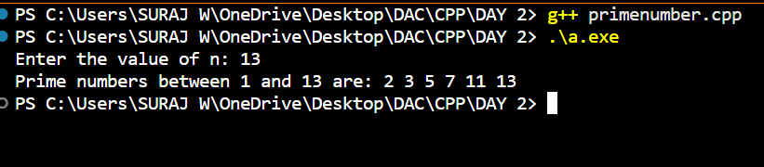

Assignment no 3
a
// 1. Write a program to create an array of integers and perform following operations on that array like finding the sum, average, maximum and minimum number in that array. Accept the numbers of the array from user.
#include <iostream>
using namespace std;
int main() {
int n;
cout << "Enter number of elements: ";
cin >> n;
// Dynamically allocate array
int* arr = new int[n];
int sum = 0, max, min;
cout << "Enter " << n << " elements: ";
for(int i = 0; i < n; i++)
{
cin >> arr[i];
sum += arr[i];
}
max = min = arr[0];
for(int i = 1; i < n; i++)
{
if(arr[i] > max) max = arr[i];
if(arr[i] < min) min = arr[i];
}
float avg = (float)sum / n;
cout << "Sum: " << sum << endl;
cout << "Average: " << avg << endl;
cout << "Maximum: " << max << endl;
cout << "Minimum: " << min << endl;
delete[] arr;
return 0;
}
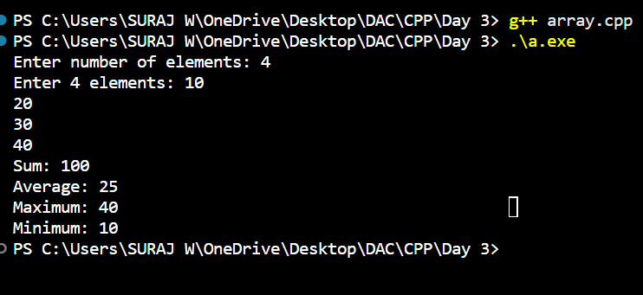

// 2: Write a program to Accept a number and display its sum of digits.: ex 568 -> 5+6+8
#include <iostream>
using namespace std;
int main()
{
int num, sum = 0;
cout << "Enter a number: ";
cin >> num;
int temp = num;
while (temp > 0)
{
sum += temp % 10;
temp /= 10;
}
cout << "Sum of digits: " << sum << endl;
return 0;
}
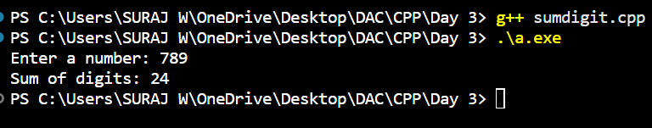

//3:Write a program to find sum of all even and odd numbers between 1 to n.
#include<iostream>
using namespace std;
int main()
int n,i=1,evensum=0,oddsum=0;
{ cout<<"Enter the range:";
cin>>n;
for(i;i<=n;i++)
{ if(i%2==0)
{ evensum=evensum+i;
}else
{ oddsum=oddsum+i;
}
}
cout<<"sum of even number between 1 to "<<n<<" is "<<evensum<<endl;
cout<<"sum of odd number between 1 to "<<n<<" is "<<oddsum;
return 0;
};
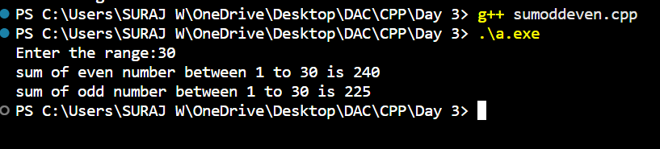

//4. Write a program to print all prime numbers between 1 to n
#include <iostream>
using namespace std;

int main() {
int n;
cout << "Enter the value of n: ";
cin >> n;
cout << "Prime numbers between 1 and " << n << " are: ";

for (int i = 2; i <= n; i++)
{
bool flag = true;
for (int j = 2; j < i; j++)
{
if (i % j == 0) {
flag = false;
break; }
}
if (flag)
{cout << i << " " }
}
return 0;
}

// 5: Write a program to accept array from user. Accept number from user and search number is present in array or not.
#include <iostream>
using namespace std;
int main() {
int n, number;
cout << "Enter size of array: ";
cin >> n;
int arr[n];
cout << "Enter " << n << " elements:\n";
for (int i = 0; i < n; i++)
{
cin >> arr[i];
}
cout << "Enter number to search: ";
cin >> number;
bool found = false;
for (int i = 0; i < n; i++)
{
if (arr[i] == number)
{found = true;
break;
}
}
if (found)
cout << "Number is present in the array." << endl;
else
cout << "Number is not present in the array." << endl;
return 0;
}
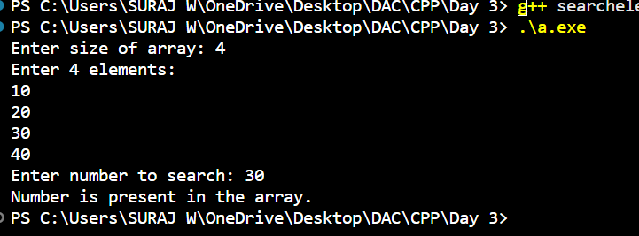

// 6: Write a program to print following pattern.
// *
// * *
// * * *
// * * * *
// * * * * *
#include <iostream>
using namespace std;
int main() {
int rows = 5;
for (int i = 1; i <= rows; i++)
{
for (int j = 1; j <= i; j++)
{
cout << "* ";
}
cout << endl;
}
return 0;
}
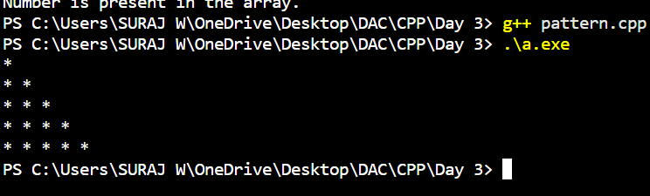

// 7: Write a program to create student class with data members rollno, marks1, mark2, mark3.
// Accept data (acceptInfo()) and display using display member function.
// Also display total, percentage and grade.
#include <iostream>
using namespace std;
class Student {
int rollno;
float marks1, marks2, marks3;
public:
void acceptInfo()
{cout << "Enter roll number: ";
cin >> rollno;
cout << "Enter marks for subject 1: ";
cin >> marks1;
cout << "Enter marks for subject 2: ";
cin >> marks2;
cout << "Enter marks for subject 3: ";
cin >> marks3;
}
void display()
{
float total = marks1 + marks2 + marks3;
float percentage = total / 3.0;
char grade;
if (percentage >= 90)
grade = 'A';
else if (percentage >= 75)
grade = 'B';
else if (percentage >= 60)
grade = 'C';
else if (percentage >= 50)
grade = 'D';
else
grade = 'F';
cout << "Roll Number: " << rollno << endl;
cout << "Marks1: " << marks1 << endl;
cout << "Marks2: " << marks2 << endl;
cout << "Marks3: " << marks3 << endl;
cout << "Total: " << total << endl;
cout << "Percentage: " << percentage << "%" << endl;
cout << "Grade: " << grade << endl;
}
};
int main() {
Student s;
s.acceptInfo();
s.display();
return 0;
}
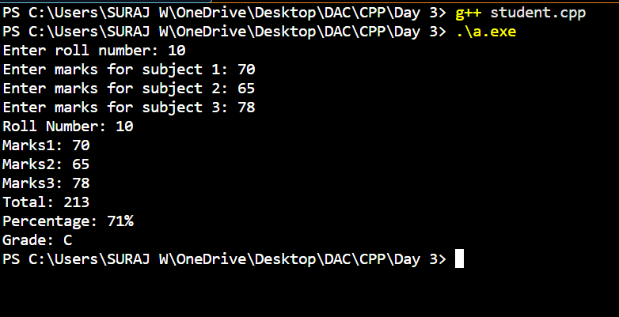

Assignment no 4

// 1. Array Input & Output
#include <iostream>
using namespace std;

int main()
{
int n;
cout << "Enter number of elements: ";
cin >> n;
int arr[n];
cout << "Enter elements:\n";
for (int i = 0; i < n; i++)
cin >> arr[i];
cout << "Array elements are:\n";
for (int i = 0; i < n; i++)
cout << arr[i] << " ";
cout << endl;
return 0;
}
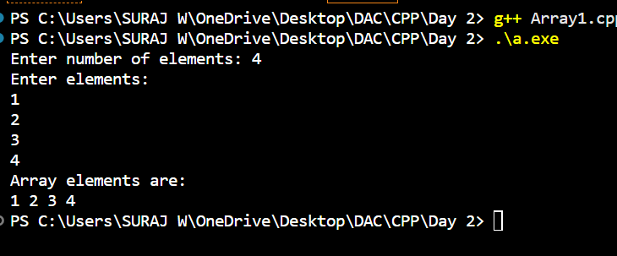

// 2. Sum & Average of Array
#include <iostream>
using namespace std;

int main() {
int n;
float sum = 0;
cout << "Enter number of students: ";
cin >> n;
float marks[n];
cout << "Enter marks:\n";
for (int i = 0; i < n; i++)
{
cin >> marks[i];
sum += marks[i];
}
cout << "Total Marks: " << sum << endl;
cout << "Average Marks: " << (sum / n) << endl;
return 0;
}
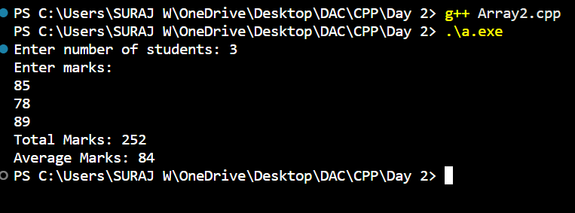
// 3. Find Maximum and Minimum
#include <iostream>
using namespace std;

int main() {
int n;
cout << "Enter size of array: ";
cin >> n;
int arr[n];
cout << "Enter elements:\n";
for (int i = 0; i < n; i++)
cin >> arr[i];
int max = arr[0], min = arr[0];
for (int i = 1; i < n; i++)
{
if (arr[i] > max) max = arr[i];
if (arr[i] < min) min = arr[i];
}
cout << "Maximum: " << max << endl;
cout << "Minimum: " << min << endl;
return 0;
}
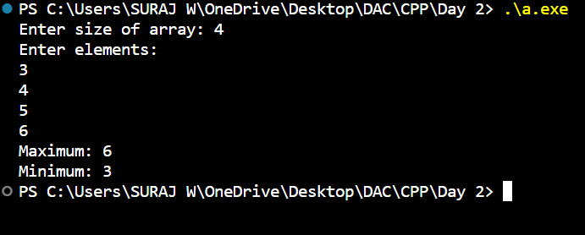

// 4. Search an Element (Linear Search)
#include <iostream>
using namespace std;

int main() {
int n, key;
cout << "Enter size of array: ";
cin >> n;
int arr[n];
cout << "Enter elements:\n";
for (int i = 0; i < n; i++) cin >> arr[i];
cout << "Enter element to search: ";
cin >> key;
bool found = false;
for (int i = 0; i < n; i++)
{
if (arr[i] == key)
{
found = true;
break;
}
}
if (found) cout << "Element found." << endl;
else cout << "Element not found." << endl;
return 0;
}
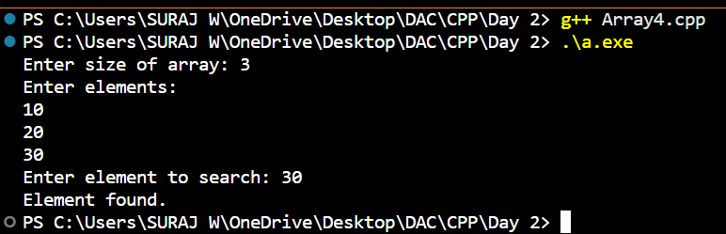

// 5. Reverse Array
#include <iostream>
using namespace std;

int main() {
int n;
cout << "Enter size of array: ";
cin >> n;
int arr[n];
cout << "Enter elements:\n";
for (int i = 0; i < n; i++)
{cin >> arr[i];}
cout << "Reversed array:\n";
for (int i = n - 1; i >= 0; i--)
cout << arr[i] << " ";
cout << endl;
return 0;
}
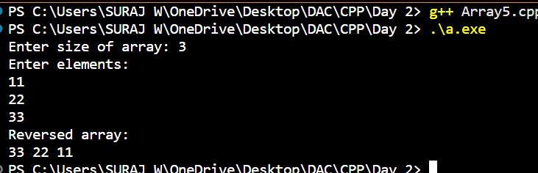

// 6. Count Even and Odd Numbers
#include <iostream>
using namespace std;

int main() {
int n, even = 0, odd = 0;
cout << "Enter size of array: ";
cin >> n;
int arr[n];
cout << "Enter elements:\n";
for (int i = 0; i < n; i++)
{
cin >> arr[i];
if (arr[i] % 2 == 0) even++;
else odd++;
}
cout << "Even numbers: " << even << endl;
cout << "Odd numbers: " << odd << endl;
return 0;
}
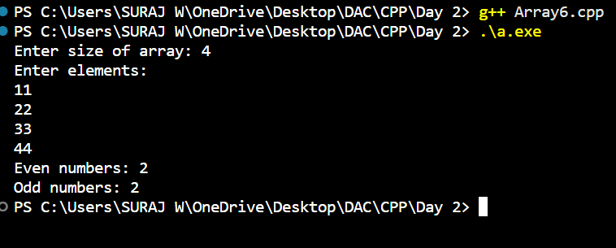

// 7. Sort Array (Ascending & Descending)
#include <iostream>
using namespace std;

int main() {
int n;
cout << "Enter size of array: ";
cin >> n;
int arr[n];
cout << "Enter elements:\n";
for (int i = 0; i < n; i++) cin >> arr[i];

for (int i = 0; i < n - 1; i++) {
for (int j = 0; j < n - i - 1; j++) {
if (arr[j] > arr[j + 1]) {
int temp = arr[j];
arr[j] = arr[j + 1];
arr[j + 1] = temp;
}
}
}
cout << "Sorted in Ascending order:\n";
for (int i = 0; i < n; i++) cout << arr[i] << " ";
cout << "\nSorted in Descending order:\n";
for (int i = n - 1; i >= 0; i--) cout << arr[i] << " ";
cout << endl;
return 0;
}
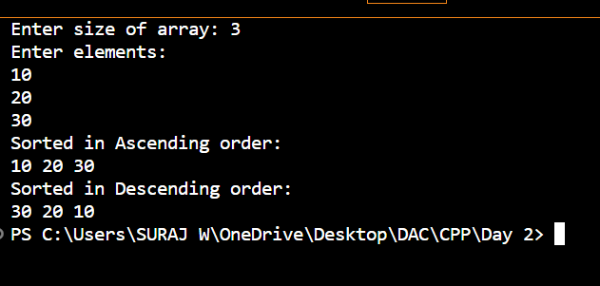

// 8. Second Largest Element
#include <iostream>
#include <limits.h>
using namespace std;

int main() {
int n;
cout << "Enter size of array: ";
cin >> n;
int arr[n];
cout << "Enter elements:\n";
for (int i = 0; i < n; i++) cin >> arr[i];
int first = INT_MIN, second = INT_MIN;
for (int i = 0; i < n; i++) {
if (arr[i] > first) {
second = first;
first = arr[i];
} else if (arr[i] > second && arr[i] != first) {
second = arr[i];
}
}
if (second == INT_MIN)
cout << "No second largest element." << endl;
else
cout << "Second largest element: " << second << endl;
return 0;
}
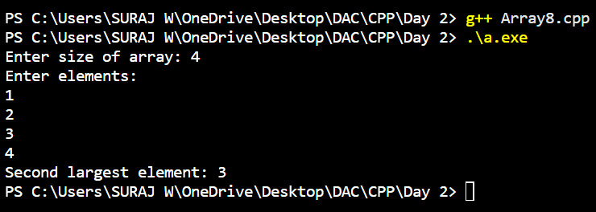

// 9. Frequency of Each Element
#include <iostream>
using namespace std;

int main() {
int n;
cout << "Enter size of array: ";
cin >> n;
int arr[n], freq[n];
cout << "Enter elements:\n";
for (int i = 0; i < n; i++)
{
cin >> arr[i];
freq[i] = -1;
}

for (int i = 0; i < n; i++) {
if (freq[i] != -1) continue;
int count = 1;
for (int j = i + 1; j < n; j++)
{
if (arr[i] == arr[j])
{
count++;
freq[j] = 0;
}
}
freq[i] = count;
}
cout << "Frequency of elements:\n";
for (int i = 0; i < n; i++)
{
if (freq[i] != 0)
cout << arr[i] << " occurs " << freq[i] << " times\n";
}
return 0;
}
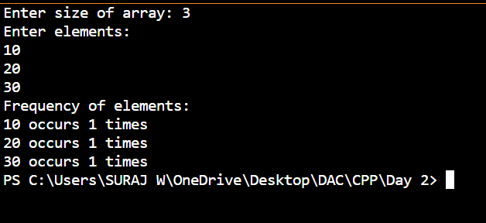
// 10. Merge Two Arrays
#include <iostream>
using namespace std;

int main() {
int n1, n2;
cout << "Enter size of first array: ";
cin >> n1;
int arr1[n1];
cout << "Enter elements of first array:\n";
for (int i = 0; i < n1; i++) cin >> arr1[i];

cout << "Enter size of second array: ";
cin >> n2;
int arr2[n2];
cout << "Enter elements of second array:\n";
for (int i = 0; i < n2; i++) cin >> arr2[i];

int merged[n1 + n2];
for (int i = 0; i < n1; i++) merged[i] = arr1[i];
for (int i = 0; i < n2; i++) merged[n1 + i] = arr2[i];

cout << "Merged array:\n";
for (int i = 0; i < n1 + n2; i++) cout << merged[i] << " ";
cout << endl;
return 0;
}
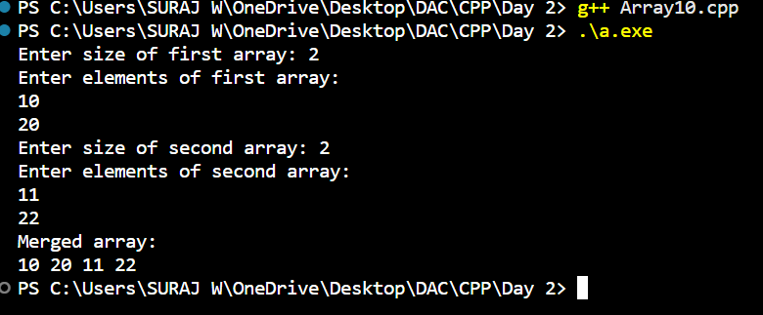

// Assignment: Inline Functions in C++
// Write a program using inline functions to calculate:
// Area of a square (side × side)
// Area of a rectangle (length × breadth)
// Area of a circle (π × r × r, use π = 3.14159)

#include <iostream>
using namespace std;
const float PI = 3.14159;
inline float areaSquare(float side) {
return side * side;
}
inline float areaRectangle(float length, float breadth) {
return length * breadth;
}

inline float areaCircle(float radius) {
return PI * radius * radius;
}
int main() {
float side, length, breadth, radius;
cout << "Enter side of square: ";
cin >> side;
cout << "Area of square: " << areaSquare(side) << endl;
cout << "\nEnter length and breadth of rectangle: ";
cin >> length >> breadth;
cout << "Area of rectangle: " << areaRectangle(length, breadth) << endl;
cout << "\nEnter radius of circle: ";
cin >> radius;
cout << "Area of circle: " << areaCircle(radius) << endl;
return 0;
}
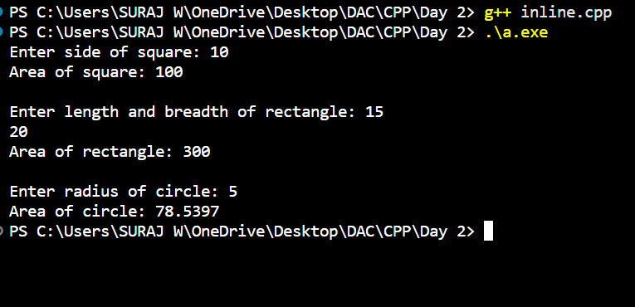

Assignment no 5
// 1:Write a program to create student class with data members rollno, marks1,mark2,mark3.
// Accept data (acceptInfo()) and display using display member function.
// Also display total,percentage and grade.

#include<iostream>
#include<iomanip>
using namespace std;
class student{
int rollno;
int marks1;
int marks2;
int marks3;
public:
student(){
rollno=0;
marks1=0;
marks2=0;
marks3=0;
}
void setter(int roll,int marks1,int marks2,int marks3){
this->rollno=roll;
this->marks1=marks1;
this->marks2=marks2;
this->marks3=marks3;
}
void display(){
cout<<rollno<<endl;
cout<<marks1<<endl;
cout<<marks2<<endl;
cout<<marks3<<endl;
}
void totalmarks(){
double total=marks1+marks2+marks3;
cout<<"total marks :"<<total<<endl;
double percentage =(total/300)*100;
cout << fixed << setprecision(2);
cout<<"percentage :"<<percentage<<endl;
if(percentage <=50){
cout<<"grade c";
}else if (percentage <=80){
cout<<"grade b";
}else {
cout<<"grade a";
}
}
};
int main()
{
student s1;
s1.setter(77,55,65,98);
s1.display();
s1.totalmarks();
return 0;
}
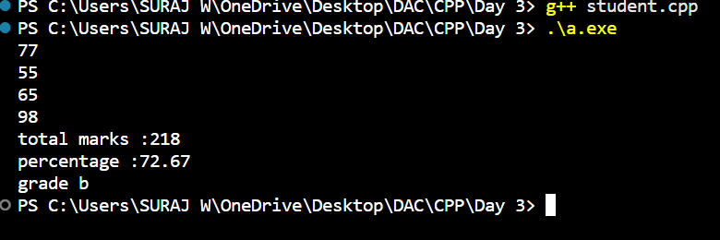

//3. Create a class Book with data members as bname,id,author,price. Write getters and setters for all the data members. Also add the display function. Create Default and Parameterized constructors. Create the object of this class in main method and invoke all the methods in that class. Create a class Person with data members as name, age, city. Write getters and setters for all the data members. Also add the display function. Create Default and Parameterized constructors. Create the object of this class in main method and invoke all the methods in that class.

#include<iostream>
#include<string>
using namespace std;
class book {
string bname;
int id;
string author;
double price;
public:
book (){
bname="xyz";
id=0;
author="xyz";
price=0.0;
}
book (string bname,int id,string author,double price){
this ->bname=bname;
this ->id=id;
this -> author=author;
this ->price=price;
}
void setter(string name,int id,string author ,double price){
this->bname=name;
this->id=id;
this->author=author;
this->price=price;
}
void display(){
cout<<"bname :"<<bname<<endl;
cout<<"id :"<<id<<endl;
cout<<"author :"<<author<<endl;
cout<<"price :"<<price<<endl;
}
};
int main()
{
book p1;
p1.display();
book p2("match",30,"wani",20);
p2.display();
p2.setter("komal",40,"amol",30);
p2.display();
return 0;
}
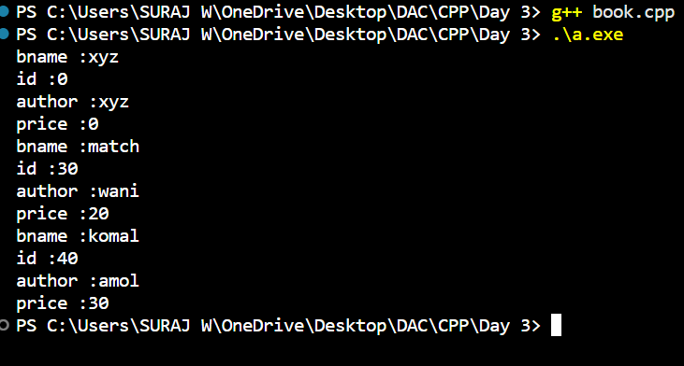

// 2. Create a class Person with data members as name, age, city. Write getters and setters for all the data members. Also add the display function. Create Default and Parameterized constructors. Create the object of this class in main method and invoke all the methods in that class.

#include<iostream>
#include<string>
using namespace std;
class person {
string name;
int age;
string city;
public:
person (){
name="xyz";
age=0;
city="xyz";

}
person (string name,int age,string city){
this ->name=name;
this ->age=age;
this -> city=city;
}
void setter(string name,int age,string city){
this->name=name;
this->age=age;
this->city=city;
}
void display(){
cout<<"name :"<<name<<endl;
cout<<"age :"<<age<<endl;
cout<<"city :"<<city<<endl;
}
};
int main()
{
person p1;
p1.display();
person p2("nayan",30,"wani");
p2.display();
p2.setter("komal",30,"wani");
p2.display();

return 0;
}
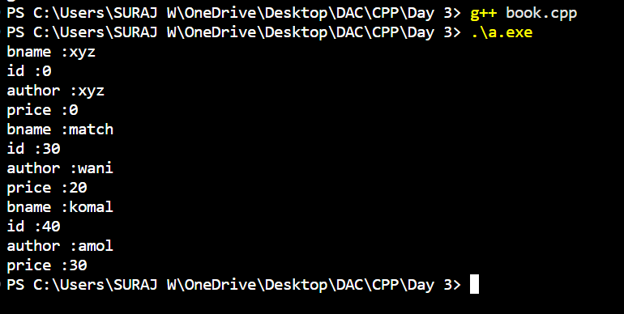

//4. Create a class Point with data members as x,y. Create Default and Parameterized constructors. Write getters and setters for all the data members. Also add the display function. Create the object of this class in main method and invoke all the methods in that class.

#include<iostream>
#include<string>
using namespace std;
class point {
int x;
int y;
public:
//non parameterised constructor
point (){
x=0;
y=0;
}
//parameterised constructor
point (int x,int y){
this ->x=x;
this ->y=y;
}
//setter
void setter(int x,int y){
this->x=x;
this->y=y;
}
//display function
void display(){
cout<<"point x:"<<x<<endl;
cout<<"point y:"<<y<<endl;
}
};
int main()
{
point p1;
p1.display();
point p2(10,20);
p2.display();
p2.setter(15,45);
p2.display();

return 0;
}
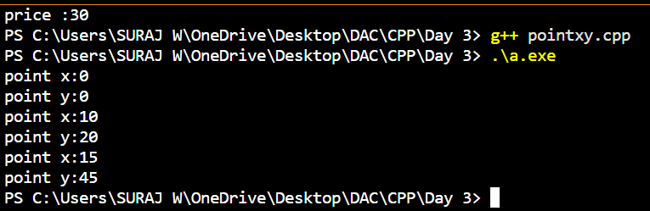

// 5.Create a class ComplexNumber with data members real, imaginary. Create Default and Parameterized constructors. Write getters and setters for all the data members. Also add the display function. Create the object of this class in main method and invoke all the methods in that class.
#include <iostream>
using namespace std;
class ComplexNumber {
private:
double real;
double imaginary;
public:
ComplexNumber() {
real = 0;
imaginary = 0;
}
ComplexNumber(double r, double i) {
real = r;
imaginary = i;
}
void setReal(double r) {
real = r;
}
void setImaginary(double i) {
imaginary = i;
}
double getReal() {
return real;
}
double getImaginary() {
return imaginary;
}

// Display function
void display() {
cout << "Complex Number: " << real;
if (imaginary >= 0)
cout << " + " << imaginary << "i" << endl;
else
cout << " - " << -imaginary << "i" << endl;
}
};
int main() {
// Creating object using default constructor
ComplexNumber c1;
cout << "Default Constructor Output:" << endl;
c1.display();
c1.setReal(3.5);
c1.setImaginary(-2.5);
cout << "\nAfter using setters:" << endl;
c1.display();
cout << "\nUsing getters:" << endl;
cout << "Real part: " << c1.getReal() << endl;
cout << "Imaginary part: " << c1.getImaginary() << endl;

ComplexNumber c2(4.2, 5.8);
cout << "\nParameterized Constructor Output:" << endl;
c2.display();

return 0;
}
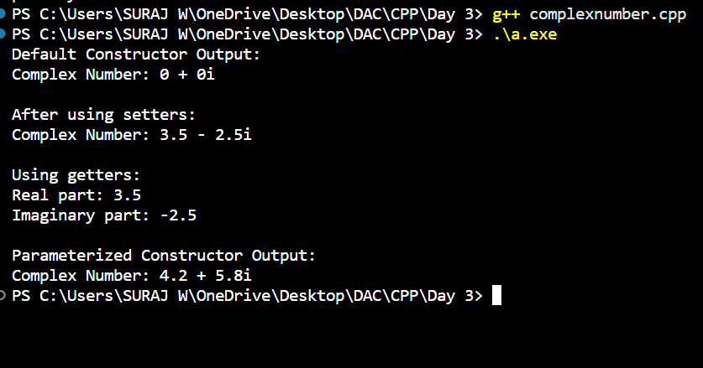

Assignment no 6
//1:Create Date class with members day,month ,year.Write no argument and parameterised constructor .Create two object s and initialize them using no argument and parameterised constructor respectively.Print date using display function.

#include<iostream>
using namespace std;
class date {
private:
int day;
int month;
int year;
public:
date(){
day=0;
month=0;
year=0;
}
date(int day,int month,int year){
this->day=day;
this->month=month;
this->year=year;
}
//display function
void display()
{
cout<<day<<"-"<<month<<"-"<<year<<endl;
}
void setdate(int day,int month,int year)
{
this->day=day;
this->month=month;
this->year=year;
}
};
int main()
{
date d1;
d1.display();
d1.setdate(10,10,1999);
d1.display();
date d2(20,2,2023);
d2.display();
return 0;
}
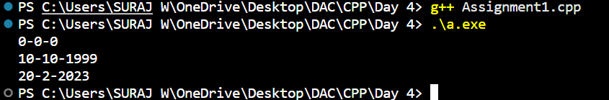

// 2:Create Employee class with members id(int),name(string),dob(Date).Use above created Date class.
// Write default and parameterised constructor in Employee Class.Write accept() function to accept information and display() to display emp information.
#include<iostream>
#include<string>
using namespace std;
struct date
{
int day;
int month;
int year;
};

class Employee
{
private:
int id;
string name;
date dob;
public:
//no argument constructor
Employee()
{
id=0;
name="not given yet";
dob.day=0;
dob.month=0;
dob.year=0;
}
Employee(int id,string name,int d,int month,int year){
this ->id=id;
this ->name=name;
this ->dob.day=d;
this ->dob.month=month;
this ->dob.year=year;
}
void accept ()
{
cout<<"----plz enter the employee details-------\n";
cout<<"enter employee id:";
cin>>id;
cout<<"enter employee name:";
cin>>name;
cout<<"enter employee dob:";
cout<<"enter the day: ";
cin>>dob.day;cout<<"enter the month:";cin>>dob.month;cout<<"plz enter the year :";cin>>dob.year;
}
void display()
{
cout<<"--------employee details-------------\n";
cout<<"employee id :"<<id<<endl;
cout<<"employee name :"<<name<<endl;
cout<<"date of birth :"<<dob.day<<"/"<<dob.month<<"/"<<dob.year<<endl;
}
};
int main()
{
Employee e1,e2(10,"nayanbonde",10,10,2234);
e1.display();
e1.accept();
e1.display();
e2.display();
return 0;
}
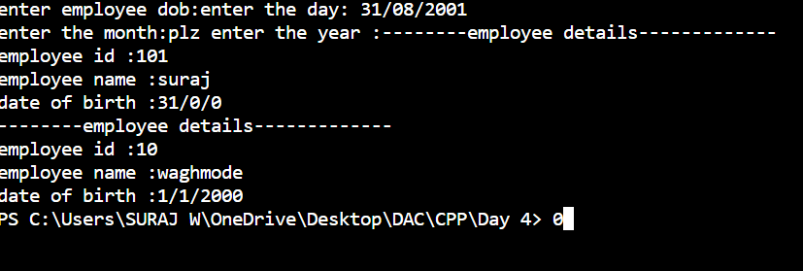

/* 3.1. Construct a class Employee with following members using private access
specifies: Employee Id integer Employee Name stringBasic Salary doubleHRA double Medical double=1000 PF double PT double Net Salary double Gross Salary double Please use following expressions for calculations://Note:Don't accept HRA,PF PT from user*/
// * HRA = 50% of Basic Salary
// * PF = 12% of Basic Salary
// * PT = Rs. 200

// 3.2. Write methods to display the details of an employee and calculate the gross
// and net salary.
// * Goss Salary = Basic Salary + HRA + Medical
// * Net Salary = Gross Salary – (PT + PF)
// Create Object of employee class and assign values and display Details.

#include<iostream>
#include<string>
using namespace std;
class Employee {
private:
int empid;
string name;
double basic_salary;
double hra;
double medical;
double pf;
double pt;
double gross_salary;
double netsalary;

public:
Employee()
{
basic_salary=0;
name="null";
hra=0;
medical=1000;
pf=0;
pt=200;
gross_salary=0;;
netsalary=0;

}
void setter()
{
cout<<"enter the employe id :";
cin>>empid;
cout<<"enter the employee name : ";
cin.ignore();
getline(cin,name);
cout<<"basic salary: ";
cin>>basic_salary;
}
void display()
{
cout<<"--------------employee details--------"<<endl;
cout<<"name :"<<name<<endl;
cout<<"employee id :"<<empid<<endl;
cout<<"basic salary :"<<basic_salary<<endl;
hra=basic_salary*0.50;
pf=basic_salary*0.12;
gross_salary=basic_salary+hra+medical;
netsalary=gross_salary-(pf+pt);
cout<<"hra :"<<hra<<endl;
cout<<"medical :"<<medical<<endl;
cout<<"pf :"<<pf<<endl;
cout<<"gross_salary :"<<gross_salary<<endl;
cout<<"net salary: "<<netsalary;
}
};
int main()
{
Employee e1;
e1.setter();
e1.display();
return 0;
}
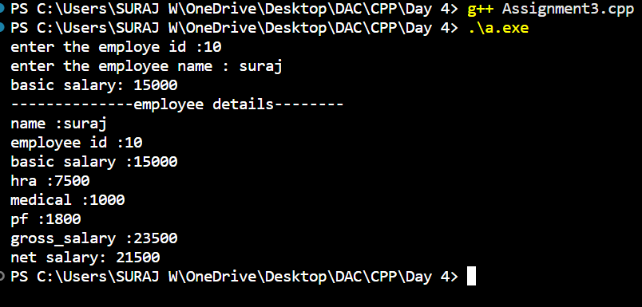

// 1. Fresh business scenario to apply inheritance , polymorphism to emp based organization scenario.

#include <iostream>
#include <string>
using namespace std;
// 1.1 Emp base class
class Emp {
protected:
int id;
string name;
int deptId;
double basicSalary;
public:
Emp(int id, string name, int deptId, double basicSalary)
: id(id), name(name), deptId(deptId), basicSalary(basicSalary) {}
virtual double computeNetSalary() {
return 0;
}
virtual void displayInfo() {
cout << "\nID: " << id
<< "\nName: " << name
<< "\nDepartment ID: " << deptId
<< "\nBasic Salary: " << basicSalary
<< "\nNet Salary: " << computeNetSalary() << endl;
}
virtual ~Emp() {}
};

// 1.2 Manager class
class Mgr : public Emp {
double perfBonus;
public:
Mgr(int id, string name, int deptId, double basicSalary, double perfBonus)
: Emp(id, name, deptId, basicSalary), perfBonus(perfBonus) {}
double computeNetSalary() override {
return basicSalary + perfBonus;
}
void displayInfo() override {
cout << "\n[Manager]";
Emp::displayInfo();
cout << "Performance Bonus: " << perfBonus << endl;
}
};

// 1.3 Worker class
class Worker : public Emp {
int hoursWorked;
double hourlyRate;
public:
Worker(int id, string name, int deptId, double basicSalary, int hoursWorked, double hourlyRate)
: Emp(id, name, deptId, basicSalary), hoursWorked(hoursWorked), hourlyRate(hourlyRate) {}
double computeNetSalary() override {
return basicSalary + (hoursWorked * hourlyRate);
}
double getHourlyRate() const {
return hourlyRate;
}
void displayInfo() override {
cout << "\n[Worker]";
Emp::displayInfo();
cout << "Hours Worked: " << hoursWorked
<< "\nHourly Rate: " << hourlyRate << endl;
}
};
int main() {
const int MAX_EMP = 100;
Emp* org[MAX_EMP];
int empCount = 0;
int choice;
do {
cout << "\n=========== Employee Management Menu ===========\n";
cout << "1. Hire Manager\n";
cout << "2. Hire Worker\n";
cout << "3. Display All Employees Info with Net Salary\n";
cout << "4. Exit\n";
cout << "Enter your choice: ";
cin >> choice;

switch (choice) {
case 1:
{
if (empCount >= MAX_EMP) {
cout << "Cannot hire more employees.\n";
break;
}
int id, deptId;
string name;
double basic, bonus;
cout << "Enter Manager ID: ";
cin >> id;
cout << "Enter Name: ";
cin.ignore();
getline(cin, name);
cout << "Enter Department ID: ";
cin >> deptId;
cout << "Enter Basic Salary: ";
cin >> basic;
cout << "Enter Performance Bonus: ";
cin >> bonus;
org[empCount++] = new Mgr(id, name, deptId, basic, bonus);
cout << "Manager hired successfully.\n";
break;
}

case 2:
{
if (empCount >= MAX_EMP) {
cout << "Cannot hire more employees.\n";
break;
}
int id, deptId, hours;
string name;
double basic, rate;
cout << "Enter Worker ID: ";
cin >> id;
cout << "Enter Name: ";
cin.ignore();
getline(cin, name);
cout << "Enter Department ID: ";
cin >> deptId;
cout << "Enter Basic Salary: ";
cin >> basic;
cout << "Enter Hours Worked: ";
cin >> hours;
cout << "Enter Hourly Rate: ";
cin >> rate;
org[empCount++] = new Worker(id, name, deptId, basic, hours, rate);
cout << "Worker hired successfully.\n";
break;
}

case 3:
{
if (empCount == 0) {
cout << "No employees to display.\n";
} else {
cout << "\n--- All Employees ---\n";
for (int i = 0; i < empCount; i++) {
org[i]->displayInfo();
cout << "---------------------------------\n";
}
}
break;
}
case 4:
{
cout << "Exiting program...\n";
break;
default:
cout << "Invalid choice. Please try again.\n";
}
} while (choice != 4);
for (int i = 0; i < empCount; i++) {
delete org[i];
}
return 0;
}
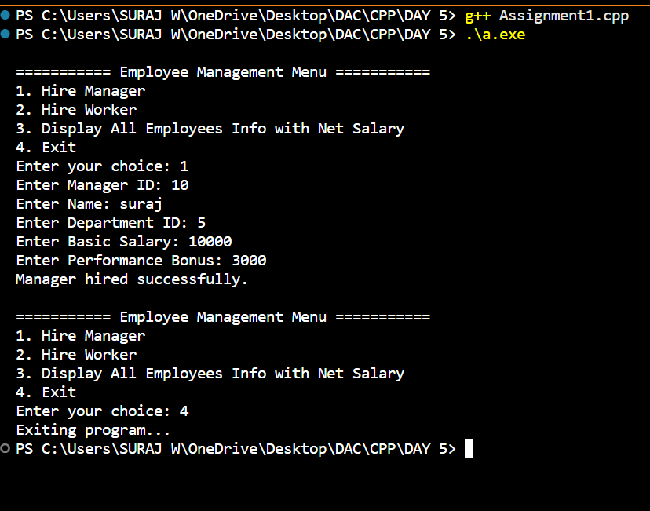

// 2: Create cpp application for bank account handling.
// 2.1. Create a class BankAccount -- acct no(int), customer name(string), balance(double)
// Add constr. (2 constrs : first to accept all details )
// 2.2 Add Business logic methods
// Methods
// public void withdraw(double amt)
// public void deposit(double amt)
// 2.3: Create object of account class and test withdraw and deposit methods.

#include <iostream>
#include <string>
using namespace std;
class BankAccount {
int accountNo;
string customerName;
double balance;
public:
BankAccount(int acct, string name, double bal)
: accountNo(acct), customerName(name), balance(bal) {}
BankAccount() : accountNo(0), customerName(""), balance(0.0) {}
void deposit(double amt)
{
if (amt > 0)
balance += amt;
}
void withdraw(double amt)
{
if (amt > 0 && amt <= balance)
balance -= amt;
else
cout << "Insufficient balance or invalid amount!" << endl;
}
void display()
{
cout << "\nAccount No: " << accountNo
<< "\nCustomer Name: " << customerName
<< "\nBalance: " << balance << endl;
}
};
int main()
{
BankAccount acc(101, "John Doe", 1000.0);
acc.display();
acc.deposit(500);
cout << "\nAfter depositing 500:" << endl;
acc.display();
acc.withdraw(300);
cout << "\nAfter withdrawing 300:" << endl;
acc.display();
acc.withdraw(1500);
cout << "\nAttempt to withdraw 1500 (more than balance):" << endl;
acc.display();
return 0;
}
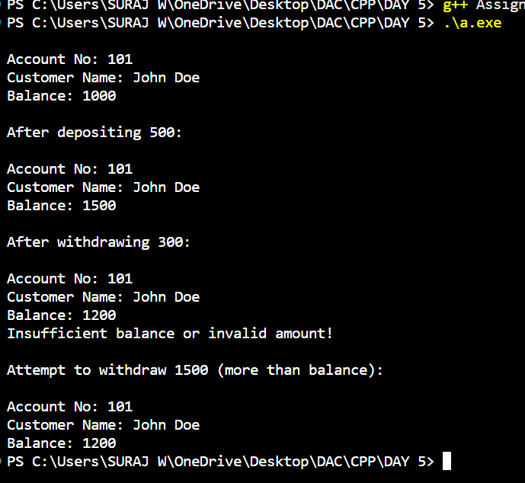

Assignment no 7
// 1. Basic Template Assignments

#include <iostream>
#include <string>
using namespace std;
// 1: Function Swap
template <typename T>
void swapValues(T &a, T &b)
{
T temp = a;
a = b;
b = temp;
}
// 2: Function Template – Maximum
template <typename T>
T findMax(T a, T b)
{
return (a > b) ? a : b;
}
// 3: Class Template – Box
template <typename T>
class Box {
T value;
public:
void setValue(T val)
{
value = val;
}
T getValue() {
return value;
}
};
// 4: Class Template – Calculator
template <typename T>
class Calculator
{
public:
T add(T a, T b) {
return a + b;
}
T subtract(T a, T b)
{
return a - b;
}
T multiply(T a, T b)
{
return a * b;
}
T divide(T a, T b)
{
return b != 0 ? a / b : 0;
}
};

// 5: Function Template – Array Sum
template <typename T>
T sumArray(T arr[], int size)
{
T sum = 0;
for (int i = 0; i < size; i++)
{
sum += arr[i];
}
return sum;
}

// 6: Class Template – Stack
template <typename T>
class Stack {
T arr[100];
int top;
public:
Stack() { top = -1; }
void push(T val)
{
if (top < 99)
arr[++top] = val;
}
void pop()
{
if (top >= 0)
top--;
}
T peek() {
return top >= 0 ? arr[top] : T();
}
bool isEmpty()
{
return top == -1;
}
};

// 7: Class Template – Queue
template <typename T>
class Queue {
T arr[100];
int frontIdx, rearIdx;
public:
Queue() {
frontIdx = 0;
rearIdx = -1;
}
void enqueue(T val)
{
if (rearIdx < 99)
arr[++rearIdx] = val;
}
void dequeue() {
if (!isEmpty())
frontIdx++;
}
T front() {
return !isEmpty() ? arr[frontIdx] : T();
}
bool isEmpty() {
return frontIdx > rearIdx;
}
};

int main() {

// 1: Swap Function Template Test
int a = 5, b = 10;
swapValues(a, b);
cout << "Swapped int: " << a << " " << b << endl;

double x = 2.5, y = 4.7;
swapValues(x, y);
cout << "Swapped double: " << x << " " << y << endl;
string s1 = "Hello", s2 = "World";
swapValues(s1, s2);
cout << "Swapped string: " << s1 << " " << s2 << endl;
// 2: Maximum Function Template Test
cout << "Max of 3 and 7 (int): " << findMax(3, 7) << endl;
cout << "Max of 3.5 and 7.2 (float): " << findMax(3.5f, 7.2f) << endl;
cout << "Max of 'a' and 'z' (char): " << findMax('a', 'z') << endl;
// 3: Box Class Template Test
Box<int> intBox;
intBox.setValue(42);
cout << "Boxed int: " << intBox.getValue() << endl;
Box<string> strBox;
strBox.setValue("Template");
cout << "Boxed string: " << strBox.getValue() << endl;
// 4: Calculator Class Template Test
Calculator<int> intCalc;
cout << "Add (int): " << intCalc.add(10, 5) << endl;
cout << "Divide (int): " << intCalc.divide(10, 2) << endl;
Calculator<double> dblCalc;
cout << "Multiply (double): " << dblCalc.multiply(2.5, 4.0) << endl;
// 5: Array Sum Function Template Test
int arr1[] = {1, 2, 3, 4, 5};
cout << "Sum of int array: " << sumArray(arr1, 5) << endl;
double arr2[] = {1.1, 2.2, 3.3};
cout << "Sum of double array: " << sumArray(arr2, 3) << endl;
// 6: Stack Class Template Test
Stack<int> intStack;
intStack.push(10);
intStack.push(20);
cout << "Stack peek (int): " << intStack.peek() << endl;
intStack.pop();
cout << "After pop, peek: " << intStack.peek() << endl;
Stack<string> strStack;
strStack.push("C++");
strStack.push("Templates");
cout << "Stack peek (string): " << strStack.peek() << endl;
// 7: Queue Class Template Test
Queue<int> intQueue;
intQueue.enqueue(100);
intQueue.enqueue(200);
cout << "Queue front (int): " << intQueue.front() << endl;
intQueue.dequeue();
cout << "After dequeue, front: " << intQueue.front() << endl;
Queue<string> strQueue;
strQueue.enqueue("One");
strQueue.enqueue("Two");
cout << "Queue front (string): " << strQueue.front() << endl;
return 0;
}
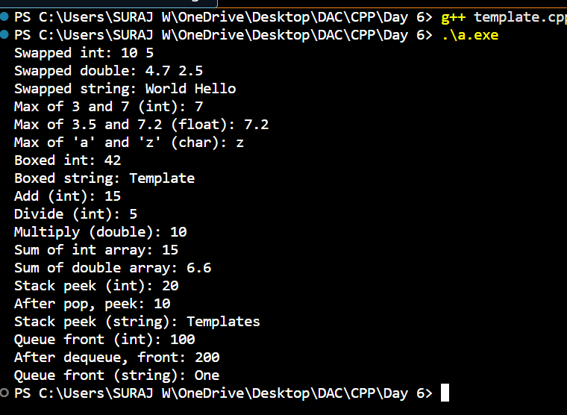

Assignment no 9

a// 1: Create an application for storing int values in vector. Create menu drivin app for //following menu;
// 1:add 2:show all 3:search 4:sort 5:reverse 6:clear

#include <iostream>
#include <vector>
#include <algorithm>
using namespace std;
int main()
{ vector<int> nums;
int choice;
do {
cout << "\n1. Add\n2. Show All\n3. Search\n4. Sort\n5. Reverse\n6. Clear\n7. Exit\nEnter choice: ";
cin >> choice;
switch (choice) {
case 1:
{
int val;
cout << "Enter value to add: ";
cin >> val;
nums.push_back(val);
break;
}
case 2:
{
if (nums.empty())
{
cout << "Vector is empty.\n";
} else {
cout << "Elements: ";
for (int n : nums) cout << n << " ";
cout << endl;
}
break;
}
case 3:
{
int key;
cout << "Enter value to search: ";
cin >> key;
auto it = find(nums.begin(), nums.end(), key);
if (it != nums.end())
cout << "Found at position: " << (it - nums.begin()) << endl;
else
cout << "Not found.\n";
break;
}
case 4:
{
sort(nums.begin(), nums.end());
cout << "Sorted.\n";
break;
}
case 5:
{
reverse(nums.begin(), nums.end());
cout << "Reversed.\n";
break;
}
case 6:
{
nums.clear();
cout << "Cleared.\n";
break;
}
case 7:
{
cout << "Exiting...\n";
break;
}
default:
cout << "Invalid choice.\n";
}
} while (choice != 7);
return 0;
}
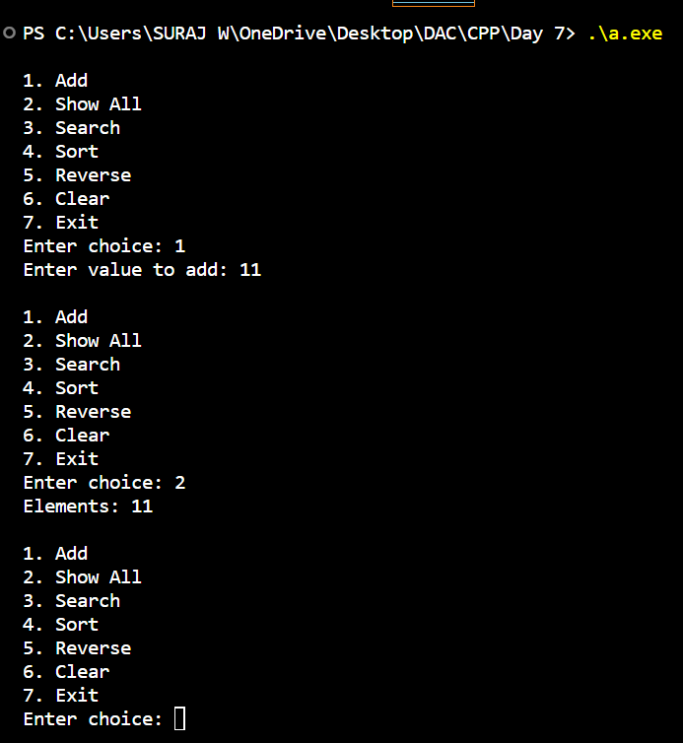

// 2: Create an application for storing user information in vector.
// (Hint:User class with data member userid,name,email,pwd)
// Create Menu Driven app
// 1:add user
// 2:display all users
// 3:search user
// 4:change pwd
// 5:delete all

#include <iostream>
#include <vector>
#include <string>
using namespace std;

class User {
int userid;
string name;
string email;
string pwd;

public:
User(int id, string n, string e, string p) : userid(id), name(n), email(e), pwd(p) {}

int getId() const {
return userid;
}

string getEmail() const {
return email;
}

void display() const {
cout << "\nUserID: " << userid << "\nName: " << name << "\nEmail: " << email << endl;
}

void changePassword(string newPwd) {
pwd = newPwd;
}
};

int main() {
vector<User> users;
int choice;

do {
cout << "\n1. Add User\n2. Display All Users\n3. Search User by ID\n4. Change Password\n5. Delete All Users\n6. Exit\nEnter choice: ";
cin >> choice;

switch (choice) {
case 1: {
int id;
string name, email, pwd;
cout << "Enter UserID: ";
cin >> id;
cin.ignore();
cout << "Enter Name: ";
getline(cin, name);
cout << "Enter Email: ";
getline(cin, email);
cout << "Enter Password: ";
getline(cin, pwd);
users.push_back(User(id, name, email, pwd));
break;
}

case 2: {
if (users.empty()) {
cout << "No users available.\n";
} else {
for (const auto& u : users)
u.display();
}
break;
}

case 3: {
int id;
cout << "Enter UserID to search: ";
cin >> id;
bool found = false;
for (const auto& u : users) {
if (u.getId() == id) {
u.display();
found = true;
break;
}
}
if (!found)
cout << "User not found.\n";
break;
}

case 4: {
int id;
string newPwd;
cout << "Enter UserID to change password: ";
cin >> id;
cin.ignore();
cout << "Enter new password: ";
getline(cin, newPwd);
bool found = false;
for (auto& u : users) {
if (u.getId() == id) {
u.changePassword(newPwd);
cout << "Password updated.\n";
found = true;
break;
}
}
if (!found)
cout << "User not found.\n";
break;
}

case 5: {
users.clear();
cout << "All users deleted.\n";
break;
}

case 6:
cout << "Exiting...\n";
break;

default:
cout << "Invalid choice.\n";
}

} while (choice != 6);

return 0;
}
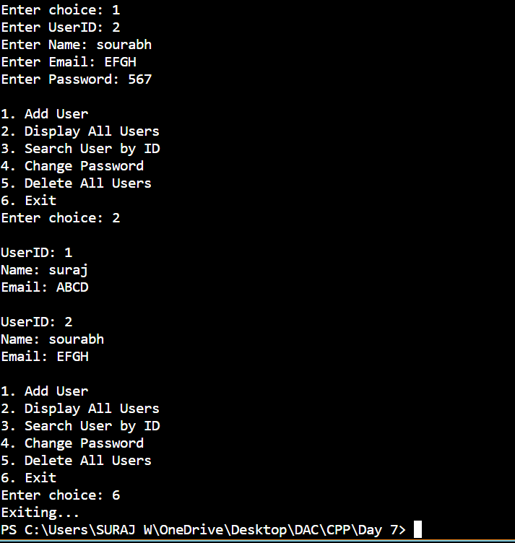

// 3: Create an application using set.
// Accept name of city from user and store in set
// Create Menu drivien app
// 1:add city
// 2:display all city
// 3: serach city

#include <iostream>
#include <set>
#include <string>
using namespace std;

int main()
{
set<string> cities;
int choice;
do {
cout << "\n1. Add City\n2. Display All Cities\n3. Search City\n4. Exit\nEnter choice: ";
cin >> choice;
switch (choice)
{
case 1:
{
string city;
cout << "Enter city name: ";
cin.ignore();
getline(cin, city);
cities.insert(city);
break;
}

case 2:
{
if (cities.empty()) {
cout << "No cities available.\n";
} else {
cout << "Cities:\n";
for (const auto& city : cities)
cout << city << endl;
}
break;
}
case 3:
{
string city;
cout << "Enter city name to search: ";
cin.ignore();
getline(cin, city);
if (cities.find(city) != cities.end())
cout << "City found.\n";
else
cout << "City not found.\n";
break;
}
case 4:
cout << "Exiting...\n";
break;
default:
cout << "Invalid choice.\n";
}

} while (choice != 4);
return 0;
}

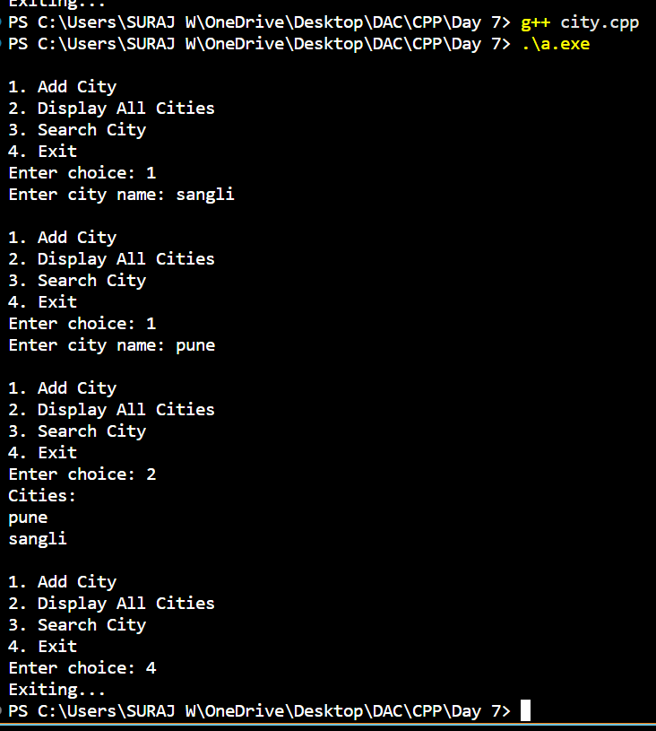

// 4: Create an application using map for storing key and value
// key:int
// value:Account type
// Create Account class with actid, name, balance
// Create Menu driven app
// 1:Add Account
// 2:Display all
// 3:Search account by actid
// 4:Remove all

#include <iostream>
#include <map>
#include <string>
using namespace std;

class Account {
int actid;
string name;
double balance;

public:
Account() {}
Account(int id, string n, double bal) : actid(id), name(n), balance(bal) {}

int getActId() const {
return actid;
}

void display() const {
cout << "\nAccount ID: " << actid
<< "\nName: " << name
<< "\nBalance: " << balance << endl;
}
};

int main() {
map<int, Account> accounts;
int choice;

do {
cout << "\n1. Add Account\n2. Display All\n3. Search Account by actid\n4. Remove All\n5. Exit\nEnter choice: ";
cin >> choice;

switch (choice) {
case 1: {
int id;
string name;
double bal;
cout << "Enter Account ID: ";
cin >> id;
cin.ignore();
cout << "Enter Name: ";
getline(cin, name);
cout << "Enter Balance: ";
cin >> bal;
accounts[id] = Account(id, name, bal);
break;
}

case 2: {
if (accounts.empty()) {
cout << "No accounts available.\n";
} else {
for (const auto& pair : accounts) {
pair.second.display();
}
}
break;
}

case 3: {
int id;
cout << "Enter Account ID to search: ";
cin >> id;
auto it = accounts.find(id);
if (it != accounts.end()) {
it->second.display();
} else {
cout << "Account not found.\n";
}
break;
}

case 4: {
accounts.clear();
cout << "All accounts removed.\n";
break;
}

case 5:
cout << "Exiting...\n";
break;

default:
cout << "Invalid choice.\n";
}

} while (choice != 5);

return 0;
}
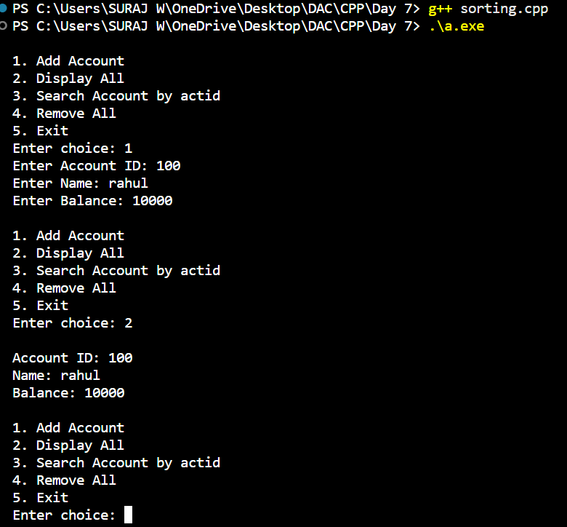

// 5: Create an File IO application for basic operation
// 1:Write file:accept data from user and store in file
// 2:Read file:display line by line
// 3:copy data from one file into another file

#include <iostream>
#include <fstream>
#include <string>
using namespace std;

int main() {
int choice;
do {
cout << "\n1. Write to file\n2. Read from file\n3. Copy file\n4. Exit\nEnter choice: ";
cin >> choice;
cin.ignore();

switch (choice) {
case 1: {
string filename, line;
cout << "Enter filename to write: ";
getline(cin, filename);
ofstream outfile(filename, ios::app);
if (!outfile) {
cout << "Error opening file.\n";
break;
}
cout << "Enter data (type 'END' to stop):\n";
while (true) {
getline(cin, line);
if (line == "END") break;
outfile << line << "\n";
}
outfile.close();
cout << "Data written successfully.\n";
break;
}
case 2: {
string filename, line;
cout << "Enter filename to read: ";
getline(cin, filename);
ifstream infile(filename);
if (!infile) {
cout << "Error opening file.\n";
break;
}
cout << "File contents:\n";
while (getline(infile, line)) {
cout << line << endl;
}
infile.close();
break;
}
case 3: {
string sourceFile, destFile;
cout << "Enter source filename: ";
getline(cin, sourceFile);
cout << "Enter destination filename: ";
getline(cin, destFile);
ifstream src(sourceFile);
if (!src) {
cout << "Error opening source file.\n";
break;
}
ofstream dest(destFile);
if (!dest) {
cout << "Error opening destination file.\n";
break;
}
string line;
while (getline(src, line)) {
dest << line << "\n";
}
src.close();
dest.close();
cout << "File copied successfully.\n";
break;
}
case 4:
cout << "Exiting...\n";
break;
default:
cout << "Invalid choice.\n";
}

} while (choice != 4);

return 0;
}
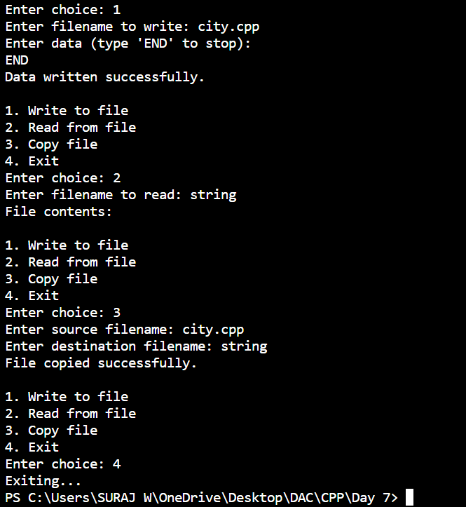

// 6: Create CRUD Shop Application Using File
// Write class Product with data member prdid,name,qty,price;
// Menus:
// 1:Add Prd
// 2:Display Prds
// 3:Search Prd
// 4:Update/Modify prd
// 5:delete prd

#include <iostream>
#include <fstream>
#include <string>
using namespace std;

class Product
{
public:
int prdid;
string name;
int qty;
double price;
Product() : prdid(0), name(""), qty(0), price(0.0) {}
Product(int id, string n, int q, double p) : prdid(id), name(n), qty(q), price(p) {}

void accept()
{
cout << "Enter Product ID: "; cin >> prdid; cin.ignore();
cout << "Enter Product Name: "; getline(cin, name);
cout << "Enter Quantity: "; cin >> qty;
cout << "Enter Price: "; cin >> price;
cin.ignore();
}
void display() const
{
cout << "\nID: " << prdid << "\nName: " << name << "\nQuantity: " << qty << "\nPrice: " << price << endl;
}
};
string filename = "products.dat";
void addProduct() {
Product p;
p.accept();
ofstream fout(filename, ios::app | ios::binary);
fout.write(reinterpret_cast<char*>(&p), sizeof(p));
fout.close();
cout << "Product added.\n";
}
void displayProducts()
{
ifstream fin(filename, ios::binary);
if (!fin) {
cout << "No products found.\n";
return;
}
Product p;
bool found = false;
while (fin.read(reinterpret_cast<char*>(&p), sizeof(p)))
{
p.display();
found = true;
}
fin.close();
if (!found) cout << "No products to display.\n";
}
void searchProduct()
{
int id;
cout << "Enter Product ID to search: ";
cin >> id;
ifstream fin(filename, ios::binary);
if (!fin) {
cout << "No products found.\n";
return;
}
Product p;
bool found = false;
while (fin.read(reinterpret_cast<char*>(&p), sizeof(p)))
{
if (p.prdid == id) {
p.display();
found = true;
break;
}
}
fin.close();
if (!found) cout << "Product not found.\n";
}

void updateProduct()
{
int id;
cout << "Enter Product ID to update: ";
cin >> id;
fstream file(filename, ios::in | ios::out | ios::binary);
if (!file) {
cout << "No products found.\n";
return;
}
Product p;
bool found = false;
while (file.read(reinterpret_cast<char*>(&p), sizeof(p))) {
if (p.prdid == id) {
cout << "Current details:\n";
p.display();
cout << "Enter new details:\n";
p.accept();
file.seekp(-static_cast<int>(sizeof(p)), ios::cur);
file.write(reinterpret_cast<char*>(&p), sizeof(p));
cout << "Product updated.\n";
found = true;
break;
}
}
file.close();
if (!found) cout << "Product not found.\n";
}

void deleteProduct()
{
int id;
cout << "Enter Product ID to delete: ";
cin >> id;
ifstream fin(filename, ios::binary);
if (!fin) {
cout << "No products found.\n";
return;
}
ofstream fout("temp.dat", ios::binary);
Product p;
bool found = false;
while (fin.read(reinterpret_cast<char*>(&p), sizeof(p))) {
if (p.prdid == id) {
found = true;
continue;
}
fout.write(reinterpret_cast<char*>(&p), sizeof(p));
}
fin.close();
fout.close();
if (found) {
remove(filename.c_str());
rename("temp.dat", filename.c_str());
cout << "Product deleted.\n";
} else {
remove("temp.dat");
cout << "Product not found.\n";
}
}
int main() {
int choice;
do {
cout << "\n1. Add Product\n2. Display Products\n3. Search Product\n4. Update Product\n5. Delete Product\n6. Exit\nEnter choice: ";
cin >> choice;
cin.ignore();
switch (choice) {
case 1: addProduct(); break;
case 2: displayProducts(); break;
case 3: searchProduct(); break;
case 4: updateProduct(); break;
case 5: deleteProduct(); break;
case 6: cout << "Exiting...\n"; break;
default: cout << "Invalid choice.\n";
}
} while (choice != 6);
return 0;
}
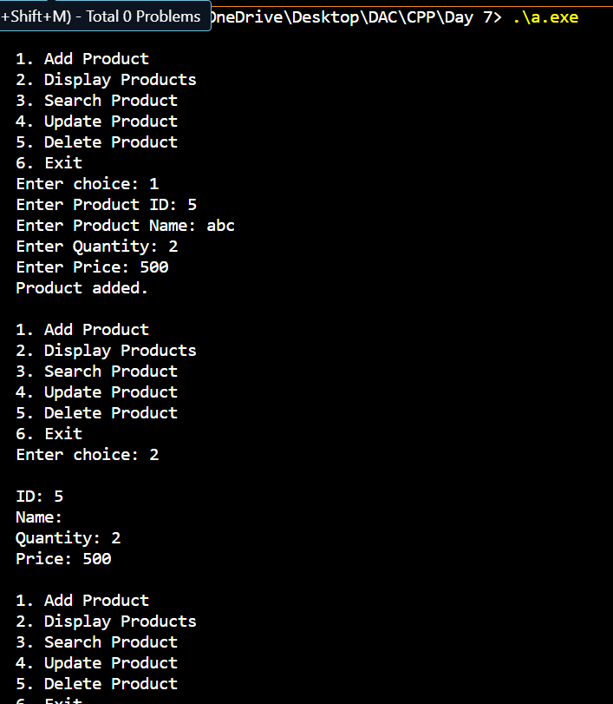

// 7: Create Student class in namespace CDAC namespace.
// Create another Student class in IACSD namespace.
// Try to access both student classes using namespace

#include <iostream>
using namespace std;
namespace CDAC
{
class Student {
public:
void display() {
cout << "CDAC Student class\n";
}
};
}

namespace IACSD
{
class Student {
public:
void display() {
cout << "IACSD Student class\n";
}
};
}
int main()
{
CDAC::Student s1;
IACSD::Student s2;
s1.display();
s2.display();
return 0;
}
