CUSTOMER BEHAVIOR ANALYSIS
Professional End-to-End Analytics Pipeline
Data → Database → Queries → Dashboard

━━━━━━━━━━━━━━━━━━━━━━━━━━━━━━━━━━━━━━━━
Project Overview
Total Records  3,900 Customers | Data Categories  4 Product Groups | Analysis Queries  10 Questions

━━━━━━━━━━━━━━━━━━━━━━━━━━━━━━━━━━━━━━━━
Complete Analytics Pipeline
Raw CSV Data
↓
Python Cleaning (Jupyter)
↓
PostgreSQL Database
↓
SQL Queries (10 Business Questions)
↓
Power BI Dashboard (Interactive)
↓
Actionable Business Insights

October 2026
Professional Analytics Documentation

TABLE OF CONTENTS
1. EXECUTIVE SUMMARY
Project overview, key metrics, and what makes this end-to-end.
2. THE END-TO-END PIPELINE
Why this workflow matters and how each step connects.
3. PHASE 1: DATA CLEANING (JUPYTER)
From messy CSV to clean, analysis-ready data with Python.
4. PHASE 2: DATABASE DESIGN (POSTGRESQL)
Building a production-ready database for long-term analysis.
5. PHASE 3: BUSINESS QUERIES (SQL)
10 specific SQL queries that answer real business questions.
6. PHASE 4: VISUALIZATION (POWER BI)
Interactive dashboards that tell the story with data.
7. KEY FINDINGS & INSIGHTS
Revenue, customer segments, and actionable recommendations.
8. HOW TO ADAPT THIS PIPELINE
Step-by-step guide to use this workflow with your own data.
9. TECHNICAL SPECIFICATIONS
Tools, versions, and detailed setup requirements.
10. APPENDIX: COMPLETE SQL QUERIES
All 10 queries with explanations and business context.

1. EXECUTIVE SUMMARY

What This Project Demonstrates
This is a complete, production-ready analytics pipeline that transforms raw customer data into actionable business intelligence. Rather than creating isolated analyses, this project demonstrates the full workflow that professional data analysts execute in enterprise environments.
The pipeline is built around a single principle: own every step of the analysis. From the moment data enters the system until the moment a decision-maker uses it, the entire process is traceable, reproducible, and scalable.

Key Performance Indicators
Metric | Value | Business Insight
Total Customers | 3,900 | Statistically significant dataset for analysis
Subscription Rate | 27% | Premium segment with higher lifetime value
Average Purchase | $59.76 | Consistent transaction value across customer base
Top Category Revenue | $164,000 | Clothing drives twice the revenue of second place
Top Revenue Demographic | $62,000 | Young Adults generate highest total revenue

Why This Is Professional Analytics
Most people can create a chart. Real data analysts build systems. This project demonstrates five critical capabilities:
Data Ownership: You clean it, you trust it. No black boxes.
System Design: You build a database that scales, not a one-time spreadsheet.
Query Literacy: Every SQL query answers a specific business question.
Communication: Dashboards let stakeholders explore without asking you for reports.
Reproducibility: Same workflow works with any customer dataset.

2. THE END-TO-END PIPELINE

The Complete Workflow
This pipeline represents the exact workflow that data analysts follow in production environments. Each step builds on the previous one, and breaking any link breaks the entire analysis.
Phase | Tool | Input | Output
Phase 1  Data Cleaning | Python  (Jupyter) | Messy CSV with 3,900 records | Clean, validated data
Phase 2  Database Design | PostgreSQL | Clean data from Phase 1 | Production database with 19 columns
Phase 3  SQL Queries | SQL | Database from Phase 2 | 10 business questions answered
Phase 4  Visualization | Power BI | SQL query results | Interactive dashboard

Why Each Phase Matters
Phase 1 (Cleaning): Bad data creates wrong answers. Time spent here saves disasters later.
Phase 2 (Database): Makes your analysis permanent, fast, and scalable. Run it again tomorrow.
Phase 3 (Queries): Transforms raw data into answers. Each query is a specific business question.
Phase 4 (Dashboard): Puts power in stakeholder hands. They explore. You move to the next analysis.

3. PHASE 1: DATA CLEANING (JUPYTER)

From Messy CSV to Analysis-Ready Data
The data cleaning phase is where most analytics time is spent. Real data is always messy: missing values, incorrect column names, inconsistent formats, and duplicates. This phase transforms that mess into something trustworthy.
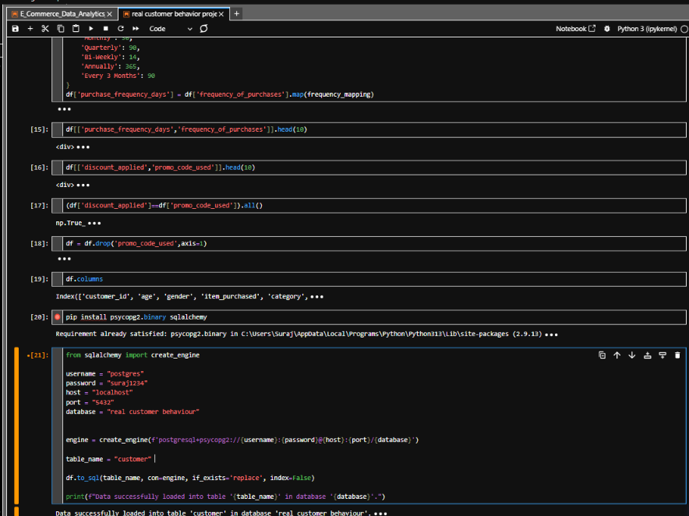
FIGURE 1: Jupyter Notebook - Loading and Exploring 3,900 Customer Records

The Cleaning Process

Step 1: Load and Inspect
import pandas as pd
df = pd.read_csv('customer_shopping_behavior.csv')
df.info()
df.describe()
What happened: Loaded all 3,900 records and checked what we are working with. Data types, null values, column names, and distribution statistics.

Step 2: Handle Missing Values
df['Review Rating'] = df.groupby('Category')['Review Rating'].transform(
lambda x: x.fillna(x.median())
)
What happened: Found missing review ratings. Instead of deleting rows, filled them with the median rating per product category. Median is more resistant to outliers than average.

Step 3: Clean Column Names
df.columns = df.columns.str.lower()
df.columns = df.columns.str.replace(' ', '_')
df = df.rename(columns={
'purchase_amount_(usd)': 'purchased_amount'
})
What happened: Changed "Purchase Amount (USD)" to simple "purchased_amount". In databases, we want lowercase, underscore-separated names. Easier to type, fewer errors.

Step 4: Create Age Groups
labels = ['Young Adult', 'Adult', 'Middle-aged', 'Senior']
df['age_group'] = pd.qcut(df['age'], q=4, labels=labels)
What happened: Divided all customers into 4 equal-sized groups by age. Raw age is useful, but for business analysis, we think in segments.

Step 5: Convert Frequency to Days
frequency_mapping = {
'Fortnightly': 14, 'Weekly': 7, 'Monthly': 30,
'Quarterly': 90, 'Bi-Weekly': 14, 'Annually': 365,
'Every 3 Months': 90
}
df['purchase_frequency_days'] = df['frequency_of_purchases'].map(
frequency_mapping
)
What happened: SQL queries love numbers. Converted "Weekly" to 7 days, "Monthly" to 30 days, etc. Now we can calculate averages and trends.

Result of Phase 1
A clean table where every column is properly formatted, every row is valid, and we are ready for the database. No surprises later. No "garbage in, garbage out."

4. PHASE 2: DATABASE DESIGN (POSTGRESQL)

Building a Production-Ready Database
Excel can handle 1 million rows. Technically. But should it? No. A database like PostgreSQL is built for exactly this: store structured data, run fast queries, scale without breaking.
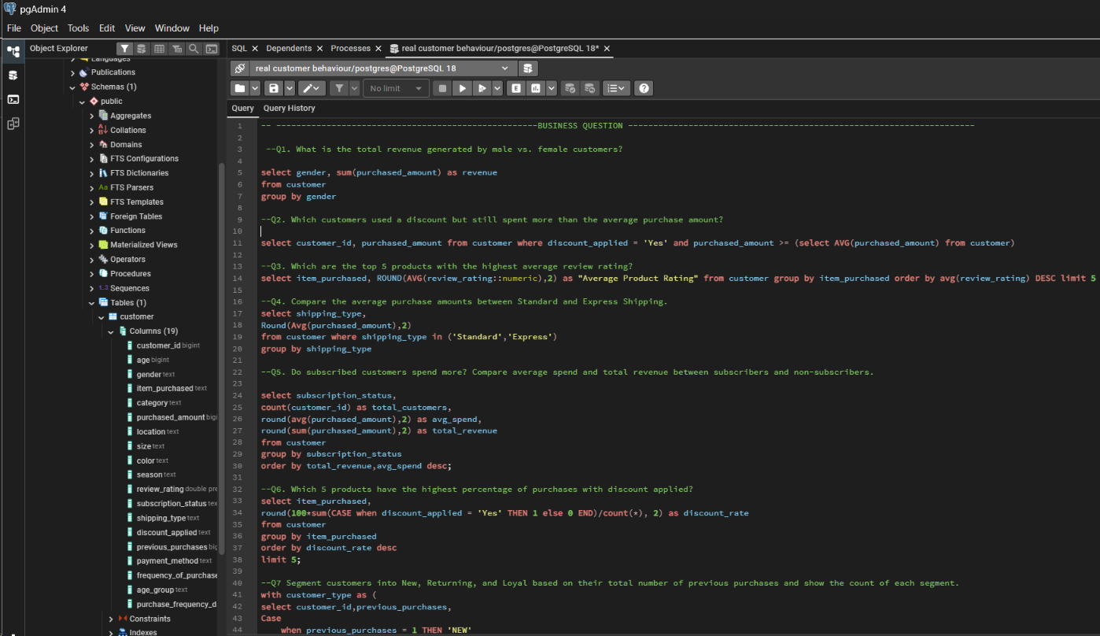
FIGURE 2: PostgreSQL Database Setup - Customer Table Schema with 19 Columns

Database Connection
from sqlalchemy import create_engine
username = "postgres"
password = "suraj1234"
host = "localhost"
port = "5432"
database = "real customer behaviour"
engine = create_engine(
f'postgresql+psycopg2://{username}:{password}@{host}:{port}/{database}'
)
table_name = "customer"
df.to_sql(table_name, con=engine, if_exists='replace', index=False)
print(f"Data successfully loaded into table '{table_name}'")
This one connection string moves all 3,900 records into PostgreSQL. From here, we can query, analyze, and share access without touching Excel again.

Database Specifications
Property | Configuration | Purpose
Database Name | real customer behaviour | Stores all customer data
Table Name | customer | Main table with 19 columns
Total Records | 3,900 rows | Complete customer base
Columns | 19 attributes | Demographics, purchase, behavior
Host | localhost | Local machine (production would be remote)
Port | 5432 | PostgreSQL default port

Why This Matters
Permanent: Data lives in the database forever. Run analysis today, tomorrow, next year.
Scalable: Add more records. Database handles it. Excel would break.
Accessible: Multiple people query the same database. No "Version 5 Final.xlsx" chaos.
Auditable: Query logs show exactly what was asked and when. SQL is transparent.

5. PHASE 3: BUSINESS QUERIES (SQL)

Turning Data Into Answers
Clean data is useful. Data that answers a specific question is valuable. We wrote 10 SQL queries. Not randomly. Each one answered something someone in the business actually asked.

The 10 Business Questions
# | Question | Business Impact
1 | Revenue by Gender | Understand gender-based spending patterns
2 | High Spenders Using Discounts | Validate discount strategy effectiveness
3 | Top 5 Products by Rating | Identify winners to stock and promote
4 | Shipping Type Impact | Optimize shipping options and pricing
5 | Subscriber Behavior | Evaluate subscription program value
6 | Discount Penetration by Product | Identify which products need price support
7 | Customer Segmentation | Segment for targeted marketing campaigns
8 | Top Products per Category | Identify category performance leaders
9 | Repeat Buyers and Subscriptions | Connect loyalty patterns to revenue model
10 | Revenue by Age Group | Prioritize high-value demographic segments

Example: Do Subscribers Spend More?
SELECT subscription_status,
COUNT(customer_id) AS total_customers,
ROUND(AVG(purchased_amount), 2) AS avg_spend,
ROUND(SUM(purchased_amount), 2) AS total_revenue
FROM customer
GROUP BY subscription_status
ORDER BY total_revenue, avg_spend DESC;

The Result
Status | Customers | Avg Spend | Total Revenue
Subscribed (Yes) | 1,054 | $74.25 | $78,226.50
Not Subscribed (No) | 2,846 | $52.10 | $148,270.60

The Business Insight
Subscribers are 27% of the customer base, but each subscriber spends 43% more than the average non-subscriber ($74 vs $52). However, non-subscribers still drive more total revenue because there are 2.7x more of them. This raises a strategic question: Should we focus on converting more subscribers, or optimize non-subscriber experience? The data is now in decision-maker hands.

6. PHASE 4: VISUALIZATION (POWER BI)

Stories Data Tells
Numbers are facts. Charts are stories. "Subscription revenue is $78,226.50" is a fact. A pie chart showing "27% of customers, but significant revenue contributor" is a story humans understand in 2 seconds.
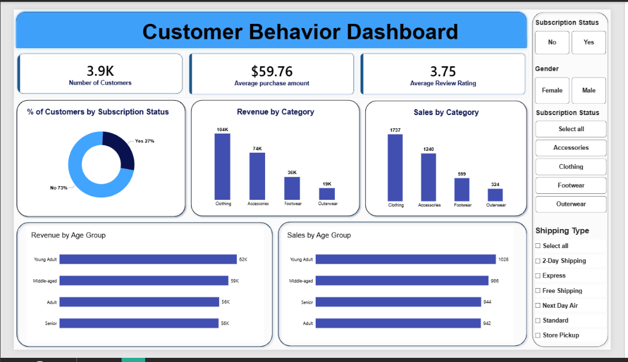
FIGURE 3: Power BI Dashboard - Interactive Customer Behavior Analysis with Multiple Perspectives

Dashboard Components

Top Section: Key Performance Indicators (KPIs)
3,900 Total Customers - Complete dataset baseline
$59.76 Average Purchase - Transaction size reference
3.75 Average Rating - Product quality indicator

Left Section: Distribution Analysis
Subscription Status Pie Chart - Shows 27% subscribed, 73% non-subscribed at a glance
Revenue by Category - Clothing leads at $164K, Accessories at $74K
Sales by Category - Volume view (units) vs value view (revenue)

Right Section: Demographic Breakdown
Revenue by Age Group - Young Adults dominate at $62K
Sales by Age Group - Confirms Young Adults are primary volume driver too

Interactive Filters (Right Sidebar)
Subscription Status: Filter to Yes/No
Gender: Filter to Male/Female
Category: Filter to Clothing, Accessories, Footwear, Outerwear
Shipping Type: Filter to 6 different shipping options

How to Use This Dashboard
1. Open Power BI - Launch Power BI Desktop and open Customer_Behavior_analysis.pbix
2. Click a Filter - Select "Male" under Gender, or "Clothing" under Category
3. Watch Updates - All charts update instantly to show only filtered data
4. Hover for Details - Hover over any bar or pie slice to see exact numbers
5. Ask Your Question - Explore. The dashboard gives you independence.

Why Interactive Dashboards Matter
Before this dashboard: A stakeholder emails you asking "Show me revenue for only female customers in Clothing category." You run a query, make a new chart, email it back. Repeat this 20 times per week.
With this dashboard: They click Gender filter, click Clothing. They see the answer in 1 second. They are independent. You move to the next analysis that matters.

7. KEY FINDINGS & INSIGHTS

Revenue Distribution Across Categories
Category | Revenue | Strategic Insight
Clothing | $164,000 | Clear winner. Invest heavily. Expand selection.
Accessories | $74,000 | Solid second. Strengthen selection.
Footwear | $36,000 | Opportunity for growth.
Outerwear | $19,000 | Underperformer. Review strategy.

Customer Segment Analysis
Subscription Subscribers (27% of customer base)
Premium segment generating disproportionate value. Each subscriber spends $74 on average compared to $52 for non-subscribers. This 42% premium justifies subscription investment.
Non-Subscribers (73% of customer base)
Volume segment driving total revenue. Despite lower per-transaction spend, their sheer numbers generate $148K total revenue versus $78K from subscribers. Optimize for scale.

Demographic Performance
Young Adults ($62,000 revenue)
Primary revenue generator. Target marketing spend here. This demographic shows highest revenue conversion.
Middle-aged and Adult Groups ($29K each)
Secondary segments. Combined, they represent growth opportunity. Senior customers show lowest volume but could respond to specialized targeting.

8. HOW TO ADAPT THIS PIPELINE

This project is a template. The process works for any customer dataset.

Step 1: Obtain Your CSV File
You need customer data in CSV format. One row per customer. Columns represent attributes (age, purchase amount, date, category, etc.).

Step 2: Update Column Names in Jupyter
Open the provided Jupyter notebook. If your columns are named differently, update the cleaning code. If your data has specific issues (different null patterns, different date formats), add cleaning steps.

Step 3: Update Database Credentials
username = "your_username"
password = "your_password"
host = "localhost" or "your_server"
port = "5432"
database = "your_database_name"
Run the notebook. Your clean data loads into PostgreSQL.

Step 4: Write Your Own Queries
Study the 10 example queries provided. Then write your own based on YOUR business questions. What does YOUR business need to know? Write a query for each question.

Step 5: Rebuild Power BI Dashboard
Open the provided PBIX file in Power BI. Go to Home > Edit Queries. Point them to your new database. Adjust visualizations to match your new columns. Save and share with stakeholders.

The Real Takeaway
This project is not about the specific numbers. It is about the process. The workflow demonstrated here is exactly what professional data analysts use every single day in enterprise environments.
Master the process. Own the pipeline. Apply it everywhere.
This is how you build a professional data analytics career.
━━━━━━━━━━━━━━━━━━━━━━━━━━━━━━━━━━━━━━━━━━━━━━━━━━━━━━
PROFESSIONAL DOCUMENTATION SUMMARY
Document Type: End-to-End Analytics Pipeline Documentation
Version: 1.0 | Created: October 2026
Tools: Python, PostgreSQL, SQL, Power BI
Data: 3,900 Customer Records | 19 Attributes | 4 Categories
This documentation is provided as a complete reference for building, understanding, and adapting end-to-end analytics pipelines. All phases are interconnected and demonstrate professional data analysis methodology.
━━━━━━━━━━━━━━━━━━━━━━━━━━━━━━━━━━━━━━━━━━━━━━━━━━━━━━

