Offensive Security Assessment Report
Metasploitable 2 Lab Walkthrough
A practice hack against a training VM
Target | Metasploitable 2 (192.168.11.130)
Attacker Machine | Kali Linux
Date | July 14, 2026
Environment | Isolated home lab (VirtualBox, host-only network)
Purpose | Learning / portfolio practice — not a real-world engagement

1. What This Report Is About
This is a simplified writeup of a hands-on lab exercise using Metasploitable 2, a Linux virtual machine that is intentionally built with security holes so people can practice ethical hacking safely. The goal was to find a weakness, use it to get into the system, look at what an attacker could do once inside, and then write down how to fix it.
Everything here happened inside a private, isolated lab. No real systems or real people were involved.

2. The Weakness That Was Found
A scan of the target showed it was running an old version of the FTP file-sharing service called vsftpd (version 2.3.4). This exact version has a well-known bug: a hidden "backdoor" was secretly added to it back in 2011. If someone connects and sends a specific username, the server opens a hidden door that gives full control of the machine — no password needed.
Service | vsftpd 2.3.4 (FTP)
Issue | Known backdoor (CVE-2011-2523)
Severity | Critical — full remote takeover, no login required
Result | Attacker gets root (admin) access instantly

3. Step-by-Step: How It Was Tested

Step 1 — Confirm the target is reachable
Before doing anything else, a simple ping test confirmed the target machine was online and reachable on the lab network.
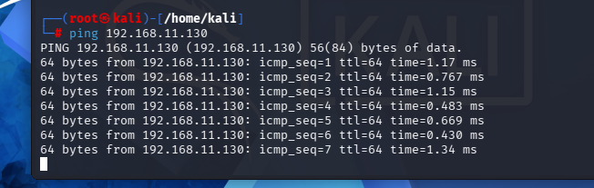
Figure 1ping tetsing

Step 2 — Open the hacking toolkit
Metasploit (msfconsole) was launched on the Kali attacker machine. This is the main tool used to find and run exploits against known vulnerabilities.
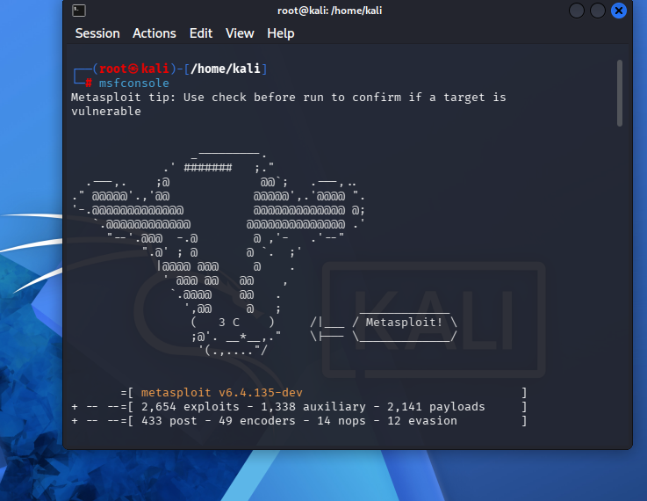
Figure 2 frameowrk

Step 3 — Find and select the matching exploit
Inside Metasploit, a search for "vsftpd" turned up the exact module needed: the vsftpd 2.3.4 backdoor exploit. This module was selected and pointed at the target's IP address.
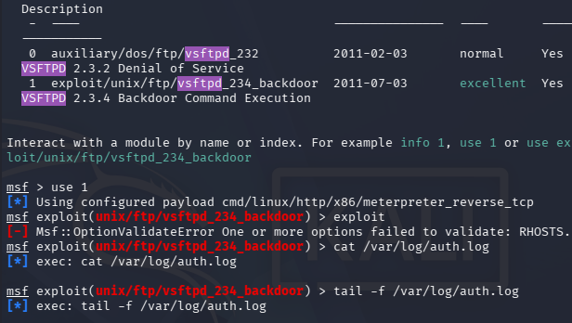
Figure 3 backdoor

Step 4 — Run the exploit and get access
Once the target address was set correctly and the exploit was run, Metasploit connected to the FTP service, triggered the backdoor, and opened a remote command session on the target — handing over full control of the machine.
Checking who the attacker "became" on the target confirmed the highest possible level of access:
whoami root id uid=0(root) gid=0(root)
In plain terms: the attacker was instantly logged in as the system's all-powerful administrator account, with zero credentials.

4. What an Attacker Could Do Next (Log Tampering)
After gaining root access, the exercise also looked at how an attacker could cover their tracks by reading and editing the target's log files — the records that normally show who connected and when.
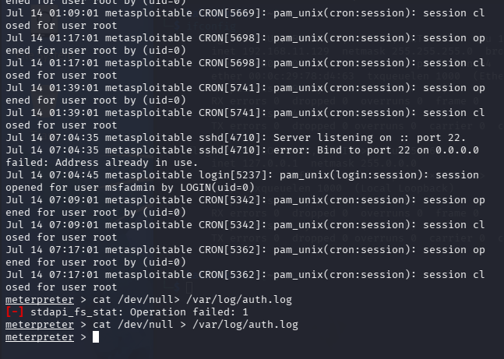
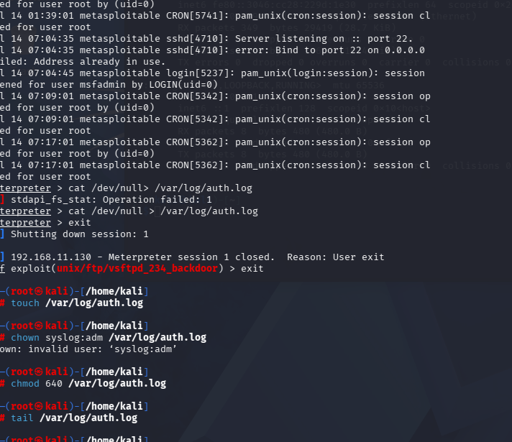
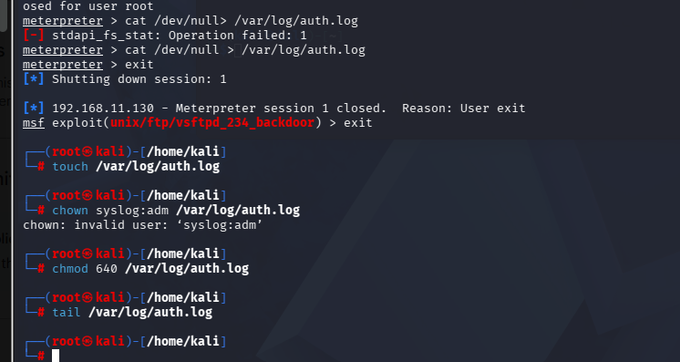
Figure 4Reading and manipulating /var/log/auth.log from the compromised session.
Because the attacker had root access, they had full read and write control over the system's log files. This means a real attacker could delete or edit these logs to hide evidence of the break-in — which is exactly why relying only on local logs is risky.

5. Fixing the Problem
The core issue is a single outdated, backdoored piece of software. The fix is straightforward:
- Remove or upgrade vsftpd 2.3.4 immediately — replace it with the latest patched version.
- Replace FTP with secure SFTP configurations, since plain FTP sends data (including credentials) in the clear.
- Establish active update managers so vulnerable software versions like this don't sit unpatched for years.
- If FTP must stay temporarily, block port 21 at the firewall except for trusted, known IP addresses.
- Send logs off the box in real time (e.g. to a central log server) so an attacker with root can't quietly erase the evidence.
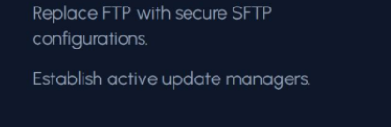
Key remediation actions.

6. Summary
This lab exercise showed, start to finish, how one outdated service can lead to complete loss of control over a machine — and how that same access can then be used to hide the tracks of the intrusion. The fix is simple in this case (patch or remove the vulnerable software), but the exercise is a good reminder of why keeping software updated and logging externally both matter.

7. Disclaimer
This report was created for personal learning and portfolio purposes only, using an intentionally vulnerable practice VM inside a private, isolated lab. Scanning or attacking systems you do not own or do not have explicit written permission to test is illegal.

