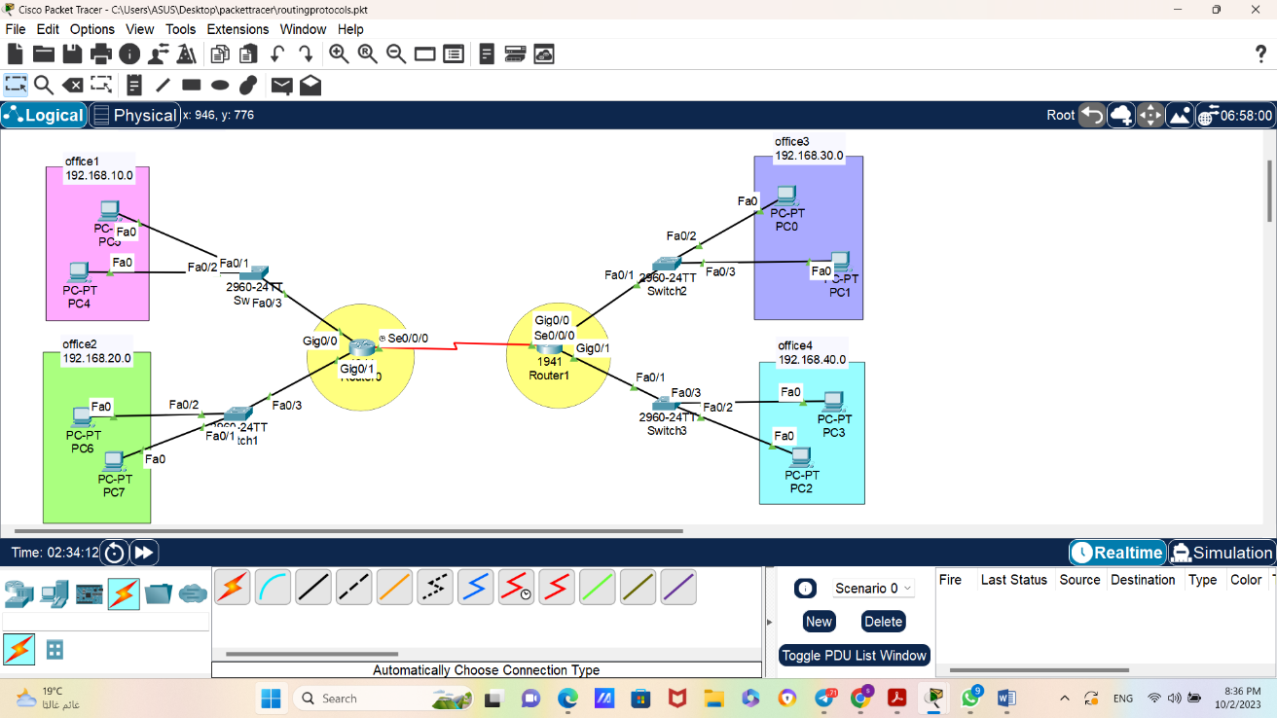
Router0
Router(config)#hostname FLOOR1
FLOOR1(config)#interface gig 0/0
FLOOR1(config-if)#no shutdown
FLOOR1(config-if)#ip address 192.168.10.1 255.255.255.0
FLOOR1(config-if)#ip dhcp pool office1
FLOOR1(dhcp-config)#network 192.168.10.0 255.255.255.0
FLOOR1(dhcp-config)#default-router 192.168.10.1
FLOOR1(dhcp-config)#exit

FLOOR1(config)#interface gig 0/1
FLOOR1(config-if)#no shutdown
FLOOR1(config-if)#ip address 192.168.20.1 255.255.255.0
FLOOR1(config-if)#ip dhcp pool office2
FLOOR1(dhcp-config)#network 192.168.20.0 255.255.255.0
FLOOR1(dhcp-config)#default-router 192.168.20.1
FLOOR1(dhcp-config)#exit

FLOOR1(config)#interface serial 0/0/0
FLOOR1(config-if)#no shutdown
FLOOR1(config-if)#ip address 192.168.50.1 255.255.255.0

Router1
Router(config)#hostname FLOOR10
FLOOR10(config)#interface gig 0/0
FLOOR10(config-if)#no shutdown
FLOOR10(config-if)#ip address 192.168.30.1 255.255.255.0
FLOOR10(config-if)#ip dhcp pool test1
FLOOR10(dhcp-config)#network 192.168.30.0 255.255.255.0
FLOOR10(dhcp-config)#default-router 192.168.30.1
FLOOR10(dhcp-config)#exit

FLOOR10(config)#interface gig 0/1
FLOOR10(config-if)#no shutdown
FLOOR10(config-if)#ip address 192.168.40.1 255.255.255.0
FLOOR10(config-if)#ip dhcp pool test2
FLOOR10(dhcp-config)#network 192.168.40.0 255.255.255.0
FLOOR10(dhcp-config)#default-router 192.168.40.1
FLOOR10(dhcp-config)#exit

FLOOR10(config)#interface serial 0/0/0
FLOOR10(config-if)#no shutdown
FLOOR10(config-if)#ip address 192.168.50.2 255.255.255.0
FLOOR10(config-if)#end

Protocols:
Rip protocol:
FLOOR1(config)#router rip
FLOOR1(config-router)#version 2
FLOOR1(config-router)#network 192.168.10.0
FLOOR1(config-router)#network 192.168.20.0
FLOOR1(config-router)#network 192.168.50.0
FLOOR1(config)#no router rip

eigrp Protocol:
FLOOR1(config)#router eigrp 100
FLOOR1(config-router)#network 192.168.10.0
FLOOR1(config-router)#network 192.168.20.0
FLOOR1(config-router)#network 192.168.50.0

OSPF Protocol:
FLOOR1(config)#router ospf 1000
FLOOR1(config-router)#network 192.168.10.0 0.0.0.255 area 0
FLOOR1(config-router)#network 192.168.20.0 0.0.0.255 area 0
FLOOR1(config-router)#network 192.168.50.2 remote-as 2000

Bgp protocol:
FLOOR1(config)#router bgp 1000
FLOOR1(config-router)#network 192.168.10.0 mask 255.255.255.0
FLOOR1(config-router)#network 192.168.20.0 mask 255.255.255.0
FLOOR1(config-router)#network 192.168.50.0 mask 255.255.255.0
FLOOR1(config-router)#neighbor 192.168.50.2 remote-as 2000

