Satellite Image Classification with Deep Learning

In this paper author is using deep learning convolution neural network algorithm to classify satellite images such as presence of Airport, agriculture land, forest from satellite images and to train CNN algorithm author has used IARPA Functional Map of the World (fMoW) dataset which consist of 63 different classes such as Airport, park, storage tank and many more and this dataset size is 177 GB and we cannot used such huge dataset to train CNN in normal laptop so I took few classes from this dataset which consists of agriculture land, forest and urban land. This 3 classes images consist of 2 GB size and I trained this 3 classes with CNN algorithm. After training we can upload any satellite image and then CNN model will classify that image as forest land, urban or agriculture land. To train CNN I am using below satellite images dataset

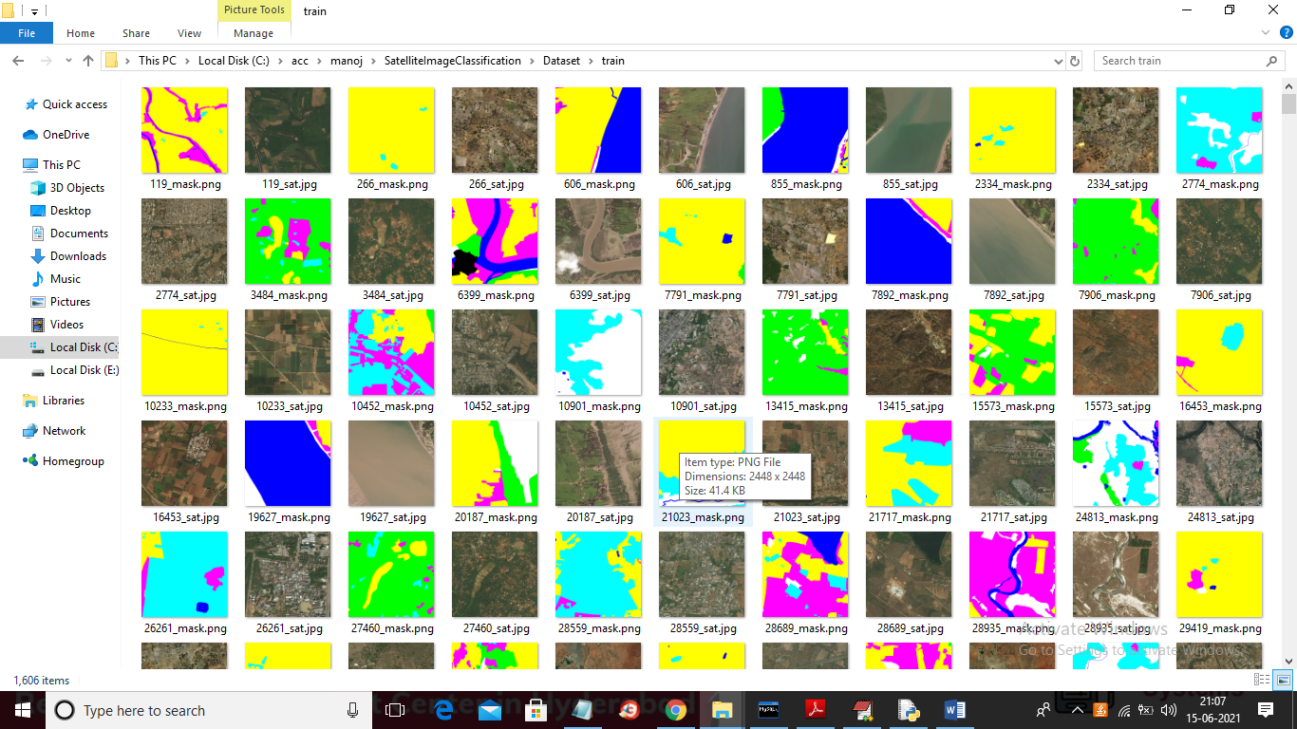

Above dataset images are available inside ‘Dataset’ folder.

SCREEN SHOTS

To run project double click on ‘run.bat’ file to get below screen

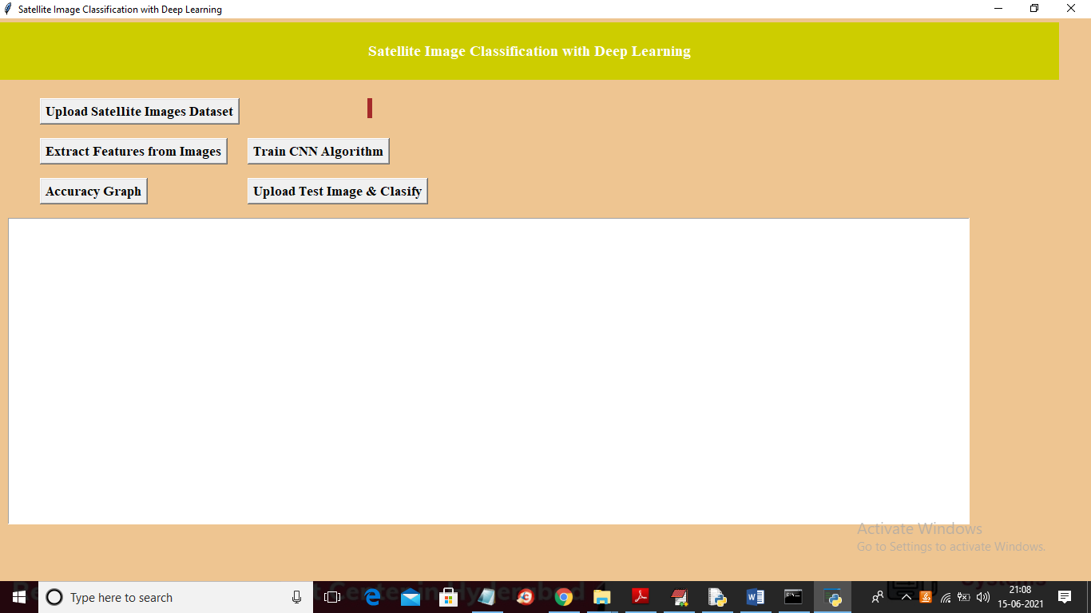

In above screen click on ‘Upload Satellite Images dataset’ button to upload dataset

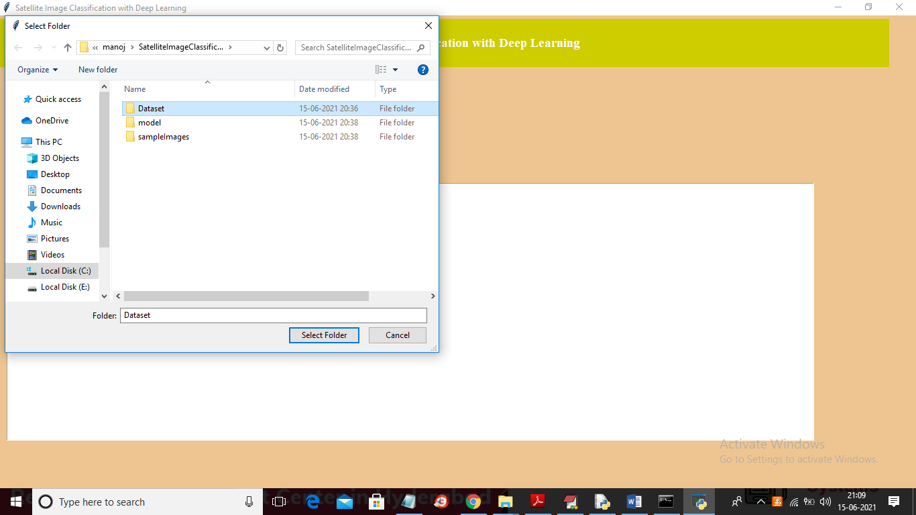

In above screen selecting and uploading ‘Dataset’ folder and then click on ‘Select Folder’ button to load dataset and to get below screen

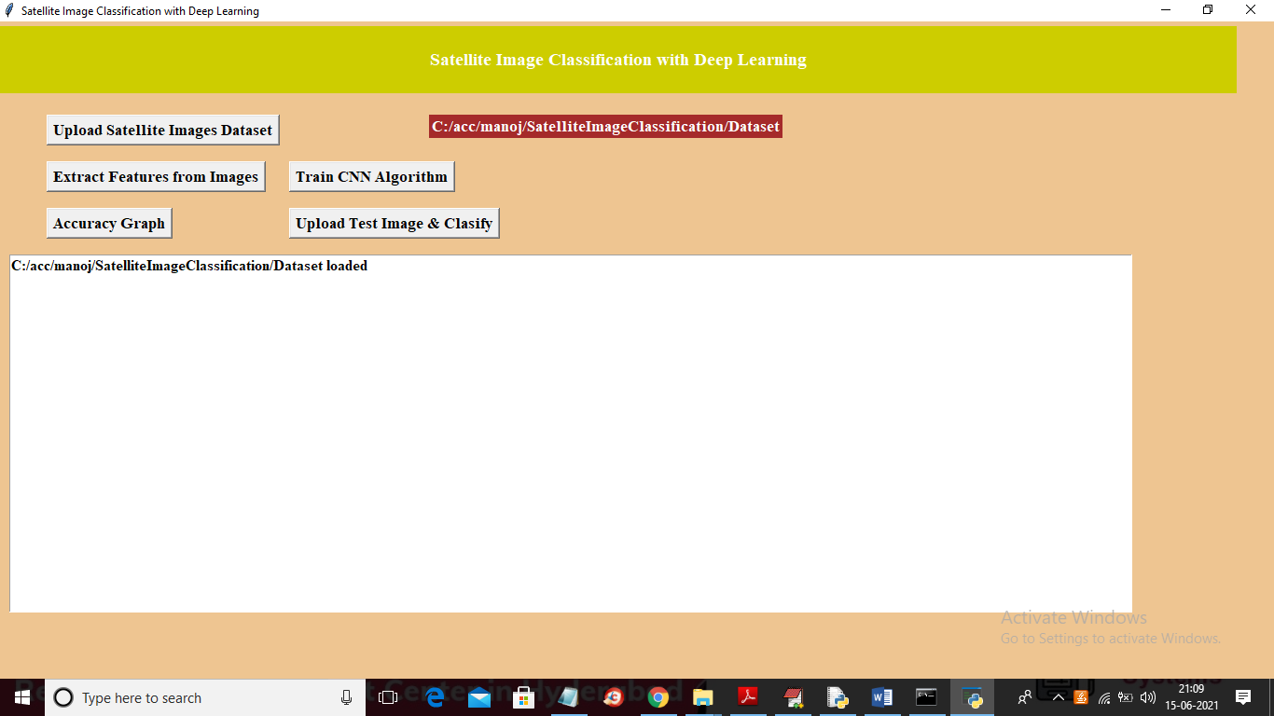

In above screen dataset loaded and now click on ‘Extract Features from Images” to read images and then resize and extract pixels from each image and then generate training data

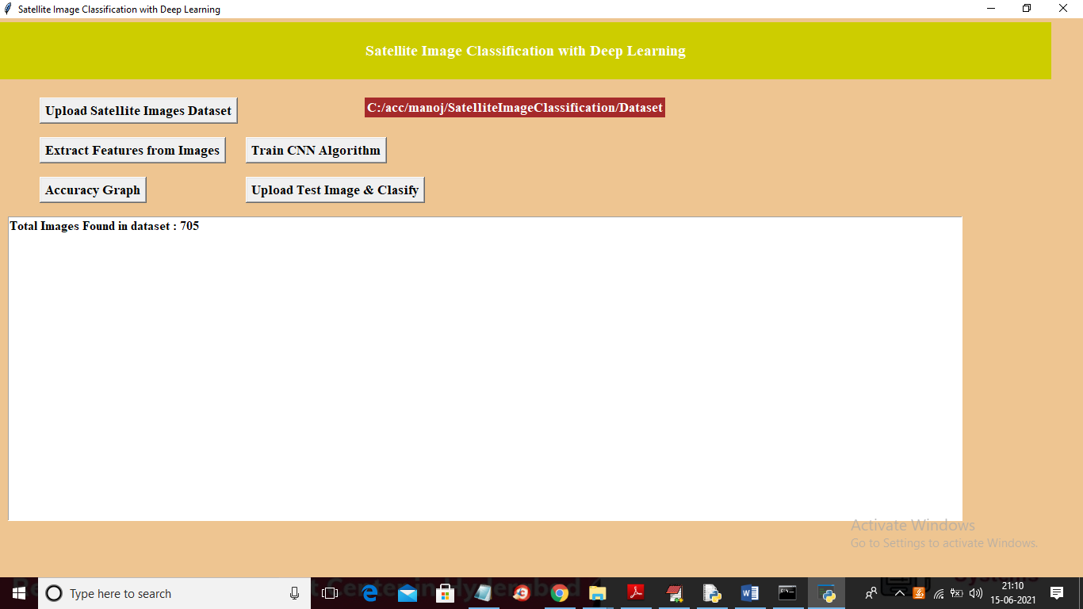

In above screen we can see dataset contains total 705 images and now click on ‘Train CNN Algorithm’ button to train CNN with above images

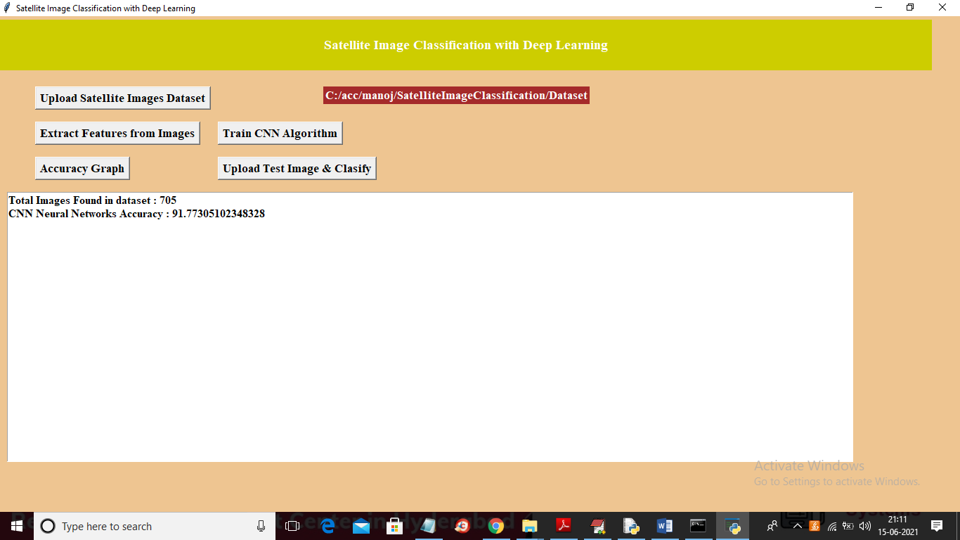

In above screen CNN training is completed and we got its accuracy as 91% and below screen showing all layer details of CNN

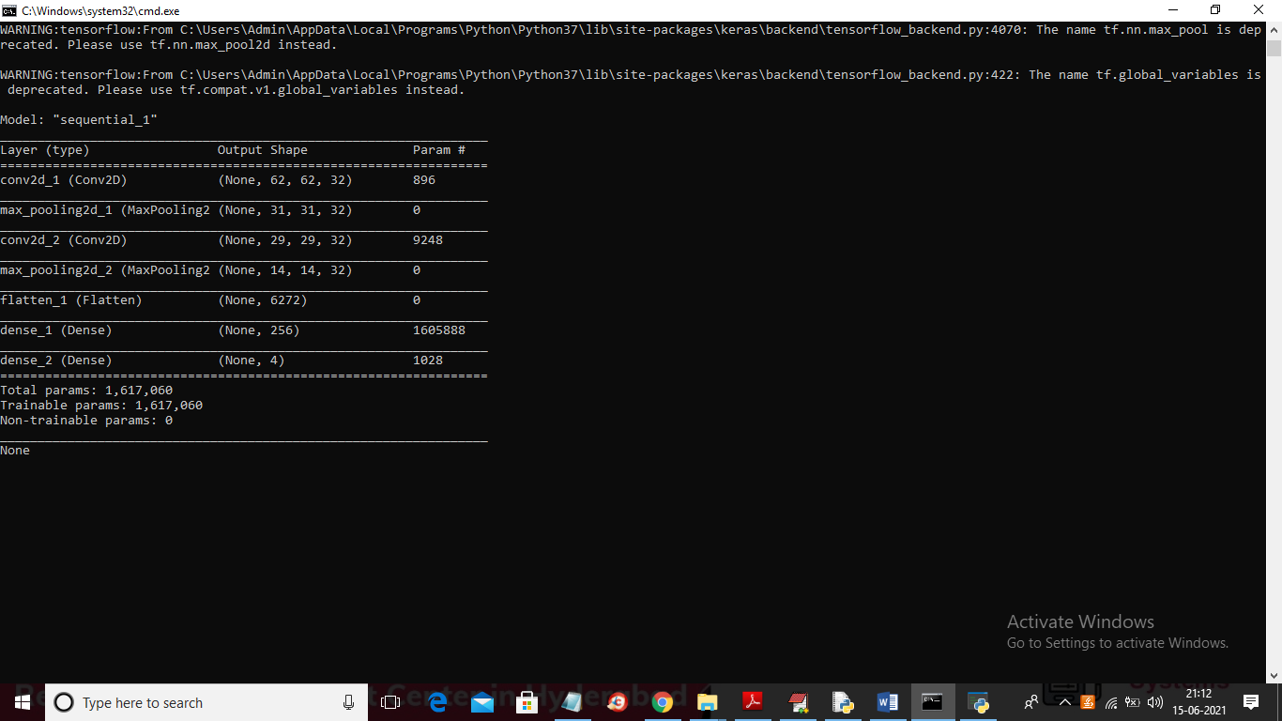

In above screen we can see CNN is using different layers with different image size to filter images and to build trained model with better accuracy and in above screen first layer using image size as 62 X 62 and second layer using 31 X 31 and goes on. Now CNN model is ready and now click on ‘Accuracy Graph’ button to get accuracy of CNN model on each iterations or epoch

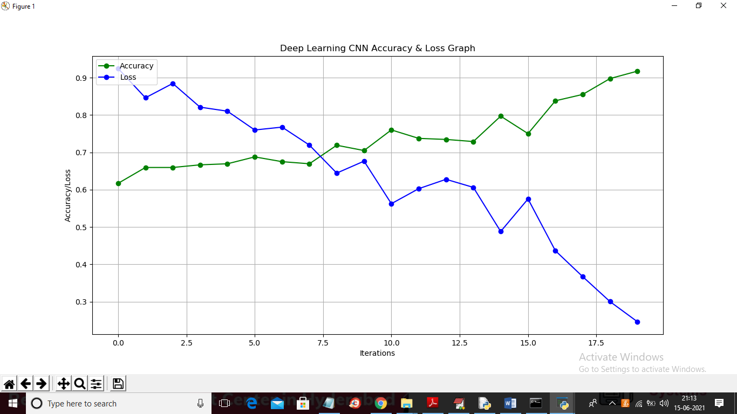

In above graph x-axis represents epoch and y-axis represents accuracy and to train CNN I took 20 epochs and at each increasing epoch CNN LOSS value decrease and CNN ACCURACY get increase and in above graph green line represents accuracy and blue line represents loss. Now click on ‘Upload Test Image & Classify’ button to upload test image and get below classification result

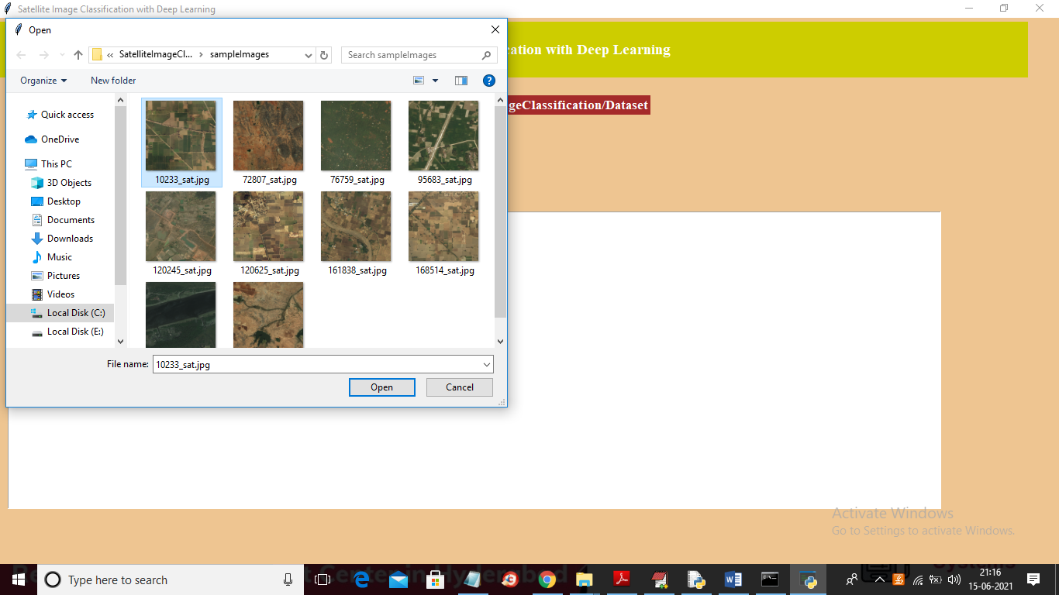

In above screen I am selecting and uploading ‘10233_sat.jpg’ and then click on ‘Open’ button to get below result

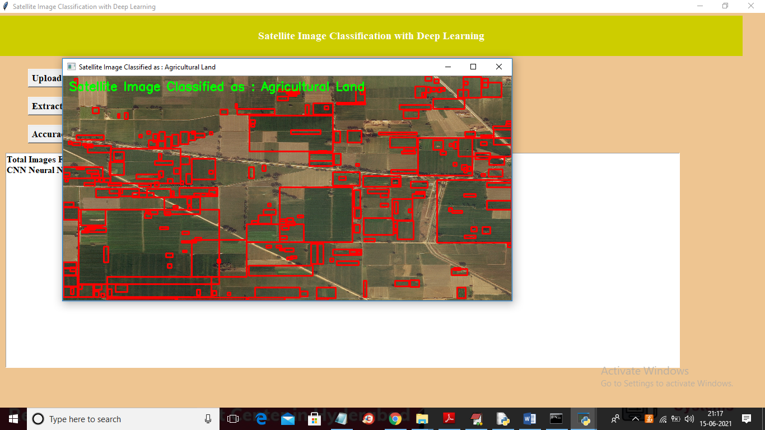

In above screen in green colour text we can see image classified as ‘Agriculture Land’ and all agriculture area is surrounded with red colour bounding boxes. Now upload other image and test

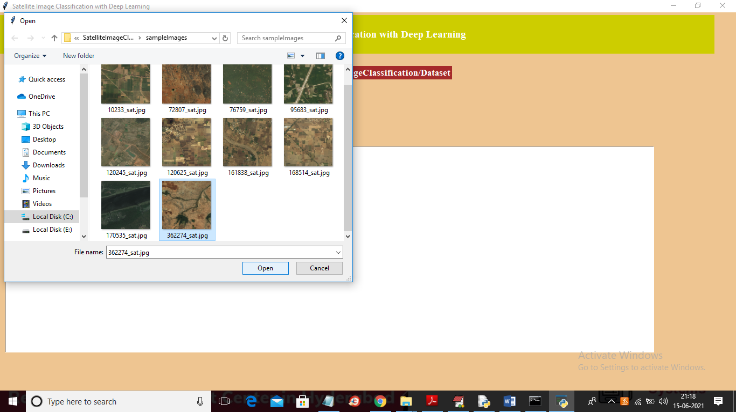

For above selected area below is the classification result

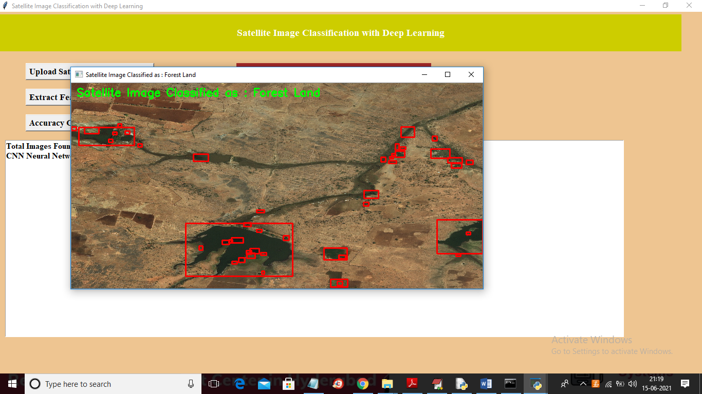

In above screen image classified as ‘Forest Land’ and entire forest area is surrounded with red colour bounding boxes. Similarly you can upload and test remaining images.

Note: dataset size is huge with 63 different classes so I took images with 3 classes and application can classify images correctly up to 80%