**Question1-3**

Last login: Thu Apr 27 10:46:03 on ttys000

(base) suranjanachowdhury@Suranjanas-MacBook-Air ~ % cd documents

(base) suranjanachowdhury@Suranjanas-MacBook-Air documents % vim index.html

(base) suranjanachowdhury@Suranjanas-MacBook-Air documents %

(base) suranjanachowdhury@Suranjanas-MacBook-Air documents % vim index.html

(base) suranjanachowdhury@Suranjanas-MacBook-Air documents % vim index.html

(base) suranjanachowdhury@Suranjanas-MacBook-Air documents % git init Exercise-2

Initialized empty Git repository in /Users/suranjanachowdhury/Documents/Exercise-2/.git/

(base) suranjanachowdhury@Suranjanas-MacBook-Air documents % touch index.html

(base) suranjanachowdhury@Suranjanas-MacBook-Air documents % touch about.html

(base) suranjanachowdhury@Suranjanas-MacBook-Air documents % vim index.html

(base) suranjanachowdhury@Suranjanas-MacBook-Air documents % vim index.html

(base) suranjanachowdhury@Suranjanas-MacBook-Air documents % git add index.html

fatal: not a git repository (or any of the parent directories): .git

(base) suranjanachowdhury@Suranjanas-MacBook-Air documents % git commit -m 'Initial commit'

fatal: not a git repository (or any of the parent directories): .git

(base) suranjanachowdhury@Suranjanas-MacBook-Air documents % git init

Initialized empty Git repository in /Users/suranjanachowdhury/Documents/.git/

(base) suranjanachowdhury@Suranjanas-MacBook-Air documents % git add index.html

(base) suranjanachowdhury@Suranjanas-MacBook-Air documents % git commit -m 'Initial commit'

[main (root-commit) a06e111] Initial commit

1 file changed, 1 insertion(+)

create mode 100644 index.html

(base) suranjanachowdhury@Suranjanas-MacBook-Air documents % git add about.html

(base) suranjanachowdhury@Suranjanas-MacBook-Air documents % git commit -m 'File x addeed'

[main a8cfc4d] File x addeed

1 file changed, 0 insertions(+), 0 deletions(-)

create mode 100644 about.html

(base) suranjanachowdhury@Suranjanas-MacBook-Air documents % cd Exercise 3

cd: string not in pwd: Exercise

(base) suranjanachowdhury@Suranjanas-MacBook-Air documents % mkdir Exercise3

(base) suranjanachowdhury@Suranjanas-MacBook-Air documents % git init

Reinitialized existing Git repository in /Users/suranjanachowdhury/Documents/.git/

(base) suranjanachowdhury@Suranjanas-MacBook-Air documents % touch index.html

(base) suranjanachowdhury@Suranjanas-MacBook-Air documents % vim index.html

(base) suranjanachowdhury@Suranjanas-MacBook-Air documents % git add about.html

(base) suranjanachowdhury@Suranjanas-MacBook-Air documents % git commit --amend -m "Adding index.html and about.html."

[main 78c9724] Adding index.html and about.html.

Date: Thu Apr 27 10:57:20 2023 -0400

1 file changed, 0 insertions(+), 0 deletions(-)

create mode 100644 about.html

(base) suranjanachowdhury@Suranjanas-MacBook-Air documents %

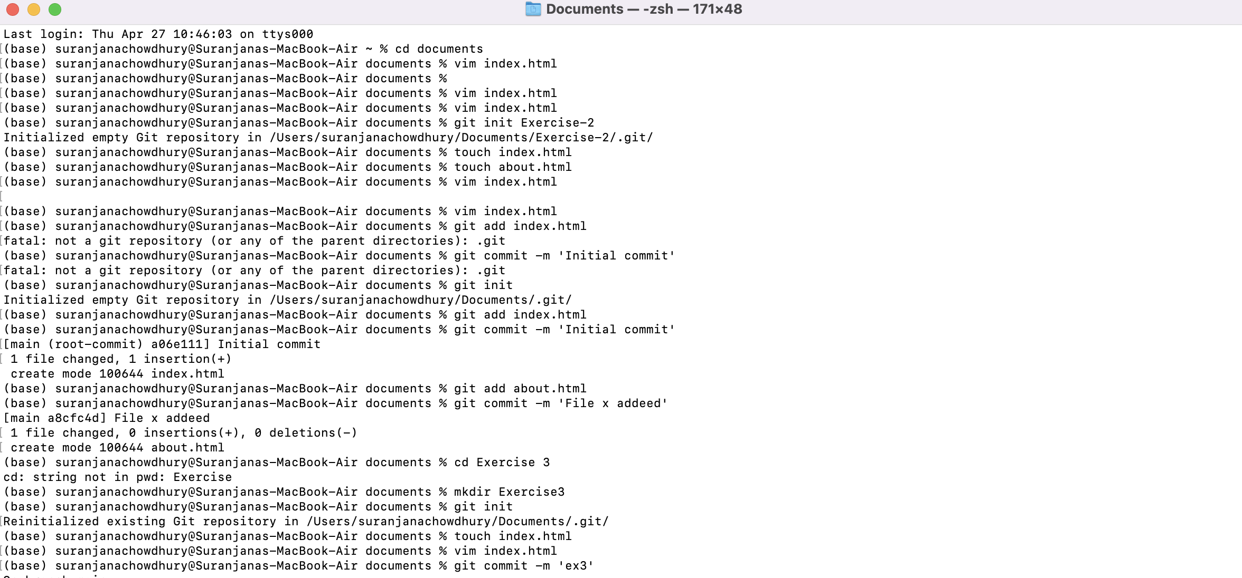

**Question 4**

(base) suranjanachowdhury@Suranjanas-MacBook-Air documents % git init

Reinitialized existing Git repository in /Users/suranjanachowdhury/Documents/.git/

(base) suranjanachowdhury@Suranjanas-MacBook-Air documents % touch .gitignore

(base) suranjanachowdhury@Suranjanas-MacBook-Air documents % vim .gitignore

(base) suranjanachowdhury@Suranjanas-MacBook-Air documents % git add .gitignore

git commit -m "Add .gitignore file to ignore certain files and directories"

[main c58cacb] Add .gitignore file to ignore certain files and directories

1 file changed, 5 insertions(+)

create mode 100644 .gitignore

(base) suranjanachowdhury@Suranjanas-MacBook-Air documents %

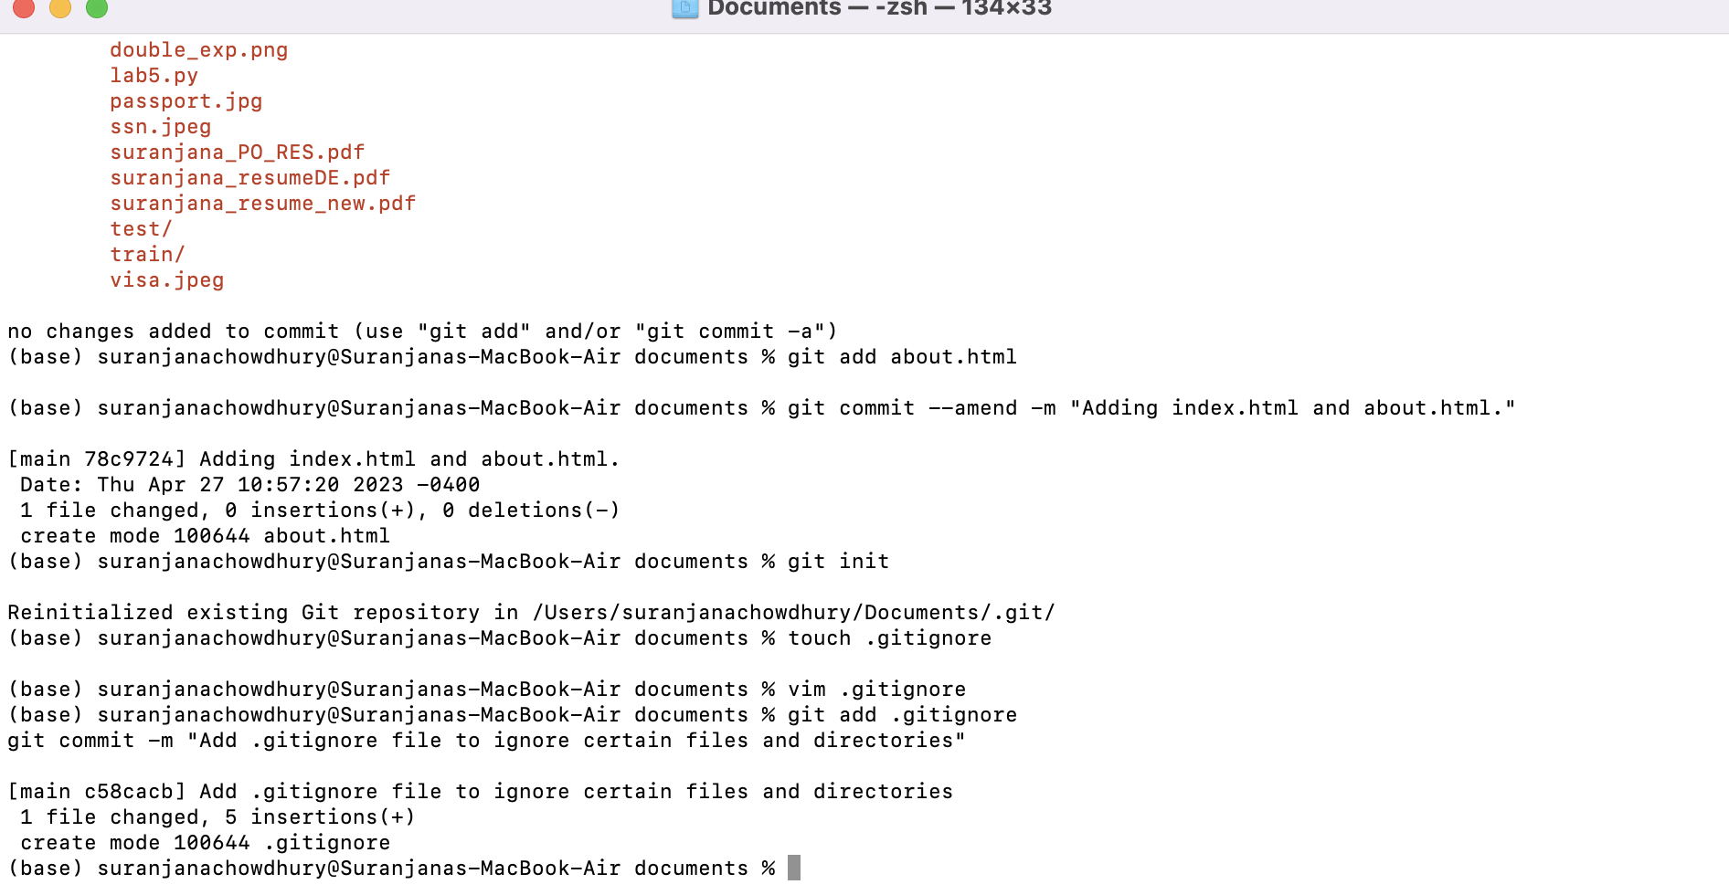

Question 5

(base) suranjanachowdhury@Suranjanas-MacBook-Air documents % mkdir Exercise5

(base) suranjanachowdhury@Suranjanas-MacBook-Air documents % gi init

zsh: command not found: gi

(base) suranjanachowdhury@Suranjanas-MacBook-Air documents % git init

Reinitialized existing Git repository in /Users/suranjanachowdhury/Documents/.git/

(base) suranjanachowdhury@Suranjanas-MacBook-Air documents % touch files.html

(base) suranjanachowdhury@Suranjanas-MacBook-Air documents % vim files.html

(base) suranjanachowdhury@Suranjanas-MacBook-Air documents % git status

On branch main

Changes not staged for commit:

(use "git add <file>..." to update what will be committed)

(use "git restore <file>..." to discard changes in working directory)

modified: index.html

Untracked files:

(use "git add <file>..." to include in what will be committed)

mar/

.DS_Store

.index.html.swo

.localized

ETS.png

Exercise-1/

Exercise-2/

HW2_ml.ipynb

HW2_pa.R

HW4_pred.R

HW_ec 2.R

HW_ec.R

Q1_HW3_OP.png

Q1_spark_op.png

Q2_hw3.py

Q2_hw3_op.png

Q2_spark_op.png

Q3_1.py

Resume_Suranjana_J23.pdf

Resume_suranjana_dev.pdf

Rplot.png

Screen Shot 2023-01-03 at 10.10.33 AM.png

Simple_exp.png

Student Account - Fall 2022.pdf

Unique_innovation.xlsx

arima.png

baker_acf.png

cov letter.pdf

decom_baker.png

double_exp.png

files.html

lab5.py

passport.jpg

ssn.jpeg

suranjana_PO_RES.pdf

suranjana_resumeDE.pdf

suranjana_resume_new.pdf

test/

train/

visa.jpeg

no changes added to commit (use "git add" and/or "git commit -a")

(base) suranjanachowdhury@Suranjanas-MacBook-Air documents % git stash

Saved working directory and index state WIP on main: c58cacb Add .gitignore file to ignore certain files and directories

(base) suranjanachowdhury@Suranjanas-MacBook-Air documents % git status

On branch main

Untracked files:

(use "git add <file>..." to include in what will be committed)

mar/

.DS_Store

.index.html.swo

.localized

ETS.png

Exercise-1/

Exercise-2/

HW2_ml.ipynb

HW2_pa.R

HW4_pred.R

HW_ec 2.R

HW_ec.R

Q1_HW3_OP.png

Q1_spark_op.png

Q2_hw3.py

Q2_hw3_op.png

Q2_spark_op.png

Q3_1.py

Resume_Suranjana_J23.pdf

Resume_suranjana_dev.pdf

Rplot.png

Screen Shot 2023-01-03 at 10.10.33 AM.png

Simple_exp.png

Student Account - Fall 2022.pdf

Unique_innovation.xlsx

arima.png

baker_acf.png

cov letter.pdf

decom_baker.png

double_exp.png

files.html

lab5.py

passport.jpg

ssn.jpeg

suranjana_PO_RES.pdf

suranjana_resumeDE.pdf

suranjana_resume_new.pdf

test/

train/

visa.jpeg

nothing added to commit but untracked files present (use "git add" to track)

(base) suranjanachowdhury@Suranjanas-MacBook-Air documents % git stash list

stash@{0}: WIP on main: c58cacb Add .gitignore file to ignore certain files and directories

(base) suranjanachowdhury@Suranjanas-MacBook-Air documents % git stash apply

On branch main

Changes not staged for commit:

(use "git add <file>..." to update what will be committed)

(use "git restore <file>..." to discard changes in working directory)

modified: index.html

Untracked files:

(use "git add <file>..." to include in what will be committed)

mar/

.DS_Store

.index.html.swo

.localized

ETS.png

Exercise-1/

Exercise-2/

HW2_ml.ipynb

HW2_pa.R

HW4_pred.R

HW_ec 2.R

HW_ec.R

Q1_HW3_OP.png

Q1_spark_op.png

Q2_hw3.py

Q2_hw3_op.png

Q2_spark_op.png

Q3_1.py

Resume_Suranjana_J23.pdf

Resume_suranjana_dev.pdf

Rplot.png

Screen Shot 2023-01-03 at 10.10.33 AM.png

Simple_exp.png

Student Account - Fall 2022.pdf

Unique_innovation.xlsx

arima.png

baker_acf.png

cov letter.pdf

decom_baker.png

double_exp.png

files.html

lab5.py

passport.jpg

ssn.jpeg

suranjana_PO_RES.pdf

suranjana_resumeDE.pdf

suranjana_resume_new.pdf

test/

train/

visa.jpeg

no changes added to commit (use "git add" and/or "git commit -a")

(base) suranjanachowdhury@Suranjanas-MacBook-Air documents %

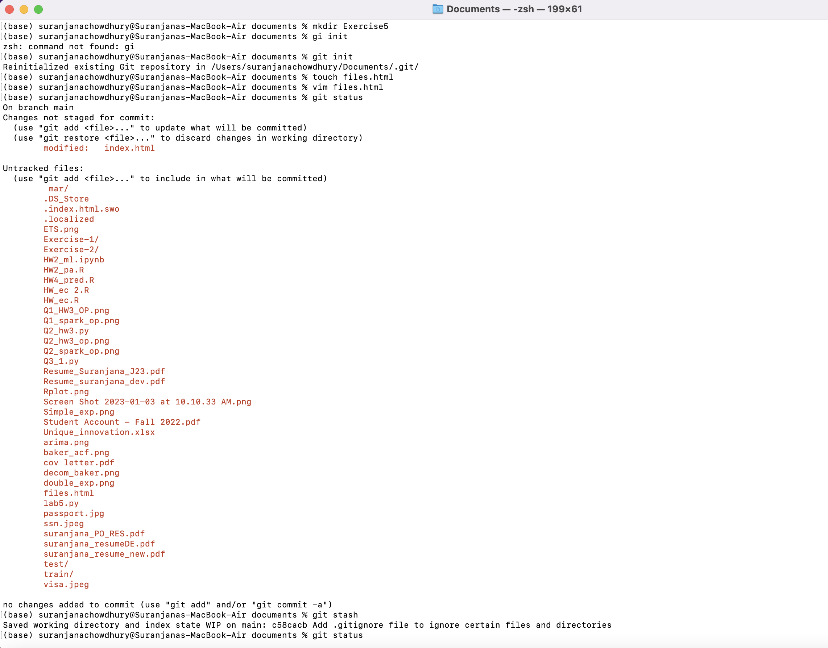

Question 6,7

no changes added to commit (use "git add" and/or "git commit -a")

(base) suranjanachowdhury@Suranjanas-MacBook-Air documents % git log

commit c58cacb6fa2d6fcb99be1e8e0bca9492c8c92852 (**HEAD -> main**)

Author: Suranjana [<su581994@gmail.com](mailto:<su581994@gmail.com)>

Date: Thu Apr 27 15:19:49 2023 -0400

Add .gitignore file to ignore certain files and directories

commit 78c9724da2bfd68213cef0bebc37ce591f97f061

Author: Suranjana [<su581994@gmail.com](mailto:<su581994@gmail.com)>

Date: Thu Apr 27 10:57:20 2023 -0400

Adding index.html and about.html.

commit a06e111f1374f33ff55f46afa75030e7154309c6

Author: Suranjana [<su581994@gmail.com](mailto:<su581994@gmail.com)>

Date: Thu Apr 27 10:56:05 2023 -0400

Initial commit

(base) suranjanachowdhury@Suranjanas-MacBook-Air documents % git reset --soft <commit-hash>

zsh: parse error near `\n'

(base) suranjanachowdhury@Suranjanas-MacBook-Air documents % git reset --soft

(base) suranjanachowdhury@Suranjanas-MacBook-Air documents % git status

On branch main

Changes not staged for commit:

(use "git add <file>..." to update what will be committed)

(use "git restore <file>..." to discard changes in working directory)

modified: index.html

Untracked files:

(use "git add <file>..." to include in what will be committed)

mar/

.DS_Store

.index.html.swo

.localized

ETS.png

Exercise-1/

Exercise-2/

HW2_ml.ipynb

HW2_pa.R

HW4_pred.R

HW_ec 2.R

HW_ec.R

Q1_HW3_OP.png

Q1_spark_op.png

Q2_hw3.py

Q2_hw3_op.png

Q2_spark_op.png

Q3_1.py

Resume_Suranjana_J23.pdf

Resume_suranjana_dev.pdf

Rplot.png

Screen Shot 2023-01-03 at 10.10.33 AM.png

Simple_exp.png

Student Account - Fall 2022.pdf

Unique_innovation.xlsx

arima.png

baker_acf.png

cov letter.pdf

decom_baker.png

double_exp.png

files.html

lab5.py

passport.jpg

ssn.jpeg

suranjana_PO_RES.pdf

suranjana_resumeDE.pdf

suranjana_resume_new.pdf

test/

train/

visa.jpeg

no changes added to commit (use "git add" and/or "git commit -a")

(base) suranjanachowdhury@Suranjanas-MacBook-Air documents % git log

commit c58cacb6fa2d6fcb99be1e8e0bca9492c8c92852 (**HEAD -> main**)

Author: Suranjana [<su581994@gmail.com](mailto:<su581994@gmail.com)>

Date: Thu Apr 27 15:19:49 2023 -0400

Add .gitignore file to ignore certain files and directories

commit 78c9724da2bfd68213cef0bebc37ce591f97f061

Author: Suranjana [<su581994@gmail.com](mailto:<su581994@gmail.com)>

Date: Thu Apr 27 10:57:20 2023 -0400

Adding index.html and about.html.

commit a06e111f1374f33ff55f46afa75030e7154309c6

Author: Suranjana [<su581994@gmail.com](mailto:<su581994@gmail.com)>

Date: Thu Apr 27 10:56:05 2023 -0400

Initial commit

(base) suranjanachowdhury@Suranjanas-MacBook-Air documents % git reset --hard

HEAD is now at c58cacb Add .gitignore file to ignore certain files and directories

(base) suranjanachowdhury@Suranjanas-MacBook-Air documents % git status

On branch main

Untracked files:

(use "git add <file>..." to include in what will be committed)

mar/

.DS_Store

.index.html.swo

.localized

ETS.png

Exercise-1/

Exercise-2/

HW2_ml.ipynb

HW2_pa.R

HW4_pred.R

HW_ec 2.R

HW_ec.R

Q1_HW3_OP.png

Q1_spark_op.png

Q2_hw3.py

Q2_hw3_op.png

Q2_spark_op.png

Q3_1.py

Resume_Suranjana_J23.pdf

Resume_suranjana_dev.pdf

Rplot.png

Screen Shot 2023-01-03 at 10.10.33 AM.png

Simple_exp.png

Student Account - Fall 2022.pdf

Unique_innovation.xlsx

arima.png

baker_acf.png

cov letter.pdf

decom_baker.png

double_exp.png

files.html

lab5.py

passport.jpg

ssn.jpeg

suranjana_PO_RES.pdf

suranjana_resumeDE.pdf

suranjana_resume_new.pdf

test/

train/

visa.jpeg

nothing added to commit but untracked files present (use "git add" to tr

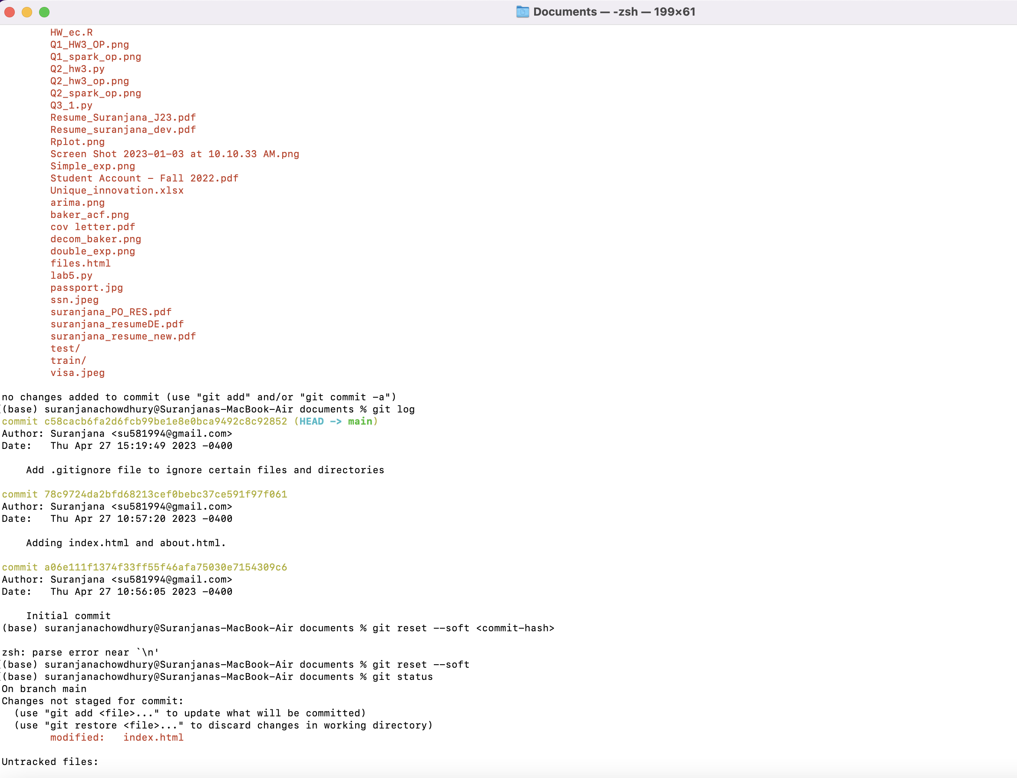

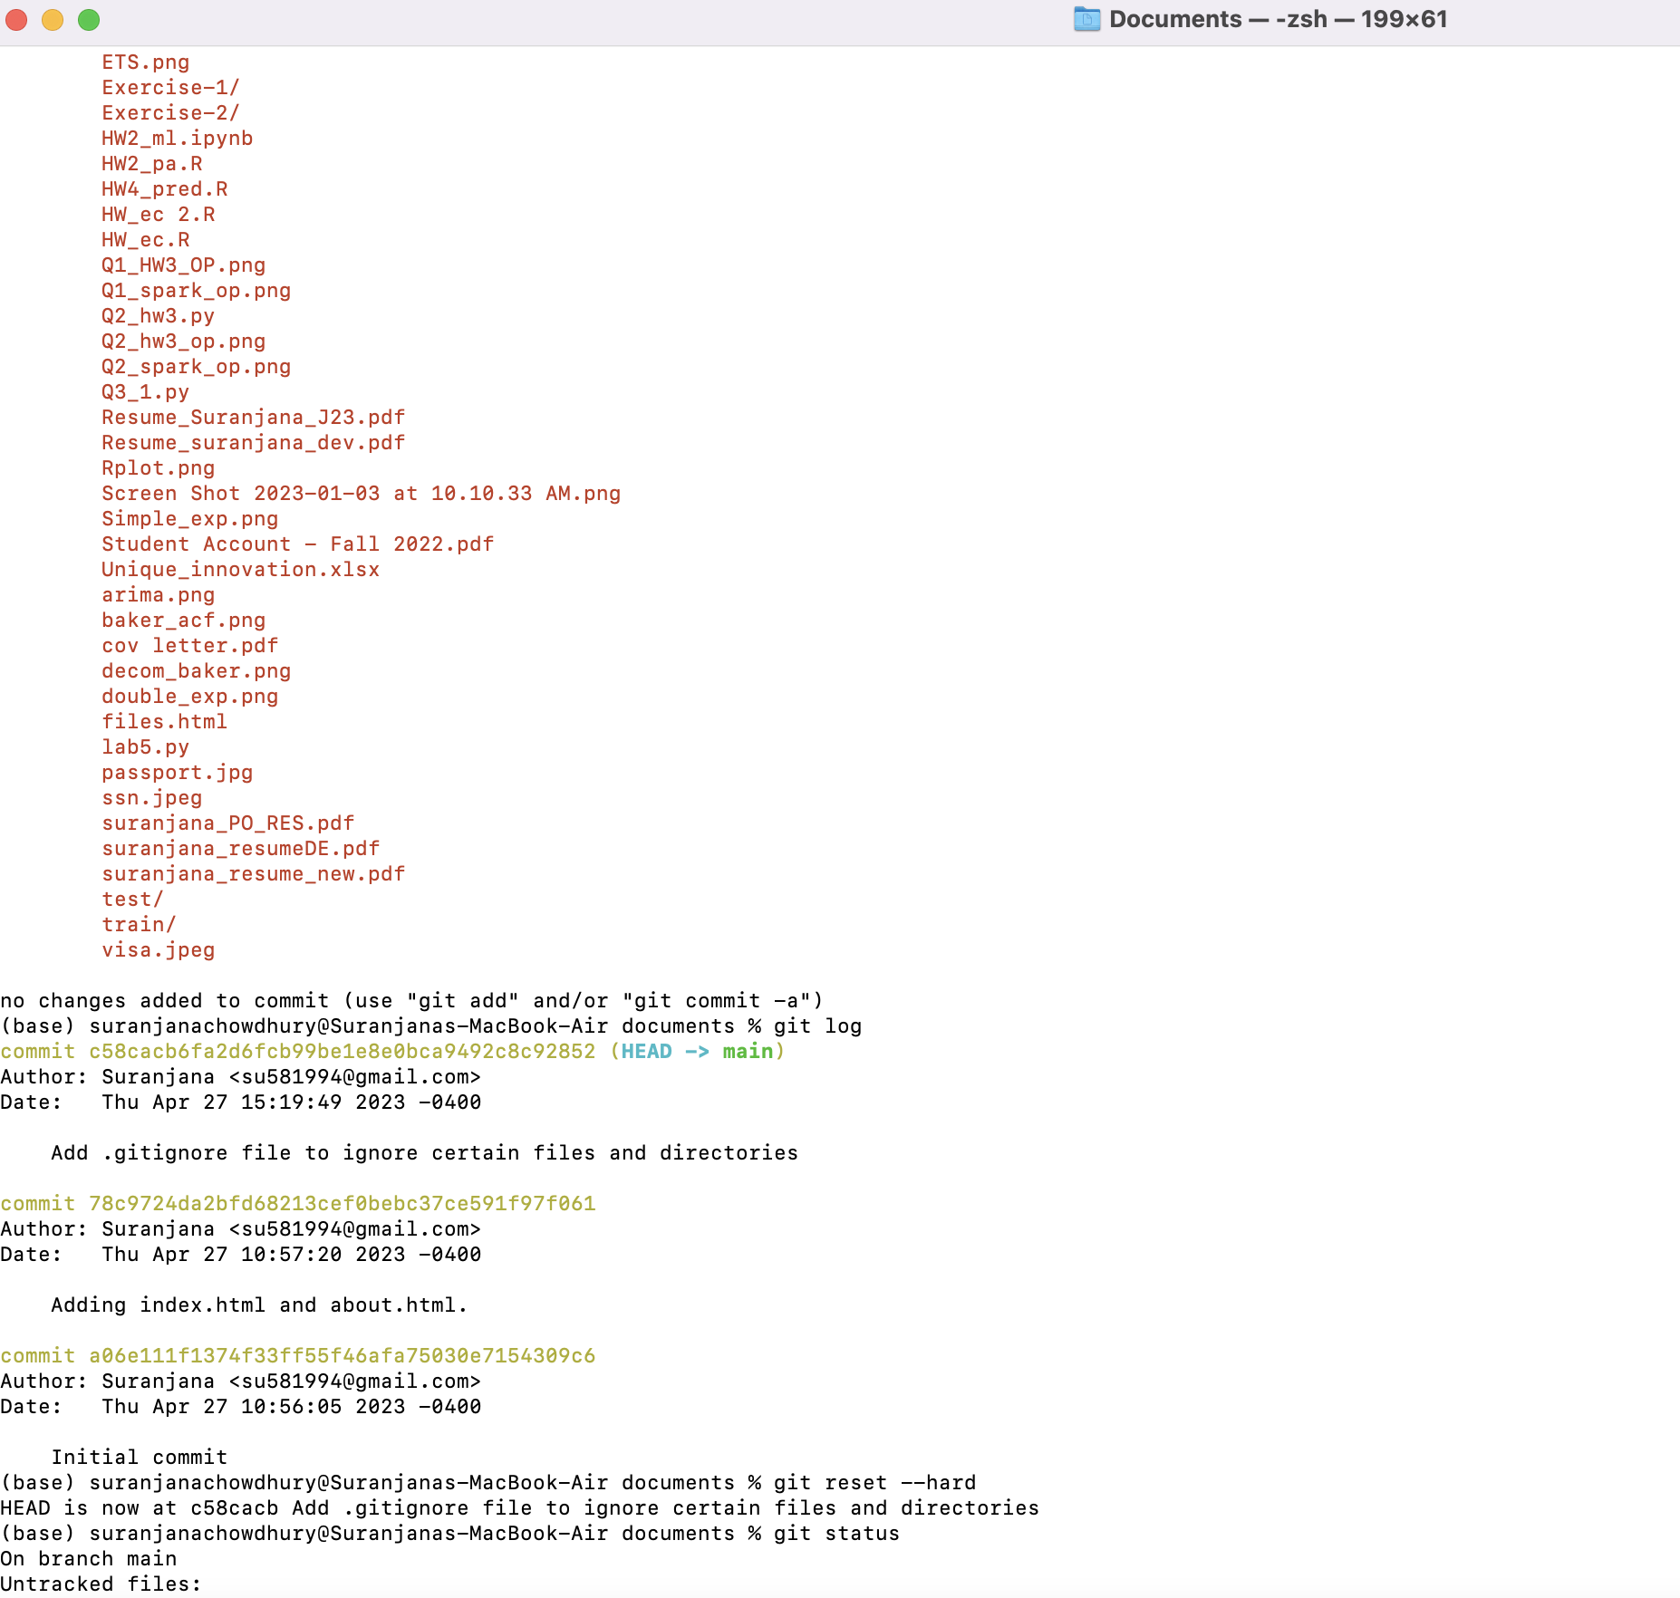

Question 8

base) suranjanachowdhury@Suranjanas-MacBook-Air documents % mkdir Exercise8

(base) suranjanachowdhury@Suranjanas-MacBook-Air documents % git init

Reinitialized existing Git repository in /Users/suranjanachowdhury/Documents/.git/

(base) suranjanachowdhury@Suranjanas-MacBook-Air documents % touch index.html

(base) suranjanachowdhury@Suranjanas-MacBook-Air documents % git add index.html

git commit -m "Add index.html file"

On branch main

Untracked files:

(use "git add <file>..." to include in what will be committed)

mar/

.DS_Store

.index.html.swo

.localized

ETS.png

Exercise-1/

Exercise-2/

HW2_ml.ipynb

HW2_pa.R

HW4_pred.R

HW_ec 2.R

HW_ec.R

Q1_HW3_OP.png

Q1_spark_op.png

Q2_hw3.py

Q2_hw3_op.png

Q2_spark_op.png

Q3_1.py

Resume_Suranjana_J23.pdf

Resume_suranjana_dev.pdf

Rplot.png

Screen Shot 2023-01-03 at 10.10.33 AM.png

Simple_exp.png

Student Account - Fall 2022.pdf

Unique_innovation.xlsx

arima.png

baker_acf.png

cov letter.pdf

decom_baker.png

double_exp.png

files.html

lab5.py

passport.jpg

ssn.jpeg

suranjana_PO_RES.pdf

suranjana_resumeDE.pdf

suranjana_resume_new.pdf

test/

train/

visa.jpeg

nothing added to commit but untracked files present (use "git add" to track)

(base) suranjanachowdhury@Suranjanas-MacBook-Air documents % git checkout -b myfile

Switched to a new branch 'myfile'

(base) suranjanachowdhury@Suranjanas-MacBook-Air documents % touch about-us.html

(base) suranjanachowdhury@Suranjanas-MacBook-Air documents % git add about-us.html

git commit -m "Add about-us.html file to myfile branch"

[myfile 100fc93] Add about-us.html file to myfile branch

1 file changed, 0 insertions(+), 0 deletions(-)

create mode 100644 about-us.html

(base) suranjanachowdhury@Suranjanas-MacBook-Air documents % git checkout master

error: pathspec 'master' did not match any file(s) known to git

(base) suranjanachowdhury@Suranjanas-MacBook-Air documents % git merge myfile

Already up to date.

(base) suranjanachowdhury@Suranjanas-MacBook-Air documents %

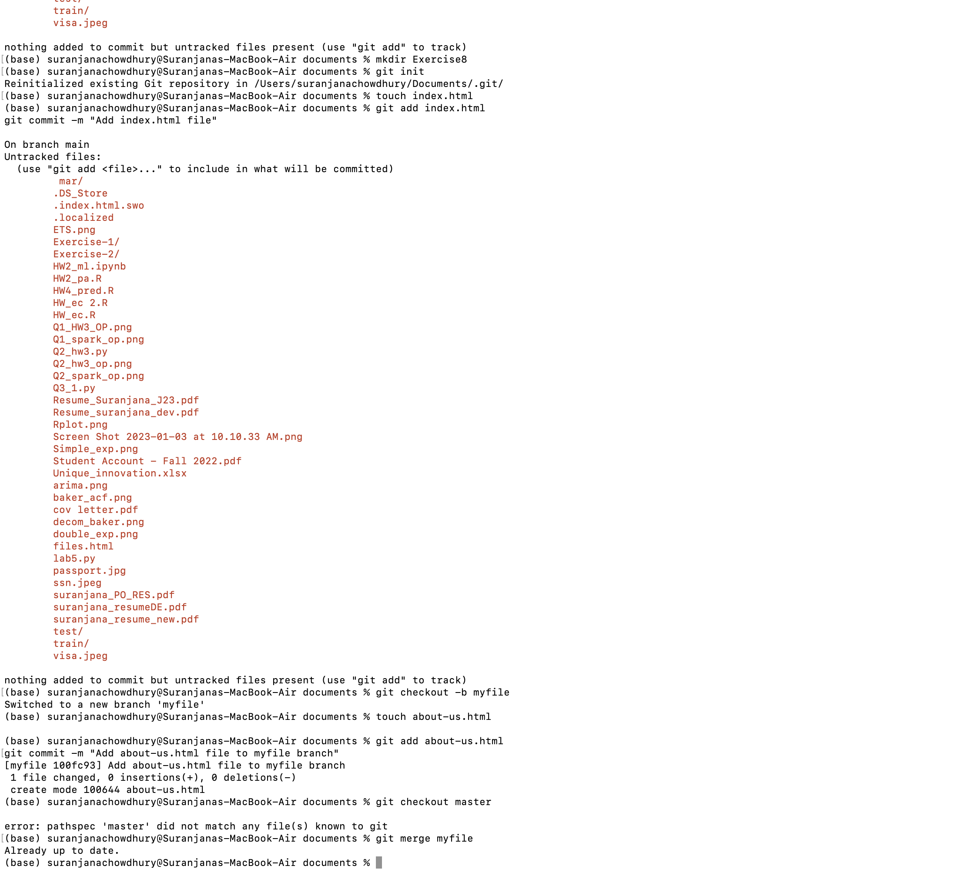

Exercise9

~ % vim index.html

(base) suranjanachowdhury@Suranjanas-MacBook-Air ~ % cd documents

(base) suranjanachowdhury@Suranjanas-MacBook-Air documents % cd Exercise9

(base) suranjanachowdhury@Suranjanas-MacBook-Air Exercise9 % vim index.html

(base) suranjanachowdhury@Suranjanas-MacBook-Air Exercise9 % git add index.html

git commit -m "Update index.html in master branch"

[my-feature 35dd401] Update index.html in master branch

1 file changed, 1 insertion(+)

create mode 100644 Exercise9/index.html

(base) suranjanachowdhury@Suranjanas-MacBook-Air Exercise9 % git merge my-feature

Already up to date.

(base) suranjanachowdhury@Suranjanas-MacBook-Air Exercise9 % git add index.html

(base) suranjanachowdhury@Suranjanas-MacBook-Air Exercise9 % git commit -m "Resolve conflict in index.html file"

On branch my-feature

Untracked files:

(use "git add <file>..." to include in what will be committed)

../ mar/

../.DS_Store

../.index.html.swo

../.localized

../ETS.png

../Exercise-1/

../Exercise-2/

../HW2_ml.ipynb

../HW2_pa.R

../HW4_pred.R

../HW_ec 2.R

../HW_ec.R

../Q1_HW3_OP.png

../Q1_spark_op.png

../Q2_hw3.py

../Q2_hw3_op.png

../Q2_spark_op.png

../Q3_1.py

../Resume_Suranjana_J23.pdf

../Resume_suranjana_dev.pdf

../Rplot.png

../Screen Shot 2023-01-03 at 10.10.33 AM.png

../Simple_exp.png

../Student Account - Fall 2022.pdf

../Unique_innovation.xlsx

../arima.png

../baker_acf.png

../cov letter.pdf

../decom_baker.png

../double_exp.png

../files.html

../index.html.save

../lab5.py

../passport.jpg

../ssn.jpeg

../suranjana_PO_RES.pdf

../suranjana_resumeDE.pdf

../suranjana_resume_new.pdf

../test/

../train/

../visa.jpeg

nothing added to commit but untracked files present (use "git add" to track)

(base) suranjanachowdhury@Suranjanas-MacBook-Air Exercise9 %

