Exercise1

-- Create the Customers table with the specified columns

CREATE TABLE Customers1 (

Cust_ID INTEGER PRIMARY KEY NOT NULL,

Cust_Name VARCHAR(255),

Cust_City VARCHAR(255),

Cust_RoomNo INTEGER,

CheckIn_Time DATETIME

);

-- Insert 5 random data into the table

INSERT INTO Customers1 (Cust_ID, Cust_Name, Cust_City, Cust_RoomNo, CheckIn_Time)

VALUES (1, 'John Smith', 'New York', 101, '2023-04-27 10:30:00'),

(2, 'Jane Doe', 'Los Angeles', 202, '2023-04-27 11:45:00'),

(3, 'Bob Johnson', 'Chicago', 303, '2023-04-27 12:00:00'),

(4, 'Alice Lee', 'Houston', 404, '2023-04-27 13:15:00'),

(5, 'David Kim', 'San Francisco', 505, '2023-04-27 14:30:00');

-- Print the whole table data

SELECT * FROM Customers1;

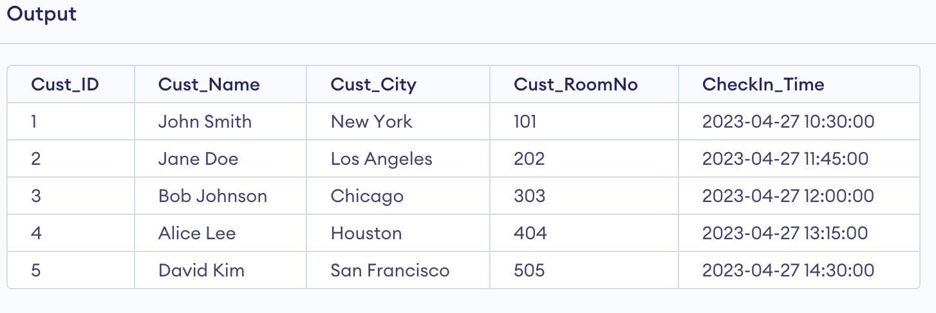

Ran Script that was provided

Exercise2

->SELECT DISTINCT City

FROM Customers1;

SELECT COUNT(DISTINCT City) AS DistinctCityCount

FROM Customers1;

-> SELECT MIN(Quantity) AS LeastQuantity, MAX(Quantity) AS HighestQuantity

FROM Order_details;

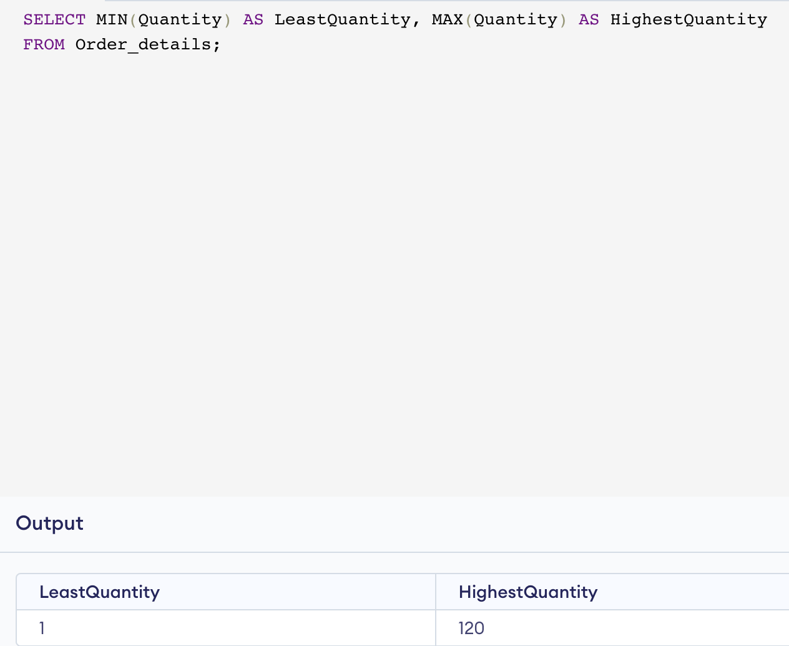

SELECT SUM(Quantity) AS TotalQuantities, AVG(Quantity) AS AvgQuantities

FROM Order_details;

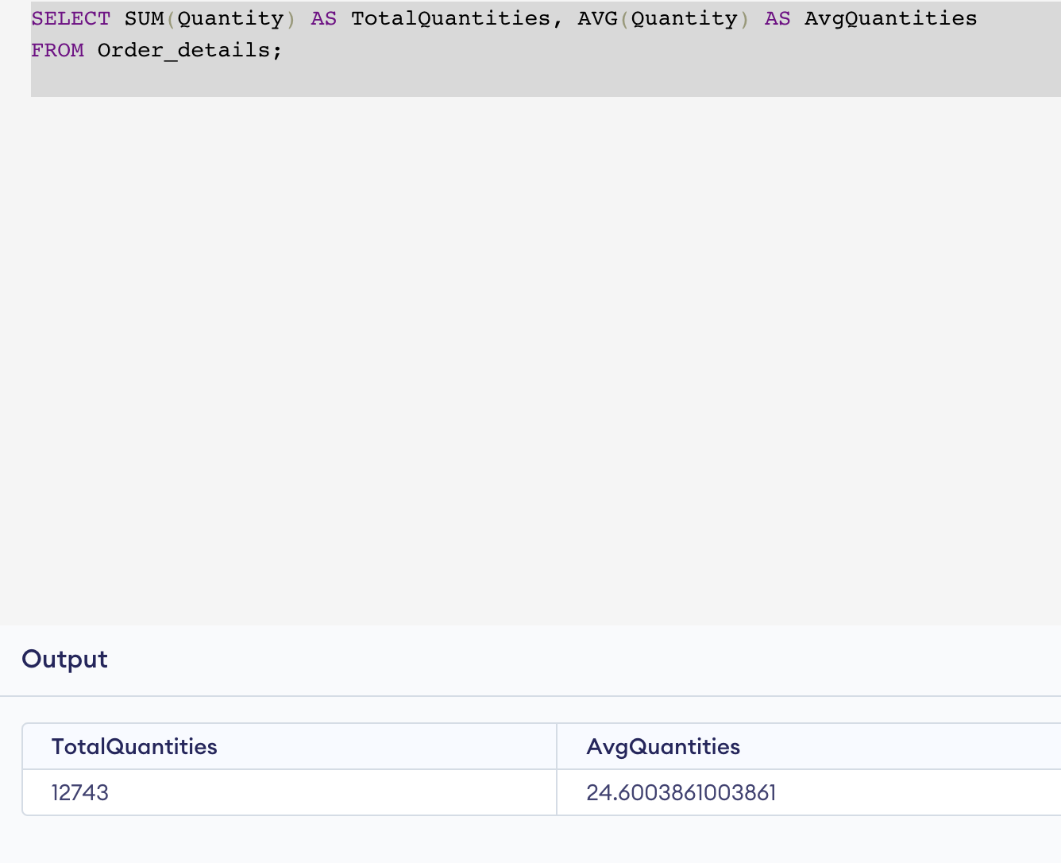

SELECT ProductName FROM Products LIMIT 4, 10;

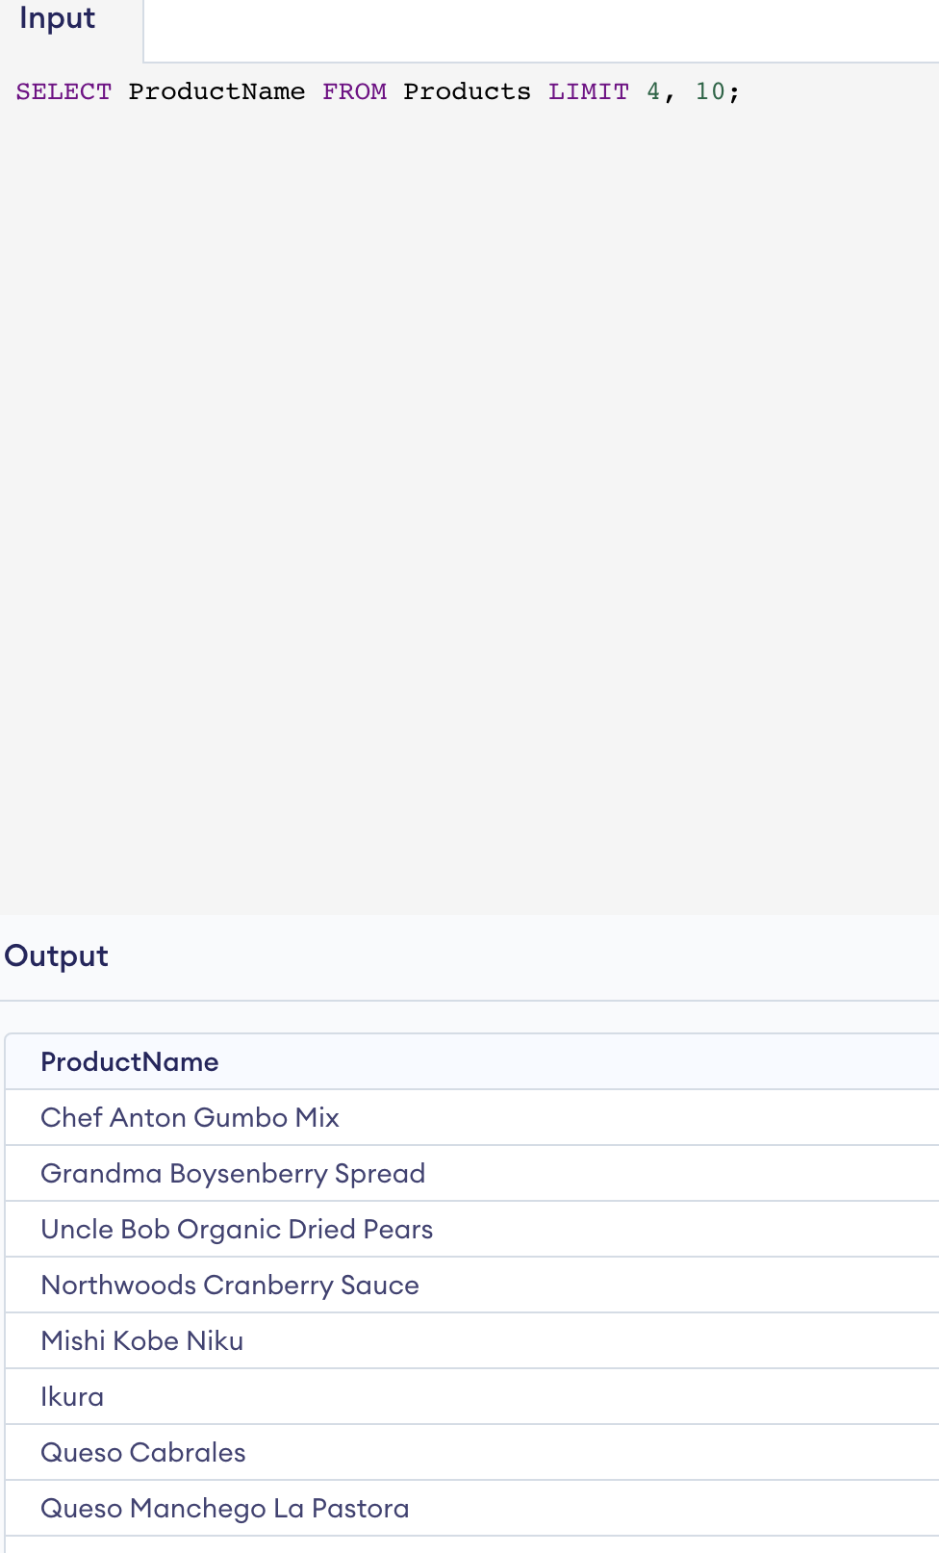

SELECT *

FROM Suppliers

WHERE SupplierName LIKE '_A%';

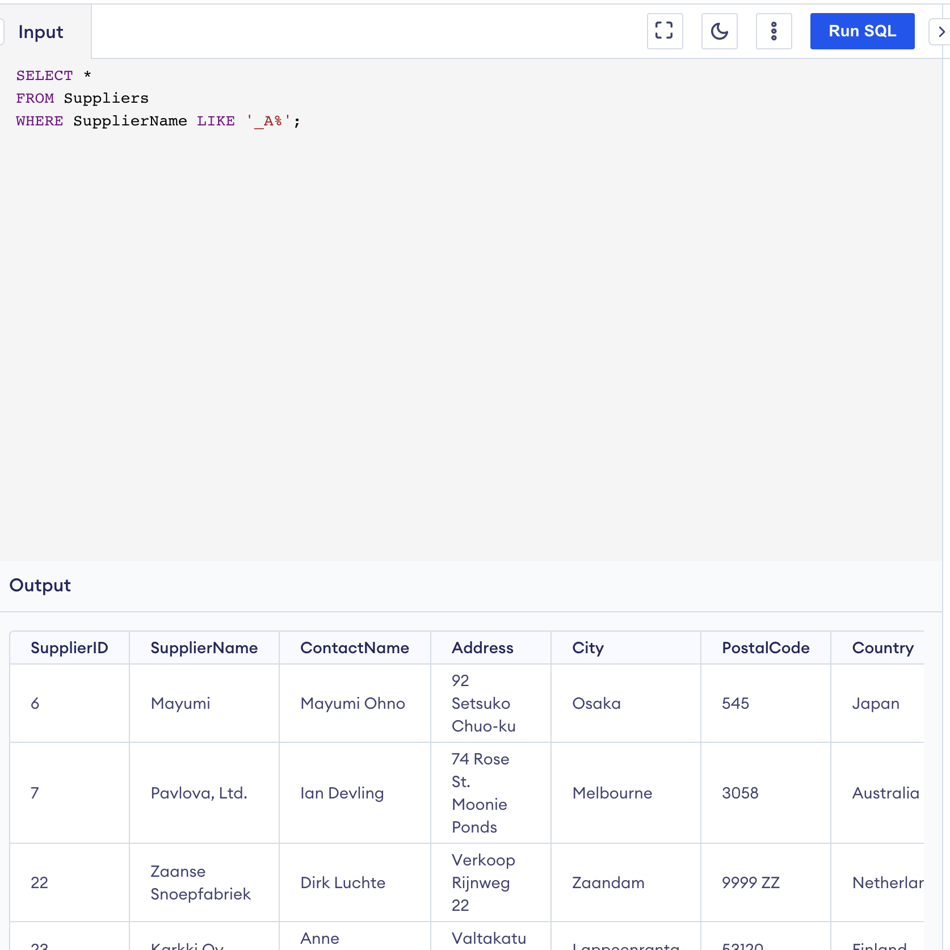

SELECT * FROM Customers

WHERE Country NOT IN ('USA', 'Canada');

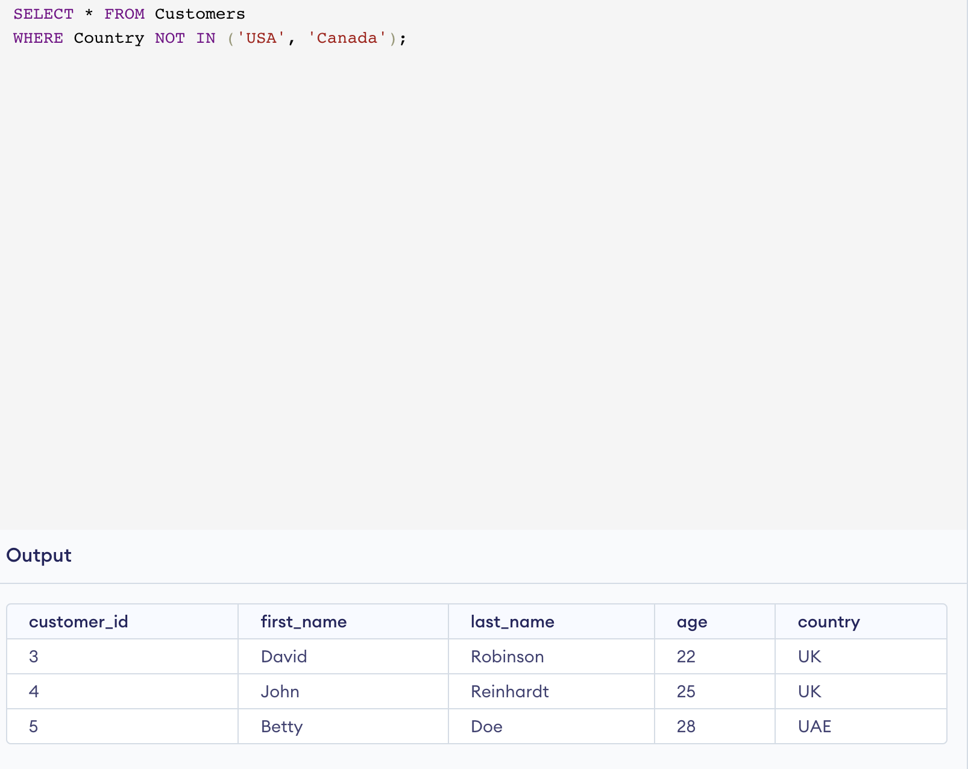

SELECT * FROM orders1

WHERE OrderDate BETWEEN '2020-01-01' AND '2021-12-31'

ORDER BY OrderDate DESC;

SELECT City, COUNT(*) AS Count

FROM Customers1

GROUP BY City;

SELECT *

FROM Employees

WHERE firstName NOT IN ('Sanjay', 'Sonia');

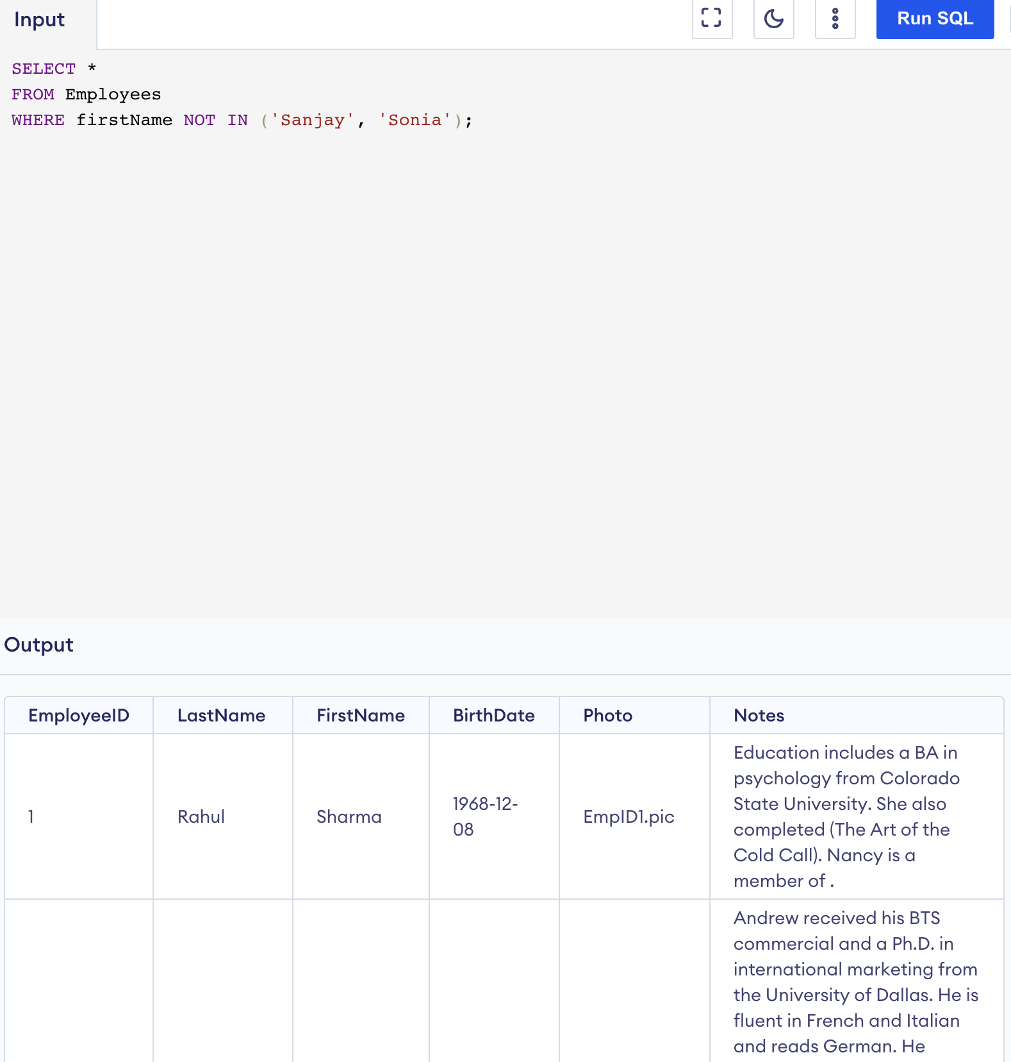

CREATE TABLE SupplierDetail AS

SELECT *

FROM Suppliers;

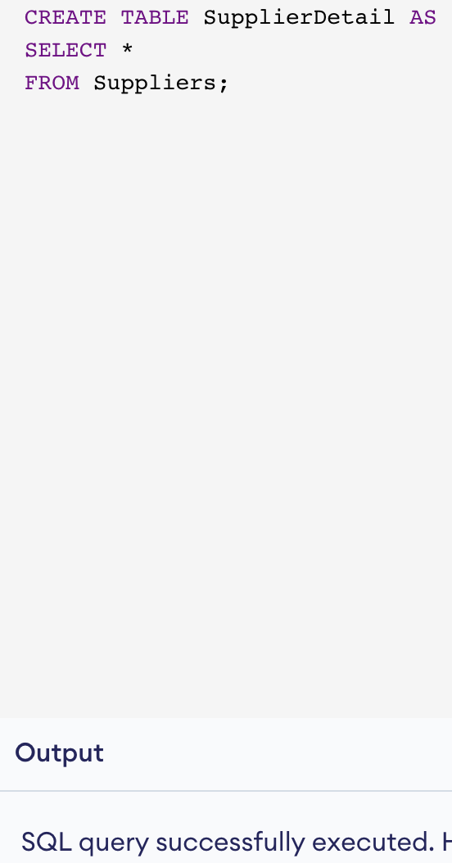

DELETE FROM Customers1 WHERE Country = 'Venezuela';

SELECT * FROM Customers1;

