“Multithreaded Linux Application Using POSIX Threads and Mutexes”
A Project Report submitted in partial fulfillment of the requirements for the award of the degree of

BACHELOR OF TECHNOLOGY
in
DEPARTMENT OF COMPUTER SCIENCE AND ENGINEERING

Course: Operating System and System Programming (25CS2104E)
Team Number: 23

By
Aditya Vallala | 2520090110
Dheeraj Naidu | 2520080067
Surapaneni Karthikeya | 2520080054

Under the Esteemed Guidance of
Raghupathi M
Department of Computer Science and Engineering




K L (Deemed to be) University
DEPARTMENT OF COMPUTER SCIENCE AND ENGINEERING

Declaration
The Project Report entitled “Multithreaded Linux Application Using POSIX Threads and Mutexes” is a record of Bonafide work of ADITYA VALLALA - 2520090110, DHEERAJ NAIDU - 2520080067, SURAPANENI KARTHIKEYA - 2520080054 submitted in partial fulfillment for the award of B.Tech in Computer Science and Engineering to K L (Deemed to be) University. The results embodied in this report have not been copied from any other department / University / Institute.

Aditya Vallala | 2520090110
Dheeraj Naidu | 2520080067
Surapaneni Karthikeya | 2520080054

K L (Deemed to be) University
DEPARTMENT OF COMPUTER SCIENCE AND ENGINEERING

CERTIFICATE
This is to certify that the mini project based report entitled “Multithreaded Linux Application Using POSIX Threads and Mutexes” is a bonafide work done and submitted by Aditya Vallala – 2520090110, Dheeraj Naidu – 2520080067, Surapaneni Karthikeya – 2520080054 in partial fulfillment of the requirements for the award of the degree of BACHELOR OF TECHNOLOGY in the Department of Computer Science and Engineering, K L (Deemed to be University), during the academic year 2026-2027.

Signature of the Guide

Signature of the Course Coordinator Signature of the HOD

ACKNOWLEDGEMENT
The success of this project would not have been possible without the timely help and guidance rendered by many people. We wish to express our sincere thanks to all those who have assisted us in one way or the other in the completion of our project.
Our greatest appreciation goes to our guide, Raghupathi M, Department of Computer Science and Engineering, for his tremendous support, encouragement and guidance throughout this project. We also thank our Course Coordinator for the continuous direction provided during the course Operating System and System Programming (25CS2104E).
We express our gratitude to Dr. P. Venkateshwara Rao, Head of the Department of Computer Science and Engineering, for providing us with adequate facilities, ways and means by which we were able to complete this project-based lab.
We thank all the members of the teaching and non-teaching staff, and everyone who has assisted us directly or indirectly in the successful completion of this project. Finally, we sincerely thank our parents, friends and classmates for their kind help and cooperation during our work.

Aditya Vallala | 2520090110
Dheeraj Naidu | 2520080067
Surapaneni Karthikeya | 2520080054

Abstract
The Multithreaded Linux Application Using POSIX Threads and Mutexes is designed to demonstrate the concepts of concurrent programming in a Linux environment. The application uses POSIX Threads (Pthreads) to execute multiple tasks concurrently, improving responsiveness and resource utilization. Since multiple threads may access shared resources simultaneously, mutexes (mutual exclusion locks) are used to prevent race conditions and maintain data consistency. The project demonstrates thread creation, execution, synchronization, shared-resource management and proper thread termination, and gives a practical understanding of how multithreading and synchronization mechanisms are implemented in Linux using the C programming language.
The application uses a shared file as the common resource. Three threads write fixed-size structured records to the file and a verification phase reads them back, using the Linux file-I/O system calls open, read, write, lseek, pread, fstat, fsync and close, while a mutex protects the shared file offset and the global sequence counter. The project also analyses the file-system abstractions behind these calls: inodes, directory entries, the Virtual File System (VFS) layer and mount points.
The program can be run with the mutex (consistent file) or without it (corrupted file) to demonstrate a race condition. In our test with three threads writing 1000 records each, the mutex version produced a 192,000-byte file with 3000 whole records and unique sequence numbers, whereas the version without the mutex produced duplicate sequence numbers. In summary, the project delivers a small but complete system-programming study that connects thread synchronization with the file-system internals of the operating system.
Keywords: POSIX Threads, Mutex, Race Condition, Critical Section, File Descriptor, Inode, VFS, System Calls, Linux.

Index
S.No. | Chapter | Topics / Subtopics | Page No.
 | Acknowledgement |  | iii
 | Abstract |  | iv
1 | Introduction |  | 1–2
 |  | 1.1 Background of the Project | 1
 |  | 1.2 Problem Statement | 1
 |  | 1.3 Scope of the Project | 1
 |  | 1.4 Objectives of the Project | 2
 |  | 1.5 Importance of the Application | 2
 |  | 1.6 Target Users / Audience | 2
2 | OS Concepts and Background Study |  | 3–5
 |  | 2.1 Operating System Concepts Related to the Project | 3
 |  | 2.2 Existing Methods / Algorithms | 4
 |  | 2.3 Proposed Approach | 4
 |  | 2.4 Advantages of the Proposed Approach | 5
3 | System Requirements |  | 6–7
 |  | 3.1 Hardware Requirements | 6
 |  | 3.2 Software Requirements | 6
 |  | 3.3 Operating System Environment – Ubuntu / WSL | 6
 |  | 3.4 Development Tools and Compilers | 7
4 | Technology and Tools Used |  | 8–9
 |  | 4.1 C Programming | 8
 |  | 4.2 GCC Compiler | 8
 |  | 4.3 Linux System Calls | 8
 |  | 4.4 POSIX Threads / Synchronization | 8
 |  | 4.5 Linux Commands and Utilities | 9
 |  | 4.6 Other Tools / Libraries Used | 9
5 | System Architecture and Design |  | 10–12
 |  | 5.1 Overall System Architecture | 10
 |  | 5.2 System Workflow | 10
 |  | 5.3 Flowchart / Data Flow | 11
 |  | 5.4 Module Description | 11
 |  | 5.5 Input and Output Design | 12
6 | Implementation |  | 13–17
 |  | 6.1 Module-wise Implementation | 13
 |  | 6.2 Algorithm / Pseudocode | 13
 |  | 6.3 Core C Implementation | 13
 |  | 6.4 Linux System Calls / APIs Used | 16
 |  | 6.5 Process / Thread Implementation | 16
 |  | 6.6 IPC / Synchronization Implementation | 17
 |  | 6.7 Memory Management Implementation | 17
 |  | 6.8 Optional User Interface Implementation | 17
7 | Execution and Demonstration |  | 18–20
 |  | 7.1 Compilation in Ubuntu | 18
 |  | 7.2 Execution Commands | 18
 |  | 7.3 Sample Inputs and Outputs | 18
 |  | 7.4 Screenshots of Execution | 19
 |  | 7.5 Demonstration of OS Concepts | 20
8 | Conclusion |  | 21–22
 |  | 8.1 Summary of the Project | 21
 |  | 8.2 Objectives Achieved | 21
 |  | 8.3 Results Achieved | 21
 |  | 8.4 Skills and Learning Outcomes | 21
 |  | 8.5 Limitations and Future Scope | 22
9 | References |  | 23
 |  | 9.1 Books | 23
 |  | 9.2 Research Papers | 23
 |  | 9.3 Linux / GNU Documentation | 23
 |  | 9.4 Online Resources | 23

CHAPTER 1: INTRODUCTION

1.1 Background of the Project
Multithreading is an important concept in modern operating systems that allows a single process to perform multiple tasks concurrently. A thread is a lightweight unit of execution within a process, and multiple threads can share the same memory and resources. This makes multithreading useful for applications that need better performance, responsiveness and efficient CPU utilization.
Linux provides strong support for multithreaded programming through the POSIX Threads (Pthreads) library. Functions such as pthread_create(), pthread_join() and pthread_exit() are used to create, manage and terminate threads. When multiple threads access a common resource, problems such as race conditions can occur. To avoid these problems, the project uses mutexes. A mutex allows only one thread at a time to enter a critical section of code, which ensures that shared data is modified safely and consistently.
In Linux, files are accessed through file descriptors, and the threads of a process share the descriptor table and the file offset. The project therefore lets threads write structured records to one shared file, protected by a mutex, using file-I/O system calls (open, read, write, lseek) that rely on inodes, directory entries, the VFS layer and mount points.

1.2 Problem Statement
When several threads of one process write to the same file, they share a single file descriptor and therefore a single file offset. Without coordination, one thread can move the offset between another thread’s positioning call and its write call, and shared counters such as a sequence number can be updated by two threads at the same time. The result is overwritten, interleaved or duplicated records and a file that cannot be trusted.
The problem addressed in this project is to design and implement a Linux application in C in which multiple POSIX threads safely append structured records to a shared file, to prove the correctness of the result by reading the file back, and to explain, using the operating system’s own file-system abstractions, why the synchronization is necessary.

1.3 Scope of the Project
- Creation and joining of three worker threads using the Pthreads library.
- Protection of the shared file offset and the global sequence counter using one pthread mutex.
- Use of the file-I/O system calls open, read, write, lseek, pread, fstat, fsync and close on a fixed-size binary record format.
- Robust I/O: handling of short reads and writes, EINTR, end-of-file and error return values.
- Study and demonstration of inodes, directory entries (hard links), the VFS layer and mount points using stat, ls -i, ln and findmnt.
- A switch to run the application without the mutex to demonstrate a race condition.
- Out of scope: network I/O, multi-process IPC, graphical interfaces and performance tuning for very large workloads.

1.4 Objectives of the Project
- To demonstrate thread creation, concurrent execution and termination using POSIX threads.
- To demonstrate synchronization with mutexes and the protection of critical sections.
- To show how race conditions occur on a shared file offset and shared counter, and how the mutex removes them.
- To explain and demonstrate inodes, directory entries, the VFS layer and mount points on a real Linux system.
- To apply correct read, write and seek semantics, including random access with pread().
- To read and write structured, fixed-size binary data robustly, with validation and complete error handling.

1.5 Importance of the Application
Concurrent access to shared files is common in logging systems, databases, servers and data-collection tools. A programmer who does not understand how threads share descriptors and offsets will produce intermittent, hard-to-reproduce bugs. This project turns that abstract knowledge into a small, reproducible experiment: the same program yields a clean file with the mutex and a corrupted file without it. The concepts are the foundation of advanced operating-system and concurrent-programming work.

1.6 Target Users / Audience
- Students of operating systems and system programming who need a hands-on view of threads, synchronization and file I/O.
- Instructors who want a compact demonstration of race conditions and their cure.
- Beginner Linux developers learning the system-call interface and the Pthreads API.

CHAPTER 2: OS CONCEPTS AND BACKGROUND STUDY

2.1 Operating System Concepts Related to the Project
Processes and threads
A process owns an address space and a table of open files. A thread is a schedulable unit inside a process; all threads of a process share its code, heap, global variables and file-descriptor table, but each has its own stack and registers. On Linux, Pthreads are implemented as kernel-scheduled tasks created with clone(), so the kernel can run the three workers on different CPU cores at the same time.
Race condition, critical section and mutex
A race condition exists when the result of a computation depends on the relative timing of threads. The code that touches shared state is the critical section. A mutex (mutual exclusion lock) guarantees that at most one thread is inside the critical section: a thread calls pthread_mutex_lock() before entering and pthread_mutex_unlock() on leaving; other threads block until the lock is released. A correct solution needs mutual exclusion, progress and bounded waiting.
File descriptors, open file descriptions and the shared offset
Each process has a file-descriptor (fd) table. An fd entry points to an open file description, which holds the current offset and the open flags, and that in turn points to the inode. Because all threads share the fd table, they share the same open file description and therefore one file offset. Calls such as lseek() followed by write() are two separate steps; if another thread runs between them, the offset is no longer what the first thread set. This is why the mutex is needed.
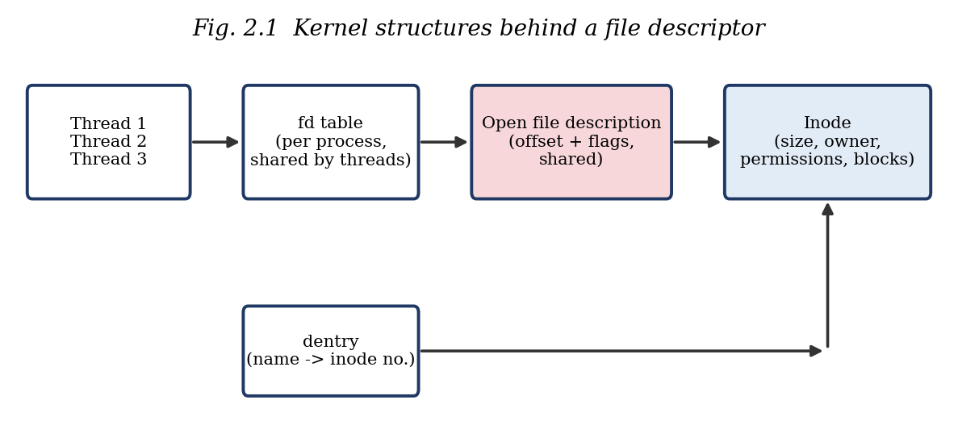
Inode, directory entry, VFS and mount point
Abstraction | Meaning
Inode | Kernel object that stores a file’s metadata: size, owner, permissions, timestamps and block pointers. It has a number but no name. Shown by ls -i, stat, or st_ino from fstat().
Directory entry (dentry) | Maps a file name to an inode number. A directory is a special file made of such entries, and several names (hard links) can point to one inode.
Virtual File System (VFS) | Common layer that makes open, read and write behave the same on ext4, tmpfs, NFS and others, using superblock, inode, dentry and file objects.
Mount point | Directory where a file system is attached to the single directory tree. Path lookup crosses mount points transparently (findmnt, df).

File-I/O system call semantics
- open(path, flags, mode): uses flags such as O_RDWR, O_CREAT, O_TRUNC and O_APPEND; returns a file descriptor, or -1 with errno set.
- read / write: may transfer fewer bytes than requested (a short count); read returns 0 at end of file; -1 with EINTR means the call was interrupted and should be retried.
- lseek(fd, off, whence): SEEK_SET, SEEK_CUR and SEEK_END move the offset without any I/O and enable random access.
- pread / pwrite: read or write at an explicit offset without changing the shared offset.
- fstat, fsync, close: fstat queries the inode, fsync flushes data to disk, close releases the descriptor.

2.2 Existing Methods / Algorithms
Several approaches exist for letting concurrent writers share a file:
Method | Idea | Limitation
Single-threaded writing | Only one thread ever writes. | No concurrency; does not use multiple cores.
O_APPEND | Kernel atomically moves each write to the end of file. | Does not protect shared user-space state such as a sequence counter; no random-access updates.
One file per thread | Each thread owns a private file. | Files must be merged later; ordering information is lost.
pwrite() with pre-assigned slots | Each thread writes to its own offsets. | Requires a coordinated slot allocator, which itself needs synchronization.
File locks (flock / fcntl) | Advisory locks on the file. | Locks are per open file description; heavier than a user-space mutex for threads of one process.
Semaphores / condition variables | Counting or signalling primitives. | More general than needed; a binary mutex expresses the intent directly.

2.3 Proposed Approach
The proposed solution uses one process with three Pthreads and one shared file, data.bin. All threads use the same descriptor. Each thread builds a 64-byte record_t and then enters a short critical section guarded by a single mutex, file_lock. Inside the critical section it assigns the next sequence number, positions the offset at the end of the file with lseek(fd, 0, SEEK_END) and writes the record with write_all(), which retries on short writes and EINTR. After all threads are joined, a verification phase reopens the file and uses fstat() and pread() to check the total size, the magic number of every record and the uniqueness of every sequence number.

2.4 Advantages of the Proposed Approach
- Correctness: every record is whole and every sequence number is unique, and this is checked automatically.
- Simplicity: one mutex and a short critical section keep the design easy to reason about and free of deadlock.
- Random access: fixed-size records place record N at offset N x sizeof(record_t), so pread() can read any record without touching the shared offset.
- Robustness: write_all() and pread_all() handle short counts and EINTR; every return value is checked.
- Teaching value: the --nolock switch makes the race visible, and standard Linux tools (stat, ls -i, findmnt, strace) expose the file-system layers.

CHAPTER 3: SYSTEM REQUIREMENTS

3.1 Hardware Requirements
Component | Requirement
Processor | Intel / AMD Dual-Core or above
RAM | Minimum 4 GB
Storage | Minimum 10 GB free space
Keyboard | Standard keyboard
Display | Standard monitor
Network | Optional

A dual-core processor is recommended so that the three threads can genuinely run in parallel; the program also works on a single core, where the threads are time-sliced.

3.2 Software Requirements
Software | Requirement
Operating System | Linux (Ubuntu recommended)
Programming Language | C
Compiler | GCC
Thread Library | POSIX Threads (Pthreads)
Development Tools | GCC, Make, Text Editor / IDE
Terminal | Linux Terminal
Libraries | pthread.h, standard C libraries
Additional headers | fcntl.h, unistd.h, sys/stat.h, errno.h, stdint.h
File-system inspection tools | strace, stat, ls -i, findmnt, hexdump

3.3 Operating System Environment – Ubuntu / WSL
The project is developed and tested on Ubuntu Linux. Students using Windows can use Ubuntu on Windows Subsystem for Linux (WSL), which provides a real Linux kernel interface with the same system calls. The required tools are installed as follows:
sudo apt update
sudo apt install build-essential strace bsdextrautils util-linux coreutils
# build-essential: gcc, make, libc headers (pthread is part of glibc)
# bsdextrautils: hexdump ; util-linux: findmnt ; coreutils: stat, ls, ln

Note: on WSL, files stored under /mnt/c belong to a Windows file system exposed through a different mount; for the file-system demonstrations (inode numbers, hard links) the project directory should be placed inside the Linux home directory, which is an ext4 file system.

3.4 Development Tools and Compilers
Tool | Purpose
gcc | Compiles app.c; flags -Wall -Wextra enable warnings and -pthread links the Pthreads library.
make | Optional build automation.
gdb / valgrind (helgrind) | Optional debugging and data-race detection.
VS Code / vim / nano | Text editors used to write the source.
strace | Shows the real system calls issued by each thread.

CHAPTER 4: TECHNOLOGY AND TOOLS USED

4.1 C Programming
C is the native language of the Linux kernel and its system-call interface. It gives direct control over memory layout, which is essential here: record_t is a packed, fixed-width structure (uint32_t, uint64_t and a char array) so that every record occupies exactly 64 bytes and record N lives at byte offset N x 64. Fixed-width integer types from stdint.h keep the file layout predictable.

4.2 GCC Compiler
The GNU Compiler Collection is used to build the program. The command gcc -Wall -Wextra -pthread -o app app.c compiles the source with all common warnings enabled and links the Pthreads support. Warnings are treated as a first line of defence against mistakes such as ignored return values or signed/unsigned mismatches.

4.3 Linux System Calls
System call | Use in this project
open() | Create or truncate data.bin with O_RDWR | O_CREAT | O_TRUNC (mode 0644); reopen it read-only for verification.
write() | Append a record; wrapped by write_all() to handle short writes and EINTR.
lseek() | Move the shared file offset to the end of the file (SEEK_END) before each append.
read() / pread() | pread() reads record N at an explicit offset without changing the shared offset; read() returns 0 at end of file.
fstat() | Reads the inode: st_size (checked against 3N x 64) and st_ino (printed).
fsync() | Flushes the written data from the page cache to the disk.
close() | Releases the file descriptor on both normal and error paths.

4.4 POSIX Threads / Synchronization
Pthreads function | Purpose
pthread_create() | Starts a worker thread running worker() with its thread id as argument.
pthread_join() | Waits for a worker to finish; ensures all writes are done before verification.
pthread_exit() / return | Terminates a thread; the workers return NULL when their loop ends.
pthread_mutex_lock() | Enters the critical section; blocks if another thread holds the lock.
pthread_mutex_unlock() | Leaves the critical section and wakes a waiting thread.
pthread_mutex_destroy() | Releases the mutex after all threads are joined.
PTHREAD_MUTEX_INITIALIZER | Static initialization of file_lock.

4.5 Linux Commands and Utilities
Command | What it shows
strace -f ./app | Real openat, lseek, write and read system calls issued by the threads
stat data.bin | Inode number, size, blocks, permissions, timestamps
ls -i data.bin | Inode number linked to the directory entry (name)
ln data.bin link.bin; ls -i | Two names (dentries) share one inode (hard link)
findmnt -T data.bin | Mount point and file-system type that holds the file
hexdump -C data.bin | Structured records: magic, thread_id, seq, msg
./app N --nolock | Race demonstration: corrupted file versus consistent file

4.6 Other Tools / Libraries Used
- stdio.h, stdlib.h, string.h: printf, snprintf, calloc/free, memset, strcmp.
- stdint.h: fixed-width types uint32_t and uint64_t.
- errno.h: errno and EINTR for robust system-call handling.
- sys/stat.h: struct stat and fstat().
- fcntl.h and unistd.h: open flags, read, write, lseek, pread, fsync, close, usleep.

CHAPTER 5: SYSTEM ARCHITECTURE AND DESIGN

5.1 Overall System Architecture
The Linux system runs one main application process. The main thread creates three worker threads. All three share one resource, the file open as data.bin, and access to it is serialized by a mutex. Below the application, the system-call interface passes each request to the VFS layer, which uses the dentry and inode caches, and then to the concrete file system mounted at the file’s mount point (ext4, tmpfs or NFS) and finally to the block device.
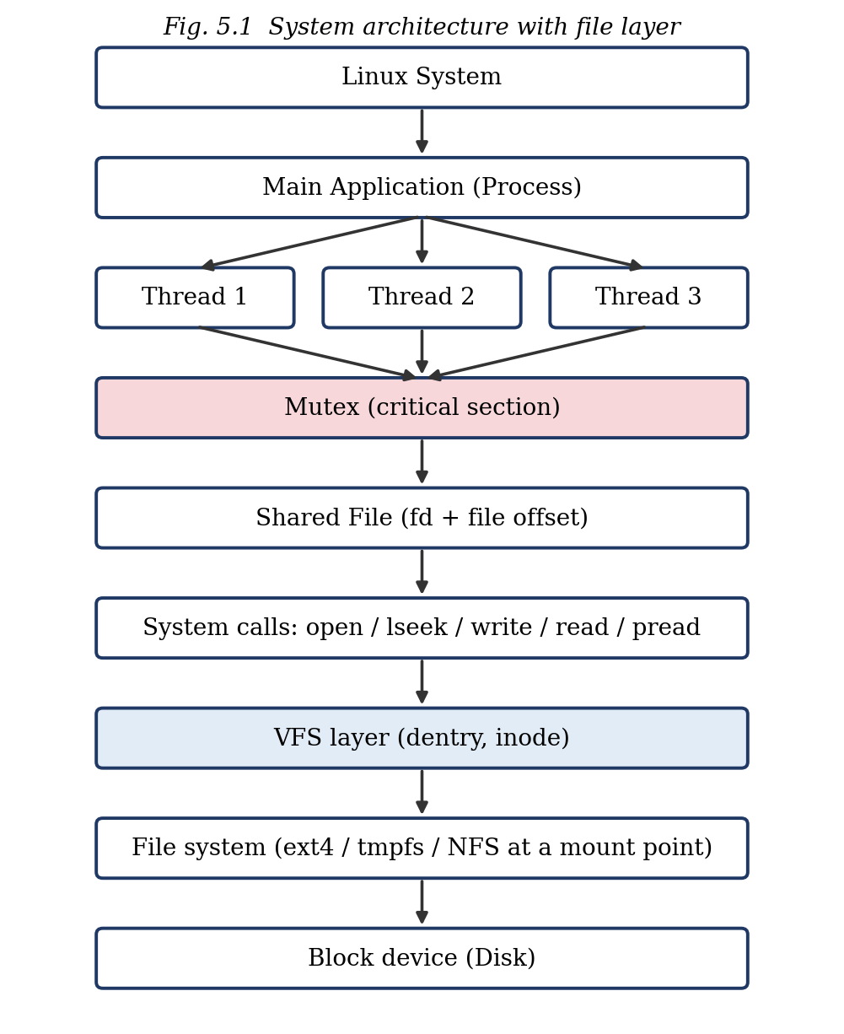

5.2 System Workflow
- main() parses the optional arguments (records per thread and --nolock) and opens data.bin with O_RDWR | O_CREAT | O_TRUNC.
- main() creates three threads; each builds N records and appends them under the mutex.
- pthread_join() waits for all three threads to finish.
- main() calls fsync() and close(fd).
- Verification: the file is reopened; fstat() size must equal 3N x sizeof(record_t); pread() reads every record and checks the magic number and the uniqueness of seq.
- pthread_mutex_destroy() is called and the program prints PASS or FAIL and returns 0 or 1.

5.3 Flowchart / Data Flow
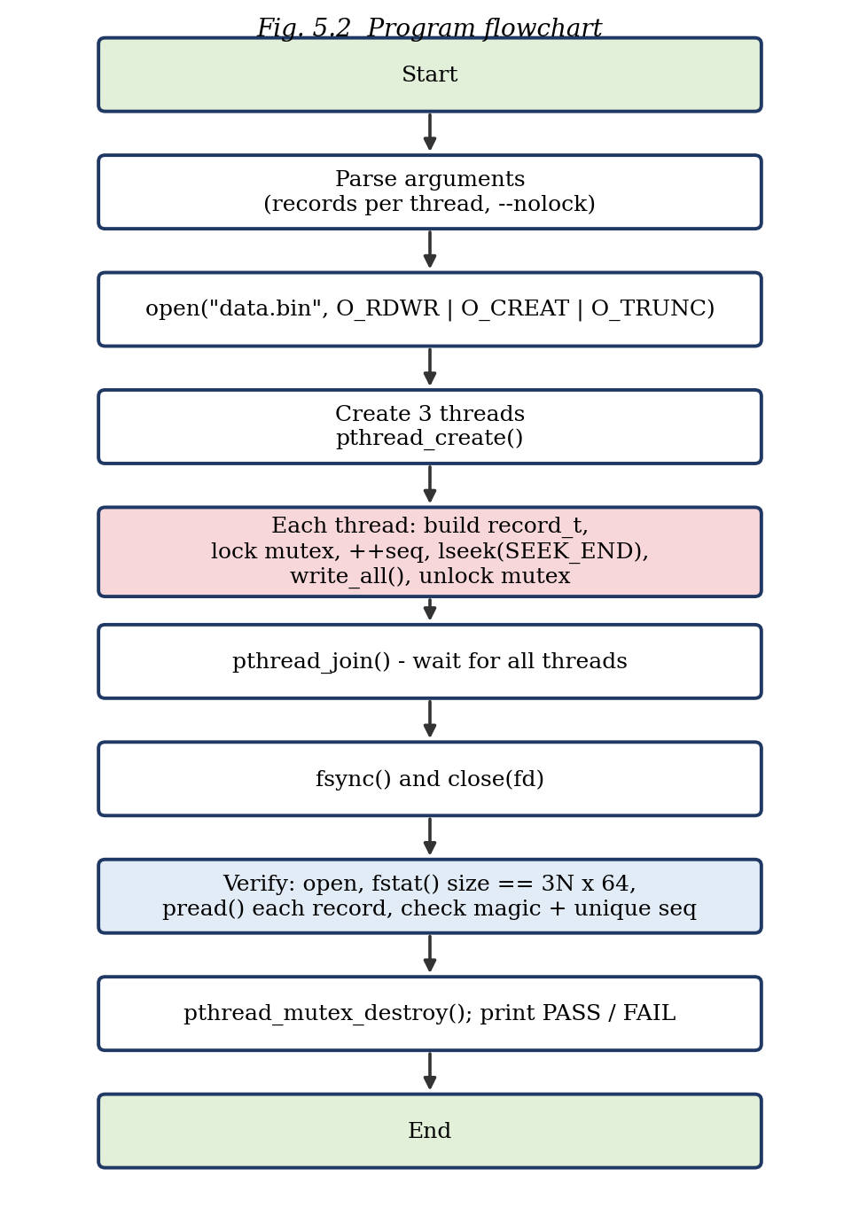
Data flow: each worker creates a record in its own stack memory (no sharing), copies it into the shared file through the single shared descriptor, and only the sequence counter global_seq and the file offset are shared state; both are touched only while the mutex is held.

5.4 Module Description
Module / function | Responsibility
main() | Argument parsing, file open, thread creation and join, fsync/close, call to verify(), mutex destroy.
worker() | Thread function: builds records, takes the mutex, assigns seq, lseek, write_all, releases the mutex.
write_all() | Writes exactly n bytes; loops on short writes and retries on EINTR.
pread_all() | Reads exactly n bytes at a given offset using pread(); stops at end of file.
verify() | Reopens the file, checks size with fstat(), validates magic and uniqueness of every record, reports PASS/FAIL.
file_lock | Global pthread mutex protecting the shared offset and global_seq.

5.5 Input and Output Design
Input
The program is run from the terminal: ./app [records_per_thread] [--nolock]. The default is 100 records per thread with the mutex enabled.
Record layout (output file)
Field | Type | Offset / size | Description
magic | uint32_t | 0 / 4 bytes | 0xCAFEBABE, used to validate a record on read
thread_id | uint32_t | 4 / 4 bytes | Writer thread number (1 to 3)
seq | uint64_t | 8 / 8 bytes | Global sequence number, unique when the mutex is used
msg | char[48] | 16 / 48 bytes | Text such as “record 0 from thread 1”
Total |  | 64 bytes | Record N is stored at offset N x 64

Output
The console shows the mode, the thread count, the record size and the verification result (inode number, file size against the expected size, number of bad-magic, duplicate and out-of-range records, and PASS or FAIL). The binary file data.bin holds the records.

CHAPTER 6: IMPLEMENTATION

6.1 Module-wise Implementation
The program is a single C source file, app.c, organised into the modules described in Section 5.4. The record structure and the two I/O helpers form the data and I/O layer, worker() forms the concurrency layer, and verify() forms the validation layer. The following subsections describe each part; the complete program is listed in Section 6.3.

6.2 Algorithm / Pseudocode
main:
open data.bin (O_RDWR | O_CREAT | O_TRUNC)
for t = 1..3: pthread_create(worker, t)
for t = 1..3: pthread_join(t)
fsync(fd); close(fd)
verify()

worker(t):
repeat N times:
rec = { MAGIC, t, 0, "record i from thread t" }
lock(file_lock)
rec.seq = ++global_seq
lseek(fd, 0, SEEK_END)
write_all(fd, rec, 64)
unlock(file_lock)

verify:
fd2 = open(data.bin, O_RDONLY); fstat(fd2)
size must equal 3 * N * 64
for i in 0..records-1:
pread_all(fd2, rec, 64, i * 64)
check rec.magic == MAGIC
check rec.seq not seen before
print PASS if no error else FAIL

6.3 Core C Implementation
The complete source code of app.c is given below.
/*
* Multithreaded Linux Application Using POSIX Threads and Mutexes
* Shared file: data.bin ; fixed-size records ; mutex protects shared offset
* Build : gcc -Wall -Wextra -pthread -o app app.c
* Run : ./app [records_per_thread] [--nolock]
*/
#include <stdio.h>
#include <stdlib.h>
#include <string.h>
#include <stdint.h>
#include <errno.h>
#include <fcntl.h>
#include <unistd.h>
#include <pthread.h>
#include <sys/stat.h>

#define NTHREADS 3
#define MAGIC 0xCAFEBABEu
#define DATA_FILE "data.bin"

typedef struct {
uint32_t magic; /* 0xCAFEBABE */
uint32_t thread_id;
uint64_t seq;
char msg[48];
} record_t; /* 64 bytes */

static int fd;
static int use_lock = 1;
static int n_per_thread = 100;
static uint64_t global_seq = 0;
static pthread_mutex_t file_lock = PTHREAD_MUTEX_INITIALIZER;

/* write exactly n bytes: handles short counts and EINTR */
static ssize_t write_all(int f, const void *buf, size_t n)
{
const char *p = buf; size_t left = n;
while (left > 0) {
ssize_t w = write(f, p, left);
if (w < 0) { if (errno == EINTR) continue; return -1; }
p += w; left -= (size_t)w;
}
return (ssize_t)n;
}

/* read exactly n bytes at an explicit offset using pread() */
static ssize_t pread_all(int f, void *buf, size_t n, off_t off)
{
char *p = buf; size_t left = n;
while (left > 0) {
ssize_t r = pread(f, p, left, off);
if (r < 0) { if (errno == EINTR) continue; return -1; }
if (r == 0) break; /* end of file */
p += r; left -= (size_t)r; off += r;
}
return (ssize_t)(n - left);
}

static void *worker(void *arg)
{
uint32_t tid = (uint32_t)(uintptr_t)arg;
for (int i = 0; i < n_per_thread; i++) {
record_t rec;
memset(&rec, 0, sizeof rec);
rec.magic = MAGIC;
rec.thread_id = tid;
snprintf(rec.msg, sizeof rec.msg, "record %d from thread %u", i, tid);

if (use_lock) pthread_mutex_lock(&file_lock);
if (use_lock) {
rec.seq = ++global_seq; /* safe: lock is held */
} else {
uint64_t tmp = global_seq; /* read ... */
usleep(1); /* widen race window */
global_seq = tmp + 1; /* ... modify, write */
rec.seq = global_seq; /* lost updates occur */
}
if (lseek(fd, 0, SEEK_END) < 0) perror("lseek");
if (write_all(fd, &rec, sizeof rec) < 0) perror("write");
if (use_lock) pthread_mutex_unlock(&file_lock);
}
return NULL;
}

static int verify(void)
{
int vfd = open(DATA_FILE, O_RDONLY);
if (vfd < 0) { perror("open(verify)"); return -1; }

struct stat st;
if (fstat(vfd, &st) < 0) { perror("fstat"); close(vfd); return -1; }

off_t expected = (off_t)NTHREADS * n_per_thread * (off_t)sizeof(record_t);
long total = st.st_size / (long)sizeof(record_t);
printf("[verify] inode=%lu size=%ld bytes (expected %ld) records=%ld\n",
(unsigned long)st.st_ino, (long)st.st_size, (long)expected, total);

char *seen = calloc((size_t)NTHREADS * n_per_thread + 1, 1);
long bad_magic = 0, dup = 0, out_of_range = 0;
for (long i = 0; i < total; i++) {
record_t r;
if (pread_all(vfd, &r, sizeof r, (off_t)(i * (long)sizeof r)) != (ssize_t)sizeof r)
break;
if (r.magic != MAGIC) { bad_magic++; continue; }
if (r.seq == 0 || r.seq > (uint64_t)NTHREADS * n_per_thread) { out_of_range++; continue; }
if (seen[r.seq]) dup++; else seen[r.seq] = 1;
}
free(seen);
close(vfd);

int ok = (st.st_size == expected) && !bad_magic && !dup && !out_of_range;
printf("[verify] bad_magic=%ld duplicate_seq=%ld out_of_range=%ld -> %s\n",
bad_magic, dup, out_of_range, ok ? "PASS (consistent)" : "FAIL (corrupted)");
return ok ? 0 : 1;
}

int main(int argc, char **argv)
{
for (int i = 1; i < argc; i++) {
if (!strcmp(argv[i], "--nolock")) use_lock = 0;
else n_per_thread = atoi(argv[i]);
}
if (n_per_thread <= 0) n_per_thread = 100;

fd = open(DATA_FILE, O_RDWR | O_CREAT | O_TRUNC, 0644);
if (fd < 0) { perror("open"); return EXIT_FAILURE; }

printf("Mode: %s | threads=%d | records/thread=%d | sizeof(record_t)=%zu\n",
use_lock ? "WITH mutex" : "WITHOUT mutex", NTHREADS, n_per_thread,
sizeof(record_t));

pthread_t th[NTHREADS];
for (long t = 0; t < NTHREADS; t++)
if (pthread_create(&th[t], NULL, worker, (void *)(uintptr_t)(t + 1)) != 0) {
perror("pthread_create"); close(fd); return EXIT_FAILURE;
}
for (int t = 0; t < NTHREADS; t++) pthread_join(th[t], NULL);

if (fsync(fd) < 0) perror("fsync");
close(fd);

int rc = verify();
pthread_mutex_destroy(&file_lock);
return rc;
}

6.4 Linux System Calls / APIs Used
Call | Where | Notes
open(DATA_FILE, O_RDWR|O_CREAT|O_TRUNC, 0644) | main() | Returns fd or -1; perror on failure.
open(DATA_FILE, O_RDONLY) | verify() | Independent descriptor for checking.
lseek(fd, 0, SEEK_END) | worker() | Called inside the critical section.
write(fd, p, left) | write_all() | Loop until all bytes are written.
pread(f, p, left, off) | pread_all() | Explicit offset; does not change the shared offset.
fstat(vfd, &st) | verify() | st_size and st_ino.
fsync(fd) | main() | Flush to disk before verification.
close(fd) | main(), verify() | On every path.
pthread_create / join | main() | Three workers.
pthread_mutex_lock / unlock / destroy | worker(), main() | Protect offset and seq.

6.5 Process / Thread Implementation
The program is one process. main() creates NTHREADS = 3 threads with pthread_create(); the thread id (1 to 3) is passed to each worker through the void pointer argument using a uintptr_t cast, which avoids sharing a loop variable between threads. Each worker returns NULL when its loop finishes, and main() waits for all of them with pthread_join(), so that the file is complete before it is verified. The return value of every pthread_create() call is checked.
Each thread has its own stack, which holds its local record_t. The descriptor fd, the counter global_seq and the mutex are globals and therefore shared by all threads.

6.6 IPC / Synchronization Implementation
Threads of one process communicate through shared memory, so the only coordination needed is mutual exclusion. A single mutex, file_lock, guards two pieces of shared state: the global counter global_seq and the shared file offset used by lseek() and write().
pthread_mutex_lock(&file_lock);
rec.seq = ++global_seq;
lseek(fd, 0, SEEK_END);
write_all(fd, &rec, sizeof rec);
pthread_mutex_unlock(&file_lock);

Without the mutex
When the program is started with --nolock, the increment of global_seq is split into a read, a one-microsecond usleep() and a write, which widens the window in which two threads read the same old value. Two or three threads then store the same sequence number (a lost update). The shared offset is exposed to the same interleaving between lseek() and write(): another thread can move the offset in between, so records can be overwritten or placed at the wrong position. The verification phase detects this as duplicate sequence numbers and reports FAIL.
With the mutex
With the mutex, lock/unlock make the sequence assignment, the positioning and the write one indivisible step. Every record is whole, the file size is exactly 3N x 64 bytes and the sequence numbers are unique. The critical section is kept short (no printing, no waiting) and there is only one lock, so deadlock is impossible.

6.7 Memory Management Implementation
- Stack: each thread’s record_t (64 bytes) and loop variables live on its own stack.
- Globals (data segment): fd, use_lock, n_per_thread, global_seq and file_lock are shared by all threads.
- Heap: verify() allocates a byte map with calloc((size_t)NTHREADS * n_per_thread + 1, 1) to remember which sequence numbers have been seen, and releases it with free() before returning.
- Structure layout: with uint32_t, uint32_t, uint64_t and char[48] the natural alignment gives exactly 64 bytes with no padding, which is printed at run time with sizeof(record_t).
- memset() clears each record before it is filled so that no uninitialised bytes (such as stack garbage after the message) are written to the file.

6.8 Optional User Interface Implementation
The application uses a command-line interface. The user supplies the number of records per thread and an optional --nolock switch, and the program prints a mode banner and a verification report. No graphical interface is required for the objectives of the project.

CHAPTER 7: EXECUTION AND DEMONSTRATION

7.1 Compilation in Ubuntu
gcc -Wall -Wextra -pthread -o app app.c

The program compiles without warnings. The -pthread flag enables Pthreads support in both the compiler and the linker.

7.2 Execution Commands
./app 1000 # with mutex (expected: PASS)
./app 1000 --nolock # without mutex (expected: FAIL)
strace -f ./app 3 # system calls issued by the threads
stat data.bin # inode, size, blocks, permissions, timestamps
ls -i data.bin # inode number of the directory entry
ln data.bin link.bin; ls -i data.bin link.bin # hard link
findmnt -T data.bin # mount point and file-system type
hexdump -C data.bin | head

7.3 Sample Inputs and Outputs
The outputs below were produced by running the program in an Ubuntu Linux environment (ext4 file system).
Run with the mutex
Mode: WITH mutex | threads=3 | records/thread=1000 | sizeof(record_t)=64
[verify] inode=573505 size=192000 bytes (expected 192000) records=3000
[verify] bad_magic=0 duplicate_seq=0 out_of_range=0 -> PASS (consistent)
Run without the mutex (race demonstration)
Mode: WITHOUT mutex | threads=3 | records/thread=1000 | sizeof(record_t)=64
[verify] inode=573505 size=192000 bytes (expected 192000) records=3000
[verify] bad_magic=0 duplicate_seq=1999 out_of_range=0 -> FAIL (corrupted)

The expected size is 3 x 1000 x 64 = 192,000 bytes. In the run without the mutex, the sequence counter suffered lost updates, so 1999 of the 3000 records carry a sequence number that had already been used: the file looks complete, but its contents are inconsistent. The exact number of duplicates varies from run to run, which is typical of a race condition.
File-system inspection
$ stat data.bin
File: data.bin
Size: 192000 Blocks: 376 IO Block: 4096 regular file
Device: 254,0 Inode: 573505 Links: 1
Access: (0644/-rw-r--r--) Uid: ( 0/ root) Gid: ( 0/ root)
Access: 2026-10-07 03:04:44.686498658 +0000
Modify: 2026-10-07 03:04:44.683756998 +0000
Change: 2026-10-07 03:04:44.683756998 +0000
Birth: 2026-10-07 03:04:20.867756020 +0000
$ ls -i data.bin
573505 data.bin
$ ln data.bin link.bin; ls -i data.bin link.bin
573505 data.bin
573505 link.bin
$ findmnt -T data.bin
TARGET SOURCE FSTYPE OPTIONS
/ /dev/vda ext4 rw,relatime,discard,no_prefetch_block

stat shows the inode number (573505), the size (192,000 bytes) and the permissions (0644). After ln, ls -i shows that data.bin and link.bin have the same inode number: two directory entries point to one inode. findmnt shows that the file lives on the ext4 file system mounted at /.
Contents of data.bin (first record)
000000 be ba fe ca 01 00 00 00 01 00 00 00 00 00 00 00 |................|
000010 72 65 63 6f 72 64 20 30 20 66 72 6f 6d 20 74 68 |record 0 from th|
000020 72 65 61 64 20 31 00 00 00 00 00 00 00 00 00 00 |read 1..........|
000030 00 00 00 00 00 00 00 00 00 00 00 00 00 00 00 00 |................|

The bytes be ba fe ca are the magic number 0xCAFEBABE stored in little-endian order, followed by thread_id = 1 and seq = 1, and then the message text.

7.4 Screenshots of Execution
Insert the screenshots captured on your own system in the boxes below (replace the placeholder boxes).
[ Paste screenshot here ]
Fig. 7.1 Compilation and execution with the mutex (PASS)
[ Paste screenshot here ]
Fig. 7.2 Execution without the mutex (FAIL – duplicate sequence numbers)
[ Paste screenshot here ]
Fig. 7.3 strace -f ./app showing openat, lseek, write and read system calls
[ Paste screenshot here ]
Fig. 7.4 stat, ls -i, hard link and findmnt output
[ Paste screenshot here ]
Fig. 7.5 hexdump -C data.bin showing the structured records

7.5 Demonstration of OS Concepts
Topic | Where it is demonstrated
Inodes and directory entries | stat, ls -i and the hard-link demo (data.bin and link.bin share inode 573505)
Virtual file system layer | Same open/read/write calls work on any file system; architecture with file layer (Fig. 5.1)
Mount points | findmnt -T data.bin shows the mount point and type
Read / write / seek semantics | Shared fd table and offset, short counts, lseek(SEEK_END), pread() in verify()
File-I/O system calls | strace -f ./app and the Threads, Mutex and File I/O design
Structured data, robustly | record_t, write_all(), pread_all(), EINTR handling, magic validation
Thread creation and termination | pthread_create() and pthread_join() in main()
Mutual exclusion | PASS with the mutex, FAIL without it

CHAPTER 8: CONCLUSION

8.1 Summary of the Project
The Multithreaded Linux Application Using POSIX Threads and Mutexes successfully demonstrates the fundamental concepts of multithreaded programming in Linux. The project shows how multiple threads can execute concurrently and how POSIX Threads can be used to create and manage them. The use of mutexes provides safe access to shared resources and prevents race conditions and data inconsistency.
The project also demonstrates the file-system side of the operating system: inodes, directory entries, the VFS layer and mount points, the semantics of file descriptors and of read, write and seek, and robust reading and writing of structured data with proper error handling.

8.2 Objectives Achieved
- Three threads were created, ran concurrently and were joined correctly.
- The shared offset and sequence counter were protected by a mutex.
- A race condition was demonstrated with --nolock and eliminated with the mutex.
- Inodes, directory entries, hard links and mount points were shown with real commands.
- Fixed-size binary records were written and read back with robust, error-checked I/O.

8.3 Results Achieved
Metric (3 threads x 1000 records) | With mutex | Without mutex
File size (expected 192,000 bytes) | 192,000 bytes | 192,000 bytes
Records read back | 3000 | 3000
Records with bad magic | 0 | 0
Duplicate sequence numbers | 0 | 1999 (varies per run)
Verification result | PASS (consistent) | FAIL (corrupted)

8.4 Skills and Learning Outcomes
- Creating, joining and terminating threads with the Pthreads API.
- Identifying critical sections and protecting them with a mutex.
- Understanding the relationship between the fd table, the open file description, the inode and the shared file offset.
- Using system calls directly and handling short counts, EINTR and error codes.
- Inspecting the file system with stat, ls -i, ln, findmnt, strace and hexdump.
- Writing a verification routine that proves the correctness of a concurrent program.

8.5 Limitations and Future Scope
- The race without the mutex is made visible with a deliberate usleep(); on some systems the unprotected version may pass on a given run, which is itself characteristic of races.
- A single global mutex serializes all writers; a future version could use a lock-free slot allocator with pwrite() so that threads write in parallel.
- The project could be extended with a producer–consumer queue (condition variables or semaphores), reader–writer locks, a variable number of threads and performance measurements.
- Tools such as valgrind --tool=helgrind or ThreadSanitizer (-fsanitize=thread) can be added to detect data races automatically.

CHAPTER 9: REFERENCES

9.1 Books
- A. Silberschatz, P. B. Galvin and G. Gagne, Operating System Concepts, Wiley.
- M. Kerrisk, The Linux Programming Interface, No Starch Press, 2010.
- W. R. Stevens and S. A. Rago, Advanced Programming in the UNIX Environment, Addison-Wesley.
- D. R. Butenhof, Programming with POSIX Threads, Addison-Wesley, 1997.
- R. Love, Linux System Programming, O’Reilly Media.
- A. S. Tanenbaum and H. Bos, Modern Operating Systems, Pearson.

9.2 Research Papers
- E. W. Dijkstra, “Solution of a Problem in Concurrent Programming Control,” Communications of the ACM, vol. 8, no. 9, 1965.
- S. R. Kleiman, “Vnodes: An Architecture for Multiple File System Types in Sun UNIX,” USENIX Summer Conference, 1986.

9.3 Linux / GNU Documentation
- Linux manual pages: open(2), read(2), write(2), lseek(2), pread(2), fstat(2), fsync(2), close(2).
- Linux manual pages: pthreads(7), pthread_create(3), pthread_join(3), pthread_mutex_lock(3).
- Linux manual pages: inode(7), path_resolution(7), mount(8), findmnt(8), strace(1).
- GNU Compiler Collection (GCC) documentation, https://gcc.gnu.org/onlinedocs/.
- The GNU C Library (glibc) Reference Manual, https://www.gnu.org/software/libc/manual/.

9.4 Online Resources
- Linux kernel documentation, “Overview of the Linux Virtual File System,” https://docs.kernel.org/filesystems/vfs.html.
- The Open Group, POSIX.1 (IEEE Std 1003.1) Base Specifications, https://pubs.opengroup.org/onlinepubs/9699919799/.
- Linux man-pages project, https://man7.org/linux/man-pages/.

