**Mobile Doctor**

**Praveen Kumar Surapaneni**

**Uma Maheshwararao Kothuri**

**Vinod Kumar Vakalapudi**

**Venkata Reddy Guttikonda**

**James Dowling**

**Dheeraj Polisetty**

**Application Overview:**

Our Applications is a suggestion algorithm where we will be suggesting the user about the particular drug’s effectiveness based on the health conditions he faced during his life and, In addition to that our algorithm will rate all the available drugs for the particular health condition and suggest them to the user. Our App is somewhat similar to Watson User modelling Demo where a HR based on requirement searches for a developer and the HR gets all the suggestions in the percentage model and here in our APP users searches a drug for a particular health condition he is facing right now our App will suggest all the drugs based on their effectiveness score given by our algorithm.

Representational Figure

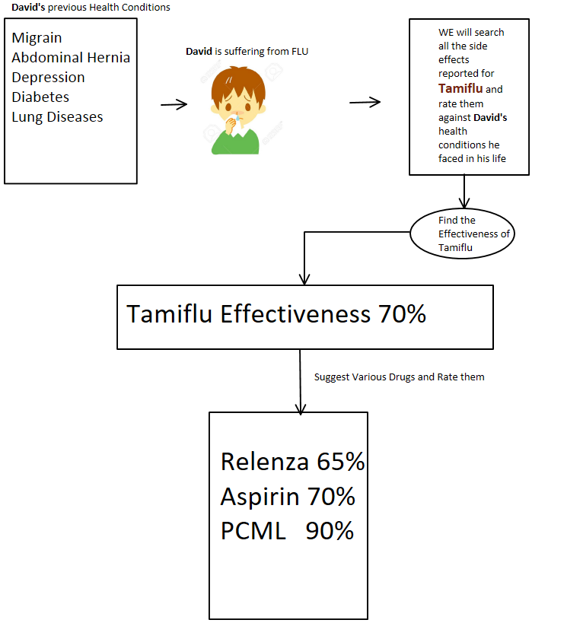

**Summary:**

For the current iteration we planned to complete the GUI part of our Android Project in which user can find the appropriate drug for the particular health condition. We are able to complete the Login screen where the user can enter all the health conditions that he ever faced and he will be able to search the medicine’s effectiveness for him and our algorithm will analyze all the health conditions that are reported for the drug he is going to use and will compare them to the conditions he already faced which results in the effectiveness score between 0-100 percent.

**Workflow:**

The first screen that we are going to show to the user consists of a drop down which has all the diseases and user can select all the health conditions he faced in his life and then the user asks the app whenever he faces any new health condition and our App will find the best medicine for this current condition

**System Architecture:**

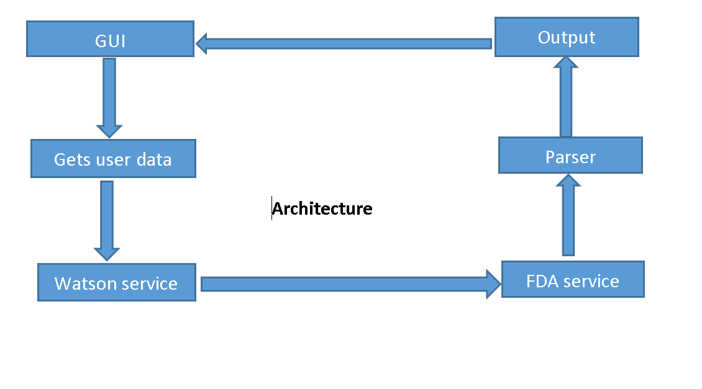

Figure 1 System Architecture

**Domain Model:**

**Services Used:**

**OpenFDA API:**

End Point:https://api.fda.gov/drug/event.json

Purpose: To get all the health Conditions reported for a particular Drug in medical history

Data Provider: US Government

**IBM Watson Concept Insights:**

End Point: <https://gateway.watsonplatform.net/>

Purpose: To get all the related and used names for any health Condition

Example: head ache can be related to sinus, migraine etc.

Data Provider: IBM Watson

**IBM Watson QA:**

End Point: https://gateway.watsonplatform.net/question-and-answer-beta/api

Purpose: To get the Side effects of particular Medicine

Example: what are the side effects of Aspirin

Data Provider: IBM Watson

**Drug Labelling API:**

End Point**:** <https://open.fda.gov/drug/label/reference/>

Purpose: To get the Do NOT Use When conditions for any medicine

Example: Aspirin should not be used when user is pregnant

Data Provider: IBM Watson

**Application Specification:**

* **Software Specification**
  + Tools: Android Studio
  + Operating System: Android
  + Development Operating System: Windows 10
  + Programming Language: Java 7.0
  + Databases: SQL lite
* **Activity Diagram:**
* 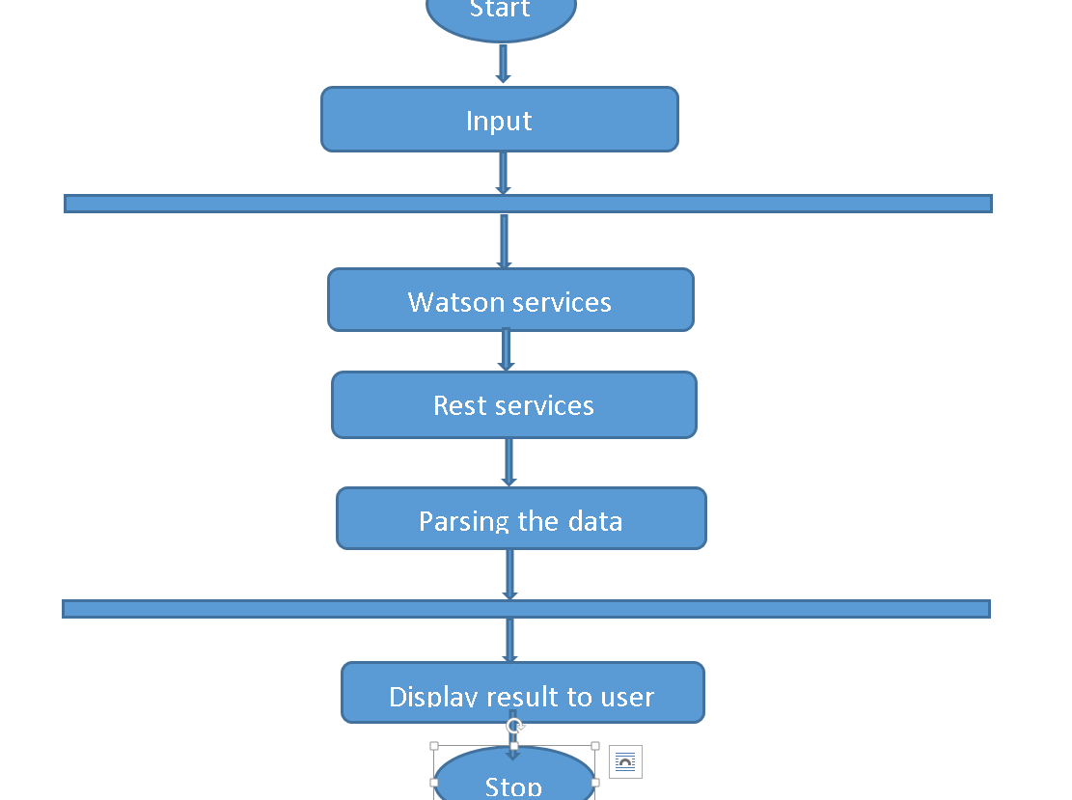

**Implementation:**

**Opening Screen where User will be able to select the conditions he had earlier.**

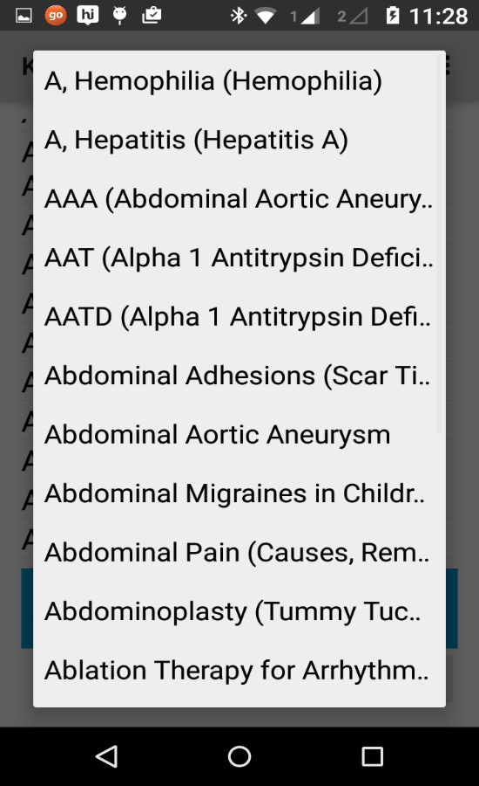 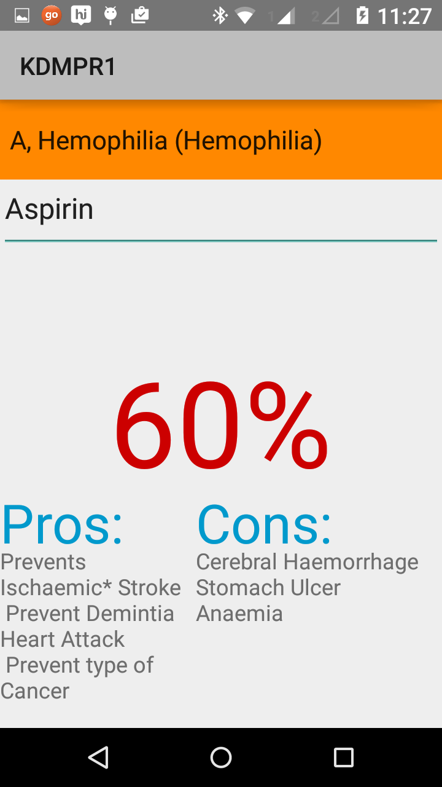

**After selecting the diseases he will be able to search for the medicine for a particular screen and our service will provide effective score for a drug**

**Project Management:**

Back End and Open FDA Services: Praveen Kumar Surapaneni(21), Vinod Kumar Vakalpudi(23)

Android UI: Uma Maheshwararao Kothuri(17), Venkat Guttikonda(13)

Watosn Services: Dheeraj Polisetty, James Dowling

**Second Increment:**

Now we are able to generate the effective score for a particular drug, for the second inc we want to provide all the suggestions by rating all the available drugs for a particular Health Condition.