Plugin Used: ngcordova.camera

I don’t own an Android device so I am using Genymotion virtual device for emulating the Android runtime.

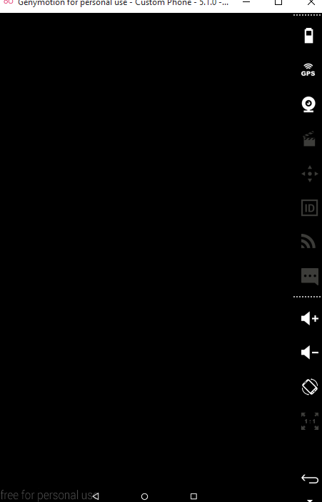

Script for Invoking Camera

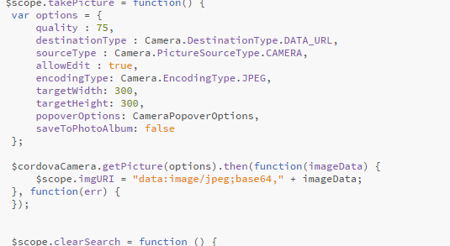



Yslow

