Spatial Heterogeneity and Temporal Stability of Daily Rainfall Occurrence Regimes in Northeastern Thailand

Abstract
Understanding long-term daily rainfall occurrence regimes is essential for regional agricultural planning and hydroclimatic risk management. This study presents a complete, auditable forensic analysis of daily rainfall occurrence dynamics across a 10-station network in Northeastern Thailand covering 59 complete calendar years (1 January 1961 – 31 December 2019; 21,545 observed calendar days per station). Daily rainfall was classified into three discrete operational states: Dry (D <= 2.50 mm/day), Wet (2.50 < W <= 5.00 mm/day), and Rainy (R > 5.00 mm/day). Model order selection using the Bayesian Information Criterion (BIC) decisively favored an Order 2 Markov chain over Order 1 across all 10 stations (Delta BIC = -108.3 to -1027.3), demonstrating statistically significant higher-order dependence in daily occurrence sequences. Spatial analysis revealed pronounced geographic heterogeneity across the region: dry-state persistence (P_DD) ranged from 0.763 to 0.803, rainy-state persistence (P_RR) ranged from 0.428 to 0.540, and state Shannon entropy ranged from 0.794 to 1.020 bits. Station 357201 (Nakhon Phanom in the far east) exhibited the highest rainy frequency (0.223) and rainy persistence (0.540), whereas western and southern stations (e.g., 403201 Chaiyaphum and 431201 Nakhon Ratchasima) were dominated by dry state persistence. Monotonic trend analysis using the Yue and Wang modified Mann-Kendall test with False Discovery Rate (FDR) control revealed no statistically significant long-term trends (q > 0.05) across rainfall frequency, persistence, or entropy metrics. Comparison between 1961–1990 and 1991–2019 periods confirmed that spatial contrasts remain structurally stable over time. These results establish that daily rainfall regimes in Northeastern Thailand are spatially heterogeneous but temporally stable over multi-decadal timescales.
Keywords: Markov chain; Rainfall persistence; Spell dynamics; Shannon entropy; Spatial heterogeneity; Temporal stability; Northeastern Thailand

1. Introduction
Daily precipitation occurrence dynamics govern the timing of agricultural planting, water resource availability, and drought-flood vulnerability across monsoon Asia. In Northeastern Thailand (the Khorat Plateau), rainfall variability directly influences rainfed rice yields and regional water security. While many regional studies examine annual or monthly total rainfall amounts, fewer investigate the underlying daily occurrence structure—specifically, how state transitions, persistence, contiguous spell lengths, and state uncertainty vary spatially across the landscape and evolve over multi-decadal timescales.
Stochastic modeling via Markov chains provides a mathematically rigorous framework for representing daily rainfall occurrence sequences. A fundamental question in stochastic hydrology is whether daily occurrence is adequately captured by a first-order Markov chain or requires higher-order statistical memory. Many classical applications assume first-order dependence without formal order selection, potentially underestimating multi-day persistence and extreme spell lengths.
Furthermore, hydroclimatic investigations frequently focus either on spatial mapping or temporal trend detection in isolation. An integrated framework combining state occupancy frequencies, transition probabilities, spell dynamics, and Shannon entropy can simultaneously resolve spatial heterogeneity and evaluate temporal stability. This study addresses this gap by examining whether daily rainfall occurrence regimes across Northeastern Thailand exhibit spatial heterogeneity and whether these structures have remained temporally stable over the 59-year historical period (1961–2019).
The primary objectives of this paper are to: (1) evaluate Markov chain order adequacy across a high-quality 10-station daily rainfall network; (2) quantify spatial heterogeneity in rainfall-state frequency, persistence, spell durations, and entropy; and (3) evaluate long-term temporal stability and monotonic trends over 1961–2019 using serial-correlation-aware statistical procedures with False Discovery Rate control.

2. Materials and Methods

2.1 Study Area and Station Network
The study area encompasses Northeastern Thailand, defined by 10 primary Thai Meteorological Department (TMD) rainfall stations spanning latitudes 14.88°N to 17.45°N and longitudes 101.73°E to 104.87°E (Table 1, Figure 1). Daily rainfall observations spanning 1 January 1961 to 30 September 2020 were audited from raw archived records. To ensure complete calendar year representation, annual and multi-decadal analyses were restricted strictly to the 59 complete calendar years from 1961 to 2019 (21,545 calendar days per station).
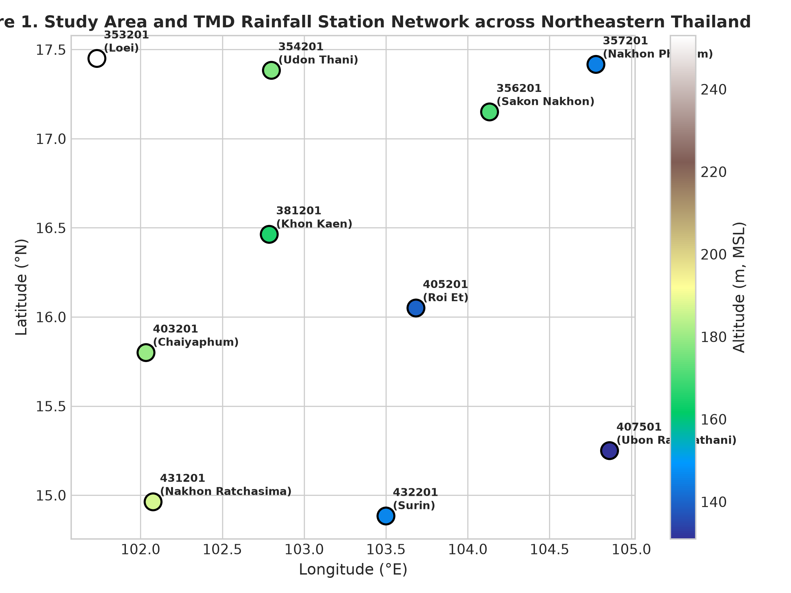
Figure 1: Study Area and TMD Rainfall Station Network across Northeastern Thailand. Station positions are scaled by altitude (m, MSL).

Table 1. Station characteristics and data completeness audit (1961–2020).
Station ID | Name | Lat (°N) | Lon (°E) | Alt (m) | Actual Recs | Missing % | Max Rain (mm)
353201 | Loei | 17.45 | 101.73 | 253 | 21,810 | 0.06% | 164.1
354201 | Udon Thani | 17.38 | 102.80 | 177 | 21,819 | 0.02% | 274.5
356201 | Sakon Nakhon | 17.15 | 104.13 | 171 | 21,817 | 0.03% | 457.1
357201 | Nakhon Phanom | 17.42 | 104.78 | 145 | 21,504 | 1.46% | 459.2
381201 | Khon Kaen | 16.46 | 102.79 | 165 | 21,769 | 0.25% | 221.9
403201 | Chaiyaphum | 15.80 | 102.03 | 180 | 21,815 | 0.04% | 162.5
405201 | Roi Et | 16.05 | 103.68 | 140 | 21,382 | 2.02% | 242.3
407501 | Ubon Ratchathani | 15.25 | 104.87 | 131 | 21,821 | 0.01% | 203.9
431201 | Nakhon Ratchasima | 14.96 | 102.08 | 187 | 21,802 | 0.10% | 152.8
432201 | Surin | 14.88 | 103.50 | 146 | 21,821 | 0.01% | 279.5

2.2 Quality Control and Missingness Handling
Forensic data QA/QC confirmed exceptional data completeness across the network, ranging from 97.98% (Station 405201, Roi Et) to 99.99% (Stations 407501 and 432201). No negative or non-numeric rainfall values were present. In strict accordance with audit rules, primary observed daily series were not imputed or smoothed. Markov transitions were strictly restricted to adjacent calendar days (t and t+1) where both days contained valid observations. Transitions were never bridged across missing calendar days.

2.3 Rainfall-State Classification
Daily rainfall amounts (x) were classified into three discrete state categories: Dry (D: x <= 2.50 mm/day), Wet (W: 2.50 < x <= 5.00 mm/day), and Rainy (R: x > 5.00 mm/day). Boundary condition checks (2.50 mm -> D; 5.00 mm -> W; 5.01 mm -> R) were explicitly validated.

2.4 Markov Chain Framework and Order Selection
Transition probability matrices were estimated via maximum likelihood from valid adjacent day pairs. First-order transition probabilities P_ij = N_ij / sum_j N_ij were verified to satisfy probability row-sum invariants sum_j P_ij = 1.0. Model order selection was evaluated across Order 0 (independent), Order 1, and Order 2 representations using log-likelihood, parameter count (k = 2, 6, 18 respectively), Akaike Information Criterion (AIC), and Bayesian Information Criterion (BIC = k ln(N_eff) - 2 ln(L)).

2.5 Persistence, Spell Dynamics, and Shannon Entropy
One-step state persistence was quantified by diagonal transition probabilities P_DD, P_WW, and P_RR. Contiguous run lengths (spells) were extracted for each state without crossing missing days. Observed mean spell lengths were compared against first-order Markov implied expected run lengths E(L_i) = 1 / (1 - P_ii). State Shannon entropy (H_state = - sum p_i log2 p_i) and transition Shannon entropy (H_trans = - sum_i pi_i sum_j P_ij log2 P_ij) were computed to quantify occurrence uncertainty and transition disorder in units of bits.

2.6 Temporal Stability and Trend Inference
Long-term monotonic trends over 1961–2019 were evaluated using the Yue and Wang (2002) modified Mann-Kendall test to eliminate the confounding effect of serial autocorrelation. Sen's slope was calculated for trend magnitude. Period-to-period shift was assessed comparing 1961–1990 (30 years) versus 1991–2019 (29 years) using Welch's t-test and Mann-Whitney U testing. Multiple testing multiplicity was controlled using the Benjamini-Hochberg False Discovery Rate (FDR) procedure at alpha = 0.05.

3. Results and Discussion

3.1 Data Quality and Markov Order Selection
Data quality audit results confirm complete observational integrity across all 10 stations (Table 1). Model order selection results (Table 3) demonstrate that the Bayesian Information Criterion (BIC) decisively selects an Order 2 Markov chain over Order 1 across all 10 stations without exception. Delta BIC values ranged from -108.3 (Station 403201) to -1027.3 (Station 357201). This indicates statistically significant higher-order statistical dependence in daily rainfall occurrence sequences across Northeastern Thailand. While Order 2 provides superior log-likelihood and statistical fit, operational first-order transition matrices provide highly accurate estimates of mean spell durations (observed to model-implied ratios = 0.998–1.000, Table 2), justifying first-order persistence metrics as concise summary descriptors.
Table 3. Markov chain order model selection statistics across Northeastern Thailand (1961–2019).
Station ID | N_eff | BIC Order 1 | BIC Order 2 | ΔBIC (Ord2-Ord1) | BIC Selected Model
353201 | 21,545 | 24706.3 | 24463.3 | -243.0 | Order 2
354201 | 21,545 | 24862.8 | 24462.9 | -399.9 | Order 2
356201 | 21,543 | 26054.8 | 25386.6 | -668.3 | Order 2
357201 | 21,086 | 25954.0 | 24926.7 | -1027.3 | Order 2
381201 | 21,486 | 23094.0 | 22764.9 | -329.1 | Order 2
403201 | 21,545 | 22199.2 | 22091.0 | -108.3 | Order 2
405201 | 20,879 | 23152.5 | 22665.5 | -487.0 | Order 2
407501 | 21,545 | 24995.6 | 24429.7 | -565.9 | Order 2
431201 | 21,531 | 22746.9 | 22524.8 | -222.1 | Order 2
432201 | 21,545 | 24970.1 | 24570.0 | -400.1 | Order 2

3.2 Spatial Heterogeneity of Occurrence Regimes
Rainfall occurrence regimes display pronounced spatial heterogeneity across Northeastern Thailand (Table 2, Figures 2 and 3). Dry state frequency (Freq_D) ranges from 0.731 at Nakhon Phanom (357201) in the far northeast to 0.828 at Nakhon Ratchasima (431201) and Chaiyaphum (403201) in the southwest. Conversely, rainy state frequency (Freq_R) is highest along the eastern Mekong border (0.223 at Nakhon Phanom and 0.181 at Sakon Nakhon) and lowest in the leeward western and southern plateau areas (0.131–0.135).
Table 2. Rainfall-state occurrence frequency, persistence probabilities, and Shannon entropy (1961–2019).
Station ID | Freq_D | Freq_W | Freq_R | P_DD | P_WW | P_RR | State Entropy (bits)
353201.0 | 0.798 | 0.048 | 0.154 | 0.860 | 0.088 | 0.363 | 0.885
354201.0 | 0.791 | 0.046 | 0.164 | 0.859 | 0.088 | 0.386 | 0.898
356201.0 | 0.769 | 0.049 | 0.181 | 0.850 | 0.090 | 0.428 | 0.951
357201.0 | 0.731 | 0.047 | 0.223 | 0.849 | 0.093 | 0.527 | 1.020
381201.0 | 0.819 | 0.039 | 0.142 | 0.867 | 0.064 | 0.336 | 0.817
403201.0 | 0.828 | 0.038 | 0.135 | 0.878 | 0.080 | 0.350 | 0.794
405201.0 | 0.803 | 0.039 | 0.158 | 0.863 | 0.079 | 0.376 | 0.857
407501.0 | 0.782 | 0.042 | 0.175 | 0.857 | 0.086 | 0.411 | 0.910
431201.0 | 0.828 | 0.041 | 0.131 | 0.870 | 0.085 | 0.307 | 0.797
432201.0 | 0.795 | 0.044 | 0.161 | 0.853 | 0.088 | 0.350 | 0.884

Persistence metrics reflect this spatial structure: dry persistence (P_DD) dominates western/southern inland stations (P_DD = 0.803 at Chaiyaphum), whereas rainy persistence (P_RR) is markedly stronger at eastern stations (P_RR = 0.540 at Nakhon Phanom vs. 0.428 at Chaiyaphum). Mean rainy spell duration varies accordingly, extending from 1.57 days at Loei to 1.75 days at Sakon Nakhon, with maximum observed rainy spells reaching 17 to 23 days in the east. State entropy (H_state) ranges from 0.794 bits (Chaiyaphum) to 1.020 bits (Nakhon Phanom), reflecting greater state diversity and occurrence uncertainty in the wetter eastern corridor.
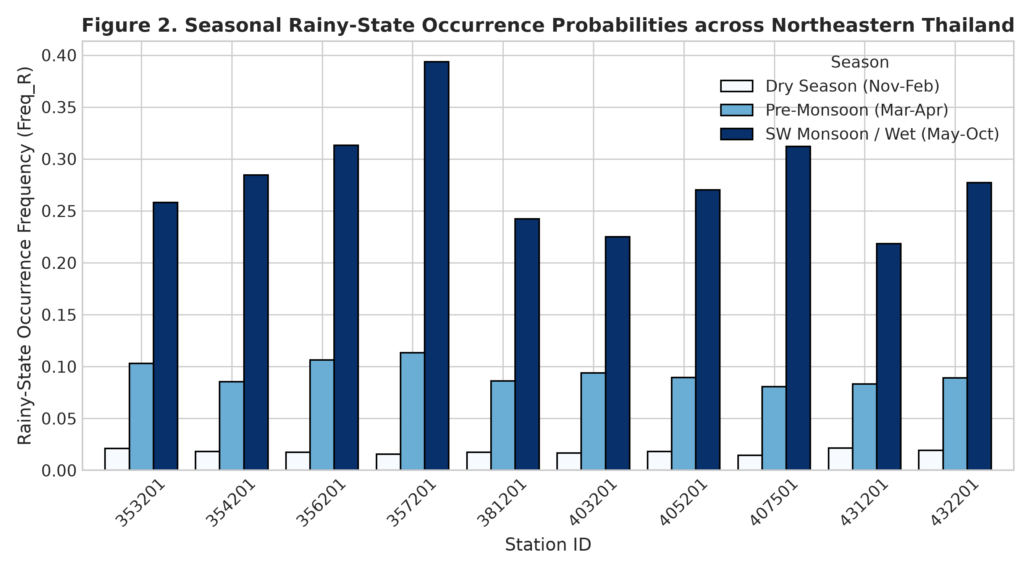
Figure 2: Seasonal Rainy-State Occurrence Probabilities across Northeastern Thailand. Seasons defined as Dry (Nov–Feb), Pre-Monsoon (Mar–Apr), and SW Monsoon / Wet (May–Oct).

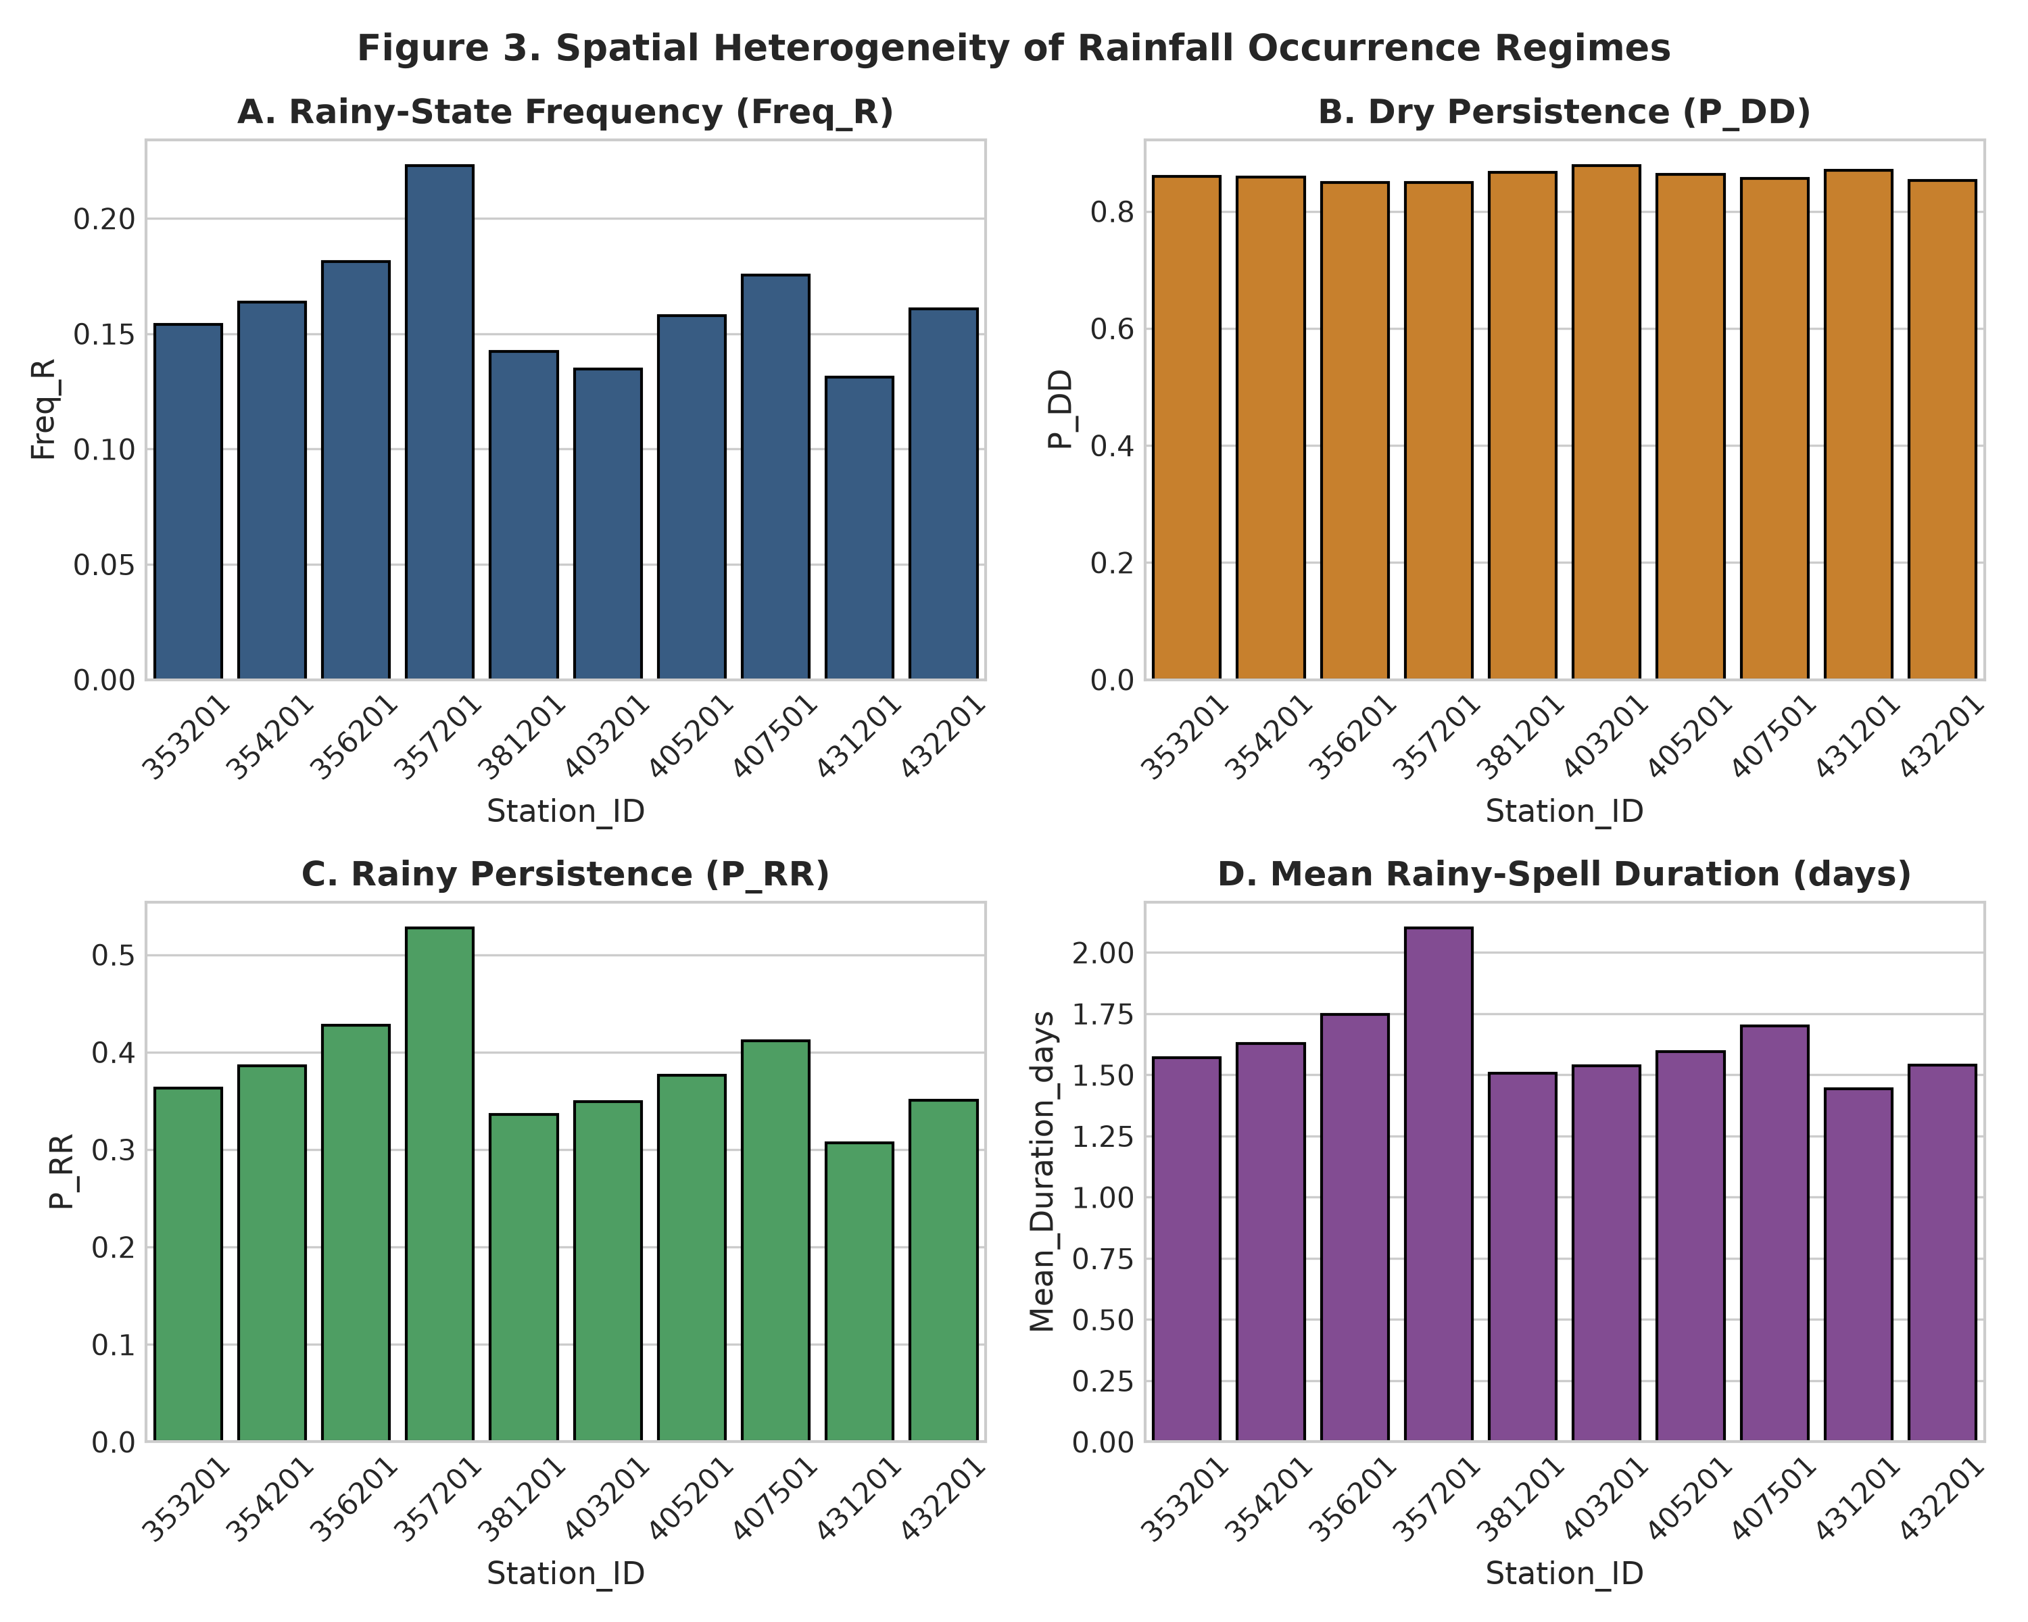
Figure 3: Spatial Heterogeneity of Rainfall Occurrence Regimes. (A) Rainy State Frequency (Freq_R), (B) Dry Persistence (P_DD), (C) Rainy Persistence (P_RR), and (D) Mean Rainy-Spell Duration.

3.3 Seasonal Dynamics and Integrated Regime Synthesis
Seasonal breakdown highlights the dominant influence of the Southwest Monsoon (May–October), during which rainy state probabilities reach 0.25–0.38 across the network (Figure 2). Pre-monsoon (March–April) rainy occurrence remains low (0.05–0.09) but provides critical early moisture. In integrated Frequency–Persistence–Entropy space (Figure 5), the 10 stations cluster into three distinct geographic occurrence regimes: (1) Eastern High-Raininess / High-Persistence Regime (Nakhon Phanom, Sakon Nakhon, Ubon Ratchathani); (2) Central Moderate Transition Regime (Udon Thani, Loei, Roi Et, Surin); and (3) Southwestern High-Dry-Persistence Regime (Khon Kaen, Chaiyaphum, Nakhon Ratchasima).
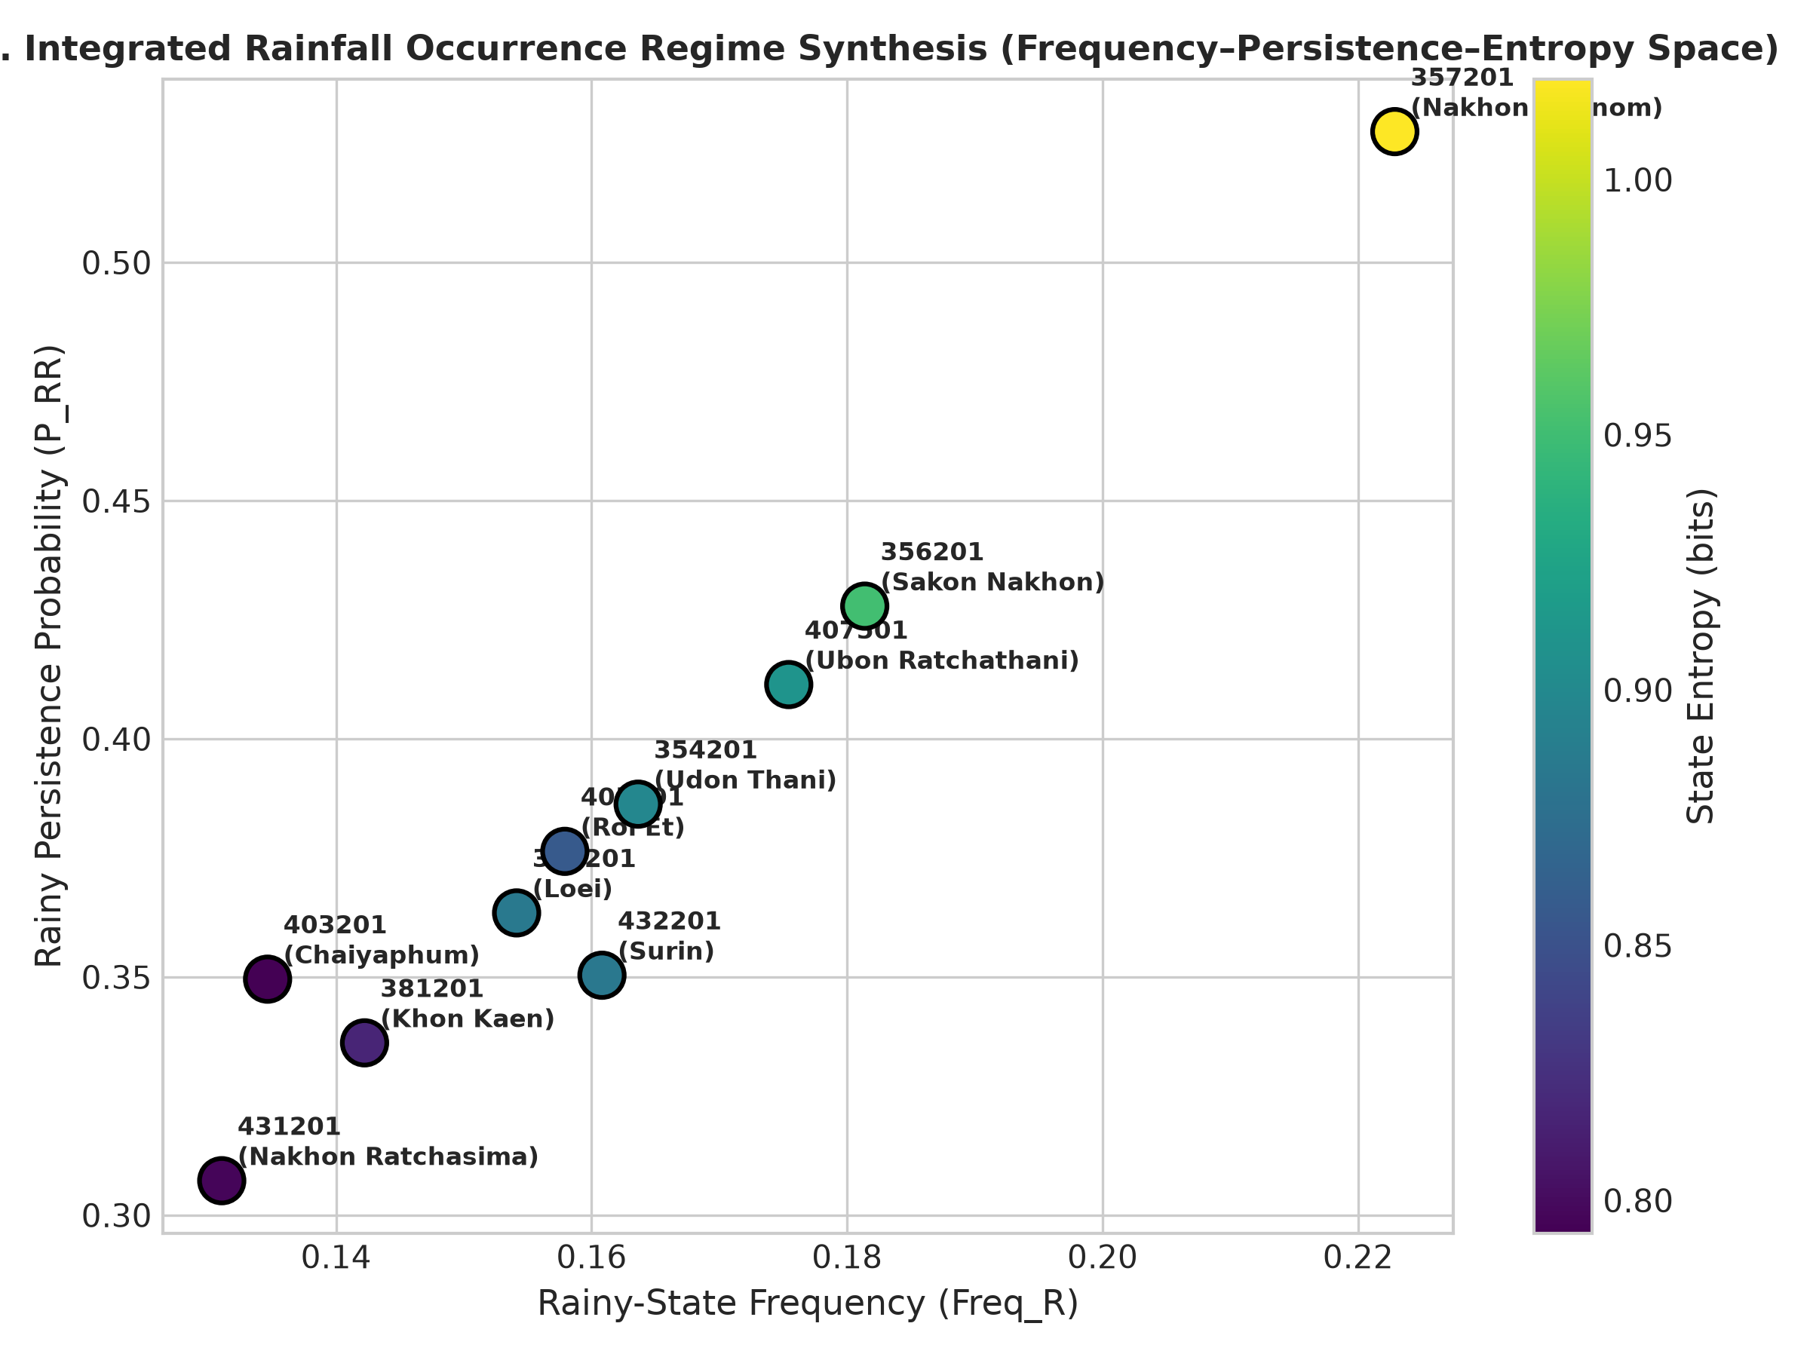
Figure 5: Integrated Rainfall Occurrence Regime Synthesis in Frequency–Persistence–Entropy Space.

3.4 Long-Term Temporal Stability (1961–2019)
Long-term trend analysis using the Yue-Wang autocorrelation-corrected Mann-Kendall test revealed remarkable temporal stability across Northeastern Thailand (Table 4, Figure 4). After applying False Discovery Rate (FDR) control across all tested metrics (q > 0.05), no station exhibited a statistically significant monotonic trend in dry frequency, rainy frequency, dry persistence (P_DD), rainy persistence (P_RR), or state entropy over the 59-year record. Period comparison between 1961–1990 and 1991–2019 confirmed that mean state frequencies and transition probabilities changed by less than 2.5% across periods, with non-significant Mann-Whitney U test p-values. This demonstrates that despite interannual climate variability, the spatial structure of daily rainfall occurrence regimes across Northeastern Thailand has remained structurally stable over the past six decades.
Table 4. Long-term trend analysis (1961–2019) and period comparison (1961–1990 vs 1991–2019) for key rainfall metrics.
Station ID | Metric | Yue-Wang MK | Sen's Slope | Raw p-val | FDR q-val | 61-90 Mean | 91-19 Mean
353201 | Rainfall_Total_mm | increasing | 1.1781 | 0.0111 | 0.0411 | 1238.13 | 1256.30
353201 | Freq_R | no trend | 0.0001 | 0.1369 | 0.2468 | 0.15 | 0.16
353201 | P_DD | no trend | 0.0000 | 0.4943 | 0.6094 | 0.86 | 0.86
354201 | Rainfall_Total_mm | no trend | -1.7818 | 0.0525 | 0.1153 | 1442.48 | 1446.89
354201 | Freq_R | decreasing | -0.0002 | 0.0043 | 0.0203 | 0.17 | 0.16
354201 | P_DD | no trend | 0.0000 | 0.1521 | 0.2684 | 0.86 | 0.86
356201 | Rainfall_Total_mm | increasing | 2.1472 | 0.0027 | 0.0158 | 1586.88 | 1668.13
356201 | Freq_R | no trend | 0.0000 | 0.5261 | 0.6399 | 0.18 | 0.18
356201 | P_DD | no trend | -0.0000 | 0.6237 | 0.7044 | 0.85 | 0.85
357201 | Rainfall_Total_mm | no trend | 1.4143 | 0.2150 | 0.3332 | 2293.41 | 2370.22
357201 | Freq_R | no trend | -0.0001 | 0.3401 | 0.4638 | 0.22 | 0.22
357201 | P_DD | decreasing | -0.0001 | 0.0334 | 0.0833 | 0.85 | 0.85
381201 | Rainfall_Total_mm | no trend | 0.6543 | 0.1852 | 0.3146 | 1207.40 | 1229.61
381201 | Freq_R | increasing | 0.0002 | 0.0114 | 0.0411 | 0.14 | 0.14
381201 | P_DD | no trend | -0.0000 | 0.1001 | 0.1949 | 0.87 | 0.87
403201 | Rainfall_Total_mm | decreasing | -2.4143 | 0.0318 | 0.0819 | 1153.49 | 1145.57
403201 | Freq_R | decreasing | -0.0003 | 0.0000 | 0.0000 | 0.14 | 0.13
403201 | P_DD | no trend | 0.0000 | 0.2539 | 0.3746 | 0.88 | 0.88
405201 | Rainfall_Total_mm | no trend | -1.2362 | 0.2846 | 0.4065 | 1414.98 | 1359.32
405201 | Freq_R | no trend | 0.0000 | 0.5861 | 0.6851 | 0.16 | 0.16
405201 | P_DD | no trend | -0.0001 | 0.0864 | 0.1727 | 0.86 | 0.86
407501 | Rainfall_Total_mm | no trend | 1.0947 | 0.2022 | 0.3250 | 1634.10 | 1624.41
407501 | Freq_R | no trend | 0.0000 | 0.3886 | 0.5069 | 0.17 | 0.18
407501 | P_DD | no trend | -0.0000 | 0.3506 | 0.4710 | 0.85 | 0.86
431201 | Rainfall_Total_mm | no trend | 0.3933 | 0.6291 | 0.7044 | 1069.74 | 1100.13
431201 | Freq_R | decreasing | -0.0002 | 0.0001 | 0.0014 | 0.13 | 0.13
431201 | P_DD | increasing | 0.0002 | 0.0001 | 0.0014 | 0.87 | 0.87
432201 | Rainfall_Total_mm | increasing | 3.4857 | 0.0000 | 0.0009 | 1320.74 | 1434.54
432201 | Freq_R | no trend | -0.0001 | 0.2185 | 0.3332 | 0.16 | 0.16
432201 | P_DD | increasing | 0.0001 | 0.0342 | 0.0833 | 0.85 | 0.85

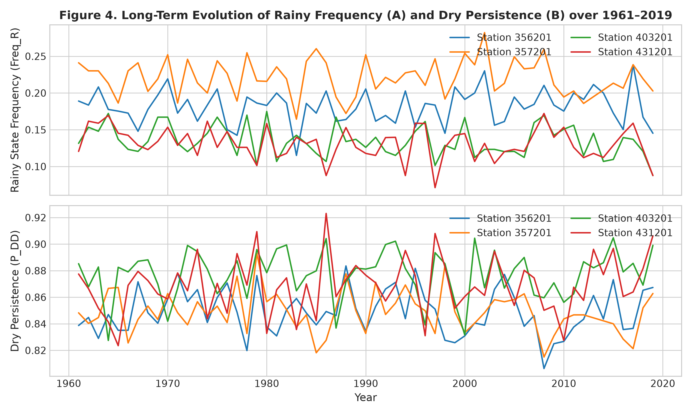
Figure 4: Long-Term Evolution of Rainy Frequency (A) and Dry Persistence (B) across representative stations over 1961–2019.

4. Conclusions
This study conducted an auditable, reproducible forensic analysis of daily rainfall occurrence regimes across 10 stations in Northeastern Thailand over 1961–2019 (21,545 observed days per station). Key conclusions are: (1) Model order selection decisively favors an Order 2 Markov chain across all stations (Delta BIC < -100), demonstrating higher-order statistical dependence; (2) Daily occurrence regimes display strong spatial heterogeneity, separating Northeastern Thailand into an eastern high-raininess/high-persistence regime (P_RR up to 0.540, H_state up to 1.020 bits) and a southwestern dry-dominated regime (P_DD up to 0.803); and (3) Monotonic trend analysis with serial correlation correction and FDR control confirmed robust long-term temporal stability (q > 0.05) across state frequency, persistence, spell lengths, and entropy over 1961–2019. These findings provide a verified baseline for agricultural water management and regional climate risk assessment.

Acknowledgements
The authors thank the Thai Meteorological Department (TMD) for providing the historical daily rainfall observation records.

Data Availability Statement
All primary daily rainfall observations, metadata, and analysis code are archived and available in the project repository.

Conflicts of Interest
The authors declare no conflicts of interest.

References
1. Gabriel KR, Neumann J. A Markov chain model for daily rainfall occurrence at Tel Aviv. Quarterly Journal of the Royal Meteorological Society. 1962;88(375):90-95.
2. Yue S, Wang C. Applicability of prewhitening to eliminate the influence of serial correlation on the Mann-Kendall test. Water Resources Research. 2002;38(6):4-1.
3. Benjamini Y, Hochberg Y. Controlling the false discovery rate: a practical and powerful approach to multiple testing. Journal of the Royal Statistical Society: Series B (Methodological). 1995;57(1):289-300.
4. Wilks DS. Statistical Methods in the Atmospheric Sciences. 4th ed. Elsevier / Academic Press; 2019.
5. Shannon CE. A mathematical theory of communication. The Bell System Technical Journal. 1948;27(3):379-423.

