Climate-signal preservation in bias-corrected daily precipitation over Nan, Thailand, and the effect of an observational discontinuity on method evaluation
Surasit Punyawansiri^{1,*}
¹Office of Water Management and Hydrology, Royal Irrigation Department, Dusit, Bangkok 10300, Thailand
*Corresponding author: Surasit.ku@ku.th
Received … ; Revised … ; Accepted …
Abstract
Bias correction is usually judged by how much historical error it removes, yet a correction applied to future simulations must also decide how much of the model's own climate-change signal survives, and both judgements depend on an observed record being homogeneous. Empirical, detrended and delta quantile mapping were applied to daily precipitation from seven CMIP6 models at 14 rain gauges in Nan Province, northern Thailand, under two SSP scenarios. The gauge record was found to contain a network-wide discontinuity: the wet-day frequency falls from about 60% before 2005 to between 22.92% and 30.85% after 2006 in every calendar month at 12 of the 14 gauges, while the adjacent province is unchanged over the same years, so the shift is a property of the record rather than of the climate. A split-sample straddling the discontinuity left a residual out-of-sample error of 52.09%, larger than the uncorrected models; placing calibration in 1981–1992 and validation in 1993–2004, both inside the homogeneous era, reduced it to 14.56% and improved every primary metric. Over calibration all three methods reduced the mean absolute bias in wet-day frequency from 36.7% to 0.03–0.43%; out of sample they converged to 15.6–16.2%. For 2021–2050 the median signal-preservation error stayed within 4.84% for bulk statistics and wet-day quantiles but reached 24.94% for R99p, and the method with the smallest absolute error changed with the scenario for nine of the sixteen indices. Homogeneity screening should precede method comparison, not follow it.

Keywords: Bias adjustment; Data homogeneity; Extreme rainfall; Quantile mapping; Signal preservation

1. Introduction
Reliable precipitation projections are essential for assessing future water availability, hydrological risk, and other climate-related impacts at the local scale. Global climate models (GCMs) provide an important basis for such assessments, but systematic differences between simulated and observed precipitation can limit their direct application at regional and local scales. Statistical bias correction is therefore widely used to improve the suitability of GCM precipitation for impact-oriented applications [1–3].
Quantile-based bias-correction methods are particularly widely applied because they can effectively adjust systematic differences in precipitation characteristics. However, different formulations are designed to preserve different aspects of the simulated climate signal. Empirical quantile mapping (QM/EQM) primarily focuses on correcting the historical model distribution, whereas detrended quantile mapping (DetQM) and quantile delta mapping (QDM) incorporate mechanisms intended to retain changes simulated by the original model [1]. The choice among these approaches therefore involves more than selecting a method that produces the smallest historical error.
This issue is particularly relevant when corrected precipitation is used to assess rainfall extremes. Daily precipitation indices are derived in different ways, and their response to bias correction may not be uniform. A correction that performs well for general precipitation characteristics may not provide the same behaviour for extreme rainfall or persistence-related indices. Consequently, assessment of bias-correction methods should consider both how effectively they reduce historical bias and how they affect the climate-change signal represented by the original model.
Recent CMIP6-based assessments in Thailand have highlighted substantial spatial and temporal variability in projected precipitation, with some rainfall extremes exhibiting stronger changes than overall precipitation totals [4, 5]. A broader review of CMIP6 extreme precipitation projections across Asian subregions confirms that while models show substantial improvements over previous generations—particularly for intensity indices such as RX1day and R95p—persistent biases remain, especially in topographically complex and data-sparse regions [6]. These characteristics increase the importance of selecting an appropriate bias-correction approach for local climate applications. For regions such as Uttaradit Province in northern Thailand, where climate information is relevant to water-resource and environmental planning, a clearer understanding of the implications of method selection is particularly valuable.
Despite the extensive use of quantile-based bias correction, several questions remain open regarding the comparative behaviour of different formulations when they are evaluated within the same experimental framework. It remains important to determine whether strong historical bias reduction is maintained during independent validation, whether the intended climate-signal preservation associated with each method is consistently achieved across future scenarios, and whether preservation of the modelled signal extends from general precipitation characteristics to derived rainfall extremes and persistence-related indices. Addressing these questions requires a controlled comparison in which differences among methods can be examined without confounding changes in the observational data, model ensemble, calibration strategy, or evaluation periods. A recent systematic review of CMIP6 downscaling and extreme analysis across Asia has identified persistent gaps in the application of bias correction methods, particularly regarding the treatment of extremes in topographically complex regions [7].
This study compares QM/EQM, DetQM and QDM for daily precipitation from seven CMIP6 models and 14 rain gauges in Nan Province, northern Thailand. A companion study applied the same framework to the neighbouring province of Uttaradit; here the same design meets an observed record that is not homogeneous, and the consequences of that for method evaluation are examined alongside the method comparison itself. Using a split-sample framework placed inside the homogeneous part of the record, with 1981–1992 for calibration, 1993–2004 for independent validation, and 2021–2050 for future assessment relative to 1985–2004, the study evaluates the performance of the three methods from complementary perspectives: historical bias reduction, independent out-of-sample performance, and preservation of the modelled climate-change signal across daily precipitation characteristics and rainfall extremes. The study seeks to clarify how bias-correction method choice affects the characteristics of corrected precipitation and the climate signal available for subsequent impact assessment, thereby providing a more informative basis for selecting bias-correction methods for local climate applications.
2. Materials and methods
2.1 Study area and data
Nan Province lies in northern Thailand between 18.01° and 19.63° N and 100.34° and 101.36° E (Figure 1). The provincial boundary was taken from the Natural Earth 10 m Admin-1 dataset (ISO 3166-2 code TH-55) and verified for geometry validity, coordinate reference system (EPSG:4326), polygon complexity and containment of every gauge; its geodesic area is 11,721.9 km², close to the commonly cited provincial figure, and all 14 gauges fall inside it.
Daily rainfall for 1981–2014 was obtained for 14 gauges at elevations from 193 to 781 m.
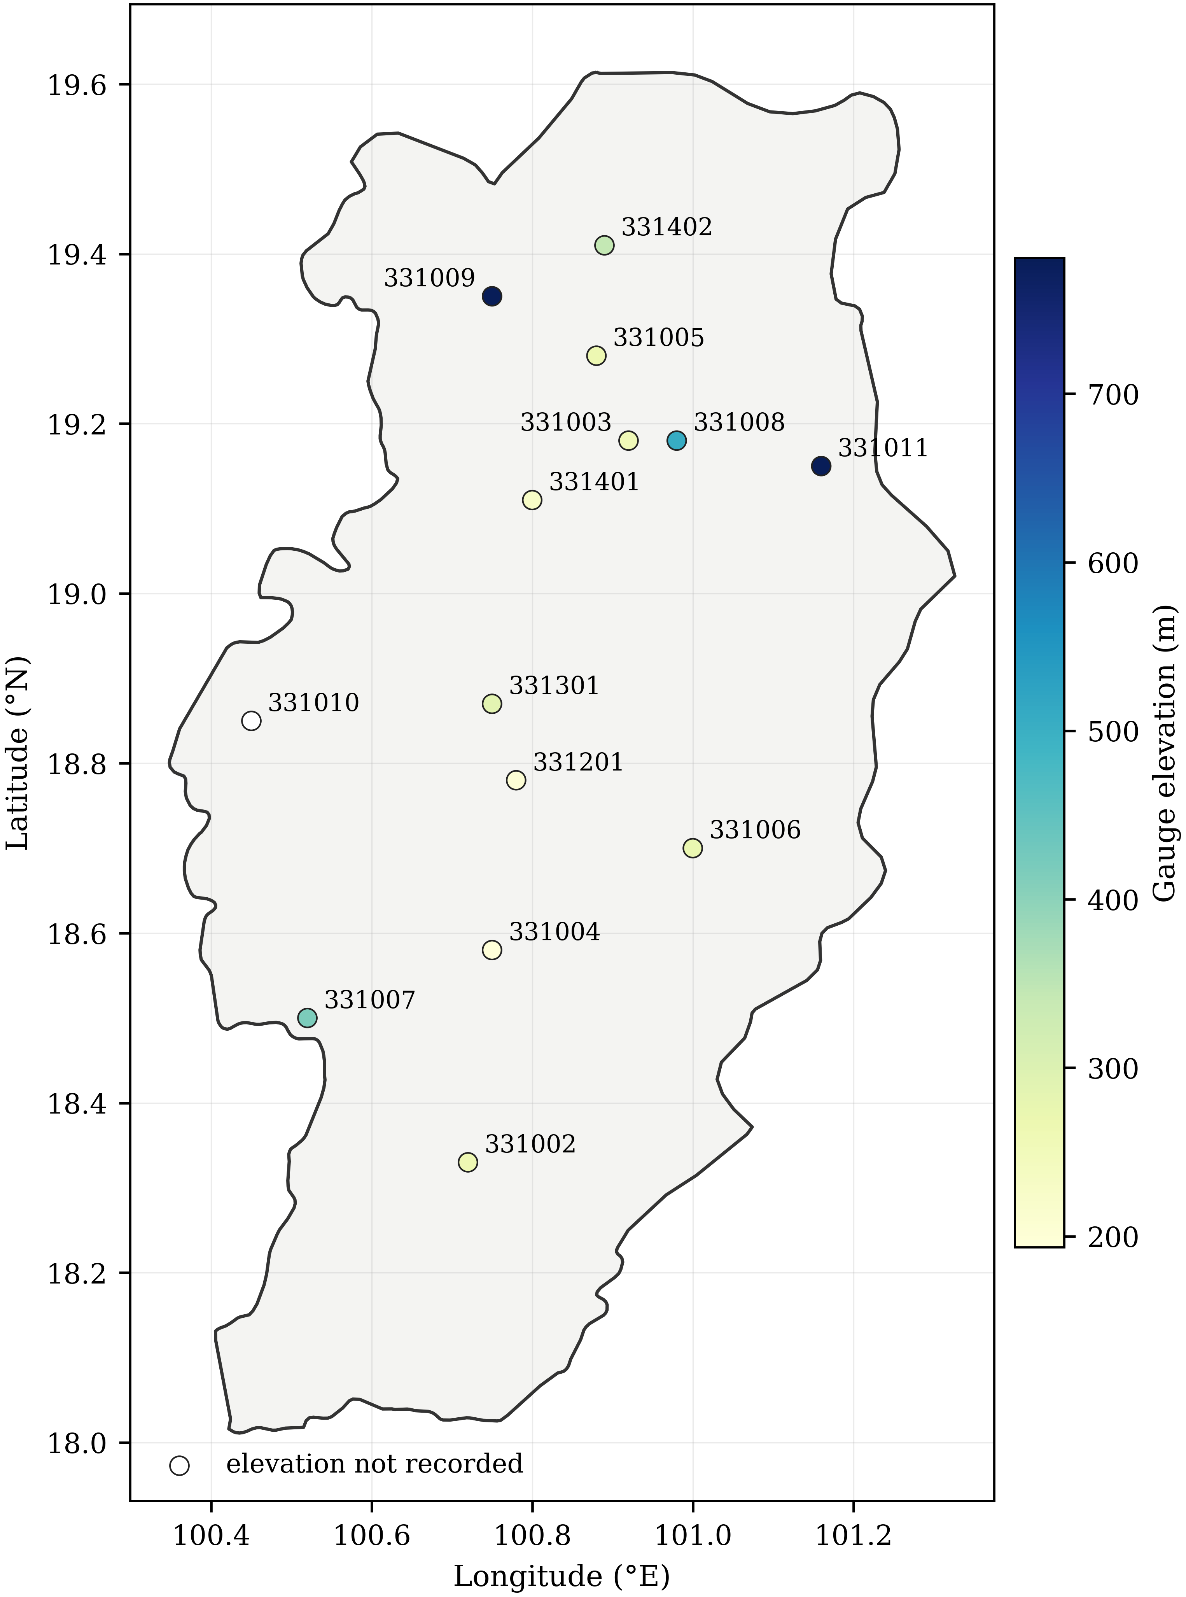
Figure 1 Nan Province and the 14 rain gauges used in this study, on the verified provincial boundary. Symbol colour gives gauge elevation; the open symbol marks the one gauge whose elevation is not recorded in the station table. The figure is drawn from the same boundary and station files the analysis reads.
2.2 Observed-data quality control and homogeneity
Zeros standing in for missing observations were screened against six diagnostics per station-month, combining the surrounding gauges, the station's own climatology for that calendar month and the length of the zero run; a zero was reclassified as missing only when at least one neighbour-based diagnostic and at least two in total supported it. Of 5,712 station-months, 136 were classified as probable missing and 214 as uncertain and left unaltered; no value was imputed.
Homogeneity was screened by the ratio of wet-day frequency in the validation period to that in the calibration period, with a gauge flagged when the ratio falls outside 0.75–1.33. Under the split-sample used in the companion study, 12 of the 14 Nan gauges were flagged, and 11 of those showed the frequency roughly halving. Section 3.1 examines that result before the methods are compared, because it determines which periods the comparison can use.
2.3 Climate model data and experimental design
Daily precipitation was used from seven CMIP6 models [8, 9] for the historical experiment and for SSP2-4.5 and SSP5-8.5: ACCESS-ESM1-5 [10], CESM2 [11], CanESM5 [12], EC-Earth3 [13], FGOALS-g3 [14], MIROC6 [15] and MRI-ESM2-0 [16], all realisation r1i1p1f1 except CESM2 (r11i1p1f1). CESM2, CanESM5 and FGOALS-g3 use a 365-day calendar and the remainder the standard calendar; calendars were detected from the data. Across the 14 analysed gauges each model delivers between one and four distinct daily series (Supplementary Table S10), so the raw fields carry limited sub-provincial structure.
Parameters were estimated on 1981–1992 and frozen. The frozen parameters were applied to the calibration period itself, to the independent validation period 1993–2004, to the baseline 1985–2004 and to the future window 2021–2050. All statistics for 2021–2050 were recomputed from the daily corrected series over that 30-year window. Acceptance criteria governing what may be claimed are given in Supplementary Table S9.
2.4 Bias-correction methods
Supplementary Table S1 summarises the design of the three methods and the settings they share. All operate on wet days defined by a 1.0 mm d-1 threshold. Frequency adaptation is applied once per gauge–model pair before any intensity mapping: the model wet-day threshold is raised until the model wet-day frequency over the calibration period matches the observed frequency [17]. Because this occurrence model is estimated once and shared, differences between the methods arise from the intensity transformation alone.
Writing F⁻¹obs,cal and F⁻¹mod,cal for the observed and modelled wet-day quantile functions over the calibration period, and x for a target-period value,
$BC\left(x\right) = F_{obs,cal}^{-1}\left(F_{mod,cal}\left(x\right)\right)$ (1)
$BC\left(x\right) = s · F_{obs,cal}^{-1}\left(F_{mod,cal}\left(\frac{x}{s}\right)\right), s = \frac{μ_{tgt}}{μ_{cal}}$ (2)
$BC\left(x\right) = F_{obs,cal}^{-1}\left(p\right) · \left[\frac{x}{F_{mod,cal}^{-1}\left(p\right)}\right], p = F_{mod,tgt}\left(x\right)$ (3)
where s is the ratio of the target-period to the calibration-period wet-day mean of the model. Empirical distributions were estimated from the sorted wet-day sample with Hazen plotting positions and linear interpolation. Beyond the calibration range the multiplicative correction ratio at the nearest calibration quantile was held constant, with no clipping; extrapolation affected 0.41% of wet days on average.
2.5 Rainfall indices
Indices follow the definitions of the Expert Team on Climate Change Detection and Indices [18] where applicable, supplemented by wet-day frequency and empirical wet-day quantiles: PRCPTOT, wet-day frequency, SDII, q50, q90, q95, q99, Rx1day, Rx5day, R10mm, R20mm, R50mm, R95p, R99p, CDD and CWD. Percentile thresholds for R95p and R99p came from observed wet days over the calibration period at each gauge. Direct quantiles, derived extremes and sequence-dependent indices are reported separately throughout.
2.6 Performance metric
Historical performance is the mean absolute bias,
$MAB\left(k\right) = \frac{1}{NM}\sum_{i = 1}^{N}{\sum_{j = 1}^{M}{∣ε_{ijk}∣}}$ (4)
$ε_{ijk} = 100 · \frac{S_{ijk} - O_{ik}}{O_{ik}}$ (5)
where S and O are the simulated and observed values of index k, N = 13 gauges and M = 7 models; cases with a zero observed denominator were excluded.
2.7 Climate-signal preservation
For a statistic q, the raw and corrected signals are the ratios of its 2021–2050 value to its 1985–2004 baseline value within the same model, written qfut and qbase,
$S_{raw} = \frac{q_{fut,raw}}{q_{base,raw}}, S_{BC} = \frac{q_{fut,BC}}{q_{base,BC}}$ (6)
and the signal-preservation error is
$PE\left(q\right) = 100 · \frac{S_{BC}\left(q\right) - S_{raw}\left(q\right)}{S_{raw}\left(q\right)}$ (7)
PE near zero indicates close preservation, positive values amplification and negative values attenuation. Observations never enter the denominator of a climate-change signal.
2.8 Method and model effects
The spread of projected changes was summarised by a descriptive two-factor sum-of-squares partition with GCM and bias-correction method as the explicit factors, computed separately for each scenario. Because station is not modelled as a factor although the data are indexed by GCM × method × station, the residual carries the GCM × method interaction together with station-level and higher-order unmodelled variation; it should not be read as interaction alone, and this is not a full variance-component analysis.
2.9 Statistical interpretation
One estimator is used for every reported ensemble quantity. Within each GCM the signal-preservation error is averaged across the gauge evaluation locations at which it is defined, giving one value per model; the reported summary is the median of those values across the GCMs, with the inter-model interquartile range as a measure of spread rather than a confidence interval. Formally, for scenario c, index k and method m,
$E_{j} = \frac{1}{N_{j}}\sum_{i = 1}^{N_{j}}{{PE}_{ijkmc}}, reported value = median\left(E_{j}\right)$ (8)
where i runs over gauges and j over GCMs. The gauges are evaluation locations, not independent model realizations, so they are averaged inside a model before the ensemble summary is taken; pooling gauge-by-model combinations into a single sample would allow the number of gauges to outweigh the inter-model spread, which is the quantity of interest here. Estimation is always separate by scenario: no aggregation across forcing pathways is defined, and none is reported. Where a threshold index has no qualifying day in a model's baseline the ratio is undefined, so the number of contributing GCMs is stated with every table.
When identifying the method closest to the raw signal, methods are compared on the absolute value of the ensemble-median PE. Paired method contrasts, given in Supplementary Table S8, are descriptive and carry no significance test. Seven models are too few, and are not a random sample of a defined population, to support an inferential claim about between-method differences; a non-significant result would be read as equivalence when it would only indicate low power.
3. Results and discussion
3.1 A discontinuity in the observed record
The homogeneity screening flagged 12 of the 14 gauges, and 11 of those in the same direction: the wet-day frequency after 2002 was roughly half its earlier value, with ratios between 0.41 and 0.67. Because a screening result of that size governs what the rest of the analysis can support, it was examined before the methods were compared.
Three features of the record place the change in the observations rather than in the climate. First, the network-mean wet-day frequency is stable from 1981 to 2004, ending that era at 56.73% in 2004; it falls to 36.32% in 2005, returns to 55.73% in 2006, and then settles between 22.92% and 30.85% for 2007 to 2014. Seven gauges cross below 45% in 2005 and five in 2007. Second, the reduction is present in every calendar month and is proportionally larger in the dry season than in the wet season: January falls from 18.68% to 5.00% and August from 88.73% to 45.71%, ratios of 0.268 and 0.515. A monsoon signal would not remove three-quarters of the January rain days. Third, the neighbouring province of Uttaradit, which shares the same monsoon regime and was analysed with the identical framework, is nearly unchanged across the same years, moving from 36.35% to 35.10% wet days and from 1,128 to 1,096 mm per year, while Nan moves from 61.55% to 30.69% and from 1,512 to 1,040 mm. Before 2005 the Nan network records 1.69 times as many rain days as its neighbour; from 2005 it records 0.87 times as many.
The direction of the anomaly follows from the same comparison: it is the earlier period that is unusual. A wet-day frequency of 84.59% to 91.44% from May to October, sustained for more than two decades, means measurable rain on almost every day of the monsoon at almost every gauge, which the neighbouring network does not show. The most likely explanation is a change in observing or digitising practice, but station history metadata were not available and the record is therefore flagged diagnostically rather than attributed to a specific cause.
The consequence for method evaluation is direct. With calibration on 1981–2002 and validation on 2003–2014, the split straddles the change: the parameters are fitted entirely inside the early regime and applied to a period that is half early and half late. The out-of-sample mean absolute bias in wet-day frequency was then 83.26% for QM/EQM and 82.18% for QDM against 35.62% for the uncorrected models, and the network-mean residual across the four primary metrics was 52.09%. Correction made the models worse than leaving them alone, and the acceptance criterion on independent validation was not met.
Moving both periods inside the homogeneous era, with calibration on 1981–1992 and validation on 1993–2004, removes the problem: the residual falls to 14.56% and every primary metric improves on the uncorrected model. All results that follow use this split. The cost is a shorter calibration sample, twelve years rather than twenty-two, and a baseline of 1985–2004 rather than a recent twenty years; both are stated wherever they affect interpretation.
This is the first finding of the study, and it is a methodological one. A comparison of bias-correction methods measures the transformations only if the target record is homogeneous over the periods used to fit and to test them. Had the screening been treated as a reporting formality rather than as a precondition, the same data would have supported the conclusion that all three methods fail out of sample, when what fails is the pairing of the periods with the record.
3.2 Historical bias reduction
Over the calibration period 1981–1992 all three methods removed almost all of the marginal bias (Supplementary Table S2, Figure 2). The mean absolute bias in wet-day frequency fell from 36.70% in the raw models to 0.03% under QM/EQM and QDM and 0.43% under DetQM; annual precipitation fell from 44.39% to 1.67–1.72%, the simple daily intensity index from 31.30% to 0.00–0.37%, and the 95th wet-day percentile from 42.98% to 0.03–0.19%. QM/EQM and QDM are numerically identical here because the delta term of Eq. (3) equals unity over the period used to fit it, so the sub-1% figures describe the estimator rather than its skill.
The largest reduction was for the frequency of days above 50 mm, from 367.24% to 0.86%. Sequence-dependent indices behaved differently: maximum consecutive wet days improved only from 79.38% to 56.94–57.23%, and maximum consecutive dry days was made worse, rising from 23.88% in the raw models to 51.39–51.77% after correction. Frequency adaptation raises the model wet-day threshold until the modelled wet-day count matches the observed count, and where the observed count is as high as it is here that lengthens the modelled wet spells and shortens the dry ones.
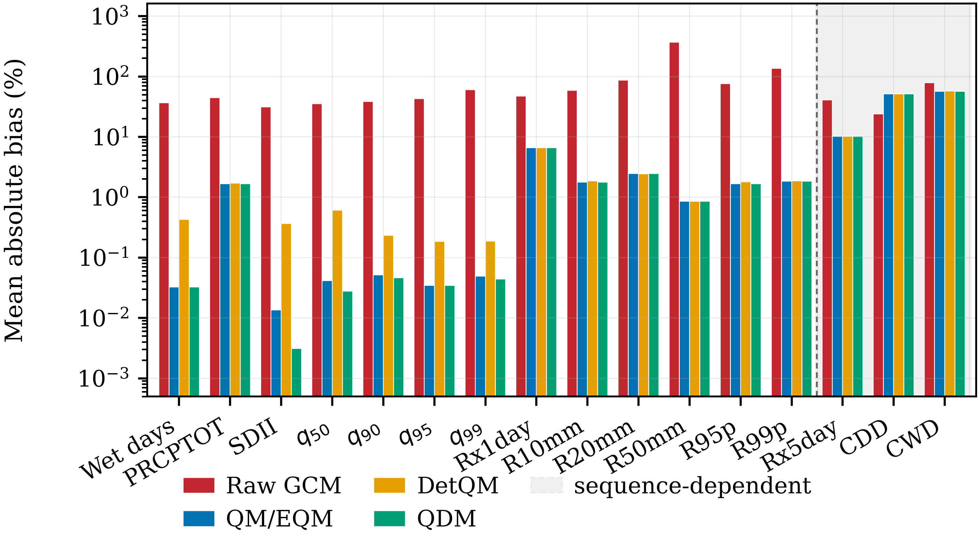
Figure 2 Mean absolute bias of raw and bias-corrected daily precipitation against gauge observations over the calibration period 1981-1992, averaged across 14 gauges and 7 climate models. Indices to the right of the dashed rule, on the shaded background, are sequence-dependent: quantile mapping does not reorder days, so it does not reconstruct them. The vertical axis is logarithmic because the corrected and uncorrected values differ by more than two orders of magnitude over the period used to fit the correction.
3.3 Independent validation
Applying the frozen parameters to 1993–2004 gives the out-of-sample picture (Supplementary Table S3, Figure 3). Mean absolute bias in wet-day frequency was 15.62% for QM/EQM, 15.81% for DetQM and 16.21% for QDM against 43.21% for the raw models; annual precipitation 12.09%, 12.35% and 12.73% against 43.16%; the simple daily intensity index 12.51%, 13.50% and 14.57% against 31.03%; and the 95th wet-day percentile 11.95%, 13.45% and 14.72% against 41.41%.
The three methods therefore converge out of sample, differing by at most 2.8 percentage points on any primary metric while the residual against observations is an order of magnitude larger than the difference between them. The ordering also changes: QM/EQM has the smallest error on all four primary metrics, whereas QDM has the smallest for Rx1day (19.28% against 19.99%), Rx5day (25.14% against 25.82%) and the frequency of days above 50 mm (60.64% against 83.90%). No method is uniformly better. A multi-continent comparison of the same three formulations on CMIP6 daily precipitation reached the same shape of result, with empirical quantile mapping performing best overall while the relative ranking varied by region and by the metric chosen [19].
Sequence-dependent indices are not corrected. Maximum consecutive dry days remains worse after correction than before it, at 47.85–48.79% against 29.42%, and maximum consecutive wet days improves only from 88.73% to 71.09–71.40%.
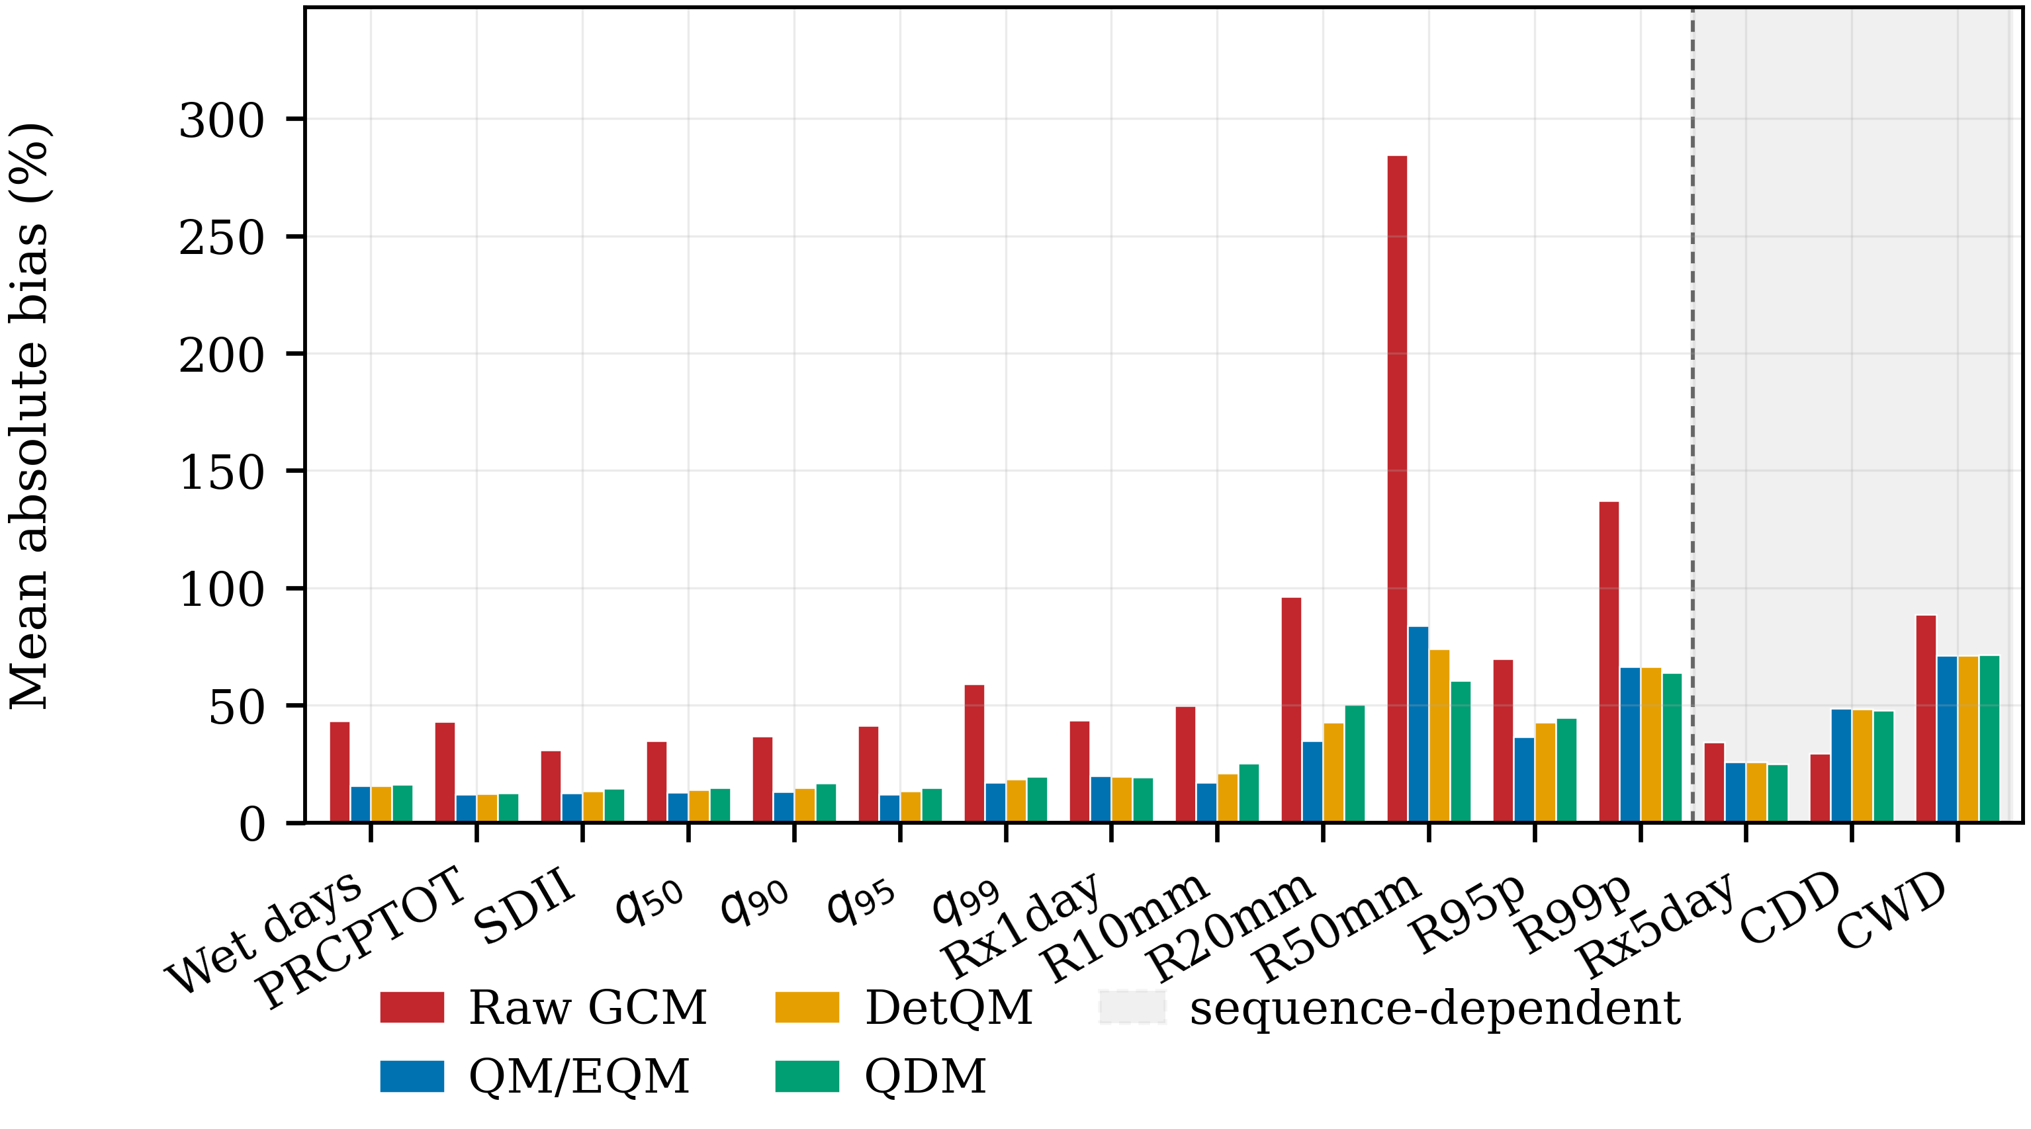
Figure 3 As Figure 2, for the independent validation period 1993-2004, using parameters fitted on 1981-1992 and frozen. Both periods lie inside the homogeneous part of the gauge record, before the discontinuity described in Section 3.1.
3.4 Preservation of bulk and distributional climate signals
Signal-preservation errors for the bulk statistics and the direct wet-day quantiles were small under every method and in both scenarios (Table 1, Figure 4; all indices in Supplementary Table S4 and the full listing in Supplementary Data S5). Preservation here is measured against each model's own raw change, not against observations, so an error near zero means the modelled change was carried through, not that the corrected series matches the gauges. The largest absolute median error in this group was +3.49% for q99 under QM/EQM in SSP2-4.5 and +4.84% for q50 under QM/EQM in SSP5-8.5.
Which method came closest to the raw signal depended on the quantile and on the scenario. At q99 QDM gave the smallest absolute error under SSP5-8.5, with a median of +0.14% against +3.62% for QM/EQM, but under SSP2-4.5 DetQM was smallest at +0.39% while QDM gave −2.77%. At q90 DetQM was smallest under SSP2-4.5 and QDM under SSP5-8.5. The spread between the best and the worst method is 0.67 and 1.08 percentage points for annual precipitation and 0.31 and 1.41 for q95, so at this level the choice among the three has little consequence.
Table 1 Climate-signal preservation for bulk statistics and wet-day quantiles, 2021-2050 relative to the 1985-2004 baseline of the same model and method. Each cell is the median [interquartile range] of the signal-preservation error from Eq. (7), where the error is first averaged across the 14 gauge evaluation locations within each climate model and the summary is then taken across models, as defined by Eq. (8). Scenarios are reported separately and are never pooled. The column n gives the number of contributing climate models.
Index | Type | Scenario | QM/EQM | DetQM | QDM | n
Wet days | occurrence | SSP2-4.5 | -0.55 [-1.86, +0.84] | -0.01 [-1.14, +1.21] | -0.55 [-1.42, +0.73] | 7
 |  | SSP5-8.5 | -1.43 [-2.94, -0.47] | -1.51 [-2.63, -0.41] | -1.13 [-3.10, -0.46]
PRCPTOT | accumulation | SSP2-4.5 | -0.88 [-1.39, +0.19] | -0.36 [-0.68, +0.77] | -0.21 [-2.33, +0.68] | 7
 |  | SSP5-8.5 | -0.43 [-1.04, +0.72] | +0.65 [-0.11, +0.83] | +0.11 [-1.13, +0.30]
SDII | intensity | SSP2-4.5 | -0.34 [-2.26, +2.95] | -0.39 [-2.00, +2.16] | +0.08 [-1.39, +1.13] | 7
 |  | SSP5-8.5 | +2.18 [+0.90, +3.18] | +3.00 [+1.25, +3.55] | +1.69 [-0.07, +3.14]
q50 | direct quantile | SSP2-4.5 | +1.48 [+0.84, +4.57] | +0.66 [-0.62, +2.63] | +1.51 [+0.76, +2.77] | 7
 |  | SSP5-8.5 | +4.84 [+2.44, +6.15] | +3.55 [+1.48, +5.53] | +3.73 [+1.94, +4.69]
q90 | direct quantile | SSP2-4.5 | -0.98 [-4.70, +0.71] | -0.01 [-3.03, +1.41] | -0.18 [-4.37, +1.05] | 7
 |  | SSP5-8.5 | -1.20 [-2.54, +1.96] | -0.36 [-0.88, +5.26] | +0.07 [-0.56, +2.31]
q95 | direct quantile | SSP2-4.5 | -1.48 [-6.16, +2.00] | -1.30 [-3.50, +1.33] | -1.61 [-2.57, +1.33] | 7
 |  | SSP5-8.5 | +0.32 [-2.86, +1.14] | -0.44 [-2.40, +3.24] | -1.09 [-3.27, +3.08]
q99 | direct quantile | SSP2-4.5 | +3.49 [-0.50, +4.55] | +0.39 [-2.37, +1.78] | -2.77 [-4.02, +1.81] | 7
 |  | SSP5-8.5 | +3.62 [+1.52, +8.90] | +4.63 [+1.93, +5.70] | +0.14 [-0.11, +2.78]
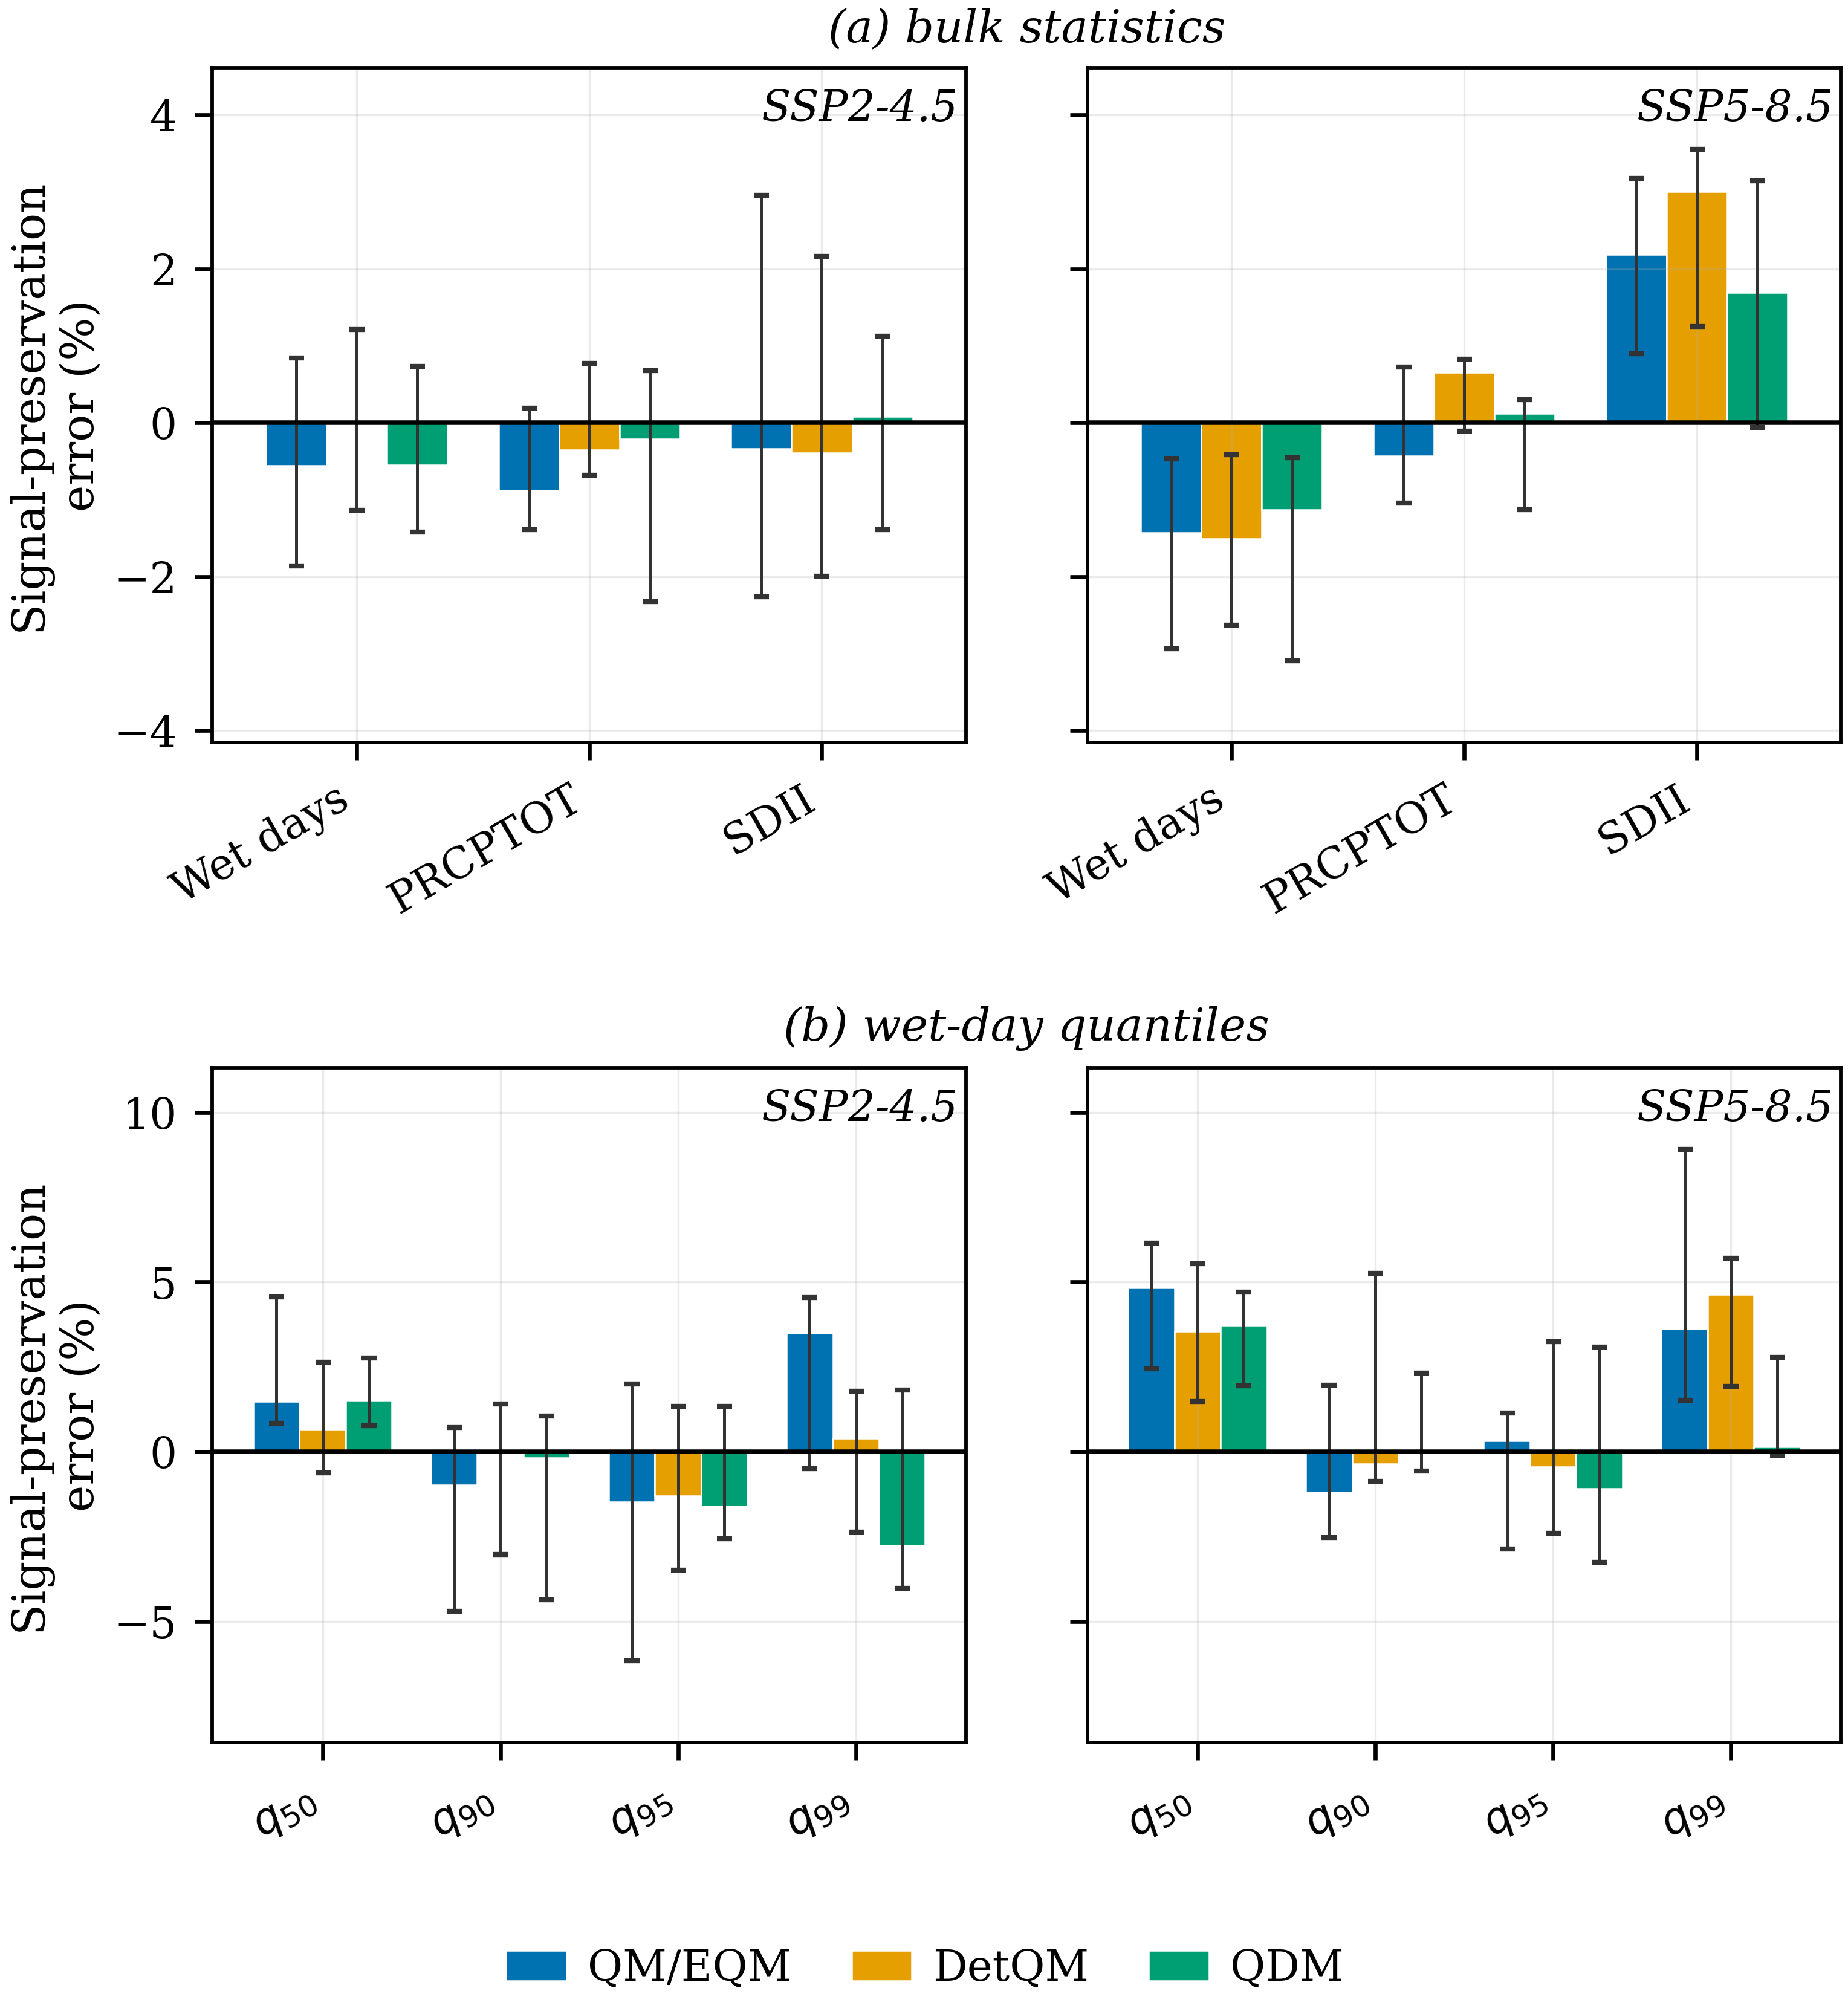
Figure 4 Signal-preservation error for 2021-2050 relative to the 1985-2004 baseline of the same model and method: (a) bulk statistics and (b) wet-day quantiles, each with the two scenarios side by side on a shared vertical scale. Bars are the ensemble median across the seven climate models and whiskers the inter-model interquartile range, a measure of spread and not a confidence interval; both follow Eq. (8). A value of zero means the raw model signal was reproduced exactly.
3.5 Preservation of extreme-rainfall signals
Errors were larger and the method contrasts wider for the derived extreme indices than for the direct quantiles (Table 2, Figure 5). The largest median error of the study was +24.94% for R99p under QDM in SSP2-4.5, against +6.95% for QM/EQM and +9.05% for DetQM; under SSP5-8.5 the same index gave +15.83%, +20.06% and +9.19%, with QDM now the smallest of the three. For the frequency of days above 50 mm the medians were +1.12%, −5.52% and −17.14% in SSP2-4.5 and +5.90%, +2.57% and +11.46% in SSP5-8.5.
The spread between the best and the worst method summarises how much the choice matters: 0.67 percentage points for annual precipitation in SSP2-4.5 against 18.26 for the frequency of days above 50 mm and 17.99 for R99p. Method-related differences are therefore substantially larger for several derived extreme indices than for the bulk statistics.
The method with the smallest absolute error for a direct quantile is not systematically the method with the smallest error for the indices derived from it. Under SSP2-4.5, QDM gave a median error of −2.77% at q99 yet +24.94% at R99p, the largest departure of any index and method in the study; under SSP5-8.5 the ordering reversed, QDM being smallest at both q99 and R99p. Preservation of a direct quantile signal and preservation of a derived threshold or tail index are separate properties, and the Nan results answer that question in the negative as the companion study did. Padulano et al. [20] reported the same for extreme rainfall, finding that the error of a quantile-based correction depends not only on the technique but on the magnitude and direction of the underlying bias and signal, and evidence from southern Africa likewise shows that the choice of quantile-mapping variant materially influences projected heavy precipitation and consecutive dry-day characteristics [21].
Across the sixteen indices, the smallest absolute error was returned by QDM in 14 of the 32 scenario-index combinations, by QM/EQM in 9 and by DetQM in 9, and the method with the smallest error was the same in both scenarios for only seven of the sixteen indices. A ranking established under one forcing pathway therefore transfers to the other for fewer than half of the indices examined.
Table 2 Climate-signal preservation for derived extreme-rainfall indices. Format and estimator as Table 1. The Type column records how each index is constructed.
Index | Type | Scenario | QM/EQM | DetQM | QDM | n
Rx1day | derived extreme | SSP2-4.5 | +3.91 [-0.43, +9.76] | +1.43 [-1.25, +9.85] | +1.16 [-0.13, +2.81] | 7
 |  | SSP5-8.5 | +3.00 [+1.32, +4.13] | +4.05 [+1.91, +5.25] | +1.64 [-0.01, +2.42]
R10mm | derived threshold | SSP2-4.5 | -1.66 [-1.96, -0.75] | +1.68 [+0.82, +3.94] | +0.44 [-2.69, +2.08] | 7
 |  | SSP5-8.5 | -3.40 [-4.69, +0.14] | +0.69 [-0.90, +3.82] | -2.99 [-4.82, +1.39]
R20mm | derived threshold | SSP2-4.5 | +0.02 [-6.39, +13.62] | +1.56 [-0.98, +17.24] | +15.95 [+3.52, +27.81] | 7
 |  | SSP5-8.5 | +1.30 [+1.19, +7.59] | +7.59 [+2.48, +17.52] | +10.71 [+6.43, +25.35]
R50mm | derived threshold | SSP2-4.5 | +1.12 [-23.50, +63.91] | -5.52 [-28.10, +51.66] | -17.14 [-19.21, +21.05] | 7
 |  | SSP5-8.5 | +5.90 [-15.71, +11.74] | +2.57 [-14.29, +15.35] | +11.46 [-12.63, +30.15]
R95p | derived tail | SSP2-4.5 | +0.84 [-1.94, +7.04] | +3.80 [-1.81, +8.93] | +3.17 [-9.38, +9.04] | 7
 |  | SSP5-8.5 | +1.37 [-1.40, +8.68] | +5.28 [-2.25, +17.92] | +6.27 [-10.40, +20.63]
R99p | derived tail | SSP2-4.5 | +6.95 [+3.30, +25.55] | +9.05 [+5.06, +28.75] | +24.94 [+3.51, +51.37] | 7
 |  | SSP5-8.5 | +15.83 [+4.70, +25.55] | +20.06 [+10.82, +25.20] | +9.19 [+4.48, +18.18]
Rx5day | sequence | SSP2-4.5 | +2.87 [+0.36, +7.61] | +3.11 [-0.31, +5.12] | +0.29 [+0.07, +3.77] | 7
 |  | SSP5-8.5 | +2.07 [-0.01, +5.58] | +2.83 [+0.07, +5.45] | -0.92 [-1.60, +1.86]
CDD | sequence | SSP2-4.5 | -3.28 [-7.51, -0.55] | -4.90 [-8.28, -1.52] | -2.85 [-7.23, -1.16] | 7
 |  | SSP5-8.5 | -0.50 [-3.76, -0.17] | -1.65 [-5.30, +0.52] | -0.75 [-3.56, +0.47]
CWD | sequence | SSP2-4.5 | +1.35 [-0.07, +3.26] | +2.24 [+0.31, +3.60] | +1.46 [+0.50, +4.47] | 7
 |  | SSP5-8.5 | -2.70 [-4.75, -0.27] | -2.24 [-3.71, -0.78] | -2.25 [-5.09, -0.05]
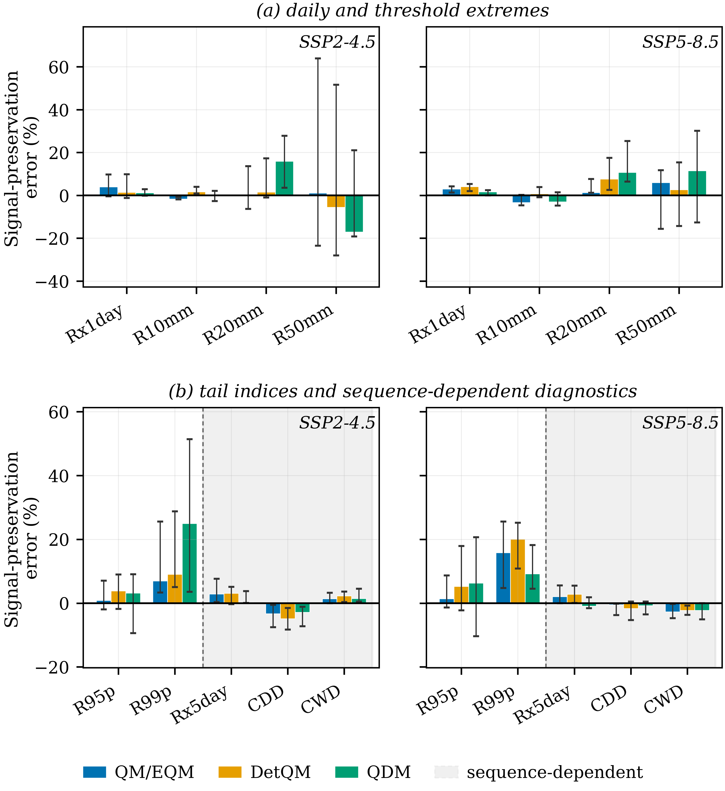
Figure 5 As Figure 4, for derived extreme-rainfall indices: (a) daily and threshold-derived extremes and (b) tail-derived and sequence-dependent indices, using the construction types of Table 2. Indices on the shaded background, to the right of the dashed rule, are sequence-dependent: a marginal transformation cannot reconstruct the day ordering on which they are defined. The same marking is used in Figures 2, 3 and 6.
3.6 Temporal dependence and persistence
Residual errors in the wet–dry sequence were very similar across the three methods (Supplementary Table S7). Over the validation period the mean absolute bias in the transition probability P(wet | wet) was 14.02% for QM/EQM, 14.09% for DetQM and 14.27% for QDM against 25.84% for the raw models, an improvement that follows from the shared frequency adaptation rather than from the intensity transformation. The lag-1 autocorrelation of occurrence was not improved by any method, at 37.38–37.53% against 33.15% before correction, and mean dry-spell length was made worse, at 37.71–38.31% against 22.45%. Mean wet-spell length improved from 64.56% to 48.38–48.83%.
That dry-spell statistics degrade while wet-spell statistics improve is consistent with the mechanism described in Section 3.2: raising the model wet-day threshold to match an observed wet-day frequency of about 62% converts many modelled dry days into wet ones, which lengthens wet spells towards the observed value and shortens dry spells away from it. The three methods differ by less than 0.7 percentage points on every sequencing statistic, because they share that occurrence model and differ only in the intensity transformation. Potter et al. [22] showed that quantile mapping cannot correct an underestimated autocorrelation in rainfall sequencing, which is what the unimproved lag-1 statistic shows here, and O'Brien et al. [23] noted that quantile mapping takes no account of consecutiveness and can insert wet-day interruptions into otherwise dry periods, which is the mechanism by which the dry-spell bias is made worse.
3.7 Relative roles of climate model and method effects
The additive main effect of the bias-correction method was small in both scenarios (Table 3). It reached at most 2.1% of the total sum of squares, for the frequency of days above 20 mm under SSP2-4.5, and at most 1.3% under SSP5-8.5, for q95. The climate-model main effect spanned 43.2% to 89.8% under SSP2-4.5 and 52.2% to 92.5% under SSP5-8.5.
The residual term ranged from 10.0% to 54.7% under SSP2-4.5 and from 7.4% to 47.1% under SSP5-8.5, and was largest for the same indices on which the methods diverged most. Because station is not an explicit factor, this term carries station-level and higher-order variation as well as the model × method interaction and cannot be read as interaction alone. The residual shares are smaller than those found in the companion province, where they reached 90%; the Nan network is more spatially coherent, with 14 gauges over a larger area and a stronger elevation gradient.
Table 3 Descriptive two-factor sum-of-squares partition of the projected change by climate model and bias-correction method, computed separately for each scenario, for the indices discussed in Section 3.7; the full listing is in Supplementary Table S6. N is the number of model x method x gauge cells entering the partition and n the number of contributing models. The residual includes the model x method interaction together with station-level and higher-order unmodelled variation, because station is not an explicit factor. This is not a variance-component analysis.
Scenario | Index | N | n | GCM main effect (%) | BC-method main effect (%) | Residual (%)
SSP2‑4.5 | PRCPTOT | 294 | 7 | 75.3 | 0.4 | 24.3
SSP2‑4.5 | R20mm | 294 | 7 | 43.2 | 2.1 | 54.7
SSP2‑4.5 | R50mm | 292 | 7 | 47.0 | 1.7 | 51.3
SSP2‑4.5 | R95p | 294 | 7 | 78.3 | 0.6 | 21.1
SSP2‑4.5 | SDII | 294 | 7 | 72.7 | 0.1 | 27.2
SSP2‑4.5 | q50 | 294 | 7 | 73.9 | 0.9 | 25.1
SSP5‑8.5 | PRCPTOT | 294 | 7 | 89.7 | 0.2 | 10.1
SSP5‑8.5 | R20mm | 294 | 7 | 61.9 | 1.2 | 37.0
SSP5‑8.5 | R50mm | 292 | 7 | 52.2 | 0.7 | 47.1
SSP5‑8.5 | R95p | 294 | 7 | 83.5 | 0.3 | 16.3
SSP5‑8.5 | SDII | 294 | 7 | 84.1 | 0.2 | 15.7
SSP5‑8.5 | q50 | 294 | 7 | 73.9 | 0.4 | 25.7
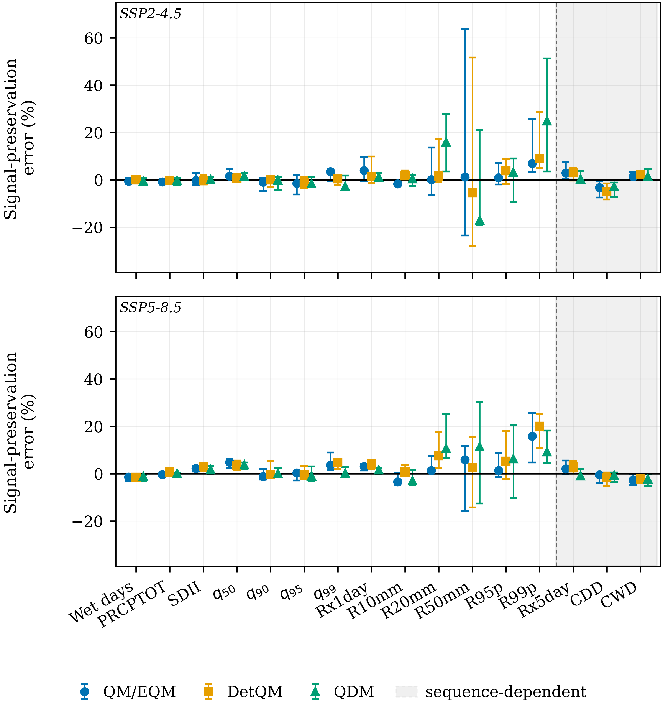
Figure 6 Signal-preservation error for every index and method, with (a) SSP2-4.5 and (b) SSP5-8.5 on a shared vertical scale. Values are those of Tables 1 and 2. Symbols are ensemble medians and bars the inter-model interquartile range. Indices to the right of the dashed rule, on the shaded background, are sequence-dependent, marked as in Figures 2, 3 and 5.
3.8 Implications for impact studies
The order of operations matters more than the choice of method. Screening the observed record for homogeneity, and placing the calibration and validation periods inside a homogeneous era, changed the out-of-sample residual from 52.09% to 14.56% and changed the conclusion from "no method works" to "all three work about equally well". No choice among QM/EQM, DetQM and QDM comes close to that effect.
Given a homogeneous record, method selection should follow the target quantity. For annual precipitation and the wet-day quantiles the differences between methods are within about 1.4 percentage points and any of the three would support the same conclusion. For indices built on threshold exceedance the differences reach 18 percentage points and their sign changes between scenarios, so a study reporting a single method conveys less than the evidence supports. For drought-duration indicators the limiting factor is not the method but the uncorrected sequencing, which here is made worse rather than better by the correction, and which points towards approaches that model occurrence explicitly.
3.9 Limitations
The discontinuity confines the analysis to 1981–2004. The calibration sample is twelve years, shorter than is desirable for empirical quantile mapping in the upper tail, and the baseline is 1985–2004 rather than a recent twenty years, so the projected changes are expressed relative to an older reference period than is customary. The post-2006 decade is excluded altogether, so nothing here describes the recent observed climate of Nan.
Each model contributes one realisation, so the forced response cannot be separated from internal variability. Station history metadata were unavailable, so the discontinuity is documented but not attributed. Raw model fields deliver only one to four distinct series across the province, limiting spatial inference, and only two emission pathways and one future window were examined. All three methods are marginal daily transformations, so the comparison cannot establish how a method that models temporal structure explicitly would behave.
4. Conclusions
Screening the observed record was decisive. A split-sample straddling a network-wide discontinuity in the Nan gauge record left a residual out-of-sample error of 52.09%, worse than the uncorrected models; moving both periods inside the homogeneous era reduced it to 14.56% and improved every primary metric. All three methods then reduced calibration bias to below 1.8% and converged out of sample to within 2.8 percentage points of one another. Climate-signal preservation stayed within 4.84% for bulk statistics and direct quantiles but reached 24.94% for a tail index, and no method had the smallest absolute error consistently across scenarios and indices. Sequence-dependent indices were made worse by correction. Homogeneity screening should therefore precede method comparison, and method choice should be matched to the rainfall characteristic of interest.
5. Acknowledgements
The author thanks the Royal Irrigation Department and the Thai Meteorological Department for the rain-gauge records, the World Climate Research Programme for coordinating the Coupled Model Intercomparison Project, and the modelling groups listed in Supplementary Table S10 for making their output available.
6. Conflict of interest
The author declares no conflict of interest.
7. Declaration of generative artificial intelligence in the writing process
During the preparation of this work the author used a generative artificial intelligence assistant for code review, statistical verification and language editing. The author reviewed and edited the content afterwards and takes full responsibility for the publication.
8. References
[1] Cannon, A.J., Sobie, S.R., Murdock, T.Q. Bias correction of GCM precipitation by quantile mapping: how well do methods preserve changes in quantiles and extremes? Journal of Climate, 2015, 28(17), 6938-6959.
[2] Maraun, D. Bias correcting climate change simulations: a critical review. Current Climate Change Reports, 2016, 2(4), 211-220.
[3] Teutschbein, C., Seibert, J. Bias correction of regional climate model simulations for hydrological climate-change impact studies: review and evaluation of different methods. Journal of Hydrology, 2012, 456-457, 12-29.
[4] Khadka, D., Babel, M.S., Collins, M., Shrestha, S., Virdis, S.G.P., Chen, A.S. Projected changes in the near-future mean climate and extreme climate events in northeast Thailand. International Journal of Climatology, 2022, 42(2), 1088-1111.
[5] Kuinkel, D., Promchote, P., Upreti, K.R., Aryal, D., Bhandari, S., Adhikari, S. Projected changes in precipitation extremes in southern Thailand using CMIP6 models. Theoretical and Applied Climatology, 2024, 155(9), 8703-8716.
[6] Tandon, A., Awasthi, A., Pattnayak, K.C. Extreme precipitation projections in Asian subregions: study on CMIP6 development, geographic patterns, and research gaps. Physics and Chemistry of the Earth, 2025, 140, 103963.
[7] Devadarshini, E., Geethalakshmi, V., McDermid, S.P., Bhuvaneswari, K., Mohan Kumar, S., Sathyamoorthy, N.K., … Anandhi, V. A systematic review of climate downscaling and extremes in Coupled Model Intercomparison Project 6 (CMIP6). Environmental Development, 2025, 56, 101280.
[8] Eyring, V., Bony, S., Meehl, G.A., Senior, C.A., Stevens, B., Stouffer, R.J., … Taylor, K.E. Overview of the Coupled Model Intercomparison Project Phase 6 (CMIP6) experimental design and organization. Geoscientific Model Development, 2016, 9(5), 1937-1958.
[9] O'Neill, B.C., Tebaldi, C., van Vuuren, D.P., Eyring, V., Friedlingstein, P., Hurtt, G., … Sanderson, B.M. The Scenario Model Intercomparison Project (ScenarioMIP) for CMIP6. Geoscientific Model Development, 2016, 9(9), 3461-3482.
[10] Ziehn, T., Chamberlain, M.A., Law, R.M., Lenton, A., Bodman, R.W., Dix, M., … Srbinovsky, J. The Australian Earth System Model: ACCESS-ESM1.5. Journal of Southern Hemisphere Earth Systems Science, 2020, 70(1), 193-214.
[11] Danabasoglu, G., Lamarque, J.F., Bacmeister, J., Bailey, D.A., DuVivier, A.K., Edwards, J., … Strand, W.G. The Community Earth System Model version 2 (CESM2). Journal of Advances in Modeling Earth Systems, 2020, 12(2), e2019MS001916.
[12] Swart, N.C., Cole, J.N.S., Kharin, V.V., Lazare, M., Scinocca, J.F., Gillett, N.P., … Winter, B. The Canadian Earth System Model version 5 (CanESM5.0.3). Geoscientific Model Development, 2019, 12(11), 4823-4873.
[13] Döscher, R., Acosta, M., Alessandri, A., Anthoni, P., Arneth, A., Arsouze, T., … Zhang, Q. The EC-Earth3 Earth system model for the Coupled Model Intercomparison Project 6. Geoscientific Model Development, 2022, 15(7), 2973-3020.
[14] Li, L., Yu, Y., Tang, Y., Lin, P., Xie, J., Song, M., … Wang, B. The Flexible Global Ocean-Atmosphere-Land System Model grid-point version 3 (FGOALS-g3): description and evaluation. Journal of Advances in Modeling Earth Systems, 2020, 12(9), e2019MS002012.
[15] Tatebe, H., Ogura, T., Nitta, T., Komuro, Y., Ogochi, K., Takemura, T., … Kimoto, M. Description and basic evaluation of simulated mean state, internal variability, and climate sensitivity in MIROC6. Geoscientific Model Development, 2019, 12(7), 2727-2765.
[16] Yukimoto, S., Kawai, H., Koshiro, T., Oshima, N., Yoshida, K., Urakawa, S., … Ishii, M. The Meteorological Research Institute Earth System Model version 2.0, MRI-ESM2.0: description and basic evaluation of the physical component. Journal of the Meteorological Society of Japan, 2019, 97(5), 931-965.
[17] Themeßl, M.J., Gobiet, A., Heinrich, G. Empirical-statistical downscaling and error correction of regional climate models and its impact on the climate change signal. Climatic Change, 2012, 112(2), 449-468.
[18] Zhang, X., Alexander, L., Hegerl, G.C., Jones, P., Klein Tank, A., Peterson, T.C., … Zwiers, F.W. Indices for monitoring changes in extremes based on daily temperature and precipitation data. WIREs Climate Change, 2011, 2(6), 851-870.
[19] Song, Y.H., Chung, E.-S. Intercomparison of bias correction methods for precipitation of multiple GCMs across six continents. Geoscientific Model Development, 2025, 18(21), 8017-8045.
[20] Padulano, R., Gomez-Mogollon, L.A., Napolitano, L., Rianna, G. Quantile-based bias-correction of extreme rainfall: pros and cons of popular methods for climate signal preservation. Journal of Hydrology, 2025, 653, 132814.
[21] Potter, N.J., Chiew, F.H.S., Charles, S.P., Fu, G., Zheng, H., Zhang, L. Bias in dynamically downscaled rainfall characteristics for hydroclimatic projections. Hydrology and Earth System Sciences, 2020, 24, 2963-2979.
[22] O'Brien, E., Griffin, S., Duffy, C., Nolan, P. Resolving the dry period projection paradox: treat 'consecutiveness' as a nonlinearity. International Journal of Climatology, 2025, 45(11), e8745.
[23] Addisuu, A.A., Tsidu, G.M., Basupi, L.V. Impact of two variants of quantile mapping bias correction on CMIP6-based projections of extreme precipitation over southern Africa. International Journal of Climatology, 2026, 46(10), e70428.

