Short-record rainfall trend inference under serial and spatial dependence
A reproducible comparison of MK, HR-MMK-3, PW-MK, and TFPW-MK

Abstract
Trend tests used for short hydroclimatic records can produce materially different decisions when serial dependence is present. We compared the standard Mann–Kendall test (MK), a prespecified three-lag Hamed–Rao variance variant (HR-MMK-3), raw prewhitening (PW-MK), and trend-free prewhitening (TFPW-MK) in stationary Gaussian AR(1) records of length 33. Each calibration and power scenario used 10,000 replicates, while a complete-null Benjamini–Hochberg (BH) experiment used 5,000 replicates, 12 tests, temporal phi=0.4, and equicorrelated innovations (rho=0.3). At phi=0, empirical Type I error ranged from 4.7% to 7.5%. At phi=0.4, estimates were 17.2% for MK, 15.5% for HR-MMK-3, 4.5% for PW-MK, and 20.1% for TFPW-MK. PW-MK stayed closest to nominal size but lost substantial raw power as persistence increased; the other procedures often showed inflated rejection rates. BH did not repair miscalibrated marginal p-values. No method was uniformly reliable across the prespecified scenarios, so method agreement, calibration evidence, and multiplicity must be reported together.
Keywords: Mann–Kendall; autocorrelation; prewhitening; false discovery rate; Monte Carlo simulation; rainfall

1. Introduction
Monotonic-trend screening is common in hydroclimatology because rank procedures are robust to non-normal observations and outliers. That robustness does not remove the independence requirement of the ordinary MK null distribution. Positive serial dependence can inflate apparent trend evidence, while a transformation intended to remove dependence can also remove part of a real trend. The practical problem is therefore not to select a method by name, but to quantify its operating behavior for the record length and dependence range at issue.
This study prespecified a narrow, falsifiable comparison. It does not claim universal performance and does not tune methods after seeing the empirical rainfall results. The objective is to show how calibration, power, undefined variance factors, and BH behavior interact in records as short as the complete dry-season series used in the companion application.

2. Methods

2.1 Procedures
MK used the tie-corrected variance and continuity-corrected normal approximation; the Sen effect estimate used the actual time coordinates. HR-MMK-3 first removed the Sen line, computed autocorrelation of residual ranks, retained only individually significant lags 1–3, and multiplied the MK variance by the signed Hamed–Rao factor. A non-positive factor was declared undefined rather than clamped. PW-MK estimated lag-one dependence from the raw series and tested the prewhitened sequence, while reporting the original-series Sen slope. TFPW-MK estimated the Sen trend, prewhitened the detrended residuals, restored the trend, and then applied MK.

2.2 Simulation design
Stationary Gaussian AR(1) noise had unit marginal variance. We used n=33, phi values 0, 0.2, 0.4, 0.6, and 0.8, and standardized slopes 0 (calibration), 0.01, 0.025, and 0.05 standard deviations per year (raw power). Each cell used 10,000 seeded replicates. Wilson 95% intervals and Monte Carlo standard errors describe simulation uncertainty. Because elevated Type I error can inflate unadjusted power, power curves are not interpreted without their matching calibration curves.

2.3 Multiplicity experiment
The complete-null experiment simulated 5,000 replicate families of 12 series with phi=0.4 and spatial innovation correlation rho=0.3. BH was applied at alpha=0.05. For each replicate, FDP was V/max(R,1); FDR was the mean FDP. Under the complete null every rejection is false, so FDR equals the probability of one or more rejections (FWER). Mean rejection share was reported separately and was never substituted for FDR.

3. Results
Table 1. Empirical Type I error (95% Wilson interval).
Phi | MK | HR-MMK-3 | PW-MK | TFPW-MK
0.0 | 0.051 (0.046–0.055) | 0.075 (0.070–0.080) | 0.047 (0.043–0.051) | 0.056 (0.052–0.061)
0.2 | 0.099 (0.093–0.105) | 0.112 (0.106–0.118) | 0.050 (0.046–0.054) | 0.107 (0.101–0.113)
0.4 | 0.172 (0.164–0.179) | 0.155 (0.148–0.162) | 0.045 (0.042–0.050) | 0.201 (0.194–0.209)
0.6 | 0.293 (0.284–0.302) | 0.187 (0.179–0.194) | 0.046 (0.042–0.051) | 0.366 (0.357–0.376)
0.8 | 0.478 (0.469–0.488) | 0.276 (0.268–0.285) | 0.044 (0.040–0.048) | 0.606 (0.596–0.615)

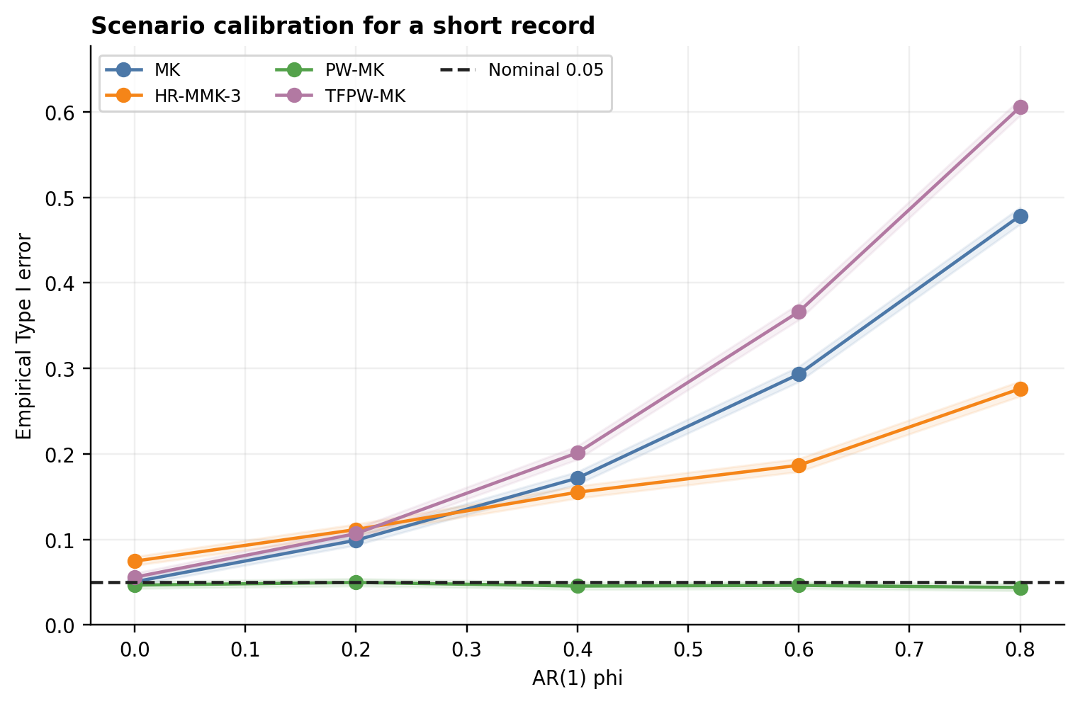
Figure 1. Type I error by AR(1) persistence. Shaded bands are Wilson 95% intervals; the dashed line is the nominal 0.05 level.
At phi=0, MK was compatible with the nominal level (5.1%), whereas HR-MMK-3 was high (7.5%). With positive persistence, MK, HR-MMK-3, and TFPW-MK became increasingly anti-conservative. PW-MK remained near 0.05 across the grid. HR-MMK-3 had 117 undefined replicates across the calibration grid; these were counted as non-rejections, making its displayed rejection rates conservative with respect to that handling choice.

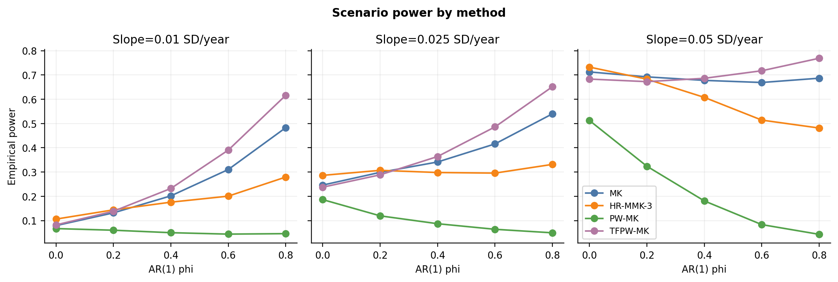
Figure 2. Raw empirical power. Curves must be interpreted with Figure 1 because size inflation can masquerade as power.
Table 2. Raw power for a standardized slope of 0.05 per year.
Phi | MK | HR-MMK-3 | PW-MK | TFPW-MK
0.0 | 0.713 | 0.733 | 0.512 | 0.683
0.2 | 0.692 | 0.683 | 0.324 | 0.672
0.4 | 0.678 | 0.608 | 0.181 | 0.686
0.6 | 0.669 | 0.514 | 0.083 | 0.717
0.8 | 0.687 | 0.481 | 0.043 | 0.769

Table 3. Complete-null BH experiment.
Method | FDR | FWER | Mean reject share | 95% interval | Undefined series
MK | 0.379 | 0.379 | 0.066 | 0.366–0.393 | 0
HR-MMK-3 | 0.399 | 0.399 | 0.062 | 0.386–0.413 | 206
PW-MK | 0.010 | 0.010 | 0.001 | 0.007–0.013 | 0
TFPW-MK | 0.466 | 0.466 | 0.086 | 0.453–0.480 | 0

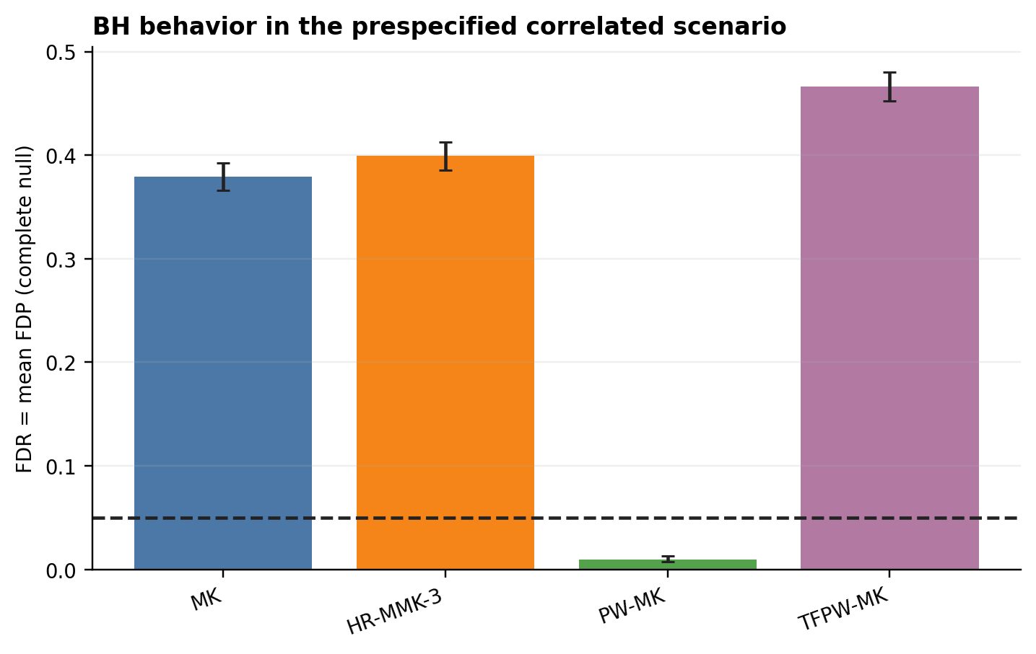
Figure 3. Complete-null FDR under the prespecified temporally and spatially correlated scenario.

4. Discussion

4.1 Findings
The prespecified short-record scenarios do not support a universal default. PW-MK was the only procedure that remained close to nominal Type I error across the phi grid, but its raw power decreased sharply as persistence increased because raw prewhitening removes low-frequency trend information. MK and TFPW-MK were strongly anti-conservative under positive persistence. HR-MMK-3 reduced inflation relative to MK at high phi but remained above nominal and was already anti-conservative at phi=0.
BH controlled neither FDR nor FWER when supplied with markedly miscalibrated marginal p-values. This is not a failure that multiplicity adjustment can be expected to repair: the quality of a multiple-testing procedure depends on the validity and dependence properties of its input p-values. The much smaller mean rejection share than FDR also demonstrates why E[R/m] is not an FDR estimator.

4.2 Uncertainty and limitations
The simulation used Gaussian continuous observations, a single record length, stationary AR(1) temporal dependence, equicorrelated innovations, fixed nominal alpha, and a three-lag HR rule. Rainfall totals may be skewed, zero-inflated at shorter aggregation scales, nonstationary, or affected by more complex dependence. Results are scenario evidence, not a theorem. Undefined HR factors were treated as non-rejections, and raw power was not size-adjusted.

4.3 Recommendations
Applications should (i) prespecify the test family and dependence treatment, (ii) report calibration evidence at the actual record length, (iii) retain effect sizes and dependence diagnostics, (iv) disclose undefined corrections and cross-method disagreement, and (v) avoid interpreting multiplicity adjustment as a repair for invalid marginal tests. When no candidate method is well calibrated for the data-generating regime, the conclusion should remain method-sensitive rather than selecting the most favorable p-value.

5. Reproducibility
This manuscript was generated from run prachuap-khiri-khan_e8bf031b3ba0. Scenario counts, seeds, software versions, source hashes, and all output hashes are recorded in run_manifest.json. The production package contains unit tests, independent comparisons with pymannkendall where definitions match, and CSV tables that control every value reported here.

References
Benjamini, Y., & Hochberg, Y. (1995). Controlling the false discovery rate: A practical and powerful approach to multiple testing. Journal of the Royal Statistical Society: Series B, 57, 289–300. https://doi.org/10.1111/j.2517-6161.1995.tb02031.x
Hamed, K. H., & Rao, A. R. (1998). A modified Mann–Kendall trend test for autocorrelated data. Journal of Hydrology, 204, 182–196. https://doi.org/10.1016/S0022-1694(97)00125-X
Mann, H. B. (1945). Nonparametric tests against trend. Econometrica, 13, 245–259. https://doi.org/10.2307/1907187
Sen, P. K. (1968). Estimates of the regression coefficient based on Kendall’s tau. Journal of the American Statistical Association, 63, 1379–1389. https://doi.org/10.1080/01621459.1968.10480934
Yue, S., & Wang, C. Y. (2002). Applicability of prewhitening to eliminate the influence of serial correlation on the Mann–Kendall test. Water Resources Research, 38(6). https://doi.org/10.1029/2001WR000861

