Observed rainfall trends across the Prachuap Khiri Khan gauge network, 1981–2014
Complete-period aggregation, dependence sensitivity, multiplicity control, and reproducible uncertainty

Abstract
We reanalyzed daily rainfall from 12 gauges in Prachuap Khiri Khan over 1981-01-01 to 2014-12-31 using fail-closed ingestion and complete-period aggregation. Annual and May–October wet-season series contained 34 complete periods per station; November–April dry seasons contained 33 after excluding incomplete edge seasons. The equal-weight gauge-network Sen slopes were 0.83 mm/year annually, -1.38 mm/year in the wet season, and 3.46 mm/year in the dry season. None of the 12 network tests across four methods survived BH adjustment. At stations, 7 method-specific decisions across 3 station-period combinations survived BH, but the pattern was method-sensitive and concentrated at stations 500002 and 500006. Residual-block bootstrap intervals included zero for annual and wet network slopes but excluded zero for dry (0.68 to 6.44 mm/year), a discrepancy that is not itself multiplicity-adjusted. Calibration simulations showed that none of the dependence procedures was uniformly reliable for a 33-year record. The defensible conclusion is therefore an inconclusive network-wide monotonic trend with localized, method-sensitive dry-season increases requiring independent confirmation.
Keywords: rainfall; Prachuap Khiri Khan; Mann–Kendall; Sen slope; hydrological season; autocorrelation; false discovery rate

1. Introduction
Rainfall-trend results can change when incomplete seasons, serial dependence, multiple station tests, and spatial interpretation are handled differently. The supplied legacy workflow mixed these issues and did not process every available station. This major revision separates data validation, aggregation, effect estimation, method sensitivity, multiplicity, and reporting so that each claim can be traced to a saved table and source hash.
The study asks whether monotonic changes are detectable in annual, wet-season, and dry-season totals at individual gauges and in an equal-weight gauge-network mean. The network statistic is explicitly not a province-wide areal mean because no spatial weighting or gridded integration is available.

2. Data and methods

2.1 Observations and quality control
The input contained 149,016 station-days for 12 station identifiers. Dates, station keys, and rainfall values were validated before analysis. Missing rainfall, negative rainfall, and duplicate station-day counts were all zero. Elevation was not supplied for 4 stations; coordinates were retained for all gauges. No synthetic values or silent input fallback were permitted.

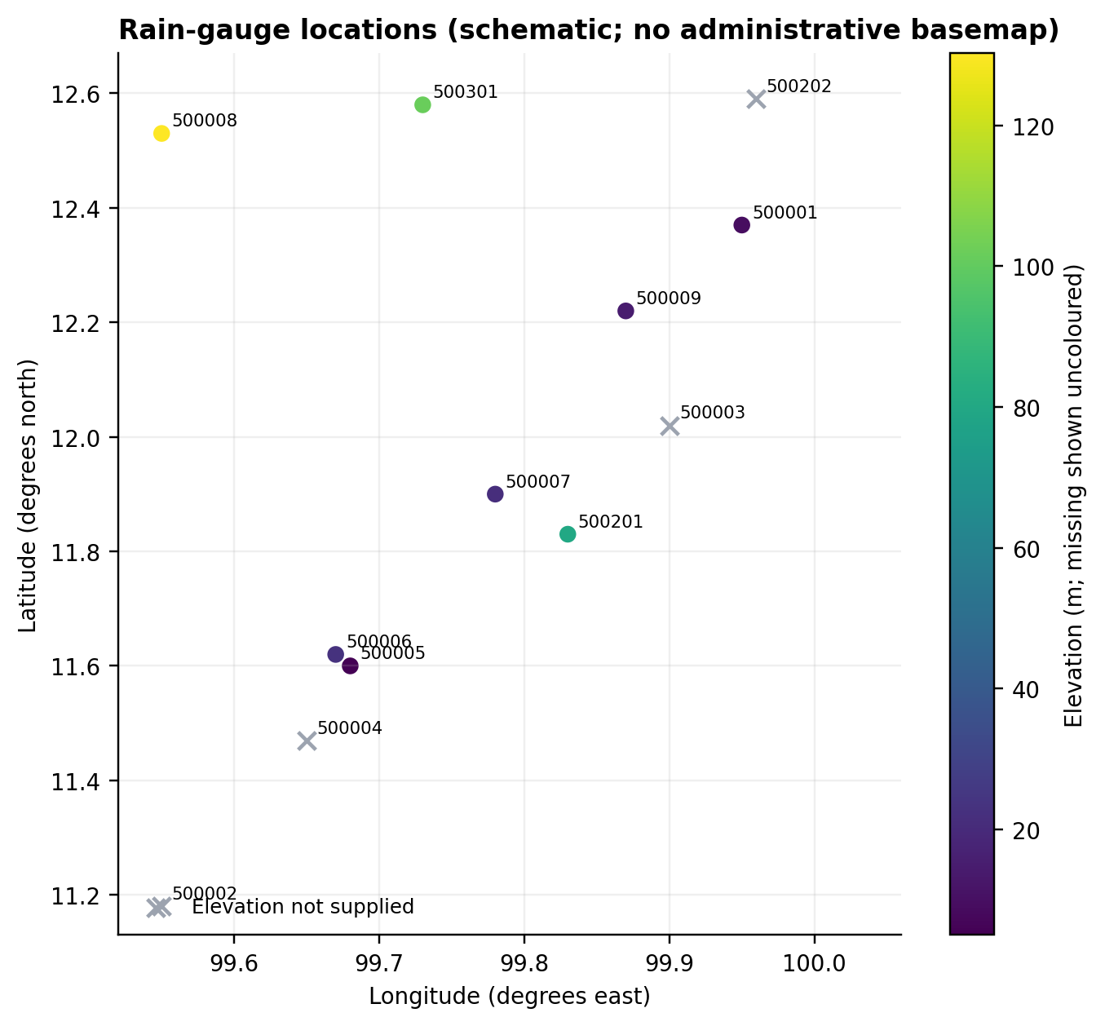
Figure 1. Gauge locations. The figure is a coordinate schematic without an administrative boundary or area-weighting interpretation.

2.2 Period definitions
Annual totals used January–December. Wet totals used May–October. Dry totals used November of the preceding calendar year through April of the label year. A period was retained only at 100% daily completeness. Consequently, annual and wet analyses spanned 1981–2014 (34 periods), whereas complete dry seasons spanned 1982–2014 (33 periods); the partial 1981 and 2015 dry endpoints were explicitly excluded.

2.3 Trend inference
Sen slope quantified change in millimetres per year using actual year coordinates. Four inference procedures were carried in parallel: MK, HR-MMK-3, PW-MK, and TFPW-MK. HR-MMK-3 was the prespecified three-lag variance-correction sensitivity procedure, not an all-lag or universally calibrated method. At stations, BH was applied separately within each period-by-method family of 12 tests. At the network level, BH was applied across the three periods within each method. A circular residual-block bootstrap with block length 3 and 2,000 seeded replicates described Sen-slope uncertainty on the original time axis.

3. Results

3.1 Seasonal rainfall contribution and network series
Across the 34 common calendar years, May–October contributed 79.0% of the summed equal-weight network annual rainfall. This is substantially less than the approximately 95% value in the legacy narrative and is calculated directly from the supplied daily observations. Interannual variability was large relative to the fitted monotonic slopes.
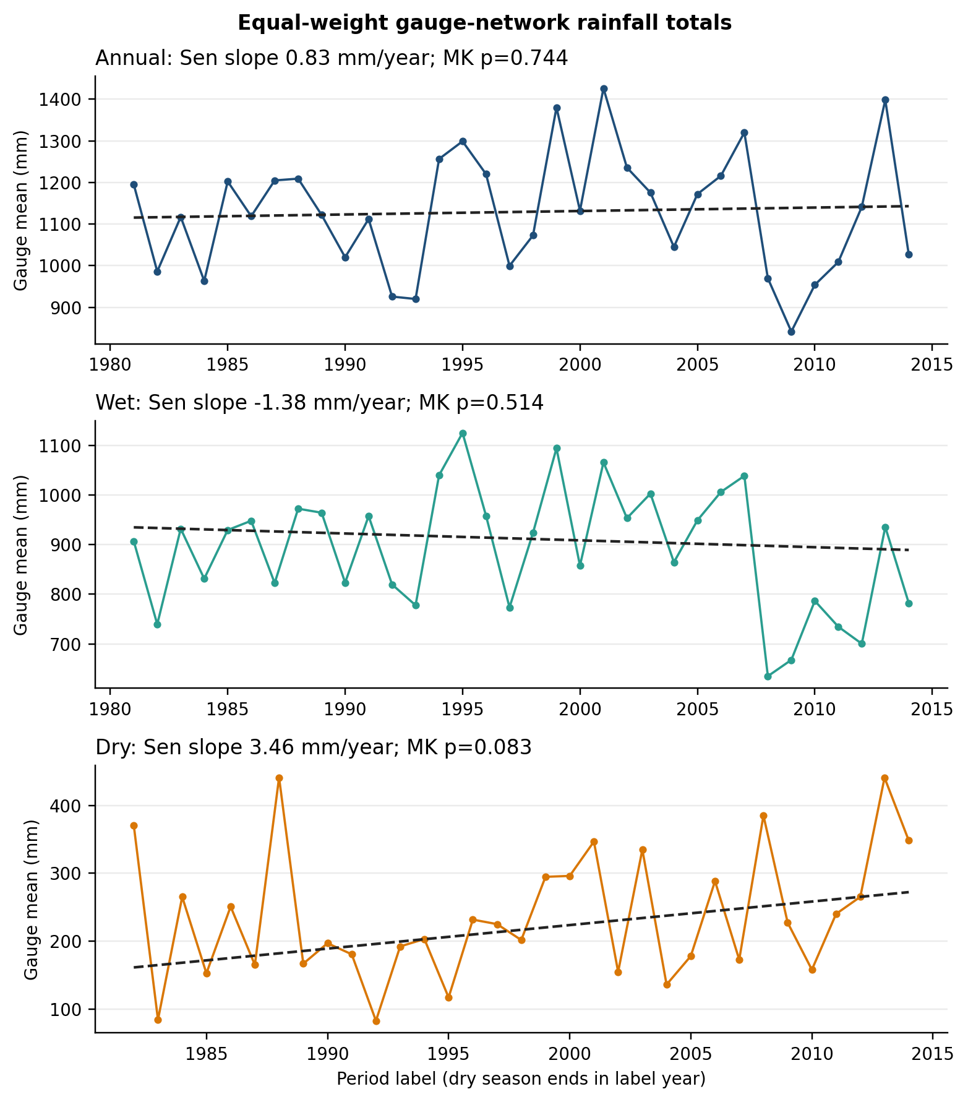
Figure 2. Equal-weight gauge-network totals and MK-associated Sen lines. Dry labels identify the year in which the season ends.
Table 1. Network trend estimates, tests, BH adjustment, and method-independent residual-block slope intervals.
Period | Method | N | Slope | p | q | BH | Bootstrap 95% CI
annual | HR-MMK-3 | 34 | 0.83 | 0.744 | 0.744 | no | -4.51 to 6.40
annual | MK | 34 | 0.83 | 0.744 | 0.744 | no | -4.51 to 6.40
annual | PW-MK | 33 | 0.83 | 0.889 | 0.889 | no | -4.51 to 6.40
annual | TFPW-MK | 33 | 0.83 | 0.865 | 0.865 | no | -4.51 to 6.40
dry | HR-MMK-3 | 33 | 3.46 | 0.083 | 0.248 | no | 0.68 to 6.44
dry | MK | 33 | 3.46 | 0.083 | 0.248 | no | 0.68 to 6.44
dry | PW-MK | 32 | 3.46 | 0.026 | 0.079 | no | 0.68 to 6.44
dry | TFPW-MK | 32 | 3.46 | 0.054 | 0.161 | no | 0.68 to 6.44
wet | HR-MMK-3 | 34 | -1.38 | 0.514 | 0.744 | no | -6.05 to 3.14
wet | MK | 34 | -1.38 | 0.514 | 0.744 | no | -6.05 to 3.14
wet | PW-MK | 33 | -1.38 | 0.588 | 0.881 | no | -6.05 to 3.14
wet | TFPW-MK | 33 | -1.38 | 0.546 | 0.818 | no | -6.05 to 3.14

For MK, annual slope was 0.83 mm/year (p=0.744, q=0.744); wet-season slope was -1.38 mm/year (p=0.514, q=0.744); and dry-season slope was 3.46 mm/year (p=0.083, q=0.248). No network result passed BH. PW-MK produced a smaller dry raw p-value (0.026) but still did not pass network BH.

3.2 Station results
Table 2. Method-specific station decisions surviving BH (all non-discoveries remain in the supplementary workbook).
Station | Period | Method | Slope | p | q | HR factor | Selected lags
500002 | annual | HR-MMK-3 | 9.18 | <0.001 | <0.001 | 0.247 | 2
500002 | dry | HR-MMK-3 | 5.77 | 0.006 | 0.033 | 1.000 | –
500002 | dry | MK | 5.77 | 0.006 | 0.033 | 1.000 | –
500002 | dry | TFPW-MK | 5.77 | 0.001 | 0.007 | 1.000 | –
500006 | dry | HR-MMK-3 | 6.78 | 0.002 | 0.025 | 1.000 | –
500006 | dry | MK | 6.78 | 0.002 | 0.025 | 1.000 | –
500006 | dry | TFPW-MK | 6.78 | <0.001 | 0.005 | 1.000 | –

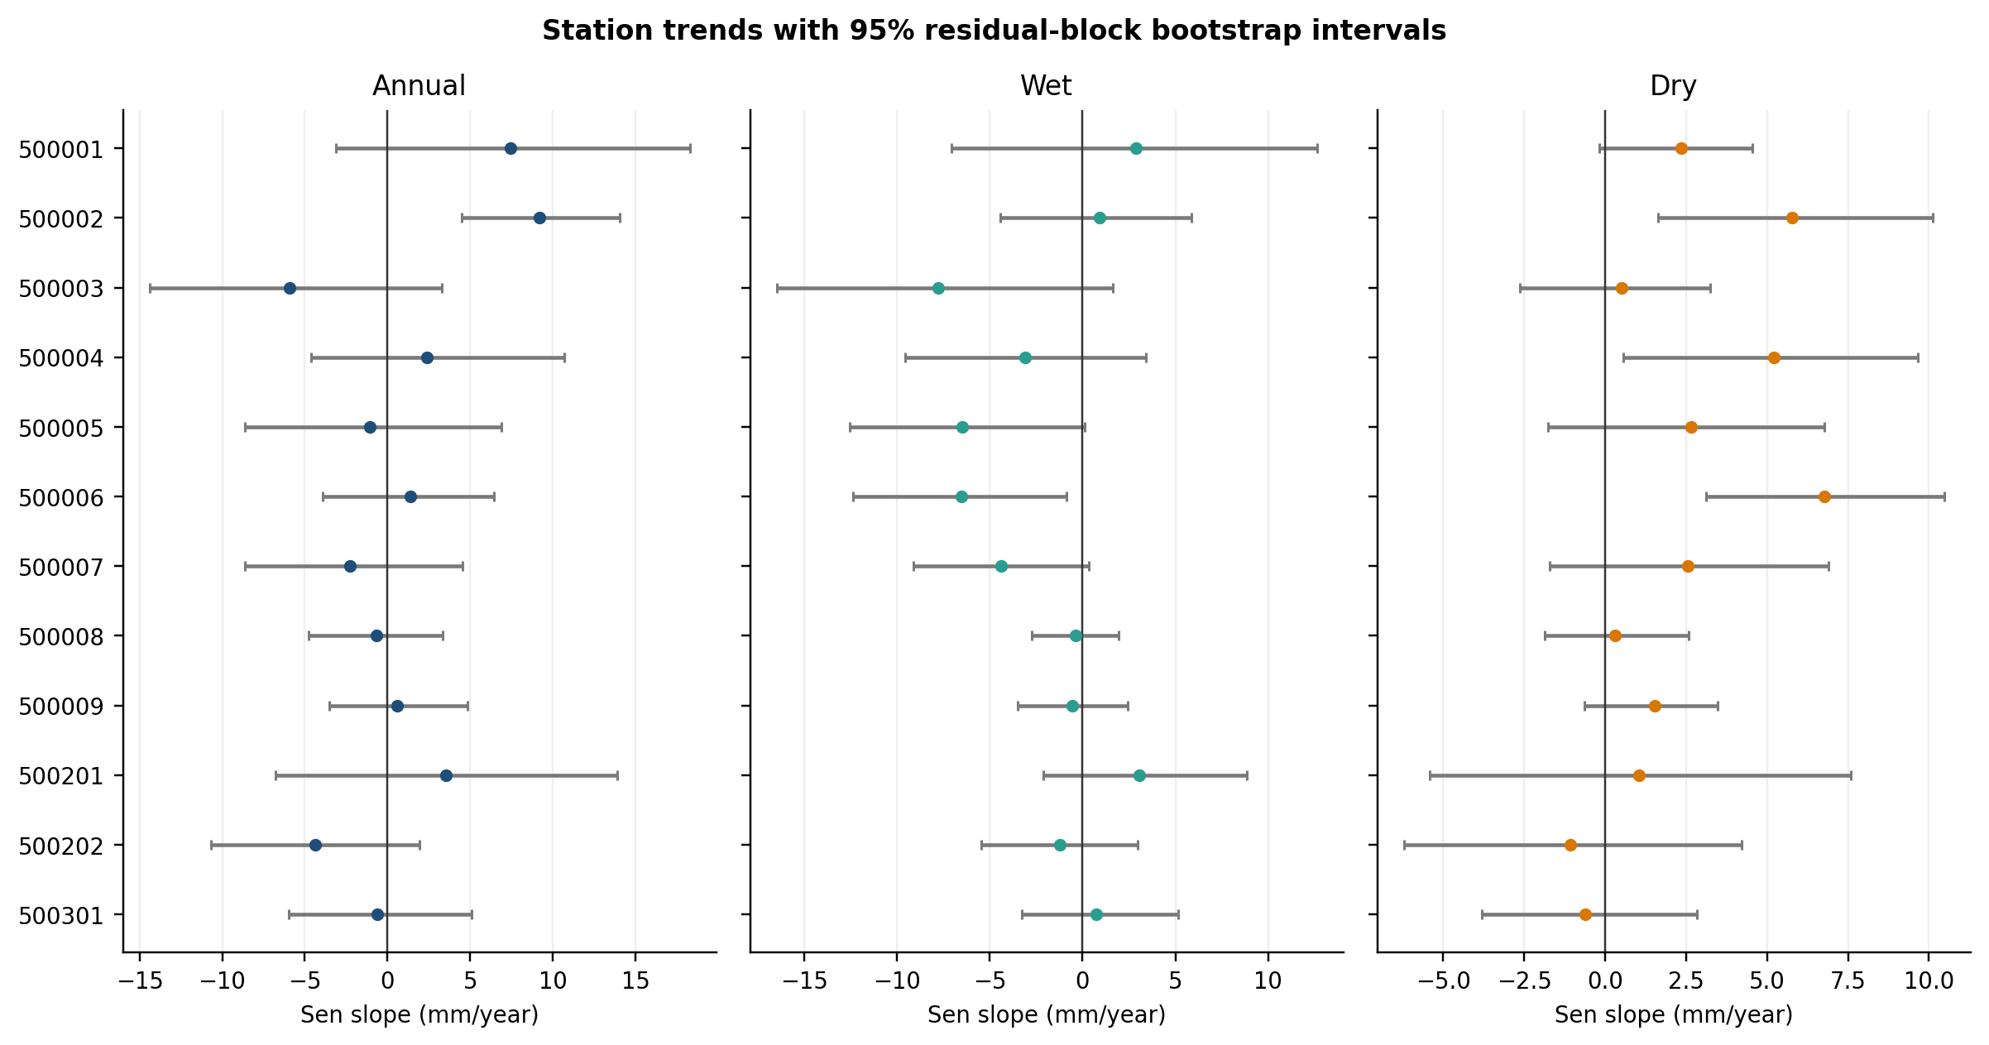
Figure 3. Station Sen slopes with 95% residual-block bootstrap intervals. Intervals are effect uncertainty summaries, not BH-adjusted hypothesis tests.
Seven method-specific rejections represented only three station-period combinations: station 500002 annual under HR-MMK-3, and dry seasons at stations 500002 and 500006 under MK, HR-MMK-3, and TFPW-MK. PW-MK produced no station discovery. For the station 500002 annual HR result, the signed variance factor was 0.247 after selecting lag 2; this variance deflation generated much stronger evidence than MK and should be treated as a method-sensitivity warning rather than a robust stand-alone discovery.

3.3 Bootstrap and hypothesis-test disagreement
Network bootstrap intervals were -4.51 to 6.40 mm/year annually, -6.05 to 3.14 mm/year for the wet season, and 0.68 to 6.44 mm/year for the dry season. The dry interval excluded zero even though no network test survived BH. The interval resamples residual blocks around the fitted trend and is not a multiplicity-adjusted test; the fixed block length and differing estimands can yield this disagreement. The conservative interpretation is increased dry-season rainfall magnitude with inconclusive network-wide monotonic-test evidence.

4. Discussion

4.1 Findings
The complete-period network shows little evidence of a monotonic annual or wet-season change. Dry-season totals have a positive effect estimate, but the inferential signal changes with the treatment of serial dependence and multiplicity. Local dry increases at two gauges recur across MK, HR-MMK-3, and TFPW-MK, yet disappear under raw prewhitening. The annual station 500002 HR result is driven by variance deflation and does not agree with the other methods after BH.

4.2 Scientific uncertainty
The companion simulation shows that MK, HR-MMK-3, and TFPW-MK can be anti-conservative for short positively persistent records, while PW-MK can be conservative and low-powered. Therefore, counting methods that reject is not a formal ensemble test. Homogeneity breaks, gauge relocations, exposure changes, and instrument metadata were unavailable. Fixed wet/dry month definitions may not capture year-to-year monsoon timing. Four elevation values were absent, and equal station weighting does not represent spatial rainfall area.

4.3 Recommendations
The present results support monitoring rather than a categorical province-wide trend claim. Future work should obtain station-history metadata, test homogenization and changepoints, repeat the analysis with spatial weighting or gridded products, evaluate alternative dependence models and block lengths, and extend the record. Confirmatory language should be reserved for effects that remain coherent across a prespecified, empirically calibrated method and multiplicity family.

5. Reproducibility and data provenance
All values in this manuscript were loaded from run prachuap-khiri-khan_e8bf031b3ba0; none were copied from the legacy DOCX. Input SHA-256 hashes, configuration, software environment, seeds, iteration counts, tables, figures, and output hashes are in run_manifest.json. The package fails when input paths, schemas, dates, station keys, or rainfall domains violate the declared contract. Unit tests cover ingestion, complete hydrological periods, MK-family calculations, BH adjustment, bootstrap determinism, simulation, and run immutability.

References
Benjamini, Y., & Hochberg, Y. (1995). Controlling the false discovery rate: A practical and powerful approach to multiple testing. Journal of the Royal Statistical Society: Series B, 57, 289–300. https://doi.org/10.1111/j.2517-6161.1995.tb02031.x
Hamed, K. H., & Rao, A. R. (1998). A modified Mann–Kendall trend test for autocorrelated data. Journal of Hydrology, 204, 182–196. https://doi.org/10.1016/S0022-1694(97)00125-X
Mann, H. B. (1945). Nonparametric tests against trend. Econometrica, 13, 245–259. https://doi.org/10.2307/1907187
Sen, P. K. (1968). Estimates of the regression coefficient based on Kendall’s tau. Journal of the American Statistical Association, 63, 1379–1389. https://doi.org/10.1080/01621459.1968.10480934
Yue, S., & Wang, C. Y. (2002). Applicability of prewhitening to eliminate the influence of serial correlation on the Mann–Kendall test. Water Resources Research, 38(6). https://doi.org/10.1029/2001WR000861

