AM CA2 Project: Weather App

Name: Surath Kumar Jhakal
UID: 20BIT022

Name: Ashwin Gupta
UID: 20BIT013

What does Project Do?
=> This is just a simple application where user enters any city name or location name and they get the weather details about that, so this was the simple overview about it.

Let me show you my application output

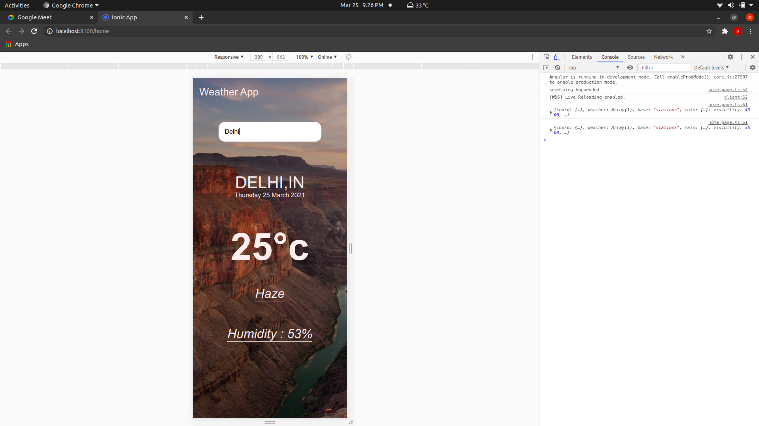

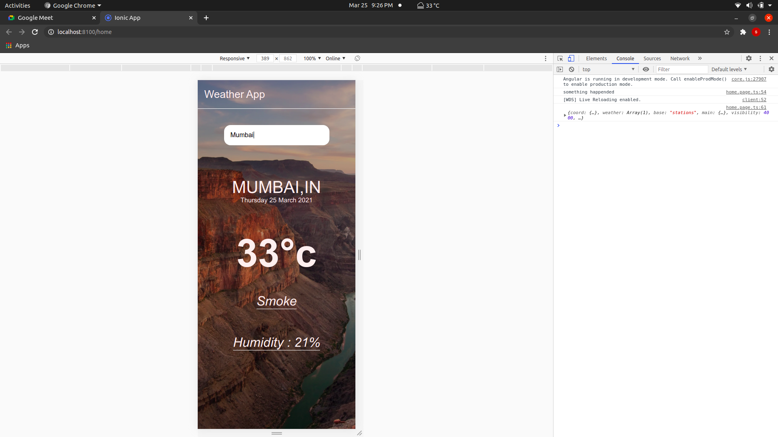

Now let me show you the code of it:

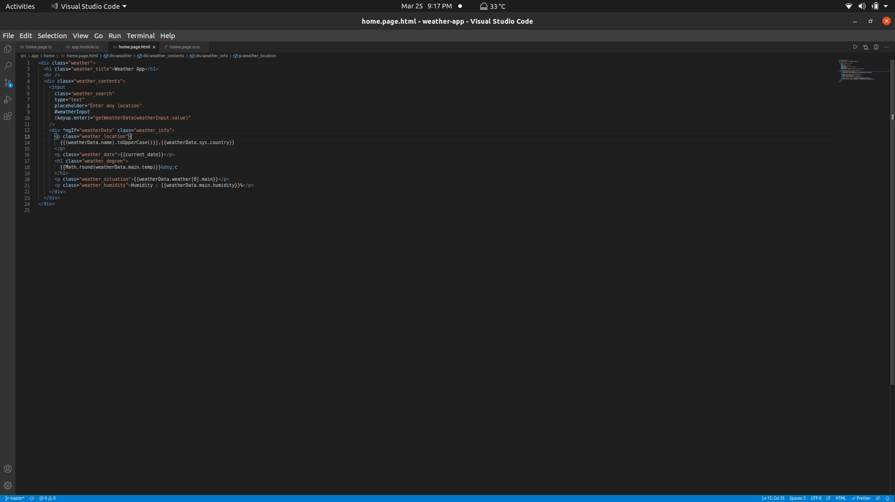

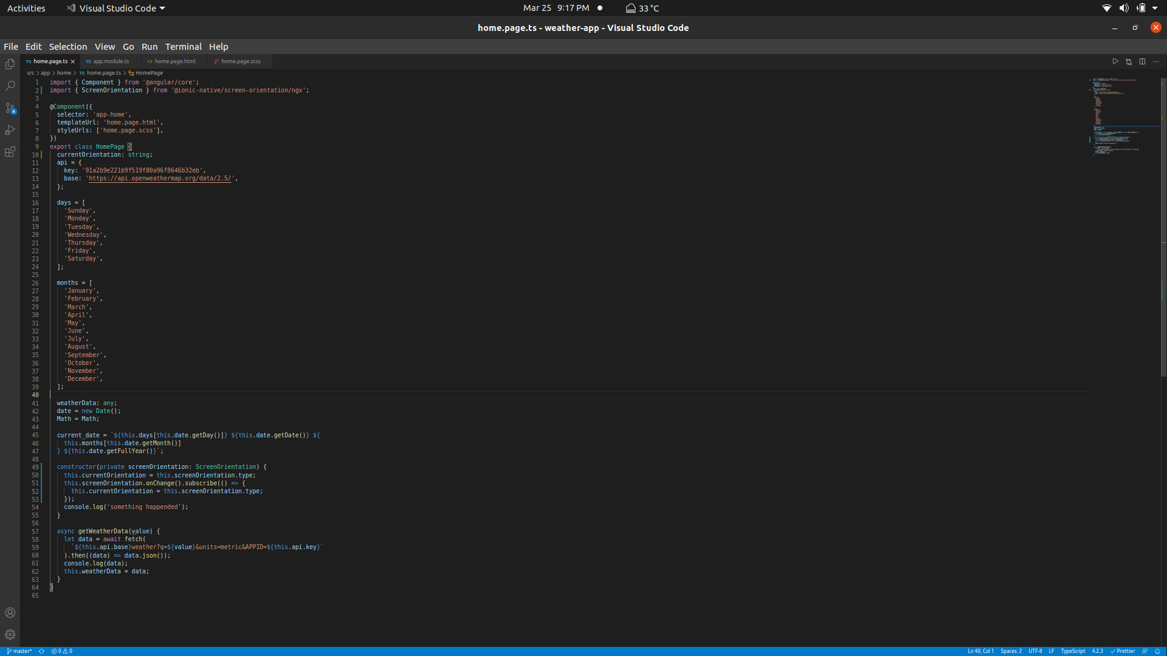
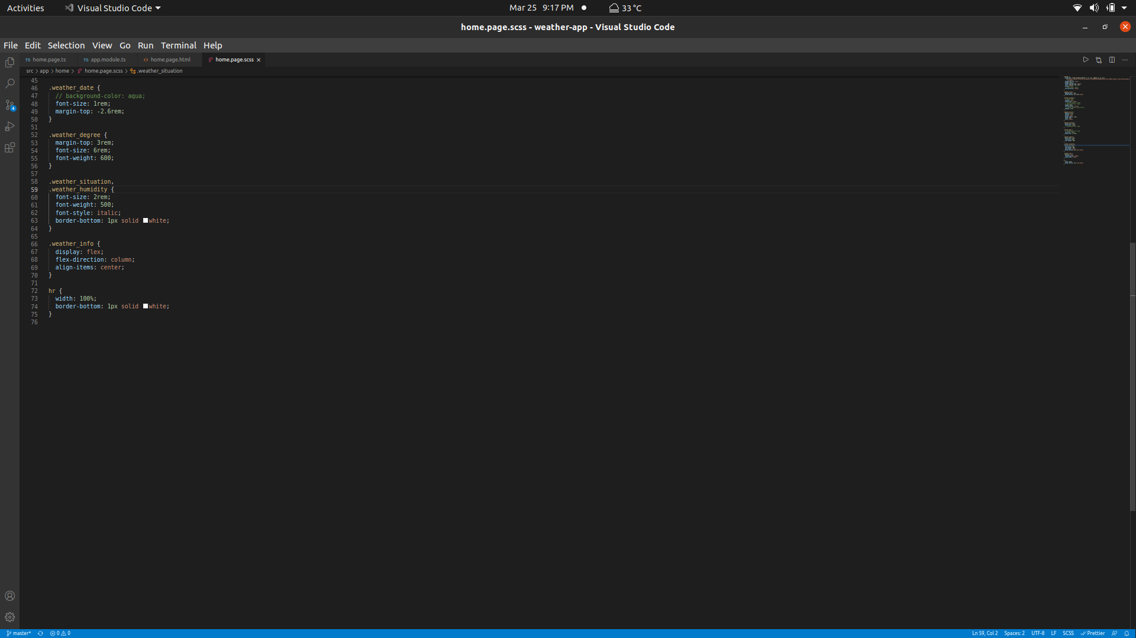

This was my overall :)

