Architecture Design Document
Legal Contract Review Orchestrator
Author: Person 1 (Coordinator, Architecture & Integration)
Status: DRAFT — for team review before Contract Freeze
Domain: Legal Contract Review (Clause Extraction → Risk Analysis → Redline Generation → Counter-Party Verification)
Stack: Python, LangGraph, LangChain Core, Pydantic, LangSmith

1. Purpose
This document defines the graph topology, node interfaces, routing rules, retry/rollback behavior, and termination conditions for the Generic Task Orchestrator instantiated in the Legal Contract Review domain. It is the reference all five team members build against. Once reviewed and approved, Person 2 will convert Section 6 (state design) into the frozen contract.py.

2. Domain Mapping
The generic 4-worker template maps onto the legal domain as follows:
Generic Role | Legal Domain Instantiation | Owner
Coordinator | Task router / loop controller | Person 1
Worker A — Analyzer | Clause Extractor + Risk Analyzer: parses raw contract text into structured clauses, tags each with a risk category | Person 2
Worker B — Actor | Redline Generator: calls (mocked) drafting tools to propose contract edits based on flagged risks | Person 3
Worker C — Validator | Counter-Party / Structural Validator: checks redlines are structurally valid and consistent with the original clause set before reporting | Person 4
Global: Tracing/Privacy | LangSmith redaction layer (client names, deal terms, PII) | Person 5
Global: Context Manager | Token/history pruning before each Coordinator loop | Person 5
Worker D — Reporter | Final counter-party verification summary + report compiler | Person 1

Note on team size: the assignment template assumes 6 owners (loop, silent-hallucination, rogue-tool, cascade, privacy, tokens). Your team has folded Reporter into Person 1's integration scope — confirm this is intentional before freeze, since the rubric grades "Global Graph Layer" work per-guardrail regardless of headcount.

3. Graph Topology
Coordinator routes to Analyzer on new tasks or retries (Route A), to Actor once analysis is validated (Route B), and to Reporter once validation succeeds (Route C). The Validator sits between Actor and Reporter and can force a rollback to the Coordinator with a rejection flag, incrementing round_number.
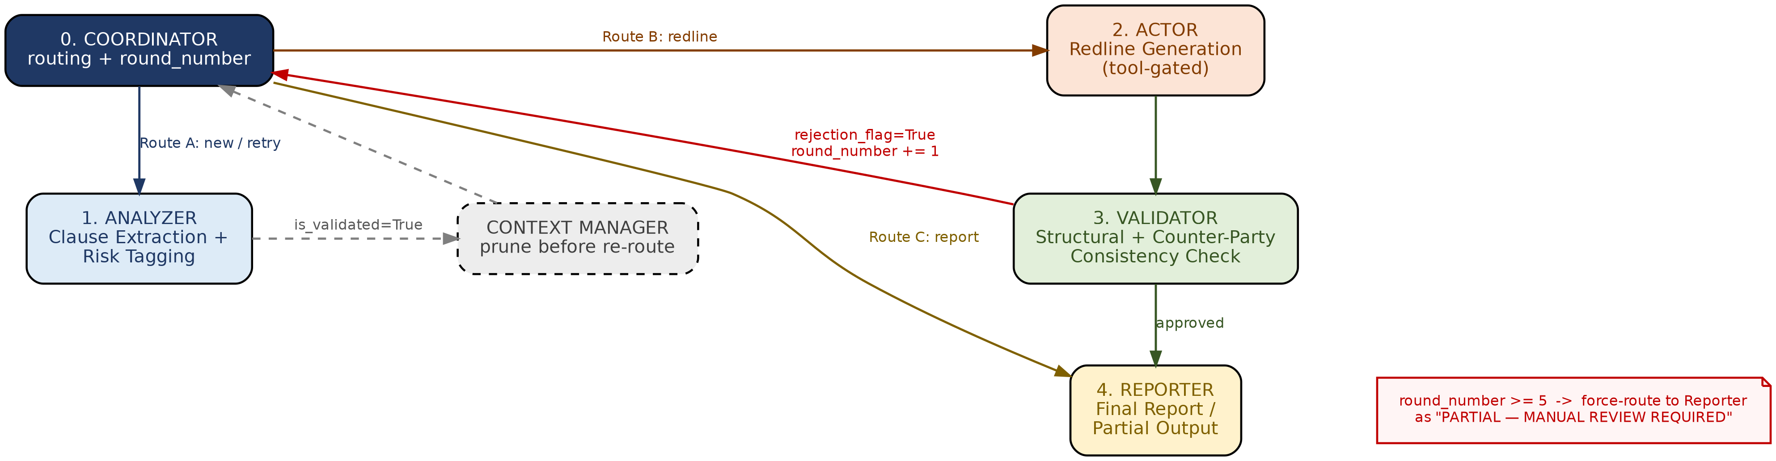
Terminal node: partial_output — reached only via forced short-circuit (Section 5.1) or successful Reporter completion.

4. Node Interfaces
Each node receives and returns the shared AgentState object (frozen contract, Section 6). No node may mutate state outside its declared fields — this is enforced by Person 4's rejection-flag logic at the Validator boundary, and by Pydantic validation on every node's return.
Node | Reads | Writes | External calls
Coordinator | round_number, is_validated, error_log, rejection_flag | round_number (+1 on loop), next_route | none (pure routing)
Analyzer | raw_input, error_log (on retry) | analysis_payload, is_validated, error_log | LLM (.with_structured_output)
Actor | analysis_payload | sanitized_tool_calls, execution_state | LLM + mocked drafting tools
Validator | sanitized_tool_calls, execution_state, analysis_payload | rejection_flag, validation_notes | none (deterministic checks)
Reporter | analysis_payload, execution_state, validation_notes | final_report | none (template/LLM summary)
Context Manager (P5) | messages | pruned messages, token_count | none — runs before Coordinator re-entry
Tracing Redactor (P5) | full state (read-only) | nothing (side-channel to LangSmith) | LangSmith

5. Routing, Retry, Rollback, Termination Rules

5.1 Termination — Infinite Loop Guardrail (Person 1)
- state.round_number increments every time the Coordinator routes back upstream (Route A after a rejection or validation error).
- Hard limit: round_number >= 5. On breach, the Coordinator does not raise an exception — it deterministically routes to partial_output, setting error_log with the last known failure reason, and the Reporter emits a "PARTIAL — MANUAL REVIEW REQUIRED" report instead of a full one.
- This check lives in the conditional-edge function, not in a prompt. It must be a plain Python if on the state field.

5.2 Retry (Person 2's scope, Coordinator enforces the count)
- Analyzer gets exactly one self-correction retry on a schema validation failure. The Coordinator does not distinguish "structured-output retry" from "loop retry" in round-counting — both consume a round. This is a deliberate design choice to keep the loop guardrail simple and universal; flag this in review if Person 2 disagrees.

5.3 Rollback (Person 4's scope, Coordinator handles the edge)
- If Validator sets rejection_flag = True, Coordinator routes back to Analyzer (Route A) with error_log populated from validation_notes, not back to Actor directly — this avoids re-running a redline against clauses that may themselves need re-extraction.
- If the same rejection_flag reason repeats twice in a row, Coordinator escalates directly to partial_output regardless of round_number, to avoid burning rounds on a deterministically unfixable error.

5.4 Rogue Tool Abort (Person 3's scope)
- If Actor raises InvalidToolCallException, this is not treated as a retryable error. Coordinator routes straight to partial_output with error_log = "BLOCKED: unauthorized tool call". No retry — a permission violation is not a transient failure.

6. Initial State Design (draft — for Person 2 to formalize into contract.py)
class AgentState(BaseModel):
task_domain: str = "legal_contract_review"
raw_input: str
round_number: int = 0
is_validated: bool = False
rejection_flag: bool = False
rejection_reason_history: List[str] = Field(default_factory=list)
error_log: Optional[str] = None
analysis_payload: Dict[str, Any] = Field(default_factory=dict) # clauses + risk tags
sanitized_tool_calls: List[str] = Field(default_factory=list) # approved redline actions
execution_state: Dict[str, Any] = Field(default_factory=dict) # Actor output
validation_notes: Optional[str] = None
final_report: Optional[str] = None
messages: List[Dict[str, Any]] = Field(default_factory=list) # pruned by Context Manager
token_count: int = 0
Open questions for freeze review:
- Should rejection_reason_history be in scope for v1, or is a single error_log string enough for the escalation rule in 5.3?
- Does Analyzer's clause/risk output need its own nested Pydantic model (ClauseRisk) inside analysis_payload, or stay as a loose dict for v1 speed?

7. Repository Structure
/orchestrator-legal-review/
├── README.md
├── DESIGN_DOCS.md
├── INTERVIEW_STORIES.md
├── contract.py # frozen after team review
├── main_system.py # Person 1 integrates here
├── [student_1_loop]/
│ ├── snippet.py # Coordinator + round_number guardrail
│ └── test_failure.py # infinite loop repro (guardrail disabled)
├── [student_2_silent]/
│ ├── snippet.py
│ └── test_failure.py
├── [student_3_rogue]/
│ ├── snippet.py
│ └── test_failure.py
├── [student_4_cascade]/
│ ├── snippet.py
│ └── test_failure.py
├── [student_5_trace]/
│ ├── snippet.py
│ └── test_failure.py
└── [student_6_tokens]/ # or folded into student_5 if team stays at 5
├── snippet.py
└── test_failure.py

8. Next Steps
- Team review of Sections 4–6 (interfaces + state) — flag disagreements before Contract Freeze.
- Person 2 formalizes Section 6 into contract.py, commits, freezes.
- Parallel build begins on individual guardrail folders.
- Person 1 builds Coordinator, loop guardrail, Reporter, then integrates all layers into main_system.py.
- Person 4 leads end-to-end testing once integration lands.

