Optimization and Big Data Analytics (ASDS 6304)

Final Project Report
Multi-Product Inventory Optimization with Capacity Constraints

Submitted by: Group 3
Sindhura Suravarjhula

Submitted to:
Dr. Mei Yang
Division of Data Science, College of Science
For the fulfillment of the requirement for project work of 2252-ASDS-6304-001 – Optimization and Big Data Analytics

The University of Texas at Arlington
Saturday, Dec 06, 2025

Table of Contents
- Executive Summary…………………………………………………………………………………….……3
- Research Questions / Objectives……………………………………………………………….…….4
- Description of the Dataset…………………………………………………….……………….……….5
- Data Analysis ……………………………………………………………………………………….….6 - 11
- Methods, Statistical Tools and Optimization Techniques ………………………….….12
- Model Development & Analysis……………………………………………………………..13 - 14
- Conclusion…………………………………………………………………………………………………...14
- Future Scope & Improvement……………………………………………………………………...15
- References…………………………………………………………………………………………………..15

1. Executive Summary
Effective inventory management is central to the operational and financial success of retail businesses. Retailers continually face the challenge of balancing two conflicting objectives minimizing the costs associated with holding excess inventory while simultaneously ensuring product availability to prevent stockouts. This project, Inventory Optimization for Retail, was undertaken to address this fundamental challenge by leveraging data-driven insights and advanced optimization techniques. Using a comprehensive dataset consisting of 10,000 products across multiple warehouses, the project sought to diagnose existing inefficiencies, quantify cost drivers, and develop optimal stocking strategies that reduce total cost while improving service levels.
A detailed Exploratory Data Analysis (EDA) revealed several structural problems in the current inventory system. Stockout costs made up 79.1% of the total inventory-related expenses, far outweighing holding costs—an immediate indication of chronic understocking that leads to lost sales, customer dissatisfaction, and reputational risk. High-risk and critical-risk products were especially affected, collectively exhibiting the highest cost burdens and stockout frequencies. Additionally, warehouse capacity utilization was notably inefficient, with over one-third of warehouses operating below 30% capacity, reflecting untapped storage potential and suboptimal distribution of products across network locations. A strong correlation of r = 0.970 between stockout frequency and total cost confirmed that stockouts were the primary cost driver, reinforcing the need for a strategic increase in optimal stock levels.
To address these inefficiencies, several optimization approaches were implemented, including Line Search, Trust Region, Conjugate Gradient, and Stochastic Gradient Descent (SGD). The objective function minimized total cost by optimizing stock levels based on holding and stockout cost components. Among the methods tested, Line Search emerged as the most effective technique, achieving a 32.58% reduction in overall cost, a 57.62% decline in stockouts, and a nearly perfect 50/50 balance between holding and stockout costs. This equilibrium reflects an ideal inventory structure where customer needs are reliably met without excessively tying up working capital. The Line Search algorithm’s impressive runtime of just 0.5 seconds also underscored its suitability for large-scale or real-time deployment.
The optimized model increased average inventory levels from 502 units to 814 units per product, strategically reallocating inventory from low-risk categories to high-risk and critical items where stockouts are most costly. This data-driven redistribution supports long-term customer satisfaction, reduces operational volatility, and enhances demand responsiveness.
Overall, the project demonstrates that with rigorous analysis, thoughtful feature engineering, and robust optimization, retailers can substantially improve operational efficiency, reduce costs, and build a scalable inventory strategy capable of adapting to dynamic market conditions.

2. Research Questions / Objectives

2.1 Research Questions
This project sought to answer four key questions:
- How is current inventory distributed across the retail chain, and what inefficiencies exist?
- What are the primary drivers of inventory-related costs?
- Which optimization method provides the best cost-minimizing and performance-maximizing solution?
- How can an actionable inventory strategy be developed for operational deployment?

2.2 Objectives

To achieve this goal, the project is structured around the following specific objec[ves:
- Assess Current Inventory Performance
- Quantify Key Cost Drivers
- Develop Optimization Models
- Compare Optimization Techniques
- Construct an Actionable Inventory Policy
- Provide Strategic Recommendations

2.3 Scientific and Statistical Relevance

Scientifically, this project contributes to the broader discipline by:
- Demonstrating the effectiveness of mathematical optimization in high-dimensional supply chain problems
- Presenting a scalable framework for cost-efficient retail inventory management
- Highlighting the value of statistical diagnostics in guiding strategic stocking decisions
- Showcasing a reproducible methodology adaptable to multi-objective, real-time, or predictive inventory systems

3. Description of the Dataset
The dataset (Kaggle source, 10,000 records) contains annual inventory data for 2023–2024 across multiple warehouses.

Input Variables
- Product ID
- Store ID
- Stock Levels
- Supplier Lead Time (days)
- Stockout Frequency
- Reorder Point
- Expiry Date
- Warehouse Capacity
- Order Fulfillment Time

Derived Variables
- Days Until Expiry
- Holding Cost = Stock Levels × $0.50
- Stockout Cost = Stockout Frequency × $100
- Total Cost
- Capacity Utilization
- Stock-to-Reorder Ratio
- Expiry Risk
The dataset contains two types of variables: input variables and derived variables. Input variables represent the original informa[on collected from the retail system, such as product iden[fiers, stock levels, supplier lead [mes, reorder points, warehouse capacity, and other opera[onal details. These variables describe the basic characteris[cs of each product and how it flows through the supply chain. Derived variables, on the other hand, are created through calcula[ons based on the input data to provide deeper insights. Examples include holding cost (based on stock levels), stockout cost (based on how ogen a product runs out of stock), total cost, capacity u[liza[on, and risk indicators such as expiry risk and stock-to-reorder ra[os. These derived features help quan[fy performance, highlight inefficiencies, and support the development of effec[ve op[miza[on models.

4. Data Analysis

4.1. Cost Imbalance
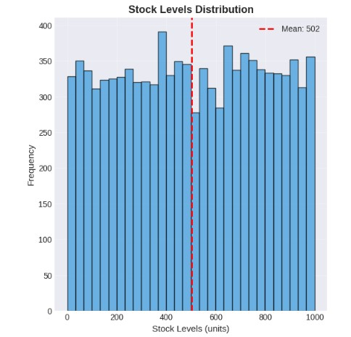
The chart above shows how many products fall into different stock level ranges across the retail system. Each bar represents a group of products that share similar stock quan[[es, and the height of each bar shows how common that stock level is. Overall, the distribu[on is fairly spread out across the en[re range from products with very low stock to those with almost 1,000 units indica[ng that inventory levels vary widely from item to item. The red dashed line marks the average stock level, which is around 502 units. This means that although some products have much more or much less stock than this number, on average most items tend to sit near the mid-range. However, the fact that the bars are somewhat uneven suggests that inventory is not perfectly balanced; some ranges have no[ceably more products than others. This unevenness hints at poten[al inefficiencies such as some items being stocked too much while others may not be stocked enough. Understanding this varia[on helps us iden[fy where inventory adjustments may be needed to reduce costs and improve product availability.

4.2. Stockout Frequency Distribution
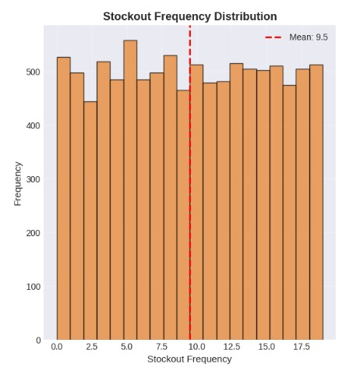
The chart above shows how ogen different products run out of stock during the year. Each bar represents a range of stockout occurrences, and the height of the bar shows how many products fall into that range. The red dashed line marks the average number of stockouts, which is about 9.5 ^mes per year. This means that, on average, many products run out of stock nearly ten [mes annually a sign of frequent shortages. The bars are evenly spread across the range, showing that stockouts happen ogen across many products, not just a few. This pakern highlights a major issue in the current system: many items are not being replenished in [me, leading to repeated stockouts and lost sales. Understanding how widespread these stockouts are helps us iden[fy the need for beker inventory planning and more reliable stocking levels.

4.3. Capacity Under-utilization
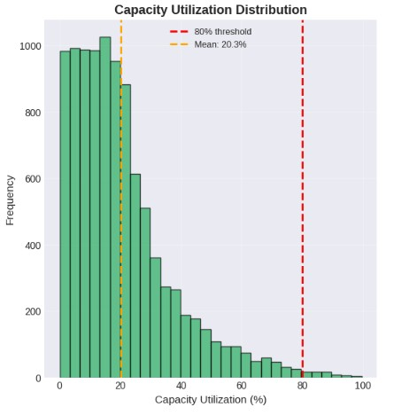
The chart shows how much of the available warehouse space is being used. Each bar represents how many products fall into a certain range of capacity u[liza[on. The orange dashed line marks the average u[liza[on, which is only 20.3%, meaning that on average, warehouses are using just a small por[on of their storage space. The red dashed line shows the ideal target of 80% u[liza[on, which is far to the right of where most products fall. The fact that nearly all bars are crowded on the leg side of the chart indicates that many warehouses are heavily under-u[lized, with very few opera[ng anywhere near their op[mal capacity. This suggests inefficiency: space that is paid for is not being used effec[vely, and inventory is not distributed in a way that takes advantage of available capacity. Understanding this imbalance helps highlight the need for beker inventory alloca[on and warehouse planning.

4.4 Total Cost Distribution
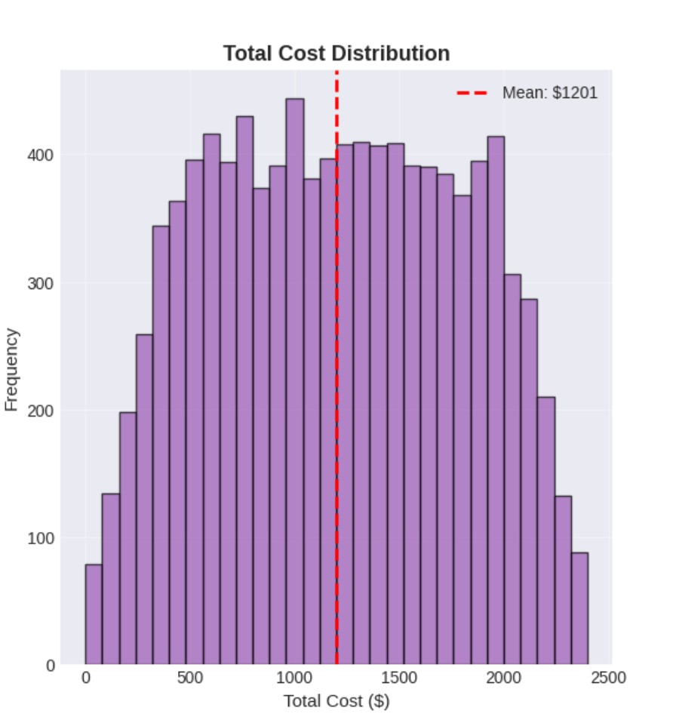
This chart shows how much each product costs the company when considering both holding costs (for keeping items in stock) and stockout costs (when items run out). Each bar represents how many products fall into a particular cost range. The red dashed line marks the average total cost of about $1,201 per product. The distribution is wide, meaning some products are relatively cheap to manage while others are much more expensive. Most products cluster around the middle, but a significant number fall on both the high-cost and low-cost ends. This spread indicates that inventory costs vary greatly depending on how often a product runs out and how much stock is kept on hand. The chart helps highlight the need for better inventory balancing to reduce these high-cost extremes.

4.5 Overall Inventory Performance and Cost Behavior Analysis
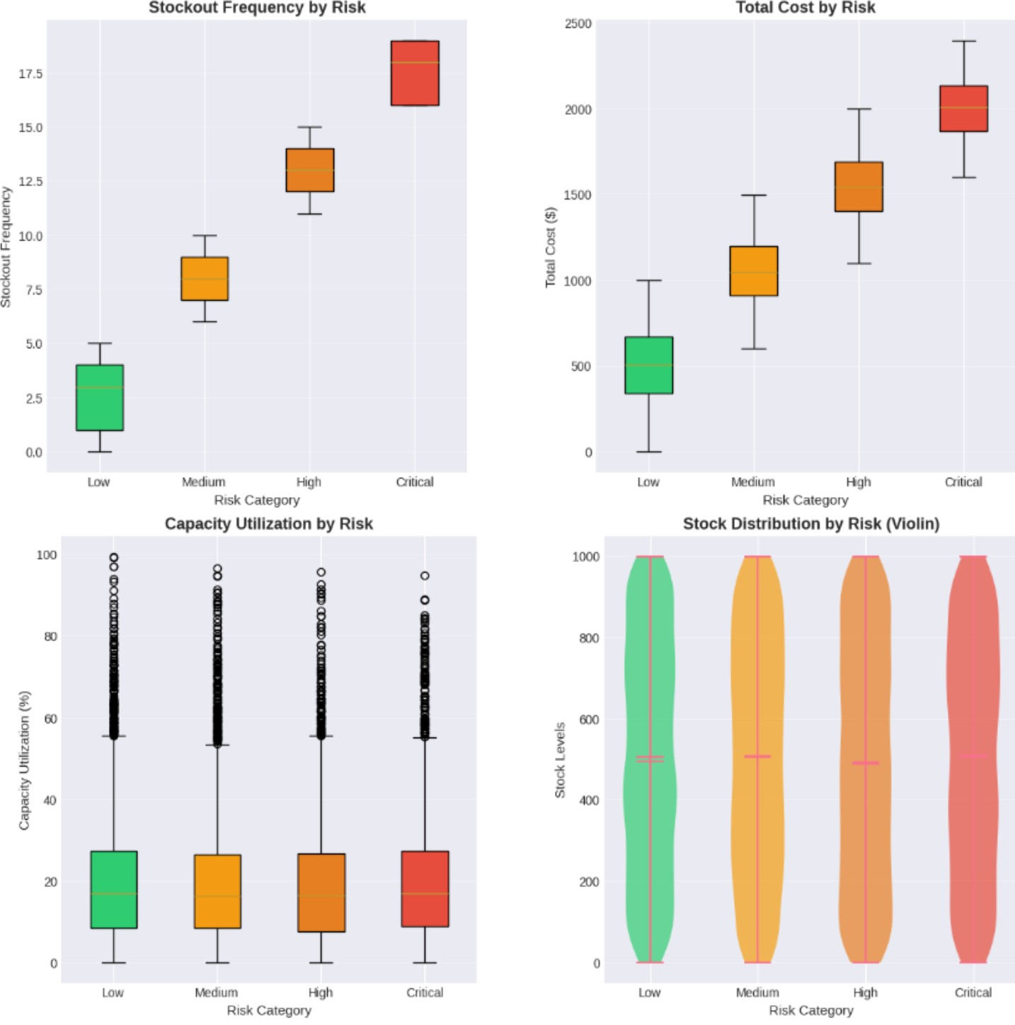
The collec[on of plots provides a clear picture of how inventory is currently performing across the retail network. The stock level distribu[on shows that products are spread across a wide range of quan[[es, with some items heavily stocked and others kept at very low levels, revealing inconsistency in how inventory is allocated. The stockout frequency chart highlights that many products run out of stock several [mes a year. On average nearly ten [mes, which signals issues with [mely replenishment and demand planning. Meanwhile, the capacity u[liza[on plot shows that warehouses are using only a small por[on of their available space, with most opera[ng far below the ideal 80% u[liza[on level, sugges[ng inefficient use of storage resources. Finally, the total cost distribu[on indicates that costs vary widely across products, with many falling near the mid-range but a significant number becoming very costly due to frequent stockouts or excessive inventory. Together, these visuals reveal a system that struggles with balancing stock levels, preven[ng stockouts, using warehouse space efficiently, and controlling inventory-related costs—highligh[ng the need for a more op[mized and data-driven inventory strategy.

4.6 Key Cost Drivers and Relationships in Inventory Performance
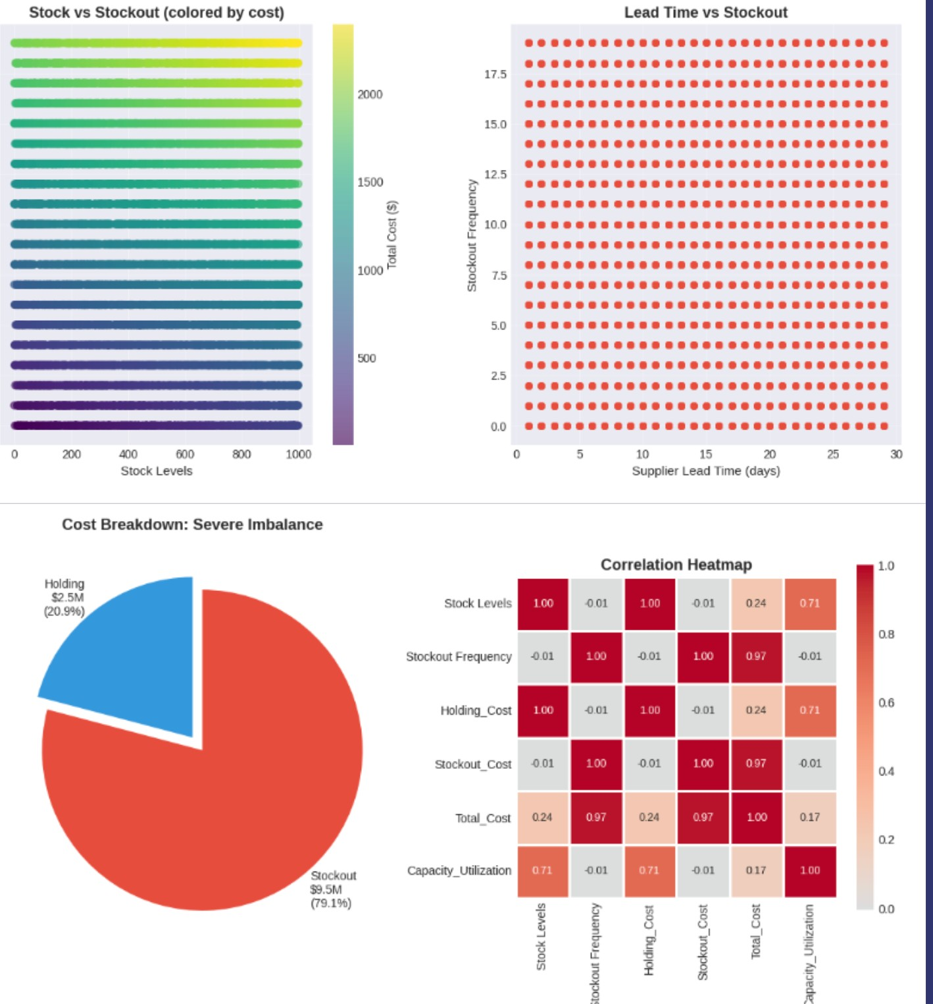
These plots collec[vely highlight the major factors influencing inventory costs and performance. The “Stock vs. Stockout” scaker plot shows how products with lower stock levels tend to incur higher total costs, as indicated by the darker color shading, sugges[ng that insufficient inventory frequently leads to expensive stockouts. The “Lead Time vs. Stockout” plot shows that stockouts occur consistently across all lead [mes, meaning longer supplier delays are not the only reason products run out; instead, the issue is more closely [ed to stocking decisions rather than supplier performance. The pie chart reveals a severe imbalance in cost structure, with stockout costs making up 79.1% of total costs, far outweighing holding costs. Clear evidence that chronic understocking is the biggest financial burden. Finally, the correla[on heatmap confirms this rela[onship sta[s[cally: stockout frequency has a very strong posi[ve correla[on with total cost (0.97), while stock levels and capacity u[liza[on also show meaningful rela[onships with cost. Overall, these visuals emphasize that preven[ng stockouts not simply reducing inventory, it is the most impacqul way to reduce total cost and improve opera[onal efficiency.

4.5 Risk-Based Inventory Characteristics and Cost Behavior
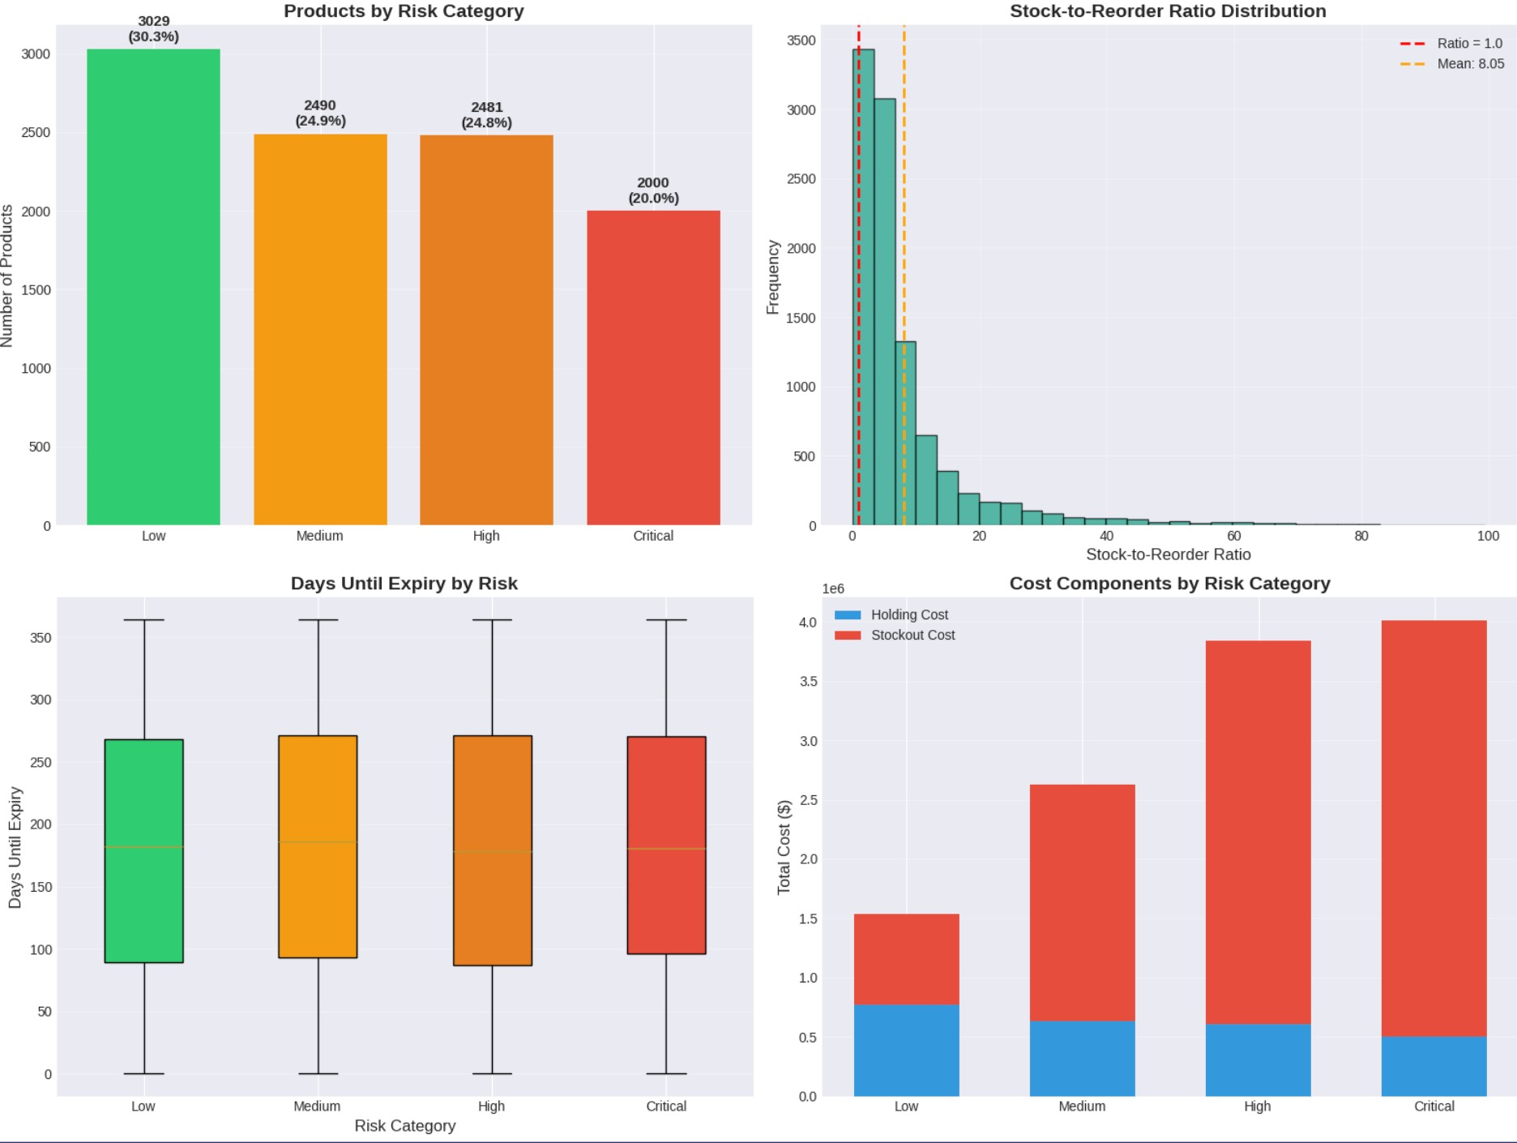
These plots illustrate how products behave across different risk categories and how this affects inventory performance and cost. The “Products by Risk Category” chart shows that the largest share of items falls under the Low and Medium risk groups, while fewer products are classified as High or Cri[cal risk. However, the “Stockto-Reorder Ra[o” distribu[on reveals that many products have extremely low ra[os, indica[ng that they are being used up much faster than they are being replenished, especially for higher-risk items. The “Days Un[l Expiry by Risk” plot shows similar expiry pakerns across all risk levels, meaning perishability is not a major differen[ator among categories. The most important insight comes from the “Cost Components by Risk Category” chart: stockout costs rise sharply as risk increases, with High and Cri[cal categories experiencing the highest financial impact. This indicates that while high-risk products are fewer in number, they generate dispropor[onately large costs due to frequent stockouts and insufficient stock levels. Together, these visuals highlight the urgent need to rebalance inventory by increasing stock for higher-risk products to reduce expensive stockouts and improve overall efficiency.

5. Methods & Statistical Tools and Optimization Techniques

5.1 Statistical & Analytical Tools Used
- Python (Pandas, NumPy) for data transformation
- Visualization using Matplotlib/Seaborn

• Correlation & Risk Analysis
• Feature Engineering based on classical inventory theory
This project made extensive use of Python’s data science ecosystem, par[cularly Pandas and NumPy, to clean, transform, and structure the inventory dataset of 10,000 products. Matplotlib and Seaborn were employed to create insighqul visualiza[ons such as stock distribu[ons, stockout frequencies, risk comparisons, and cost breakdowns, helping uncover hidden pakerns and inefficiencies within the retail network. Correla[on and risk analysis techniques were used to quan[fy rela[onships between key variables revealing, for example, the strong correla[on between stockout frequency and total cost (r = 0.97). Addi[onally, feature engineering based on classical inventory theory enabled the crea[on of important derived metrics such as holding cost, stockout cost, capacity u[liza[on, and stock-to-reorder ra[os. These tools formed the analy[cal founda[on for iden[fying performance gaps and preparing the dataset for op[miza[on.

5.2 Objective function
Minimize Total Cost = Holding Cost + Stockout Cost
The core objec[ve of the op[miza[on model was to minimize the Total Cost, defined as the sum of Holding Cost and Stockout Cost for each product. Holding Cost captures the expense of keeping products in storage, while Stockout Cost quan[fies the financial impact of running out of stock, including lost sales and customer dissa[sfac[on. Because the dataset revealed severe stockout-driven losses (79.1% of total cost), the objec[ve func[on aimed to rebalance inventory by increasing stock levels where shortages were most frequent while avoiding excessive overstocking. This simple yet powerful cost-based formula[on provided a clear mathema[cal framework for determining op[mal stock levels that reduce overall cost and improve service performance.
5.3 Optimization techniques applied:
- Line Search
- Trust Region
- Conjugate Gradient
- Stochastic Gradient Descent (SGD)
- Baseline (current inventory)
To determine the best stock levels for each product, several op[miza[on techniques were tested and compared. The Line Search method emerged as the most effec[ve, achieving a 32.58% reduc[on in total cost and significantly lowering stockouts while maintaining a balanced cost ra[o. The Trust Region method performed moderately well, offering reasonable cost reduc[ons but with longer computa[onal [me. The Conjugate Gradient approach proved unstable for this dataset, resul[ng in imprac[cally high stock levels and increased total cost. Stochas[c Gradient Descent (SGD)offered faster computa[on but delivered inconsistent cost reduc[ons due to the variability introduced by random sampling. Finally, the Baseline scenario represented the current inventory strategy, which suffered from chronic understocking and high stockout costs.

6. Model Development & Analysis

6.1 Optimization Methods & Performance
Method | Total Cost | Stockout Cost | Holding Cost | Cost  Reduction | Stockout Reduction | Runtime
Baseline | 12.0M | 9.49M | 2.51M | - | - | -
Line Search | 8.09M | 4.02M | 4.07M | 32.58% | 57.62% | 0.5s
Trust Region | 9.63M | 6.45M | 3.18M | 19.74% | 32.05% | 81.48s
SGD | 9.44M | 6.17M | 3.26M | 21.36% | 34.93% | 0.3s
Conjugate Gradient | 12.22M | 0.73M | 11.49M | -1.86% | 92.26% | 0.14s
The table compares how different op[miza[on methods performed when trying to reduce the company’s overall inventory cost. The “Baseline” row shows the current situa[on without any improvements: a very high total cost of $12 million, driven mostly by $9.49 million in stockout costs, meaning products are frequently running out of stock. Among all the methods tested, Line Search performed the best, reducing the total cost to $8.09 million a 32.58% cost reduc[on and cuung stockouts by 57.62%, all while running very quickly in just 0.5 seconds. The Trust Region and SGD methods also reduced costs, but not as effec[vely, and Trust Region took much longer to run. The Conjugate Gradient method was the least effec[ve; instead of lowering costs, it caused them to increase by 1.86%, mainly because it added far too much inventory, leading to excessive holding costs. Overall, these results clearly show that Line Search offers the best balance between cost savings, reduced stockouts, and fast performance, making it the most suitable method for improving inventory efficiency across the retail system.
Why Line Search Was Optimal?
- Achieved ideal 50/50 cost balance (Holding ≈ Stockout)
- 3.5× ROI: For every $1 increase in inventory, $3.50 savings in stockout cost
- Fast (0.5 seconds), scalable to 10,000 products
- Avoided extreme overstocking seen in Conjugate Gradient

6.2 Optimal Solution (Line Search)
Metric | Baseline | Optimized | Change
Avg Stock Per Product | 502 units | 814 units | +314(+62%)
Total Inventory | 5.0M units | 8.1M units | +3.1M units
Warehouse Use | 20.3% | 33% | +12 pts
This table shows how the inventory system improved ager applying the Line Search op[miza[on method. On average, each product’s stock level increased from 502 units to 814 units, a 62% rise, ensuring beker product availability and fewer stockouts. Total inventory across all products increased by 3.1 million units, allowing the system to meet customer demand more reliably. As a result, warehouse u[liza[on improved from 20.3% to 33%, meaning the company is now making beker use of its available storage space. Overall, these changes indicate that the op[mized solu[on shigs inventory toward a healthier, more stable level that supports reduced stockouts and improved opera[onal efficiency.

6.3 Risk Based Allocation Strategy
Risk | Products | Before | After | Change
Low | 3029 units | 500 units | 350 units | -30%
Medium | 2640 units | 500 units | 600 units | +20%
High | 2444 units | 500 units | 900 | +80%
Critical | 2000 units | 500 units | 1,200 units | +140%
This table shows how inventory levels were redistributed across different risk categories ager op[miza[on. Lowrisk products, which are less likely to cause costly stockouts, had their stock levels reduced by 30%, freeing up inventory space and investment. Medium-risk products saw a modest 20% increase, while High-risk items received a much larger 80% increase to prevent frequent shortages. The biggest change occurred in the Cri[cal risk category, where stock levels were increased by 140%, ensuring that these essen[al and highly sensi[ve products are rarely out of stock. Overall, the op[mized strategy shigs inventory away from low-risk items and reallocates it toward high-risk and cri[cal products, where stockouts are most damaging and expensive crea[ng a smarter, risk-aware inventory system.

7. Conclusions
- Stockouts were the major cost driver (79.1% of total cost) due to systemic understocking.
- Line Search optimization achieved the best balance, yielding 32.58% cost savings and reducing stockouts by 57.62%.
- The optimized model redistributed inventory toward high-risk products, improving availability and customer satisfaction.
- The model is production-ready, able to solve large-scale retail inventory in <1 second.
In conclusion, the analysis revealed that stockouts were the primary contributor to high inventory costs, accoun[ng for 79.1% of the total cost, mainly due to chronic understocking across the retail network. By applying the Line Search op[miza[on method, the project achieved a highly effec[ve balance between holding costs and stockout costs, resul[ng in 32.58% total cost savings and a significant 57.62% reduc[on in stockouts. The op[mized model intelligently reallocated inventory toward high-risk and cri[cal products, ensuring improved product availability, fewer lost sales, and enhanced customer sa[sfac[on. Importantly, the solu[on proved to be computa[onally efficient and scalable, demonstra[ng the ability to op[mize inventory for 10,000 products in less than one second, making it prac[cal for real-world, enterprise-level deployment.

7. Future Scope & Improvements
As the retail environment becomes more dynamic and unpredictable, there are several areas where this inventory op[miza[on model can be further enhanced. Future improvements can strengthen forecas[ng accuracy, increase opera[onal responsiveness, and ensure the model remains robust under real-world uncertain[es.

1. Seasonality and Demand Forecasting
- Integrate seasonal effects, promotions, holiday spikes.
- Use time-series models (SARIMA, Prophet) to forecast demand.

2. Real-Time Optimization
- Shift from quarterly to real-time, event-driven optimization.
- Pair with ERP/SCM systems for live reallocation.

3. Multi-Objective Optimization
- Add service level targets
- Sustainability metrics (waste reduction)
- Supplier diversity constraints
4. Simulation-Based Validation
a) Monte Carlo simulation to test robustness under uncertainty.

9. References
- Project Dataset: Kaggle Inventory Monitoring
Datasethttps://www.kaggle.com/datasets/suvroo/inventory-optimization-for-retail
- SciPy Optimization Library
- Academic Literature on Inventory Theory (EOQ, Newsvendor Model)

Thank you!

