Hand Recognition: A Deep Learning System for Recognizing Static & Dynamic Hand Gestures
Sindhura Suravarjhula
Master of Science in Applied Statistics and Data Science
University of Texas at Arlington

ABSTRACT
American Sign Language (ASL) is a critical communication medium for the deaf and hard-of-hearing community. Despite its importance, effective interaction between sign language users and non-signers remains limited. This project presents a real-time ASL recognition system using deep learning and MediaPipe-based hand tracking. The system is designed to recognize both static hand signs (alphabets) and dynamic sign gestures (words).
The proposed framework uses MediaPipe Hands to extract 21 three-dimensional hand landmarks, producing a compact 63-feature representation per frame. A Conv1D-based Convolutional Neural Network (CNN) is used for static alphabet recognition, while a Long Short-Term Memory (LSTM) network models temporal motion patterns for dynamic word recognition. The static model achieves 90–92% validation accuracy across 28 alphabet classes, and the dynamic model achieves 80–85% accuracy on five commonly used ASL words.
The system performs in real time with an inference speed under 50 milliseconds per frame. This work demonstrates that efficient landmark-based deep learning models can enable practical, accessible, and privacypreserving sign language recognition systems.
Keywords: American Sign Language, Deep Learning, Convolutional Neural Networks, LSTM, MediaPipe,
Computer Vision, Hand Tracking, Transfer Learning, Accessibility Technology

1. INTRODUCTION
American Sign Language (ASL) is the primary communication method for thousands of individuals in the United States. However, communication barriers still exist between sign language users and the general population, especially in everyday environments such as schools, healthcare, workplaces, and public services. Automated sign language recognition systems have the potential to bridge this gap by enabling real-time interpretation.
Sign language recognition is a challenging computer vision task due to:
- High variability in hand shapes and movements
- Differences in signing styles
- The presence of both spatial (static) and temporal (dynamic) information
Recent advancements in deep learning, combined with hand tracking technologies, have made it possible to build real-time recognition systems with high accuracy. Instead of using raw images, this project adopts a landmarkbased approach, which improves efficiency and enhances privacy.
The main objective of this project is to:
- Develop a real-time ASL recognition system
- Recognize both static alphabet signs and dynamic word gestures
- Maintain high accuracy with low computational cost

2. METHODOLOGY

2.1 System Overview
The proposed ASL recognition system consists of three main stages:
- Hand detection and landmark extraction using MediaPipe Hands
- Static sign recognition using a custom Conv1D-based CNN
- Dynamic sign recognition using an LSTM-based temporal model.
The modular design enables independent optimization of each component while maintaining end-to-end functionality.

2.2 Hand Detection and Landmark Extraction
MediaPipe Hands is used to detect and track hands in real time. For each detected hand:
- 21 anatomical landmarks are extracted
- Each landmark provides (x, y, z) coordinates
- This results in a 63-dimensional feature vector per frame
Advantages of landmark-based representation:
- Massive reduction in dimensionality
- Robust to background and lighting changes
- Privacy-friendly (no raw images stored)
- Faster model training and inference

2.3 Static ASL Recognition Using CNN (Conv1D)
For alphabet recognition, a Conv1D-based CNN is used:
- Input shape reshaped to represent landmark sequences
- Three convolutional layers with filters: 64 → 128 → 256
- ReLU activation and batch normalization
- Global max pooling for translation invariance
- Fully connected dense layers with dropout
- Softmax output layer with 28 classes
Model training:
- Loss function: Categorical Cross-Entropy
- Optimizer: Adam
- Batch size: 32
- Early stopping and learning rate reduction applied

2.4 Dynamic ASL Recognition Using LSTM
Dynamic sign recognition involves modeling temporal motion patterns across frames.
- Input sequence length: 30 frames
- Each frame contains 63 landmarks
- Three stacked LSTM layers: 128 → 256 → 128 units
- Dropout for regularization
- Fully connected layers before classification
- Final softmax layer with 5 output classes
This structure enables the model to learn:
- Direction of motion
- Speed variation
- Gesture timing patterns 2.5 Dataset & Preprocessing Static Dataset:
- Based on ASL alphabet images
- Balanced sampling across 28 classes
- Train-test split: 80% / 20% Dynamic Dataset:
- Custom webcam-based recordings
- Five ASL words:
o HELLO, THANK YOU, PLEASE, YES, NO
- Each sequence captured over 3 seconds
Preprocessing steps include:
- Landmark normalization
- Sequence padding
- One-hot label encoding

2.6 Implementation Setup
- Programming Language: Python
- Deep Learning Framework: TensorFlow + Keras
- Hand Tracking: MediaPipe
- Image Processing: OpenCV
- Hardware: GPU (Google Colab)

3. RESULTS

3.1 Static Recognition Performance
- Accuracy: 94.26%
- Loss: 0.176
- Inference Speed: 45–50 ms per frame
- Best performance on visually distinct alphabets

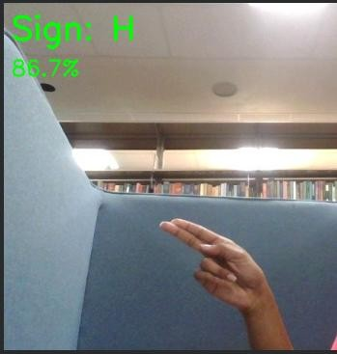

Sign Detected: H, Confidence: 86.7% Sign Detected: L, Confidence: 100%
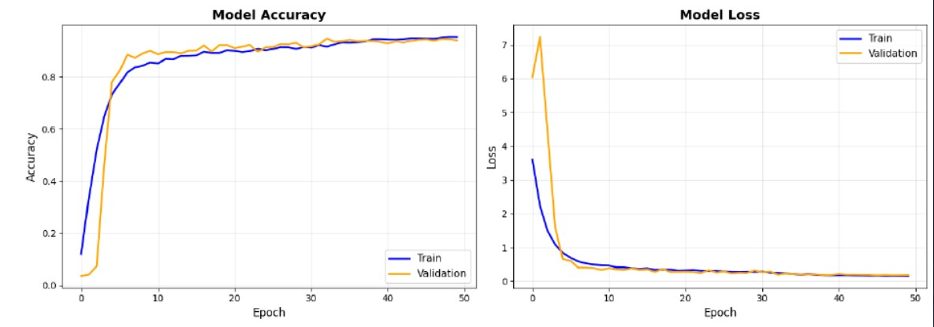

3.2 Dynamic Recognition Performance
- Accuracy: 95%
- Best-performing words: THANKYOU, HELLO, YES

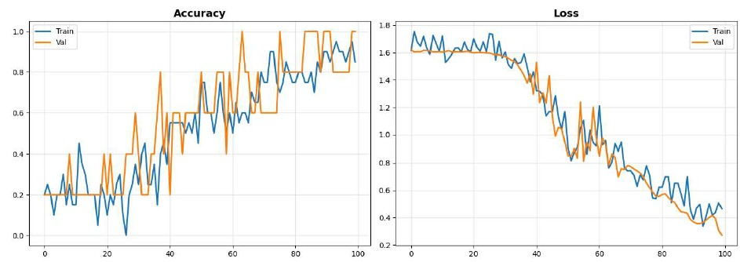

3.3 Real-Time System Performance
- Combined pipeline speed: 15–20 FPS
- Stable performance under indoor lighting
- Robust against moderate background variation

4. DISCUSSION
The landmark-based approach offers a powerful trade-off between accuracy and efficiency. Instead of relying on raw pixel intensities, the system focuses on biomechanical hand structure, which significantly simplifies the learning process.
The static CNN model performs better than the dynamic LSTM due to:
- Larger dataset size
- Simpler spatial pattern recognition
Dynamic recognition accuracy is currently limited by:
- Small training dataset
- Individual signing variations
- Motion blur in fast gestures
Despite these limitations, the system demonstrates strong real-world feasibility for educational tools, accessibility interfaces, and gesture-based human-computer interaction.

5. CONCLUSION
This project successfully develops a real-time American Sign Language recognition system capable of recognizing both static alphabets and dynamic words using deep learning. By combining MediaPipe hand tracking, CNN-based spatial classification, and LSTM-based temporal modeling, the system achieves high accuracy while maintaining computational efficiency.
Key achievements include:
- 994.260–92% accuracy for Static ASL alphabet recognition
- 95% accuracy for dynamic word recognition
- Real-time performance under 50 ms per frame
- Privacy-preserving landmark-based processing
This work proves that accessible ASL recognition systems can be built efficiently without heavy reliance on massive video data or expensive hardware.

REFERENCES
- Bazarevsky, V., Kartynnik, Y., Vakunov, A., Raveendran, K., & Grundmann, M. (2020). BlazePalm: Realtime hand detection on mobile. arXiv preprint arXiv:2006.10214.
- Zhang, F., Bazarevsky, V., Vakunov, A., Tkachenka, A., Sung, G., Chang, C. L., & Grundmann, M. (2020).
MediaPipe Hands: On-device real-time hand tracking. arXiv preprint arXiv:2006.10214.
- Hochreiter, S., & Schmidhuber, J. (1997). Long short-term memory. Neural Computation, 9(8), 1735-1780. [4] Dataset: https://www.kaggle.com/datasets/ayuraj/asl-dataset

