Software Development

Life Cycle Plan

Smart-Glass Based Remote Guidance System

Group 21

Lyndon Prado - 9740783

Tingcong Jimmy Li - 100017000

Keagan Foster - 101609822

Ayub Khan - 100667654

Dineth Gunawardena - 100862158

Kosala Edirisinghe - 101265981

Krishna Adhikari - 4953193

Liam Pan -101106174

Migara Gunarathne - 101002269

Shenal Nirushka – 101054998

**Table 1. Document Change Control**

|  |  |  |  |
| --- | --- | --- | --- |
| **Version** | **Date** | **Authors** | **Summary of Changes** |
| 1 | 21/03/2018 | Keagan Foster | Initial Draft |
| 2 | 23/03/2018 | Lyndon Prado/Liam Pan | Revisions made of initial draft |
| 3 | 12/04/2018 | Keagan Foster | Added some references and facts to document |
| 4 | 24/04/2018 | Keagan Foster | Altered content and some errors and external review was conducted by supervisor |
| 4.01 | 10/05/2018 | Liam Pan | Document Standards Review  Spelling and Grammar Review |

**Table 2. Document Sign Off**

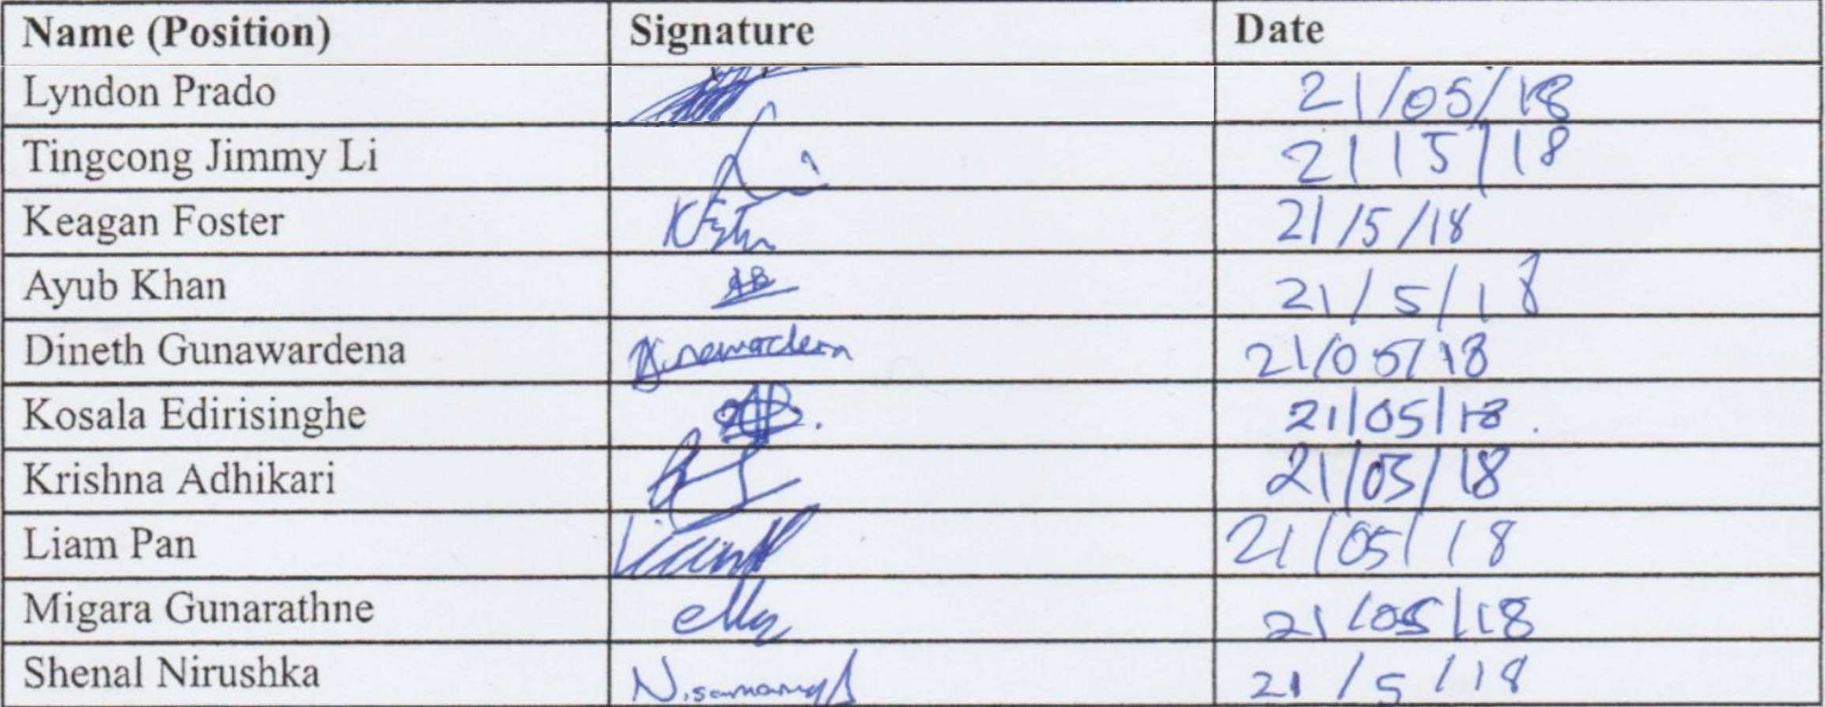

**Acronyms/Abbreviations**

**SDLC -** Software Development Life Cycle

# TABLE OF CONTENTS

TABLE OF CONTENTS 3

1) SDLC 4

1.1) Scrum 4

1.2) Reasoning 4

1.3) SDLC Decision Process 4

1.4) Scrum Application 5

2) Appendix – Advantages, Disadvantages and Risks 6

2.1) Advantages 6

2.2) Disadvantages 7

2.3) Risks 7

3) References 8

# 1) SDLC

## 1.1) Scrum

As a team, we have decided to follow the Scrum methodology. Scrum is a lightweight Agile method, used to help complete complex projects iteratively, by using techniques to increase flexibility and productivity. Scrum breaks delivery into timeboxed iterations, called Sprints, and tracks progress daily through Stand-up meetings.

## 1.2) Reasoning

The reasons why we believe Scrum to be suited for our team and the project are:

* This methodology is a user-centred approach as it focuses on user stories, and therefore is acceptable for this project.
* Our client expects us to deliver several major features (video streaming, device communication, hand gesture recognition, etc) and Scrum allows us to easily segment the project into Sprints.
* The use of the Scrum method allows us to gain feedback from our client, letting us focus on delivering the right features and allowing us to adjust features between sprints, reducing costs. High costs are usually the result of changing specifications in the middle of a project using the conventional waterfall method.
* As a team, using the scrum model will allow us to better manage the progress of the project and catch problems as they arise, because of the small iterations that sprints provide.
* Implementing Scrum will give our team opportunities to become managers for different sections and broaden our skills. Scrum will also allow us to test out what works for everyone in the team setting.

While the recommended Scrum team size is between 3 and 9, our team is a size of 10. We believe it will not be an issue, as we are all familiar with the Scrum process, and we will customize the Scrum Methodology according to the needs of the team. Although this issue does present a risk in choosing this model, we are prepared to manage it with proper organization and work delegation.

## 1.3) SDLC Decision Process

Over the period of the first four weeks of this unit, our team discussed through the meetings and the Slack communication platform, about what software development life cycle model would best suit our project and team. By making a comparison between various models (waterfall, extreme programming, iterative, etc.), we concluded that the Scrum model would work best.

The process of coming to our decision was aided by the knowledge of the project given to us by the client, and information about our team members through team meetings. This decision was unanimous.

## 1.4) Scrum Application

# 

Sprint 0

Scrum will be used to ensure a user centred approach is followed through each section of this project. In the beginning of the project, during the planning phase, we will organise the team to best take advantage of the flexibility that Scrum provides and outline the direction of the team accordingly. Through creating a requirement document we build our product backlog, which allows our team to prioritize tasks alongside product stakeholders, ensuring we follow a user centred approach, by getting constant feedback.

Sprint 1-n

As a team, we will then create sprint backlogs to segment the project into manageable chunks, each of which can be accomplished by the team within 2 to 4 weeks. In addition to sprints along with Scrum, is development and test-driven development, which will force our team to generate a narrow focus, creating higher productivity. During the creation of each sprint, we will make user stories which will be user centred and focused, which will help us better design the product, from an end-user perspective. At the end of each sprint, we will showcase our progress to key stakeholders and gain important feedback regarding the progress of our project and further refine the requirements.

Transition Sprint

Once the development sprints are completed, we begin the final sprint, which finalises the product to showcase to key stakeholders. At this stage, the entire software has been tested and the product just needs to be tidied up for release.

# 2) Appendix – Advantages, Disadvantages and Risks

## 2.1) Advantages

Scrum was invented as part of the Agile movement in response to the failure of older software development techniques, such as waterfall, and borrows many principles from lean manufacturing. As such, in addressing many issues with its predecessors it gained some advantages over them such as:

* Scrum methodology enables projects where the business requirements documentation is hard to quantify to be successfully developed.
* Fast moving, cutting edge developments can be quickly coded and tested using this method, as a mistake can be easily rectified.
* It is a lightly controlled method which insists on frequent updating of progress in work, through regular meetings. Thus, there is clear visibility and transparency of the project development.
* Like any other agile methodology, this is also iterative in nature. It requires continuous feedback from the user/client.
* Due to short sprints and constant feedback, it becomes easier to cope with the changes.
* Daily meetings make it possible to measure individual productivity. This leads to the improvement in the productivity of each of the team members.
* Issues are identified well in advance through the daily meetings, therefore they can be resolved quickly.
* Agile Scrum helps the company in saving time and money.
* It is easier to deliver a quality product in a scheduled time.
* The overhead cost in terms of process and management is minimal, thus leading to a quicker, cheaper result.
* The incremental delivery system shortens the time taken to deploy to the market and may result in higher revenue, as each completed backlog represents a new release of the product.
* Reviewing each sprint before moving to the next means that testing is conducted throughout the process, which allows teams to change the scope or direction of the project at any point.

## 2.2) Disadvantages

As with every software development lifecycle process, there are pitfalls in certain areas, compared to its competitors. Many issues come from the lack of control and unpredictable process that is involved with the agile method.

* Agile Scrum is one of the leading causes of scope creep. Unless there is a definite end date, the project management stakeholders will be tempted to keep demanding that new functionality be delivered.
* If a task is not well defined, estimating project costs and time will not be accurate. In such a case, the task can be spread over several sprints.
* If the team members are not committed, the project will either never complete or fail.
* It is only good for small, fast moving projects as it works well only with a small team.
* This methodology needs experienced team members only. If the team consists of people who are novices, the project cannot be completed in time.
* Scrum works well for project management when the Scrum Master trusts the team they are managing. If they practice too strict control over the team members, it can be extremely frustrating for them, leading to demoralization and the failure of the project.
* If any of the team members leave during a development, it can have a huge adverse effect on the project development.
* Project quality management is hard to implement and quantify unless the test team can conduct regression testing after each sprint.
* The frequent changes, frequent product delivery and uncertainty regarding the precise nature of the finished product makes an intense project life cycle for everyone.
* The daily Scrum meetings and frequent reviews require substantial resources.

## 2.3) Risks

With agile projects, some risks are more evident than with other software development methods and must be identified early in the project’s life cycle to help mitigate them.

* Less experienced team members can lead to lack of contribution in an open Scrum setting, leading to contributions only being made by a few team members.
* If the product backlog is not ready for upcoming sprints, teams will be less occupied and idle, leading to loss of productivity and increase in work towards the end of a sprint.
* Over a longer period of time, the Scrum ceremonies may become monotonous and principles of Scrum are lost.
* Changes in team composition can lead to loss of velocity.
* Overestimation of commitments and underestimation of completion time can occur in each sprint.

# 3) References

* <http://www.selectbs.com/process-maturity/what-is-scrum-development>
* <https://hygger.io/blog/the-essential-guide-to-effective-risk-management-in-scrum/>
* <https://www.scrumalliance.org/community/articles/2008/september/what-is-definition-of-done-(dod)>
* <https://www.cprime.com/resources/what-is-agile-what-is-scrum/>
* <http://smallbusiness.chron.com/advantages-disadvantages-scrum-project-management-methodology-36099.html>
* <https://www.belatrixsf.com/blog/benefits-pitfalls-of-using-scrum-software-development-methodology/>
* <https://www.scrumalliance.org/learn-about-scrum>