**A Software System for Locating Mobile Users**

**Abstract**

A software system, RADAR, to locate mobile users connected to an in-building radiofrequency (RF) wireless LAN. RADAR uses signal strength information extracted from the wireless network interface, in conjunction with a Radio Map of the building, to determine location. Over the past year this system have been deployed in multiple buildings on campus using two different wireless LAN technologies and two widely used operating systems. This experience has led to identify some shortcomings of the basic RADAR system and fundamental limitations in the way wireless network hardware is abstracted in contemporary operating systems.

**Algorithm**

The algorithm for determining how many Radio Maps to construct works as follows. RADAR starts off with an initial set of (one or more) Radio Maps. From time to time, each AP listens for beacons from other APs and uses RADAR to estimate its own location. (Figure6 illustrates an example in which AP4 determines its own location using AP1, AP2, and AP3.) Knowledge of their true location enables the APs to compute the error in RADAR’s location estimate. The APs repeat this computation using each of the Radio Maps in the pre-computed set and share the results with each other. A large error in each instance would indicate that none of the existing Radio Maps accurately represents the current radio environment, so a new map should be constructed to reflect the new environmental state.

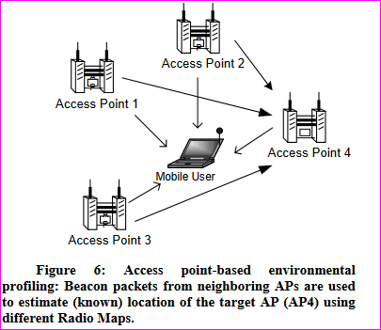

**Conclusions**

In this paper, I have described about RADAR, a software system we have developed

For locating mobile users connected to a RF wireless LAN. The single most important contribution of RADAR is that it leverages the existing wireless data Communications infrastructure to locate users rather than requiring a specialized hardware infrastructure.