LAB 2: Introduction to Prolog

1. **Making .pl file and consulting.**

* At first make a simple text file and rename it to test.pl
* Write in file

boy(hari)

Through the Prolog Terminal, use the command

?- consult (<path of the file with .pl file>).

?-consult (D:/AI_LABS /test.pl)

Then Try:

?- boy(ram).

TRUE

The file can be directly consulted form File>Consult>Select File.

Filename : first.pl

boy(hari).

girl(maya).

Terminal:

1 ?- boy(hari). // hari is a boy. So the program returns true after consulting

true.

2 ?- boy(maya). //maya is not a boy. So the program returns false after consulting

false.

1. **Graph**

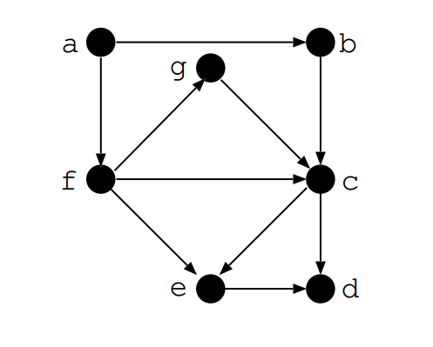

**Implement the given graph.**

File name: graph.pl

edge(a,b).// a vertex is connected to vertex b

edge(a,f). // a vertex is connected to vertex f

edge(f,e). // f vertex is connected to vertex e

edge(e,d). // e vertex is connected to vertex d

edge(b,c). // c vertex is connected to vertex c

edge(f,c). // f vertex is connected to vertex c

edge(c,e). // c vertex is connected to vertex e

edge(f,g). // f vertex is connected to vertex g

edge(g,c). // g vertex is connected to vertex c

edge(c,d) // c vertex is connected to vertex d

path(Node1,Node2):- edge(Node1,Node2). /*If node1 and node 2 is connected, then there is path between them.*/

path(Node1, Node2) :- edge(Node1,Somenode),path(Somenode,Node2). /* This is the recursion that checks the path between two nodes which are connected through many edges */

Terminal:

1 ?- edge(a,b).

true .

2 ?- edge(X,c).

X = b ;

X = f ;

X = g.

3 ?- path(a,f).

true .

4 ?- path(a,d).

true ;

1. **Family Representation**

File name: family.pl

father(amar).

mother(bina).

male(amar).

male(chandra).

female(bina).

female(divya).

parent(amar,chandra).

parent(amar,divya).

parent(bina,chandra).

parent(bina,divya).

sibling(X,Y):- parent(Z,X),parent(Z,Y),different(X,Y).

/* X is sibling of Y if parents are same and X and Y are different */

different(X,X):- !,fail. /* X is not different to X */

different(X,Y). /* X is different than Y */

Terminal:

1 ?- father(amar).

true.

2 ?- parent(X,chandra).

X = amar ;

X = bina.

3 ?- parent(X,divya).

X = amar ;

X = bina.

4 ?- sibling(chandra,divya).

true .

5 ?- sibling(chandra,chandra).

false.

6 ?- sibling(chandra,amar).

Correct to: "sibling(chandra,amar)"?

Please answer 'yes' or 'no'? yes

false.