A= LOAD 'hdfs:///user/Project_module4/Project_module4/module4.txt' USING PigStorage('\t') As (author:chararray,line:chararray);

B= GROUP A by author;

D= FOREACH B GENERATE (chararray)$0 as user,(chararray)COUNT($1) as number;

E = ORDER D BY number ASC;

Dump E

STORE D INTO 'hdfs:///user/Project_module4/Project_module4/result_module67.txt';

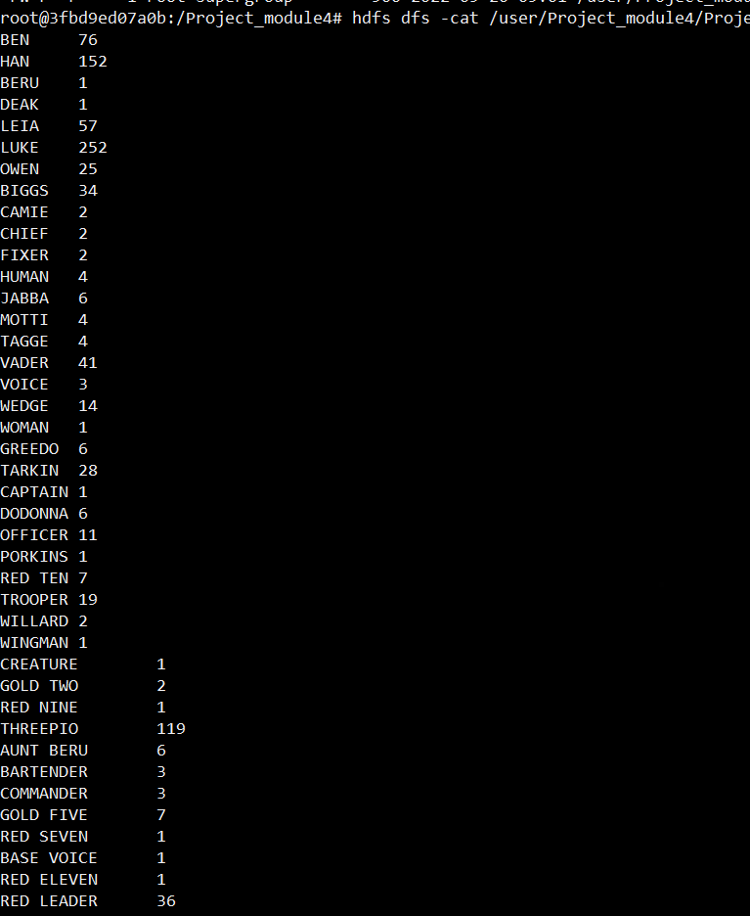

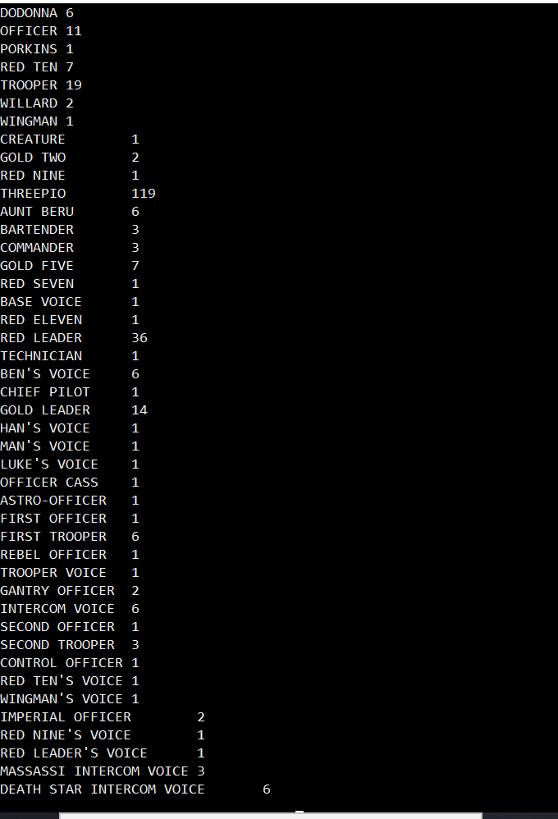



Activity2Pig:-

A= LOAD 'hdfs:///user/Project_module4/Project_module4/module6.txt' USING PigStorage('\t') As (author:chararray,line:chararray);

B= GROUP A by author;

D= FOREACH B GENERATE (chararray)$0 as user,(chararray)COUNT($1) as number;

E = ORDER D BY number ASC;

Dump E

STORE D INTO 'hdfs:///user/Project_module4/Project_module4/result_module69.txt';

Hive:-

Create TABLE file2

(ID STRING,conv STRING)

ROW FORMAT DELIMITED FIELDS TERMINATED by '\t';

LOAD DATA LOCAL INPATH

'/Project_module4/module4.txt'

INTO TABLE file2;

hive> INSERT OVERWRITE DIRECTORY '/user/Project_module4/result_hive1.txt'

> ROW FORMAT DELIMITED FIELDS TERMINATED BY ','

> select count(*) AS count1, ID FROM file2 GROUP BY ID

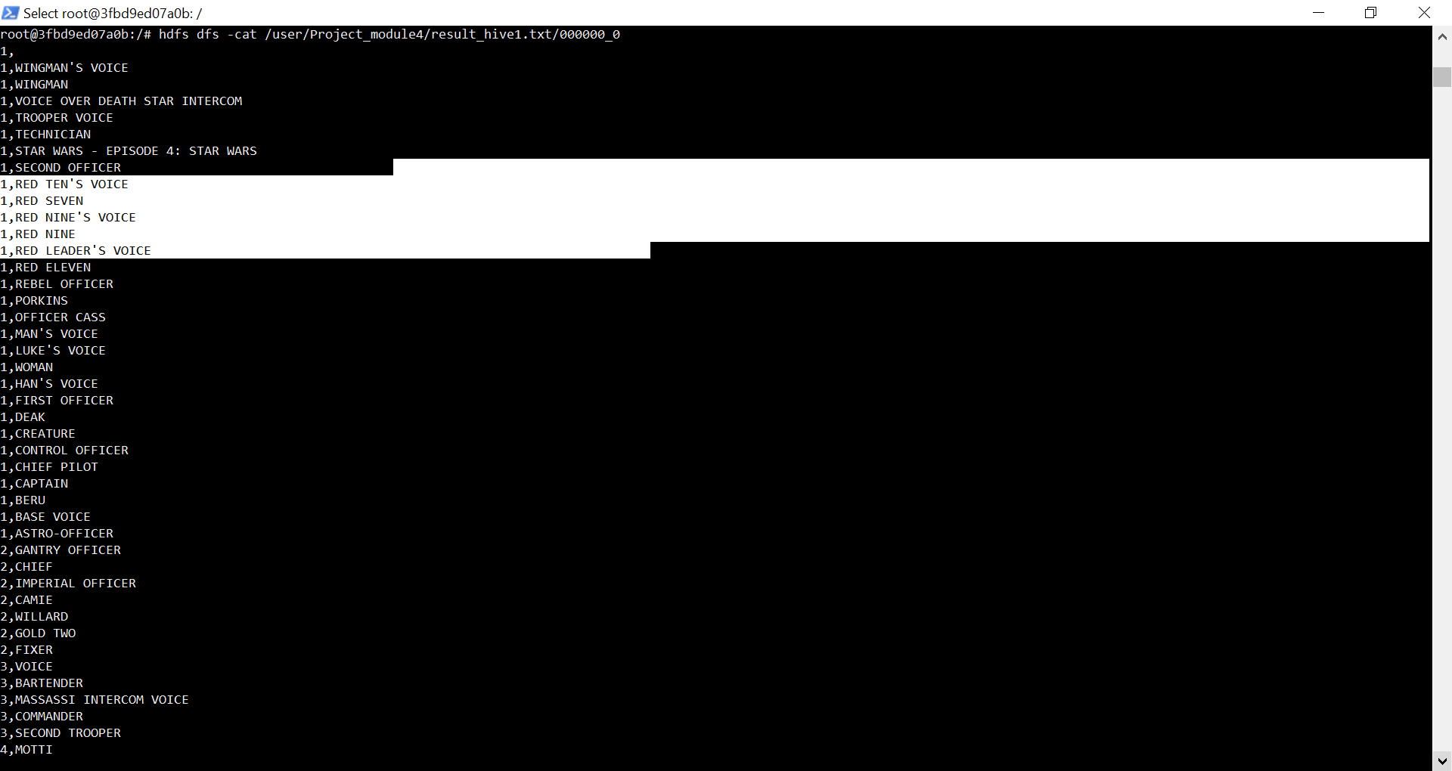

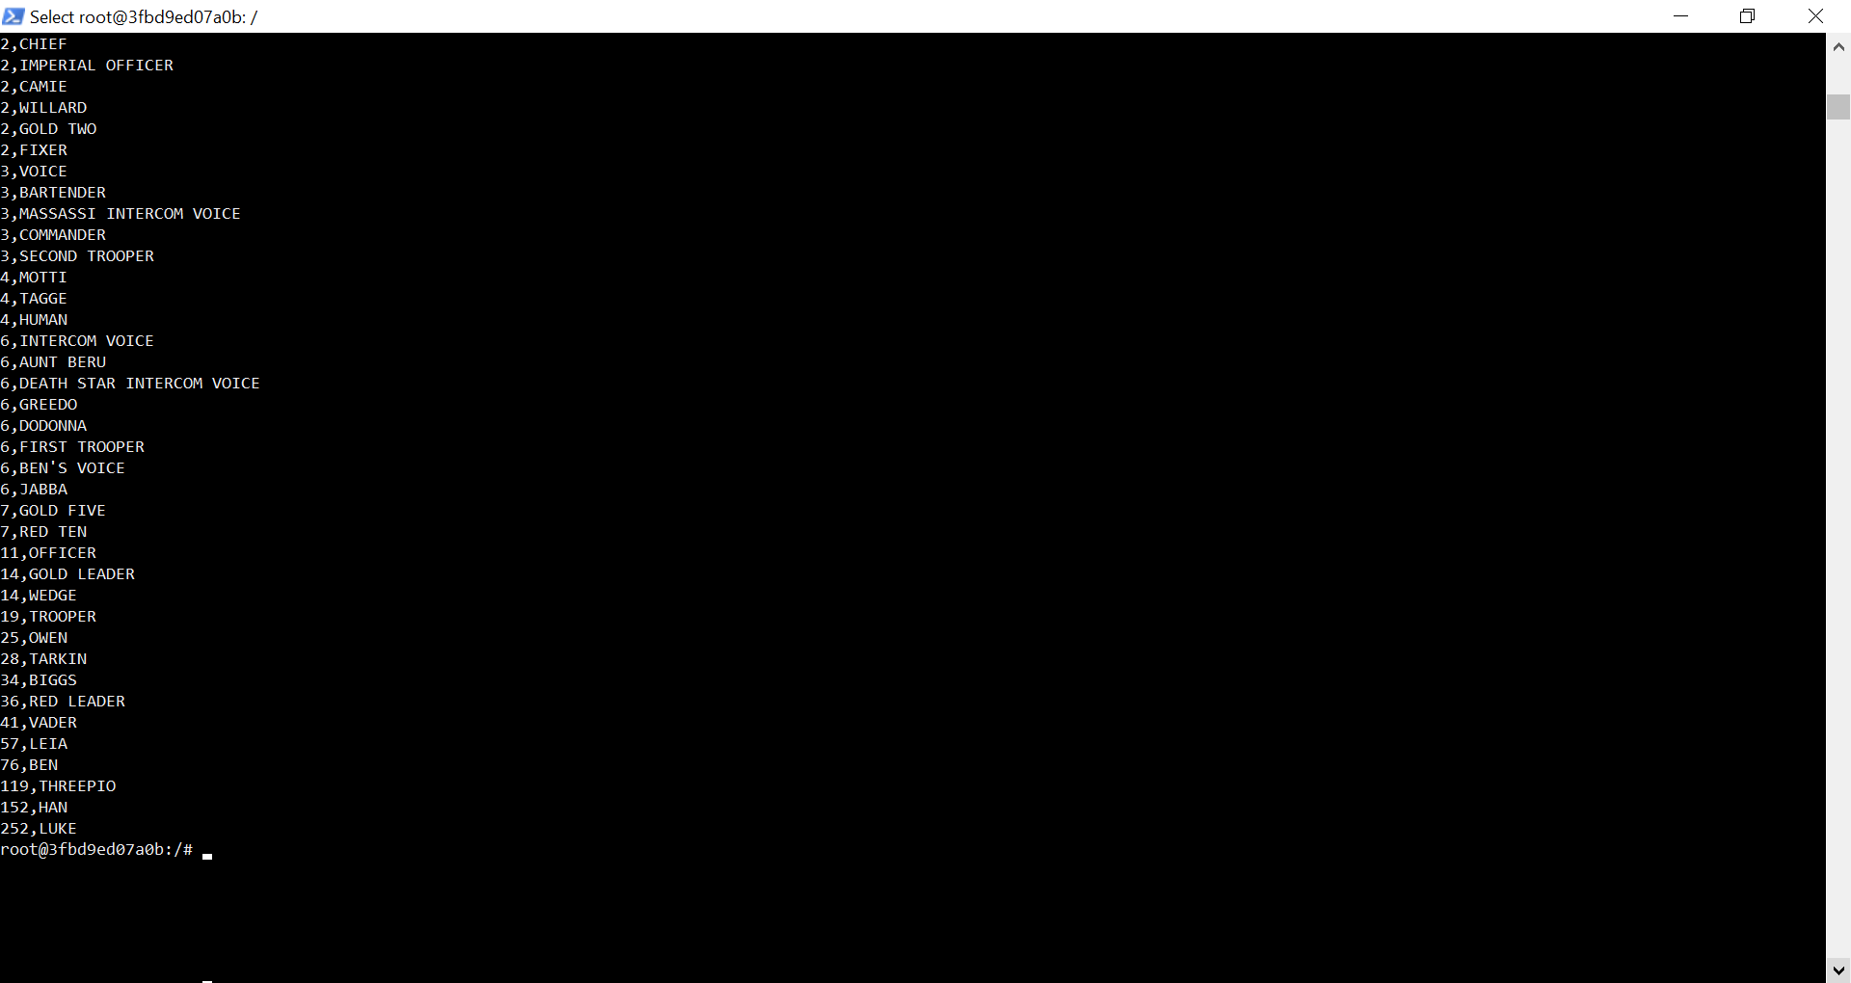

INSERT OVERWRITE DIRECTORY '/user/Project_module4/result_hive2.txt'

> ROW FORMAT DELIMITED FIELDS TERMINATED BY ','

> select * FROM file2 where instr(conv,’LUKE’)!=0

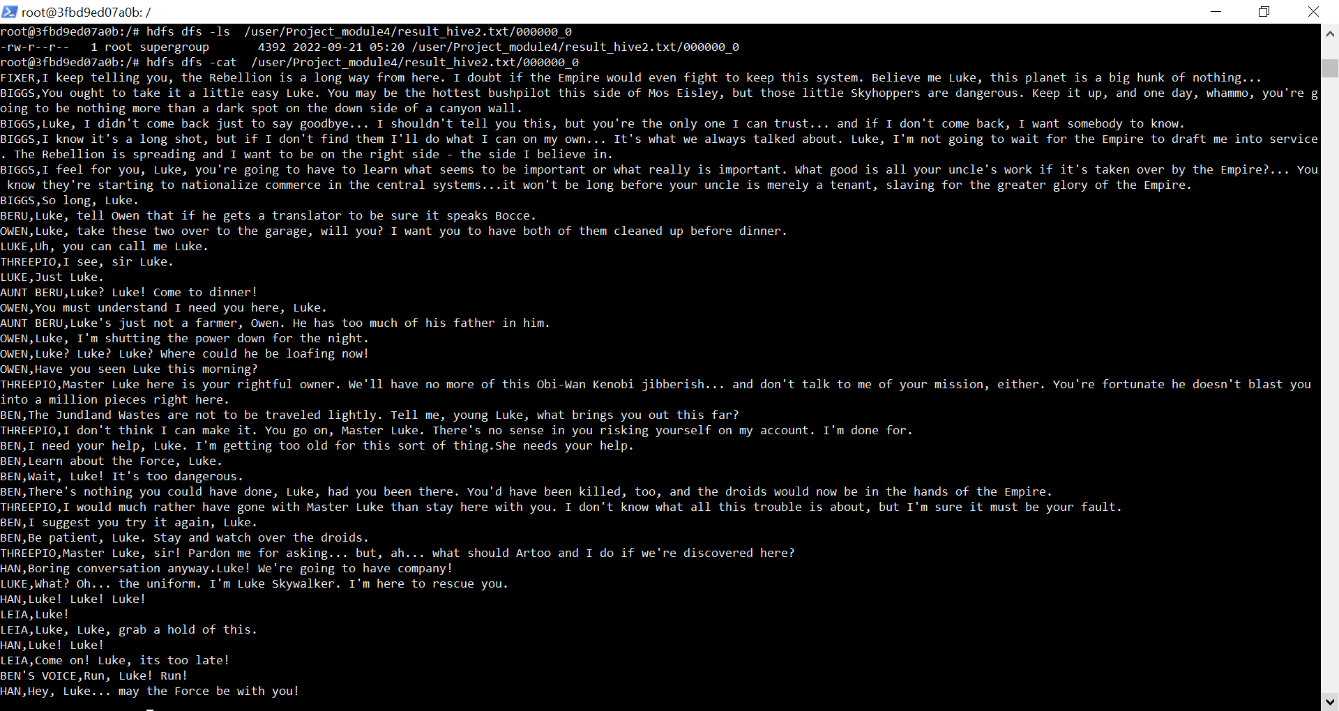

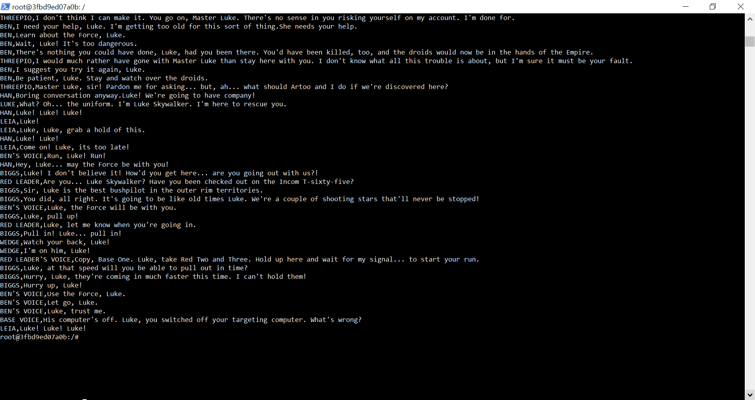

Informatica :-

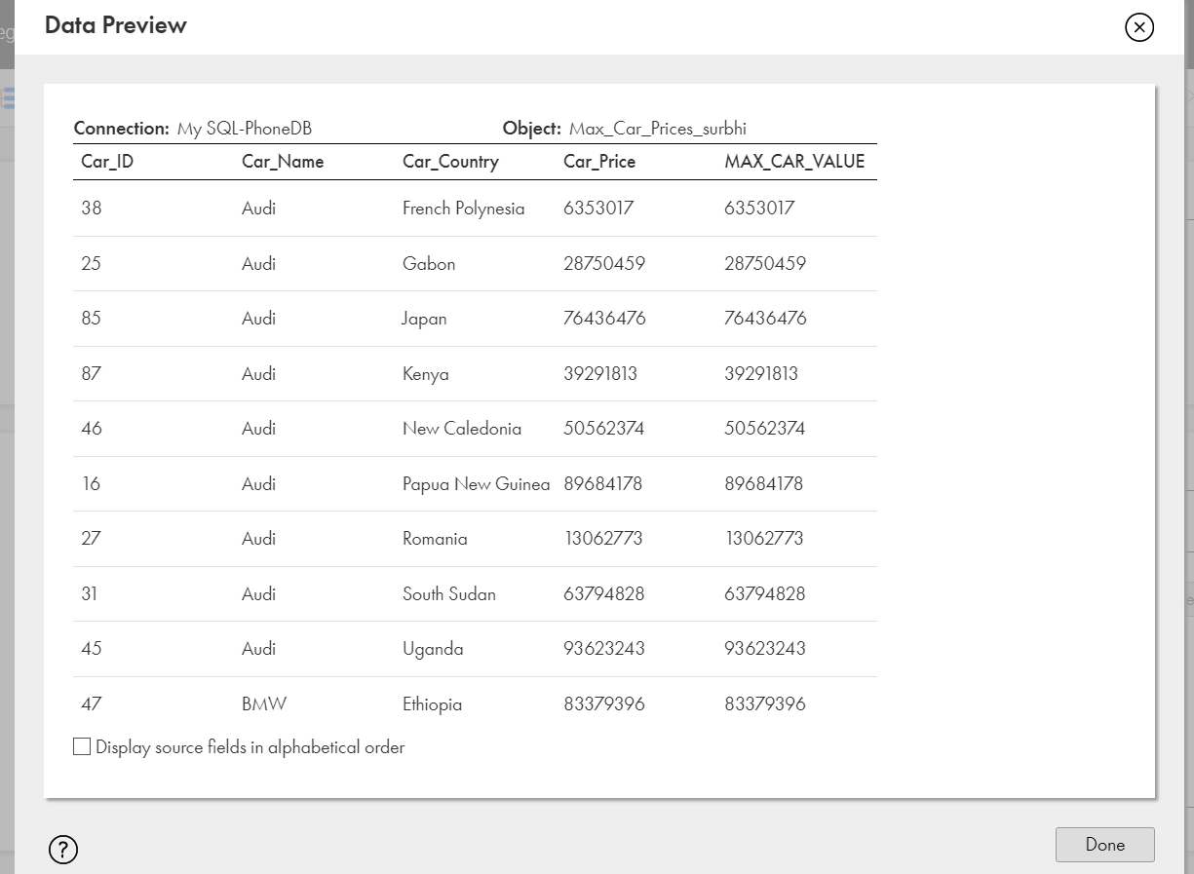

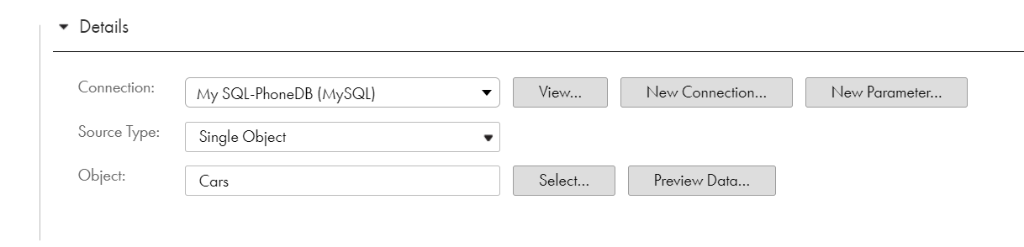

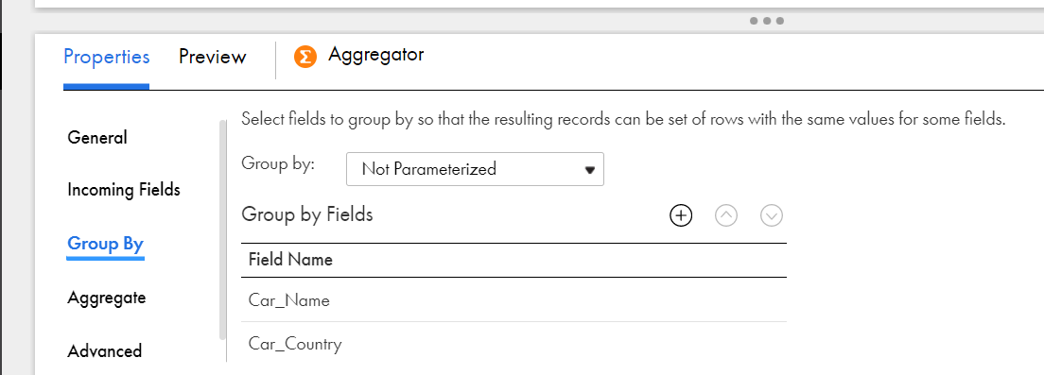

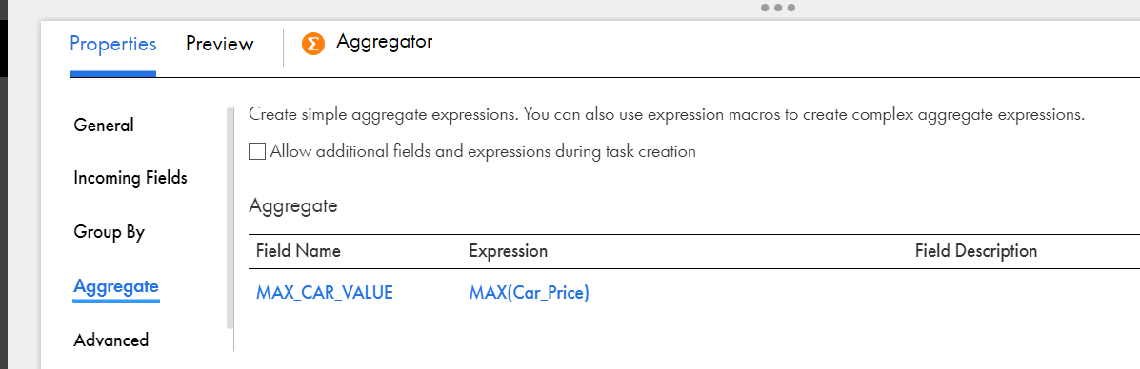

Informatica 2

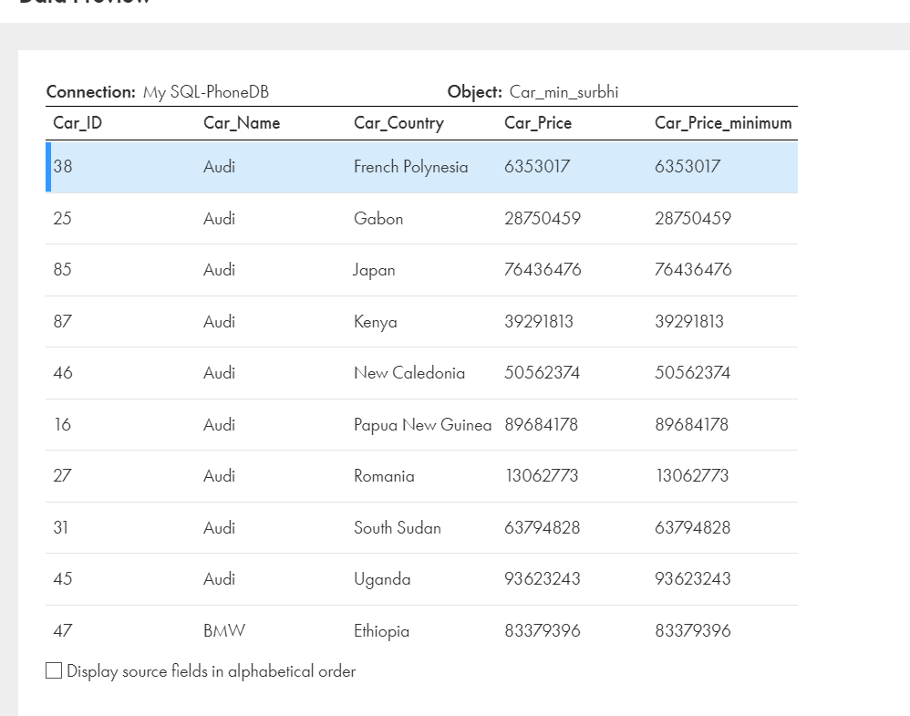

<https://docs.google.com/spreadsheets/d/1GN_1udS4395TkhK0YAJZZej664GnQzarwyUI8H71Ci8/edit#gid=495919687>

<https://github.com/training-support/FST-M4>

[ramya@cklabs.in](mailto:ramya@cklabs.in)

chandra@cklabs.com