Q1. Git Setup https://confluence.atlassian.
Command
sudo apt-get install git ˩
git config --global user.name 'Surbhi Garg'
git config --global user.email 'surbhi.garg@tothenew.com'
git --version
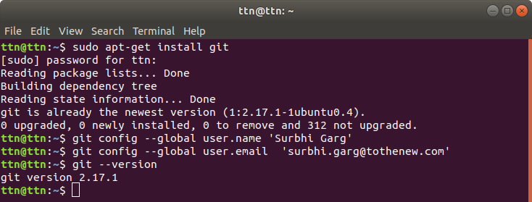
Q2 Initialize a Git Repository
Command
cd /home/ttn/Desktop
cd GitSurbhi
git init
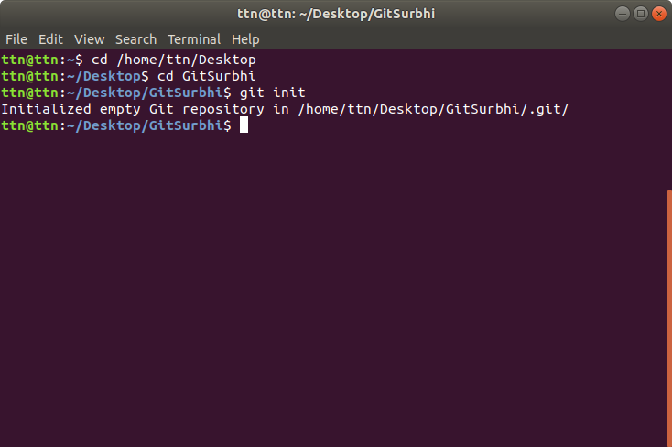

Q3 Add files to the repository
Command
vi test (further enter text infile)
vi test2 (further enter text infile)
git add .
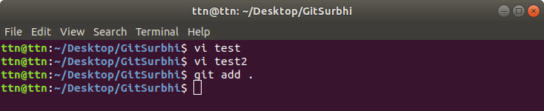
Q4. Unstage 1 file
Command
git rm test –cached
git status
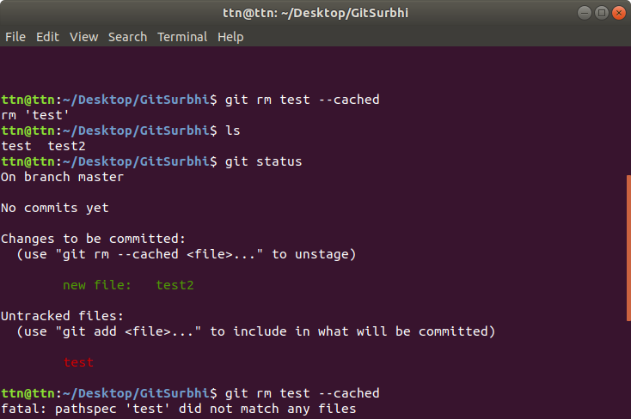

Q5. Commit the file
Command
git add test
git commit -m “This file contains a text message”

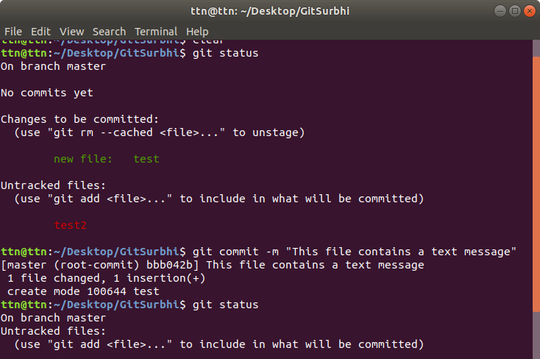

Q6. Add a remote
Command
git remote add origin https://github.com/surbhi-garg/Practice.git
git push -u origin master˩
Enter usernameand password of remote
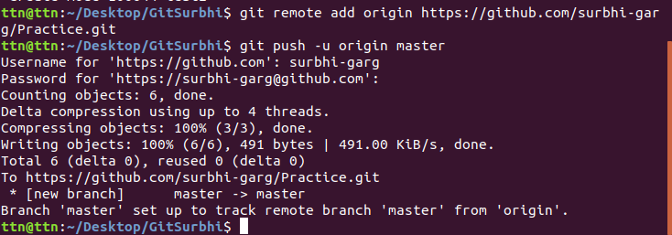
Q7. Undo changes to a particular file
Command
Edit the file,i.e, make changes
git log
git checkout <commit id> test2
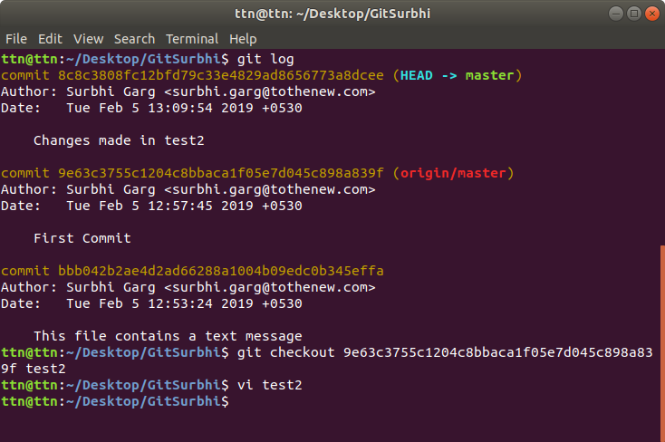

Q8. Push changes to Github
Command
git pull origin master
git push
Enter username and password
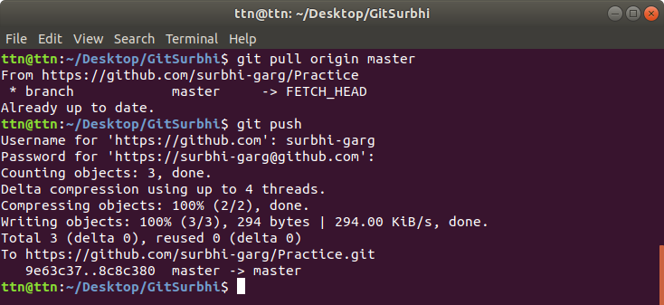
Q9. Clone the repository
Command
git clone https://github.com/surbhi-garg/Practice.git
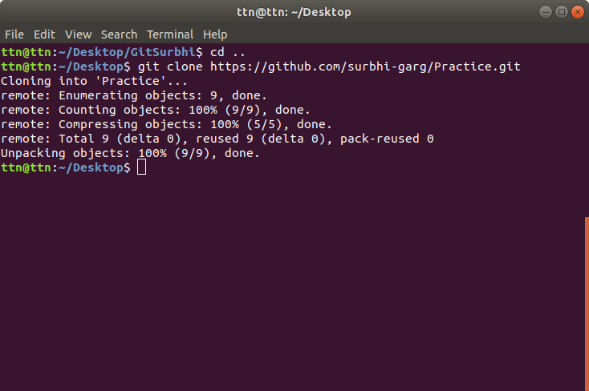

Q10. Add changes to one of the copies and pull the changes in the other.
Command
cd ../Practice
vi test
git commit -am “practice test commit”
git push
cd ../GitSurbhi
git pull origin master

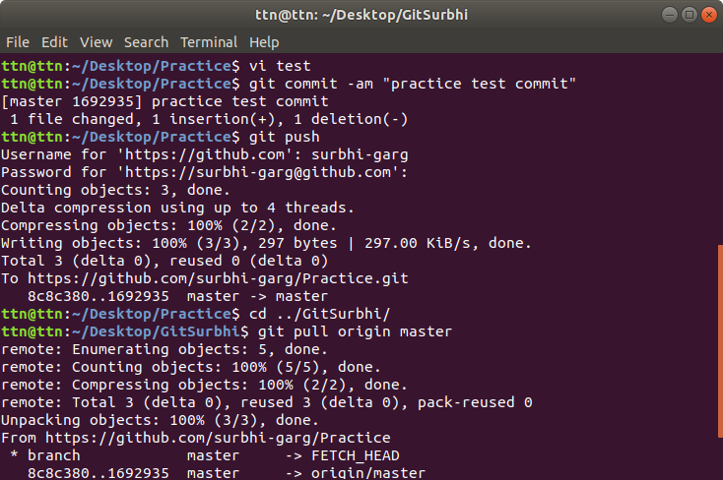

Q11. Check differences between a file and its staged version
Command
vi test3
git add test3
git commit -m “Test commit”
vi test3 (make changes)
git add test3
git diff –staged
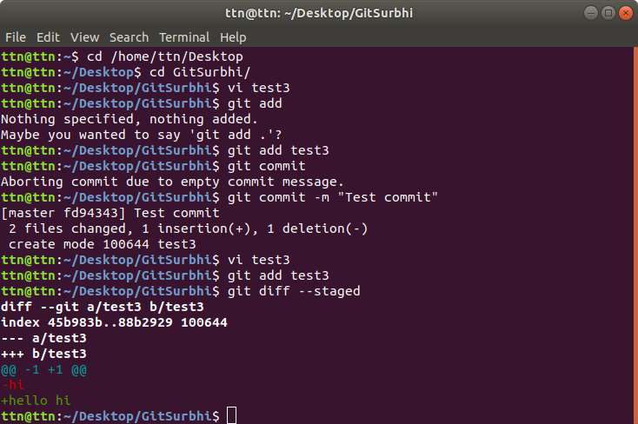

Q12 Ignore a few files to be checked in
Command
touch file3
vim .gitignore
git add .
git status
cat .gitignore

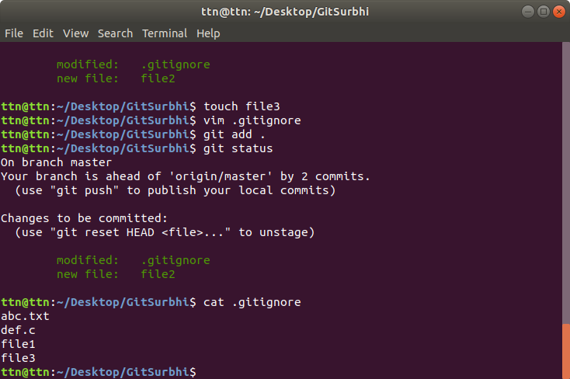

Q13. Create a new branch.
Command
git branch assign2
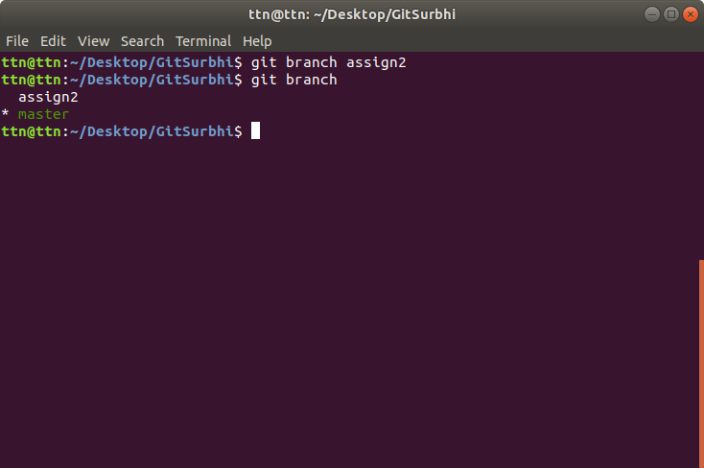

Q14. Diverge them with commits
Command
git checkout assign2
vi mergtest
git add mergetest
git commit -m “Merge Test file”
git checkout test
vi mergtest
git add mergetest
git commit -m “Merge Test”

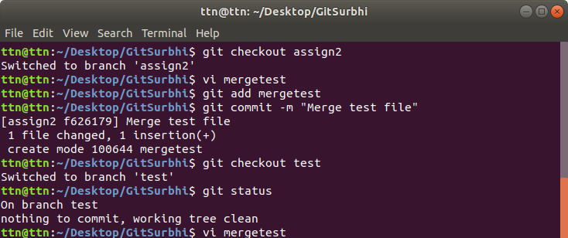
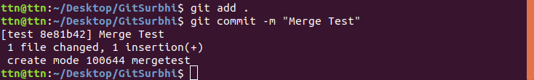

Q15. Edit the same file at the same line on both branches and commit
Command
vi mergetest
git commit -am “Editted mergetest”
git checkout assign2
vi mergetest
git commit -am “Editted mergetest”

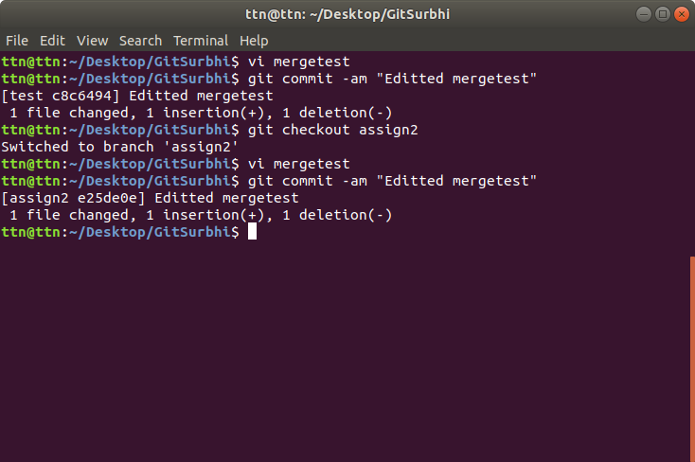

Q16. Try merging and resolve merge conflicts
Command
git merge test
vi mergetest
(Make corrections and remove the signs indicating conflict)
git add mergetest
git commit
git log -3
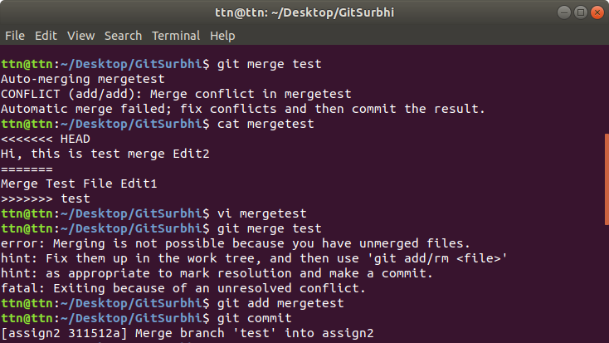
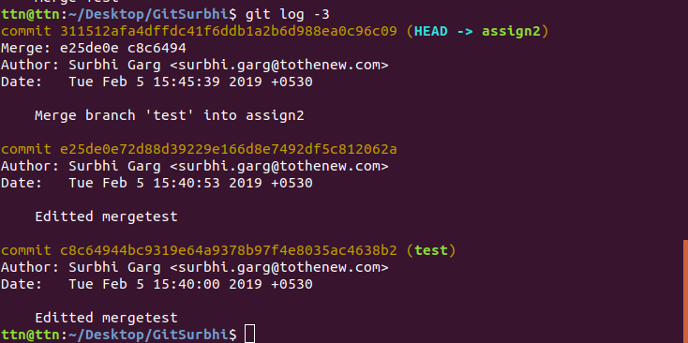

17. Stash the changes and pop them
Command
vi file
git add .
git stash
git stash pop

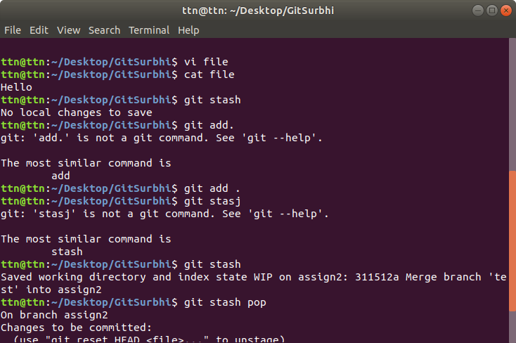

Q18. Add the following code to your .bashrc file : color_prompt="yes"
parse_git_branch() {
git branch 2> /dev/null | sed -e '/^[^*]/d' -e 's/* \(.*\)/(\1)/'
}
if [ "$color_prompt" = yes ]; then
PS1='\u@\h\[\033[00m\]:\[\033[
else
PS1='\u@\h:\W $(parse_git_branch)\$ '
fi
unset color_prompt force_color_prompt
Command
vi ~/.bashrc
Add the given code
open git repository in terminal
Able to see the current branch with which we’re logged in
