1. Prompt for amount, interest rate and no. of years and calculate simple interest.
Solution1 (using single prompt)
<!DOCTYPE html>
<html lang="en">
<head>
<meta charset="UTF-8">
<meta name="viewport" content="width=device-width, initial-scale=1.0">
<meta http-equiv="X-UA-Compatible" content="ie=edge">
<title>Simple Interest</title>

</head>
<body>
<p id="input"></p>
<p id="demo"></p>
<script type="text/javascript">
var res=1;
var inputs=prompt("Enter amount,interest rate and number of years separated by comma");
var inputarr=inputs.split(",");
document.getElementById("input").innerHTML="Inputs Received <br/>Amount "+inputarr[0]+" Rate "+inputarr[1]+" Time "+inputarr[2];
inputarr.forEach(function(i){
res=res*i;
});
var simpleInterest=res/100;
document.getElementById("demo").innerHTML="simple interest is "+simpleInterest;

</script>
</body>
</html>
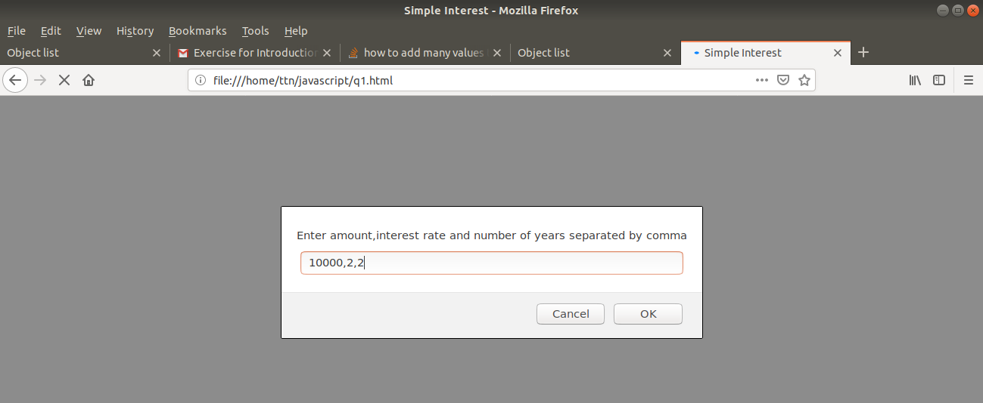
Output

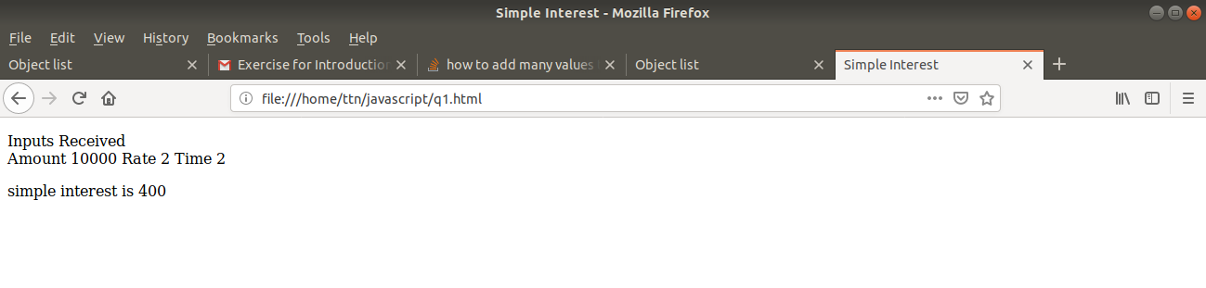
Solution2(Using multiple prompts)
<!DOCTYPE html>
<html lang="en">
<head>
<meta charset="UTF-8">
<meta name="viewport" content="width=device-width, initial-scale=1.0">
<meta http-equiv="X-UA-Compatible" content="ie=edge">
<title>Simple Interest</title>
<script>
function calcSI()
{
var principle=prompt("Enter principle");
var rate=prompt("Enter rate");
var time=prompt("Enter time");
var res=(principle*rate*time)/100;
document.getElementById("input").innerHTML="Inputs received:<br/> Amount "+principle+" Rate "+rate+" Time "+time;
document.getElementById("result").innerHTML="Simple Interest: "+res;
}
</script>
</head>
<body>
<p id="input"></p>
<p id="result"></p>
<script>calcSI()</script>
</body>
</html>
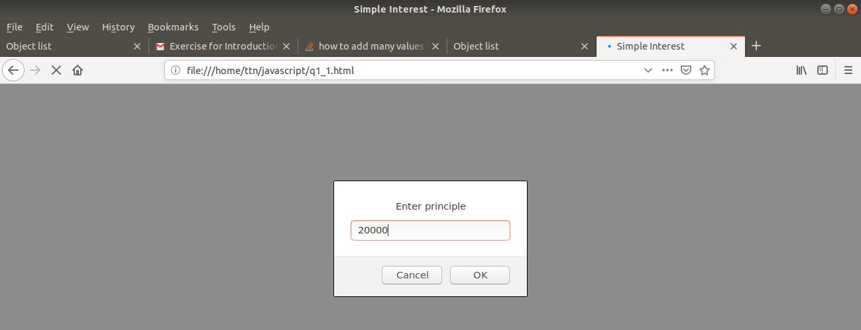
Output

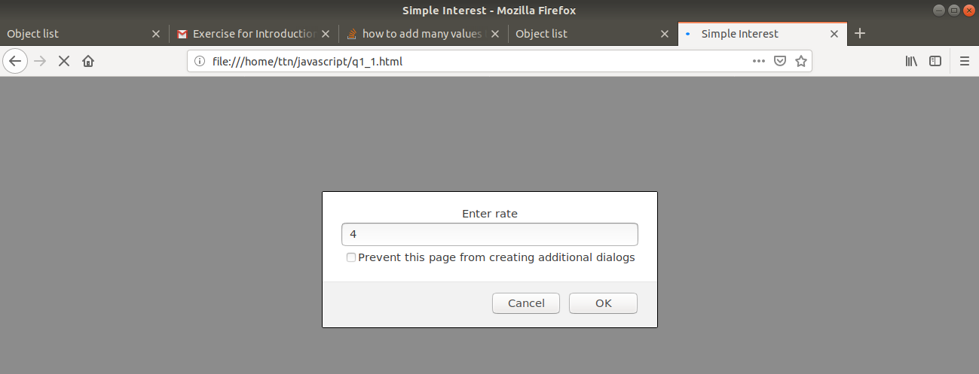

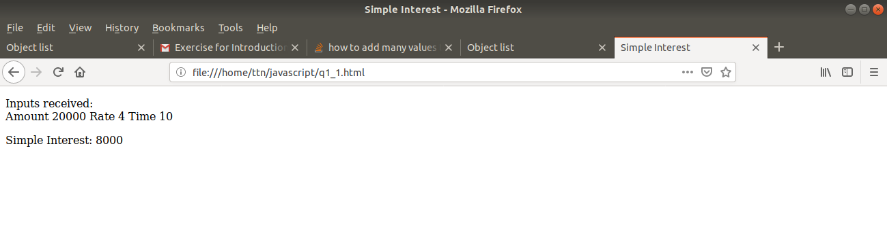
2. is palindrome string
Solution1 (Using predefined functions)
<!DOCTYPE html>
<html lang="en">
<head>
<meta charset="UTF-8">
<meta name="viewport" content="width=device-width, initial-scale=1.0">
<meta http-equiv="X-UA-Compatible" content="ie=edge">
<title>Palindrome</title>
<script type="text/javascript">
function checkPalindrome()
{
var inputString=prompt('Enter string to be checked');
var reverseString=inputString.split("").reverse().join("");
console.log(reverseString);
if(inputString===reverseString)
{
document.getElementById("result").innerHTML=inputString+" is a palindrome";
}
else
{
document.getElementById("result").innerHTML=inputString+" is <b>NOT</b> a palindrome";
}
}
</script>
</head>
<body>
<p id="result"></p>
<script>checkPalindrome();</script>
</body>
</html>
Output
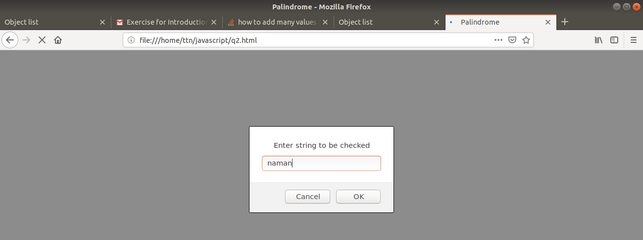
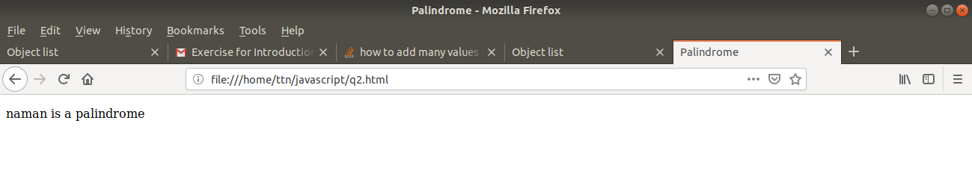
Solution2(Using logic)
<!DOCTYPE html>
<html lang="en">
<head>
<meta charset="UTF-8">
<meta name="viewport" content="width=device-width, initial-scale=1.0">
<meta http-equiv="X-UA-Compatible" content="ie=edge">
<title>Palindrome</title>
<script type="text/javascript">
function checkPalindrome()
{
var inputString=prompt("Enter string to be checked");
var length=inputString.length;
var status=true;
if(length%2!=0)
{
for(i=0;i<length/2;i++)
{
if(inputString.charAt(i)!==inputString.charAt(length-(i+1)))
{
status=false;
break;
}
}
}
else
{
for(i=0;i<=length/2;i++)
{
if(inputString.charAt(i)!==inputString.charAt(length-(i+1)))
{
status=false;
break;
}
}
}
if(status)
{
document.getElementById("result").innerHTML=inputString+" is palindrome";
}
else
{
document.getElementById("result").innerHTML=inputString+" is <b>NOT</b> a palindrome.";
}
}
</script>
</head>
<body>
<p id="result"></p>
<script>checkPalindrome();</script>
</body>
</html>

Output
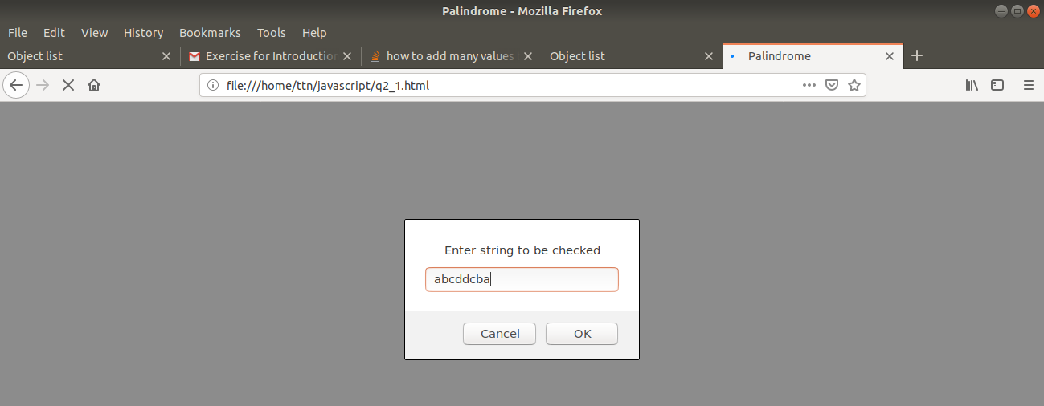
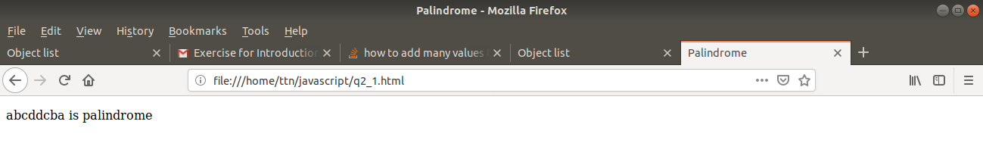
3. Area of circle
Solution
<!DOCTYPE html>
<html lang="en">
<head>
<meta charset="UTF-8">
<meta name="viewport" content="width=device-width, initial-scale=1.0">
<meta http-equiv="X-UA-Compatible" content="ie=edge">
<title>Area of circle</title>
<script type="text/javascript">
function calculateCircleArea()
{
var radius=prompt("Enter radius of circle:");
var pi=3.14;
document.getElementById("result").innerHTML="Area of circle is: "+ pi*radius*radius+"cm<sup>2</sup>";
}
</script>
</head>
<body>
<p id="result"></p>
<script>calculateCircleArea();</script>
</body>
</html>

Output
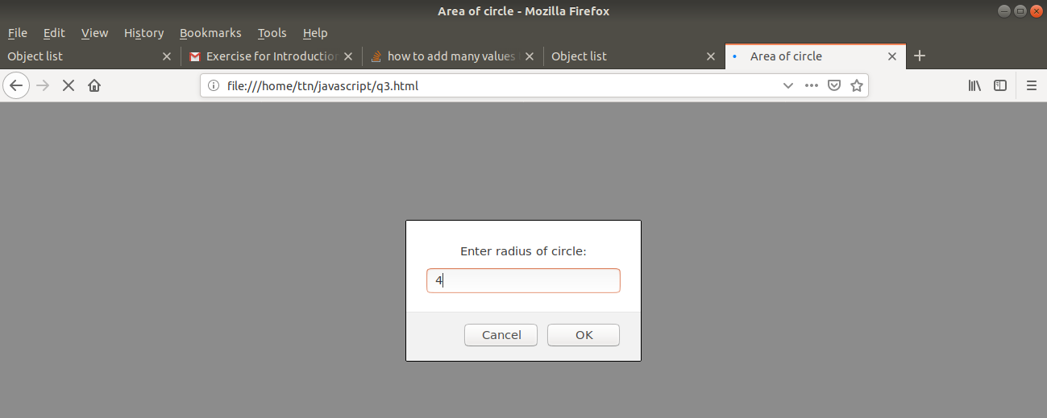
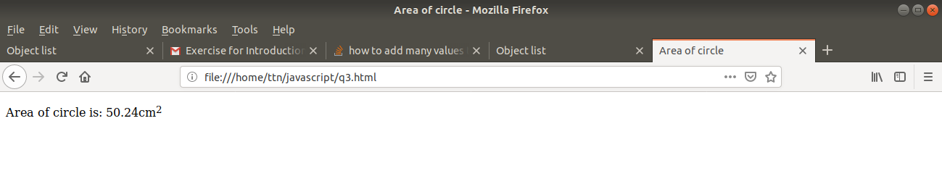

4. Copy information of one object to another and log it to console.
Solution
<!DOCTYPE html>
<html lang="en">
<head>
<meta charset="UTF-8">
<meta name="viewport" content="width=device-width, initial-scale=1.0">
<meta http-equiv="X-UA-Compatible" content="ie=edge">
<title>Object Copy</title>
<script type="text/javascript">
function copyObject(originator)
{
var clonedObject=new Object();
for(key in originator)
{
clonedObject[key]=originator[key];
}
return clonedObject;
}
</script>
</head>
<body>
<script type="text/javascript">
console.log("Cloning");
var student=new Object();
student.roll=1;
student.name="Surbhi"
var student2=copyObject(student);
console.log("After copying:");
console.log("Student 1(originator)",student);
console.log("Student2(copied object)",student2);
student.name="Surbhi Garg";
console.log("After modification in student:");
console.log("Student 1(originator)",student);
console.log("Student2(copied object)",student2);
console.log("Direct assignment");
var student=new Object();
student.roll=1;
student.name="Surbhi"
var student2=student;
console.log("After assignment:");
console.log("Student 1(originator)",student);
console.log("Student2(copied object)",student2);
student.name="Surbhi Garg";
console.log("After modification in student:");
console.log("Student 1(originator)",student);
console.log("Student2(copied object)",student2);
</script>
</body>
</html>
Output
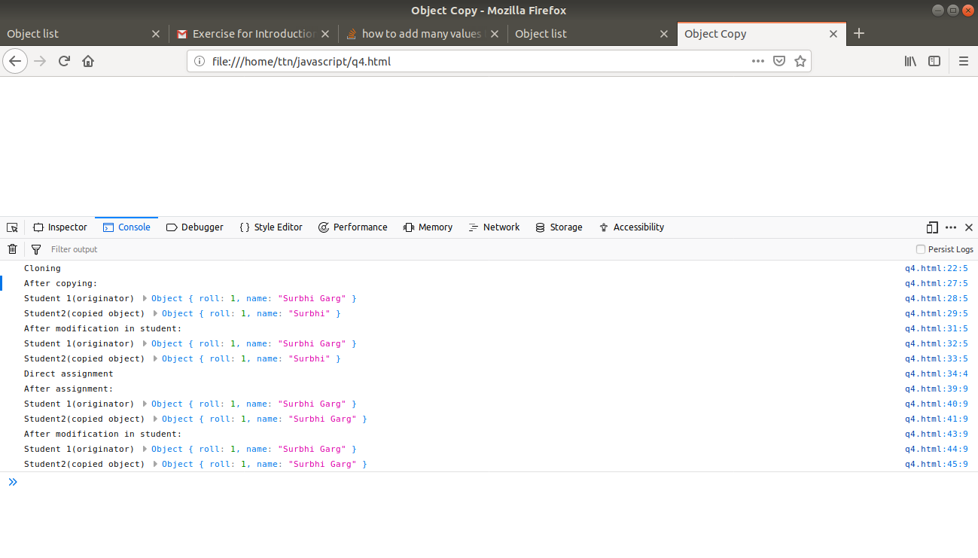
5. create a list of objects of Employee with info as follow :
  - Name, age, salary ,DOB
  - filter all employees with salary greater than 5000
  - group employee on the basis of their age
  - fetch employees with salary less than 1000 and age greater than 20. Then give them an increment 5 times their salary.
Solution1 (Using functions)
<!DOCTYPE html>
<html lang="en">
<head>
<meta charset="UTF-8">
<meta name="viewport" content="width=device-width, initial-scale=1.0">
<meta http-equiv="X-UA-Compatible" content="ie=edge">
<title>Object list</title>

</head>
<body>
<script type="text/javascript">
function Employee(name,age,salary,dob)
{
this.name=name;
this.age=age;
this.salary=salary;
this.dob=dob;
}
//part a
var list=[new Employee("Surbhi","23","6000","24-08-1995"),
new Employee("Rishabh","24","4000","12-04-1994"),
new Employee("Vagish","25","6000","24-12-1993"),
new Employee("Gagan","24","4500","11-02-1995"),
new Employee("Ram","21","900","24-08-1997"),
new Employee("Ruchi","23","850","08-12-1995"),
];

//part b
var highSalariedEmployees=list.filter(employee=>employee.salary>5000);
console.log("Employees having salary>5000",highSalariedEmployees);

//partc
var group=[];
var groupedEmployees={};
list.forEach(function(emp){if(!group.includes(emp.age))group.push(emp.age)});//finding all unique groups possible
for(let age of group)
{
groupedEmployees[age]=new Array();
for(let emp of list)
{
if(age===emp.age)
{
groupedEmployees[age].push(emp);
}
}
}
console.log("Employees grouped on the basis of age",groupedEmployees);

//partd

var lowSalHighAge=list.filter(employee=>employee.age>20 && employee.salary<1000).map(function(ele){ele.salary*=5;return ele;});
console.log("Employees having age>20 and salary<1000 mapped with 5 times salary",lowSalHighAge);

</script>
</body>
</html>
Output
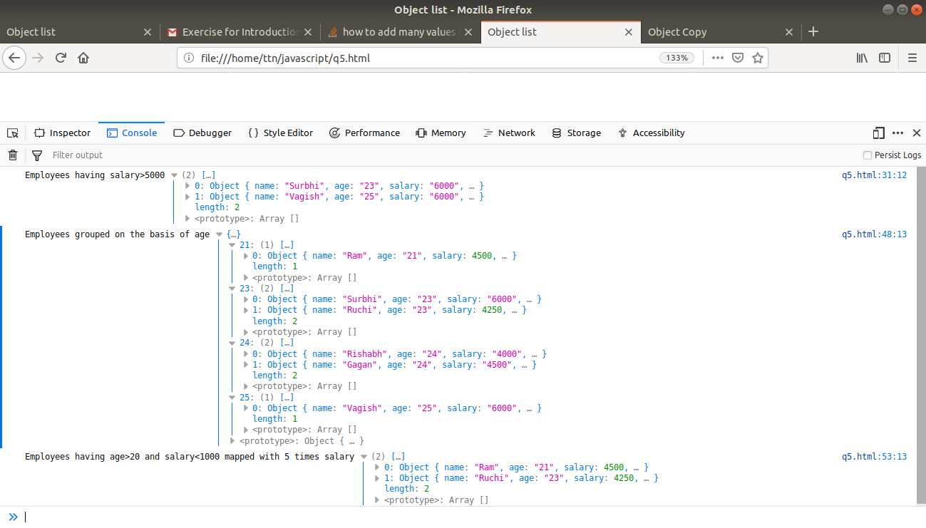
Solution2(Using logics)
<!DOCTYPE html>
<html lang="en">
<head>
<meta charset="UTF-8">
<meta name="viewport" content="width=device-width, initial-scale=1.0">
<meta http-equiv="X-UA-Compatible" content="ie=edge">
<title>Object list</title>

</head>
<body>
<script type="text/javascript">
function Employee(name,age,salary,dob)
{
this.name=name;
this.age=age;
this.salary=salary;
this.dob=dob;
}
//part a
var list=[new Employee("Surbhi","23","6000","24-08-1995"),
new Employee("Rishabh","24","4000","12-04-1994"),
new Employee("Vagish","25","6000","24-12-1993"),
new Employee("Gagan","24","4500","11-02-1995"),
new Employee("Ram","21","900","24-08-1997"),
new Employee("Ruchi","23","850","08-12-1995"),
];

//part b
var highSalariedEmployees=[];
for(index in list)
{
if(list[index].salary>5000)
highSalariedEmployees.push(list[index]);
}
console.log("Employees having salary>5000",highSalariedEmployees);

//partc
var group=[];
var groupedEmployees={};
list.forEach(function(emp){if(!group.includes(emp.age))group.push(emp.age)});//finding all unique groups possible
for(let age of group)
{
groupedEmployees[age]=new Array();
for(let emp of list)
{
if(age===emp.age)
{
groupedEmployees[age].push(emp);
}
}
}
console.log("Employees grouped on the basis of age",groupedEmployees);

//partd

var lowSalHighAge=[];
for(let emp of list)
{
if(emp.age>20 && emp.salary<1000)
{
emp.salary*=5
lowSalHighAge.push(emp);
}
}
console.log("Employees having age>20 and salary<1000 mapped with 5 times salary",lowSalHighAge);

</script>
</body>
</html>
Output
