**Q1. Console "Hello Word" in document.ready function**

**Solution**

<!DOCTYPE html>

<html lang="en">

<head>

<meta charset="UTF-8">

<meta name="viewport" content="width=device-width, initial-scale=1.0">

<meta http-equiv="X-UA-Compatible" content="ie=edge">

<title>Console Log</title>

<script

src="https://code.jquery.com/jquery-3.3.1.min.js"

integrity="sha256-FgpCb/KJQlLNfOu91ta32o/NMZxltwRo8QtmkMRdAu8="

crossorigin="anonymous"></script>

<script type="text/javascript">

$(document).ready(function(){console.log("Hello World")})

</script>

</head>

<body>

</body>

</html>

**Output**

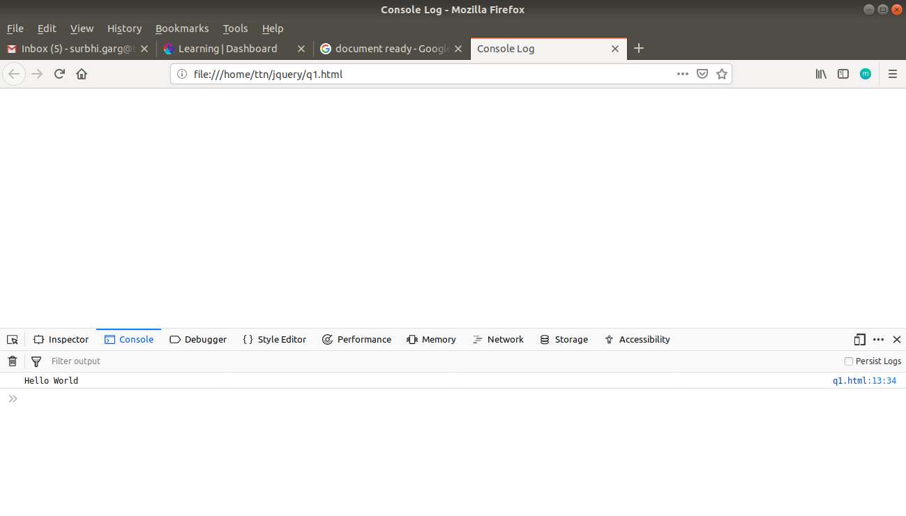

**Q2. Select a ID name "#test" and add class "load" when DOM is loaded.**

**Solution**

<!DOCTYPE html>

<html lang="en">

<head>

<meta charset="UTF-8">

<meta name="viewport" content="width=device-width, initial-scale=1.0">

<meta http-equiv="X-UA-Compatible" content="ie=edge">

<title>Q2</title>

<style>

.load{

color:red;

}

</style>

</head>

<body>

<p id="test">A class will be added</p>

<script

src="https://code.jquery.com/jquery-3.3.1.min.js"

integrity="sha256-FgpCb/KJQlLNfOu91ta32o/NMZxltwRo8QtmkMRdAu8="

crossorigin="anonymous"></script>

<script type="text/javascript">

$(function(){

$("#test").addClass("load")

});

</script>

</body>

</html>

**Output**

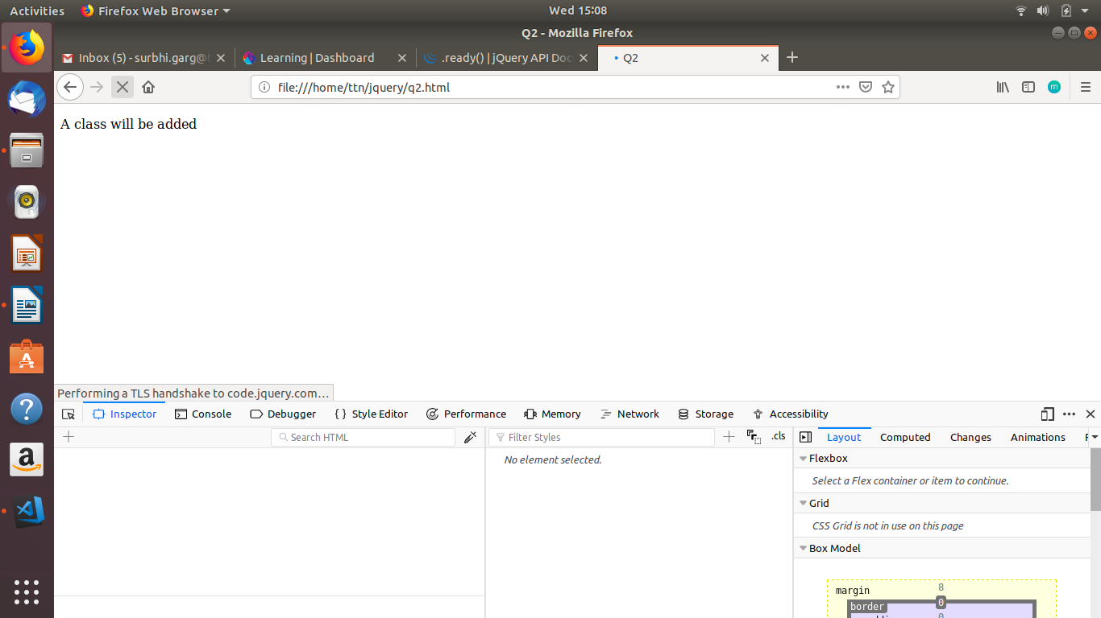

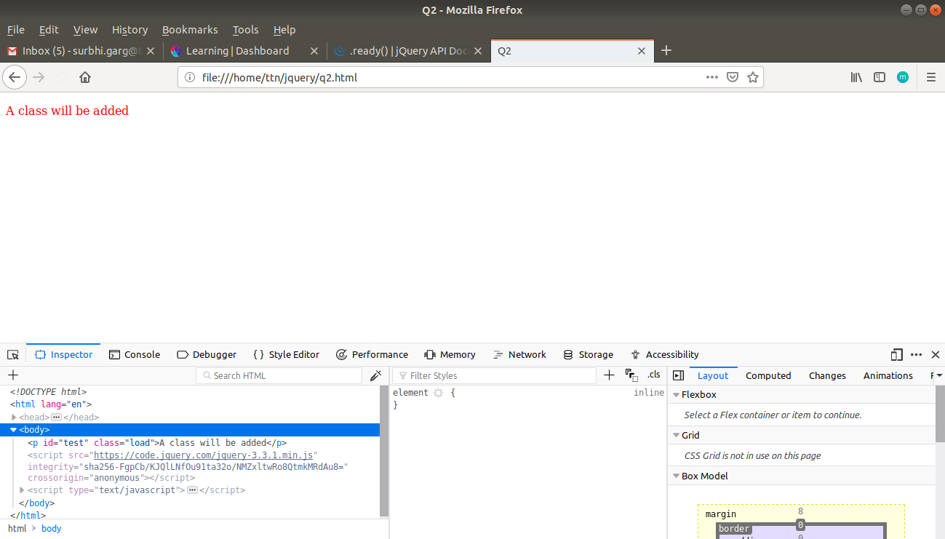

**Q3. Change the color of element which class name end with "-new"**

**Solution**

<!DOCTYPE html>

<html lang="en">

<head>

<meta charset="UTF-8">

<meta name="viewport" content="width=device-width, initial-scale=1.0">

<meta http-equiv="X-UA-Compatible" content="ie=edge">

<title>Q3</title>

</head>

<body>

<p class="test-new">Color will be changed</p>

<p class="color-new">Color will be changed</p>

<p class="color">Color will not change</p>

<script

src="https://code.jquery.com/jquery-3.3.1.min.js"

integrity="sha256-FgpCb/KJQlLNfOu91ta32o/NMZxltwRo8QtmkMRdAu8="

crossorigin="anonymous"></script>

<script type="text/javascript">

$(function(){

$("[class$='-new']").css({'color':'red'});

});

</script>

</body>

</html>

**Output**

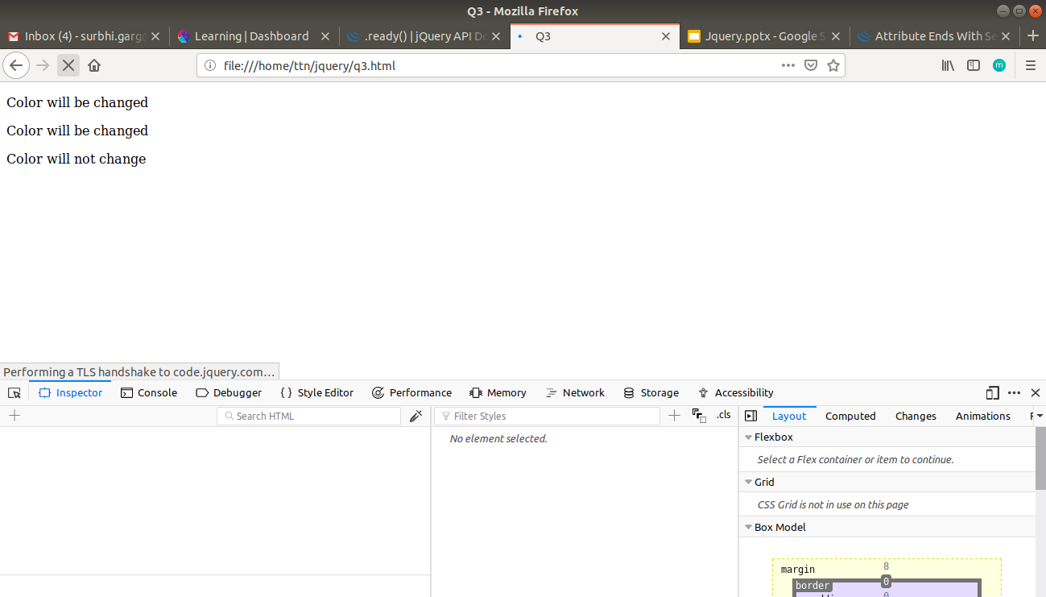

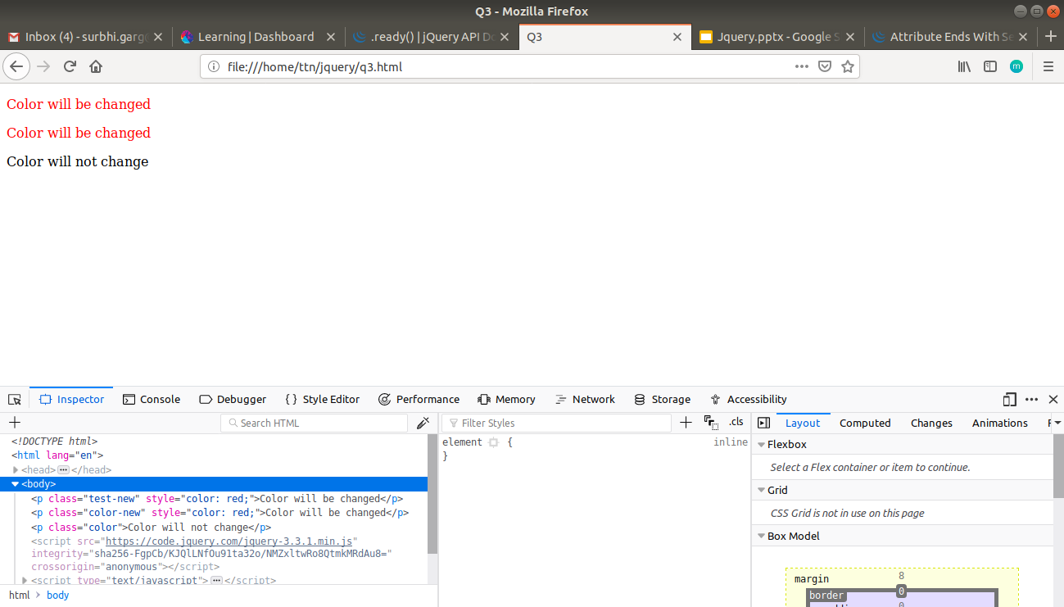

**Q4. Disable submit button using jquery attr method**

**Solution**

<!DOCTYPE html>

<html lang="en">

<head>

<meta charset="UTF-8">

<meta name="viewport" content="width=device-width, initial-scale=1.0">

<meta http-equiv="X-UA-Compatible" content="ie=edge">

<title>Q3</title>

</head>

<body>

<input type="submit" value="submit">

<script

src="https://code.jquery.com/jquery-3.3.1.min.js"

integrity="sha256-FgpCb/KJQlLNfOu91ta32o/NMZxltwRo8QtmkMRdAu8="

crossorigin="anonymous"></script>

<script type="text/javascript">

$(function(){

$("[type='submit']").attr("disabled","disabled");

});

</script>

</body>

</html>

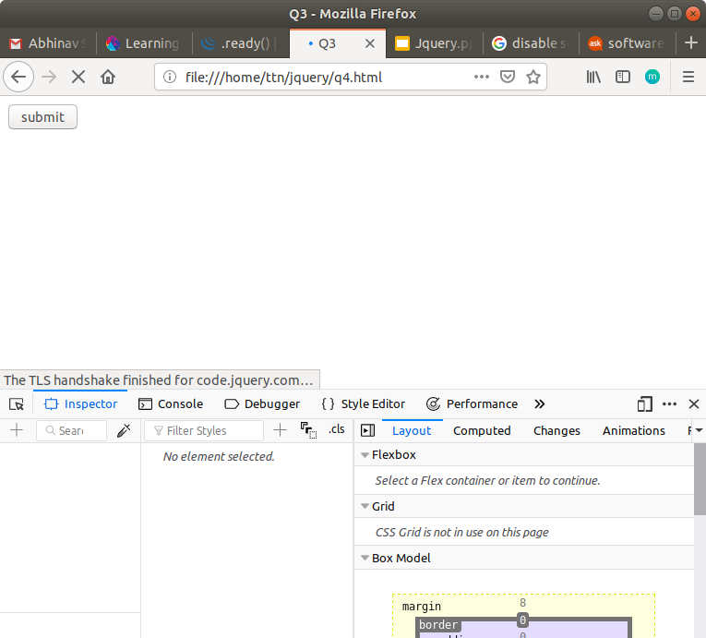**Output**

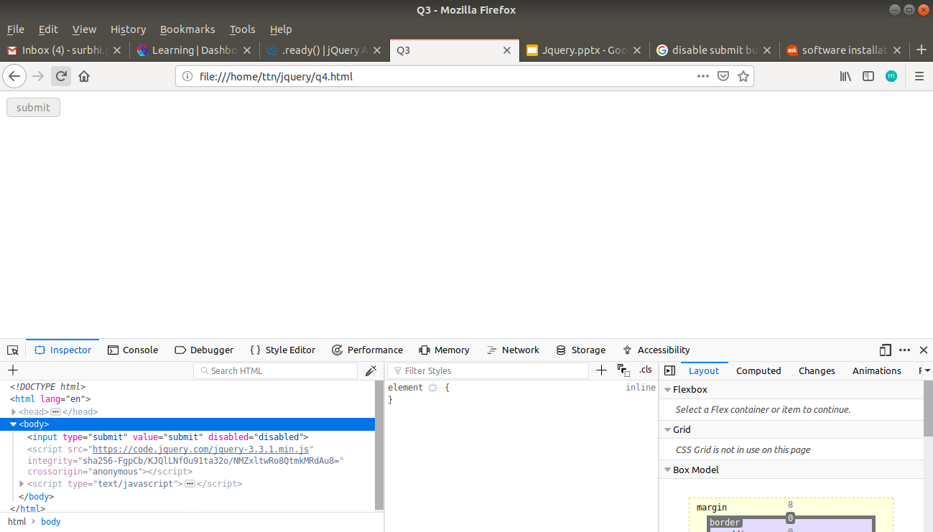

**Q5. Change the font size of ".target" which has parent element with id name "#main"**

**Solution**

<!DOCTYPE html>

<html lang="en">

<head>

<meta charset="UTF-8">

<meta name="viewport" content="width=device-width, initial-scale=1.0">

<meta http-equiv="X-UA-Compatible" content="ie=edge">

<title>Q5</title>

</head>

<body>

<div id="main">

<p class="target">This will be displayed with increased font size</p>

</div>

<script

src="https://code.jquery.com/jquery-3.3.1.min.js"

integrity="sha256-FgpCb/KJQlLNfOu91ta32o/NMZxltwRo8QtmkMRdAu8="

crossorigin="anonymous"></script>

<script type="text/javascript">

$(function(){

$("#main>.target").css("font-size","30px");

})

</script>

</body>

</html>

**Output**

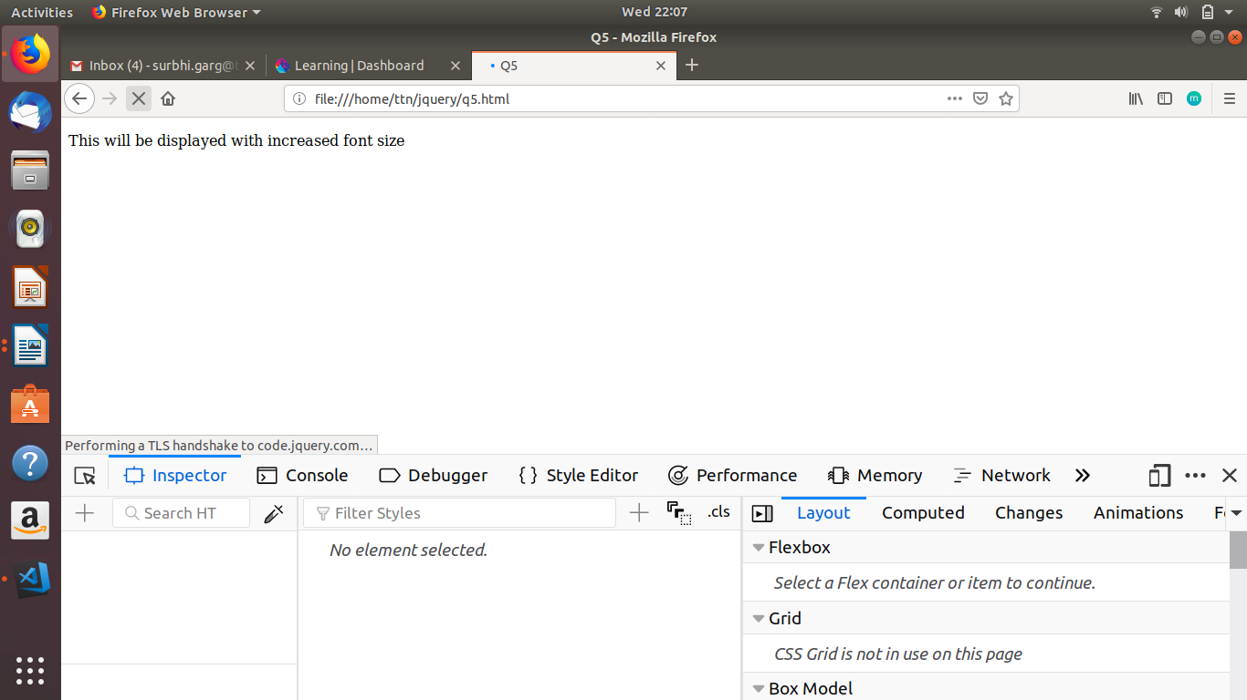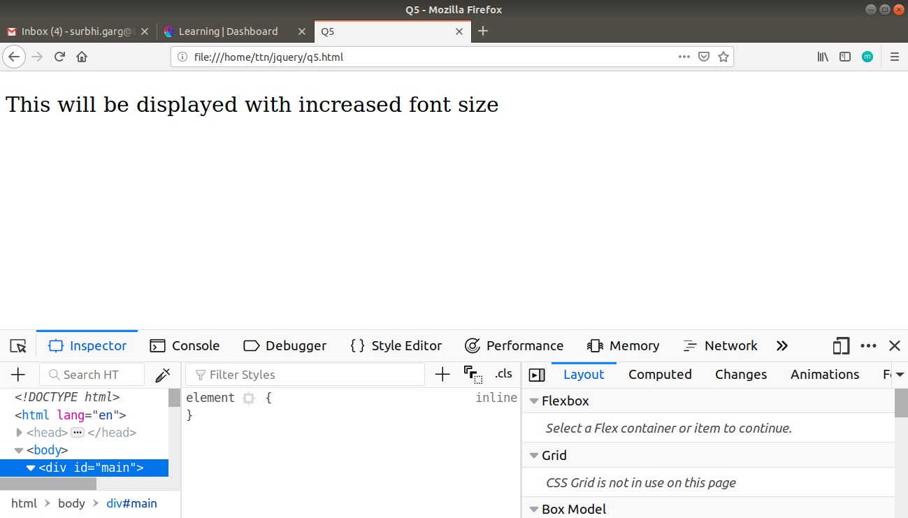

**Q6. After page load change the HTML of div element with "p" element**

**Solution**

<!DOCTYPE html>

<html lang="en">

<head>

<meta charset="UTF-8">

<meta name="viewport" content="width=device-width, initial-scale=1.0">

<meta http-equiv="X-UA-Compatible" content="ie=edge">

<title>Q6</title>

</head>

<body>

<div id="a">This will be changed to p</div>

<script

src="https://code.jquery.com/jquery-3.3.1.min.js"

integrity="sha256-FgpCb/KJQlLNfOu91ta32o/NMZxltwRo8QtmkMRdAu8="

crossorigin="anonymous"></script>

<script type="text/javascript">

$(window).on('load',function(){

var content=$("#a").val();

$("#a").html("<p style='color:blue'>New content</p>");

});

</script>

</body>

</html>

**Output**

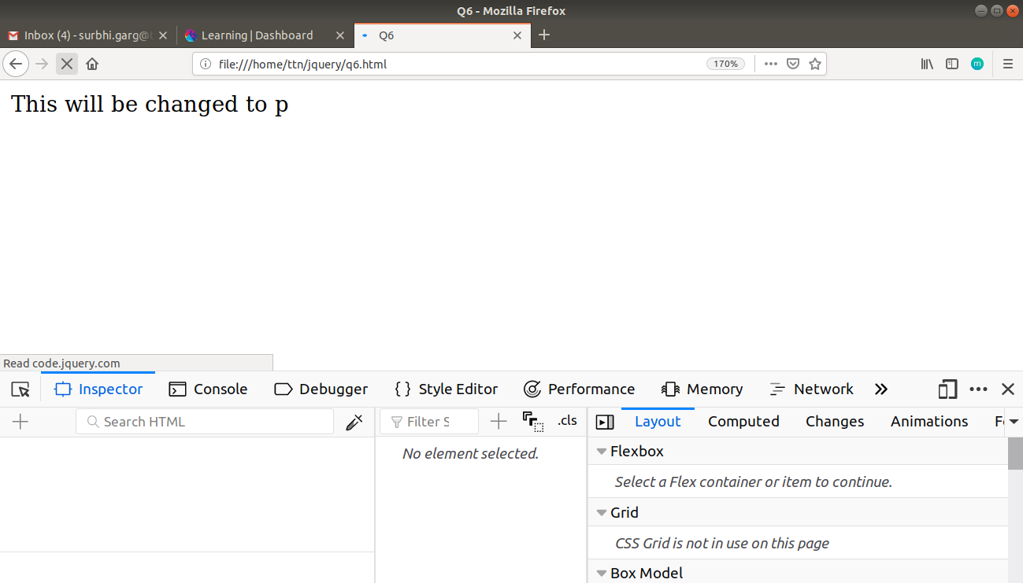

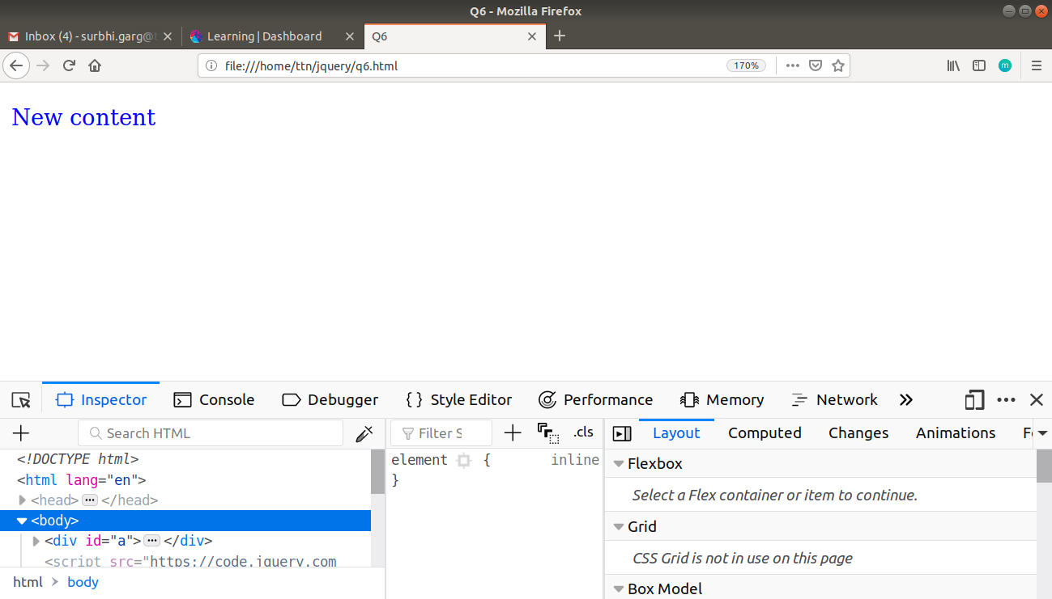

**Q7. Bind a click function to an "click" element and append next "click" next to it.**

**Solution**

<!DOCTYPE html>

<html lang="en">

<head>

<meta charset="UTF-8">

<meta name="viewport" content="width=device-width, initial-scale=1.0">

<meta http-equiv="X-UA-Compatible" content="ie=edge">

<title>Q7</title>

</head>

<body>

<click>Click to see the change</click>

<script

src="https://code.jquery.com/jquery-3.3.1.min.js"

integrity="sha256-FgpCb/KJQlLNfOu91ta32o/NMZxltwRo8QtmkMRdAu8="

crossorigin="anonymous"></script>

<script type="text/javascript">

$(function(){

$("click").on('click',function(e){

$("click").append("<click> Next Click</click>");

})

});

</script>

</body>

</html>

**Output**

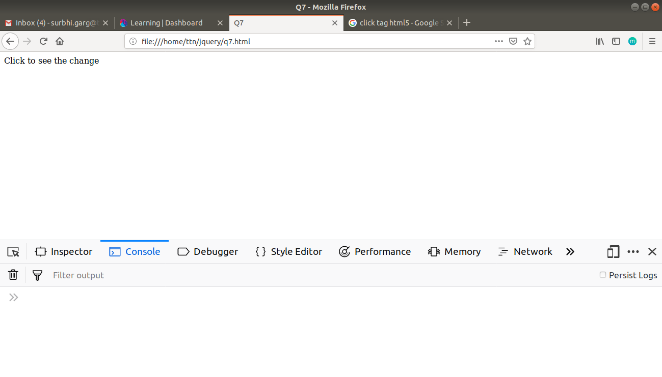

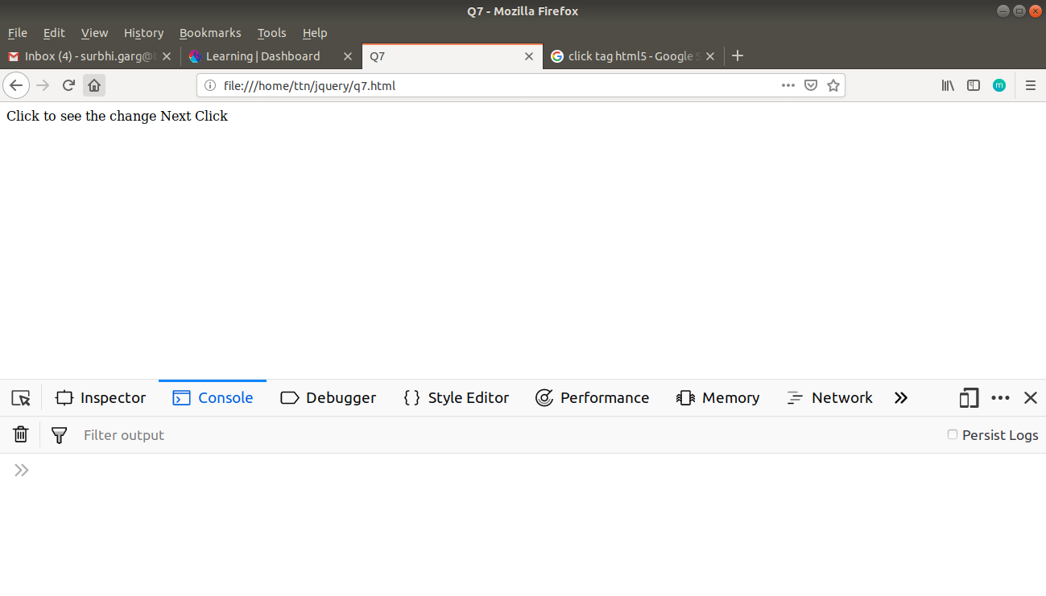

**Q8. Click event not working on element which added dynamicly or via script, make it work using .on method**

**Solution**

<!DOCTYPE html>

<html lang="en">

<head>

<meta charset="UTF-8">

<meta name="viewport" content="width=device-width, initial-scale=1.0">

<meta http-equiv="X-UA-Compatible" content="ie=edge">

<title>Q8</title>

</head>

<body>

<div id="clickable">Click Me</div>

<script

src="https://code.jquery.com/jquery-3.3.1.min.js"

integrity="sha256-FgpCb/KJQlLNfOu91ta32o/NMZxltwRo8QtmkMRdAu8="

crossorigin="anonymous"></script>

<script type="text/javascript">

$(function(){

$("#clickable").click(function(e){$("#clickable").append("<p id='demo'>Added dynamically</p>")});

$("#clickable>#demo").click(function(e){alert("click won’t work")});

$("#clickable").on('click',"#demo",function(e){alert("on click will work")});

})

</script>

</body>

</html>

**Output**

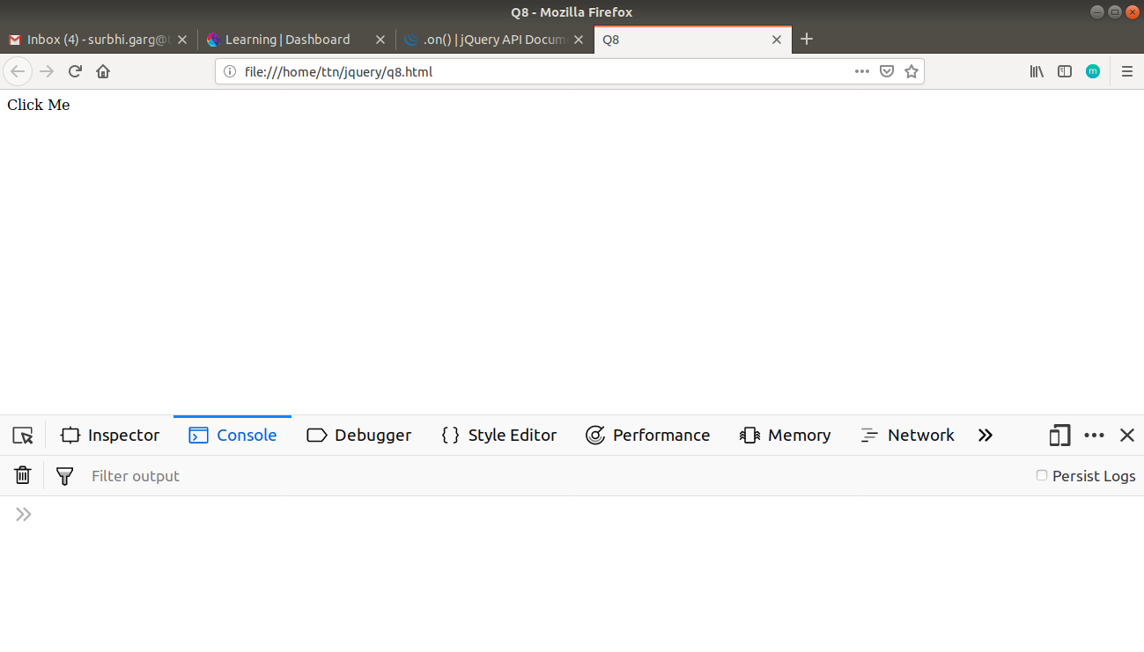

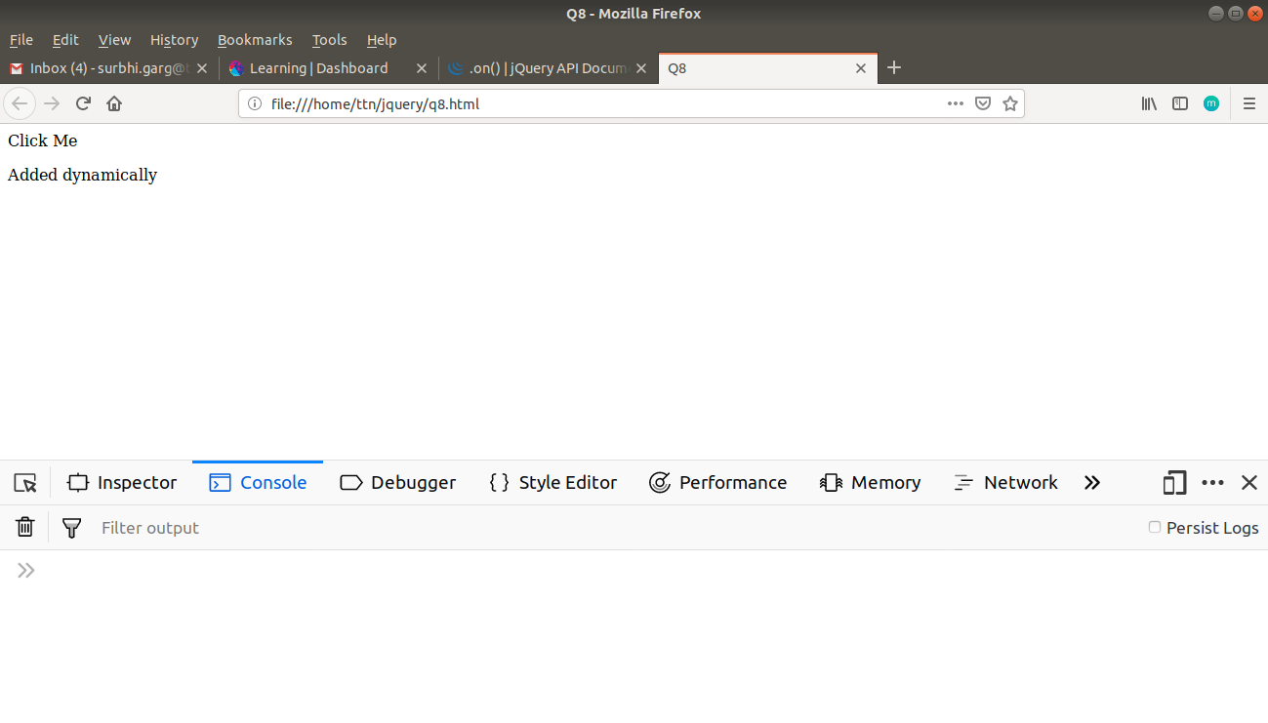

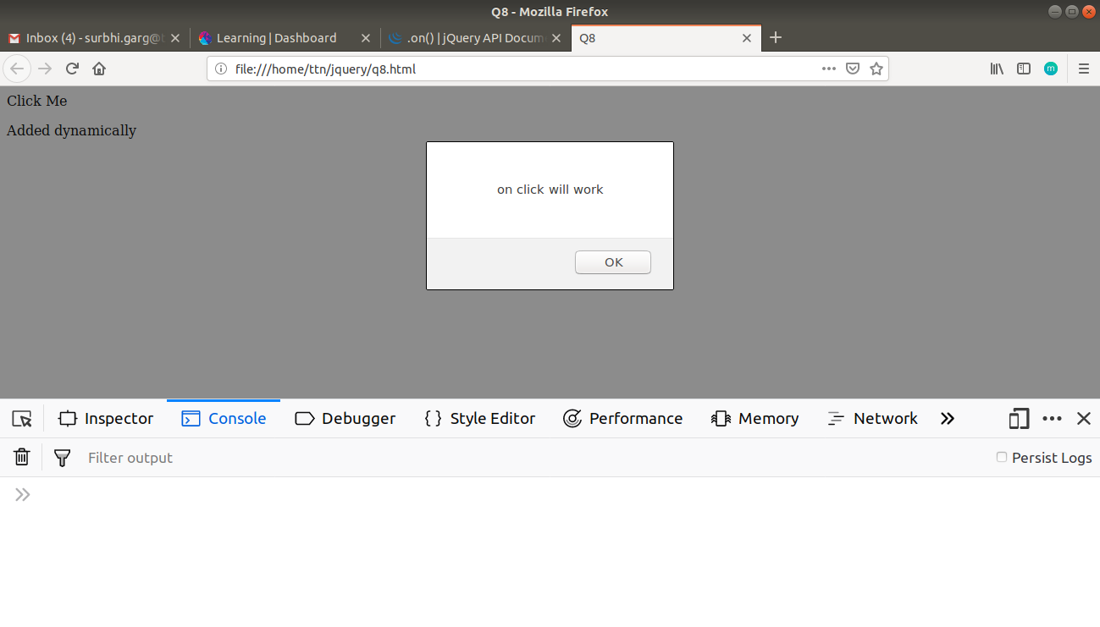

**Q9. Get dropdown selected value on onchanage event and append in div container**

**Solution**

<!DOCTYPE html>

<html lang="en">

<head>

<meta charset="UTF-8">

<meta name="viewport" content="width=device-width, initial-scale=1.0">

<meta http-equiv="X-UA-Compatible" content="ie=edge">

<title>Q9</title>

</head>

<body>

<div id="container">Items will appear here:-</div>

<select id="products" onchange="addval();">

<option value="charger">charger</option>

<option value="laptop sleeve">laptop sleeve</option>

<option value="sipper">sipper</option>

<option value="mug">mug</option>

<option value="notepad">notepad</option>

</select>

<script

src="https://code.jquery.com/jquery-3.3.1.min.js"

integrity="sha256-FgpCb/KJQlLNfOu91ta32o/NMZxltwRo8QtmkMRdAu8="

crossorigin="anonymous"></script>

<script type="text/javascript">

function addval()

{

var value=$("#products").val();

$("#container").append("<span>"+value+"</span><br/>");

}

</script>

</body>

</html>

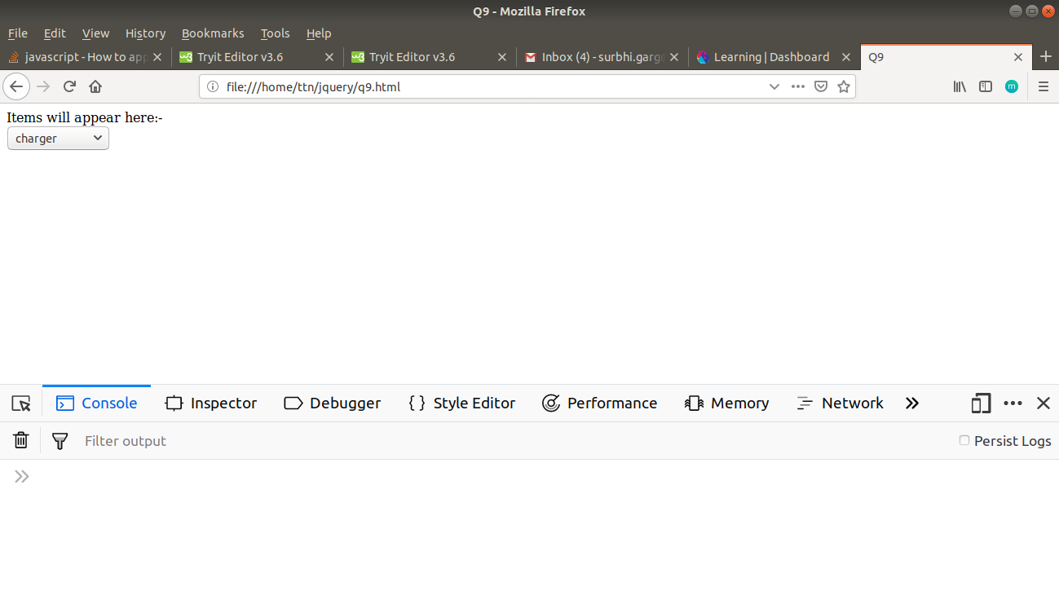**Output**

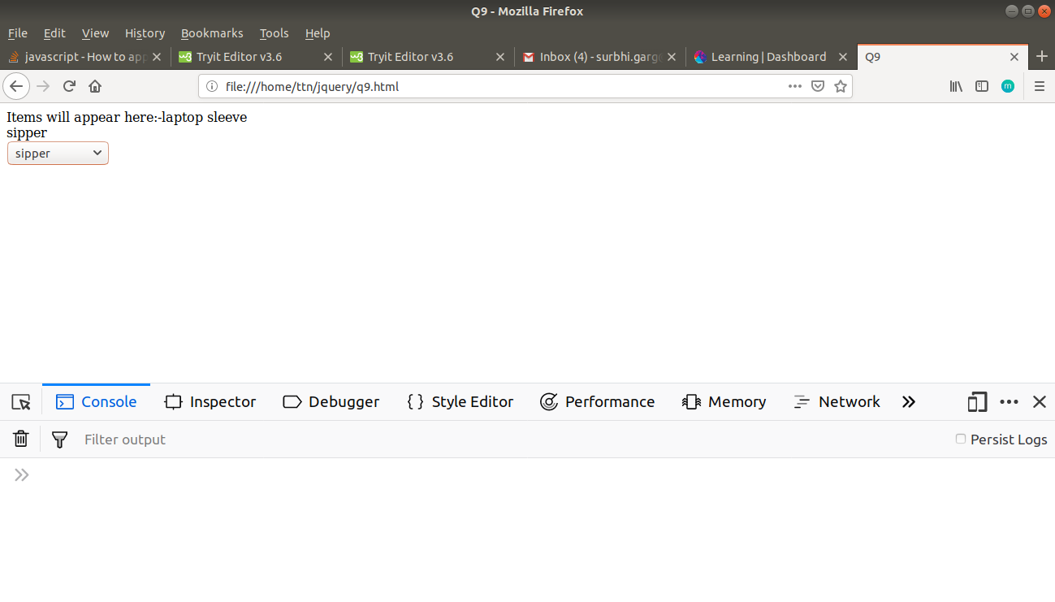

**Q10. Create a dropdown menu using hover method in jquery**

**Solution**

<!DOCTYPE html>

<html lang="en">

<head>

<meta charset="UTF-8">

<meta name="viewport" content="width=device-width, initial-scale=1.0">

<meta http-equiv="X-UA-Compatible" content="ie=edge">

<title>Q10</title>

<style>

#select

{

position: relative;

display: inline-block;

}

.select-item>a

{

display: block;

position: absolute;

}

</style>

</head>

<body>

<div id="select">

<button id="showselect">Select a value</button>

<ul class="select-item" type="none">

<li><a href="#">charger</a></li>

<li><a href="#">laptop-sleeve</a></li>

<li><a href="#">sipper</a></li>

<li><a href="#">bag</a></li>

</ul>

</div>

<script

src="https://code.jquery.com/jquery-3.3.1.min.js"

integrity="sha256-FgpCb/KJQlLNfOu91ta32o/NMZxltwRo8QtmkMRdAu8="

crossorigin="anonymous"></script>

<script type="text/javascript">

$('#showselect').hover(function(e){

$(".select-item").slideDown("fast");

},

function(e)

{

$(".select-item").slideUp("fast");

}

)

</script>

</body>

</html>

**Output**

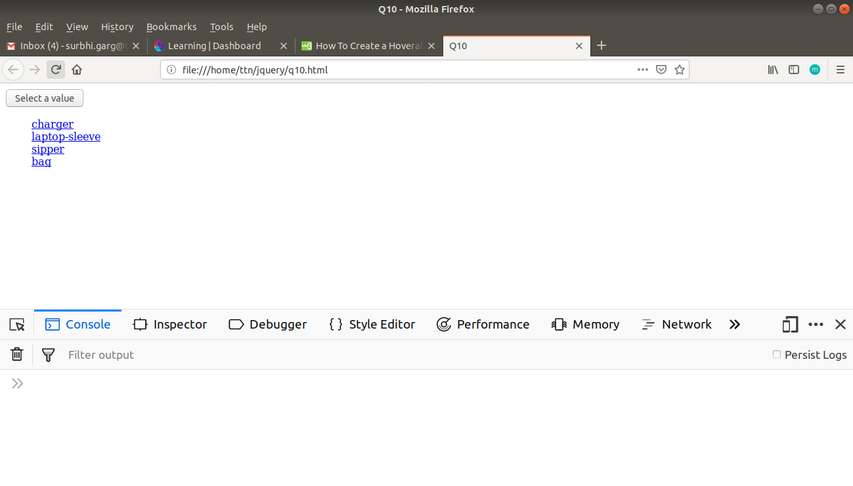

**Q11. On clicking on "**[**google**](https://www.google.com/)**" tag. It is taking us to google home page. Stop it from happening.**

**Solution**

<!DOCTYPE html>

<html lang="en">

<head>

<meta charset="UTF-8">

<meta name="viewport" content="width=device-width, initial-scale=1.0">

<meta http-equiv="X-UA-Compatible" content="ie=edge">

<title>Q11</title>

</head>

<body>

<a href="https://www.google.com">google</a>

<script

src="https://code.jquery.com/jquery-3.3.1.min.js"

integrity="sha256-FgpCb/KJQlLNfOu91ta32o/NMZxltwRo8QtmkMRdAu8="

crossorigin="anonymous"></script>

<script type="text/javascript">

$("a").click(function(e){e.preventDefault();})

</script>

</body>

</html>

**Q12. We have bind a click funtion to parent div but we want stop it from performing when user clicks on its child li.**

**Solution**

<!DOCTYPE html>

<html lang="en">

<head>

<meta charset="UTF-8">

<meta name="viewport" content="width=device-width, initial-scale=1.0">

<meta http-equiv="X-UA-Compatible" content="ie=edge">

<title>Q11</title>

</head>

<body>

<div id="parent" style="height: 50px;width: 100px;background-color: chartreuse">

<li style="background-color: coral">Hello</p>

</div>

<script

src="https://code.jquery.com/jquery-3.3.1.min.js"

integrity="sha256-FgpCb/KJQlLNfOu91ta32o/NMZxltwRo8QtmkMRdAu8="

crossorigin="anonymous"></script>

<script type="text/javascript">

$("#parent").click(function(e){alert("parent clicked")})

$("#parent>li").click(function(e){alert("child li clicked");

e.stopPropagation()})

</script>

</body>

</html>

**Output**

**When parent div is clicked**

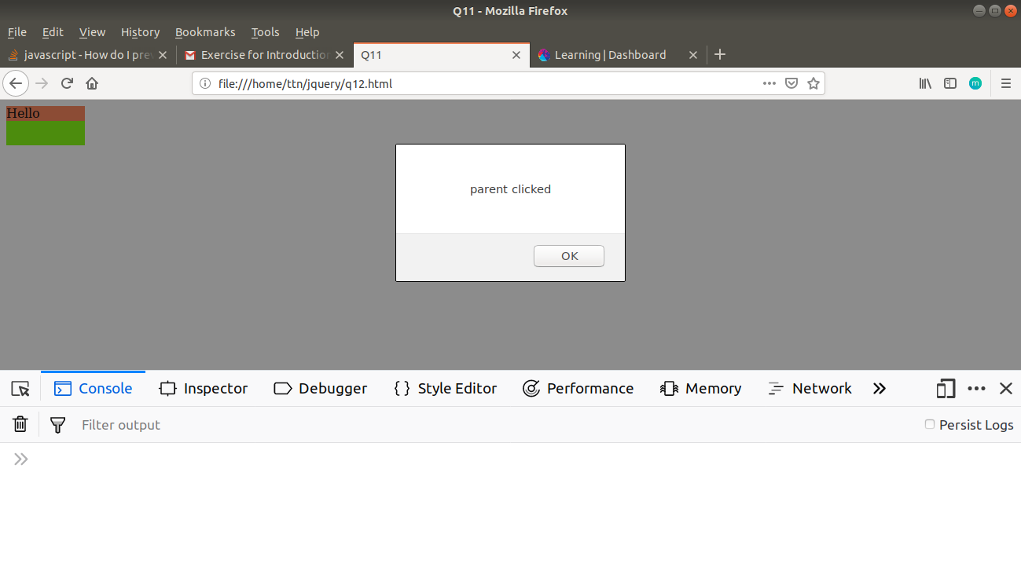

**When child li is clicked**

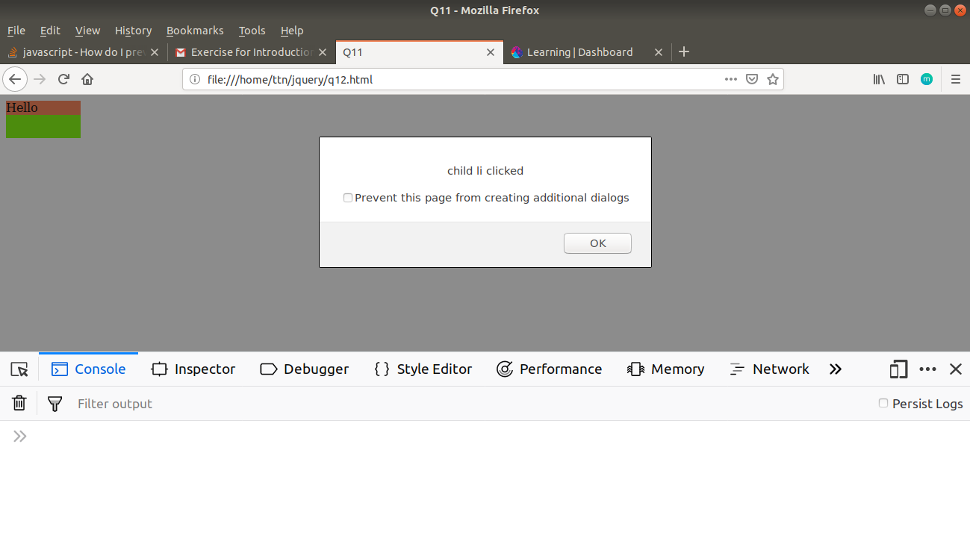

**Q13. Get the max height of elements using jquery each method**

**Solution**

<!DOCTYPE html>

<html lang="en">

<head>

<meta charset="UTF-8">

<meta name="viewport" content="width=device-width, initial-scale=1.0">

<meta http-equiv="X-UA-Compatible" content="ie=edge">

<title>Q13</title>

</head>

<body>

<span id="result"></span>

<p style="height:40px"></p>

<p style="height:80px"></p>

<p style="height:50px"></p>

<script src="https://code.jquery.com/jquery-3.3.1.min.js"

integrity="sha256-FgpCb/KJQlLNfOu91ta32o/NMZxltwRo8QtmkMRdAu8=" crossorigin="anonymous"></script>

<script>

$(document).ready(function () {

var maxHeight=0;

$("p").each(function(index,element){

if(maxHeight<$(element).height())

maxHeight=$(element).height();

});

$("#result").text("Max Height is "+maxHeight+"px");

});

</script>

</body>

</html>

**Output**

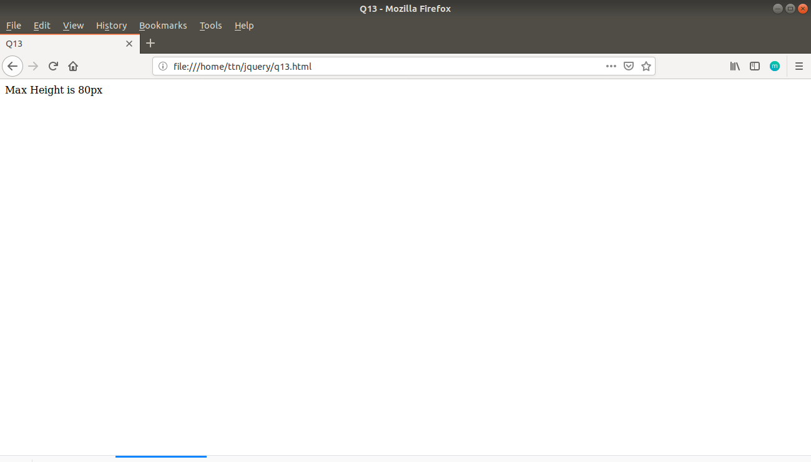

**Q14. Change color of every cell which has number larger than 10.**

**Solution**

<!DOCTYPE html>

<html lang="en">

<head>

<meta charset="UTF-8">

<meta name="viewport" content="width=device-width, initial-scale=1.0">

<meta http-equiv="X-UA-Compatible" content="ie=edge">

<title>Q14</title>

<style>

.cell

{

border:1px solid black;

}

</style>

</head>

<body>

<table style="border:1px solid black;padding: 1em;border-collapse: collapse">

<tr>

<td class="cell">9</td>

<td class="cell">11</td>

</tr>

<tr>

<td class="cell">8</td>

<td class="cell">12</td>

</tr>

<tr>

<td class="cell">16</td>

<td class="cell">7</td>

</tr>

<tr>

<td class="cell">13</td>

<td class="cell">12</td>

</tr>

</table>

<script

src="https://code.jquery.com/jquery-3.3.1.min.js"

integrity="sha256-FgpCb/KJQlLNfOu91ta32o/NMZxltwRo8QtmkMRdAu8="

crossorigin="anonymous"></script>

<script type="text/javascript">

$(".cell").each(function(index,ele){

if($(ele).text()>10)$(ele).css("color","blue");

})

</script>

</body>

</html>

**Output**

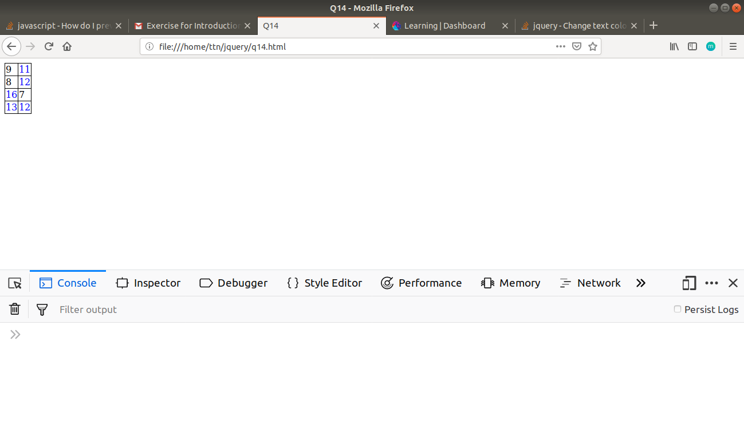

**Q15. Retrive the data from server using ajax get call**

**Solution**

<!DOCTYPE html>

<html lang="en">

<head>

<meta charset="UTF-8">

<meta name="viewport" content="width=device-width, initial-scale=1.0">

<meta http-equiv="X-UA-Compatible" content="ie=edge">

<title>Q10</title>

</head>

<body>

<table id="result">

<thead>

<tr>

<th>User Id</th>

<th>Id</th>

<th>Title</th>

<th>Body</th>

</tr>

</thead>

<tbody></tbody>

</table>

<script

src="https://code.jquery.com/jquery-3.3.1.min.js"

integrity="sha256-FgpCb/KJQlLNfOu91ta32o/NMZxltwRo8QtmkMRdAu8="

crossorigin="anonymous"></script>

<script type="text/javascript">

$.get("https://jsonplaceholder.typicode.com/posts",function(data){

for(var i=0;i<data.length;i++)

{

var

tableRow=$("<tr></tr>"),

td1=$("<td></td>"),

td2=$("<td></td>"),

td3=$("<td></td>"),

td4=$("<td></td>"),

userId=$("<p></p>"),

id=$("<p></p>"),

title=$("<p></p>"),

body=$("<p></p>");

userId.append(data[i].userId);

id.append(data[i].id);

title.append(data[i].title);

body.append(data[i].body);

td1.append(userId);

td2.append(id);

td3.append(title);

td4.append(body);

tableRow.append(td1);

tableRow.append(td2);

tableRow.append(td3);

tableRow.append(td4);

$("#result>tbody").append(tableRow);

}

})

</script>

</body>

</html>

**Output**

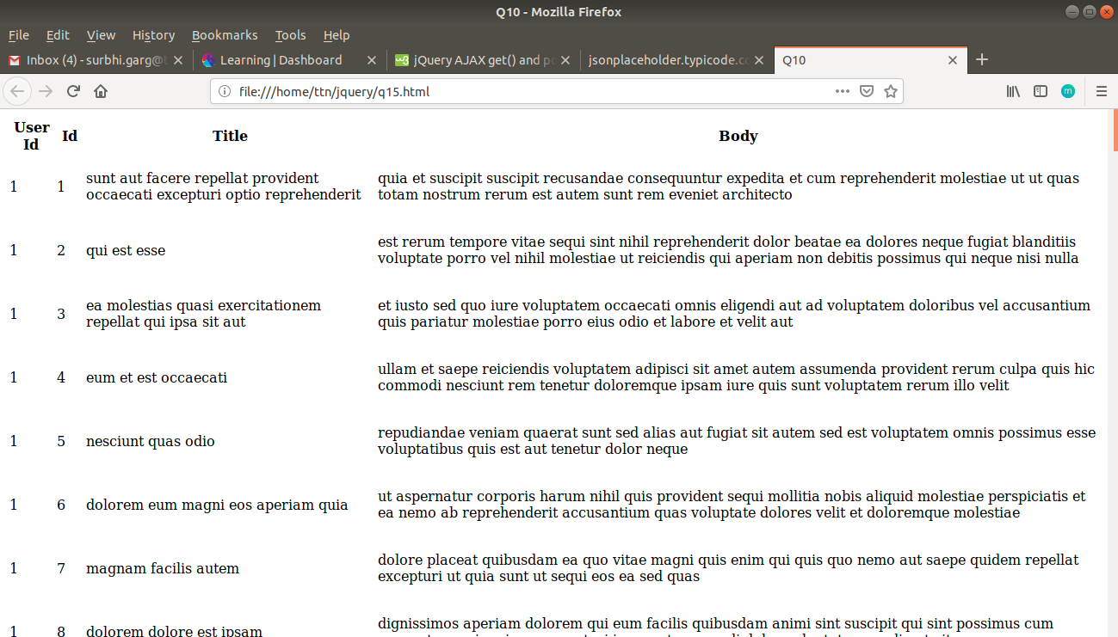

**Q16. Add cross button on row and bind click function which make a delete request to server, after success event remove the row from dom**

**Solution**

<!DOCTYPE html>

<html lang="en">

<head>

<meta charset="UTF-8">

<meta name="viewport" content="width=device-width, initial-scale=1.0">

<meta http-equiv="X-UA-Compatible" content="ie=edge">

<title>Q16</title>

</head>

<body>

<table id="result">

<thead>

<tr>

<th>User Id</th>

<th>Id</th>

<th>Title</th>

<th>Body</th>

<th></th>

</tr>

</thead>

<tbody></tbody>

</table>

<script

src="https://code.jquery.com/jquery-3.3.1.min.js"

integrity="sha256-FgpCb/KJQlLNfOu91ta32o/NMZxltwRo8QtmkMRdAu8="

crossorigin="anonymous"></script>

<script type="text/javascript">

$.get("https://jsonplaceholder.typicode.com/posts",function(data){

for(var i=0;i<data.length;i++)

{

var

tableRow=$("<tr></tr>"),

td1=$("<td></td>"),

td2=$("<td></td>"),

td3=$("<td></td>"),

td4=$("<td></td>"),

userId=$("<p></p>"),

id=$("<p></p>"),

title=$("<p></p>"),

body=$("<p></p>"),

button=$("<button style='bg-color:red,padding:1em'></button>");

userId.append(data[i].userId);

id.append(data[i].id);

title.append(data[i].title);

body.append(data[i].body);

button.append("&#x2716;");

td1.append(userId);

td2.append(id);

td3.append(title);

td4.append(body);

tableRow.append(td1);

tableRow.append(td2);

tableRow.append(td3);

tableRow.append(td4);

tableRow.append(button);

var currentButtonId=data[i].id;

$("#result>tbody").append(tableRow);

button.on('click',{

id:currentButtonId,

},function(e){

//console.log(e.data.row);

deleteData(e.data.id,$(this).closest("tr"));

})

}

function deleteData(id,row)

{

$.ajax({

url:"https://jsonplaceholder.typicode.com/posts/"+id,

method:'delete',

success:function(result)

{

row.remove();

}

})

}

})

</script>

</body>

</html>

**Output**

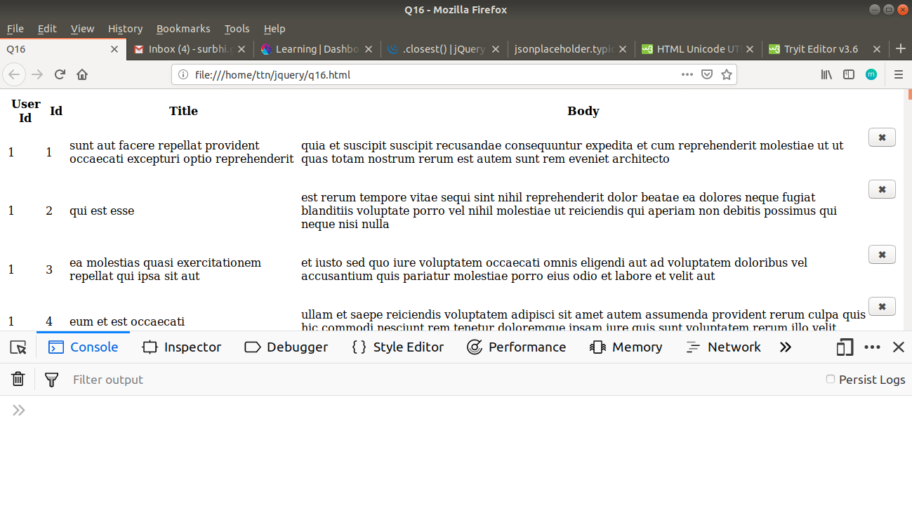

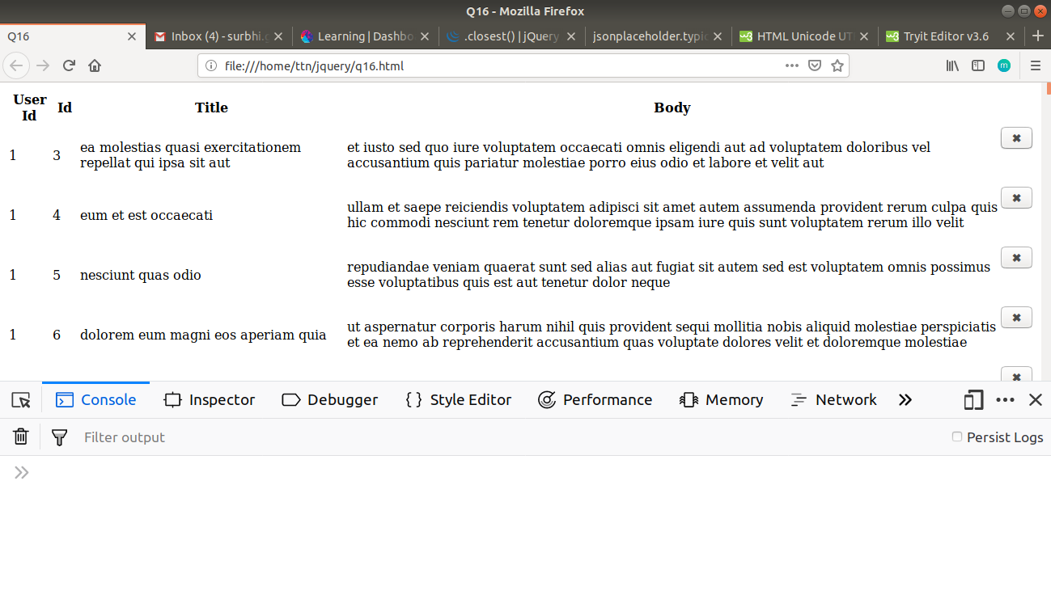

**Q17. Create a image array and in div create a slide show to animate images of delay of 500ms.**

**Solution**

**<!DOCTYPE html>**

<html lang="en">

<head>

<meta charset="UTF-8">

<meta name="viewport" content="width=device-width, initial-scale=1.0">

<meta http-equiv="X-UA-Compatible" content="ie=edge">

<title>Q17</title>

<style>

#slider {

opacity: 1;

width: 500px;

height: 200px;

background-color: blueviolet;

}

</style>

</head>

<body>

<div id="slider">Hover at me to start slideshow<img id="slide-img"></div>

<script src="https://code.jquery.com/jquery-3.3.1.min.js"

integrity="sha256-FgpCb/KJQlLNfOu91ta32o/NMZxltwRo8QtmkMRdAu8=" crossorigin="anonymous"></script>

<script>

$(document).ready(function () {

var imageArray = ["http://placekitten.com/500/200",

"http://placekitten.com/499/200",

"http://placekitten.com/501/200",

"http://placekitten.com/500/199"]

$("#slider").hover(function () {

var image = $("#slide-img");

image.animate({ opacity: 0 }, 500, function () {

var random = imageArray[Math.floor(Math.random() * imageArray.length)];

image.attr("src", random);

image.css('opacity', 1);

$("#slider").html(image);

})

})

});

</script>

</body>

</html>

**Output**



