Assignment 1
Creating a Network for UnoSecurity
Name: Surbhi Gupta
n = 15

Part A
The HR department has 15 desktop computers and 1 printer, then the address block for this department can be calculated as follows:
Total required host IPs: 16
Required IPs for future expansion: 5
Total IPs: 21 + 2 = 23
When the number of computers and printers are given, we have to add 1 for router interface for that network (1 for default gateway).
Total required IPs: 23+1=24
The address block selected is 32.
Similarly, address block for each department is calculated as follows:
There are 4 departments and required devices in each:
Department | Devices (including printers) | 30% future expansion of the devices | Required for router interface (default gateway) | Total hosts(including network ID and broadcast ID) | Required address block
HR | 15+1=16 | 5 | 1 | 22+2=24 | 32
Accounting | 15+20=35 | 11 | 1 | 47+2=49 | 64
IT | 15+35+1=51 | 16 | 1 | 68+2=70 | 128
Guest | 15+10=25 | 8 | 1 | 34+2=36 | 64

The largest address block is for IT department which is 128. We are doing fixed size subnetting so we will take the largest address block as the ideal one for all departments.
Now, we are given with the class B network 172.16.0.0/16
Subnet mask= 255.255.255.0
For having 128 hosts in each subnet,
- Address block = 2^{h} (h= number of hosts)
- 128 = 2^{h}
- 2⁷ = 2^{h}
- h = 7
- Number of host bits = 7
- Number of network bits in 4th octet = 8 - h
= 8 – 7
=1
Total number of network bits = 25

- New subnet mask = 255.255.255.128 (in binary form- 11111111. 11111111. 11111111. 10000000)
Here 1 represents network bits and 0 represents host bits.
- Total number of borrowed bits (b) = 8+1= 9
- Total number of valid subnets = 2^{b}
= 2⁹
The third octet will be changing after (256/128=2) 2 subnets in the network table.
Label | Department | Network Address | Broadcast Address | Valid IP Addresses | Default Gateway (Router Interface)
NW0 | HR | 172.16.0.0 | 172.16.0.127 | 172.16.0.1 – 172.16.0.126 | 172.16.0.1
NW1 | Accounting | 172.16.0.128 | 172.16.0.255 | 172.16.0.129 – 172.16.0.254 | 172.16.0.129
NW2 | IT | 172.16.1.0 | 172.16.1.127 | 172.16.1.1 – 172.16.1.126 | 172.16.1.1
NW3 | Guest | 172.16.1.128 | 172.16.1.255 | 172.16.1.129 – 172.16.1.254 | 172.16.1.129

The subnet mask for each network (NW0 – NW3) is 255.255.255.128
The address block for each network (NW0 – NW3) is 128

There are 4 routers and 4 switches in the network. For router-to-router links, we need the possible smallest subnetwork for point-to-point connection.
So, the smallest possible address block = 4
- Address block = 2^{h} (h= number of hosts)
- 4 = 2^{h}
- 2² = 2^{h}
- h = 2
The host bits are 2.
Borrowed bits(b) = 8 – h = 8 – 2 = 6.
New subnet mask = 255.255.255.252 ( in binary form, 11111111. 11111111. 11111111. 11111100)
The network map for routers:
Label | Routers Link | Network Address | Broadcast Address | Valid IP Addresses
NW4 | R1 R2 | 172.16.2.0 | 172.16.2.3 | 172.16.2.1 – 172.16.2.2
NW5 | R2 R3 | 172.16.2.4 | 172.16.2.7 | 172.16.2.5 – 172.16.2.6
NW6 | R3 R4 | 172.16.2.8 | 172.16.1.11 | 172.16.2.9 – 172.16.2.10
NW7 | R4 R1 | 172.16.2.12 | 172.16.1.15 | 172.16.2.13 – 172.16.2.14

The subnet mask for each network (NW4 – NW7) is 255.255.255.252
The address block for each network (NW4 – NW7) is 4

Part B
The visual representation for the above network:
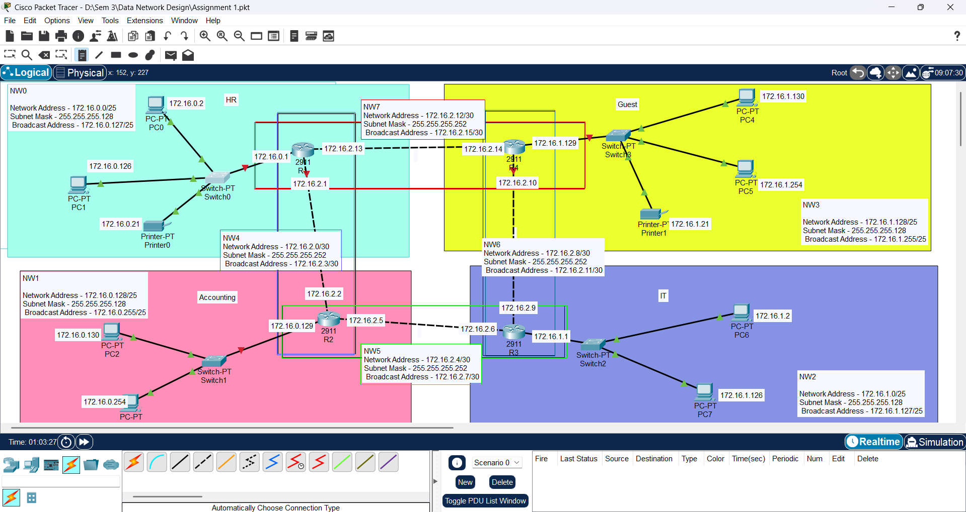

Part C
- Collision Domain: A part of the network where data packets can collide if two devices try to send data at the same time, causing delays and retransmissions.
- Broadcast Domain: A part of the network where a broadcast message sent by any device is received by all devices in that domain.
Each port on a switch, or a router is the separate collision domain.
Each port on the router is a separate broadcast domain.
We are taking the scenario before the 30% expansion.
Device/Network Segment | Number of Collision Domains | Number of Broadcast Domains
HR Department (1 Switch, 16 Devices) | 16
Accounting Department (1 Switch, 35 Devices) | 35
IT Department (1 Switch, 51 Devices) | 51
Guest Network (1 Switch, 25 Devices) | 25
Router-to-Router Links (4 Routers) | 4 | 4
Switch-to-Router Links (4 switch connected to 4 routers) | 4 | 4
Total | 135 | 8

Each department has one switch and each switch is connected to the router, so there are total of 8 broadcast domains and 135 collision domains.

