Network Design and Configuration
(By- Surbhi Gupta)

Objectives:
• To plan the IP address assignments for the Enterprise internal network using efficient subnetting.
• To plan static routing to provide end-to-end connectivity in the network.
• To provide default route to connect internal devices to internet.
Scenario: UnoSecurity is an organization that deals with providing an access control system for hospitals, banks, and government buildings. The networking team had come up with the base topology and network plan for the network as per the new requirement shown

Table of Contents

Part A ……………………………………………………………………………………………..3
Part B………………………………………………………………………………………………4
Part C………………………………………………………………………………………………8
Part D………………………………………………………………………………………………11
Tables and Figures……………………………………………………………………………….21

Assignment
UnoSecurity is an organization that deals with providing an access control system for hospitals, banks, and government buildings. The networking team had come up with the base topology and network plan for the network

Part A
According to the network plan given, the schematic is as below:
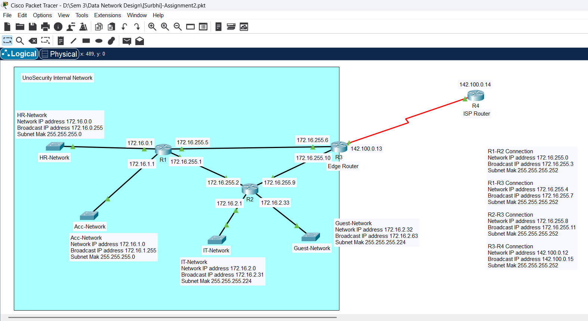
Figure 1: Router Interfaces with assigned IP addresses

Part B
The static route configuration on the routers according to the constraints:

R1 (Router 1)
Label | Destination network address | Subnet Mask (dotted decimal) | Next hop IP address | Exit interface
C | 172.16.0.0 | 255.255.255.0 | -------- | Gig 8/0
C | 172.16.1.0 | 255.255.255.0 | -------- | Gig 9/0
C | 172.16.255.0 | 255.255.255.252 | -------- | Gig 6/0
C | 172.16.255.4 | 255.255.255.252 | -------- | Gig 7/0
S | 172.16.2.0 | 255.255.255.224 | 172.16.255.2 | Gig 6/0
S | 172.16.2.32 | 255.255.255.224 | 172.16.255.2 | Gig 6/0
S | 172.16.255.8 | 255.255.255.252 | 172.16.255.2 | Gig 6/0
S | 142.100.0.12 | 255.255.255.252 | 172.16.255.6 | Gig 7/0
S* | 0.0.0.0 | 0.0.0.0 | 172.16.255.6 | Gig 7/0
Table 1: Routing Configuration for Router 1
Configuration Mode
ip route 172.16.2.0 255.255.255.192 172.16.255.2 {This is a summarized route}
ip route 172.16.255.8 255.255.255.252 172.16.255.2
ip route 142.100.0.12 255.255.255.252 172.16.255.6
ip route 0.0.0.0 0.0.0.0 172.16.255.6 {This is a default route}

Summarization
172.16.2.0/27 and 172.16.2.32/27 can be combined into a single summarized route.
In binary
172 | 16 | 2 | 0
10101100 | 0001000 | 00000010 | 00000000

172 | 16 | 2 | 32
10101100 | 0001000 | 00000010 | 00100000

There are 26 bits common in both, so the subnet mask should be /26 in CIDR notation.
In dotted decimal notation, the new subnet mask is 255.255.255.192
Therefore, R1 can summarize 172.16.2.0/27 and 172.16.2.32/27 as 172.16.2.0/26.

R2 (Router 2)
Label | Destination network address | Subnet Mask (dotted decimal) | Next hop IP address | Exit interface
C | 172.16.2.0 | 255.255.255.224 | -------- | Gig 7/0
C | 172.16.2.32 | 255.255.255.224 | -------- | Gig 8/0
C | 172.16.255.0 | 255.255.255.252 | -------- | Gig 6/0
C | 172.16.255.8 | 255.255.255.252 | -------- | Gig 9/0
S | 172.16.0.0 | 255.255.255.0 | 172.16.255.1 | Gig 6/0
S | 172.16.1.0 | 255.255.255.0 | 172.16.255.1 | Gig 6/0
S | 172.16.255.4 | 255.255.255.252 | 172.16.255.10 | Gig 8/0
S | 142.100.0.12 | 255.255.255.252 | 172.16.255.10 | Gig 8/0
S* | 0.0.0.0 | 0.0.0.0 | 172.16.255.10 | Gig 8/0
Table 2: Routing Configuration for Router 2
Configuration Mode
ip route 172.16.0.0 255.255.254.0 172.16.255.1 {This is a summarized route}
ip route 172.16.255.4 255.255.255.252 172.16.255.10
ip route 142.100.0.12 255.255.255.252 172.16.255.10
ip route 0.0.0.0 0.0.0.0 172.16.255.10 {This is a default route}

Summarization
172.16.0.0 and 172.16.1.0 can be combined into a single summarized route.
In binary
172 | 16 | 0 | 0
10101100 | 0001000 | 00000000 | 00000000

172 | 16 | 1 | 0
10101100 | 0001000 | 00000001 | 00000000

There are 23 bits common in both, so the subnet mask should be /23 in CIDR notation.
In dotted decimal notation, the new subnet mask is 255.255.254.0
Therefore, R2 can summarize 172.16.0.0/24 and 172.16.1.0/24 as 172.16.0.0/23.

R3 (Edge Router)
Label | Destination network address | Subnet Mask (dotted decimal) | Next hop IP address | Exit interface
C | 172.16.255.4 | 255.255.255.252 | -------- | Gig 8/0
C | 172.16.255.8 | 255.255.255.252 | -------- | Gig 9/0
C | 142.100.0.12 | 255.255.255.252 | -------- | Se 5/0
S | 172.16.255.0 | 255.255.255.252 | 172.16.255.5 | Gig 8/0
S | 172.16.0.0 | 255.255.255.0 | 172.16.255.5 | Gig 8/0
S | 172.16.1.0 | 255.255.255.0 | 172.16.255.5 | Gig 8/0
S | 172.16.2.0 | 255.255.255.224 | 172.16.255.9 | Gig 9/0
S | 172.16.2.32 | 255.255.255.224 | 172.16.255.9 | Gig 9/0
S* | 0.0.0.0 | 0.0.0.0 | 142.100.0.14 | Se 5/0
Table 3: Routing Configuration for Edge Router
Configuration Mode
ip route 172.16.255.0 255.255.255.252 172.16.255.5
ip route 172.16.0.0 255.255.254.0 172.16.255.5 {This is a summarized route}
ip route 172.16.2.0 255.255.255.192 172.16.255.9 {This is a summarized route}
ip route 0.0.0.0 0.0.0.0 142.100.0.14 {This is a default route}

Summarization
172.16.0.0 and 172.16.1.0 can be combined into a single summarized route.
In binary
172 | 16 | 0 | 0
10101100 | 0001000 | 00000000 | 00000000

172 | 16 | 1 | 0
10101100 | 0001000 | 00000001 | 00000000

There are 23 bits common in both, so the subnet mask should be /23 in CIDR notation.
In dotted decimal notation, the new subnet mask is 255.255.254.0
Therefore, R3 can summarize 172.16.0.0/24 and 172.16.1.0/24 as 172.16.0.0/23.
And now, 172.16.2.0/27 and 172.16.2.32/27 can also be combined into a single summarized route.
In binary
172 | 16 | 2 | 0
10101100 | 0001000 | 00000010 | 00000000

172 | 16 | 2 | 32
10101100 | 0001000 | 00000010 | 00100000

There are 26 bits common in both, so the subnet mask should be /26 in CIDR notation.
In dotted decimal notation, the new subnet mask is 255.255.255.192
Therefore, R3 can summarize 172.16.2.0/27 and 172.16.2.32/27 as 172.16.2.0/26.

R4 (ISP Router)
Label | Destination network address | Subnet Mask (dotted decimal) | Next hop IP address | Exit interface
C | 142.100.0.12 | 255.255.255.252 | -------- | Se 2/0
S* | 0.0.0.0 | 0.0.0.0 | 142.100.0.13 | Se 2/0
Table 4: Routing Configuration for ISP Router

Configuration Mode
ip route 0.0.0.0 0.0.0.0 142.100.0.13 {This is a default route}

Part C

1. Syntax of Configuration Commands Required

Basic Router Configuration
enable # Enters privileged EXEC mode (requires the enable password or secret if configured).
config t # Enters global configuration mode, allowing changes to the router's settings.
hostname <hostname> # Change router hostname (In our case, we have to set SG-R#)
enable secret cisco123 # Configures a secure, encrypted password for privileged EXEC mode.
line console 0 # Enters console line configuration mode.
password cisco123 # Sets the console password to 'cisco123'.
login # Requires a password for console access.
exec-timeout 0 0 # Disables automatic timeout for console sessions.
logging synchronous # Ensures system messages don’t interrupt command input
exit # Exits console line configuration mode.

Interface IP Address Assignment
interface <interface-name> # Enters the specified interface configuration mode (e.g., GigabitEthernet0/0)
description <network description> # Adds a description to the interface for documentation purposes.
ip address <ip address> <subnet mask> # Assigns an IP address and subnet mask to the interface.
no shutdown # Activates the interface (by default, interfaces are shut down).
Exit # Exits interface configuration mode.

Static Route Configuration
ip route <destination network> <mask> <next-hop_address or exitinterface> <administrative_distance> <permanent>
#Destination Network – Specifies the network we want to reach.
#Subnet Mask – Defines the network's subnet mask.
#Next-Hop Address or Exit Interface – Indicates the next-hop IP address or the router's outgoing interface.
#Administrative Distance – Sets the route's preference. Lower values mean higher priority.
#Permanent – Keeps the route in the routing table even if the next hop is unreachable.

DHCP Configuration
ip dhcp pool <pool_name> # Creates a DHCP pool.
network <network address> <subnet mask> # Defines network and subnet.
default-router <router_ip address> # Sets default gateway for clients.
ip dhcp excluded-address <first ip address> <last ip address> # Excludes IP range from DHCP assignment.
exit # Exits pool configuration mode.

2. Syntax of Verification commands required
Command | Purpose
For Routers
show ip interface brief | Verify the status of interfaces and ip address assignments to them.
show interface <interface> | Shows the additional interface information in addition to status, description and ip address which helps to monitor the specific interface properly.
show interfaces | Provides detailed IP settings, including IP address, subnet mask, ACLs, switching type, and compression settings of all interfaces.
show running-config | Checks the current configurations
show interfaces description | Lists all interfaces with their descriptions.
show ip route | Helps to view routing table of the router and verify static routes.
show dhcp binding | Displays DHCP-leased IP addresses
show ip dhcp pool | Displays details about the configured DHCP pool, including the number of leased and available addresses
show run | include ip dhcp excluded-address | Verifies the IP addresses that have been excluded from the DHCP pool
For PCs
ping <destination ip address> | Tests the network connectivity
traceroute <destination ip address> | Checks the path taken by packets
ipconfig /all | Displays detailed network configuration information
Table 5: Syntax for Verification Commands
Note: show interfaces description does not work on certain devices or some IOS versions. This command does not work with the router I used in the Cisco lab.

3. A Connectivity Check Table
Source Network | Destination Network | Connectivity Check (Success/Fail)
HR-Network | IT-Network | Success
HR-Network | Guest-Network | Success
HR-Network | Acc-Network | Success
Acc-Network | IT-Network | Success
Acc-Network | Guest-Network | Success
IT-Network | Guest Network | Success
R1 | R2 | Success
R1 | R3 | Success
R1 | R4 ISP Router | Success
R2 | R3 | Success
R2 | R4 ISP Router | Success
R3 | R4 ISP Router | Success
HR-Network | R4 ISP Router | Success
Acc-Network | R4 ISP Router | Success
IT-Network | R4 ISP Router | Success
Guest Network | R4 ISP Router | Success
Table 6: A Connectivity Check Table

Part D
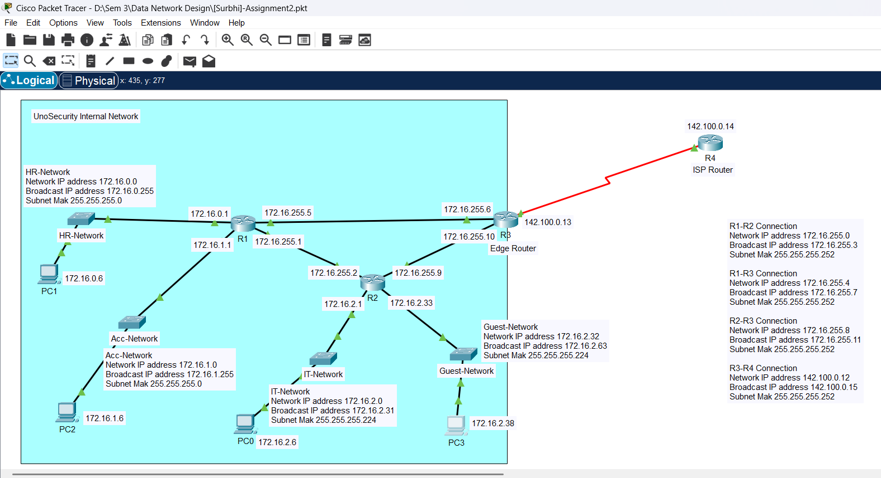
Figure 2: Screenshot of Prototype created

!Configuration for Router 1
enable
configure terminal

!Configuring hostname
hostname SG-R#

!Setting password
enable password cisco123

!Basic router configuration
line console 0
password cisco123
login
exec-timeout 0 0
logging synchronous
exit

!Configuring Interfaces

interface Gig8/0
ip address 172.16.0.1 255.255.255.0
description Connection to HR-Network
no shutdown
exit

interface Gig9/0
ip address 172.16.1.1 255.255.255.0
description Connection to Acc-Network
no shutdown
exit

interface Gig7/0
ip address 172.16.255.5 255.255.255.252
description Link to Router 3 (R3)
no shutdown
exit

interface Gig6/0
ip address 172.16.255.1 255.255.255.252
description Link to Router 2 (R2)
no shutdown
exit

!Configuring Static Routes
ip route 172.16.2.0 255.255.255.192 172.16.255.2
ip route 172.16.255.8 255.255.255.252 172.16.255.2
ip route 142.100.0.12 255.255.255.252 172.16.255.6
ip route 0.0.0.0 0.0.0.0 172.16.255.6

!DHCP Configuration
ip dhcp pool HR_Pool
network 172.16.0.0 255.255.255.0
default-router 172.16.0.1
ip dhcp excluded-address 172.16.0.1 172.16.0.5

ip dhcp pool Acc_Pool
network 172.16.1.0 255.255.255.0
default-router 172.16.1.1
ip dhcp excluded-address 172.16.1.1 172.16.1.5

!Privileged EXEC-Mode
exit

!Viewing Routing table
show ip route

!Viewing dhcp configuration
show ip dhcp pool

!Configuration for Router 2
enable
configure terminal

!Configuring hostname
hostname SG-R#

!Setting password
enable password cisco123

!Basic router configuration
line console 0
password cisco123
login
exec-timeout 0 0
logging synchronous
exit

!Configuring Interfaces

interface Gig7/0
ip address 172.16.2.1 255.255.255.224
description Connection to IT-Network
no shutdown
exit

interface Gig8/0
ip address 172.16.2.33 255.255.255.224
description Connection to Guest-Network
no shutdown
exit

interface Gig6/0
ip address 172.16.255.2 255.255.255.252
description Link to Router 1 (R1)
no shutdown
exit

interface Gig9/0
ip address 172.16.255.9 255.255.255.252
description Link to Router 3 (R3)
no shutdown
exit

!Configuring Static Routes
ip route 172.16.0.0 255.255.254.0 172.16.255.1
ip route 172.16.255.4 255.255.255.252 172.16.255.10
ip route 142.100.0.12 255.255.255.252 172.16.255.10
ip route 0.0.0.0 0.0.0.0 172.16.255.10

!DHCP Configuration
ip dhcp pool IT_Pool
network 172.16.2.0
default-router 172.16.2.1
ip dhcp excluded-address 172.16.2.1 172.16.2.5

ip dhcp pool Guest_Pool
network 172.16.2.32
default-router 172.16.2.33
ip dhcp excluded-address 172.16.2.33 172.16.2.37

!Privileged EXEC-Mode
exit

!Viewing Routing table
show ip route

!Viewing dhcp configuration
show ip dhcp pool

!Configuration for Router 3
enable
configure terminal

!Configuring hostname
hostname SG-R#

!Setting password
enable password cisco123

!Basic router configuration
line console 0
password cisco123
login
exec-timeout 0 0
logging synchronous
exit

!Configuring Interfaces

interface Gig8/0
ip address 172.16.255.6 255.255.255.252
description Link to Router 1 (R1)
no shutdown
exit

interface Gig9/0
ip address 172.16.255.10 255.255.255.252
description Link to Router 2 (R2)
no shutdown
exit

interface Se5/0
ip address 142.100.0.13 255.255.255.252
description Link to ISP Router (R4)
no shutdown
exit

!Configuring Static Routes
ip route 172.16.255.0 255.255.255.252 172.16.255.5
ip route 172.16.0.0 255.255.254.0 172.16.255.5
ip route 172.16.2.0 255.255.255.192 172.16.255.9
ip route 0.0.0.0 0.0.0.0 142.100.0.14

!Privileged EXEC-Mode
exit

!Viewing Routing table
show ip route

!Configuration for ISP Router
enable
configure terminal

!Configuring hostname
hostname SG-R#

!Setting password
enable password cisco123

!Basic router configuration
line console 0
password cisco123
login
exec-timeout 0 0
logging synchronous
exit

!Configuring Interfaces

interface Se2/0
ip address 142.100.0.14 255.255.255.252
description Link to Router 3 (R3)
no shutdown
exit

!Configuring Static Routes
ip route 0.0.0.0 0.0.0.0 142.100.0.13

!Privileged EXEC-Mode
exit

!Viewing Routing table
show ip route

Tables and Figures
Figure 1: Router Interfaces with assigned IP addresses 1
Figure 2: Screenshot of Prototype created 9

Table 1: Routing Configuration for Router 1 2
Table 2: Routing Configuration for Router 2 3
Table 3: Routing Configuration for Edge Router 4
Table 4: Routing Configuration for ISP Router 5
Table 5: Syntax for Verification Commands 8
Table 6: A Connectivity Check Table 8

