Network Design and Configuration
(By- Surbhi Gupta)

Objectives:
• To successfully configure RIP Protocol in the enterprise network.
• To successfully configure OSPF Protocol in the enterprise network.

Scenario:
UnoSecurity specializes in providing access control systems for hospitals, banks, and government buildings. The networking team initially completed the network plan and configured manual routing. However, they soon realized that static routing is not flexible enough to meet the changing needs of the network. The solution is to implement a dynamic routing protocol. There are two options: Routing Information Protocol (RIP) and Open Shortest Path First (OSPF). The team lead has requested you to create prototype networks for both options. Additionally, you need to compare these protocols and recommend the most suitable one.

Table of Contents

P
Part A: Configure Interfaces 3
Part B: Configure the RIP routing and verify the configuration 6
Part C: Configure the OSPF routing and verify the configuration 9
Part D: Recommendation 14
R
References 16
T
Tables and Figures 15

Part A: Configure Interfaces

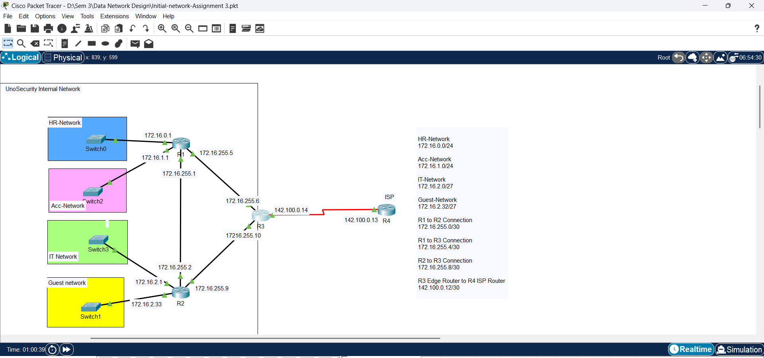
Figure 1: Configured Interfaces of Routers
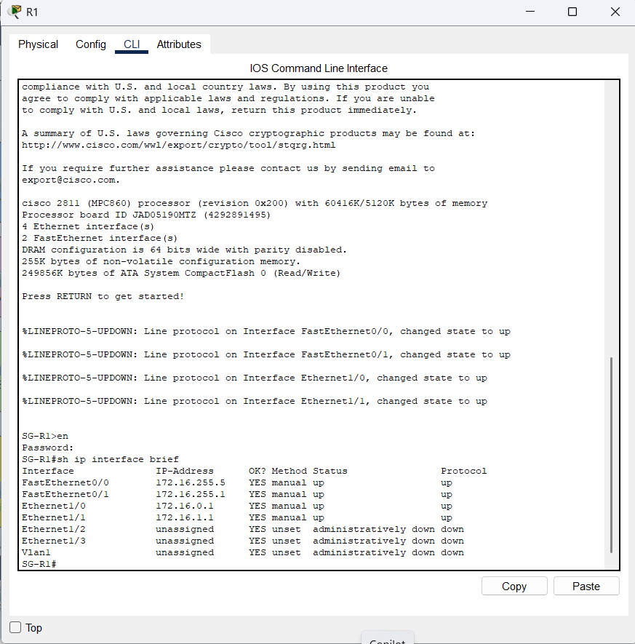
The green symbols show the routers have been configured.
Figure 2: IP interfaces on R1
The followings commands on each router shows the status of interfaces:
On R1,

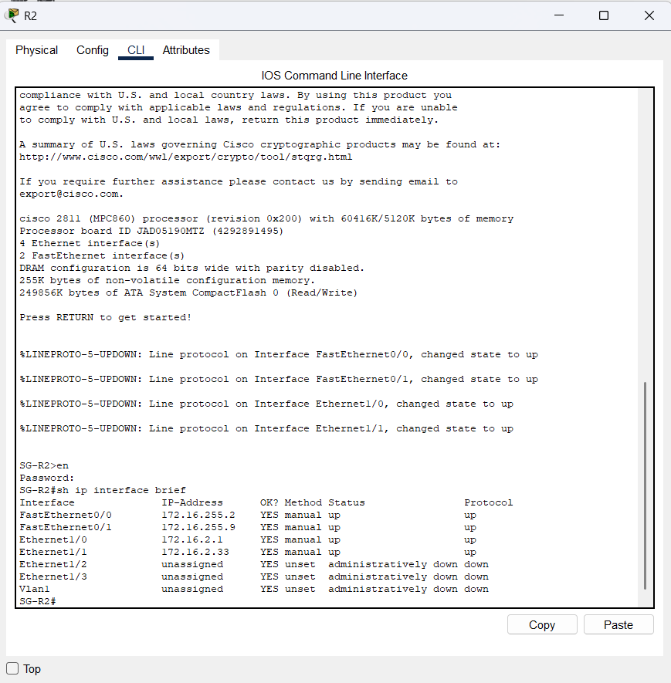
On R2,

Figure 3: IP interfaces on R2
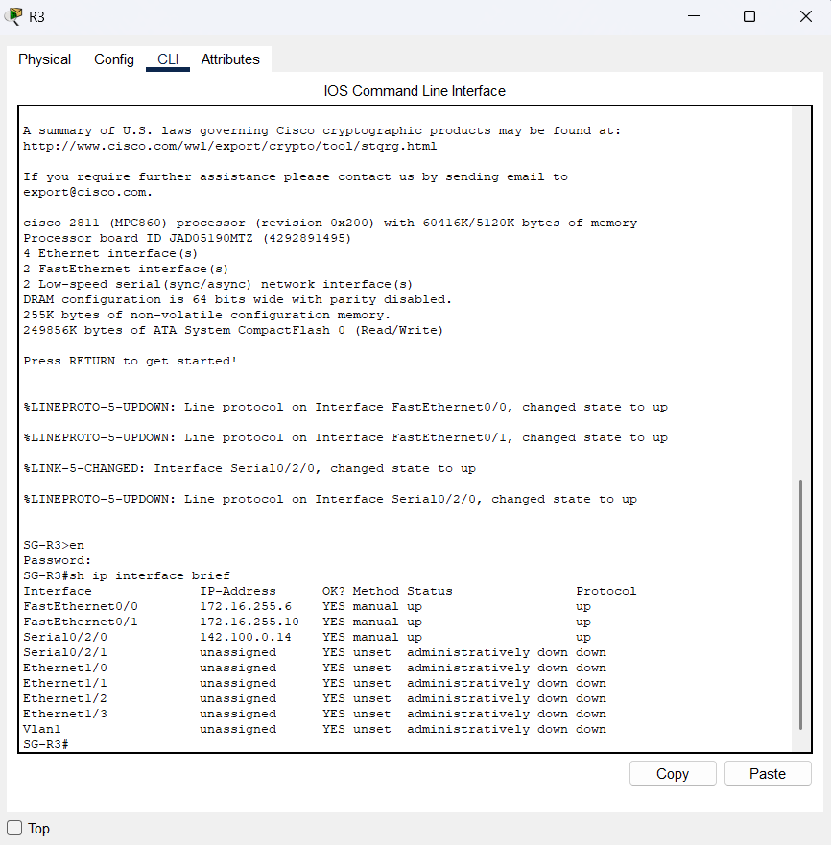
On R3,

Figure 4: IP Interfaces on R3
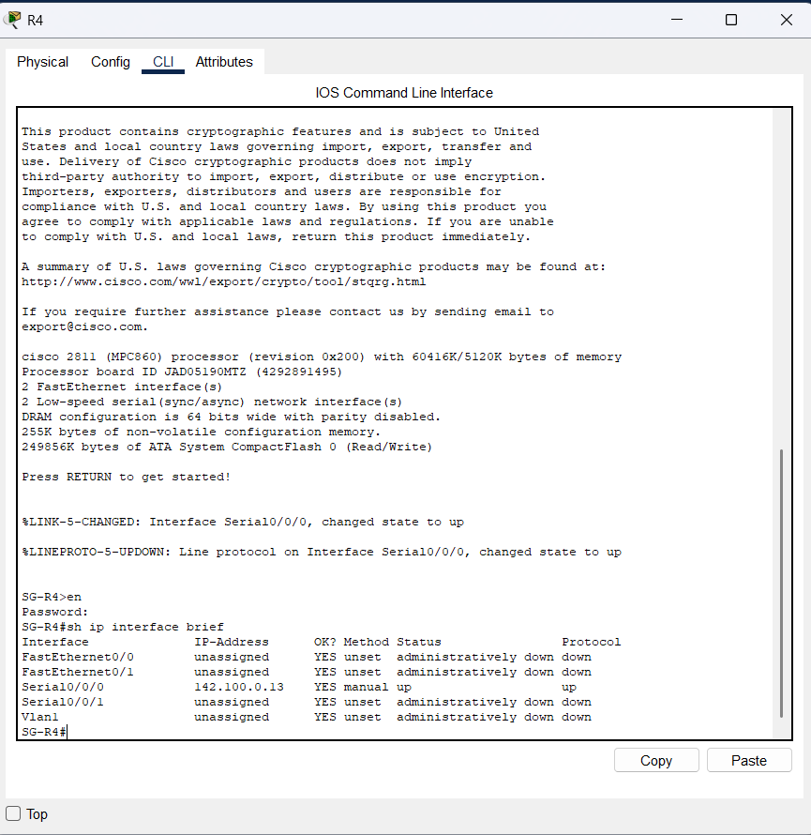
On R4,
Figure 5: IP Interfaces on R4

Part B: Configure the RIP routing and verify the configuration

1. Configuring the RIP routing protocol
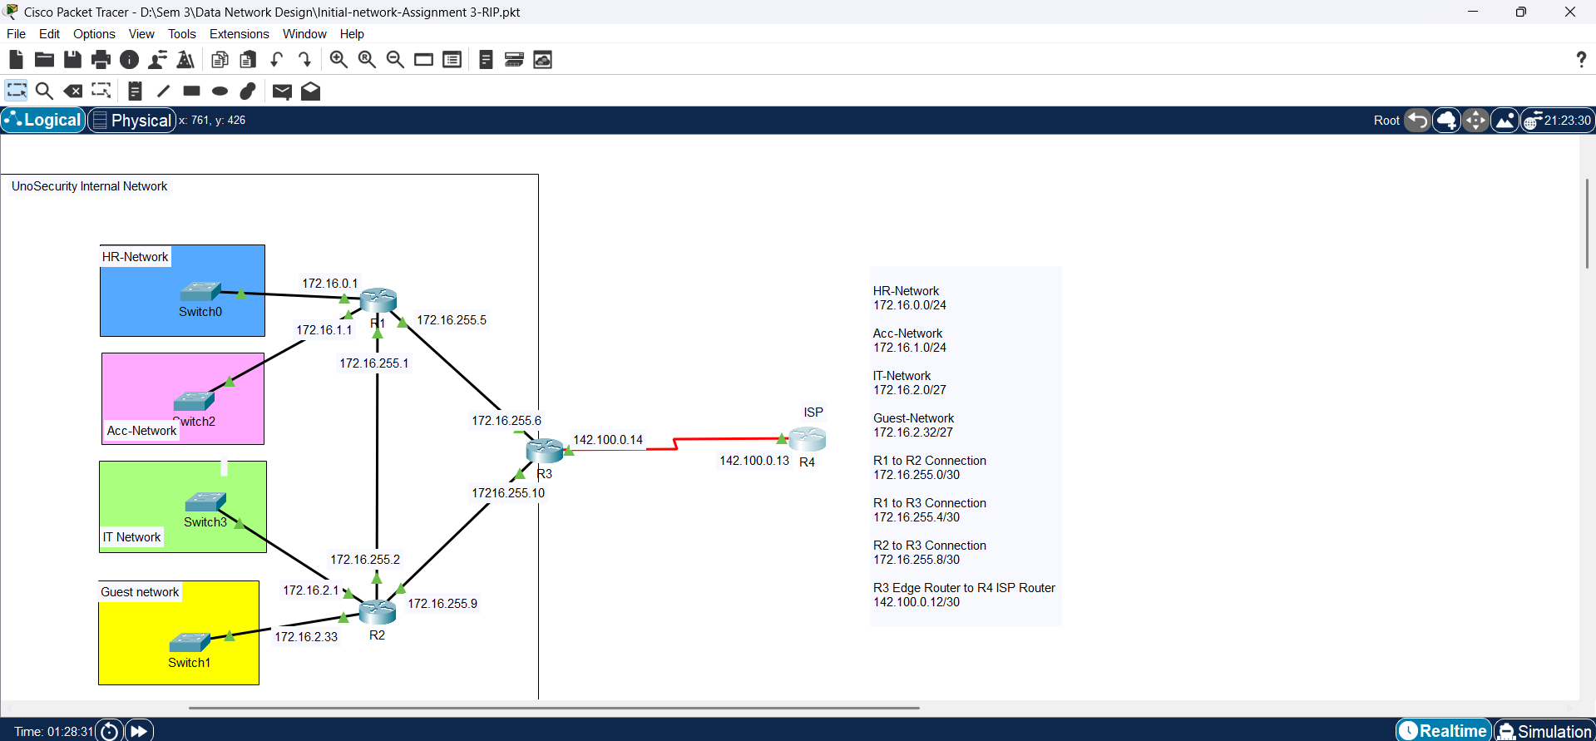
Figure 6: Configured RIP Protocol on Routers

2. Verifying the configuration

1. On R1, show ip route rip
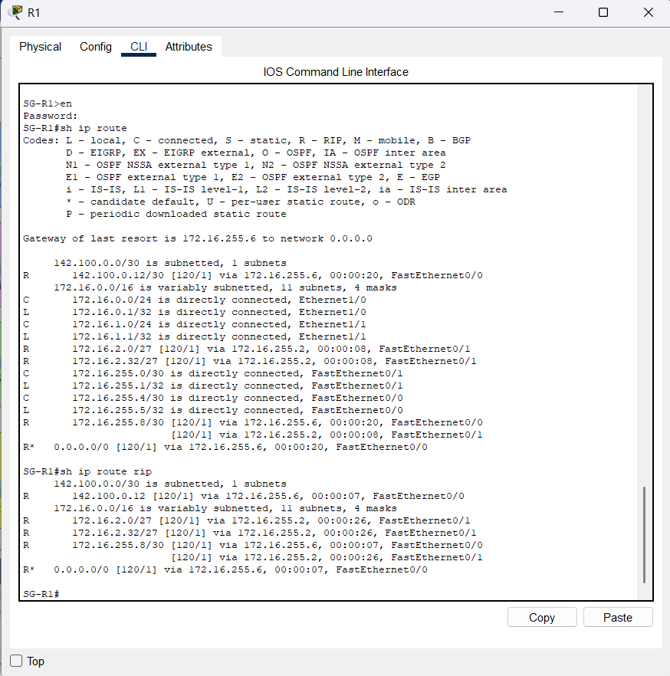
Figure 7: Running the command on R1
This command helps to show the rip routes in the routing table of the specific router.
For example, the result of the above command is the rip routes in the routing table of R1.
We can interpret one of the routes as below:
R | Identifies the source of the route as RIP
172.16.2.0 | Indicates the address of the remote network
/27 | The subnet mask for this network
[120/2] | 120 – administrative distance  2 – metric (hop counts)
Via 172.16.255.2 | Specifies the address of the next router to send the traffic to for the remote network.
00:00:08 | Specifies the amount of time since the route was updated.
FastEthernet0/1 | 172.16.255.1
Note: In this output, R* shows the default route set up by RIP Protocol.
Table 1: Interpreting RIP route

2. On R2, show ip protocols
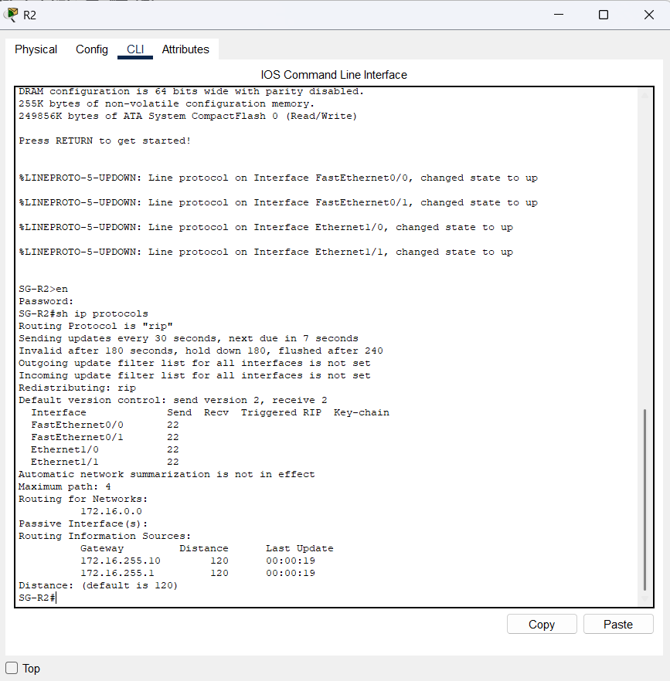
Figure 8: Running the command on R2
This command provides the information about routing protocols running on Cisco Router. This command is essential for verifying routing protocol operations.
Here, it is showing Routing Protocol is “rip”. It means that it is using rip protocol. All RIP timers are displayed via this command. It also shows the networks the router is advertising. It also tells about neighbor routers along with redistributing routes. Besides all this, it also shows the default administrative distance i.e. 120.

Part C: Configure the OSPF routing and verify the configuration

1. Configuring the OSPF Routing Protocol
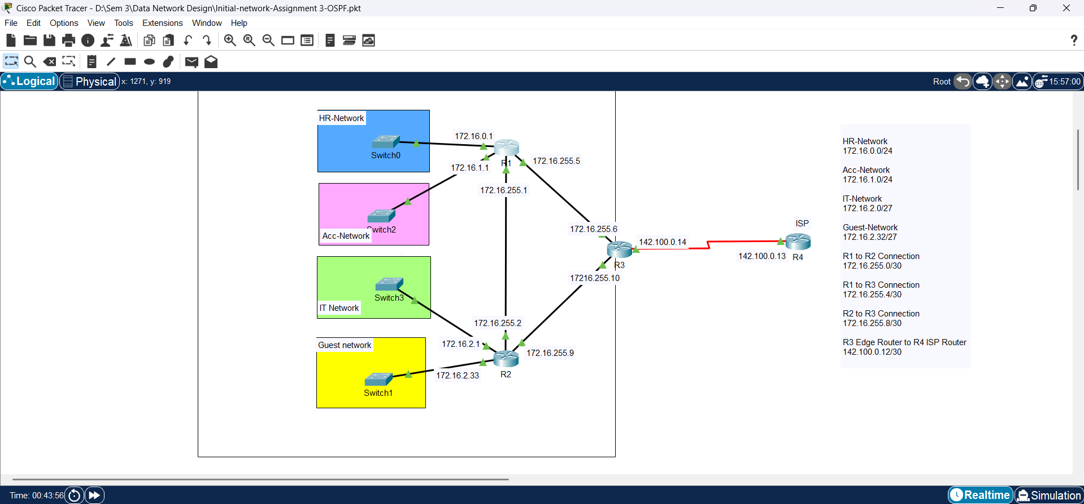
Figure 9: Configured OSPF Protocol on Routers

2. Verifying the configuration

1. On R1, show ip route ospf
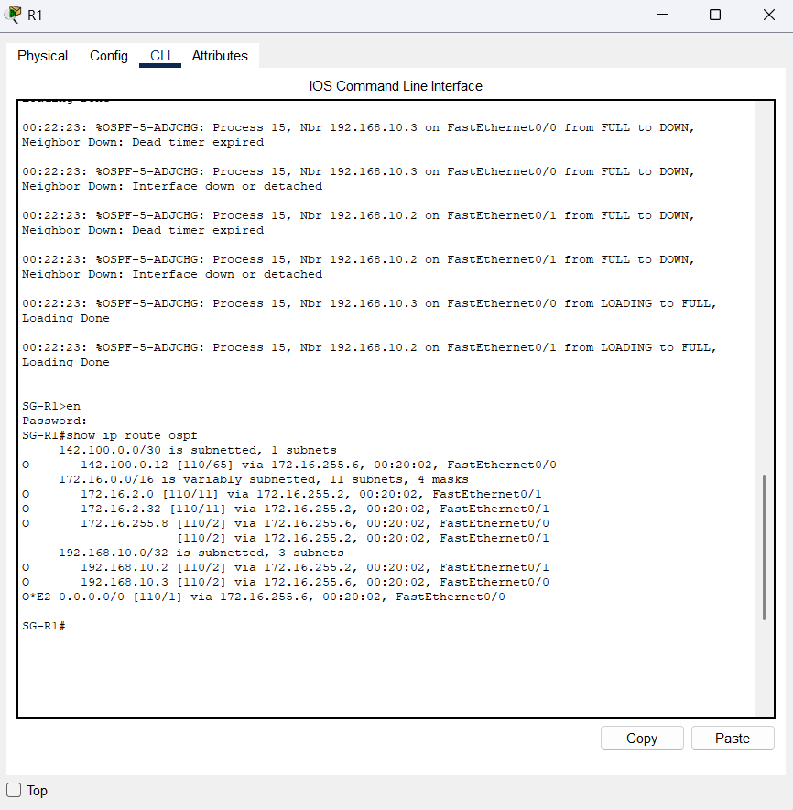
Figure 10: Running the command on R1
This command helps to show the ospf routes in the routing table of the specific router.
For example, the result of the above command is the ospf routes in the routing table of R1.
We can interpret one of the routes as below:
O | Identifies the source of the route as OSPF
172.16.2.0 | Indicates the address of the remote network
[110/11] | 110 – OSPF administrative distance  11 – metric (cost)
Via 172.16.255.2 | Specifies the address of the next router to send the traffic to for the remote network.
00:20:02 | Specifies the amount of time since the route was updated.
FastEthernet0/1 | 172.16.255.1
Note: In this output, O*E2 shows the default route set up by OSPF Protocol as OSPF external route (Type 2)
Table 2: Interpreting OSPF Route

2. On R2, show ip protocols
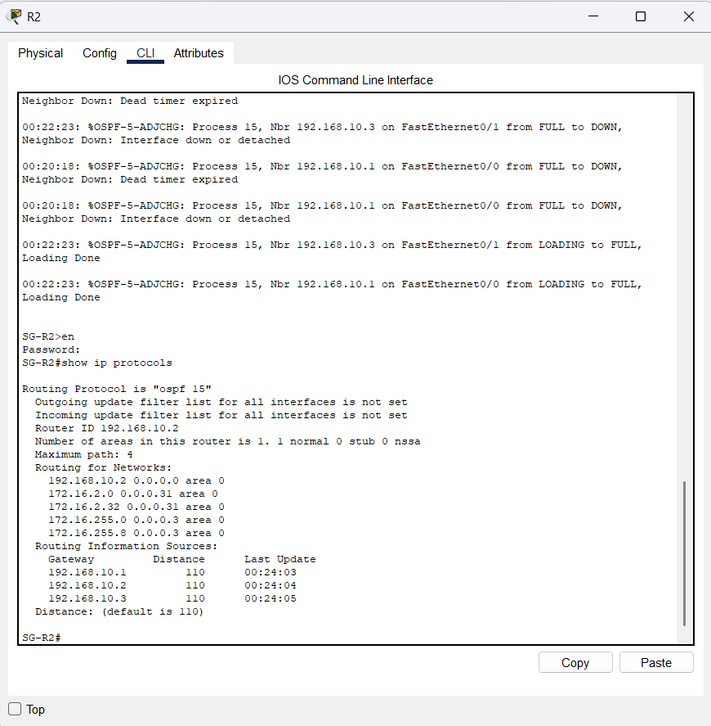
Figure 11: Running the command on R2
The show ip protocols command in OSPF displays OSPF process details, including Router ID, advertised networks, areas, administrative distance (110), and redistribution settings. It also shows OSPF neighbors, update timers, and reference bandwidth. This command helps verify OSPF configuration, troubleshoot missing routes, and check route filtering or redistribution.

3. On R2, show ip ospf neighbor
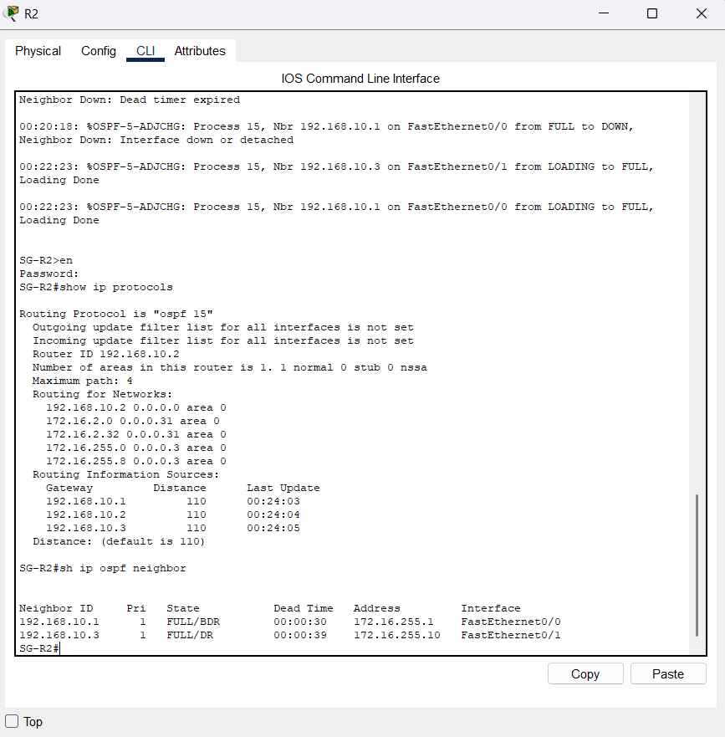
Figure 12: Running the command on R2
The show ip ospf neighbor command displays information about OSPF neighbor relationships. It lists routers that are directly connected and participating in OSPF, showing details like their state, router ID, priority, interface, and last hello time. This command is useful for verifying OSPF adjacency and diagnosing connectivity issues between OSPF routers.

4. On R2, show ip ospf database
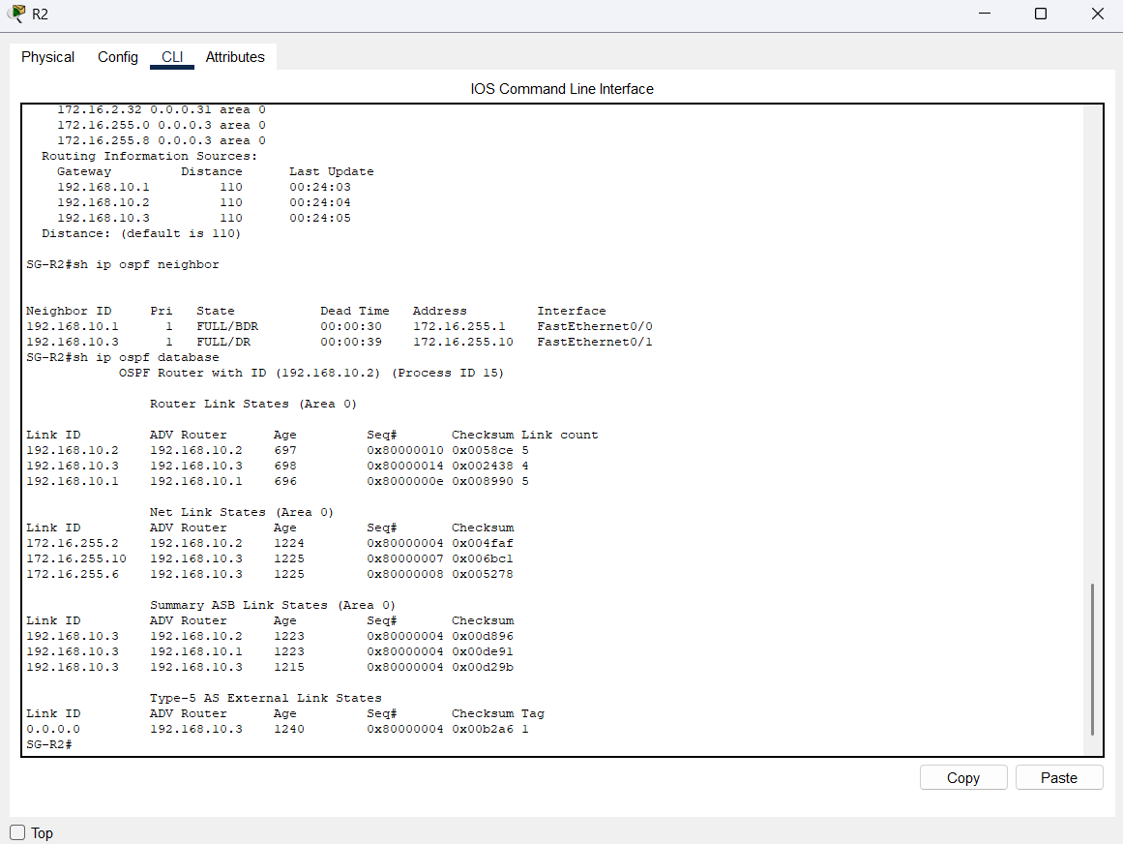
Figure 13: Running the command on R2
The show ip ospf database command displays the OSPF Link-State Database (LSDB), which contains all the LSAs (Link-State Advertisements) that OSPF has learned. This database is used by OSPF to calculate the routing table. The LSDB includes network topology information and routing updates from OSPF neighbors.

Part D: Recommendation
Feature | RIP (Routing Information Protocol) | OSPF (Open Shortest Path First)
Type of Protocol | Distance-vector | Link-State
Convergence Speed | Slower (can take 30-90 seconds) | Faster (converges within 10 seconds)
Metric | Hop counts (max 15 hops) | Cost, Bandwidth of the links
Scalability | Small to Medium-sized networks (max 15 hops) | Highly Scalable (supports larger networks)
Routing Updates | Periodic (every 30 seconds) | Triggered updates (only when topology changes)
Security | Basic authentication (RIP v2) | More robust security features (MD5 authentication)
Databases | No dedicated database, only routing table | Uses three databases:  - Neighbor Database  - Link-State Database (LSDB)  - Forwarding Database (Routing table)
Table 3: Difference between RIP protocol and OSPF protocol
For UnoSecurity’s network, OSPF is the best choice because it is scalable, fast, and secure—essential for a growing security infrastructure. OSPF supports multiple areas, allowing better network organization, and uses link cost to find the most efficient routes, ensuring faster and more reliable connections. Its strong security features also help protect sensitive network data, which is crucial for a security-focused organization like UnoSecurity.
RIP, on the other hand, is only suitable for small, simple networks or older devices that cannot support OSPF. It has major limitations, including slow convergence, a 15-hop limit, and a higher risk of routing loops, making it unfit for larger and complex networks like UnoSecurity’s.
Conclusion: OSPF is the best routing protocol for UnoSecurity because it provides better scalability, faster route updates, and stronger security. RIP should only be used in very small or outdated networks, as it cannot handle the demands of a modern, security-driven infrastructure.

Tables and Figures

Figures
Figure 1: Configured Interfaces of Routers 3
Figure 2: IP interfaces on R1 3
Figure 3: IP interfaces on R2 4
Figure 4: IP Interfaces on R3 4
Figure 5: IP Interfaces on R4 5
Figure 6: Configured RIP Protocol on Routers 6
Figure 7: Running the command on R1 7
Figure 8: Running the command on R2 8
Figure 9: Configured OSPF Protocol on Routers 9
Figure 10: Running the command on R1 10
Figure 11: Running the command on R2 11
Figure 12: Running the command on R2 12
Figure 13: Running the command on R2 13

Tables
Table 1: Interpreting RIP route 7
Table 2: Interpreting OSPF Route 10
Table 3: Difference between RIP protocol and OSPF protocol 14

References

Kaur, M. (2025). Dynamic Routing RIP [PowerPoint slides]. Unpublished lecture material
Kaur, M. (2025). Dynamic Routing OSPF [PowerPoint slides]. Unpublished lecture material

