Network Design and Configuration
(By- Surbhi Gupta)

Objectives:
To successfully configure Virtual LANs and inter-VLAN routing.
• To successfully configure EIGRP routing.
• To successfully configure packet filtering using Standard or Extended ACL [Bonus Question]

Scenario:
UnoSecurity specializes in providing access control systems for hospitals, banks, and government buildings. As the business is growing new branch office is added in the network. There is requirement of managing the network traffic and Network performance. The networking team at UnoSecurity want to improve the implementation design and restructure the network to improve for efficiency, network performance and availability. Following this article by Cisco Press, Hierarchical Network Design Overview (1.1) > Cisco Networking Academy Connecting Networks Companion Guide: Hierarchical Network Design | Cisco Press , they have decided to restructure the internal network at both the branches.
The team lead has requested you to create prototype for the proposed network

Table of Contents

B
Bonus Question: 9
R
References 15
T
Tables and Figures 14
Task 1: Configure VLAN 3
Task 2: Configure intervlan Routing 6
Task 3: Configure Routing 8
V
Verification Commands 13

Task 1: Configure VLAN

VLAN Table
VLAN Name | VLAN ID
Operations-Net | VLAN 10
HR-Net | VLAN 20
Guest-Net | VLAN 30
Acc-Net | VLAN 40
IT-Net | VLAN 50
Mgmt-Net | VLAN 60
Table 1: VLAN Table

For the UnoSecurity, Branch Office
Switch | Connected To | Devices Connected | Final Role
Switch 5 | All switches + Router (BO) | None | Core Switch
Switch 4 | All access switches + Switch 5 | None | Aggregation Switch
Switch 0-1(1) | Switch 4 + Switch 5 | One PC each | Access Switches
Table 2: Connections in Branch Office
Switch 5 – Core Switch
- It is directly connected to the main router and all other switches.
- It is at the top of the hierarchy and acts as the central bridge to route external traffic.
- It handles traffic between distribution/aggregation and external routers or the internet.
Final Role: Core Switch

Switch 4 – Distribution/Aggregation Switch
- It connects to all access switches and connects upstream to the core (Switch 5).
- Even though Switch 5 is also connected to access switches, Switch 4 aggregates local VLAN traffic from all access switches before possibly forwarding it to the core switch.
Final Role: Aggregation/Distribution Switch
Even if both Switch 4 and Switch 5 are connected to the access switches, Switch 4 can still serve as the aggregation/distribution point if it handles more east-west VLAN traffic within the branch LAN before it’s passed to the core (Switch 5) for routing.

Switches 0, 1, 0(1), 1(1) – Access Switches
- They connect directly to end devices (PCs) and have uplinks to both Switch 4 and Switch 5.
- These are classic access switches in a three-tier architecture.
Final Role: Access Layer

Summary Table for VLAN Mapping
Switch | Function | PC Attached | VLAN | Access Port | Trunk Ports | VLAN Name
Switch 5 | Core | No | --- | --- | Fa0/1-2, Fa0/22-24 | ---
Switch 4 | Aggregation | No | --- | --- | Fa0/1,  Fa0/21-24 | ---
Switch 0 | Access | PC0 | VLAN 10 | Fa0/24 | Fa0/22-23 | Operations-Net
Switch 1 | Access | PC1 | VLAN 20 | Fa0/24 | Fa0/22-23 | HR-Net
Switch 0(1) | Access | PC0(1) | VLAN 30 | Fa0/24 | Fa0/22-23 | Guest-Net
Switch 1(1) | Access | PC1(1) | VLAN 30 | Fa0/24 | Fa0/22-23 | Guest-Net
Table 3: Summary Table for VLAN Mapping in Branch Office
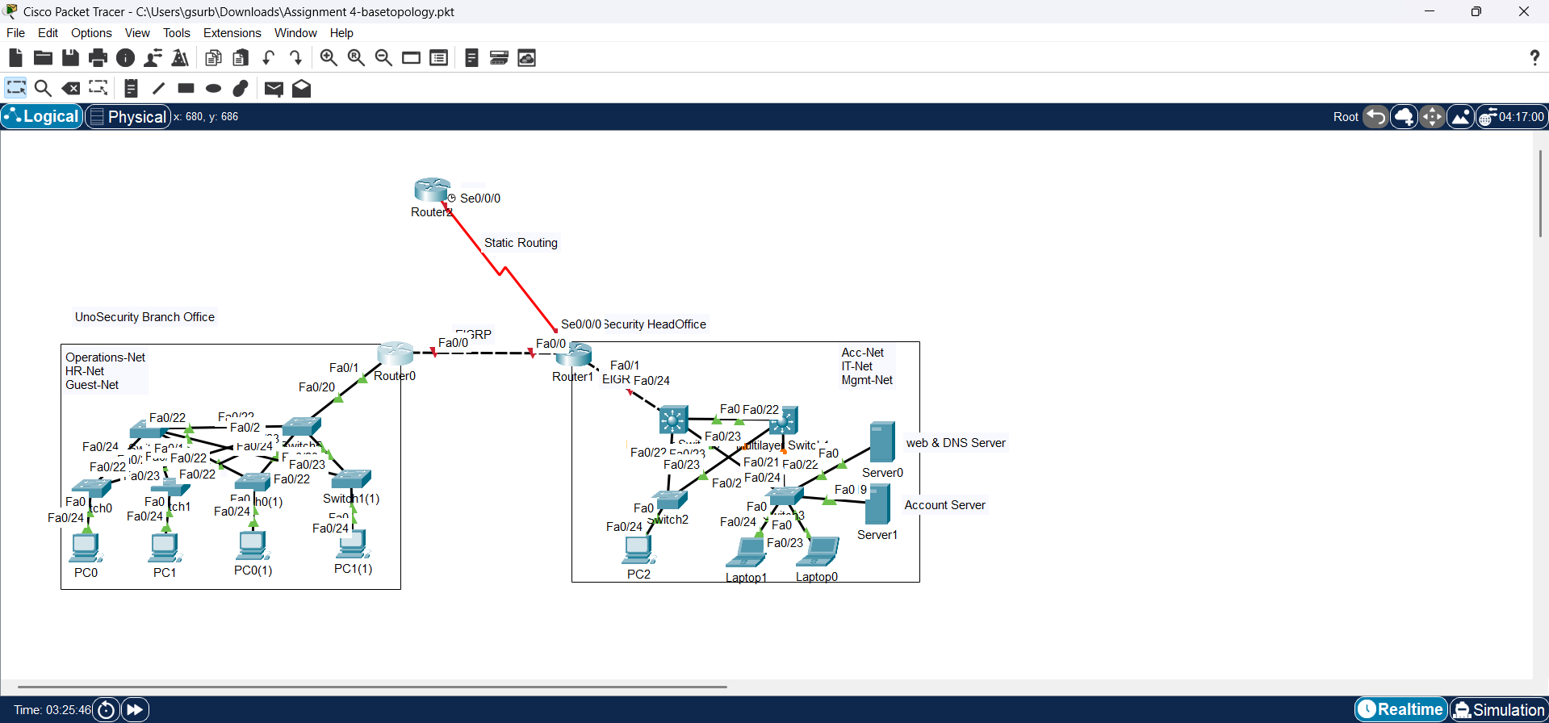
Figure 1: Branch Office Configuration

For the UnoSecurity, Head Office
Switch | Connected To | Devices Connected | Final Role
Multi-Layered Switch 0 | All switches + Router (BO) | None | Core Switch
Multi-Layered Switch 1 | All access switches + Multi-Layered Switch 0 | None | Aggregation Switch
Switch 2 | Both Multi-Layered Switches | PC2 | Access Switch
Switch 3 | Both Multi-Layered Switches | Laptop0, Laptop1, Account Server, Web & DNS Server | Access Switch
Table 4: Connections in Head Office
Similarly,

Summary Table for VLAN Mapping
Switch | Function | PC Attached | VLAN | Access Port | Trunk Ports | VLAN Name
Multi-Layered Switch 0 | Core | No | --- | --- | Fa0/1, Fa0/22-24 | ---
Multi-Layered Switch 1 | Aggregation | No | --- | --- | Fa0/22-23 | ---
Switch 2 | Access | PC2 | VLAN 50 | Fa0/24 | Fa0/22-23 | IT-Net
Switch 3 | Access | Laptop0, Laptop1 | VLAN 50 | Fa0/23-24 | Fa0/20-21 | IT-Net
Switch 3 | Access | Account Server | VLAN 40 | Fa0/19 | Fa0/20-21 | Acc-Net
Switch 3 | Access | Web & DNS Server | VLAN 60 | Fa0/22 | Fa0/20-21 | Mgmt-Net
Table 5: Summary Table for VLAN Mapping
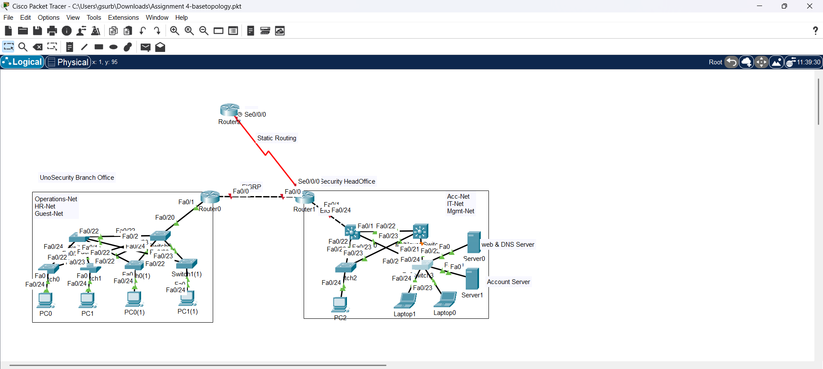
Figure 2: Head Office Configuration

Task 2: Configure intervlan Routing

In Branch Office,
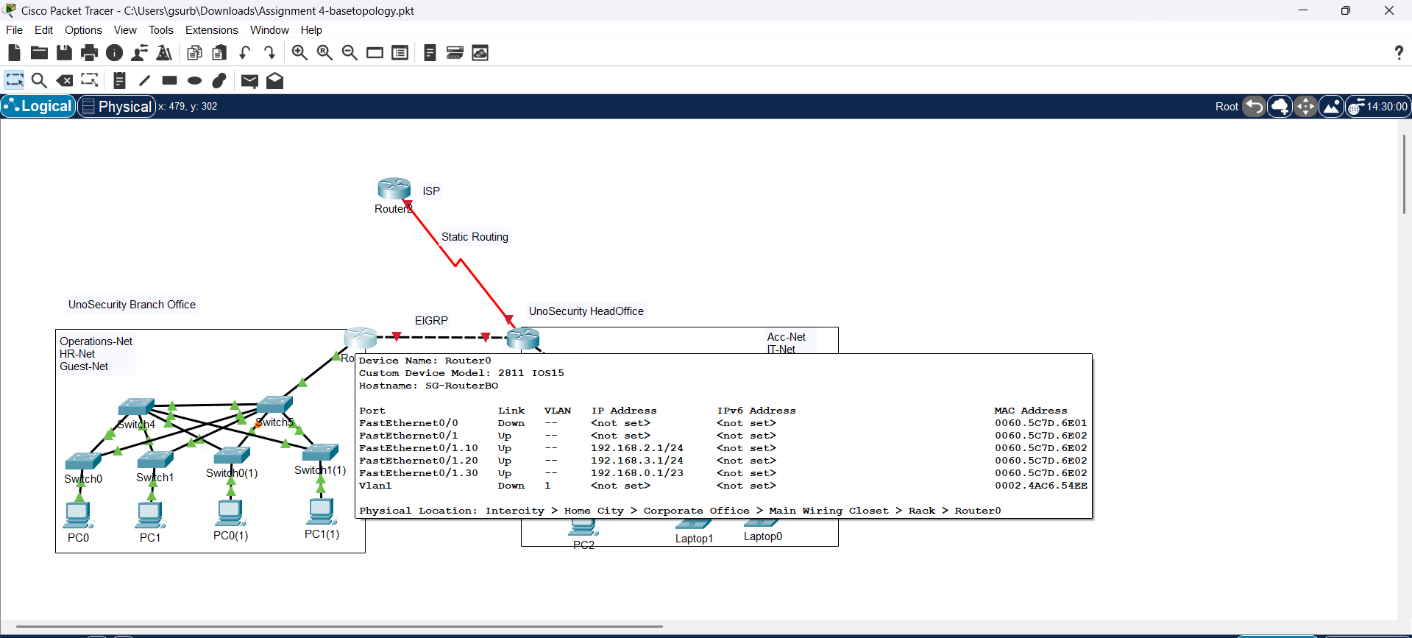
Figure 3: Router-on-a-stick has been configured

Sub interfaces Configured
Port | VLAN ID | IP Address
FastEthernet0/1.10 | VLAN 10 | 192.168.2.1/24
FastEthernet0/1.20 | VLAN 20 | 192.168.3.1/24
FastEthernet0/1.30 | VLAN 30 | 192.168.0.1/23
Table 6: Sub interfaces Of Router

In Head Office,
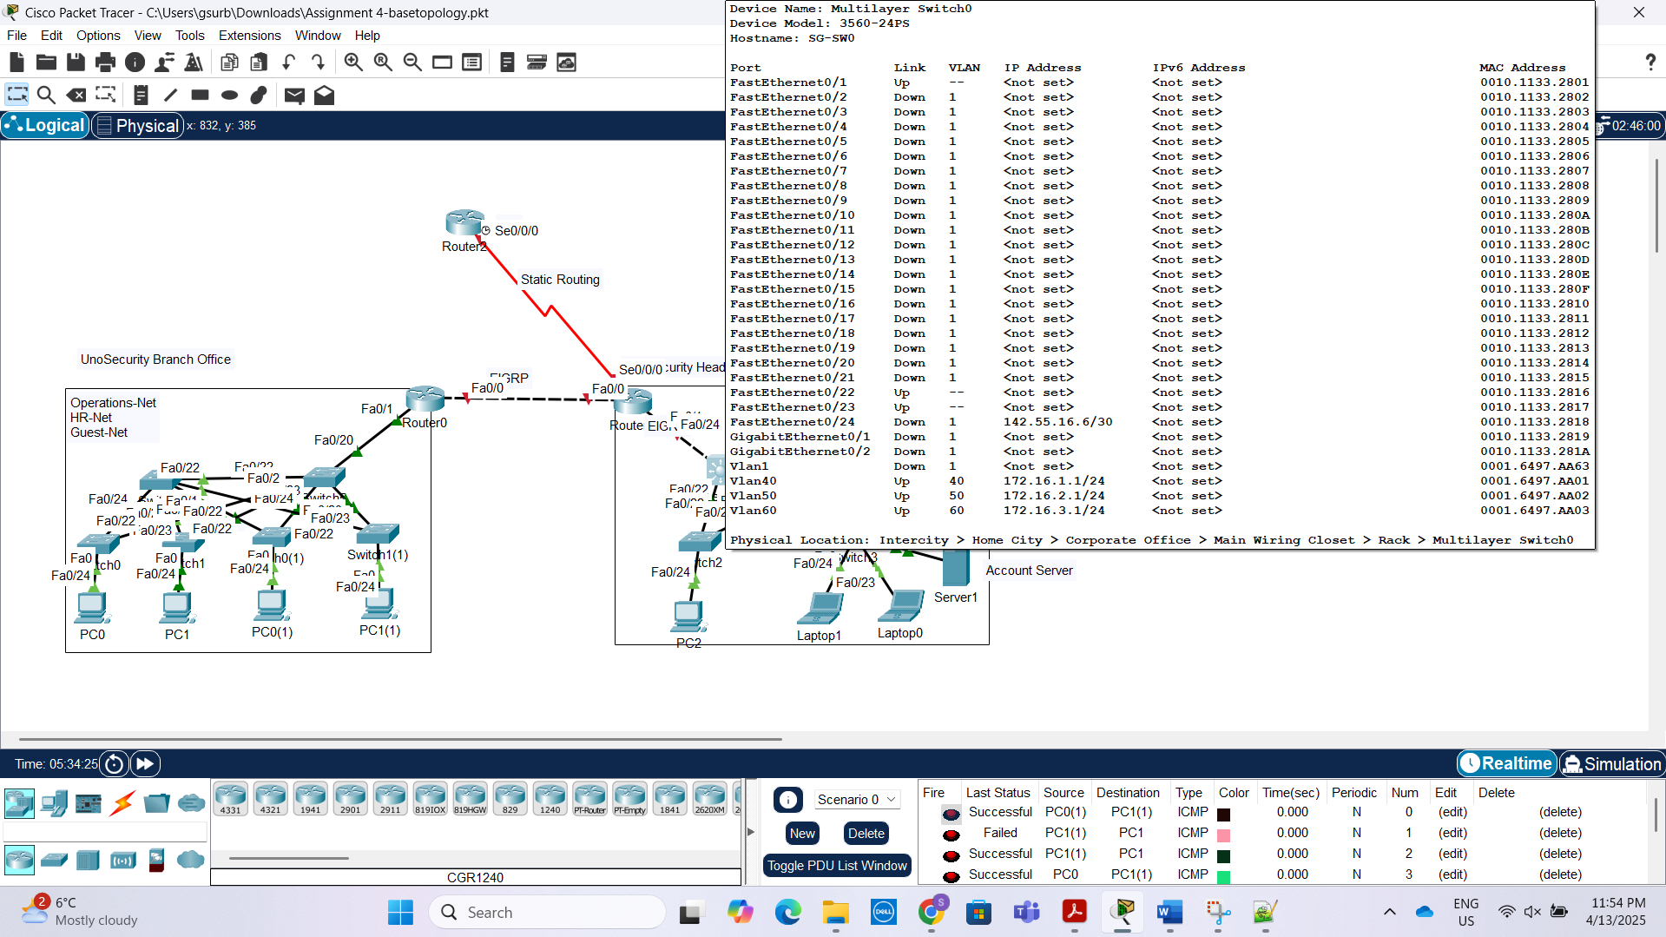
Figure 4: L3 Switch connecting to Router has been configured

Ports Configured
Port | VLAN ID | IP Address
VLAN 40 | 40 | 172.16.1.1/24
VLAN 50 | 50 | 172.16.2.1/24
VLAN 60 | 60 | 172.16.3.1/24
Table 7: Ports Configured on Multilayered Switch 0

Task 3: Configure Routing

Configuring EIGRP
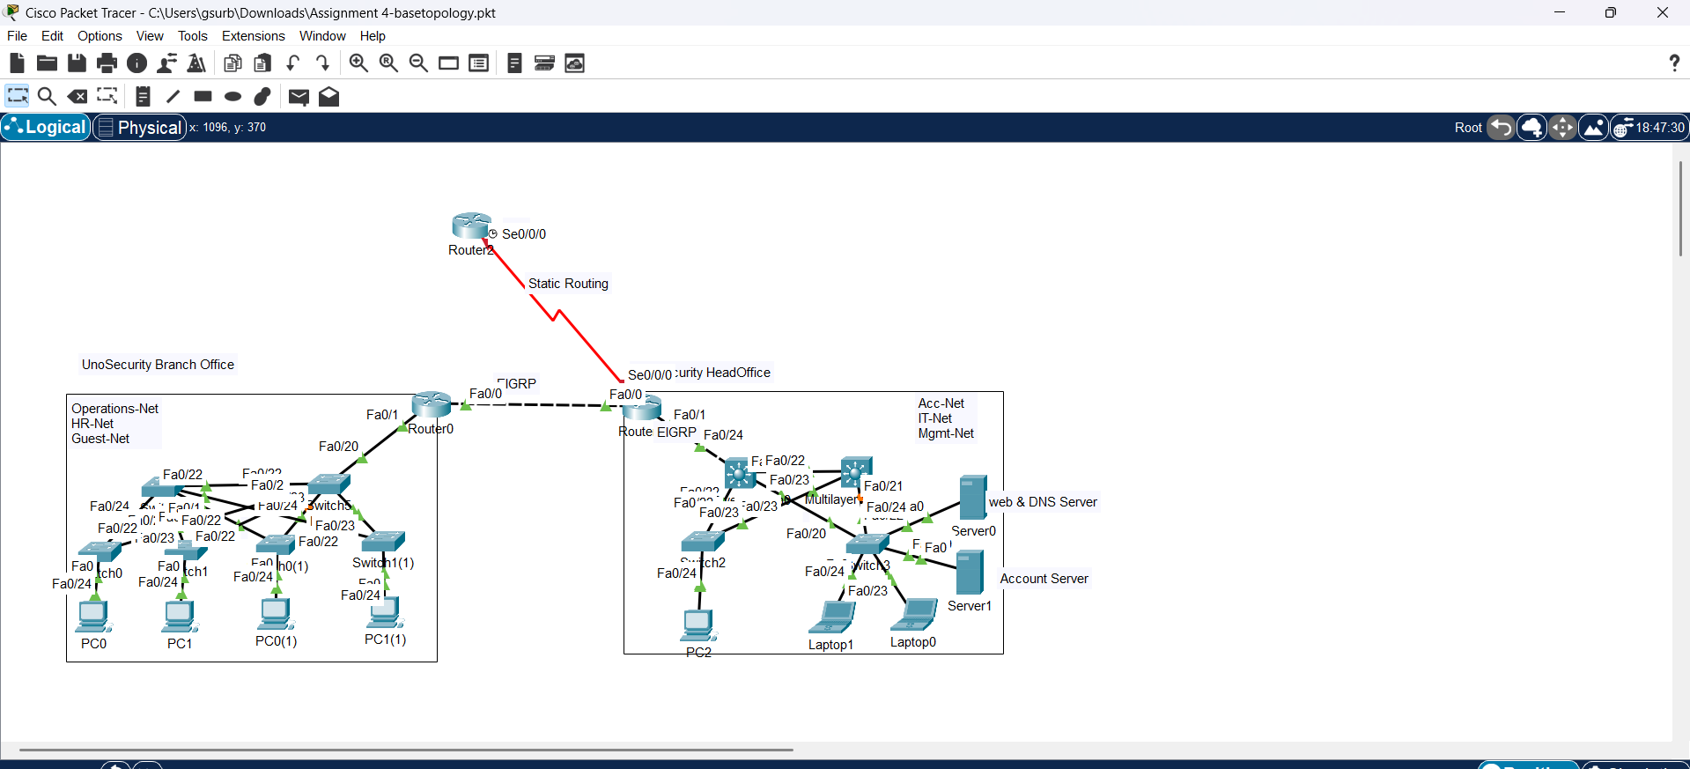
Figure 5: EIGRP Routing Protocol has been configured on both router and L3 Switch

Configuring Static Route
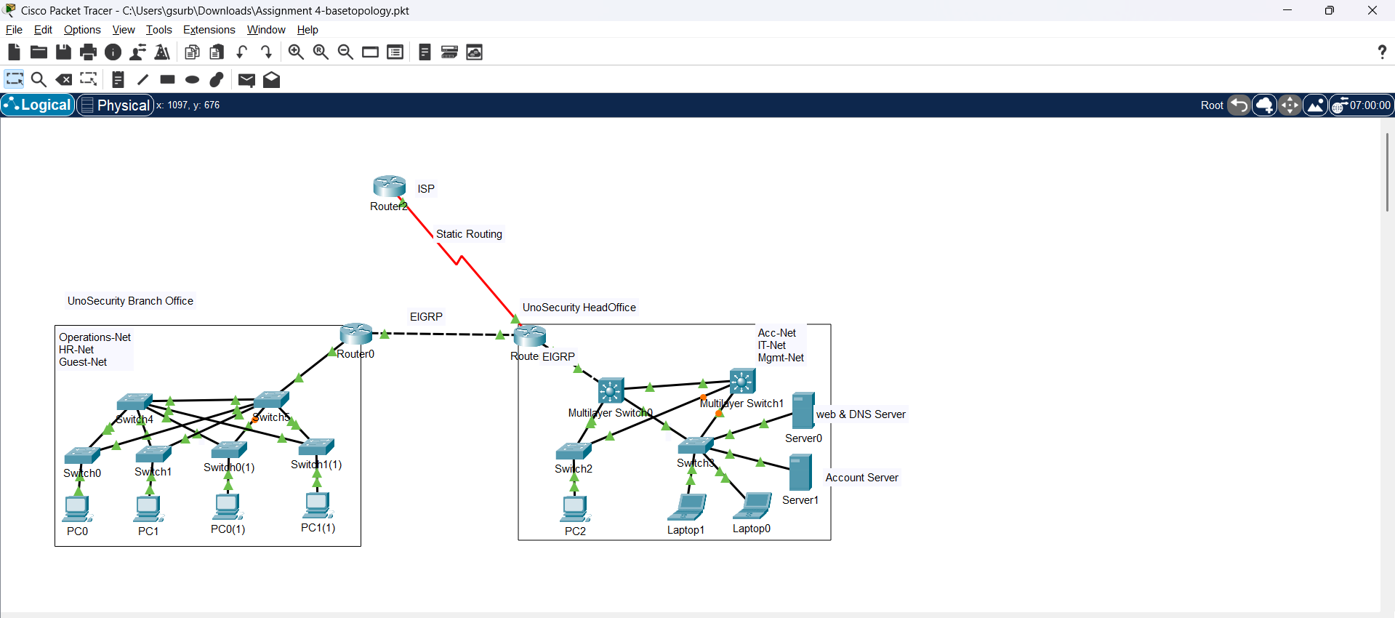Figure 6: Configuring Static Route between ISP and Router(HO)

Bonus Question:
- Guest network should have access to web server only.

Here, the guest network is 192.168.0.0/23 and the server is 172.16.3.100. I am applying the access control list on the outer interface of Router(BO).
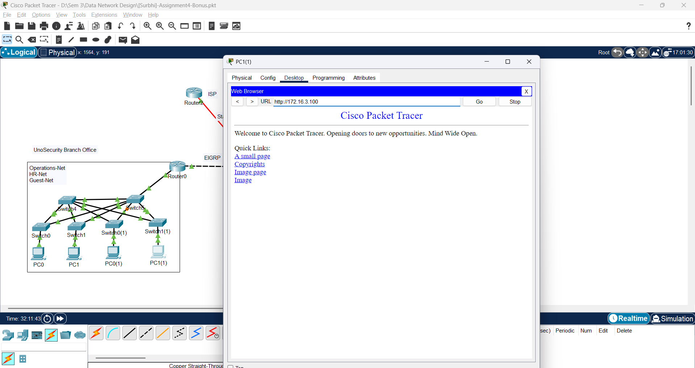
Figure 7: Accessing only web services through guest network
On PC(1), open web browser, Typed in ip address of web server. It will show this page. It means web server is reachable. Port 80 and port 443 is used for forming ACL list.
Port | Protocol | Purpose
80 | HTTP | Unencrypted Web traffic
443 | HTTPS | Encypted Web traffic
Table 8: Ports and Functions
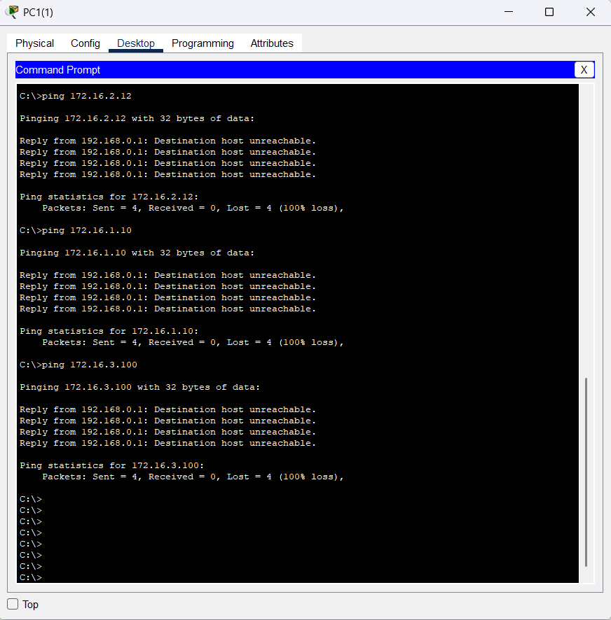
Figure 8: Guest-network cannot access any other device on the network
The devices in this network can only use web services but cannot access any other networks or even ping the web server. This means they can interact with the web services, but not communicate directly with the server or other networks.

- Only 192.168.3.10 host from the HR network can access the account server.
In this, I have again put ACL on Router(BO), so that only the host 192.168.3.10 from the HR network can access the account server 172.16.1.100, disabling the access to all other computers in HR Network.
For this, I have joined PC4 to vlan 20 temporarily to verify the ACL working.

- Pinging 172.16.1.100 from 192.168.3.10
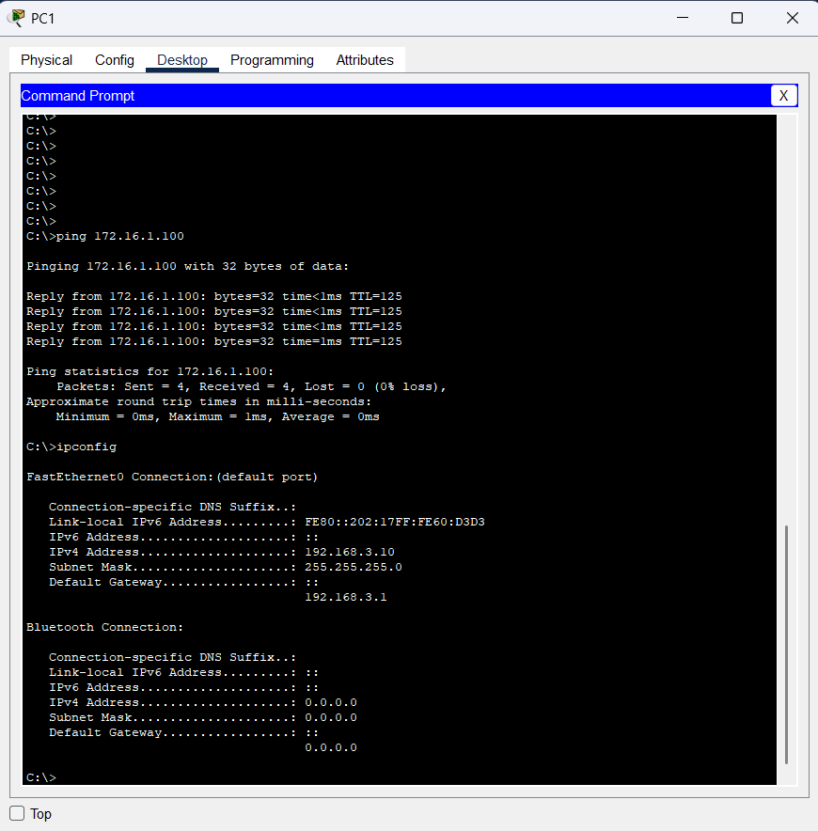
Figure 9: pinging HR-host to Account Server
- Pinging 172.16.1.100 from the any other computer from HR Network
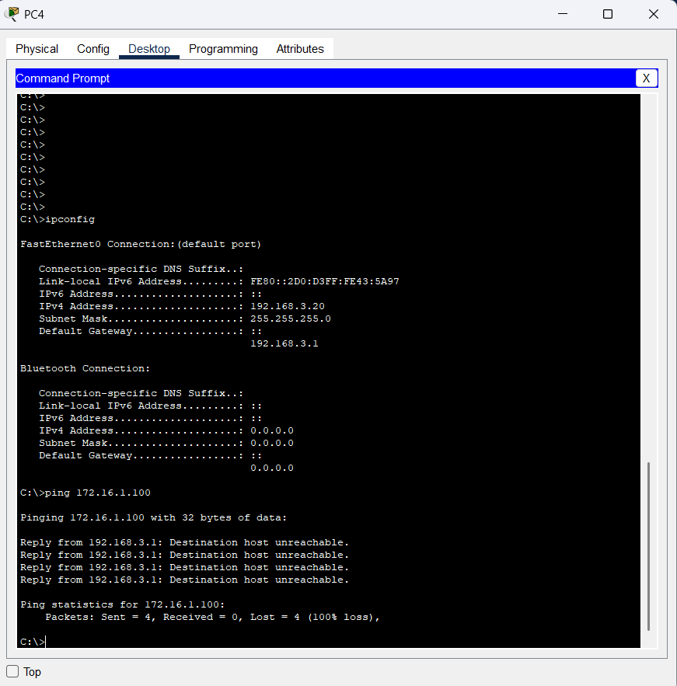
Figure 10: Destination host unreachable from other devices on HR-Network
- Only Account network can access the Account Server.
For this, I have put ACL on Multilayered Switch 0 allowing the host mentioned in part 2 i.e. 192.168.3.10 and all the devices in account network restricting any device from other networks. For checking, I have joined PC5 to vlan 40
- Pinging Account server 172.16.1.100 from PC5 172.16.1.10
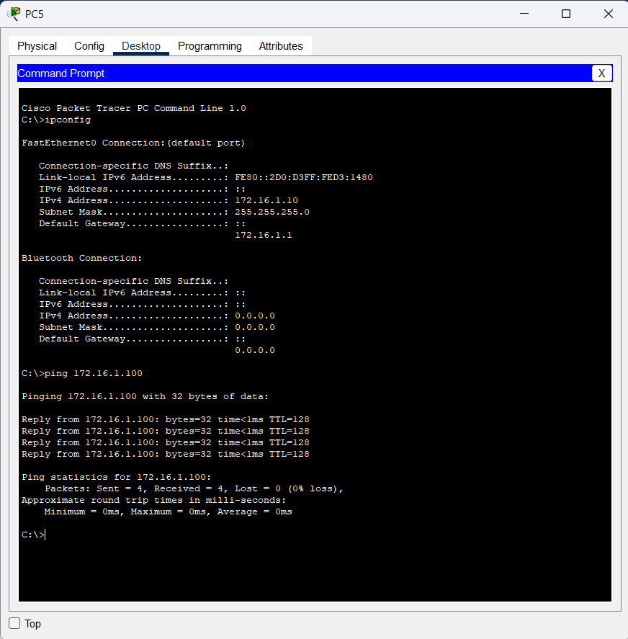
Figure 11: Pinging Account server from device in Account network
- Pinging Account Server from device in Mgmt-Network
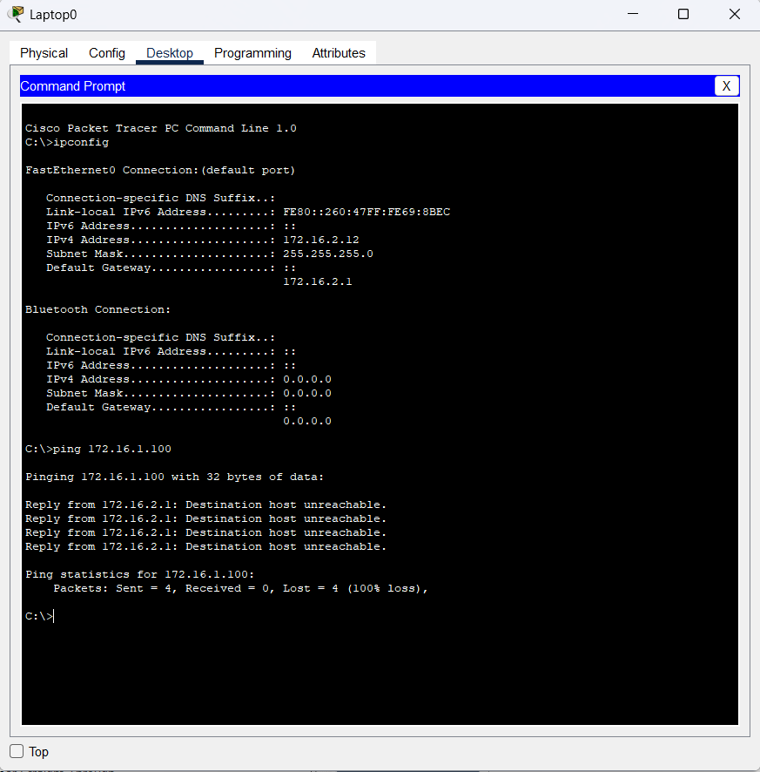
Figure 12: Pinging Account server from other networks
- Only IT network can access the DNS Server

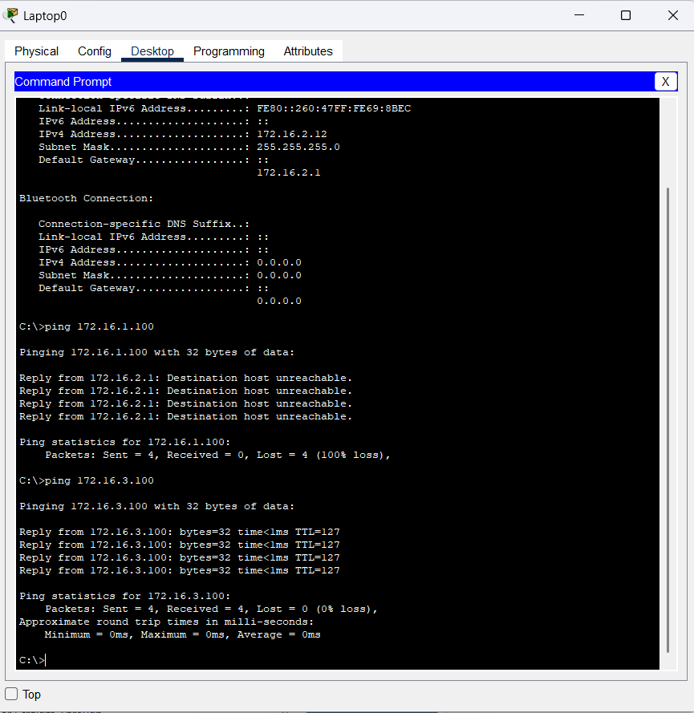
Figure 13: Ping is successful from IT Network to DNS Server

Verification Commands
ipconfig | Show Ip configuration of a device
ping <ip> | Check connectivity
tracert <ip> | Traceroute path
show ip interface brief | Check IP and interface status
show interfaces | Show detailed interface info
show interfaces switchport | Show interface status and VLAN
show vlan brief | Show all VANs configured
show vlan | Check which interfaces are in which VLAN
show interfaces trunk | Show trunking interfaces
show ip route | Show ip routing table
show ip eigrp neighbors | Show EIGRP neighbors
show ip eigrp interfaces | Show EIGRP interfaces
show ip eigrp topology | Show EIGRP topology table
show access-lists | Show ACLs and their rules
show ip interfaces brief | Show SVI status
show ip protocols | Show routing protocols
show cdp neighbors | Show directly connected Cisco neighbors
Table 9: Verification commands table

Tables and Figures
Table 1: VLAN Table 3
Table 2: Connections in Branch Office 3
Table 3: Summary Table for VLAN Mapping in Branch Office 4
Table 4: Connections in Head Office 5
Table 5: Summary Table for VLAN Mapping 5
Table 6: Sub interfaces Of Router 7
Table 7: Ports Configured on Multilayered Switch 0 7
Table 8: Ports and Functions 9
Table 9: Verification commands table 13

Figure 1: Branch Office Configuration 4
Figure 2: Head Office Configuration 6
Figure 3: Router-on-a-stick has been configured 6
Figure 4: L3 Switch connecting to Router has been configured 7
Figure 5: EIGRP Routing Protocol has been configured on both router and L3 Switch 8
Figure 6: Configuring Static Route between ISP and Router(HO) 8
Figure 7: Accessing only web services through guest network 9
Figure 8: Guest-network cannot access any other device on the network 10
Figure 9: pinging HR-host to Account Server 11
Figure 10: Destination host unreachable from other devices on HR-Network 11
Figure 11: Pinging Account server from device in Account network 12
Figure 12: Pinging Account server from other networks 12
Figure 13: Ping is successful from IT Network to DNS Server 13

References
Fibermall. (n.d.). What is an aggregation switch and its function? Fibermall. https://www.fibermall.com/blog/aggregation-switch.htm#:~:text=The%20aggregation%20switch%20is%20located,(the%20core%20layer%20switch).
Pomerium. (n.d.). East-west traffic. Pomerium.https://www.pomerium.com/glossary/east-west-traffic#:~:text=East%2Dwest%20traffic%20refers%20to,north%2Dsouth%22%20traffic).
Lecture Slides from Week 11: EIGRP & Basics of VLAN
Lecture Slides from Week 12: Inter-vlan Routing
Lecture Slides from Week 13: Introduction to ACLs

