🧮 Calculation Zone

A beautiful and functional calculator built using **HTML**, **CSS**, and **JavaScript**.

📌 About This Project

This is the **first project I ever created** while learning web development.

I built this calculator as a way to practice basic HTML structure, CSS styling, and JavaScript interactivity. It helped me understand how web pages work, how buttons can trigger logic, and how user input can be handled using JavaScript.

Although it's simple, this project is very close to my heart — because it was my first step into the world of web development.

📅 Timeline

- Created: May be in 2022 (during my early learning phase)

- Uploaded to GitHub: May 31, 2025

## ✨ Features

- Fully functional calculator interface

- Memory operations (M+, M-)

- Stylish background with blur effect

- Clean and responsive layout

- Pure HTML, CSS, and JavaScript (no frameworks)

💬 Not perfect, but special — because it's my first!

## 📷 Screenshot

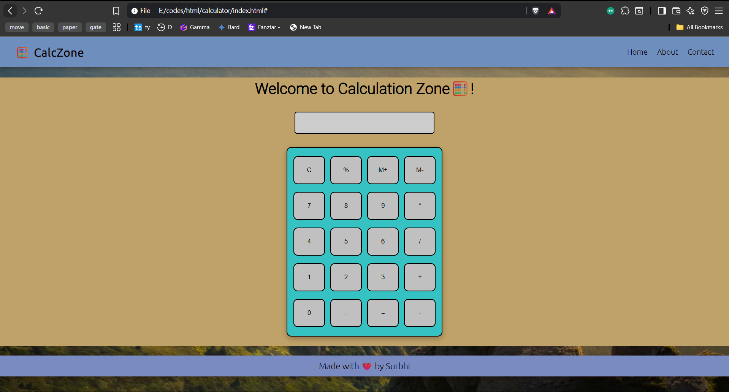

❤️ Made with love by Surbhi