ShopNest Power BI Capstone Dashboard Report
Instructions Overview
This document explains the Power BI dashboard created for ShopNest based on 9 datasets and 8 analytical questions. Each section below corresponds to a specific analysis question and includes a summary, a visual, and key findings.

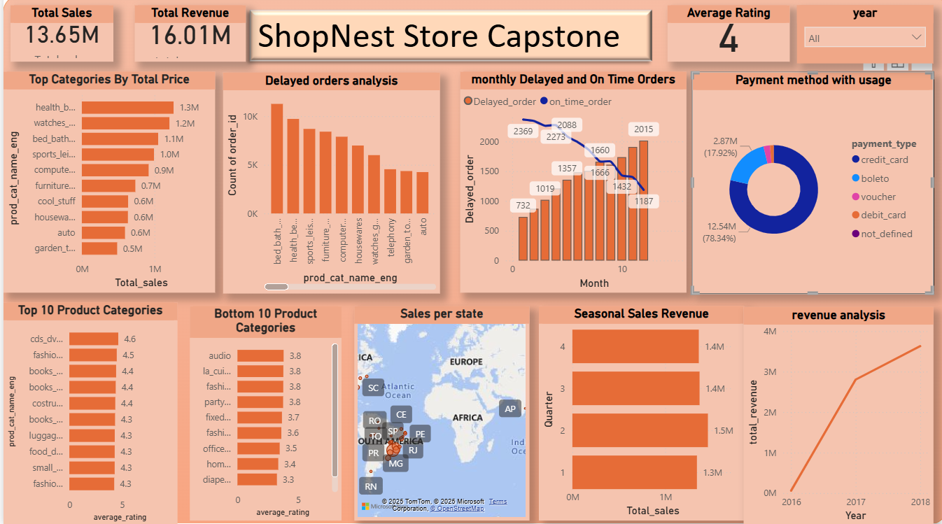

Measures and Calculated Columns
The following measures were created using DAX:
• Total Revenue = SUM(Order_items[price])
• Net Revenue (only delivered orders) = CALCULATE(SUM(Order_items[price]), Orders[order_status] = 'delivered')
• Total Orders = DISTINCTCOUNT(Orders[order_id])
• Average Rating = AVERAGE(Reviews[review_score])
• Delivery Status = IF(order_delivered_customer_date > order_estimated_delivery_date, 'Delayed', 'On Time')

1. Top Categories by Total Price
- Question Statement: Identify and visually represent the top 10 product categories by total sales.
- Visualization:
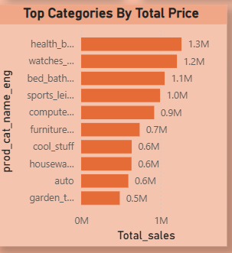

- Explanation: Identified and visually represented the top 10 product categories by total sales. Bar chart displays revenue contribution by each category.
2. Delayed Orders Analysis
- Question Statement: Determine the number of delayed orders in each category.
- Visualization:
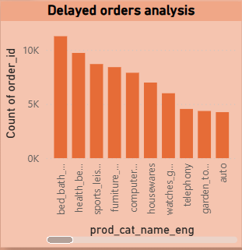

- Explanation: Calculated delayed orders by comparing estimated vs actual delivery dates. Delayed labels were created using a calculated column.
3. Monthly Comparison of Delayed and On-Time Orders
- Question Statement: Create a dynamic visual comparing the number of delayed vs on-time orders month-wise.
- Visualization:
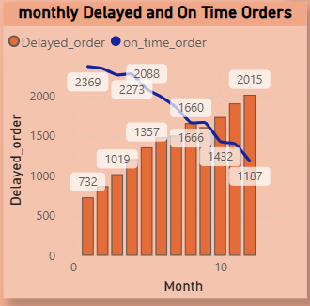

- Explanation: Visualized month-wise trend of delayed and on-time deliveries to identify seasonal delays. Combo bar chart is used.
4. Payment Method Analysis
- Question Statement: Analyze the most frequently used payment methods.
- Visualization:
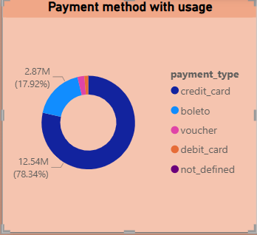

- Explanation: Analyzed frequently used payment methods using a donut chart showing % split of payment types like credit card, boleto, etc.
5. Product Rating Analysis
- Question Statement: Determine the top 10 and bottom 10 rated products.
- Visualization:
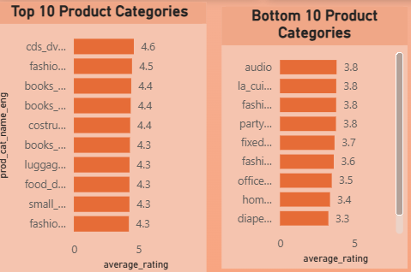
- Explanation: Displayed top and bottom 10 products based on average review score using bar charts with dynamic sorting.
6. State-wise Sales Analysis
- Question Statement: Identify and visually represent states with high and low sales.
- Visualization:
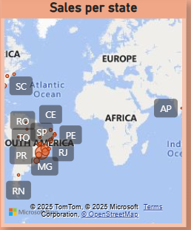

- Explanation: Mapped state-wise revenue by linking customer states to order revenue. Used bubble map to visually compare revenue by geography.
7. Seasonal Sales Patterns
- Question Statement: Visualize quarterly sales data to identify seasonal trends.
- Visualization:
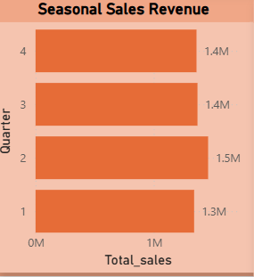
- Explanation: Quarter-wise sales trend was plotted to identify seasonal performance across the year using a Stacked bar chart.
8. Revenue Analysis
- Question Statement: Determine total revenue and analyze year-over-year growth.
- Visualization:
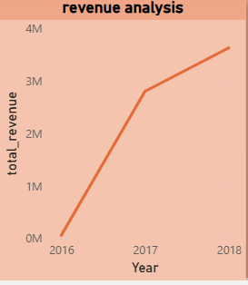
- Explanation: Annual revenue trends were analyzed using a line chart to show year-on-year growth from 2016 to 2018.

Conclusion & Submission Notes
The dashboard delivers actionable insights for ShopNest based on historic order, product, payment, and customer data. It is designed to be visually informative, with interactive slicers and categorized visuals. All visuals are placed logically to aid stakeholder understanding and decision making.

