**ACS 545 Cryptography and Network Security**

**Name: SURBHI SHARMA**

**LAB 3**

**Packet Sniffing and Spoofing Lab**

TASK 1.1 A

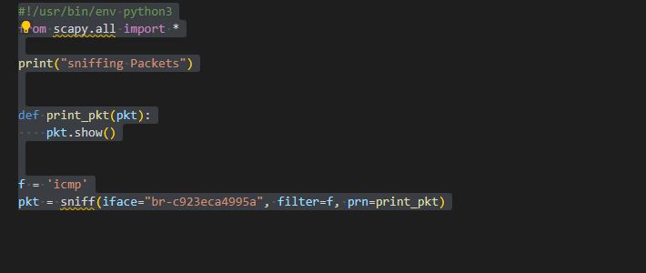

OUTPUT:

**OUTPUT WITH SUDO COMMAND**

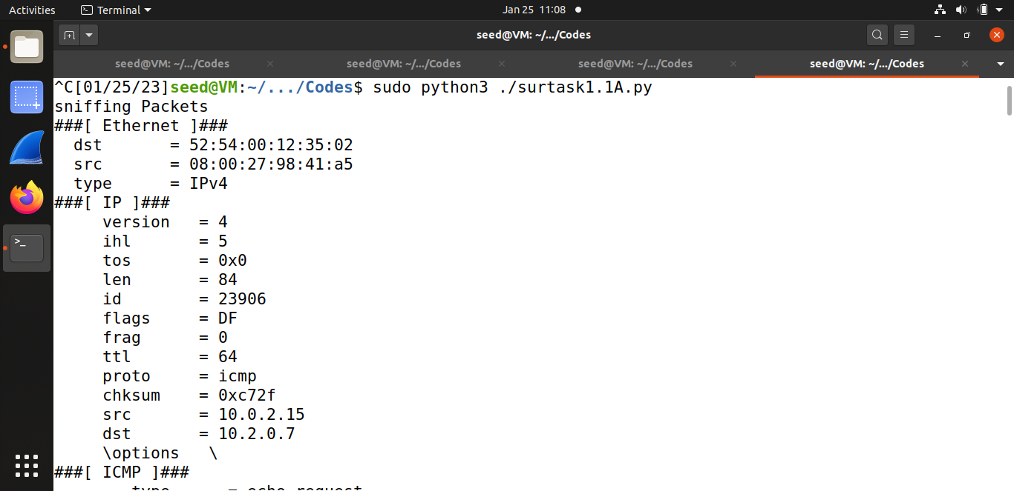

**OUTPUT:**

**Without sudo command error will be there as we can’t access the socket without superuser privilege and it will show ERROR :**

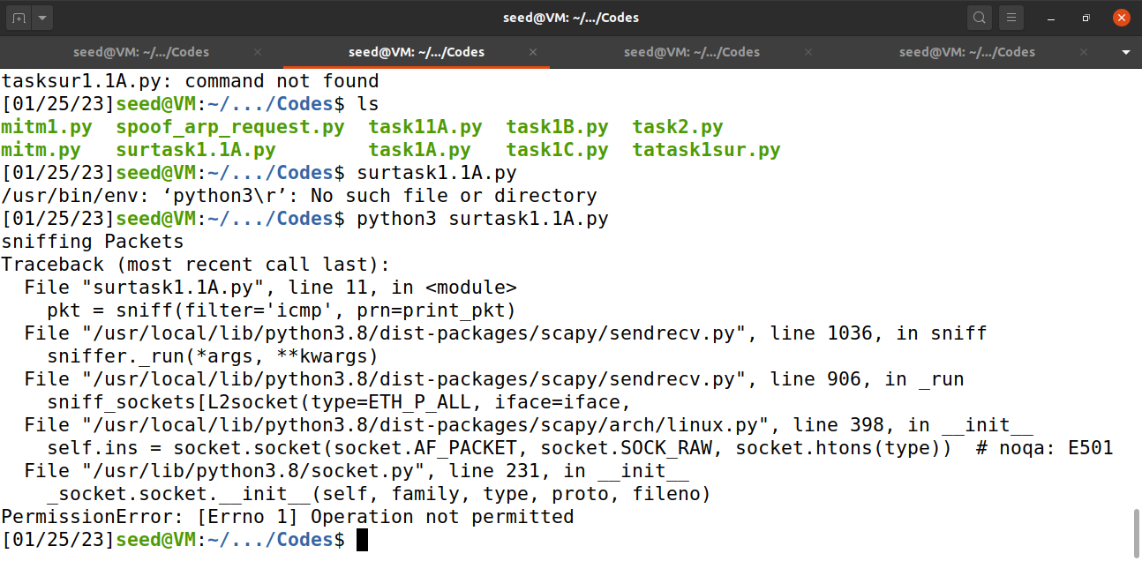

**TASK1.1 B**

**Icmp**



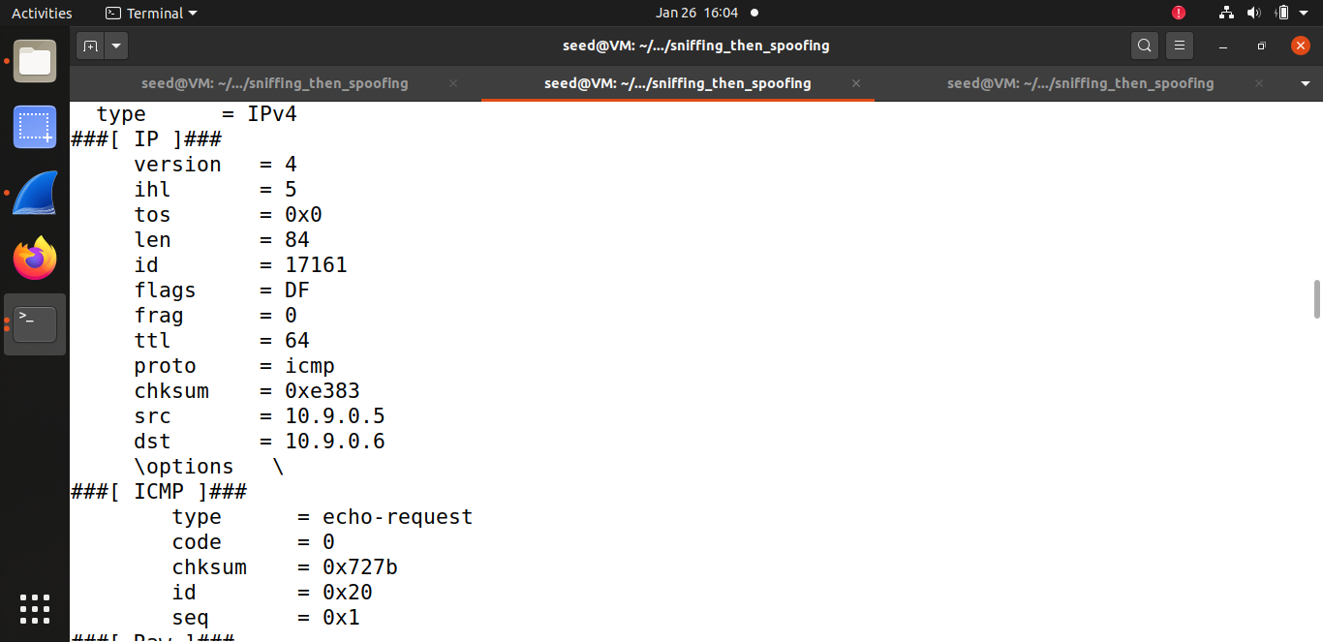

**Code: TCP and Port 23**

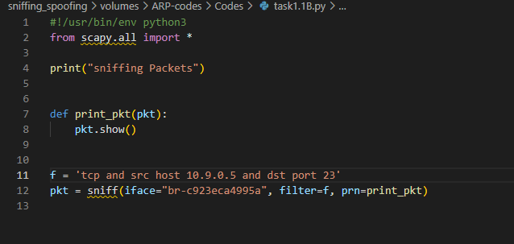

OUTPUT

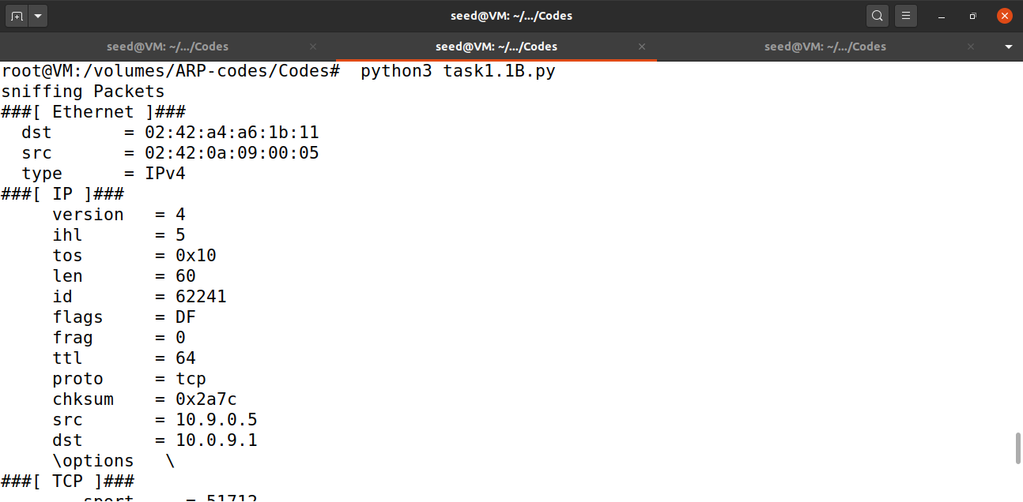

**CODE FOR SUBNET 172.17.0.0/24**

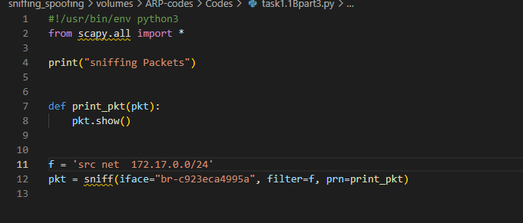

OUTPUT:

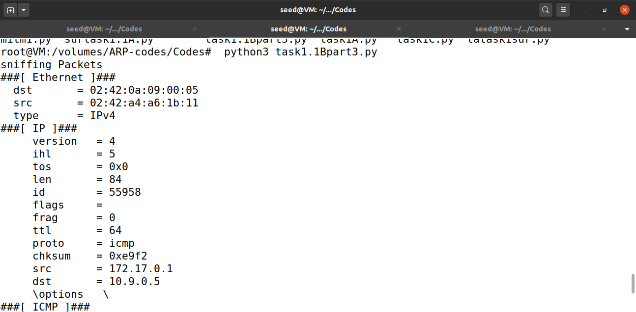

**TASK1.2 SPOOFING**

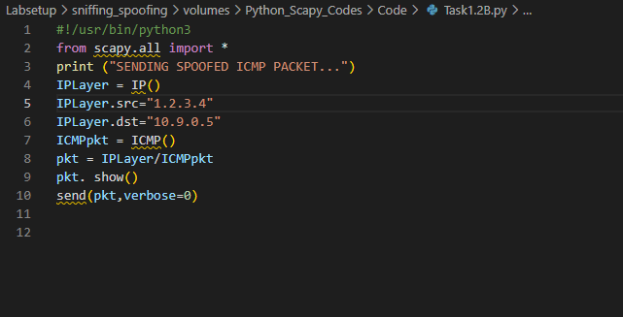

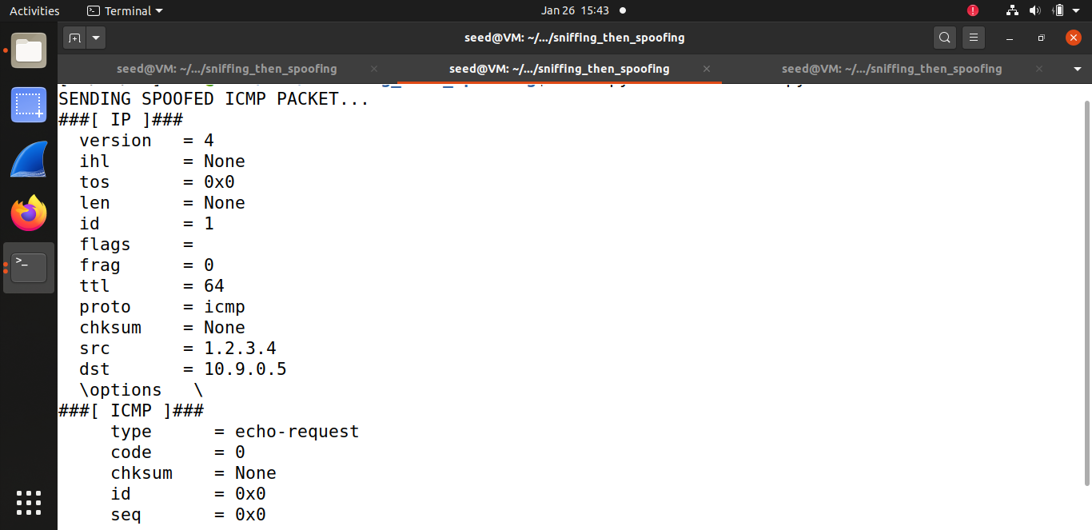

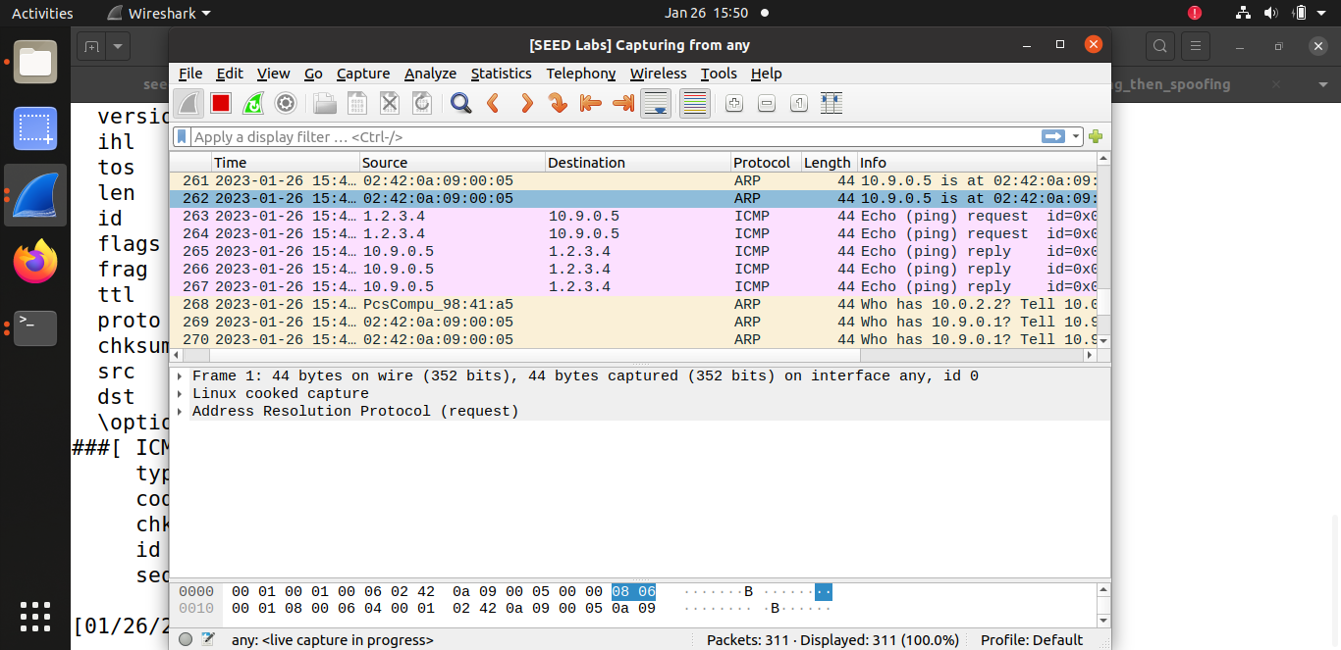

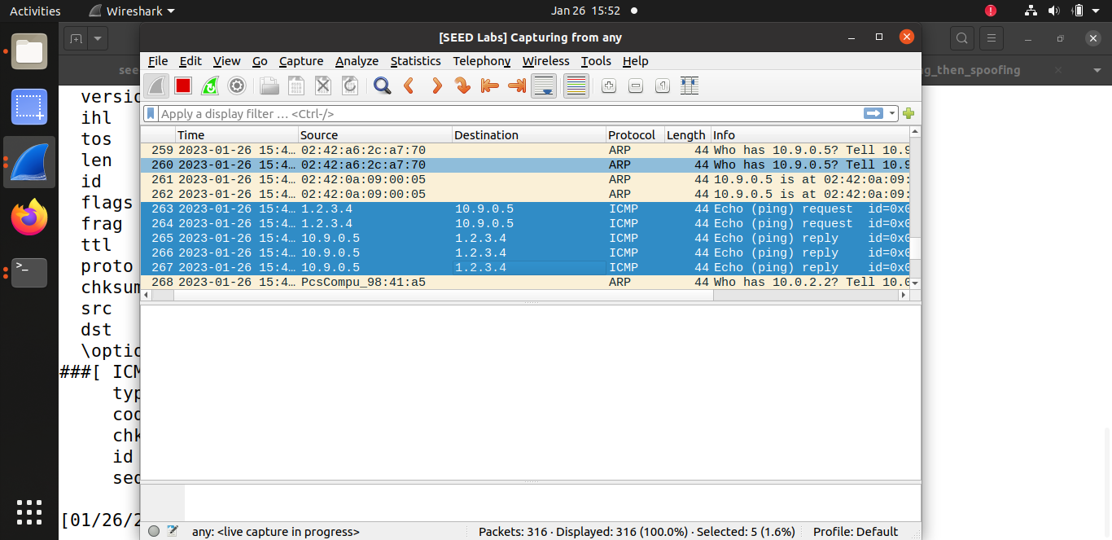

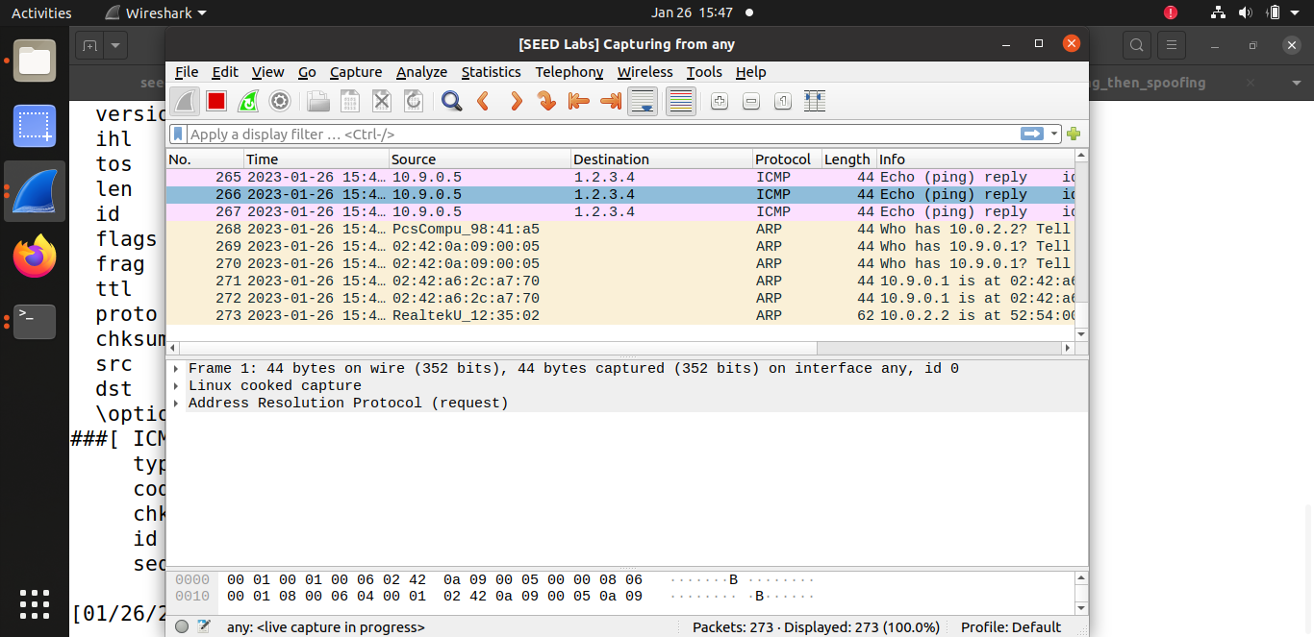

**TASK1.3 TRACEROUTE**

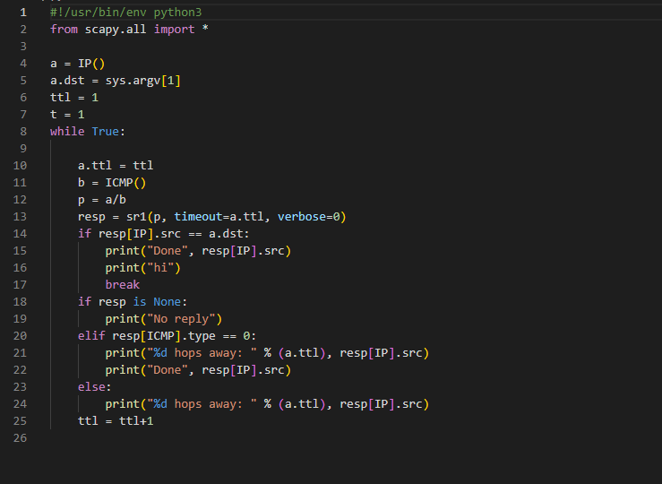

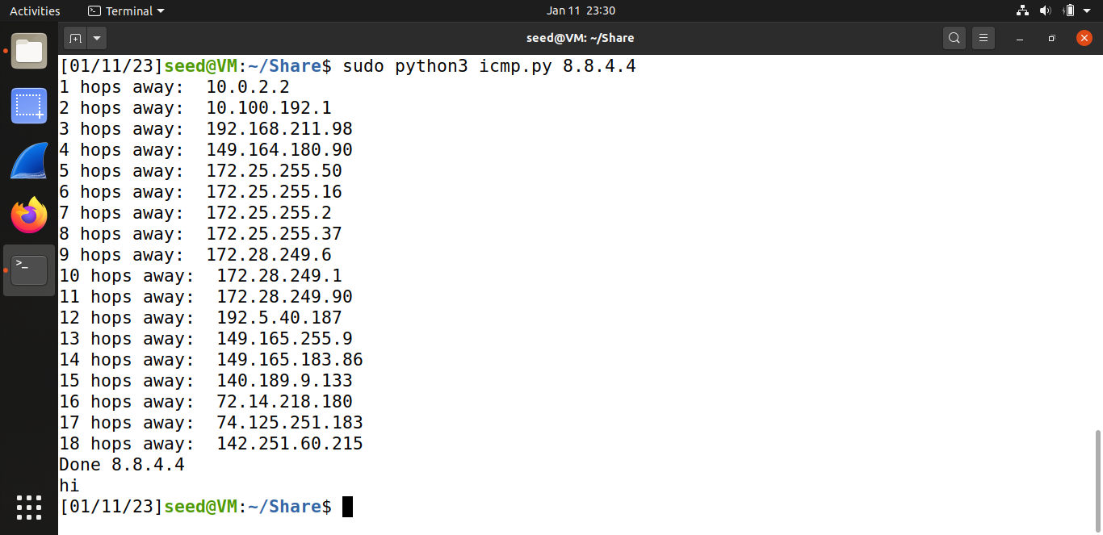

**TASK1.4 Sniffing AND SPOOFING**

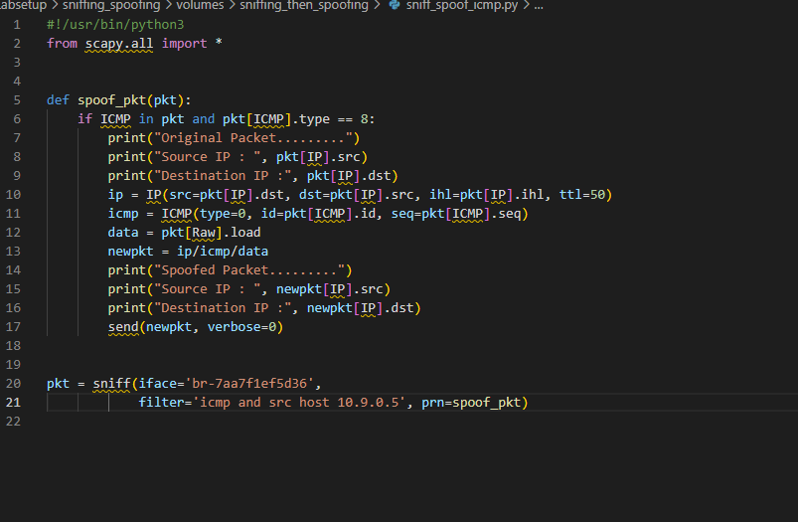

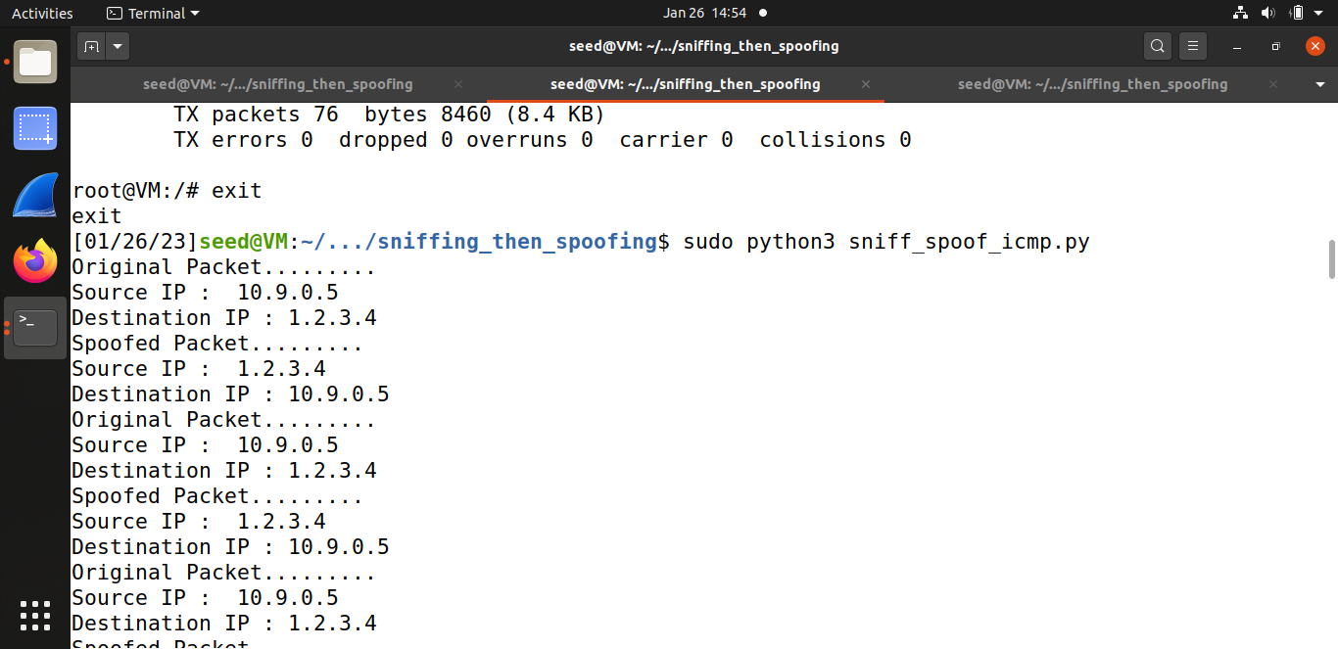

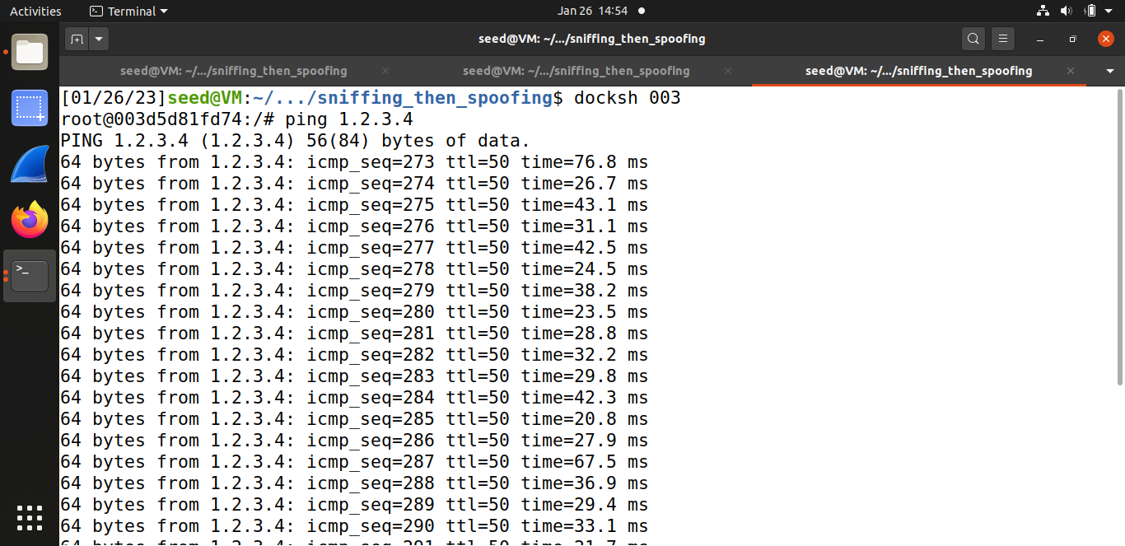

**Observation :** Based on the above screenshot, we can state that on pinging non-existing host on the Internet. We got the reply from the sniff and spoof program**.**

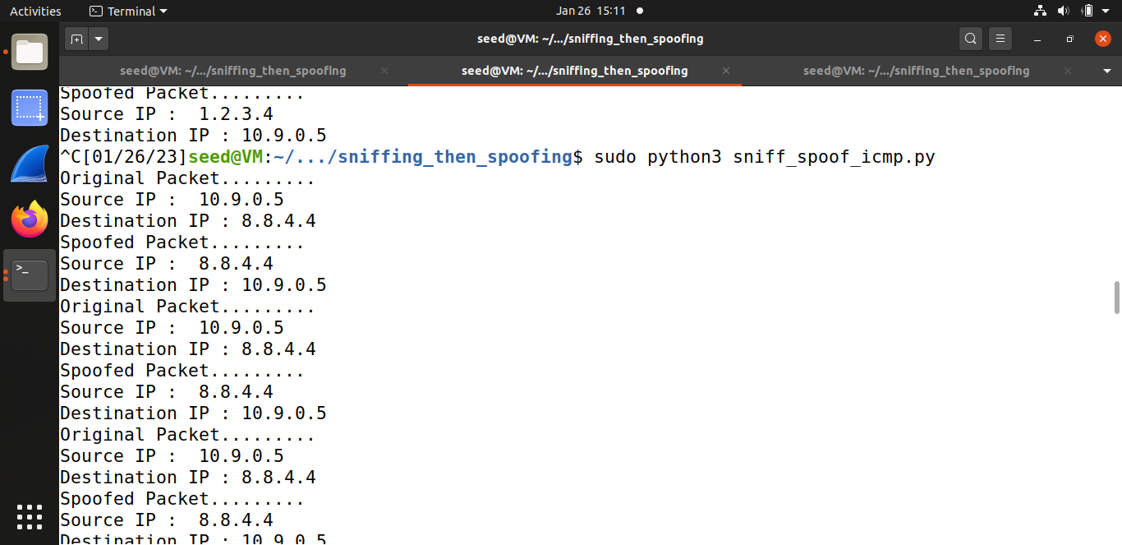

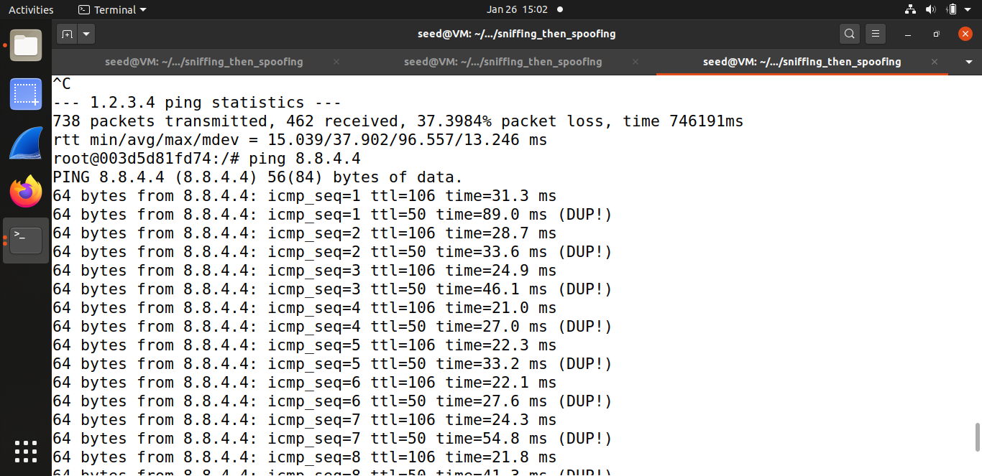

**Observation:** Based on the above screenshot, we can state that on pinging on an existing host on the Internet we can see the duplicate traceroute as one is from the sniff and spoof program and another is from original ip address: 8.8.4.4.

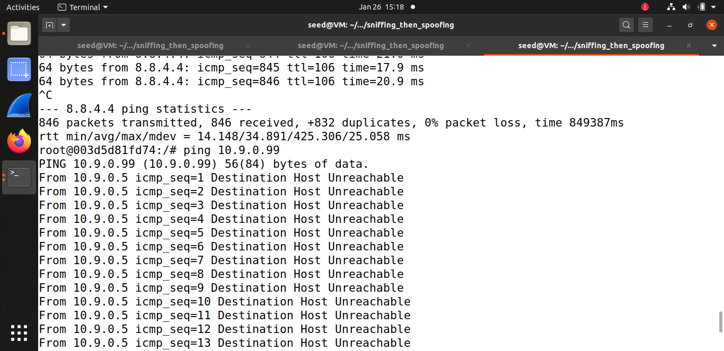

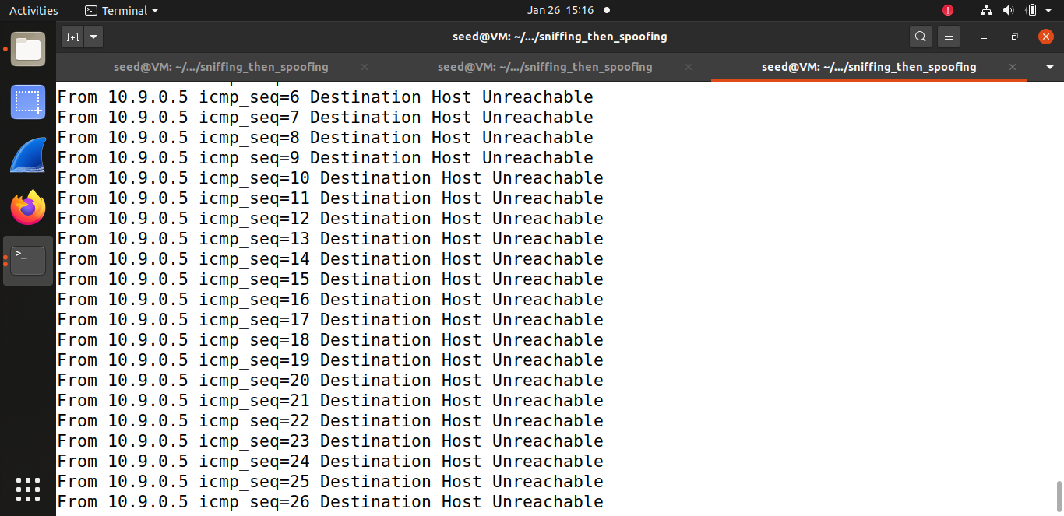

**Observation :** Based on the above screenshot, we can state that on pinging a non-existing host on the LAN. We can observe the LAN is not reachable as we are on same LAN as VM.

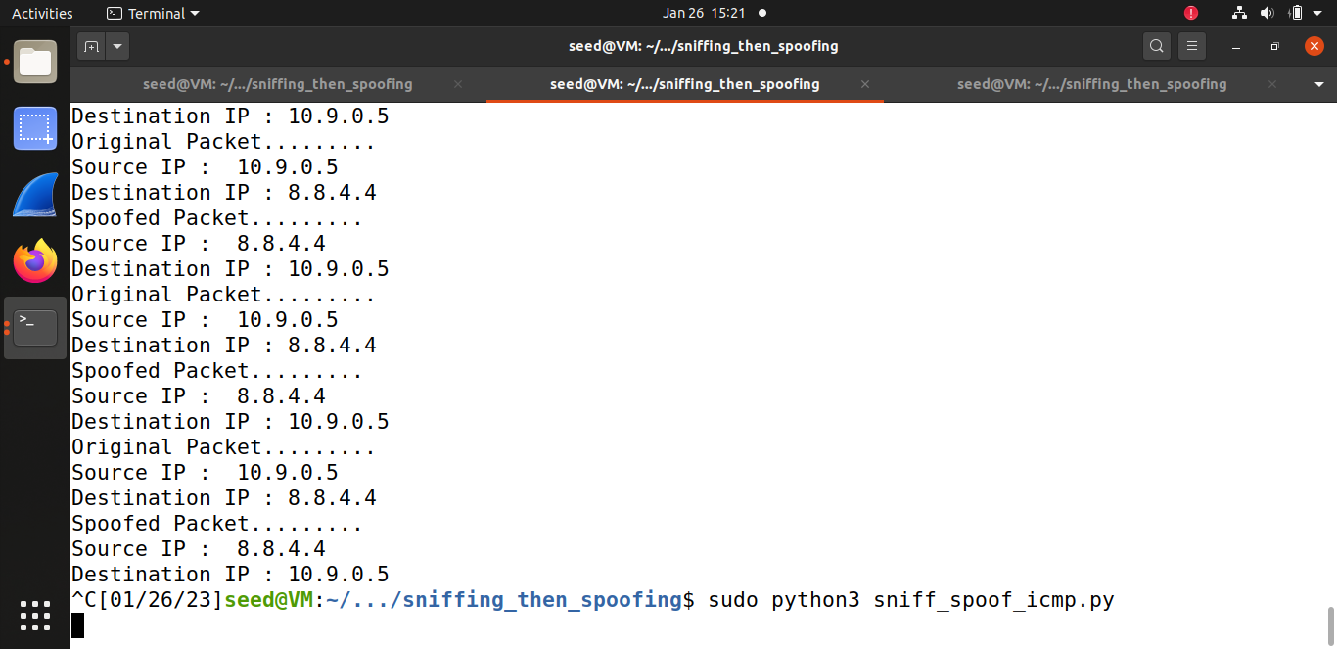

**OBSERVATION: NO OUTPUT IS SNIFFED AT ATTACKER MACHINE WHEN HOST A IS PINGED NON EXISTING HOST.**