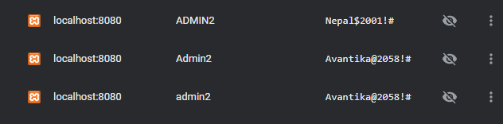

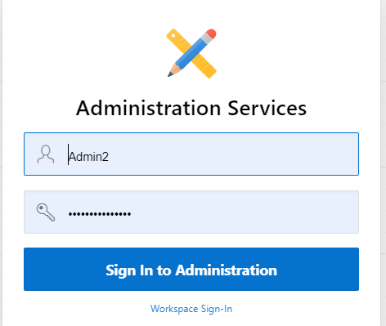

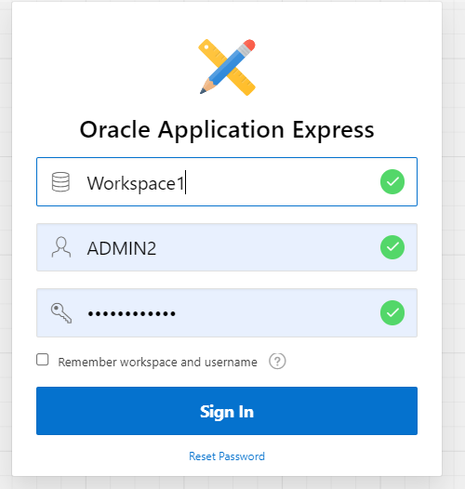

Xampp> a[ache>config>php.ini

Xampp>explorer>snedmail>semdmail.ini and follow the video.