**Amity University Madhya Pradesh**



**Title of Project**

PROPOSAL FOR ESTABLISHMENT OF MEDICAL STORE FOR UNIVERSITY

**Name of Student Member Name of mentor**

Nidhi Gupta Dr. Vivek Singh Kushwaha

B.Tech(CSE) Assistant Professor

A60205217066 ECE,ASET

Mobile no.- 8120932160 Mobile no.- 08989563787

**Broad Area of the project proposal:-**

Health issues which is increasing day by day becomes eyesore and in turn sometime create a serious issues, especially in university campus or any institution where students stay far from their homes . When in changing weather flues are the basic issues. Hence, setting up a chemist shop at that place is worthy and needed As a lot of students live their for years, and also when campus is at outskirts ,it will take a pressure for this kind of issues in any weather . This alternatively save time and efforts to go to the market and other pharmacies and search for the required drug .Also to the girls ,they monthly needed sanitary napkins and when in a busy schedule like exams when you can not plan a visit to the city for the basics ,it will be easy for them and it make it more easier and they do not need to depend on someone to help . Hence in this thesis, an attempt is fulfill that demand and will make things easier .

**THE BUSINESS**

**INTRODUCTION**

Pharmacy is the science and technique of preparing, dispensing, and reviewing [drugs](https://en.wikipedia.org/wiki/Drug) and providing additional clinical services.  It aims to ensure the safe, effective, and affordable use of [drugs](https://en.wikipedia.org/wiki/Drug). The professional practice is becoming more clinically oriented as most of the drugs are now manufactured by pharmaceutical industries. Based on the setting, the pharmacy is classified as a community or institutional pharmacy. Providing direct patient care in the community of institutional pharmacies are considered clinical pharmacy.

The scope of pharmacy practice includes more traditional roles such as [compounding](https://en.wikipedia.org/wiki/Compounding) and dispensing medications, and it also includes more modern services related to [health care](https://en.wikipedia.org/wiki/Health_care), including clinical services, reviewing medications for safety and efficacy, and providing [drug](https://en.wikipedia.org/wiki/Drug) information.

Pharmacists , therefore, are the experts on drug therapy and are the primary health professionals who optimize use of medication for the benefit of the patients.

An establishment in which pharmacy (in the first sense) is practiced is called a pharmacy (this term is more common in the United States) or a chemist's (which is more common in Great Britain). In the United States and Canada, drugstores commonly sell medicines, as well as miscellaneous items such as confectionery, [cosmetics](https://en.wikipedia.org/wiki/Cosmetics), [office supplies](https://en.wikipedia.org/wiki/Office_supplies), [toys](https://en.wikipedia.org/wiki/Toy), hair care products and magazines and occasionally refreshments and groceries.

In its investigation of herbal and chemical ingredients, the work of the pharma may be regarded as a precursor of the modern sciences of [chemistry](https://en.wikipedia.org/wiki/Chemistry) and [pharmacology](https://en.wikipedia.org/wiki/Pharmacology), prior to the formulation of the scientific method.

**PROPOSED METHODOLOGY**

Since our campus has a no of 2000 approx hosteller and no chemist shop at our campus create a cuose in need . so basically it will satisfied that demand and will helpful to those who has urgent need of medicine and also will provide medical help for women when it needed, at service of 10 hour or as per wish.

**MISSION OF THE PROJECT**

PROJECT To emphasize the introvert and students the students who may have a long term treatment. without provide the service to the hostellers and the day scholars.

**STRATEGY OF THE PROJECT**

Establishing and running the chemist shop at the university place as already mentioned in the sub heading that target area of the project has been the first plan. Then fore most priority has to be given to all those who staying in a hostel and can’t go to the main city far from campus. The spirit of emotions ,concern and care of a family.

**PROCEDURE OF MATERIAL TO THE SHOP**

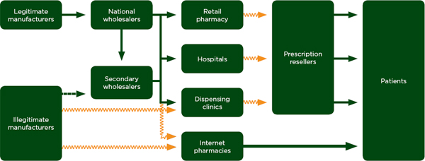

**LOGISTIC MANUFACTURER** In a general [business](https://en.wikipedia.org/wiki/Business) sense, logistics is the [management](https://en.wikipedia.org/wiki/Management) of the flow of things between the point of origin and the point of consumption in order to meet requirements of customers or corporations. The resources managed in logistics may include tangible goods such as materials, equipment, and supplies, as well as food and other consumable items.

**NATIONAL WHOLESALER**  National Wholesale Liquidators carries over 120,000 items. The company also offers appliances, automotive products, bath towels, bedding, carpets and floor covers, detergents and cleaning products, electrical hardware, electronics, food products, furniture outdoor, giftware, health and beauty aids, holiday decorative, and household storage products.

**SECONDARY WHOLESALER** The secondary pharmaceutical wholesale industry, sometimes referred to as the “gray market” is an industry comprised of smaller wholesalers who often come to the aid of medical facilities who are in need of a product when their primary contract cannot supply. These smaller wholesalers also pick up business that the larger companies leave behind because of their purchase volume. Of course, there are some bad apples in the industry, as with every other industry, but they are not the cause of drug shortages.

Simply, a drug shortage means there is not enough of a drug in the market to meet the demand. This leads us to the conclusion that the manufacturers should produce more product.

**RETAIL PHARMACY Retail pharmacists** provide general healthcare advice and supply prescription and non-prescription medication to the public. A **retail pharmacist** works in a **retail**setting rather than in a hospital or GP surgery.

**DEMAND OF PHARMACEUTICAL**

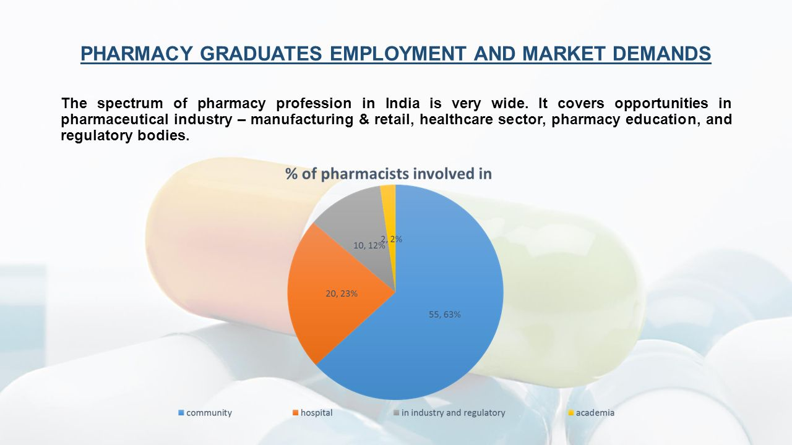

**CONCLUSION**

So in this way a particular area of campus will use as a earning part , like by renting this shop a fixed amount will be generated as for a good cause and moreover it will be convienient to the students and will be more fruitile than the shop in the market where the other competitor can break the amount of income so it will be convienient and also worthy also efficient.

It will surely reduce the stress to go out and waste the money in vehicles . student’s family will be be free with the worries to the everytime service at the campus.

**THE TEAM**

1. Brief description of each member of the team stating qualification and other details-

**Name-**Nidhi Gupta

**Department-**B.tech(CSE)

**Enrollment no.**- A60205217066

1. Name and qualification of mentor-

**Name-**Dr. Vivek Singh Kushwah

**Designation-** Assistant Professor(ECE, ASET)

1. Whether any preliminary discussion has been done with the mentor**: - Yes**
2. Whether any of the team members participated in program related to entrepreneurship: **Yes, Participating in 25 days EDP Program sponsored by NSTEDB New Delhi and EDII-Ahmedabad.**

**THE SUPPORT SYSTEM**

1. Is the host institution capable of supporting the student?**: - Yes**
2. Does the host institution have necessary equipment/hardware for product development and subsequent testing? **: - Yes**

**THE FINANCIAL REQUIREMENT**

1. **FIXED CAPITAL INVESTMENT**

|  |  |  |  |
| --- | --- | --- | --- |
| a. | Land |  | Own |

|  |  |  |  |  |  |
| --- | --- | --- | --- | --- | --- |
| **B** | | **Machinery** | **Qty.** | **Rate** | **Amount in Rs.** |
| 1. | | shop furniture | 1 | 10000.00 | 10000.00 |
| 2. | | Air cooler | 1 | 8000.00 | 8000.00 |
| 3. | Fans | 2 | 700.00 | 2800.00 |
| 4. | Lights | 6 | 400.00 | 2400.00 |
|  | **Total** |  |  | **13200.00** |

**Preliminary &Pre-operative Cost:** Rs 5000

**Contingencies:** Rs 30000

**Total Capital Expenditure:** Rs 13200

**Working Capital:** Rs 55750

**Total Cost Project:** Rs 504950

|  |  |  |  |  |  |
| --- | --- | --- | --- | --- | --- |
| **C** | ***Raw Materials*** | ***Unit*** | ***Rate/unit*** | ***Reqd.Unit*** | ***Amount in Rs.*** |
| 1 |  | 50kg | Rs 6/kg | 50 | 300.00 |
| 2 | Sand | 50kg | Rs 0.81/kg | 50 | 40.50 |
| 3 | plastic waste | 50kg | Rs 1.5/kg | 50 | 75.00 |
| 4 | fly ash | 50kg | Rs1.01/kg | 50 | 50.50 |
|  | **Total** |  |  |  | **466.00** |

|  |  |  |  |  |
| --- | --- | --- | --- | --- |
| **D** | **Wages** | ***No. of*** | ***Wages*** | ***Amount in Rs.*** |
| ***Worker*** | ***Per Month*** | ***(Per Annum)*** |
| 1 | Labour | 2 | 2000.00 | 4000.00 |
| 2 | Peon | 1 | 5000.00 | 5000.00 |
| 3 | Total | 3 |  | **9000.00** |

**Repairs and Maintenance:** Rs 5000

**Power and fuel:** Rs 15000

**Other Overhead Expences:** Rs 24000

**Telephone Expenses:** Rs 12000

**Stationery and postage:** Rs 3000

**Advertisement and publicity:** Rs 5000

**Other miscellaneous expenses:** Rs 5000

**Total :** Rs 583416

**Name-**Nidhi Gupta

Signature of the Student member

**Faculty Project Guide-** Dr. Vivek Singh Kushwah

Assistant Processor

ECE,ASET

Signature of Faculty Project Guide

Forwarded by HoI