**EXAM REGISTRATION SYSTEM**

**A PROJECT REPORT**

*Submitted by*

**Surbhi Dabhade 205119105**

*In partial fulfilment in the award of degree of*

**MASTER OF COMPUTER APPLICATIONS**



**NATIONAL INSTITUTE OF TECHNOLOGY**

**TIRUCHIRAPPALLI**

**JULY 2020**

**COMPUTER APPLICATIONS**

**DECLARATION**

**I hereby declare that the project entitled “EXAM REGISTRATION SYSTEM” which is submitted by me for the partial fulfilment of Master of Computer Applicationsof National Institute of Technology, Tiruchirappalli comprises of my own work and due acknowledgement has been made in text to all other material used.**

**The matter embodied in this project work is authenticated and is genuinely done by me and has not been submitted to this university or any other university/institute.**

**I have completed this project work during our 2nd semester session under the supervision of Dr. U. Vignesh**

**Signature of student:**

**Surbhi Dabhade –**

**Date –**

**Place -**

**CERTIFICATE FROM GUIDE**

**This is to certify that project on “EXAM REGISTRATION SYSTEM” submitted by Surbhi Dabhade (205119105) to National Institute of Technology, Tiruchirappalli has been completed under my supervision and the work is carried out and presented in a manner required for its acceptance in partial fulfilment for the award of degree of “Master of Computer Applications” 2nd semester.**

**Project Guide**

**Signature**

**Name :Dr. U. Vignesh**

**CERTIFICATE**

This is to certify that I have examined the project on “EXAM REGISTRATION SYSTEM” submitted by Surbhi Dabhade (205119105) to National Institute of Technology, Tiruchirappalli and hereby accord our approval of it as a study carried out and presented in a manner required for its acceptance in partial fulfilment for the award of degree on “Master of Computer Application 2ndsemester.

Signature:

Dr. U. Vignesh

**ACKNOWLEDGEMENT**

I acknowledge my sincere thanks to those who contributed significantly to the project. It is a pleasure to extend deep gratitude to our internal guide Dr. U. Vignesh, NITT, for his valuable guidance and support and to continuously prompt me for the progress of the project. I thank him for his valuable suggestion towards my project, which helped me in making this project more efficient and user friendly.

I thank and acknowledge each and every one effort that helped us in some or the other way for small and significant things.

Student Signature -

Student Name & Roll No-

**ABSTRACT**

Exam Registration system is used in the effective dispatch of registration form to all of the students. This system adopts a comprehensive approach to minimize the manual work and schedule resources, time in a cogent manner. The core of the system is to get the online registration form (with details such as name, roll no etc.,) filled by the student whose testament is verified for its genuineness by the Exam Registration System with respect to the already existing information in the database. This forms the first and foremost step in the processing of exam application. After the first round of sign-up done by the system, the information is in turn stored to the database. The application is then processed manually based on the report given by the system. After all the necessary criteria has been met, the original information is added to the database.

The system has log in and sign in pages as the user has to login first whit its username and password to fill the examination form. The examination form has personal details of user which is further stored in database.

**INTRODUCTION**

Student Online exam registration are a vital part of any university’s running because students are what keep a University alive. The Student exam registration is one of the most important activities within a university as exam are the only basis in Universities to check the knowledge of students.

Exam Registration Form is a Web Application which is helpful for students as well as the department. In this project, the student is facilitated by the online system for registering for exams of students, add department and roll number.

In this Application we can register as a user and user has of two types, student and administrator. Administrator has the power to add new user and delete a user.

Through this online system we overcome many Problems.

* Time is saved.
* Nothing is done manually.
* Long lines in department for these issues.

**SCHEMA AND TABLES**

SIGNIN:

----------------------- --------------- ----------------------

* ID NOT NULL NUMBER (250)
* USERNAME VARCHAR (250)
* PASSWORD VARCHAR (10)

REGINFO:

------------------------- ------------ ----------------------

* REGNO NOT NULL NUMBER (150)
* USERNAME VARCHAR (50)
* FNAME VARCHAR (50)
* LNAME VARCHAR (50)
* FTNAME VARCHAR (50)
* RNO NUMBER (100)
* DNAME VARCHAR (50)
* EMAIL VARCHAR (100)
* PHONENUMBER NUMBER (10)

**CREATING TABLES**

* Create table signin ( id number (250) primary key, username varchar (50), password varchar(10));
* Create table reginfo ( regno number (150) primary key, username varchar (50), fname varchar (50), lname varchar (50), ftname varchar (50), rno number(100), dname varchar(50), email varchar(100), phonenumber number(10));

**DATABASE DESIGN**

The general theme behind a database is to handle information as an integrated whole. A database is a collection of interrelated data stored with minimum redundancy to serve many users quickly and efficiently. The general objective is to make information access easy quick and flexible for user. In database design several objectives are considered.

**TABLE STRUCTURE**

SIGN IN:

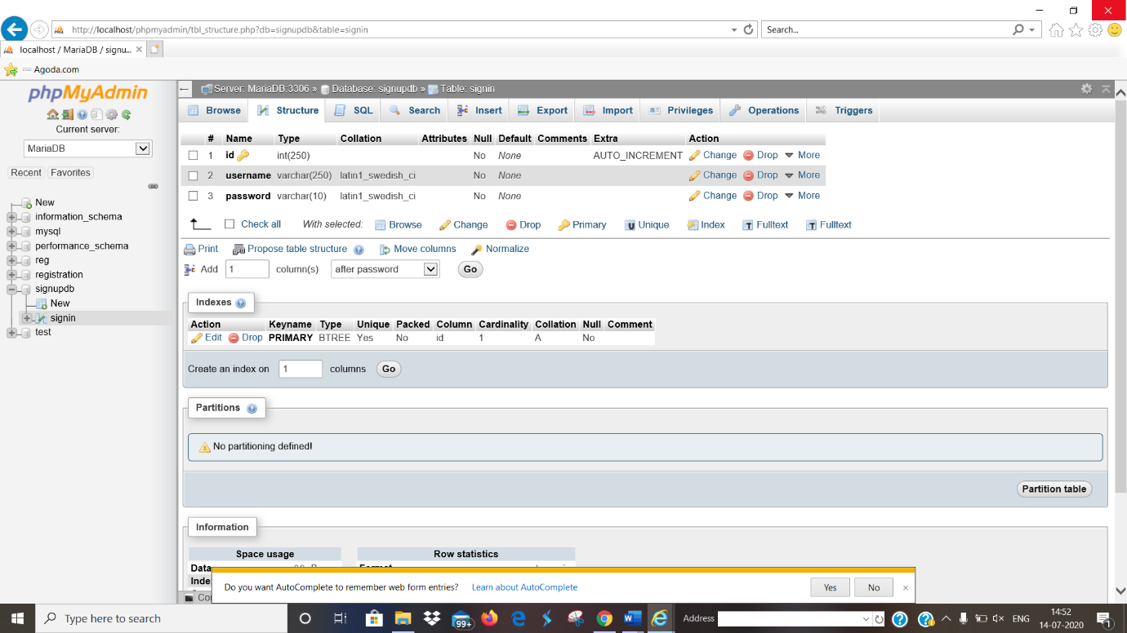

REGINFO:

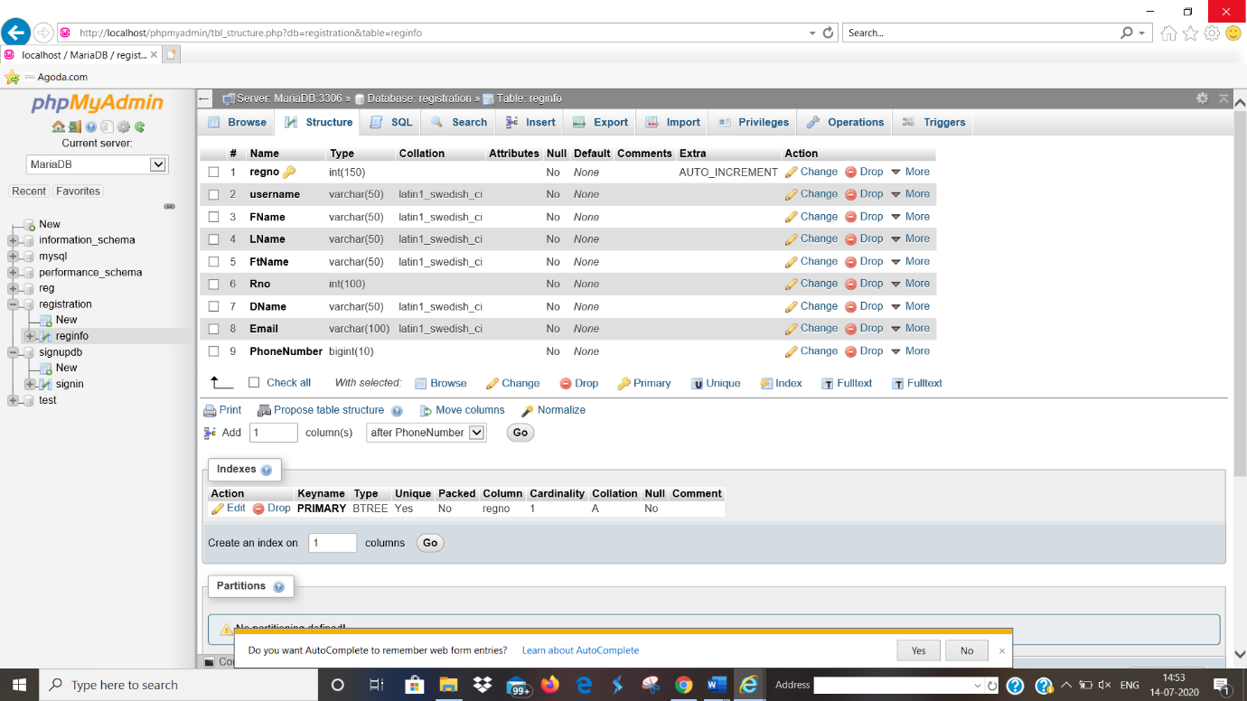

**IMPLEMENTATION OF USER-INTERFACE LAYER**

**HOME PAGE:**

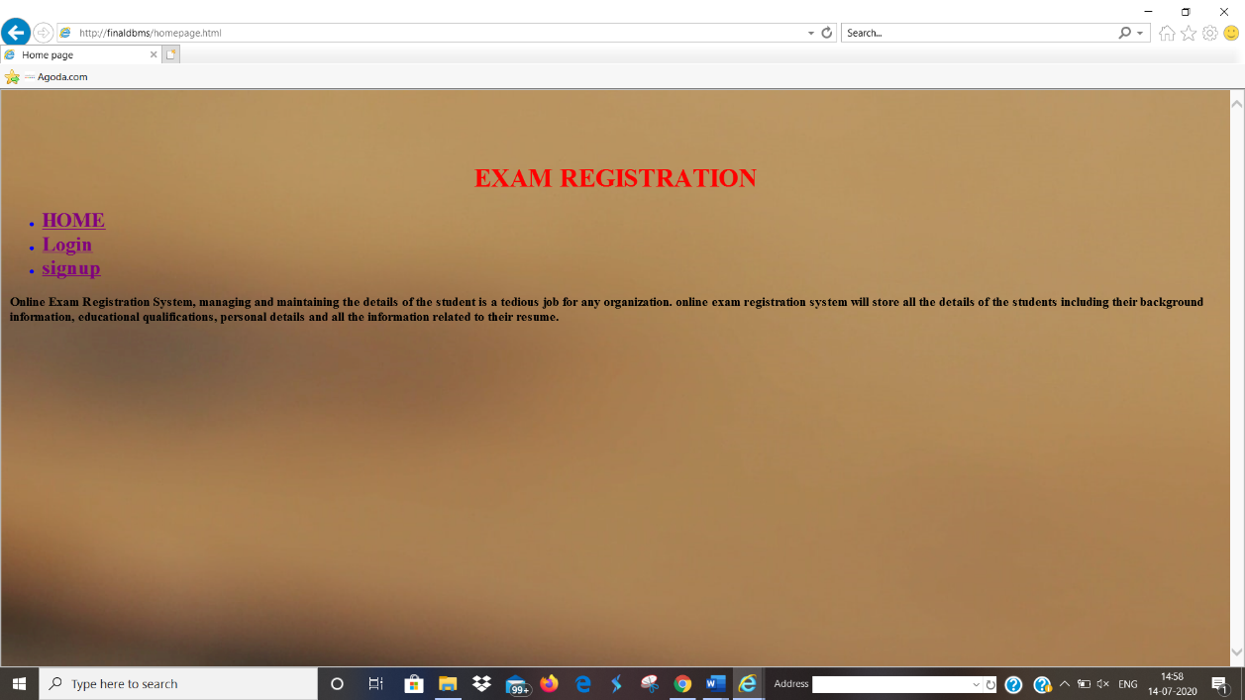

**SIGN UP PAGE:**

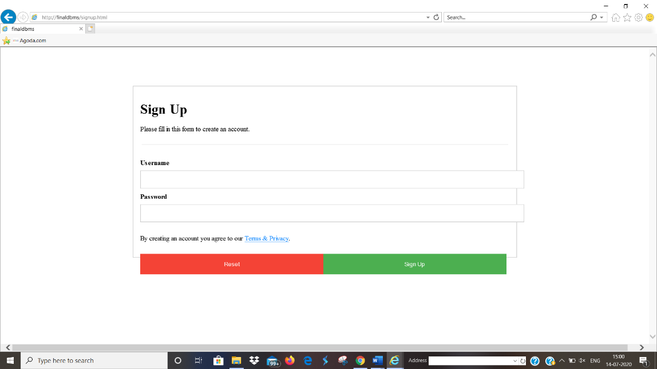

**LOG IN PAGE:**

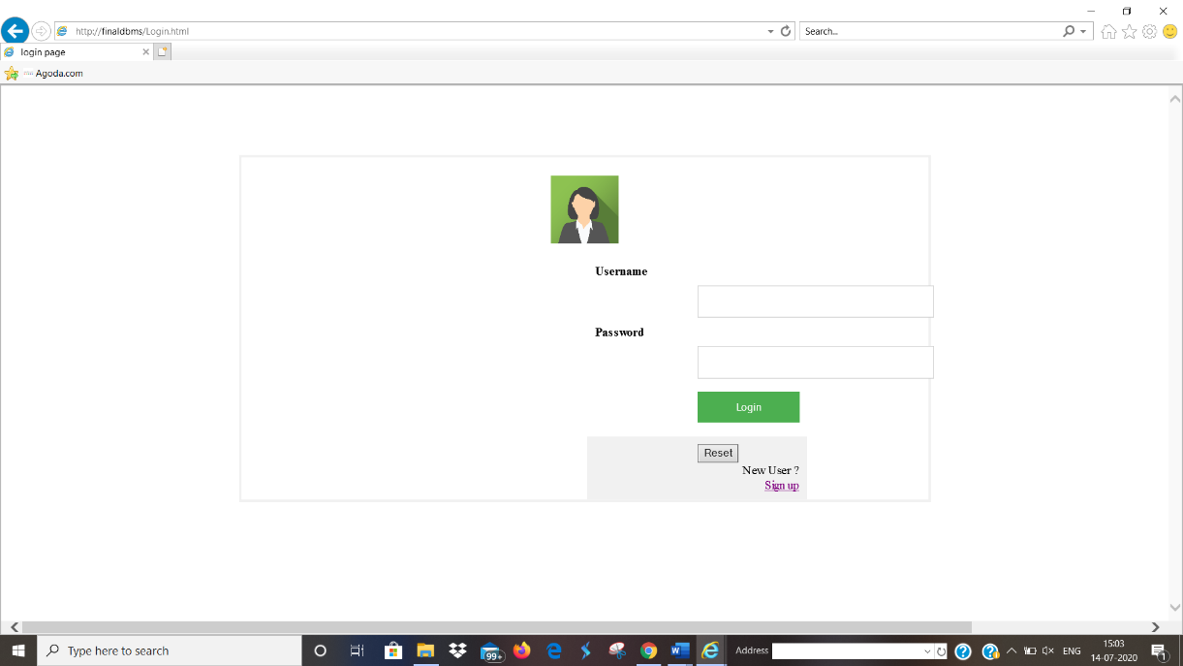

**REGISTRATION PAGE:**

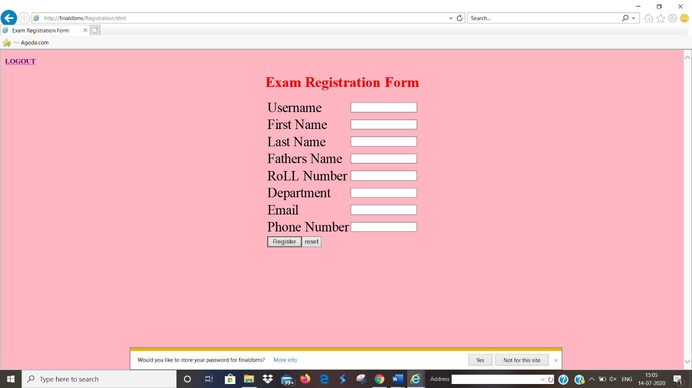

**DATABASE CONNECTIVITY:**

**FOR SIGN IN:**

Source code for data base:

$con=mysqli_connect('localhost','root');

mysqli_select_db($con,'signupdb');

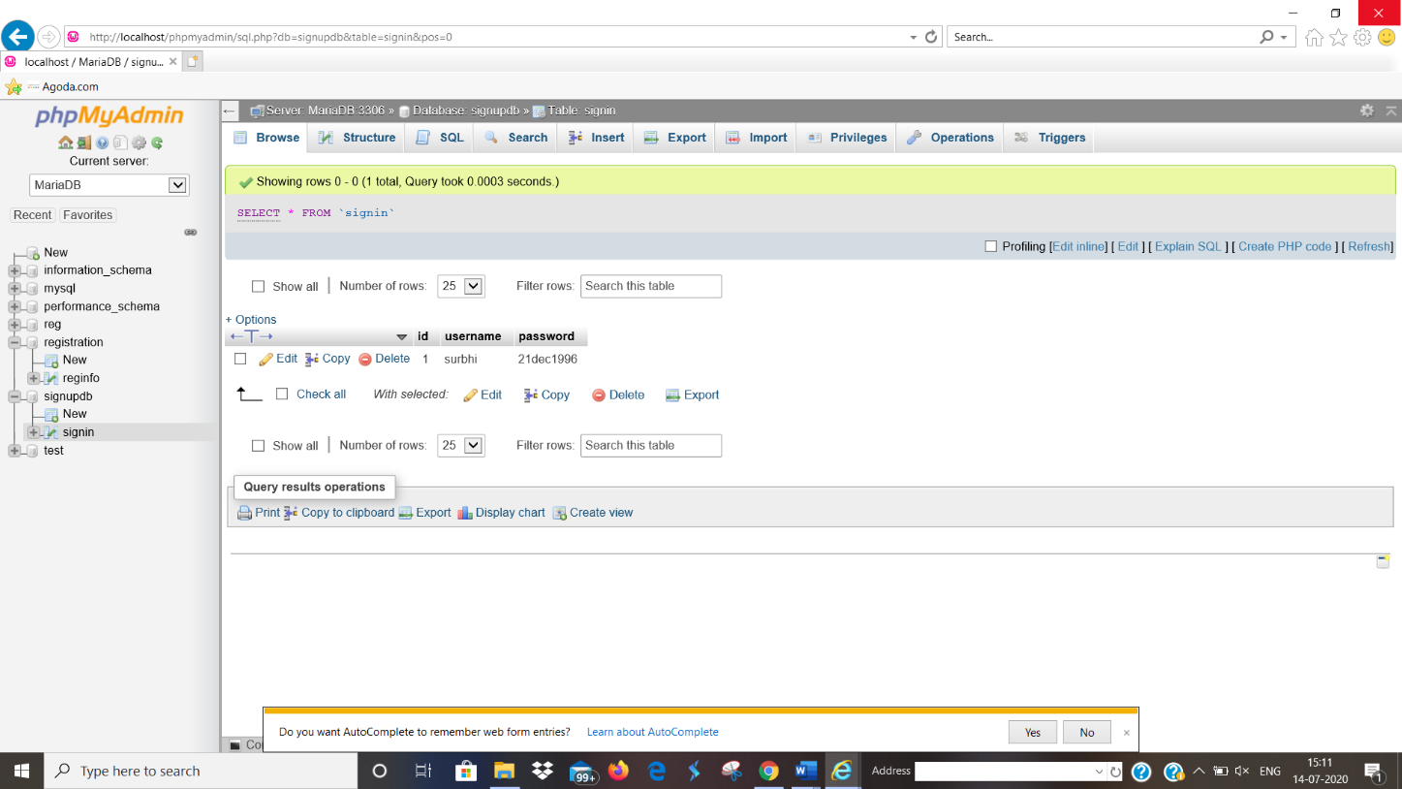

**FOR REGISTRATION:**

Source code for data base:

$conn = new mysqli($host,$dbusername,$dbpassword,$dbname);

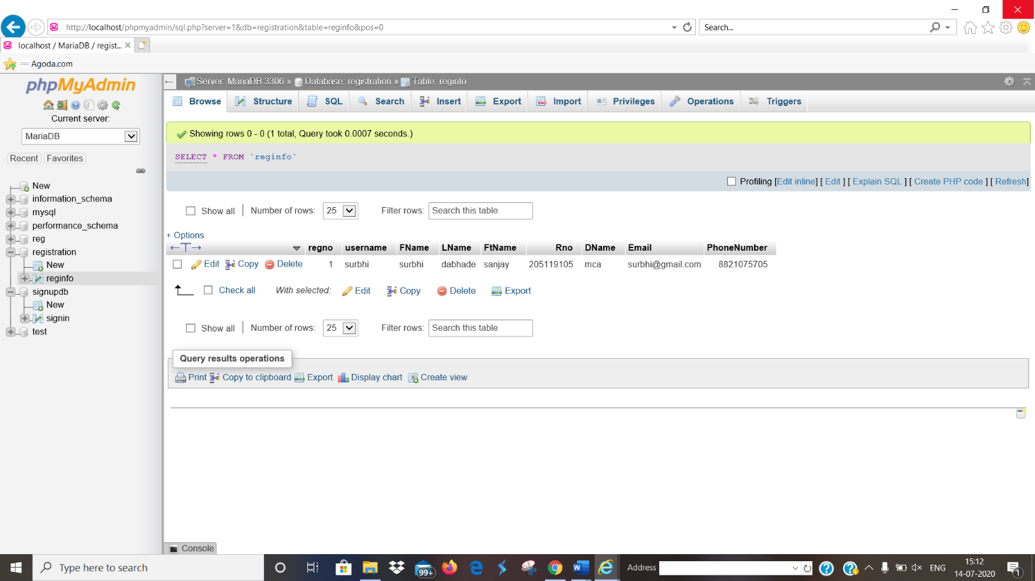

**SOURCE CODE**

**SOURCE CODE FOR HOME PAGE (IN HTML):**

<!DOCTYPE html>

<html>

<head>

<title>Home page</title>

<link rel="stylesheet" type="text/css" href="background.css">

<style type="text/css">

.linkes{

font-size: 25px;

color: blue;

}

.heading{

font-size: 30px;

text-align: center;

margin-top: 5%;

color: red;

}

article {

align-content: center;

padding: 20px;

width: 70%;

color: yellow;

height: 300px;

}

/* Clear floats after the columns */

section{

font-size: 30px;

text-align: left;

margin-left: 25%;

display: table;

}

</style>

</head>

<body>

<div class="heading" ><h1>EXAM REGISTRATION</h1></div>

<div class="linkes">

<ul>

<li><b><a href="homepage.html">HOME</a><b/></b></li>

<li><b><a href="Login.html">Login</a></b></li>

<li><b><a href="signup.html">signup</a></b></li>

</ul>

</div>

<section>

<article>

<p>Online Exam Registration System, managing and maintaining the details of the student is a tedious job for any organization.

online exam registration system will store all the details of the students including their background information, educational qualifications, personal details and all the information related to their resume.</p>

</article>

</section>

</body>

</html>

**LOG IN PAGE (FRONT-END IN HMTL):**

<!DOCTYPE html>

<html>

<head>

<title>login page</title>

<style>

/*setting form properties*/

form {

margin-top: 5%;

margin-left: 20%;

margin-right: 20%;

border: 3px solid #f1f1f1;

}

/* Full-width inputs */

input[type=text], input[type=password]

{

width: 100%;

padding: 12px 20px;

margin: 8px 0;

display: inline-block;

border: 1px solid #ccc;

box-sizing: border-box;

}

/* Set a style for all buttons */

button

{

background-color: #4CAF50;

color: white;

padding: 10px 15px;

margin: 8px 0;

margin-left: 50%;

border: none;

cursor: pointer;

width: 50%;

}

/* Center the avatar image inside this container */

.imgcontainer {

text-align: center;

margin: 24px 0 12px 0;

}

.lab{

margin-left: 25%;

}

/* Avatar image */

img.avatar {

width: 10%;

border-radius: 20%;

}

/* Add padding to containers */

.container {

margin-left: 30%;

margin-right: 30%;

padding: 10px;

width:30%;

}

.linker{

margin-left: 40%;

text-align: right;

}

</style>

</head>

<body>

<form action="loginvalidation.php" method="post">

<div class="imgcontainer">

<img src="log.png" alt="Avatar" class="avatar">

</div>

<div class="container">

<label for="uname"><b>Username</b></label>

<input type="text" placeholder="Enter Username" name="uname" required>

<label for="psw"><b>Password</b></label>

<input type="password" placeholder="Enter Password" name="psw" required>

<button type="submit" >Login</button>

</div>

<div class="container" style="background-color:#f1f1f1">

<input type="reset" class="resetbtn" name="resetbtn">

<div class="linker" >

<label class="lab">New User ?</label>

<a href="signup.html">Sign up</a></div>

</div>

</form>

</body>

</html>

**LOG IN PAGE (BACK-END IN PHP):**

<?php

session_start();

$con=mysqli_connect('localhost','root');

if($con){

echo "connection successful";

}

else{

echo "no connection";

}

mysqli_select_db($con,'signupdb');

$name=$_POST['uname'];

$pass=$_POST['psw'];

$q="select * from signin where username ='$name' && password ='$pass'";

$result = mysqli_query($con,$q);

$num = mysqli_num_rows($result);

if($num==1){

header('location:Registration.html');

}else{

header('location:login.html');

}

?>

**LOG OUT PAGE (IN PHP):**

<?php

session_start();

session_destroy();

echo "THANK YOU";

header('location:homepage.html');

?>

**SIGN UP PAGE (FRONT END IN HTML):**

<!DOCTYPE html>

<html>

<head>

<title></title>

<style type="text/css">

form{

margin-top: 5%;

margin-left: 20%;

margin-right: 20%;

border: 3px solid #f1f1f1;

}

/* Full-width input fields */

input[type=text], input[type=password] {

width: 100%;

padding: 12px 20px;

margin: 8px 0;

display: inline-block;

border: 1px solid #ccc;

box-sizing: border-box;

}

hr {

border: 1px solid #f1f1f1;

margin-bottom: 25px;

}

/* Set a style for all buttons */

button {

background-color: #4CAF50;

color: white;

padding: 14px 20px;

margin: 8px 0;

border: none;

cursor: pointer;

width: 100%;

opacity: 0.9;

}

button:hover {

opacity:1;

}

/* Extra styles for the cancel button */

.cancelbtn {

padding: 14px 20px;

background-color: #f44336;

}

/* Float cancel and signup buttons and add an equal width */

.cancelbtn, .signupbtn {

float: left;

width: 50%;

}

/* Add padding to container elements */

.container {

padding: 16px;

}

/* Clear floats */

.clearfix::after {

content: "";

clear: both;

display: table;

}

/* Change styles for cancel button and signup button on extra small screens */

@media screen and (max-width: 300px) {

.cancelbtn, .signupbtn {

width: 100%;

}

}

</style>

</head>

<body>

<form action="signupphp.php" method="POST" style="border:1px solid #ccc">

<div class="container">

<h1>Sign Up</h1>

<p>Please fill in this form to create an account.</p>

<hr>

<label for="uname"><b>Username</b></label>

<input type="text" placeholder="Enter username" name="uname" required>

<label for="psw"><b>Password</b></label>

<input type="password" placeholder="Enter Password" name="psw" required>

<p>By creating an account you agree to our <a href="#" style="color:dodgerblue">Terms & Privacy</a>.</p>

<div class="clearfix">

<button type="reset" class="cancelbtn" name="resetbtn">Reset</button>

<button type="submit" class="signupbtn" name="signupbtn">Sign Up</button>

</div>

</div>

</form>

</body>

</html>

**SIGN UP PAGE (BACK END IN PHP):**

<?php

session_start();

$con=mysqli_connect('localhost','root');

if($con){

echo "connection successful";

}

else{

echo "no connection";

}

mysqli_select_db($con,'signupdb');

$name=$_POST['uname'];

$pass=$_POST['psw'];

$q="select * from signin where username ='$name' && password ='$pass'";

$result = mysqli_query($con,$q);

$num = mysqli_num_rows($result);

if($num==1){

echo "duplicate data";

}else{

$qy = "insert into signin(username,password) values ('$name','$pass')";

mysqli_query($con,$qy);

}

?>

**REGISTRATION PAGE (FRONT END IN HTML):**

<!DOCTYPE html>

<html>

<head>

<title>Exam Registration Form</title>

<style>

body {

background-color: lightpink;

}

h1 {

color: red;

text-align: center;

}

td{

font-size: 30px;

text-align: middle;

}

table.center {

margin-left:auto;

margin-right:auto;

}

</style>

</head>

<body>

<div>

<b><a href="logout.php">LOGOUT</a></b>

</div>

<h1>Exam Registration Form</h1>

<form action="registration.php" method="POST">

<table class="center">

<tr>

<td>Username </td>

<td><input type="text" placeholder ="Username" name="username" required ></td>

</tr>

<tr>

<td>First Name </td>

<td><input type="text" placeholder ="First Name" name="FName" required ></td>

</tr>

<tr>

<td>Last Name </td>

<td><input type="text" placeholder ="Last Name" name="LName" required ></td>

</tr>

<tr>

<td>Fathers Name</td>

<td><input type="text" placeholder ="Fathers Name" name="FtName"required></td>

</tr>

<tr>

<td>RoLL Number</td>

<td><input type="number" placeholder ="Roll Number" name="Rno"required></td>

</tr>

<tr>

<td>Department</td>

<td><input type="text" placeholder ="Department Name" name="DName"required></td>

</tr>

<tr>

<td>Email</td>

<td><input type="text" placeholder ="Email" name="Email"required></td>

</tr>

<tr>

<td>Phone Number </td>

<td><input type="Phone" placeholder ="Phone number" name="PhoneNumber"required></td>

</tr>

<tr>

<td ><input type="submit" name="Register" value="Register"><input type="reset" name="reset" value="reset" ></td>

</tr>

</table>

</body>

</html>

**REGISTRATION PAGE (BACK END IN PHP):**

<?php

$username=$_POST['username'];

$FName=$_POST['FName'];

$LName=$_POST['LName'];

$FtName=$_POST['FtName'];

$Rno=$_POST['Rno'];

$DName=$_POST['DName'];

$Email=$_POST['Email'];

$PhoneNumber=$_POST['PhoneNumber'];

$host="localhost";

$dbusername="root";

$dbpassword="";

$dbname="registration";

$conn = new mysqli($host,$dbusername,$dbpassword,$dbname);

$sql="INSERT INTO reginfo (username,FName,LName,FtName,Rno,DName,Email,PhoneNumber) values ('$username','$FName','$LName','$FtName',$Rno,'$DName','$Email',$PhoneNumber)";

if($conn->query($sql))

{

echo "new data inserted successfully";

}

else

{

echo "Error";

}

$conn->close();

?>

**RESULTS**

**LOGIN PAGE:**

As we try to log in without sign in so it will throw back us to the log in page.

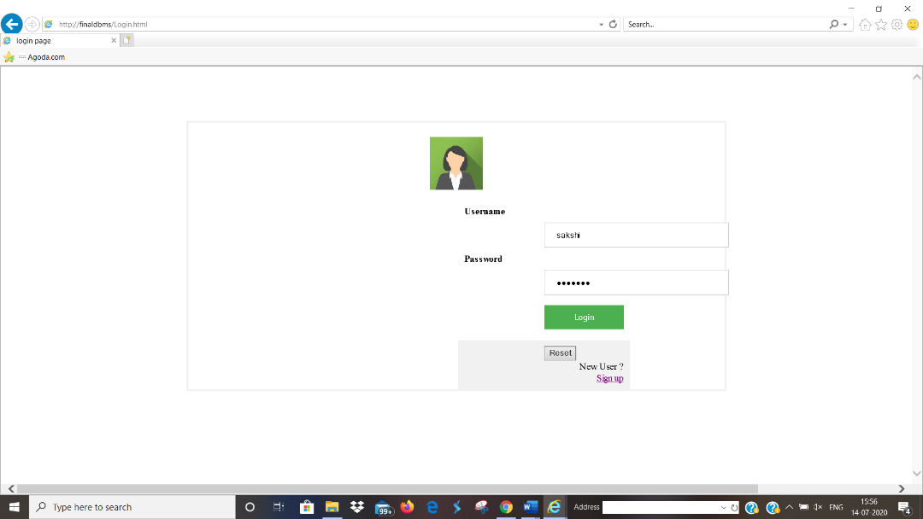

Again back to login page

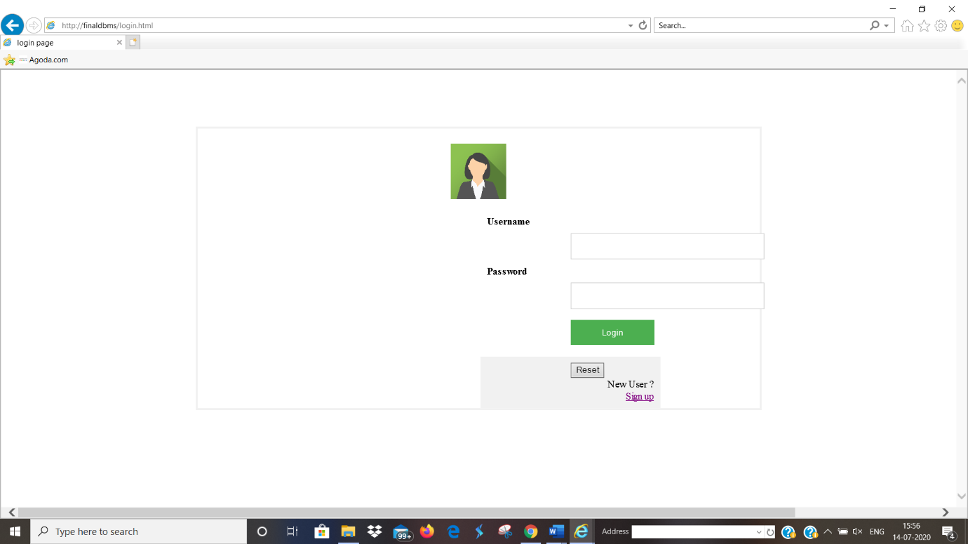

Now we will go to sign up page and fill it.

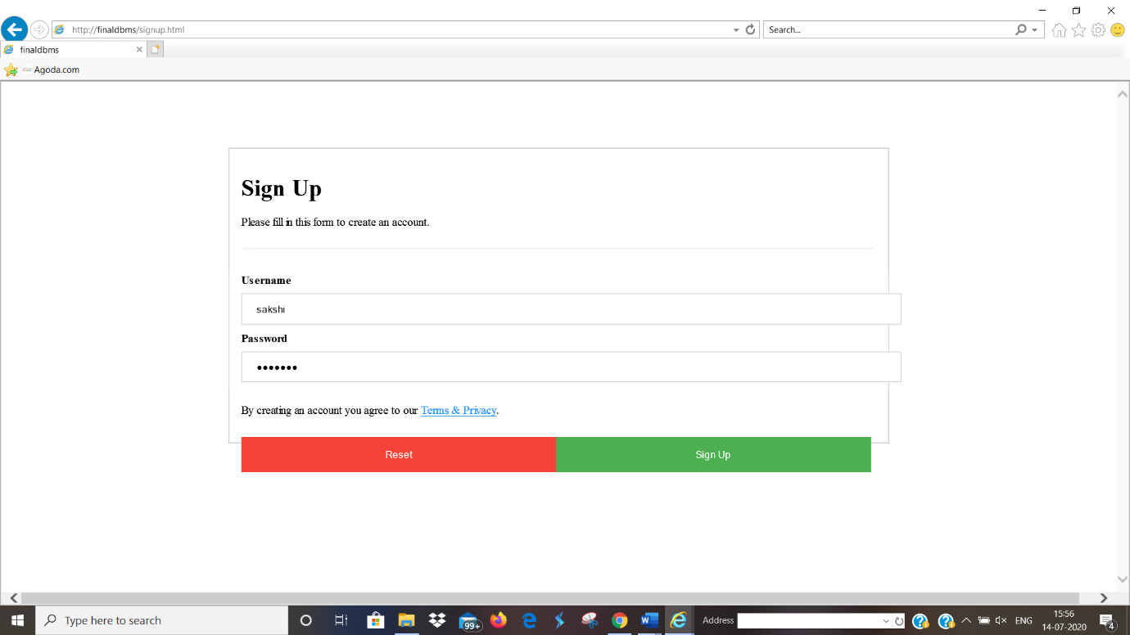

After completion of Sign-up process we will receive a message as follow

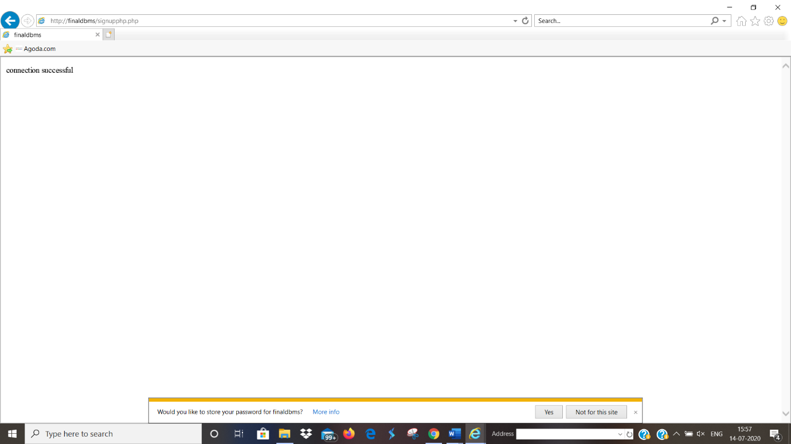

After Sign up again we will go to log in page and fill the details asked.

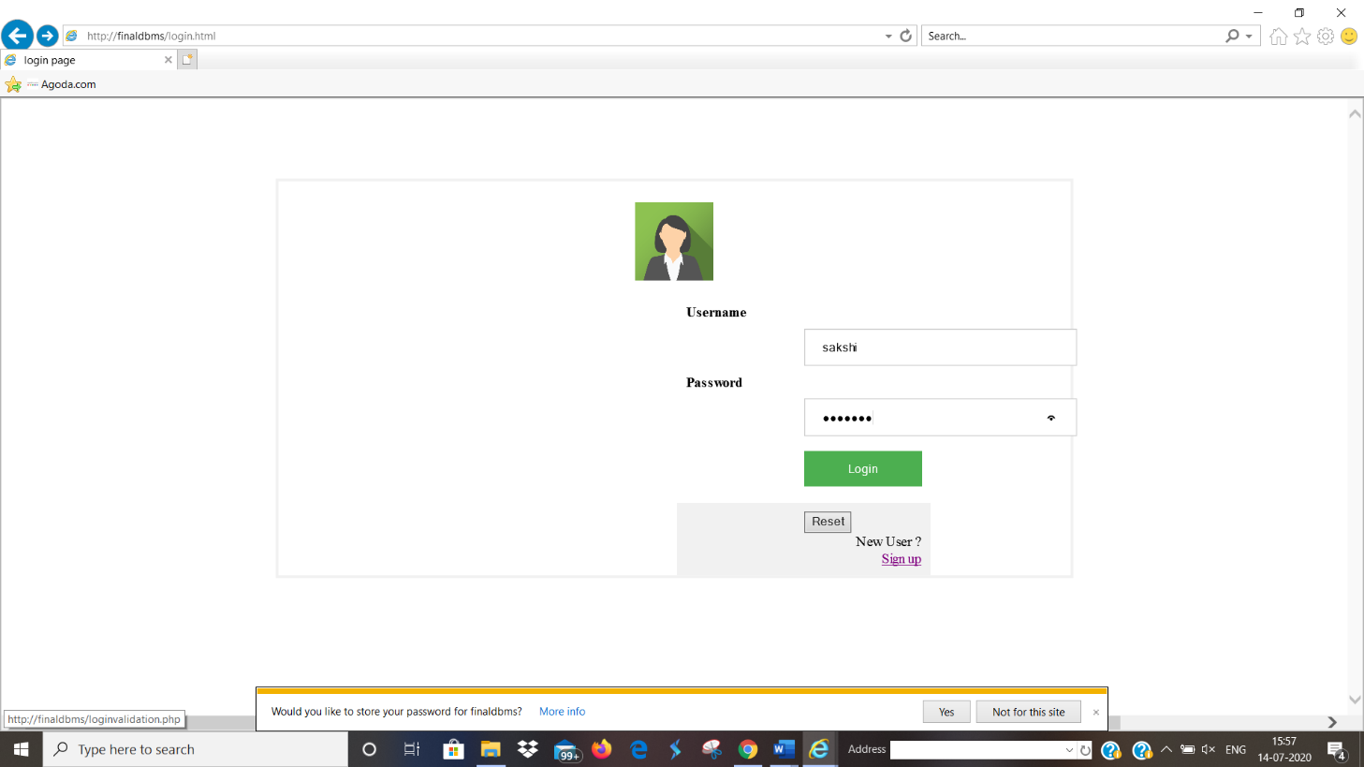

After sign up process we will be directly forwarded to Registration page

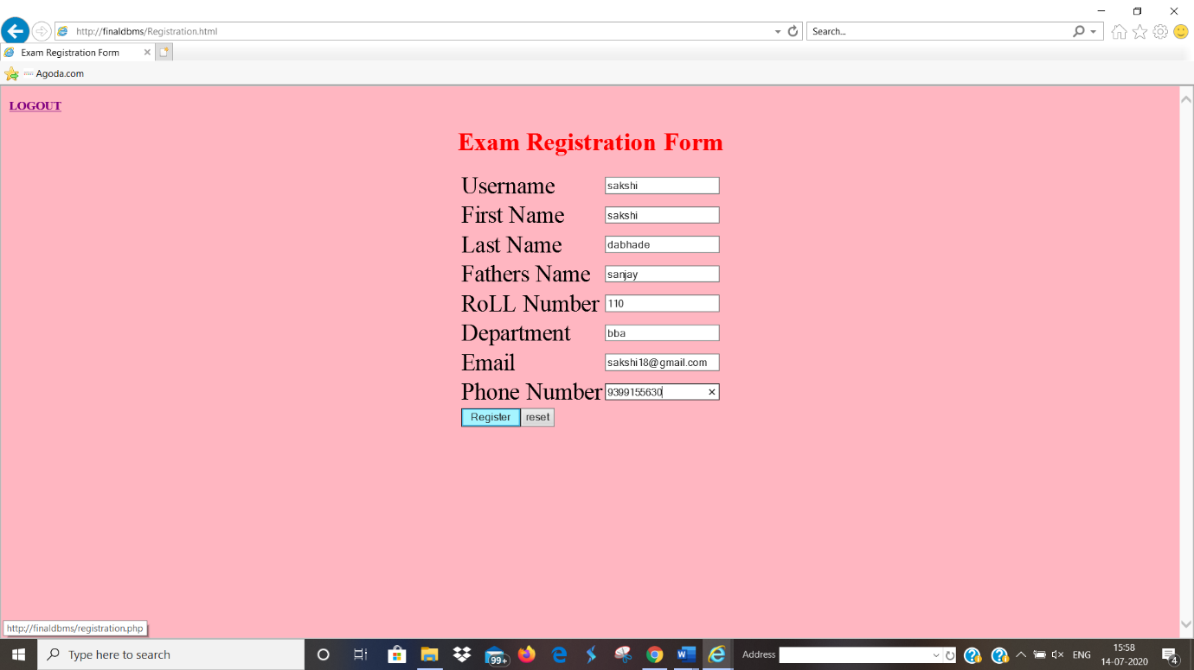

After pressing register button we will receive a message as follows:

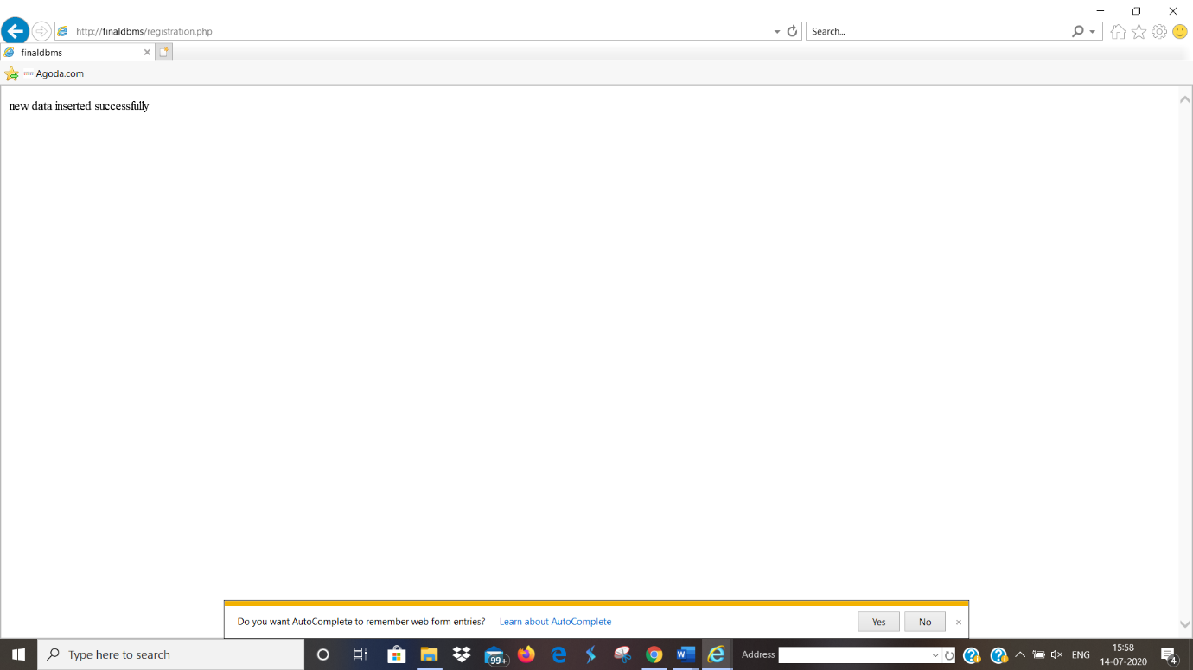

Login data stored in database:

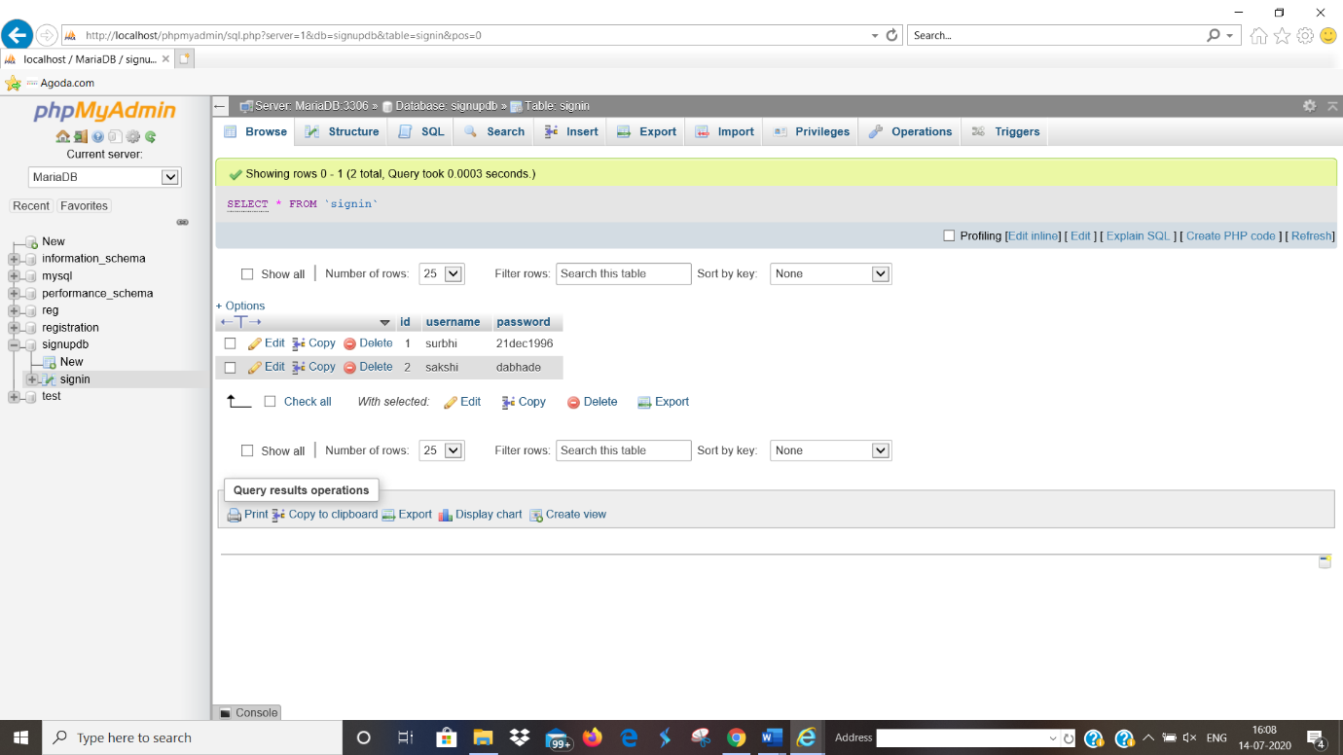

Registration details stored in database:

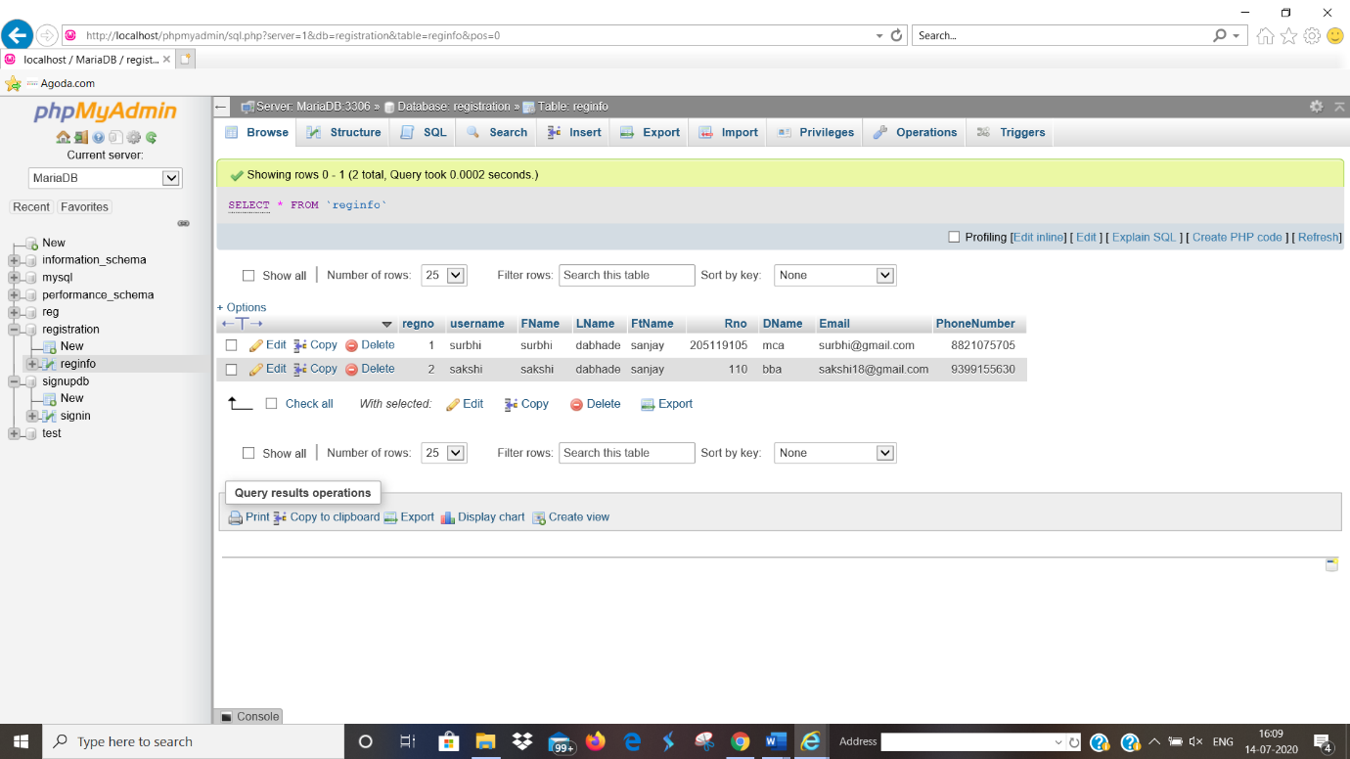

**FUTURE ENHANCEMENT**

The future scope includes expand the technologies like HTML and PHP we can also add new technologies like HTML, php many more for improving the efficiency of the software. The project will be useful for any schools and colleges with slightly modification. Project is flexible i.e. any change /modification in database may be performing easily.

Record of student who has not turned up for more than a particular period of time(say 4 year) can be deleted or can be saved to another table which will be referred very less frequently.

**BIBILOGRAPHY**

1. Silberschatz – Korth, 2001, Database System Concepts,

Tata McGraw-Hill

1. Oracle PL/SQL programming, O’Reilly
2. Raghu Ramakrishnan and Johannes Gehrke, “Data Base Management Systems”