**Capstone Project Use Cases**

1. User entry page and allow the user to enter the location.



2. When the user types the location it should auto populate the available loctions.

Woo 
Woodbridge Township NJ, United states 
Woodbridge Center Mall Woodbridge Township, 
Woodbridge Avenue Highlar•d Park, NJ, United 
Woodbridge Center Drive NJ, United states 
Wood Avenue 
Edison, NJ, United States 
powered by Google 
Search 

3. Once the user hits the search button after entering the location it should display all restaurants near to that location.

Votes:82 
Cuisines: 
Cost 
J.J. Bitting Brewing 
Woodbridge 
33 Main st, Woodbridge, NJ 07095 
American, BBQ, aar Food 

4. Once the user clicks the restaurant name it should redirect the user to the restaurant home page.

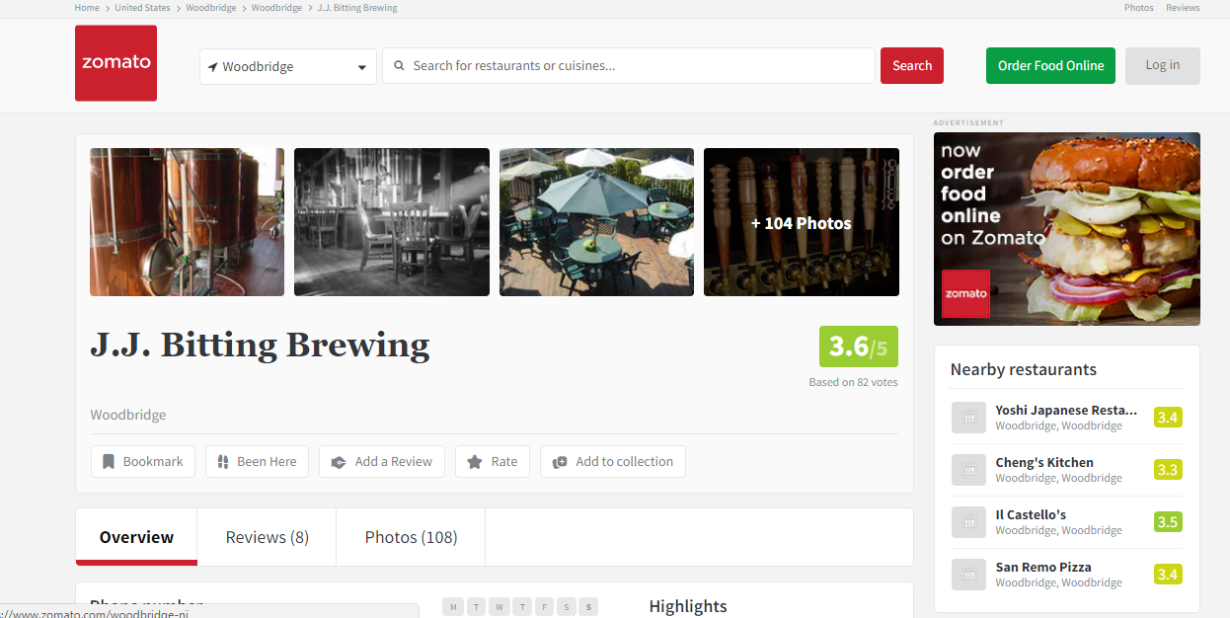

5. Responsive Web Design Test:

