Software Testing and Verification

Problem Set 3: Dataflow Coverage
a.

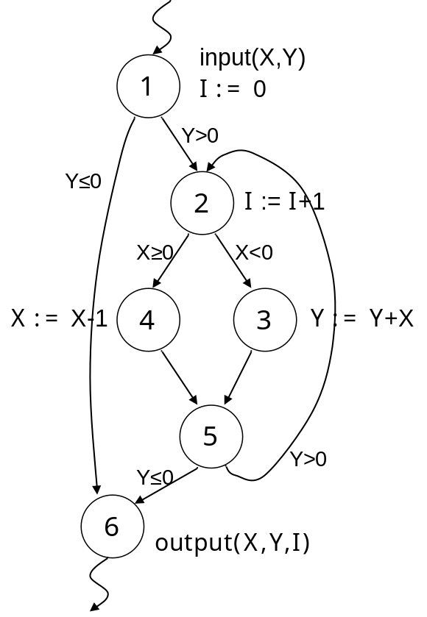

b.
X: (1,3) <1,2,3>
(1,4) <1,2,4>
<1,2,3,5,2,4> infeas
(1,6) <1,2,3,5,6>
<1,6>
(1,<2,3>) <1,2,3>
(1,<2,4>) <1,2,4>
(4,3) <4,5,2,3>
(4,4) <4,5,2,4>
(4,6) <4,5,6> infeas
<4,5,2,3,5,6>
(4,<2,3>) <4,5,2,3>
(4,<2,4>) <4,5,2,4>

Y: (1,3) <1,2,3>
<1,2,4,5,2,3>

(1,6) <1,2,4,5,6> infeas
<1,6>
(1,<1,2>) <1,2>
(1,<1,6>) <1,6>
(1,<5,6>) <1,2,4,5,6> infeas
(1,<5,2>) <1,2,4,5,2>
(3,3) <3,5,2,3>
(3,6) <3,5,6>
<3,5,2,4,5,6> infeas
(3,<5,6>) <3,5,6>
(3,<5,2>) <3,5,2>

I: (1,2) <1,2>
(1,6) <1,6>
(2,2) <2,4,5,2>
<2,3,5,2>
(2,6) <2,3,5,6>
<2,4,5,6> infeas

c.
set 1: none
set 2: statement, branch, all-defs
set 3: same as set 2
set 4: same as set 3

uses not covered Y: (1,<5,6>) infeas

du-paths not covered: <1,2,3,5,2,4> infeas
<4,5,6> infeas
<1,2,4,5,2,3>
<1,2,4,5,6> infeas
<3,5,2,4,5,6> infeas
<2,4,5,6> infeas

