UML Assisment

1. UML diagram for Airline system.

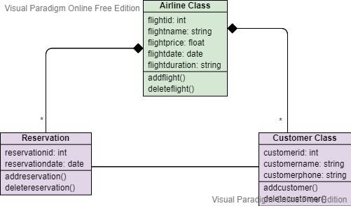

1. UML Diagram for University .

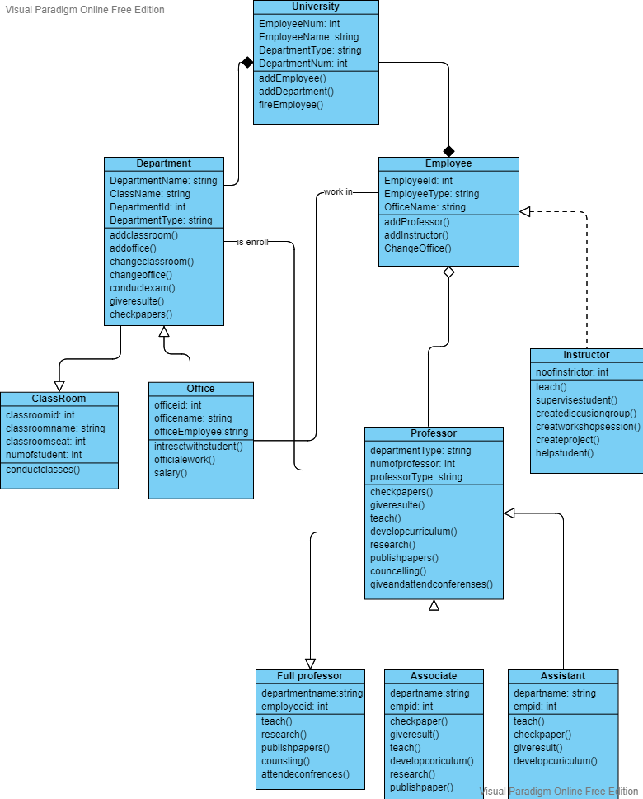

1. Activity diagram for student erollment form.

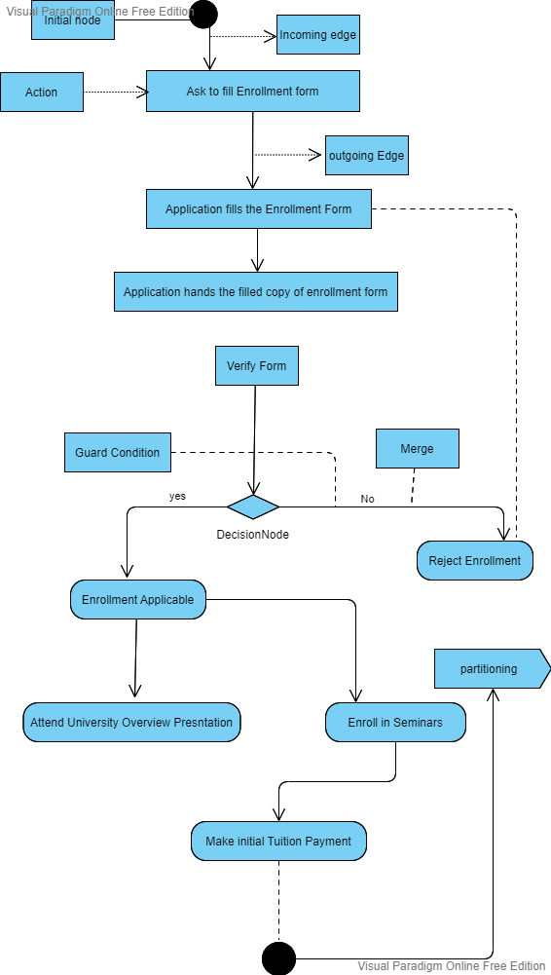

1. Sequence diagram form online library system.

