**Recipe Management System**

A **recipe management system** is a software application that manages the complex relationships and processes related to a company's production recipes.

To build the application, I chose the following technologies:

**SpringBoot 2.7.0**: I am comfortable working with springboot as it makes it easy to create stand-alone, production-grade Spring based Applications that I can "just run" by adding required dependencies.

**Java Persistence API (Jakarta Persistence 3.0 ) For database interaction**: I integrated it with with springboot for performing database operations as it provides a powerful method of creating our repository interfaces, including custom finder methods. By providing ORMs, it hides the underlying database layer and the need to write native complex queries, making developer’s work easy.

**Swagger/OPENApi 3.0.3**: to visualise UI and auto-generating documentation from the API definition. Swagger tooling helps to automatically generate an Open API document based on the code itself.

**H2 Database Engine**: as we are only creating a POC, using the integrated H2 DB that is embedded in spring application is very convenient as we don’t need a separate database installation. H2 is very fast and browser based console application, that makes it perfect choice for small projects.

**Junit5 for Unit Testing:** it is one of the best test methods for unit and integration testing. It incrementally builds test suites to measure progress and detect unintended side effects, making it easier to eliminate possibility of bugs.

**Spring DevTools:** I used this spring dev tools to automatically refresh the application whenever files change in the classpath. Applications using spring-boot-devtools will cause the application to restart, making the manual restart automated.

**Running The Application**

Step 1: Checkout the code from github:

Step 2: Open Eclipse, click on import project -> existing maven project

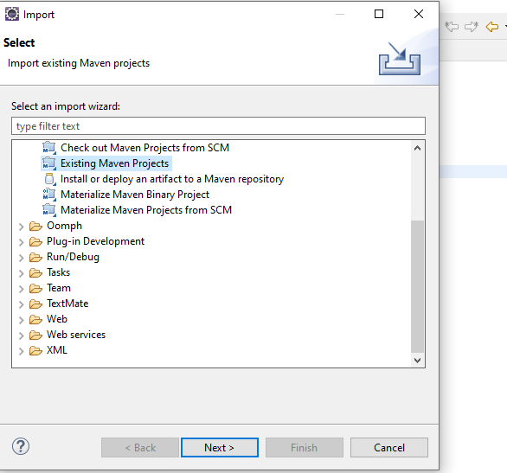

Step 3: On the project menu, right click and go to maven and click on download sources, followed by update project.

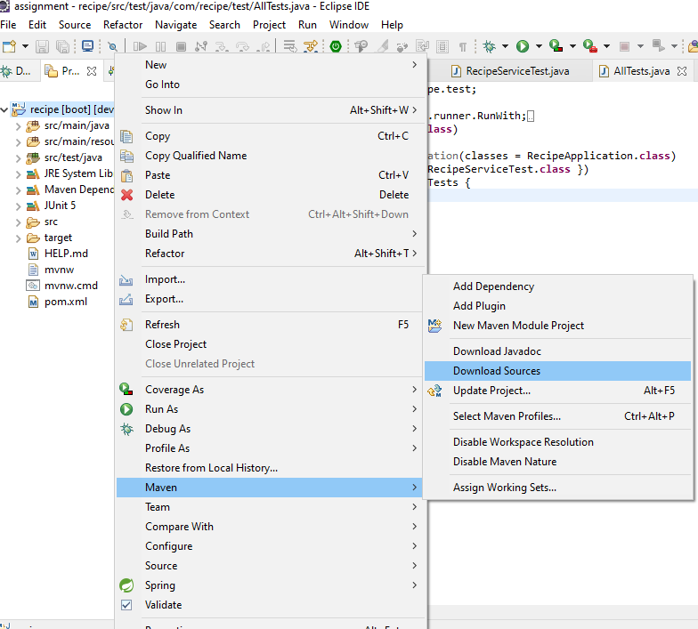

Step 4: Now run the project as spring boot application. You will need to install springboot plugn from eclipse marketplace if not already present.

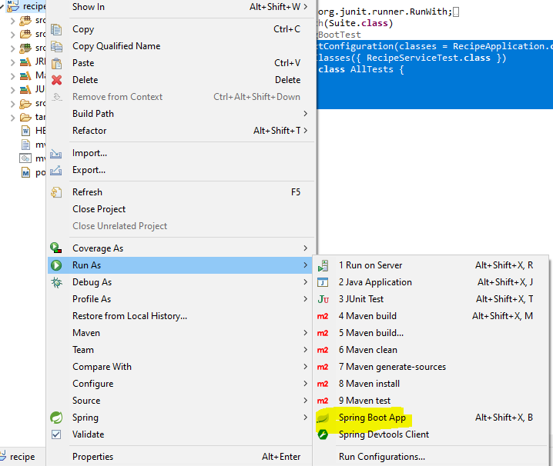

**Executing the Application**

Step 1: Open http://localhost:8080/swagger-ui/index.html#/recipe-i-interceptor

Step 2: This API will allow you to perform CRUD operations and the search operation based on input parameters.

**Inserting a new Recipe:** :

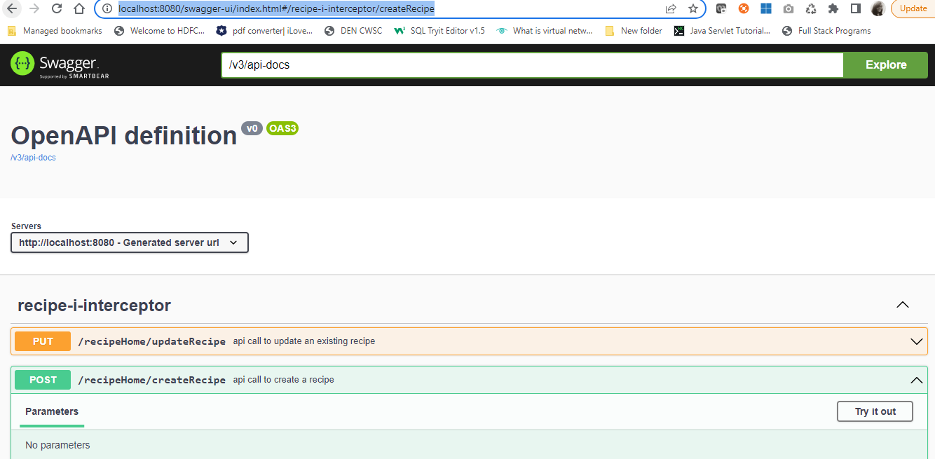

Input the parameters in below format:

**Sample 1**

{

"dishName":"Khaman Dhokla",

"recipeHeader":"Make in a go",

"recipeBody":"Take gram flour in a bowl. Add yogurt and warm water and whisk well so that there are no lumps. The mixture should be of a slightly thick consistency. Add salt and leave it covered to ferment for three to four hours. Grind green chillies and ginger into a paste. When gram flour mixture has fermented, add turmeric powder and green chilli-ginger paste.",

"author":{

"authorName":"Surbhi Mishra",

"contributorSince":"2011-02-25"

},

"isVeg":"true",

"servings":"1",

"ingredients" :[

{

"ingredientName":"gram flou",

"quantity":"2",

"quantityType":"cups"

},

{

"ingredientName":"wat",

"quantity":"1",

"quantityType":"glass"

},

{

"ingredientName":"sa",

"quantity":"1",

"quantityType":"table-spoon"

},

{

"ingredientName":"chilies",

"quantity":"4",

"quantityType":"pieces"

}

]

}

**Sample 2**

{

"dishName":"Pasta",

"recipeHeader":"Easy Vegan Pasta Salad With Creamy Mustard Dressing",

"recipeBody":"In a large pot of boiling water, cook pasta according to package directions. Drain pasta, rinse with cold water, and allow to cool. In a large bowl, combine remaining ingredients, and thoroughly mix together. Add cooled pasta and gently fold together until well combined.Place in refrigerator overnight or for at least 1 hour and then serve.",

"author":{

"authorName":"Michelle Cehn",

"contributorSince":"2020-07-15"

},

"isVeg":"true",

"servings":"4",

"ingredients" :[

{

"ingredientName":"pasta",

"quantity":"1",

"quantityType":"bowl"

},

{

"ingredientName":"water",

"quantity":"3",

"quantityType":"glass"

},

{

"ingredientName":"salt",

"quantity":"3",

"quantityType":"table-spoon"

},

{

"ingredientName":"onion",

"quantity":"1",

"quantityType":"piece"

},

{

"ingredientName":"mayonnaise",

"quantity":"4",

"quantityType":"spoon"

}

]

}

**Sample 3**

{

"dishName":"Tomato Soup",

"recipeHeader":"How To Make The Easiest Tomato Soup From Scratch",

"recipeBody":"This tomato soup is inspired by one of the most famous recipes out there — Marcella Hazan’s Tomato Sauce.Butter",

"author":{

"authorName":"Marcella Hazans",

"contributorSince":"2012-04-23"

},

"isVeg":"true",

"servings":"2",

"ingredients" :[

{

"ingredientName":"tomato",

"quantity":"2",

"quantityType":"pieces"

},

{

"ingredientName":"water",

"quantity":"3",

"quantityType":"glass"

},

{

"ingredientName":"salt",

"quantity":"1",

"quantityType":"table-spoon"

}

]

}

**Deleting a Recipe**

Functionality to delete recipe supports deleting recipe by:

* Name
* Id

<http://localhost:8080/swagger-ui/index.html#/recipe-i-interceptor/deleteRecipe>

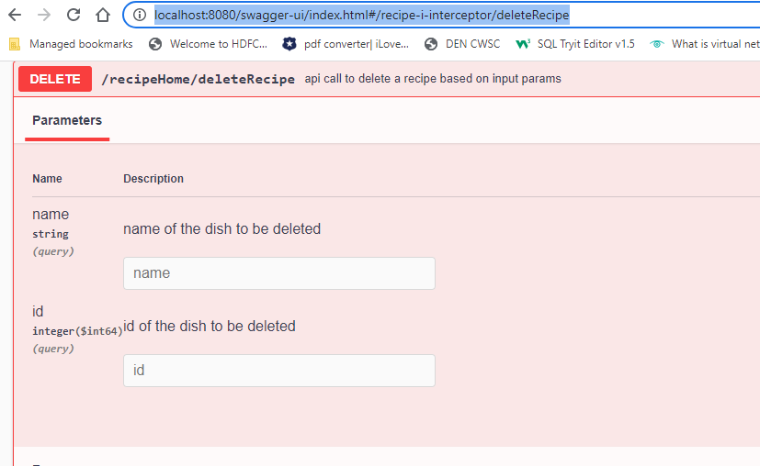

**Fetch All Recipes**

Open:http://localhost:8080/swagger-ui/index.html#/recipe-i-interceptor/getAllRecipes

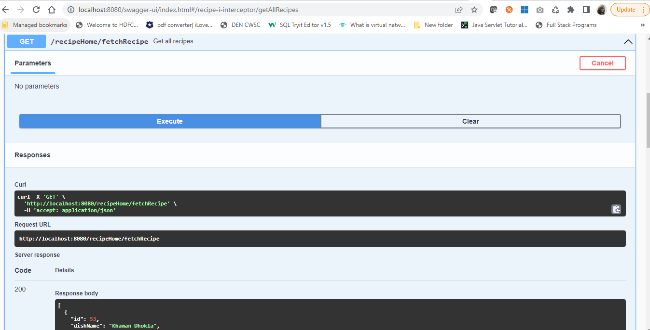

**Fetch Recipe By Recipe Name**

Open: <http://localhost:8080/swagger-ui/index.html#/recipe-i-interceptor/getRecipeByName>

and type the dish whose recipe is to be searched

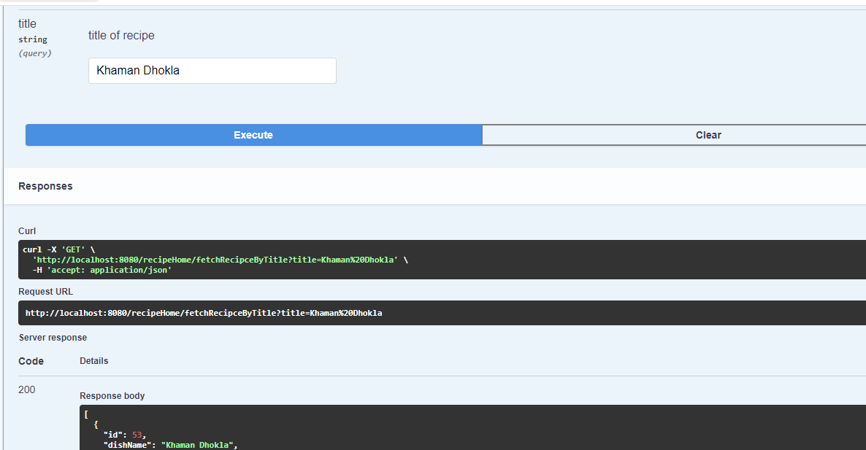

**Update Recipe**

This API call allows you to update any recipe input apart from recipe name and author name

Open:<http://localhost:8080/swagger-ui/index.html#/recipe-i-interceptor/updateRecipes>

**Sample Recipe**

{

"dishName":"Pasta",

"recipeHeader":"Easy Vegan Pasta Salad With Creamy Mustard Dressing",

"recipeBody":"In a large pot of boiling water, cook pasta according to package directions. Drain pasta, rinse with cold water, and allow to cool.

In a large bowl, combine remaining ingredients, and thoroughly mix together. Add cooled pasta and gently fold together until well combined. Place in refrigerator overnight or for at least 1 hour and then serve.",

"author":{

"authorName":"Michelle Cehn",

"contributorSince":"2020-07-15"

},

"isVeg":"true",

"servings":"4",

"ingredients" :[

{

"ingredientName":"pasta",

"quantity":"1",

"quantityType":"bowl"

},

{

"ingredientName":"water",

"quantity":"3",

"quantityType":"glass"

},

{

"ingredientName":"salt",

"quantity":"3",

"quantityType":"table-spoon"

},

{

"ingredientName":"onion",

"quantity":"1",

"quantityType":"piece"

},

{

"ingredientName":"mayonnaise",

"quantity":"4",

"quantityType":"spoon"

}

]

}

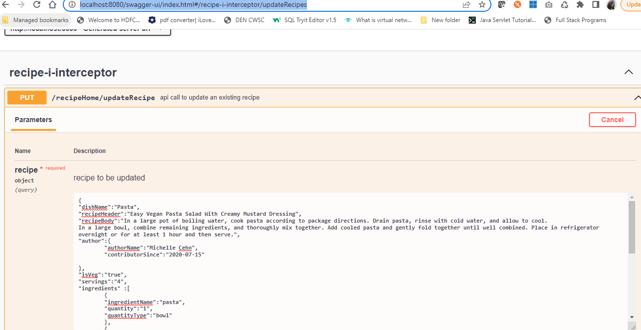

**Search Items Within a Recipe**

Open:<http://localhost:8080/swagger-ui/index.html#/recipe-i-interceptor/getAllSearchItems>.

This API call allows you to search recipes based on following parameters:

1. is the dish vegetarian
2. number of servings
3. ingredients
4. search pattern within instructions – with option to include or exclude search pattern

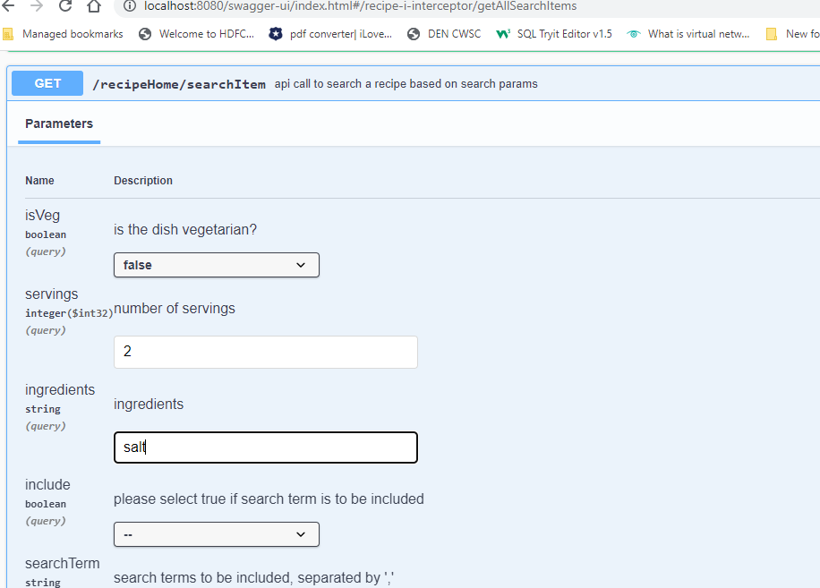

**Unit and Integration Testing**

**Unit Testing:**

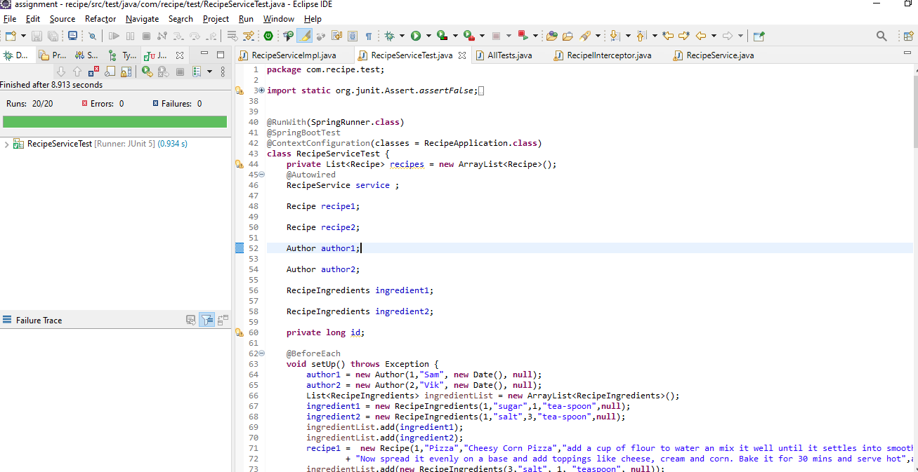

**Integration Testing**

