

Department of Information Technology

Academic Year: 2018-19 Name of Student: Amol Beldar
Semester: 6 Student ID: 16104070
Class / Branch: TE / IT Date of Performance: 02-04-2019
Subject: CSDL Date of Submission: 02-04-2019
Name of Instructor: Prof. Pranav Phadke

Experiment No. 7

Aim :- To demonstrate scaling and load balancing architecture using AWS.

1) Successfully Created Auto Scaling Group :-
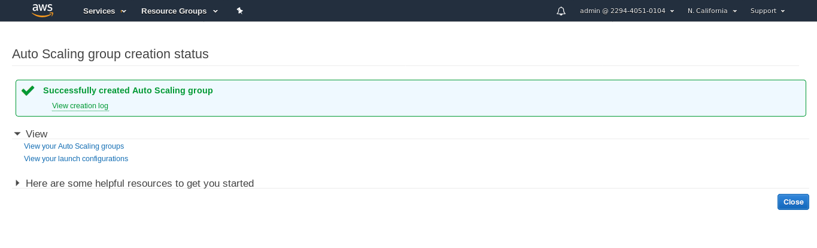
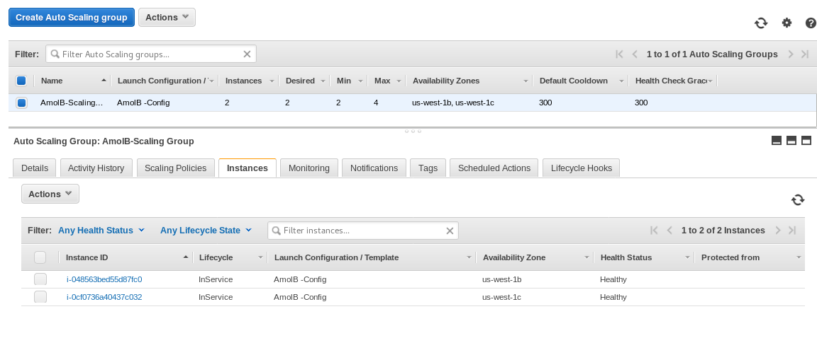
2) Healthy Instances :-
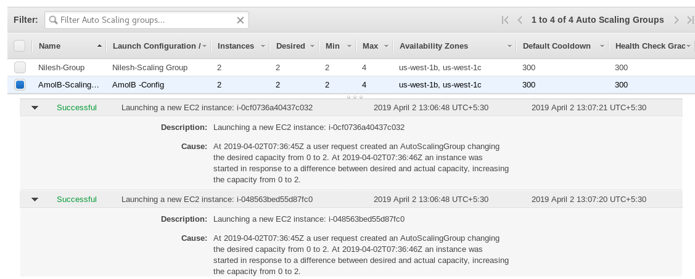
3) Both Instances Successfully Created :-

4) Load Balancer :-
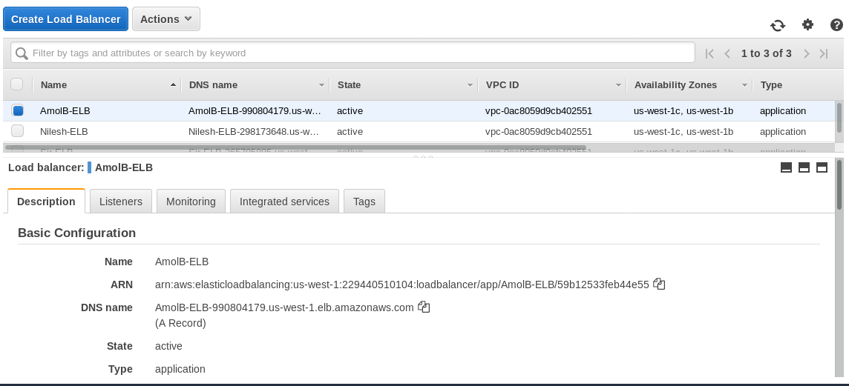
5) My AMI :-
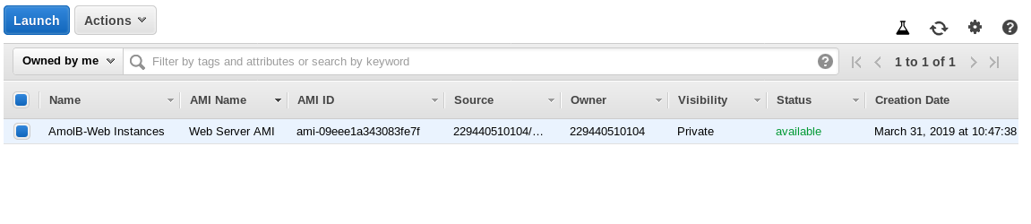
6) DNS Address Access :-

