Student Project: The Scollab Case Study

Executive Summary:

This document describes the requirements of the Scollab case study proposed as student project in the [145072] RE course.

Specifically, this document presents a solution to the problem of finding scholarships for education purpose.

The document details on the application domain, stakeholders involved, scope and constraints of the project, i* goal oriented analysis diagrams of the current system and the proposed system. It further details UML diagrams: Use case, Class and Sequence diagrams, Traceability matrices (Req-Req and Req-goal) and requirements prioritization using Analytic Hierarchy Process (AHP).

Revision History

|  |  |  |  |
| --- | --- | --- | --- |
| **Date** | **Version** | **Description** | **Author** |
| 29/10/2017 | 0.1 | Initial version of the Scollab case study | Surbhi Sonkiya |
| 15/11/2017 | 0.2 | Includes UML diagrams, traceability matrices and requirements prioritization. Updates on as-is and to-be goal models. | Surbhi Sonkiya |
| 15/01/2018 | 0.3 | Updates on to-be goal model, UML diagrams and requirements prioritization. | Surbhi Sonkiya |

Table of Contents

Glossary 4

1. The Purpose of the Project 5

1.1 The application domain (Business context) 5

1.2 The goal of the project 5

1.3 Student Project scope 5

2. Requirements Elicitation 5

2.1 Sources of Requirements information 5

2.2 Elicitation planning and execution 6

3. Early requirements analysis (Goal-oriented analysis) 7

3.1 As-Is situation 7

3.2 To-Be situation 8

4. Software system requirements: UML models 11

4.1 Use cases 11

4.2 UML class diagram 13

4.3 Sequence diagrams 14

5. Software system Requirements Specification 14

5.1 Functional and Quality Requirements 14

5.2 Traceability 16

5.3 Prioritization of requirements 17

6. Annexure 19

# Glossary

|  |  |
| --- | --- |
| **Acronym** | **Description** |
| Scollab | Scholarship Collaboration |
| Donors | People who would like to fund someone’s education or donate some amount of money for education. |
| Absorbers | People (students) who are in need for financial support for their studies. |
|  |  |

Scollab Software System Requirements

# The Purpose of the Project

## The application domain (Business context)

Scollab is a web application which will be able to connect students to people from all over the world who wish to support them with scholarships for their studies.

The problem of finding scholarships for education purpose. There are many scholarships apart from the ones provided by individual universities in case a student fails to get accepted for it or if a student’s interest of courses are not covered within the university scholarships. Unlike university scholarships, other scholarships are not easily accessible over internet. The information about such scholarships are difficult to find. As a result, student has to go for an education loan from a bank on a heavy rate of interest or quit studies if not capable to bear the huge financial expense.

The solution focuses on collaboration of scholarships available from non-profit organizations, corporate organizations, individuals, businesses, etc. and make these scholarships available on a global platform through a website named “Scollab”. Focus is on collaboration with non-university partners in order to provide them more visibility among the students and help students to avail the best scholarship available for them based on their academic background and eligibility.

## The goal of the project

I, as part of a company, propose to develop a web application named “Scollab”, to facilitate donations and scholarships, by bringing together donors and scholarship seekers (absorbers).

## Student Project scope

This project is to create a web application named “Scollab” which will allow users (students) to search for eligible scholarships provided by the non-profit organisation and corporate organisation for education purposes. To view and avail such scholarships, students will have to register at the “Scollab”, update profile details and upload mandatory documents.

**Constraints –** University scholarships are out of scope of this project. Scollab is a web application will not be available as mobile application.

# Requirements Elicitation

## Sources of Requirements information

There would be many sources in reality to carry out the requirements elicitation for the proposed project. For instance, websites, non-profit organizations, foundations, religious groups, individuals, students, communities, businesses, and corporate organizations. For the purpose of this project, I have elicited information from various websites, individuals (Mr. Mahesh, businessman in India), students (University of Trento students), non-profit organisation (Khandelwal Professional Association, India), and corporate organisation (Infosys Ltd., India).

## Elicitation planning and execution

1. Traditional – Questionnaires/Surveys, Document Analysis.

A survey has been conducted with a group of 16 students from various countries to understand the current scenario of scholarships. The survey results are in the Annexure [1].

It has been observed from the survey results that approximately 68% of the student are not able to continue their education because of no scholarships, 56% of the students are not even aware of the scholarships other than the ones offered by the university. A statistics collected by “US News World Report 2017”projected that around $120 billion funds were donated as scholarships (excluding the scholarships provided by the universities) for students. This brings to the light that there are many more unexplored opportunities for the students.

Hence, it shows the absolute need of a collaborative platform to facilitate and ease the process of scholarships for the students.

1. Collaborative – group discussions, brainstorming, group work.

A brainstorming session was conducted with a group of 8 students from different countries to analyse the problem, its solution, stakeholders, and the value proposition of the solution to the customers. Underlined below is the outcome of the brainstorming session.

1. Stakeholders: people and end-users involved in the project?
2. Stakeholders: service provider (Company).
3. Customers (end-users) – Students.
4. Scholarship sources – non-profit organizations, corporate organizations, individuals, etc.
5. Website developer and support team for the “Scollab” web application.
6. Stakeholder’s goals:
7. Service provider (Company) goal: Building a common platform for the customers. Develop a web application to facilitate donations and scholarships, by bringing together donors and scholarship seekers (absorbers). The company would charge transaction fees of 0.5% of total scholarship amount received by the student. This transaction fees should be paid by the student after he/she receives the scholarship via the company’s web application “Scollab”. The company would hire website developers to develop and support the web application “Scollab”.
8. Customer goal: To be able to find suitable scholarship options and to be able to avail them without having to go through any complex and time consuming process.
9. Scholarship sources goal: To gain more visibility and popularity among students from various parts of the world so that the best student could be provided with the scholarship. The service provider (company) publicizes the scholarship sources via advertisements on the ‘Scollab’ web application.

# Early requirements analysis (Goal-oriented analysis)

## As-Is situation

### Strategic dependency

Roles – Student.

Agents – University.

Actors – Non-profit organisation and corporate organisation.

In the current scenario, students search for scholarships on university websites and apply for it. In case they fail to find one, if they are aware of alternate scholarship sources, they search for it, and apply for those scholarships. Alternate scholarship sources like non-profit organisation and corporate organisation exist independently in many countries. They provide scholarships for education. However, they are less visible to students due to many reasons like lack of publicity, etc. This makes the whole process very time consuming and tiring for students.

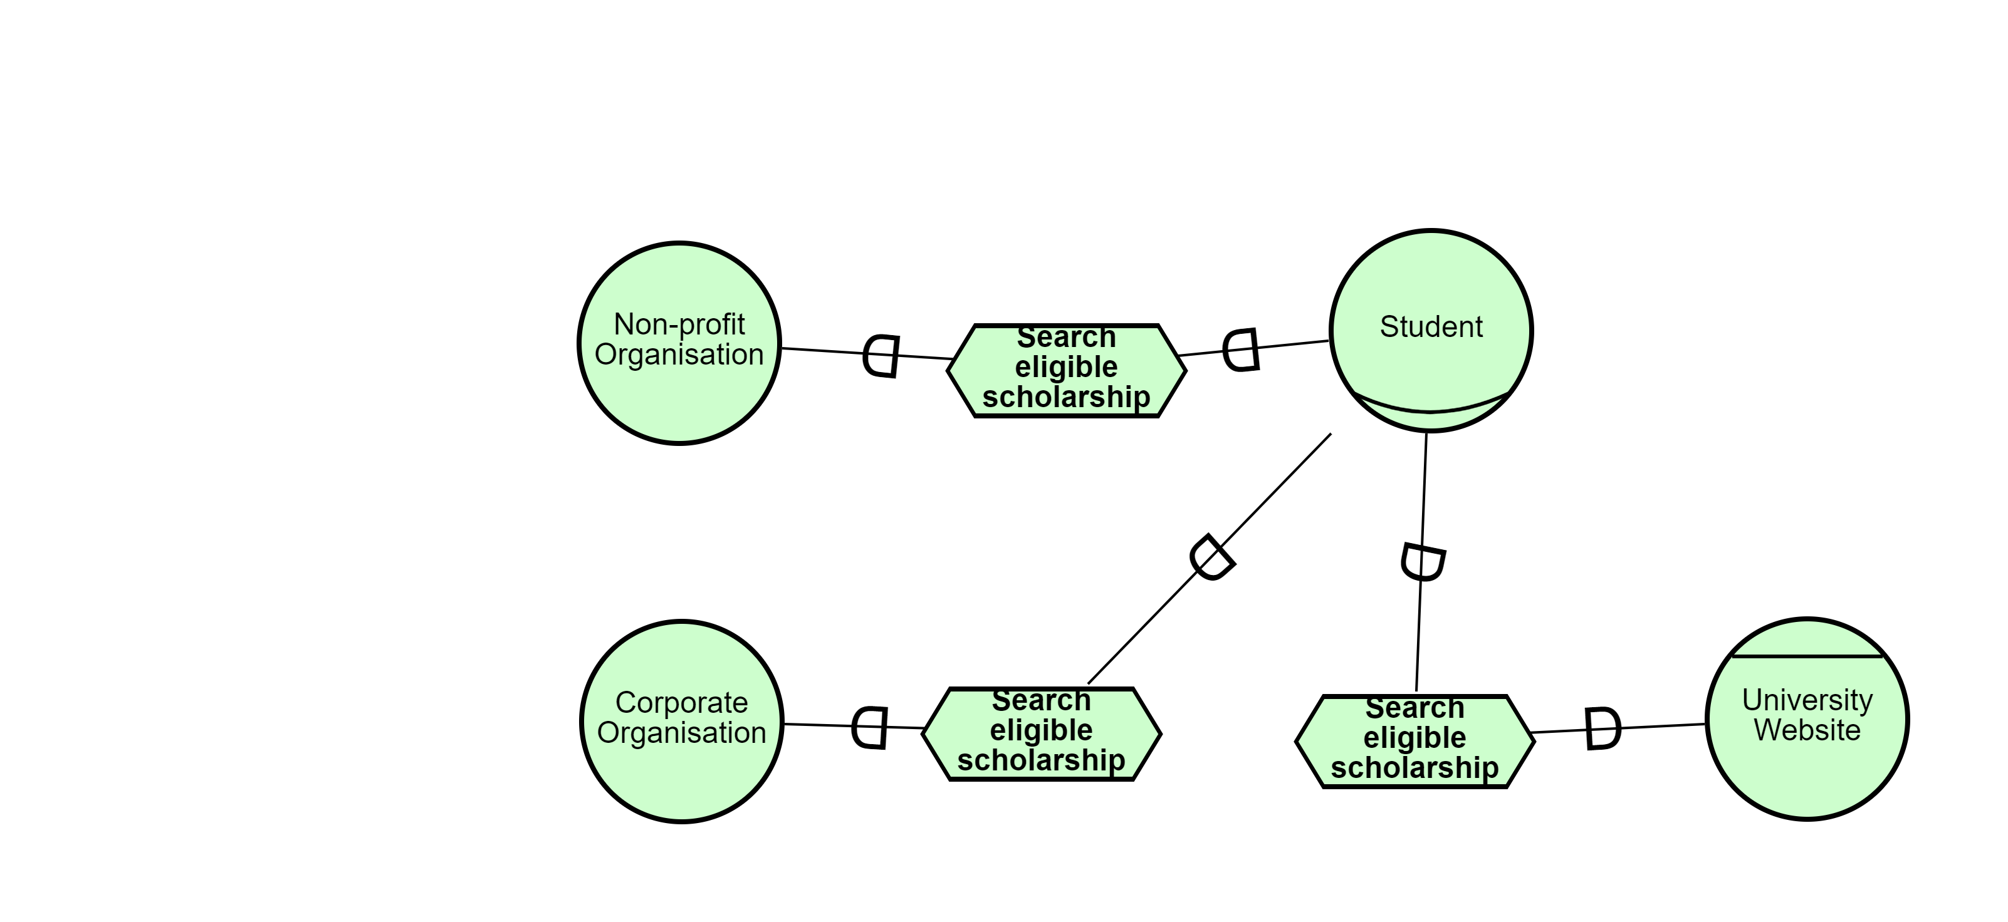

### Strategic rationale

Roles – Student.

Agents - University.

Actors – Non-profit organisation and corporate organisation.

Description of each actor’s goals and how to achieve these goals are described below –

* Student 🡪 Goal is to attend University. Navigates to the University website to search and apply for a scholarship. In case they fail to find one, if they are aware of alternate scholarship sources (non-profit and corporate organisation), they search for it, and apply for those scholarships.
* University website 🡪 displays the list of scholarships provided by the university on the website.
* Non-profit organisation and corporate organisation🡪 their goal is to provide scholarship funds for education.

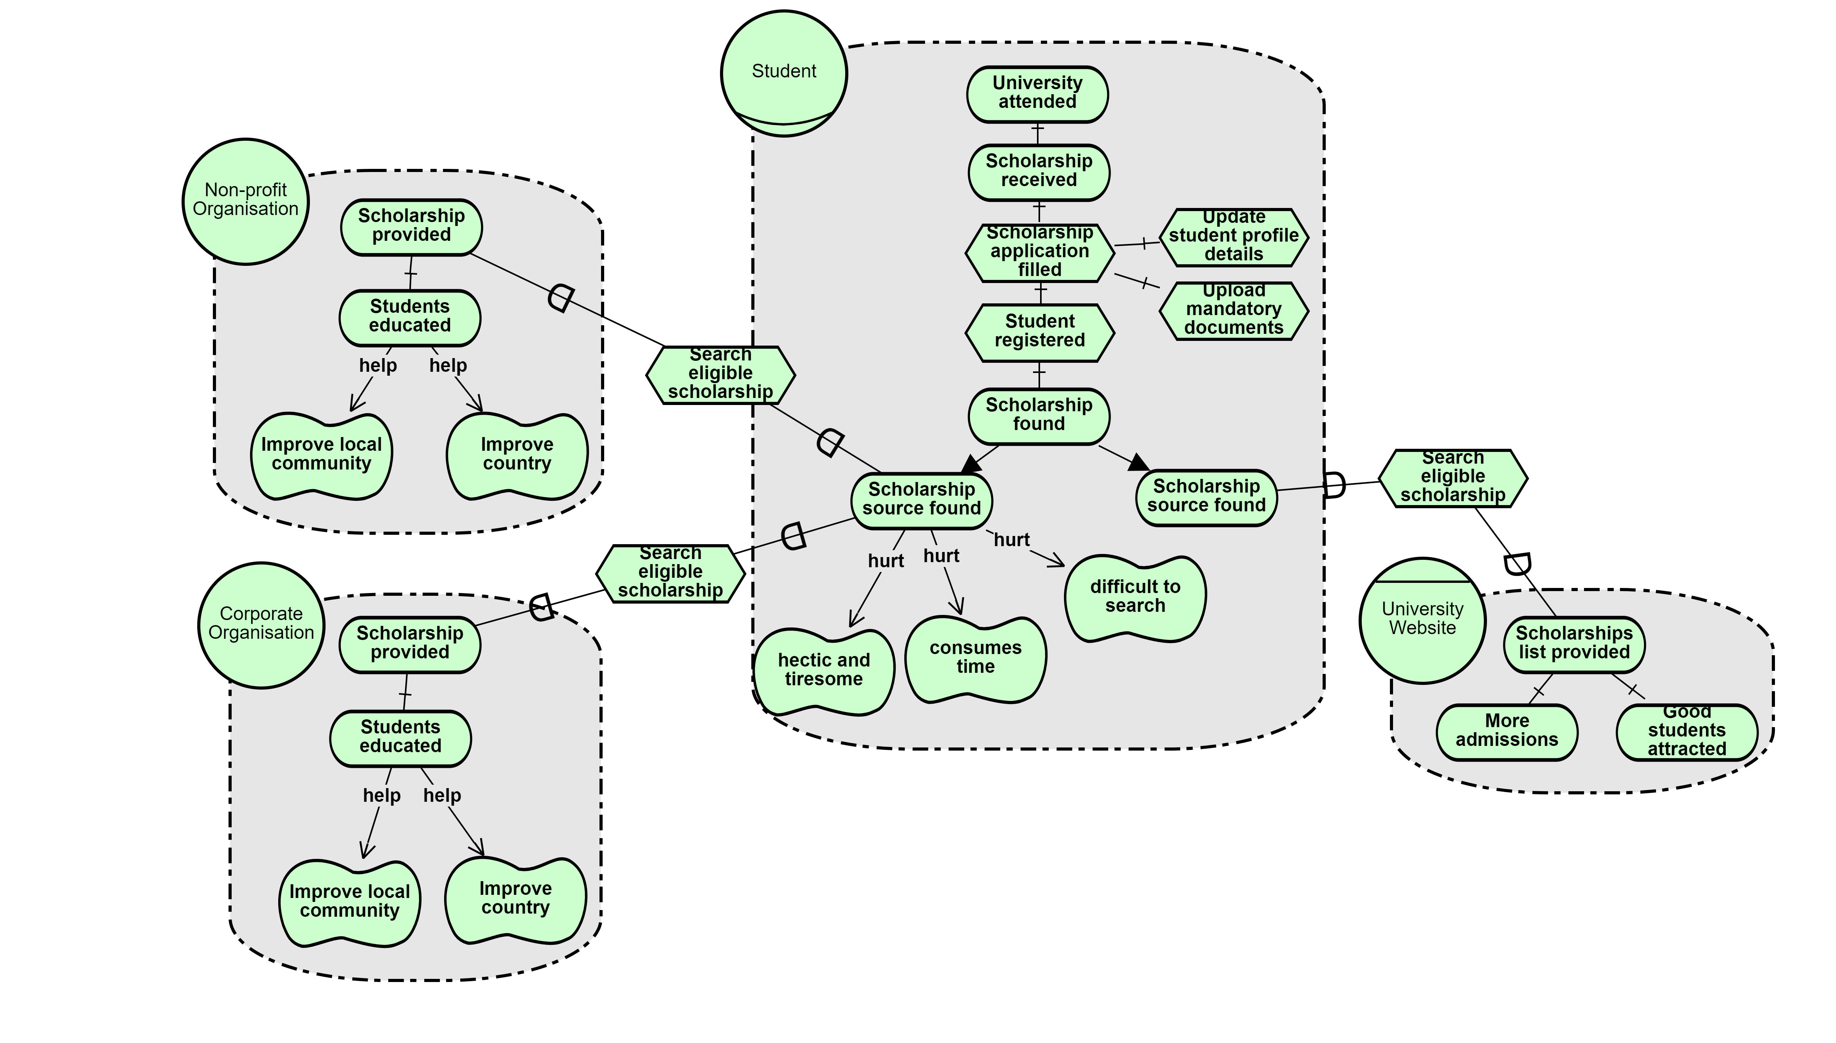

## To-Be situation

### Strategic dependency

Roles – Student and Company.

Agents - Scollab web application.

Actors – Non-profit and corporate organisation.

If a student does not find a suitable scholarship from the University for a course, they can browse to the “Scollab” web application and apply for the suitable scholarship from the list of scholarships that appear on the website. These scholarships are not from the university but from other scholarship sources such as corporate organizations, non-profit organizations, etc. who donate funds for education.

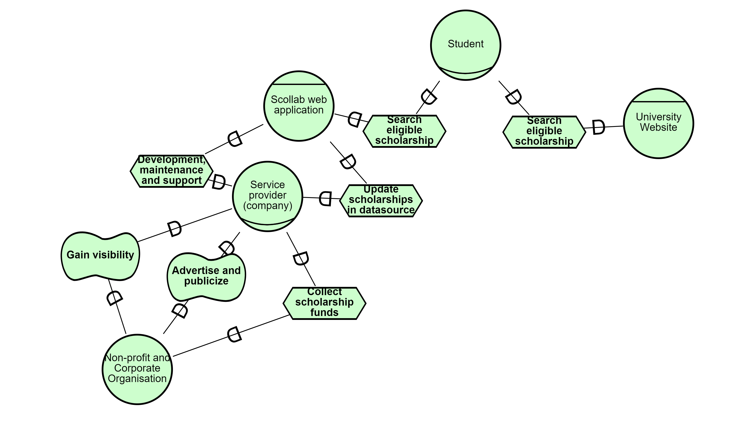

### Strategic rationale

Roles – Student and Company.

Agents - Scollab web application.

Actor – Non-profit and corporate organisation.

Description of each actor’s goals and how to achieve these goals are described below –

* Scollab web application 🡪 to display eligible scholarships list to the user (student).
* Company 🡪 to take care of the development and maintenance of the Scollab web application. Also, responsible for contacting scholarship sources, collecting scholarship funds from them, updating these in the database. To publicize and advertise about the non-profit organisation and corporate organisation on the “Scollab” web application.
* Non-profit and corporate organisation🡪 the goal is to provide scholarship funds for education.

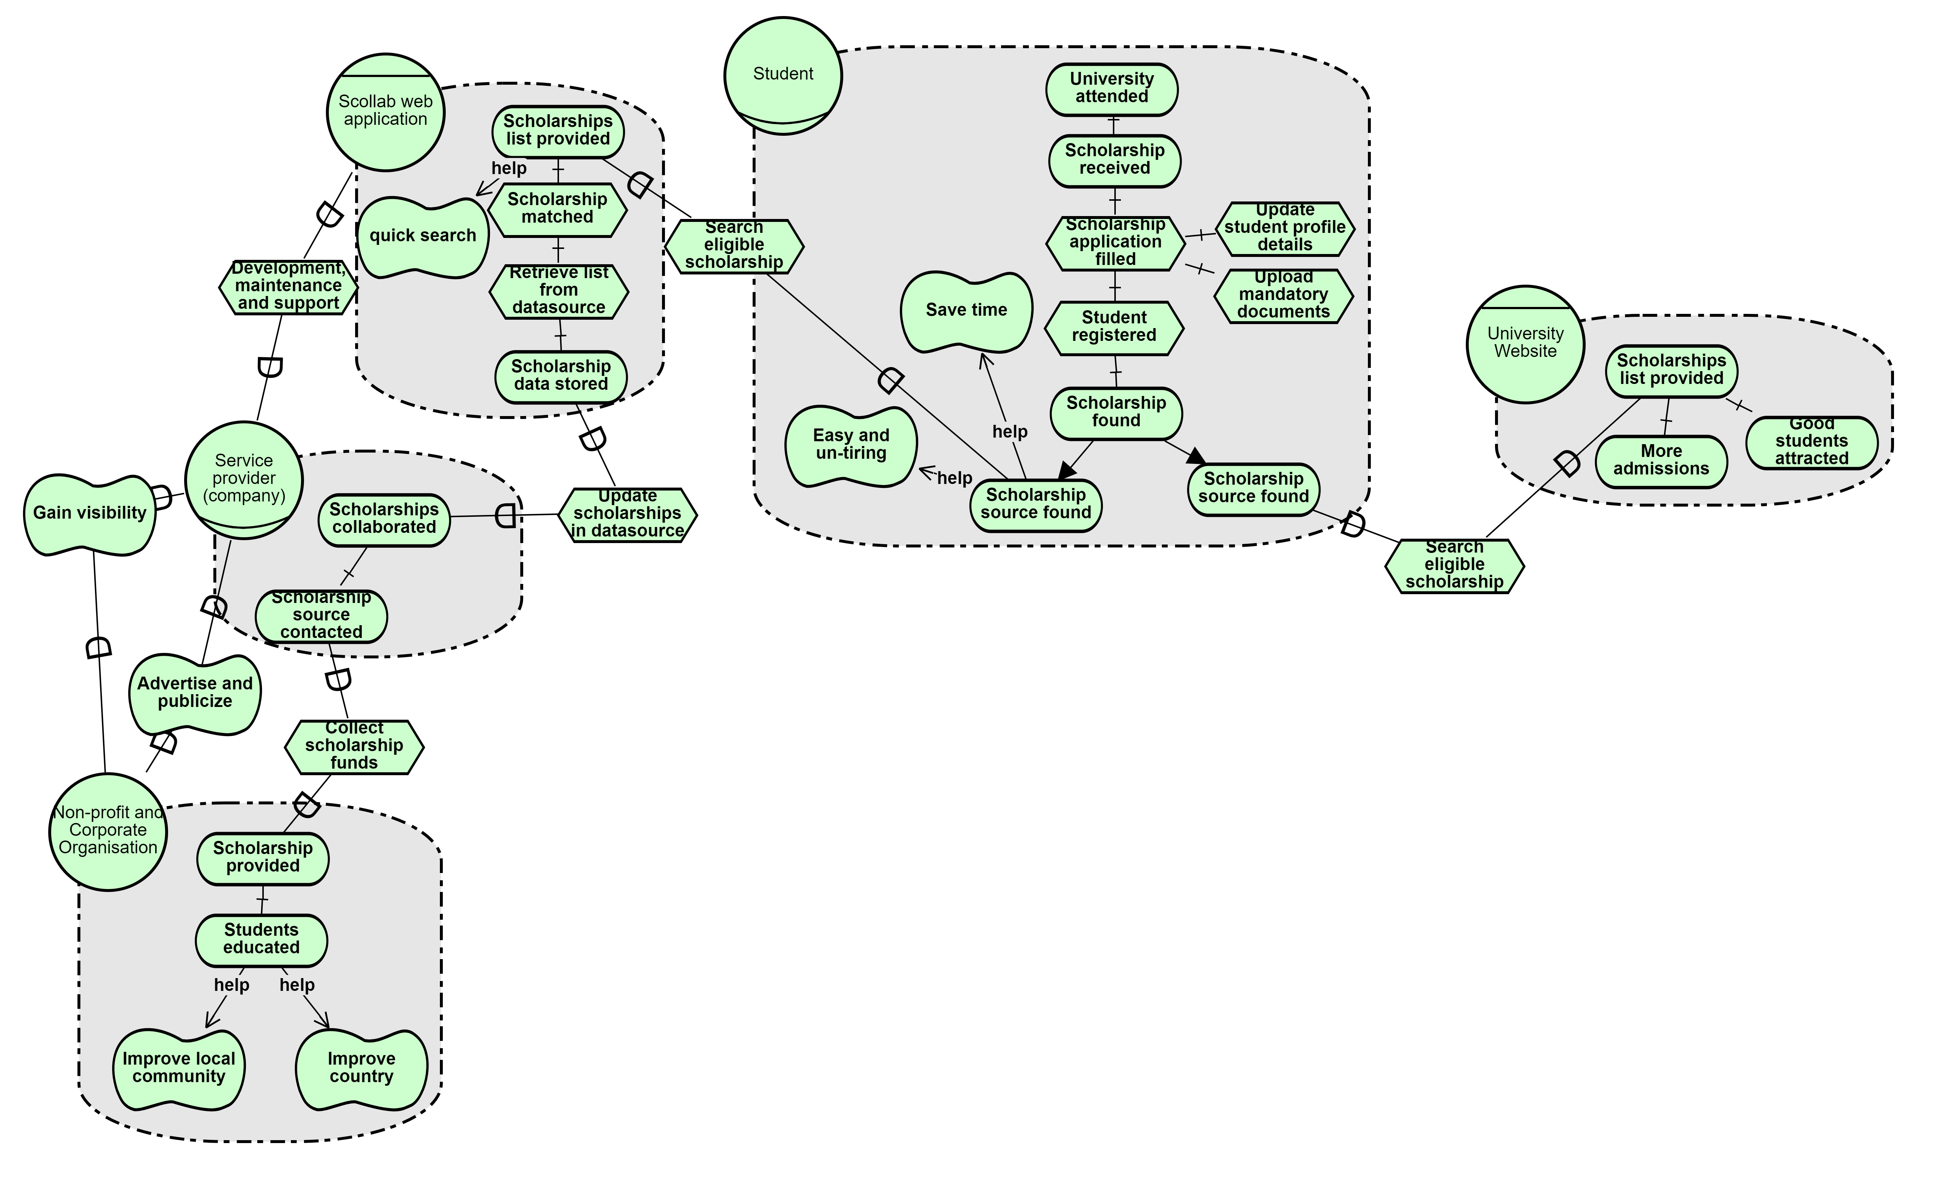

|  |  |  |  |
| --- | --- | --- | --- |
| **Depender (actor)** | **Dependee (actor)** | **Dependum** | **Short Description** |
| Student | University Website | Search eligible scholarship | University website lets user search for eligible scholarship. |
| Student | Scollab web application | Search eligible scholarship | Scollab web application lets user search for eligible scholarship. |
| Scollab web application | Service provider (company) | Update scholarships in datasource | The company updates the scholarships data in the Scollab web applciation. |
| Scollab web application | Service provider (company) | Development, maintenance and support | The company is resposnible for operational and technical support of the Scollab web application. |
| Service provider (company) | Non-profit and Corporate Organisation | Collect scholarship funds | The company contacts and collects scholarship funds from the non-profit organisation. |
| Non-profit and Corporate Organisation | Service provider (company) | Gain visibility  Advertise and publicize | The company provides visibility to the non-profit organisation through the scollab web application.  The company advertises and publicizes about the corporate organisation through the scollab web application. |

# Software system requirements: UML models

## Use cases

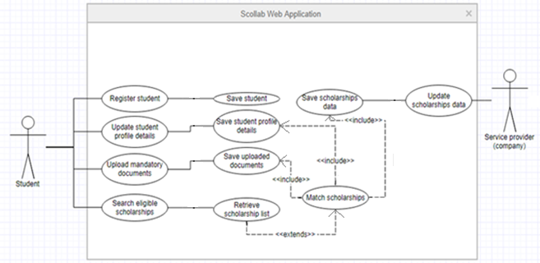

|  |  |
| --- | --- |
| **Use case** | **Register student** |
| precondition | End user must be a student. |
| postcondition | End user’s login details saved in the system. |
| Main flow | 1. User creates a login profile in the scollab web application (system). 2. The system displays a success or a failure message. |
| Alternative flow | 1. The system may prompt user for weak password. 2. The system shall prompt for incorrect data filled. 3. The system shall prompt for incomplete data provided. |

|  |  |
| --- | --- |
| **Use case** | **Update student profile details** |
| precondition | End user must register to the system and log in to the system. |
| postcondition | End user’s updated profile details saved in the system. |
| Main flow | (1) User updates his/her profile data in the scollab web application (system).  (2) The updated details are saved in the system.  (3) The system shows a success or a failure message. |
| Alternative flow | (1) The system shall prompt for incomplete data provided. |

|  |  |
| --- | --- |
| **Use case** | **Upload mandatory documents** |
| precondition | End user must register to the system and log in to the system. |
| postcondition | End user’s uploaded documents saved in the system. |
| Main flow | (1) User uploads his/her mandatory documents in the scollab web application (system).  (2) The uploaded documents are saved in the system.  (3) The system shows a success or a failure message. |
| Alternative flow | (1) The system shall prompt for incorrect file format.  (2) The system shall prompt for size limit of every document. |

|  |  |
| --- | --- |
| **Use case** | **Update scholarships data** |
| precondition | End user must be service provider (company) and must have recieved funds for scholarships from the non-profit organisation and corporate organisation. |
| postcondition | Scholarships data saved in the system. |
| Main flow | (1) The service provider updates the scholarships data in the system.  (2) The scholarships data is saved in the system.  (3) The system shows a success or a failure message. |
| Alternative flow | (1) The system shall prompt for incomplete data provided. |

|  |  |
| --- | --- |
| **Use case** | **Search eligible scholarships** |
| precondition | End user must register to the system, upload mandatory documents, update profile details and log in to the system. |
| postcondition | List of eligible scholarship will be retreived for the end user. |
| Main flow | (1) Search for eligible scholarship list.  (2) The system shall internally match the scholarships list with the student profile (uploaded documents, updated profile data to be considered).  (3) The system displays the eligible scholarships list to the student. |
| Alternative flow | (1) The system shows a failure message in case no scholarship matches with the user profile. |

## UML class diagram

Description about Classes:

1. Class Student: Client class that uses Scollab web application to search for scholarship. Many clients shall use single web application hence, many to one relationship.
2. Class Scollab web application: has-a relationship with register class to help users register to the application.
3. Class Service provider (company): is-a (extends) relationship with scholarships class. Also, has one-to-one relationship with the class Scollab web application as only this company is responsible/authorized for providing the list scholarships through Scollab web application.
4. Class Scholarship: an adapter class to persist the data regarding scholarship sources and the scholarship amount available for the student education.

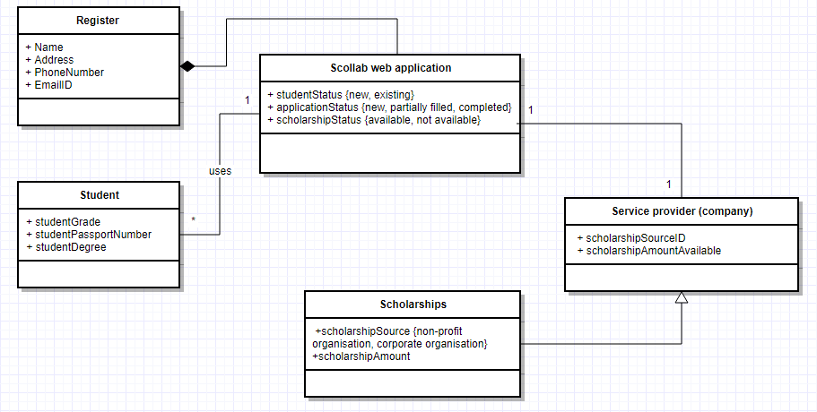

## Sequence diagrams

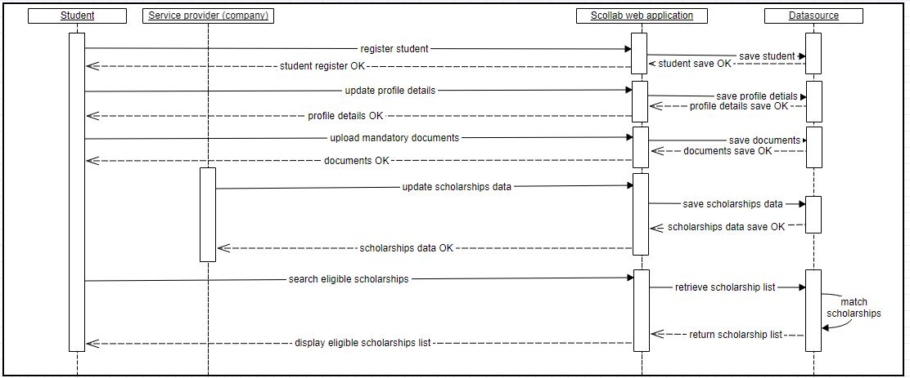

# Software system Requirements Specification

## Functional and Quality Requirements

|  |  |  |
| --- | --- | --- |
| **ID** | **Requirement Type** | **Description** |
| NF1 | Constraint | The Scollab web application shall help user (student) to access the application from all platforms (Linux, windows, and mac). |
| F1 | Functional | The Scollab web application shall allow user (student) to create a login account. |
| F2 | Functional | The Scollab web application shall allow the user to be able to login into the application later on using their login credentials. |
| NF2 | Quality | The Scollab web application shall help user (student) create password securely while registration. |
| NF3 | Quality | The Scollab web application may prompt on weak passwords while registration to reduce the risk of profile being hacked. |
| NF4 | Quality | The Scollab web application shall prompt user (student) for incorrect data filled while registration. |
| NF5 | Quality | The Scollab web application shall prompt user (student) for incomplete data while updating their profile details. |
| NF6 | Quality | The Scollab web application shall prompt user (student) for incorrect file format while uploading their documents. |
| NF7 | Quality | The Scollab web application shall prompt user (student) for size limit of every document while uploading their documents. |
| F3 | Functional | The Scollab web application shall be able to persist the successfully uploaded documents by the user (student) for future use. |
| F4 | Functional | The Scollab web application shall be able to persist the successfully updated profile details by the user (student) for future use. |
| F5 | Functional | The Scollab web application shall allow service provider (company) to update the scholarships list for the students. |
| F6 | Functional | The Scollab web application shall retrieve available scholarship list for the user (student). |
| F7 | Functional | The Scollab web application shall internally match the scholarships list with the student profile before displaying the list to the student to help students see only the ones they are eligible for. |
| NF8 | Quality | The Scollab web application shall protect the user details from being accessed by un-authorized users of the application. |
| NF9 | Performance | The response time (latency) of the Scollab web application should be less than one minute to avoid context switch by the user. |
| NF10 | Usability | The Scollab web application shall display a failure or success message after an operation is completed by user. |
| NF11 | Usability | The Scollab web application shall be user friendly to help user to easily browse through it and use the services. |
| NF12 | Quality | The Scollab web application shall allow many users to interact with the application and use its services simultaneously. |
| NF13 | Performance | The Scollab web application shall be accessible 24*7 round the clock for the users to get maximum benefit. |

## Traceability





## Prioritization of requirements

**Description**:

Quality requirements taken into consideration for prioritization:

1. Security
2. Latency
3. User friendly
4. Prompts on incorrect data filled
5. Prompts on incomplete data filled

Analytical Hierarchy Process (AHP) has been used as a multi criteria decision making technique to organize and analyze requirements and prioritize them. It involves following steps:

For this purpose, the comparison scale used is as below.

|  |  |
| --- | --- |
| Verbal judgment | Numeric value |
| Extremely important | 9 |
| Very strongly more important | 7 |
| Strongly more important | 5 |
| Moderately more important | 3 |
| Equally important | 1 |

Deriving weights (priorities) for the criteria:

Step 1: Pairwise comparison matrix with intensity judgments: rating each element with respect to the other and providing it a numeric value (using the above mentioned scale) based on how important an element is with respect to the other element.

Criteria I used to prioritize the requirements:

* 1. Security: It is the most important of all. User’s data must and should be safe and secured.
  2. Latency: This is important because if there is a long wait time between request and response, then context switch might happen and there will be a risk for losing a client for the web application. However, it not more important than security and user friendly qualities.
  3. User friendly: It is important because if the user cannot navigate through the application easily and in a friendly manner, user might feel difficult to use the services from the application.
  4. Prompts on incorrect data filled: This is an additional quality that the application provides to prompt user on every incorrect data filled. It is important for users to provide correct information and in the format accepted by the application, so that they don’t receive an incorrect list of scholarships that doesn’t match their actual data.
  5. Prompts on incomplete data filled: This is an additional quality that the application provides to facilitate/prompt it’s users to fill in all the details required to help fetch the most eligible scholarships available.

Step 2: Column addition: add sum of each column at the bottom of each column.

Step 3: Normalized matrix: The approximate method requires the normalization of the comparison matrix. To achieve this matrix, divide each cell of the matrix by the sum of that column of the cell.

Step 4: Calculation of priorities: row averages: To achieve this matrix, perform sum of all the elements in a row divide by the number of elements in that row.

Step 5: Presentation of results: original judgments and priorities are put together in a new matrix. The prioritization of the requirements as obtained:

|  |  |  |
| --- | --- | --- |
| Order of priority | Requirement | Priority |
| 1 | Security | 0.513 |
| 2 | User friendly | 0.215 |
| 3 | Latency | 0.132 |
| 4 | Prompts on incorrect data filled | 0.085 |
| 5 | Prompts on incomplete data filled | 0.051 |

Verifying if the above derived priorities are consistent:

Step 6: Priorities as factors: define criteria weights: use priorities as criteria weights for each column. Now, multiple each value in the first column with the first column’s criteria weight. Similarly, do the same for all other columns. The resultant matrix is the matrix with calculation of weighted columns.

Step 7: Calculation of weighted sum: add a new column to the above obtained matrix. The value of each row in this column is the sum of all the values of that row in the matrix.

Step 8: Calculation of lambda max: Divide the elements of the weighted sum vector (obtained in the previous step) by the corresponding priority of each criterion (obtained in Step 5).

Step 9: Calculate the average of the values obtained from the previous step by dividing weighted sum with its respective priority; this value is called lambda max. lambda max obtained for this project is following above mentioned step is 5.309.

Step 10: Calculate Consistency Index (CI): CI for this project using below formula is 0.077.

CI = (lambda max - n) / (n-1)

Where n is the number of elements compared, here n=5.

Step 11: Defining CI for randomly generated matrices as Random Index (RI) from the below table. RI for this project would be 1.12 as n=5.

|  |  |  |  |  |
| --- | --- | --- | --- | --- |
| n | 3 | 4 | 5 | 6 |
| RI | 0.58 | 0.9 | 1.12 | 1.24 |

Step 12: Calculate Consistency Ratio (CR) as per below formula:

CR = Consistency Index/ Random Index = 0.077/1.12 = **0.068**

Step 13: Evaluation: Since this value of 0.068 for the proportion of inconsistency CR is less than 0.10, we can assume that our judgments matrix is reasonably consistent so we may continue the process of decision-making using AHP.

Attached below “AHP_Prioritizaation_Project.xlsx” describes the calculation of each matrix obtained through above process in every step for deriving the priorities and consistency ratio.



# Annexure

|  |  |
| --- | --- |
| Number | Description |
| 1 |  |