PIZZA’S SALES SQL QUERIES

1. KPI’S
2. Total Revenue:

select round(sum(total_price),2) as Total_Sum from details;



1. Average Order Value:

select sum(total_price)/count(distinct order_id) as Avg_Ordered_Pizza from details;



1. Total Pizzas Sold:

select sum(quantity) as Total_Pizza_Sold from details;



1. Total_Orders:

select count(distinct order_id) as Total_Orders from details;



1. Average Pizza Per Order:

select round(sum(quantity) / count(distinct order_id),2) as Avg_Pizza_Order from details;

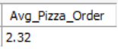

1. Daily Trend for Total Order:

select dayname(order_date), count(distinct order_id) as Total_Order from details

group by dayname(order_date)

order by Total_Order desc;

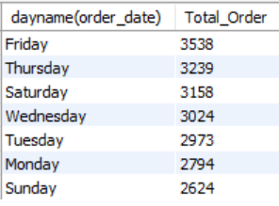

1. Hourly Trend for Total Orders:

select hour(order_time) as Hour, count(distinct order_id) as Total_Order from details

group by hour(order_time)

order by Total_Order desc;

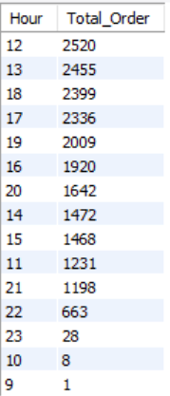

1. Percentage of Sales by Pizza Category:

select pizza_category, round(sum(total_price) *100 / (select sum(total_price) from details),2) as Percentage

from details

group by pizza_category;

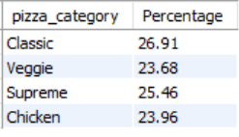

1. Percentage of Sales by Pizza Size:

select pizza_size, round(sum(total_price) * 100 / (select sum(total_price) from details),2) as Pizza_Size

from details

group by pizza_size

order by pizza_size desc;

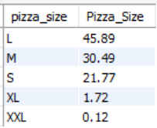

1. Percentage of Sales by Pizza Size in first quarter:

select pizza_size, round(sum(total_price) * 100 / (select sum(total_price) from details

where quarter(order_date) = 1),2) as Pizza_Size

from details

where quarter(order_date) = 1

group by pizza_size

order by pizza_size desc;

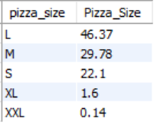

1. Total Pizza Sold by Pizza Category:

select pizza_category, sum(quantity) as Toatl_Pizza from details

group by pizza_category;

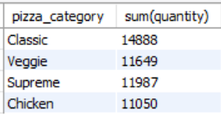

1. Top 5 Best Sellers by Total Pizzas Sold:

select pizza_name, sum(quantity) as total from details

group by pizza_name

order by total desc limit 5;

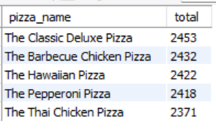

1. Top 5 Worst Sellers by Total Pizzas Sold:

select pizza_name, sum(quantity) as total from details

group by pizza_name

order by total limit 5;

