Work Instruction

BBU REPAIR

Document Number: 0000.doc

Editor: Duduc
Approved:

עותק מודפס זה הינו לעיון בלבד, חובה על המשתמש לבדוק אם הגרסה הינה עדכנית הטרם קריאה ועיון בעותק מודפס זה.
The hard copy version of this document is FOR REFERENCE ONLY. It is the responsibility of the user to ensure the completeness of this document prior to use.

Tel-Ad Engineering Department
SYS Division Group Assembly @ Tel-ad Electronics LTD

מהות השינוי | מהדורה | תאריך | תהליך | מבצע | מאשר
פרסום ראשון | A

תוכן עניינים
פרק 1. הקדמה 4
1.1. מטרה. 4
1.2. תיעוד 4
1.3. מסמכים ישימים. 4
1.4. קיצורים ופירושים. 4
1.5. הוראות עבודה כלליות. 4
פרק 2. 4
2.1. 4
פרק 3. 4
3.1. 4
פרק 4. נספחים 4
נספח 1 4
פרק 5. סוף מסמך 4

הקדמה

מטרה.

תיעוד

מסמכים ישימים.

קיצורים ופירושים.

הוראות עבודה כלליות.

- Purpose
Allow to repair a failed unit from a customer return.
- Importance Safety Instructions
Denotes a procedure or operation, which, if not perform correctly, may result in personal injury. Be sure not to continue operation until indicated conditions are fully understood and met.

- For qualified service personnel only.

- Do not performs any internal service or adjustment of this product unless another person is capable of rendering first aid and resuscitation is present.

- Dangerous voltage exists at several points in this product. To avoid personal injury, don’t touch any exposed connections or components while UPS is active.

- Turn off the UPS and disconnect input power cord before removing outside protective cover.

- AC voltage is always present if the input AC power is still available.

- High voltage may present at DC capacitors. Discharge the remaining energy at DC capacitors with resistor before disassembling the power board.
You can use a 300ohm/10W resistor contact BAT(+) terminal
And BAT(-) terminal for discharge battery filter capacitor.

- Verify input source (voltage and frequency) is within the maximum range before service.

- Do not short-circuit internal batteries.

- If the battery connector [BAT(+),BAT(-)] are disconnected, be sure to plug in the input power cord and the input power is available before re-connect the battery connectors.

- After service, verify the polarity of battery, fasten all screws and connectors before restarting the UPS.

- Main diagnostic
The failure information will be written on MRB document, in case that the information is not clear we can find the information in two options:

- Machine log files
- Network card log files

  - machine log files
    - Connect power to the UPS.
    - Wait that the LCD show the following picture:
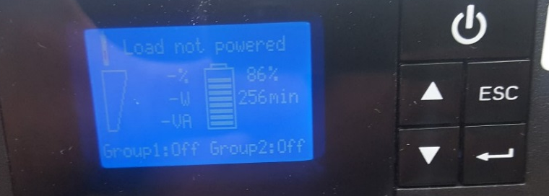
    - Press "enter" to get the main menu.

    - In the main menu choose "fault log" and press enter.
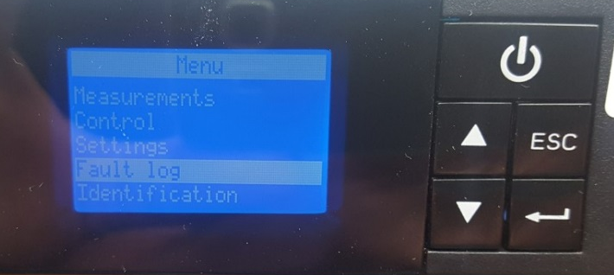
    - Choose "fault list" and press enter to see the fail reason.
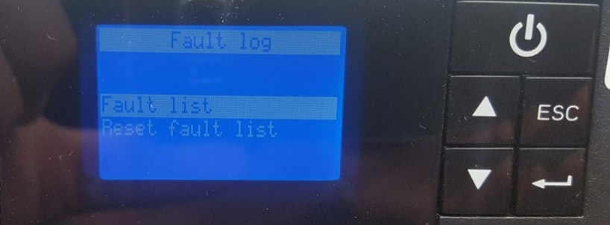

    - the next screen show the fail reason

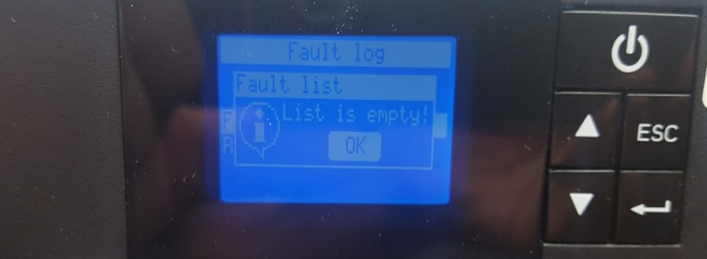

  - Network card log files
    - connect network cable from PC to UPS
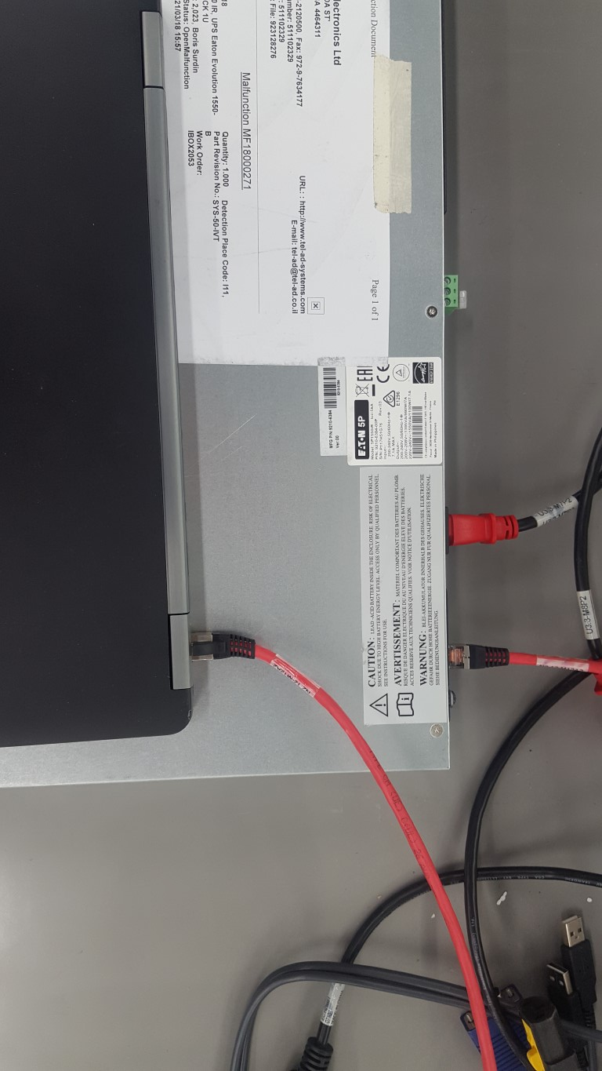
    - Connect power to the UPS.
    - Wait that the green led in the network card are blinking
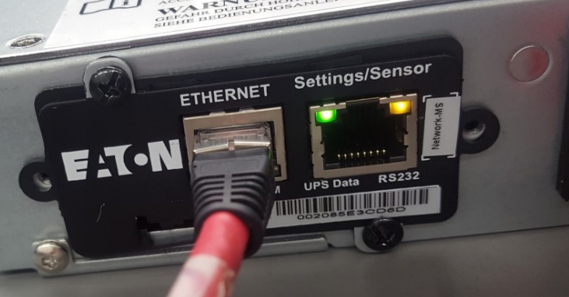

    - Check the UPS IP address in the LCD screen.

    - Press "enter" in main menu choose "identification".
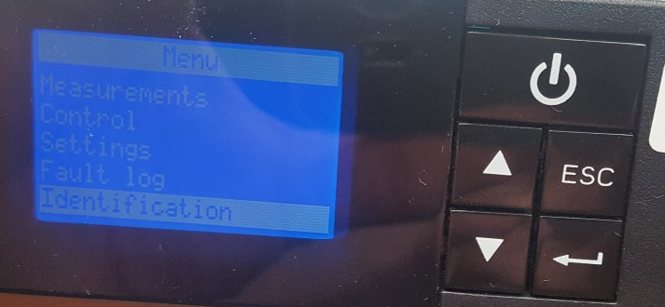

    - Press "enter" and choose "COM CARD IPV4
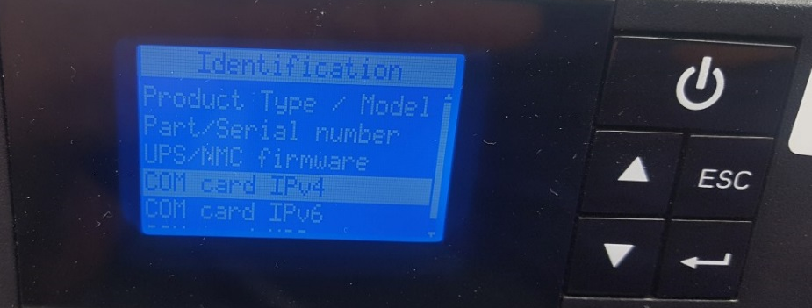
    - Press "enter" to see the IP
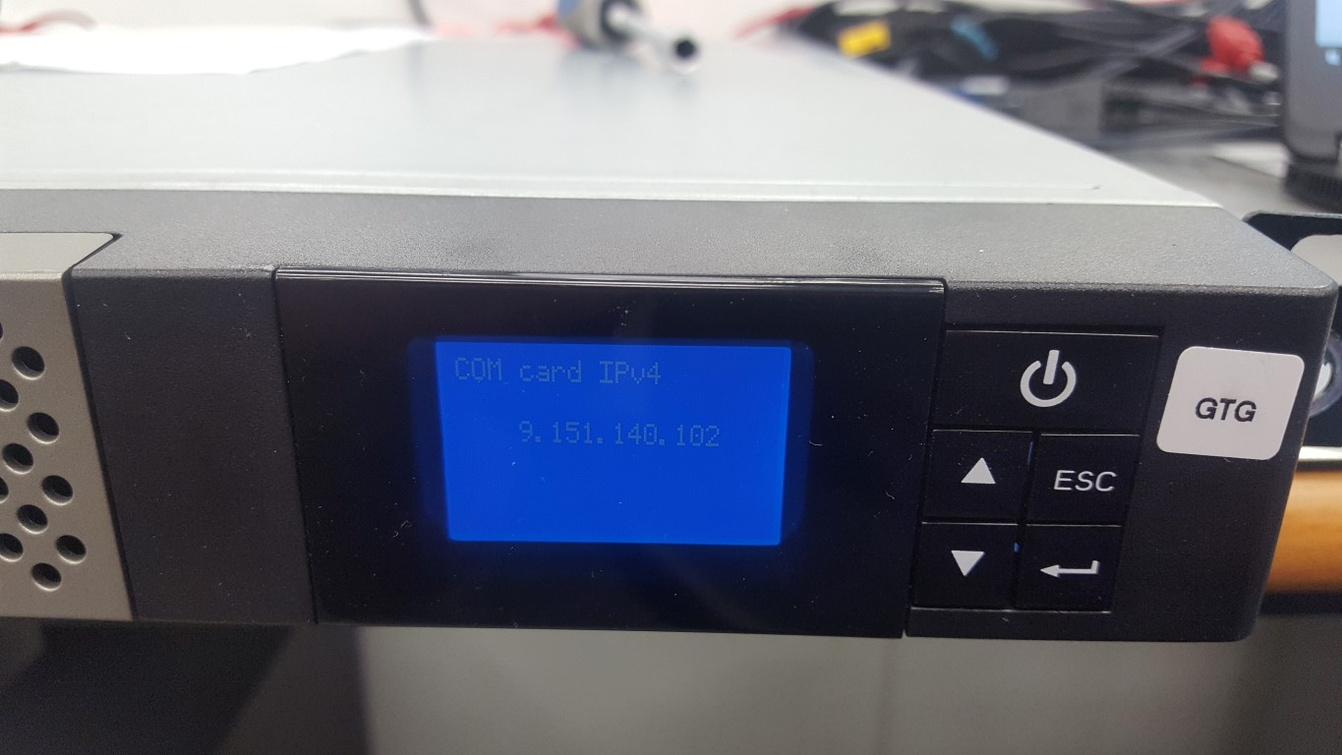
    - Change the PC IP address to the same network as UPS
- Press right click on network icon, select "open network"
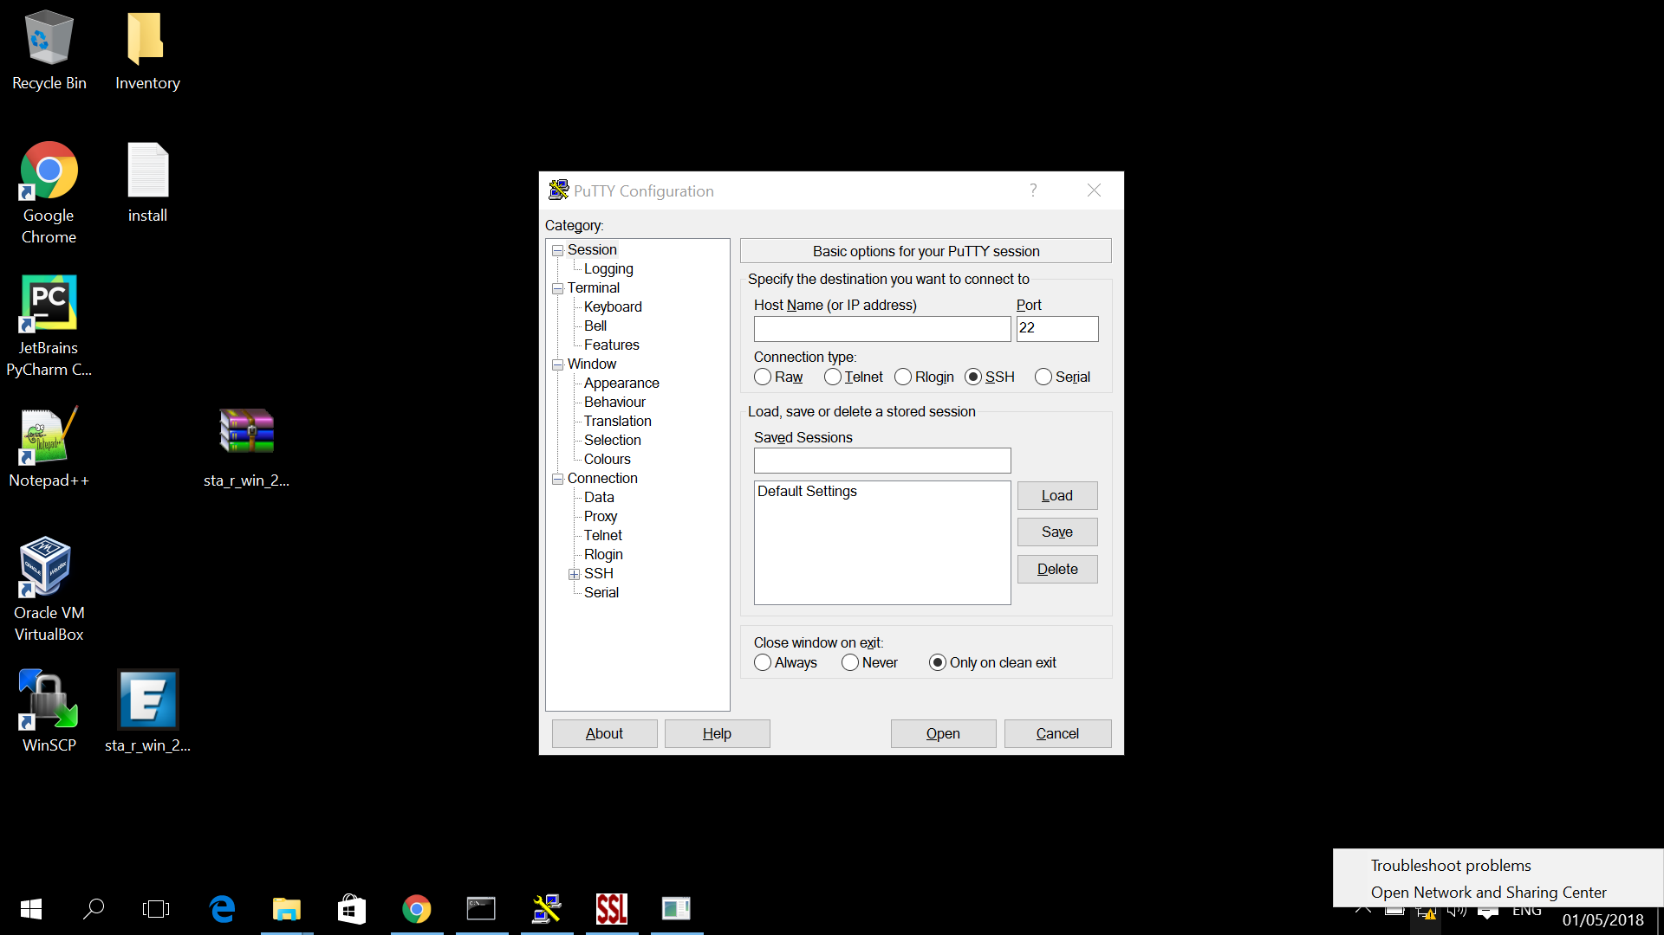

- Choose "change adapter setting" and right click on "Ethernet" icon

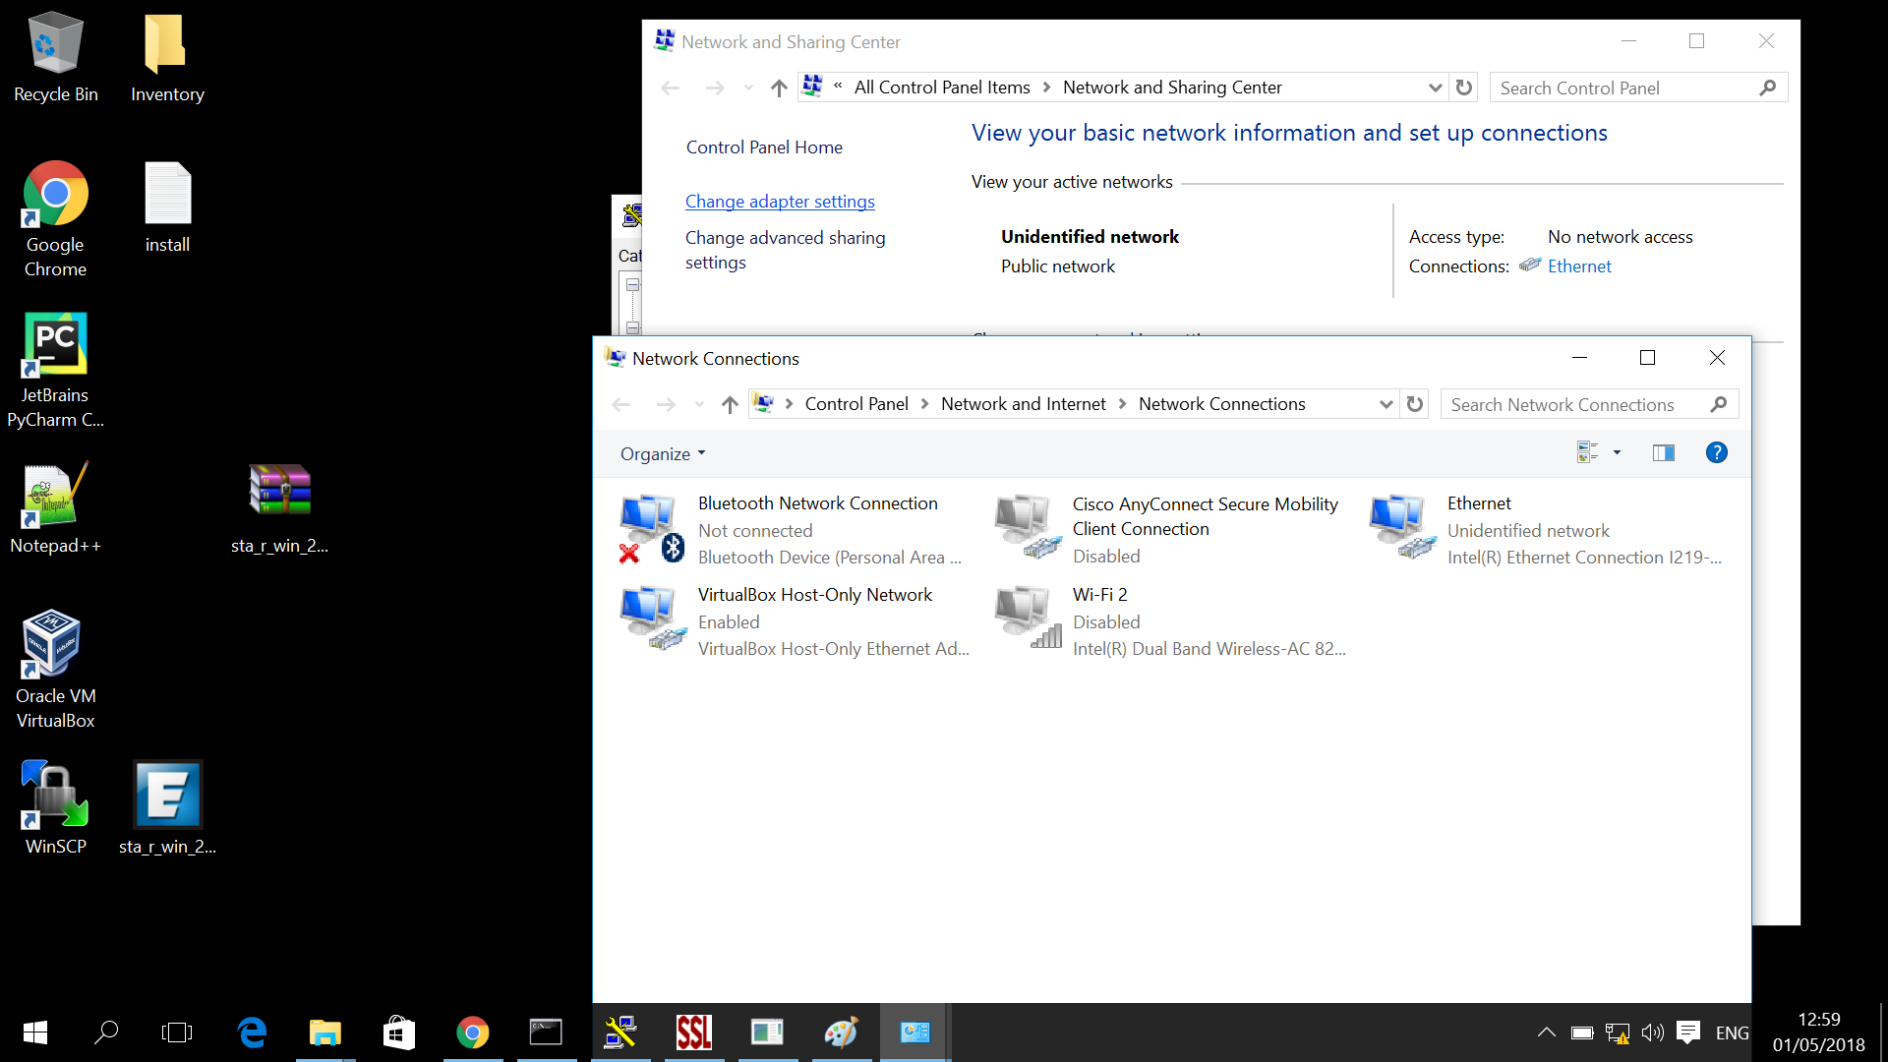

- Choose "properties" in the below picture
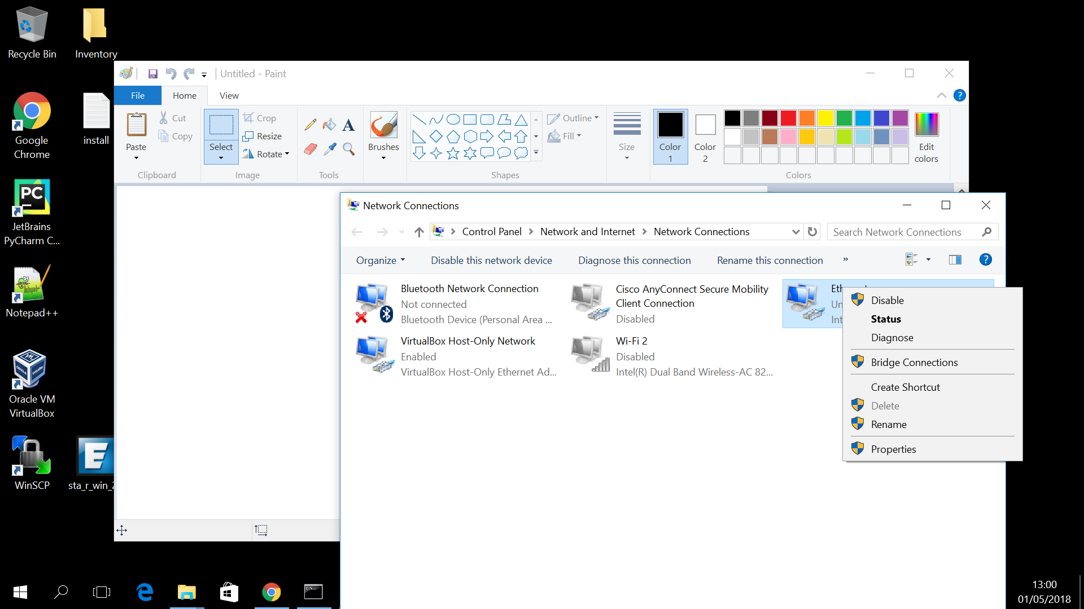
- Choose IPV4 and then press on properties

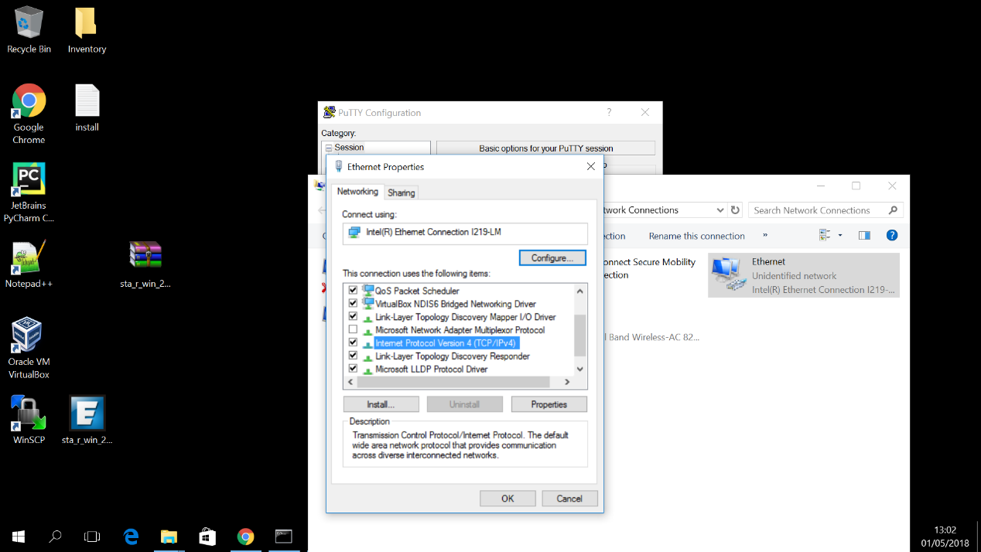
- Choose "use the …" option, and write in the IP address, the IP should be in the same network as UPS (for example: if UPS IP is 9.151.140.102, PC IP can be 9.151.140.100), press OK.

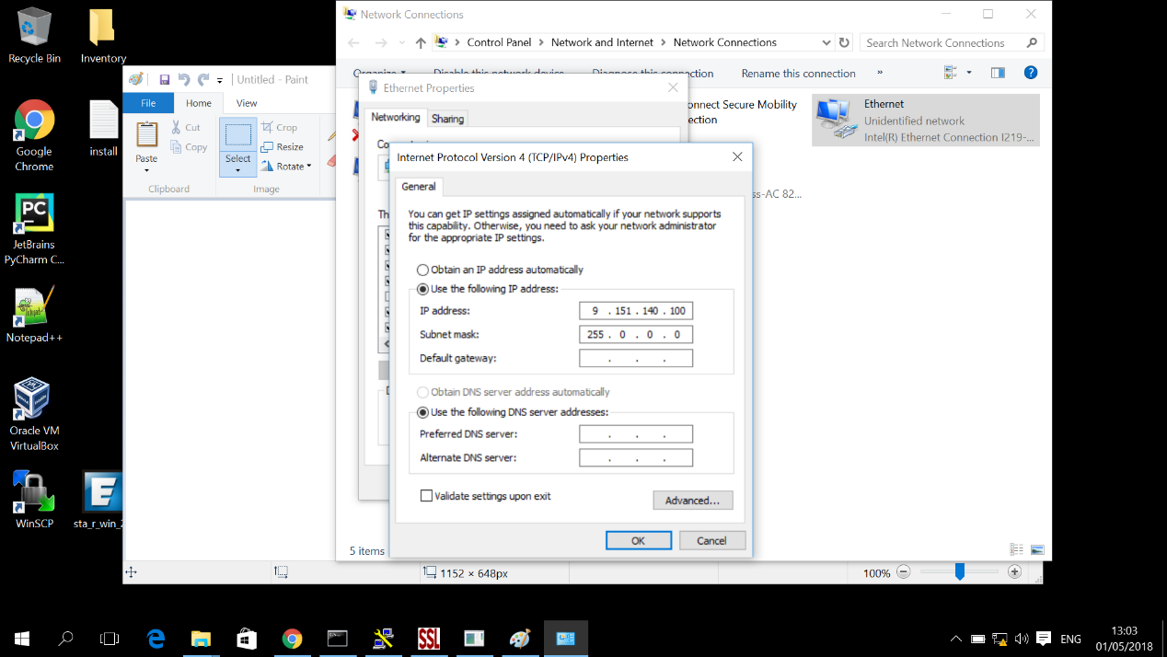

    - Write In the browser (chrome or IE) the UPS IP and get in to the UPS web interface.

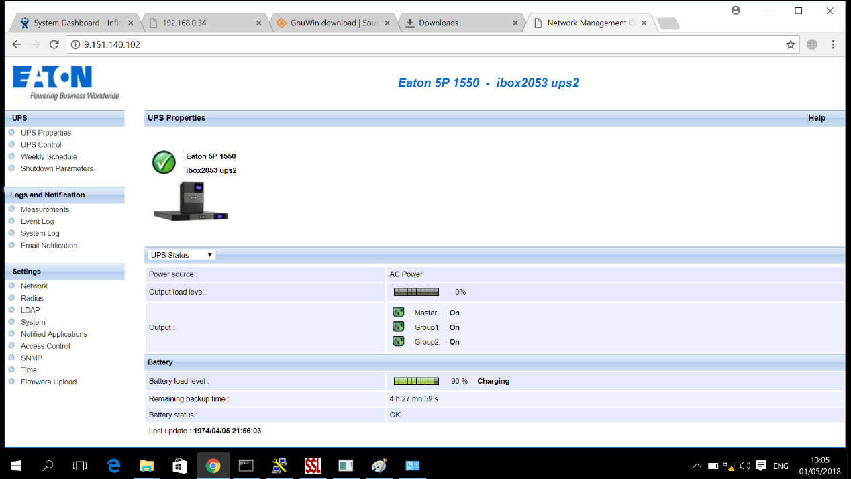

    - Press on event log in order to see the fail reason.
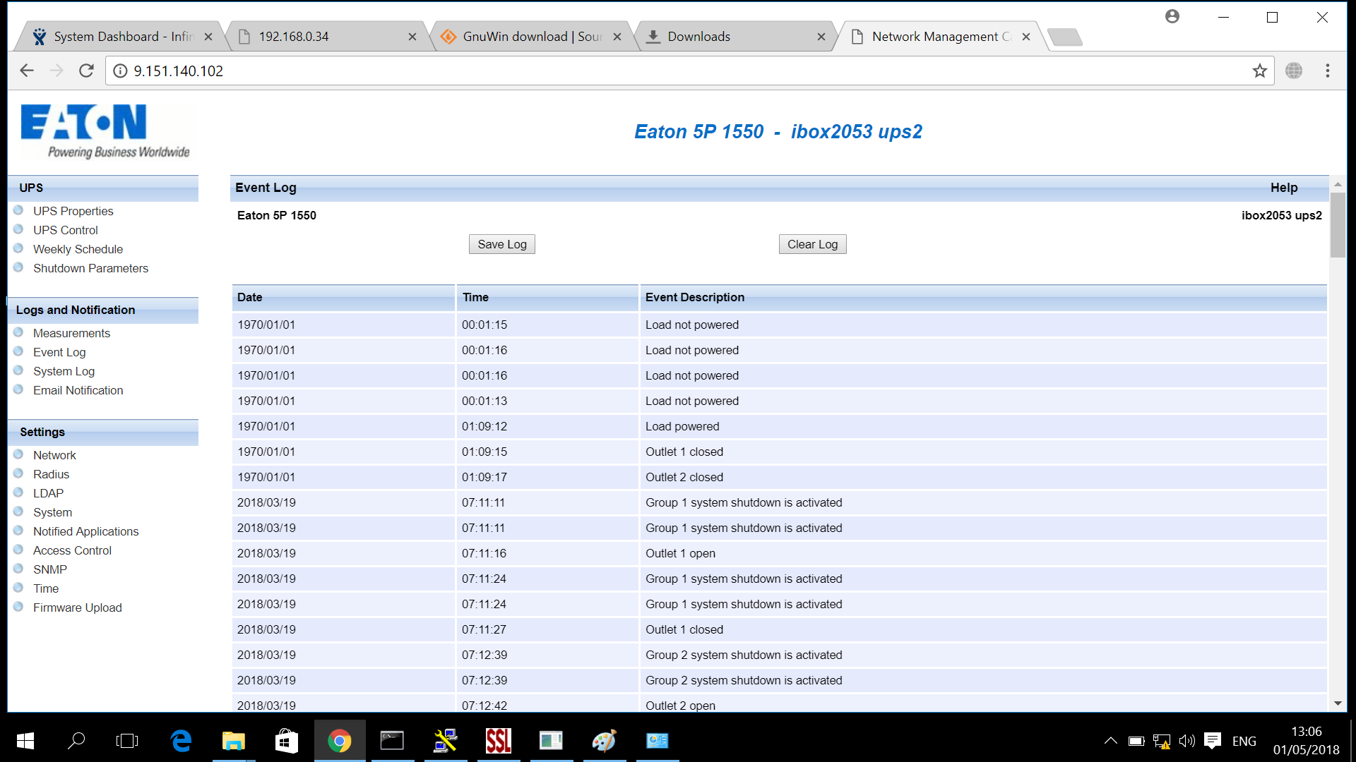

- Technical analyses and trouble shooting
  - check the product identification according below picture (product greater than 4 years, send to scrap):
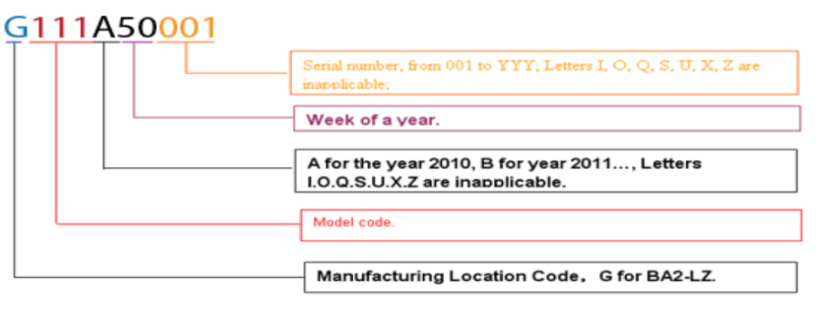
  - Visual inspection (Appendix A) before repair.
  - For most of the cases, the below tables describe the fail reason.
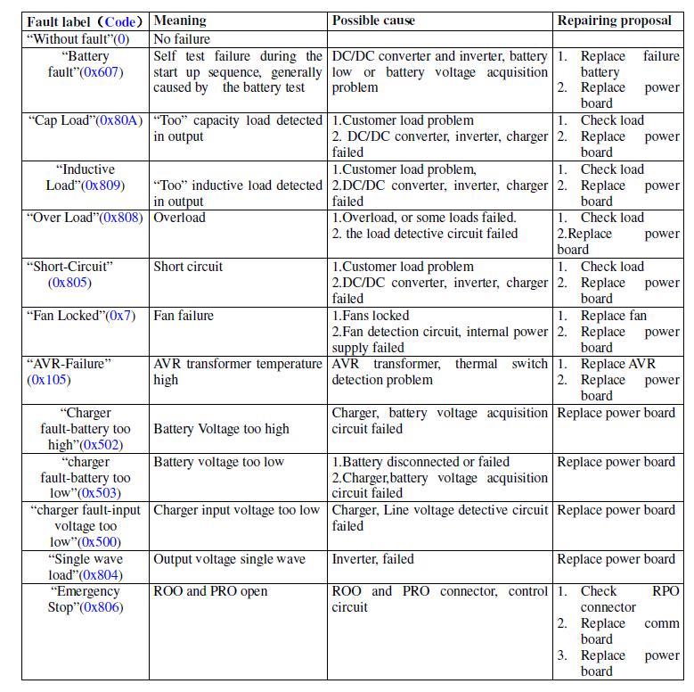
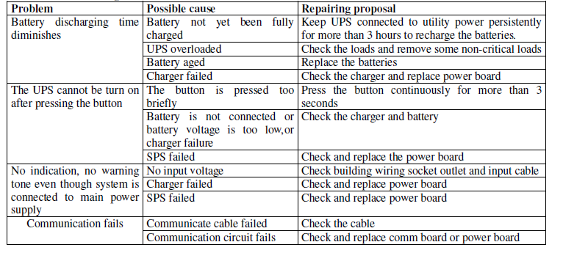

  - First level inspection
    - Verify that the AC voltage is not connected
    - Open the front panel.
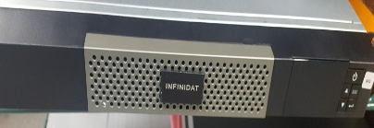
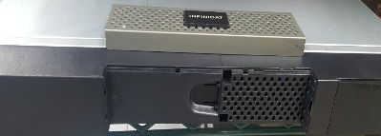
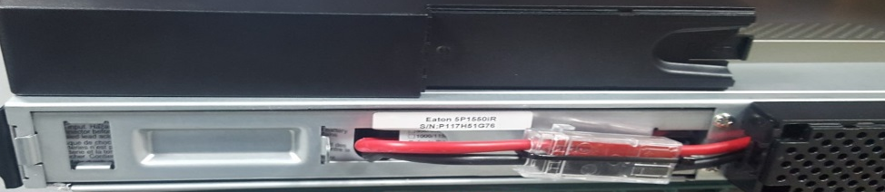
    - Cut the tie-rup on the battery connectors.
    - Disconnect the battery charge connectors and check the volt by voltmeter.
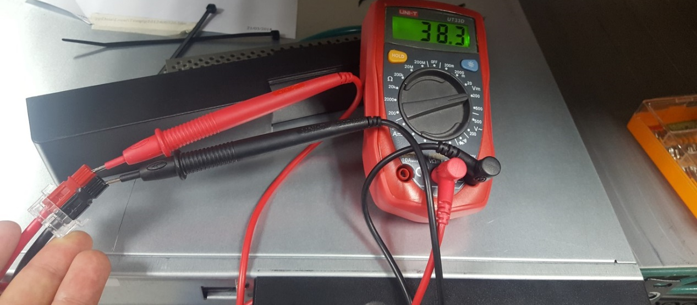
    - The voltage of the DC power should be:
UPS Battery type | Value (VOLT DC)
1B | 12V-13.5V
2B | 24V-27V
3B | 36V-40.5V
    - In case the value in the voltmeter less than the value in table, replace the battery.
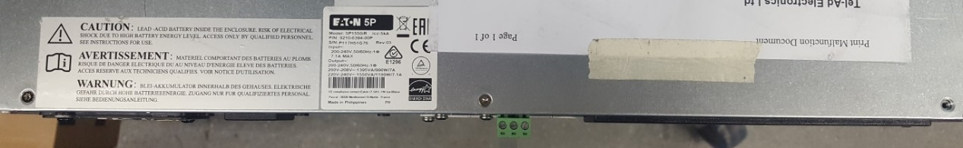
    - Open Check the UPS cover (by 3 star screw)

    - if there is damage on PCB, replace the PCB.
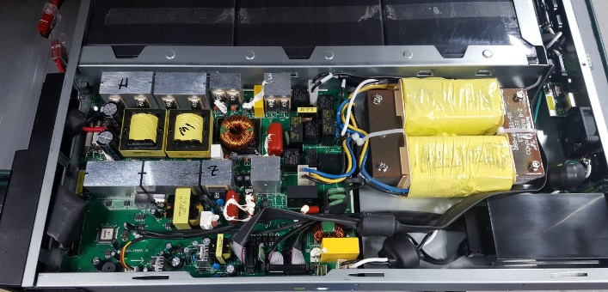

Appendix A

Packaging status

☐……….Carton damage
☐……….Carton of origin
☐……….Foam missing
☐……….Other

Product status

☐……….Case broken/scratched
☐……….Front panel broken
☐……….Rack plate damage
☐……….Feet broken
☐……….Battery door broken
☐………. Battery pack broken
☐………. Battery connector damage
☐……….Led/Lcd damage

קצה מעטפת ספירלה
Emergency Button

______________________________________________________________________________


הערה:

______________________________________________________________________________

נספחים

סוף מסמך

