NAME: SHAIK MOHAMMED SAMEER ALI

Write SQL queries for the below mentioned requirements to extract:

1. Top 3 customers based on the amount spent.

A. SELECT c.customer_id, c.cust_first_name, c.cust_last_name, SUM(oi.quantity * oi.unit_price) AS total_spent,

DENSE_RANK() OVER (ORDER BY SUM(oi.quantity * oi.unit_price) DESC) AS rank

FROM demo_customers c

INNER JOIN demo_orders o ON c.customer_id = o.customer_id

INNER JOIN demo_order_items oi ON o.order_id = oi.order_id

GROUP BY c.customer_id, c.cust_first_name, c.cust_last_name

order by total_spent desc

fetch first 3 row only;

2. Top 3 customers based on the number of orders.

A.

SELECT c.customer_id, c.cust_first_name, c.cust_last_name, COUNT(*) AS num_orders,

rank() OVER (ORDER BY COUNT(*) DESC) AS rank

FROM demo_customers c

INNER JOIN demo_orders o ON c.customer_id = o.customer_id

GROUP BY c.customer_id, c.cust_first_name, c.cust_last_name

ORDER BY num_orders DESC

fetch first 3 row only;

3. Top 3 products based on quantity sold.

A.

SELECT p.product_id, p.product_name, SUM(oi.quantity) AS total_sold, dense_rank() over (order by SUM(oi.quantity) desc) as rank

FROM demo_products p

INNER JOIN demo_order_items oi ON p.product_id = oi.product_id

GROUP BY p.product_id, p.product_name

ORDER BY total_sold DESC

fetch first 3 row only;

4. Write a query to capture the customer's last name, product names (he bought) and total quantity of each of them.

A.

SELECT c.cust_last_name, p.product_name, SUM(oi.quantity) AS total_quantity

FROM demo_customers c

INNER JOIN demo_orders o ON c.customer_id = o.customer_id

INNER JOIN demo_order_items oi ON o.order_id = oi.order_id

INNER JOIN demo_products p ON oi.product_id = p.product_id

GROUP BY c.cust_last_name, p.product_name

ORDER BY c.cust_last_name, p.product_name ;

5. Transform the rows to columns for the result you get from Query # 4 above.

A. SELECT *

FROM (

SELECT c.cust_last_name, p.product_name, SUM(oi.quantity) AS total_quantity

FROM demo_customers c

INNER JOIN demo_orders o ON c.customer_id = o.customer_id

INNER JOIN demo_order_items oi ON o.order_id = oi.order_id

INNER JOIN demo_products p ON oi.product_id = p.product_id

GROUP BY c.cust_last_name, p.product_name

ORDER BY c.cust_last_name, p.product_name

)

PIVOT(

max(total_quantity) FOR product_name IN (

'Business_Shirt' AS Business_Shirt,

'Trousers' AS Trousers,

'Jacket' AS Jacket,

'Blouse' AS Blouse,

'Skirt' AS Skirt,

'Ladies_Shoes' AS Ladies_Shoes,

'Belt' AS Belt,

'Bag' AS Bag,

'Mens_Shoes' AS Mens_Shoes,

'Wallet' AS Wallet ))

ORDER BY 1;

6. Which year had most orders?

A.

SELECT to_char(order_timestamp,'yyyy') AS order_year, COUNT(*) AS num_orders

FROM demo_orders

GROUP BY to_char(order_timestamp,'yyyy')

ORDER BY num_orders DESC

fetch first 1 row only;

7. Draw an ER (entity-relationship) model for this database depicting tables, PK and FK (i.e., relationships between them) on a plain paper using pen/pencil. Share the screenshot (ensure picture is clearly visible) and share.

A.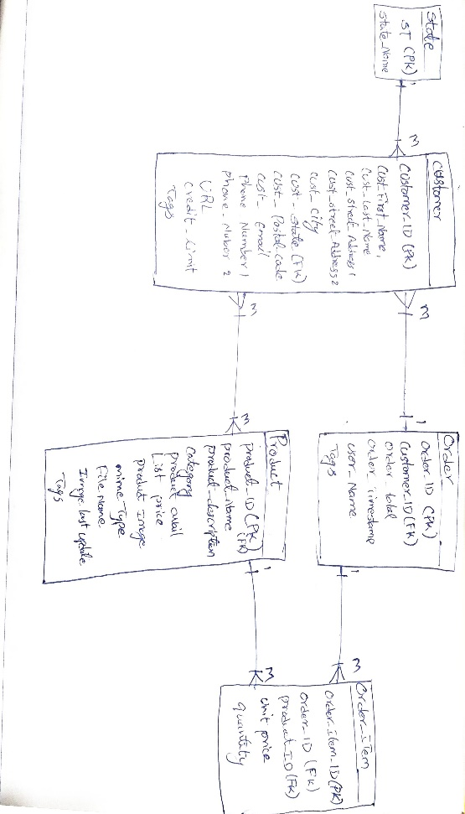

8. Which product category was most sold?

A. SELECT p.category, SUM(oi.quantity * oi.unit_price) AS total_revenue

FROM demo_products p

INNER JOIN demo_order_items oi ON p.product_id = oi.product_id

GROUP BY p.category

ORDER BY total_revenue DESC

fetch first 1 row only;

9. Which product category took the second position in terms of quantity sold?  
A. SELECT p.category, SUM(oi.quantity) AS total_sold,

RANK() OVER (ORDER BY SUM(oi.quantity) DESC) AS rank

FROM demo_products p

INNER JOIN demo_order_items oi ON p.product_id = oi.product_id

GROUP BY p.category

ORDER BY total_sold DESC

fetch next 2 row only;

10. Write a query to help rollup total quantity on customer and product (name)

A.SELECT c.cust_last_name, p.product_name, SUM(oi.quantity) AS total_quantity

FROM demo_customers c

INNER JOIN demo_orders o ON c.customer_id = o.customer_id

INNER JOIN demo_order_items oi ON o.order_id = oi.order_id

INNER JOIN demo_products p ON oi.product_id = p.product_id

GROUP BY ROLLUP (c.cust_last_name, p.product_name)

ORDER BY c.cust_last_name, p.product_name;