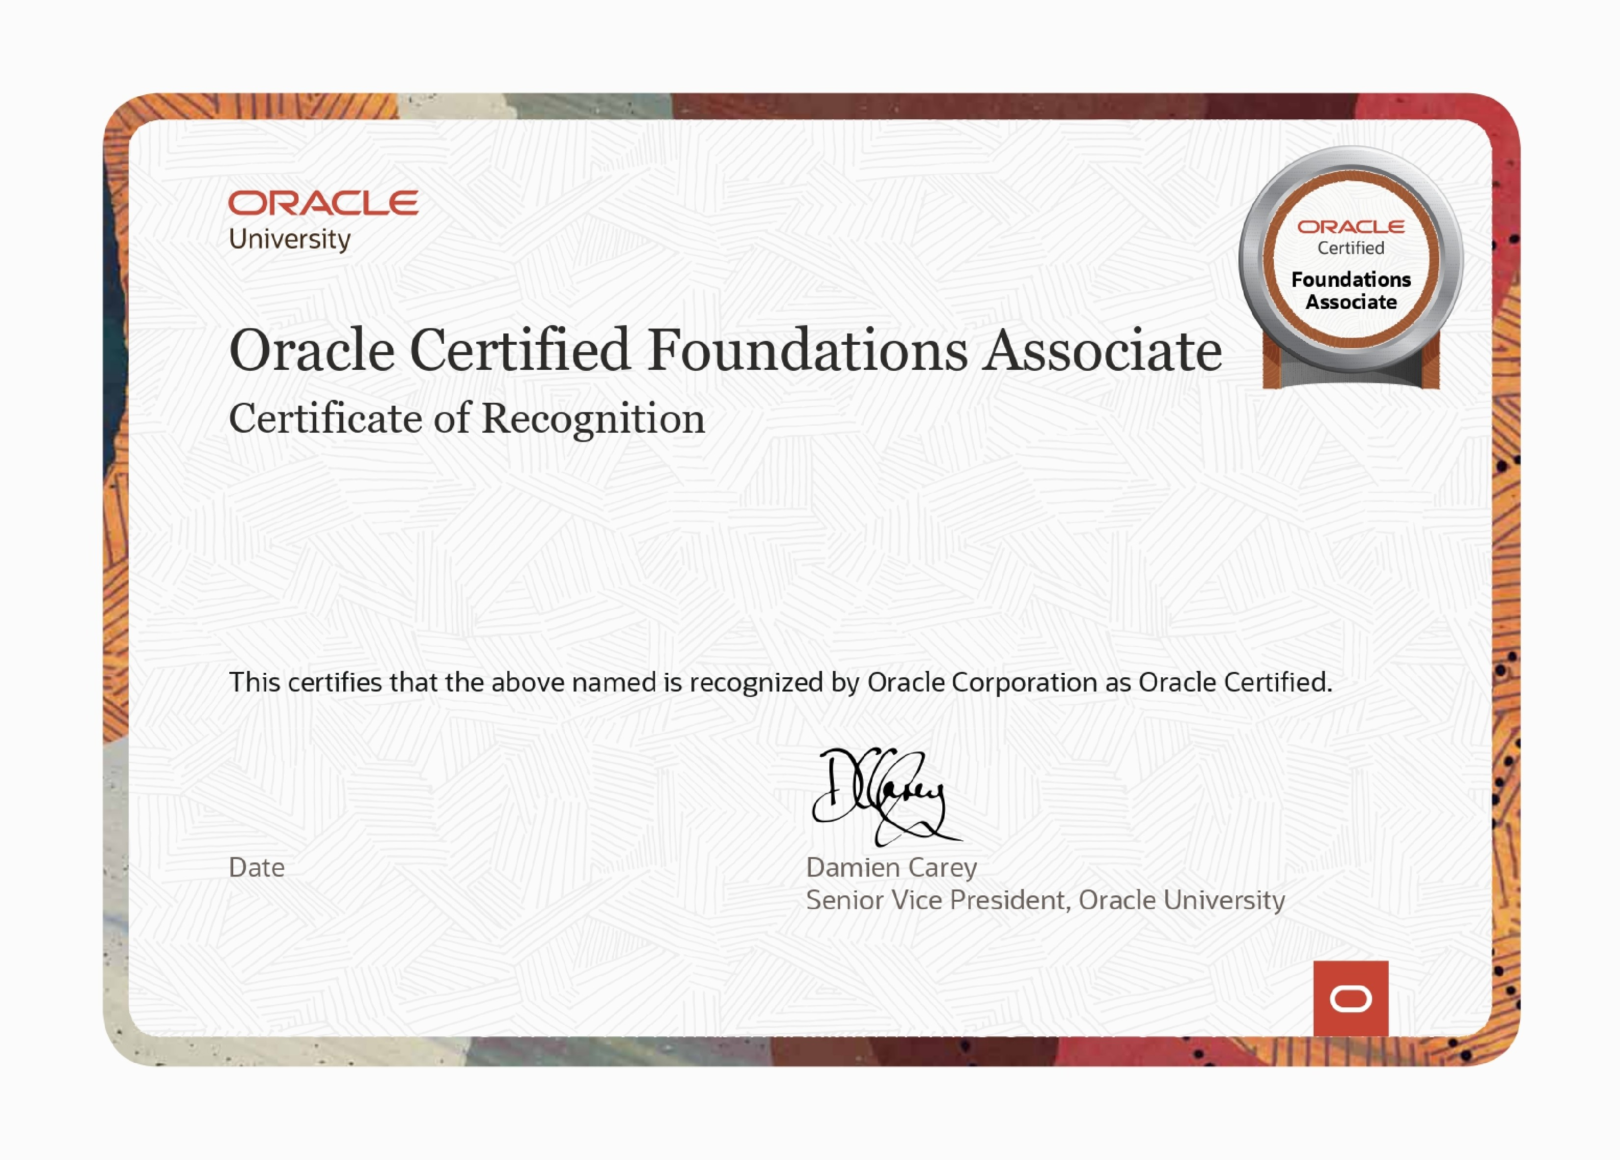

Suresh P.B

Oracle Cloud Infrastructure 2025 Certified Foundations Associate

May 08, 2025

This eCertificate is valid until May 08, 2027

101322128OCI25

FNDCFA