货币政策与企业就业预期的刚性
2026-08-11 · ECB · 发布于 2026-08-10
工作论文系列
本文研究欧洲央行货币政策意外如何影响企业的就业预期及随后的就业结果。我们将德国ifo企业调查的月度数据（2005年至2024年，每月覆盖约9000家企业）与高频货币政策意外相结合。通过比较在欧洲央行公告前与公告后不久接受调查的企业，我们隔离出政策冲击对预期的即时影响。
这与现有关于金融加速器的证据有所不同，后者侧重于已实现的就业或投资结果。这些模式表明，政策传导取决于企业特定的（财务）状况和劳动力市场法规。
因此，企业的就业预期为货币政策如何传导至劳动力市场提供了早期且直接的观察视角。然而，尽管关于货币政策对产出和通胀预期影响的文献日益增多（Bottone and Rosolia, 2019; Enders et al., 2019; Di Pace et al., 2025），但关于央行公告如何塑造企业就业预期，以及这些预期如何转化为实际就业的证据仍然有限。这一空白在微观层面尤为突出，因为企业层面的信念形成最终驱动着总体劳动力市场动态。
因此，我们能够评估中央银行是否只能通过需求变化间接影响就业，还是也能通过预期变化直接影响就业。
(Bahaj et al., 2022; Singh et al., 2023)，我们的结果表明，这种差异化响应源于企业形成招聘计划的方式，从而弥合了货币政策公告与实际就业变化之间的差距。此外，我们通过企业自我报告的财务困难和信贷获取条件直接衡量财务约束，而非依赖杠杆率或企业规模等资产负债表代理指标。
困难或报告过度约束。最后，我们的结果凸显了劳动力市场刚性在新凯恩斯主义模型中的重要性。生产预期与就业预期调整之间的差距表明，存在招聘和解雇成本，以及寻找新员工和辞退现有员工的难度。Lechthaler等人（2010）在其新凯恩斯主义模型中证明了劳动力调整成本的相关性，用以从货币政策冲击中推导出持续性的失业效应，以及就业创造与就业破坏之间的负相关关系。
Enders等人（2019）的研究表明，企业的价格预期和生产预期会对欧洲央行的公告作出反应。我们在三个方向上有所不同：从产品市场转向劳动力市场，其中制度特征产生了根本不同的动态变化；从即时影响转向通过局部投影法揭示的完整动态路径，发现就业预期的持续性远超生产预期；以及通过财务约束和劳动力市场约束分析货币政策对企业预期的传导。Bottone和Rosolia（2019）、Ferrando等人（2022）以及Di Pace等人（2025）分别提供了货币政策对通胀预期、信贷获取预期和价格预期影响的补充证据。
(2020)报告了非常规政策效果不一的结果。Francis等人(2012)展示了美国各城市间政策的异质性，与之相关的是，de Groot等人(2023)记录了欧元区的一个空间维度：货币紧缩导致较贫困地区就业和劳动生产率持续下降，这表明劳动力市场调整中存在滞后效应，与我们记录的企业招聘意向持续性相呼应。此外，经济的部门构成影响货币政策向产出的传导强度(Hauptmeier等人，2025)。关于分配后果，Coglianese等人(2025)表明货币紧缩提高了瑞典的失业率和劳动力市场不平等——这与我们发现裁员边际最终占据主导的结果相呼应。Groiss(2023)强调了就业创造渠道在塑造德国工资不平等中的作用，这一机制与我们基于企业层面的招聘边际结果相印证。与我们最接近的使用企业层面数据的研究是Bahaj等人(2022)和Singh等人(2023)，他们分别展示了企业特征如何塑造英国和美国的货币政策就业效应。我们通过将研究从实际就业转向就业预期，区分招聘和解雇意向，覆盖所有主要部门，并识别财务约束、信贷获取、工会覆盖率和最低工资在欧洲央行货币政策传导中的具体作用，从而扩展了这项工作。
数据中心（EBDC）。该数据自1980年起以月度频率提供制造业数据，其他行业的数据随后逐步可得。³自2005年起，所有行业的数据均可获得，因此我们将样本期设定为2005年至2024年。该调查覆盖面广泛，每月约有9,000份回复，且在行业内具有代表性（Sauer et al., 2023）。⁴另一个优势在于调查的月度面板结构。我们不仅能够重复观察到相同的企业，而且该自愿性调查的回复率非常高，流失率较低。³行业（包括制造业（IBS-IND, 2024）和建筑业（IBS-CON, 2024））、服务业（包括贸易业（IBS-TRA, 2024）和其他服务业（IBS-SERV, 2024））。
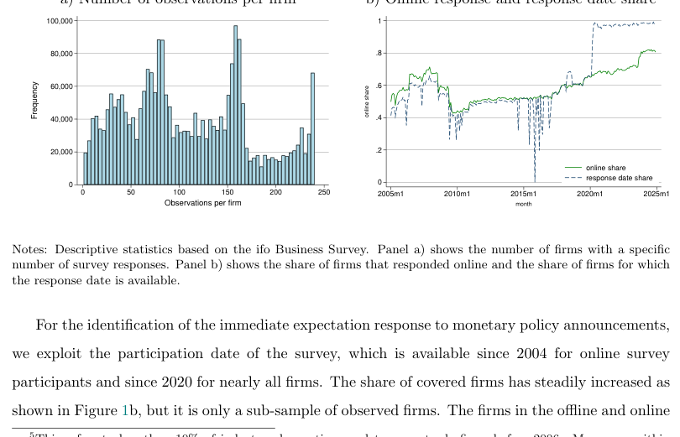
图1：ifo 调查——样本特征
,000 1
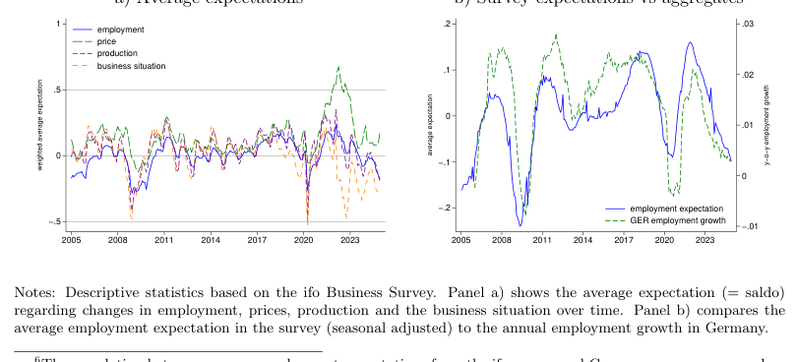
图2：就业预期
高频货币政策冲击
因此，这允许对冲击进行外生性解释。我们通过检查政策冲击的自相关性以及其他冲击是否以显著且有意义的方式影响货币政策意外来检验外生性（Bauer and Swanson, 2023），而欧元区的情况并非如此（见表B.1）。为应对剩余担忧，我们在下一节估计即时预期调整时，利用了ifo调查的准随机响应日。
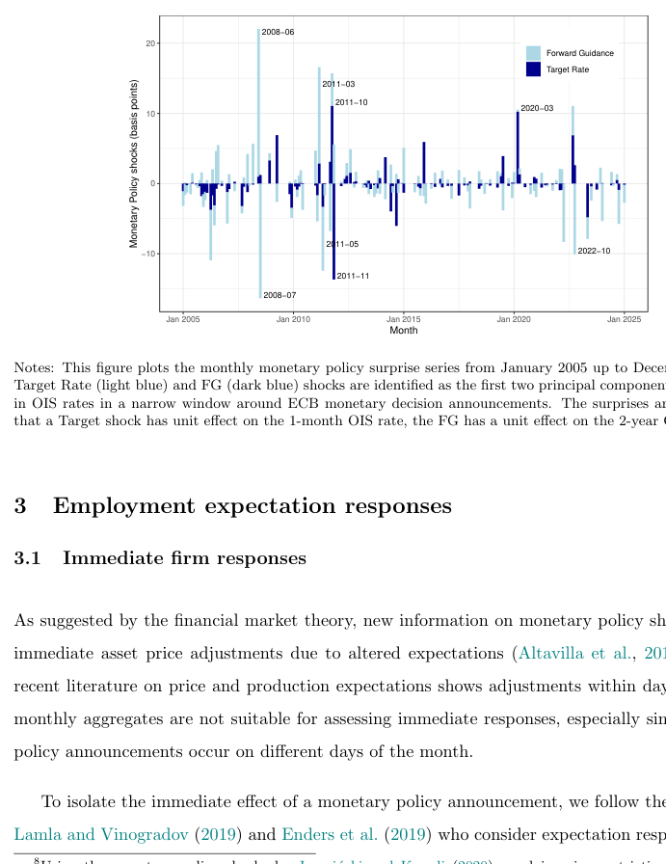
图3：高频货币政策冲击
−06 20
我们假设企业做出回应的时间与公告本身无关，这一假设得到了处理组和未处理组企业预期分布相似性的支持（见表A.2）。
表1展示了我们对企业货币政策意外即时预期响应的基准结果。第(1)列显示，目标利率意外上升25个基点会导致就业预期显著下降0.13。具体而言，在货币紧缩之后，降低就业预期的企业比增加就业预期的企业多13%。
就业预期的均值为0.02，标准差为0.54。系数范围介于-2和+2之间。在极端情况下，若所有企业在25个基点政策冲击后计划增加劳动力（1）并转而减少劳动力（-1），则特定事件的系数将为-2。
Table 1: Immediate expectation responses
employment expectationproduction expectationtotalincreasedecreasetotalincreasedecrease(1)(2)(3)(4)(5)(6)TR shock × post-0.1280∗∗∗-0.0943∗∗∗0.0296∗∗∗-0.2903∗∗∗-0.0836∗∗∗0.2046∗∗∗
(0.0120)(0.0082)(0.0083)(0.0162)(0.0099)(0.0112)Post dummy0.0003-0.0014∗-0.0014∗∗-0.0138∗∗∗-0.0044∗∗∗0.0096∗∗∗
(0.0010)(0.0007)(0.0007)(0.0013)(0.0009)(0.0008)Exp employment (t-1)0.4766∗∗∗0.4118∗∗∗0.4858∗∗∗
(0.0012)(0.0016)(0.0016)Exp production (t-1)0.3468∗∗∗0.3140∗∗∗0.3320∗∗∗
(0.0013)(0.0013)(0.0015)Exp business situation (t-1)0.0576∗∗∗0.0312∗∗∗-0.0320∗∗∗0.1520∗∗∗0.0874∗∗∗-0.0752∗∗∗
(0.0008)(0.0005)(0.0006)(0.0012)(0.0008)(0.0007)Constant0.0067∗∗∗0.0852∗∗∗0.0675∗∗∗0.0520∗∗∗0.1612∗∗∗0.1038∗∗∗
(0.0006)(0.0005)(0.0004)(0.0008)(0.0006)(0.0005)
Firm FEyesyesyesyesyesyesMeeting FEyesyesyesyesyesyesObservations209,399209,399209,399209,799209,799209,799R20.51980.48000.47690.44810.41490.3910Number of Meetings200200200200200200
Notes: OLS regressions showing the monetary policy effect of treated (=post) vs non-treated firms on employ-ment and production expectations. Heteroskedasticity robust standard errors in the parenthesis. TR=TargetRate.* p<0.10, ** p<0.05, *** p<0.001.
Turning to production expectations, column (4) reveals a notably larger immediate response. A
25 basis point Target Rate surprise reduces production expectations by 0.29 in the baseline specifi-
cation and even more when additional controls are added (see Table D.3). Because both expectation
series are ordinal, the coefficients measure the net share of firms revising their plans, not the cardinal
size of the revision, and are therefore best compared through the likelihood of adjustment. On that
basis the gap is pronounced: nearly twice as many firms adjust their production expectations rather
than their employment expectations directly after a monetary policy announcement. This pattern is
consistent with the notion that labour markets are characterised by greater rigidities than product
markets. Those could include adjustment costs associated with hiring and firing, related to the
stringency of employment protection legislation, and firm-specific human capital formation. This
contrast does not stem from the two variables being measured on different scales. Their cross-firm
12According to a cross-equation Wald test following a joint estimation, the absolute effect sizes of columns (2) and(3) in Table 1 are statistically different (p-value: 0.0005).
均值和标准差非常接近，因此对两者进行标准化处理后，差距基本保持不变：25个基点的意外冲击使标准化后的生产预期下降0.48，而就业预期下降0.25（表D.1第(4)和(5)列），比率再次接近二比一。
德国与ifo调查。因此，计划招聘或裁员的多数企业倾向于招募或解雇一人。尽管关于招聘/裁员预期的定量变量自2023年起才可得，但它有助于评估集约边际。中位数企业预期招聘一名新员工，即使第90百分位的企业也仅招聘七人（见表A.4）。为更好地拟合集约边际，我们在回归中应用了来自ifo调查的规模权重，从而使得规模较大的企业招聘更多。图2b展示了加权平均就业预期与德国总体就业增长之间的关系，并说明了其与实际动态的紧密拟合。
此外，我们通过Zi,t−1控制滞后的货币政策冲击，以提高估计的外生性和效率。我们还加入了日历月份固定效应以考虑季节性因素。虽然在此设定下我们无法控制时间固定效应，因为这会吸收货币政策效应，但我们仍可控制企业固定效应，以控制企业间未观测到的异质性αi。13 βp h是关注系数，捕捉预期对紧缩性目标利率冲击的响应。
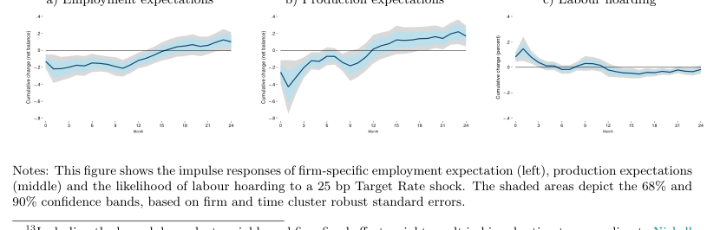
图4：动态预期响应
图4中间面板展示了生产预期的响应。与就业形成鲜明对比的是，企业更倾向于调整其生产预期，在1个月响应区间内达到峰值效应-0.43。然而，反转速度显著更快：约6个月后，该效应在统计上不再显著异于零。超过该区间后，响应并未保持在零水平，而是在更长区间内转为正值，超过其冲击前水平，这表明就业预期与生产预期不仅在初始反应的可能性上存在差异，而且在生产预期反转和反弹的速度上也存在差异。
这表明货币政策在产品市场和劳动力市场中通过不同的渠道发挥作用，其中劳动力市场表现出明显更大的惯性。德国的劳动力市场制度，包括法定就业保护、最低工资以及普遍存在的企业委员会，可能解释了这种差异性的持续性。此外，自全球金融危机以来，面对持续的技术工人短缺，企业不愿裁员（Groiss and Sondermann, 2025），这可能进一步减缓了就业预期调整的速度。
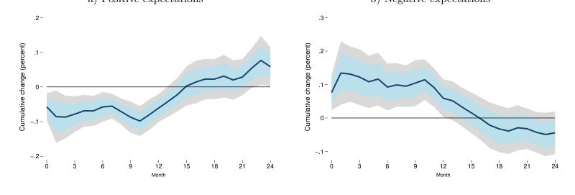
图5：招聘减少与裁员增加

Table 2: Employment growth response
year-ahead employment growth(1)(2)(3)(4)TR shock-1.4200∗∗∗-0.5973∗∗∗-0.2636-1.7360∗∗∗
(0.4055)(0.0821)(0.2405)(0.3649)Declining employment expectations (t-1)-0.6123∗∗∗-0.3672∗∗∗
(0.2237)(0.0240)Increasing employment expectations (t-1)0.3847∗∗∗0.2135∗∗∗
(0.1480)(0.0249)Employment growth (t-1)0.8932∗∗∗0.9541∗∗∗0.8888∗∗∗0.9196∗∗∗
(0.0289)(0.0028)(0.0086)(0.0061)Employment growth (t-2)0.0196-0.0083∗∗∗0.0108-0.0078(0.0248)(0.0028)(0.0081)(0.0070)Employment growth (t-3)-0.0615∗∗∗-0.0568∗∗∗-0.0485∗∗∗-0.0361∗∗∗
(0.0117)(0.0019)(0.0082)(0.0042)Lagged policy shocksyesyesyesyesFirm and calendar month FEyesyesyesyesObservations1,199,9551,109,829124,973113,457R20.81690.85380.83910.8682Number of Meetings200200200200
Notes: OLS regressions showing the monetary policy effect on 12-month employment growth.Firm cluster robust standard errors in the parenthesis. TR=Target Rate.* p<0.10, **p<0.05, *** p<0.001.
We provide a range of estimates instead of a specific estimate, as the estimates should be
interpreted with caution.The firm-level employment variable is mostly reported at an annual
frequency and forwarded across months by the ifo institute, which introduces measurement noise. To
capture the induced serial correlation within firms’ observations, we control for lagged employment
growth and estimate firm cluster robust standard errors. Column (1) reports the estimates using the
same sample and specification as for the local projections. This includes three lags of employment
15Given that the net balance deteriorates by 0.21, at least 21% of firms will have to revise their expectationsdownwards (if none revise them upwards). Assuming that each of these firms plans to reduce its workforce by oneemployee (see A.4) and that there are around 3.4 million firms in Germany, this would result in the loss of 0.71 millionjobs. Compared to the total number of employees in Germany in 2024 (42 million), this would represent a 1.7%reduction in employment, similar to the aggregate employment responses in Figure 6.
增长及货币政策冲击的三个滞后项，以及固定效应。由于这些估计可能受到异常值或错误数据的影响，而这在有序因变量的回归中并不相关，第（2）列提供了剔除就业增长观测值上下各3%后的估计结果。
更长时间。职位空缺减少和劳动力规模缩小反映在失业率上升上，这一上升在统计上显著但略有延迟，并在十二个月后达到峰值。
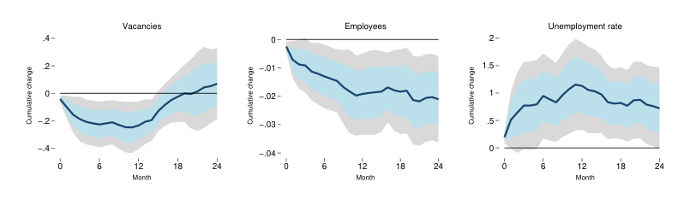
图6：总体劳动力市场响应
职位空缺
正如Enders等人（2019）所述，信息效应可能随着冲击规模的增大而增强，从而逆转观测到的效应。因此，控制这些效应对于理解实际货币政策效果至关重要。17
Table 3: Employment expectation responses - nonlinearity and information effects
employment expectation(1)(2)(3)(4)(5)TR shock × post-0.0433∗
(0.0256)Cubic TR shock × post-0.6554∗∗∗
(0.1729)JK monetary shock × post-0.1207∗∗∗
(0.0271)JK info shock × post0.3343∗∗∗
(0.0338)Positive TR shock × post-0.1537∗∗∗
(0.0132)Negative TR shock × post0.0665(0.0423)Policy rate change × post0.1357(0.1439)FG shock × post0.0120(0.0085)
Firm FEyesyesyesyesyesMeeting FEyesyesyesyesyesObservations209,399193,480209,399209,399209,399R20.51980.46700.51980.51970.5197Number of Meetings200188200200200
Notes: OLS regressions showing the monetary policy effect of treated (=post) vs non-treatedfirms on employment expectations. Heteroskedasticity robust standard errors in the parenthesis.(1) cubic effects, (2) Jaroci´nski and Karadi (2020) policy surprises, (3) asymmetric effects, (4)policy rate change, (5) forward guidance shocks. TR=Target Rate, FG=Forward Guidance,JK=Jarocinski/Karadi.* p<0.10, ** p<0.05, *** p<0.001.
Di Pace et al. (2025) compare different measures of monetary policy to test which indicator
matters for British firms. They find that firms price expectations react to the actual policy rate
change and narrative shocks, but not to ‘sophisticated’ high-frequency shocks arising at financial
markets. Therefore, we run regressions on changes in the ECB’s main refinancing operations rate
in column (4). In contrast to Di Pace et al. (2025), we do not find statistically significant effects on
firm expectations. The anticipation of policy rate changes and the information effects captured in
the policy announcement seem to dominate among German firms. However, we find significant and
theory-consistent responses to high-frequency monetary policy shocks, in line with other studies
analysing realised firm-level employment (e.g. Bahaj et al., 2022), implying that even small firms
react to financial market changes.
最后，我们还比较了常规货币政策与紧缩性前瞻性指引冲击的影响。列（5）显示，前瞻性指引呈现出明显不同的模式。其对就业预期的影响在经济上可忽略不计，且在统计上不显著（0.012）。这一发现与以下解释一致：前瞻性指引的设计目标是中期预期和未来经济状况，而非促使招聘计划立即调整。鉴于其着眼于中期发展，前瞻性指引对预期的影响可能比常规货币政策更为缓慢。同样，前瞻性指引对生产预期的影响也较小且不显著（-0.015）。
Table 4: Employment expectation responses - Robustness
employment expectation(1)(2)(3)(4)(increase)(decrease)Target Rate shock × post-0.1570∗∗∗-0.1281∗∗∗-0.1166∗∗∗-0.1003∗∗∗-0.7654∗∗∗0.7231∗∗∗
(0.0222)(0.0122)(0.0141)(0.0303)(0.1160)(0.1112)
Further controlsnonoyesnononoFirm FEyesyesyesyesyesyesMeeting FEyesyesyesyesyesyesObservations341,792209,399117,371209,399209,399209,399R20.43800.51980.56820.4655Number of Meetings200200200200200200
Notes: OLS regressions showing the monetary policy effect of treated (=post) vs non-treated firms on employ-ment expectations. Heteroskedasticity robust standard errors in the parenthesis. Further controls include fiveadditional lags in the respective expectation variable, current state of the business and number of employees(in log). (1) +/- 4 working day window, (2) set largest +/- shock to zero, (3) extra controls, (4) not weightedby firm-size, (5) multinomial logit: increasing workforce (vs unchanged), (6) multinomial logit: decreasingworkforce (vs unchanged). TR=Target Rate.* p<0.10, ** p<0.05, *** p<0.001.
of decreasing employment expectations, in line with the OLS estimates. The monetary effects on
production expectations are similarly robust, as summarised in Table D.3.
The dynamic results are also robust to adjustments to the specification. To test for potential
bias, as described in Nickell (1981), when including firm fixed effects and the lagged dependent
variable, we estimate a split-panel jackknife estimator. Using this bias-corrected estimator produces
similar, albeit more volatile, IRFs (see Figure D.1). The qualitative conclusion of a weaker but more
persistent employment expectations response remain valid. Similarly, replacing our poor man’s sign
restricted Target Rate shock with pure monetary policy shocks by Jaroci´nski and Karadi (2020)
leads to dynamics that are closely aligned with our baseline results (see Figure D.3). Finally, we
assess the role of the 3-month horizon in the expectation questions on our findings. To account for
this built-in persistence we control for three lags of the expectation variable in equation (2), however,
this might not capture the persistence in further horizons. Figure D.4 shows the robustness of our
dynamic results if we additionally control for all expectations up to (t + h −1) in the regression.
传导机制
我们的企业层面数据使我们能够直接检验这一点。
(2022)的研究表明，欧洲央行的政策通过银行传导至企业的实际决策，且这种传导因企业流动性状况的不同而存在异质性，这意味着传导链条始于政策冲击，经由感知到的金融条件，最终影响修订后的招聘计划。采用自我报告的财务困难与信贷获取指标——而非资产负债表代理变量——进一步增强了识别效力。18由于信贷可得性问题每季度仅询问一次，我们将该值前向填充以替代缺失月份，并采用三个月滞后以捕捉企业此前的响应。
Table 5: Employment expectations - Financial and Labour Market rigidities
employment expectation(1)(2)(3)(4)(5)TR shock × post-0.1303∗∗∗-0.0050-0.1269∗∗∗-0.4239∗∗∗0.0973∗
(0.0125)(0.0208)(0.0398)(0.0281)(0.0636)TR × post × Financial difficulties (t-1)-0.1367∗∗
(0.0549)TR × post × Good credit access (t-3)0.0389(0.0465)TR × post × Reserved credit access (t-3)-0.2422∗∗∗
(0.0347)TR × post × 50 −249 empl0.0153(0.0532)TR × post × 250 −999 empl0.0286(0.0674)TR × post × > 1000 empl0.0073(0.1084)TR × post × sectoral CBC share0.0110∗∗∗
(0.0010)TR × post × Minimum Wage-0.1804∗∗∗
(0.0325)Baseline controlsyesyesyesyesyesFirm & Meeting FEyesyesyesyesyesObservations201,31978,221180,516166,86526,788R20.51970.51810.47020.51950.6333Number of Meetings20013620014028
Notes: OLS regressions showing the monetary policy effect of treated (=post) vs non-treated firms on em-ployment expectations. Heteroskedasticity robust standard errors in the parenthesis. Baseline category: (1)no financial difficulties, (2) normal credit access, (3) small firms (< 50 employees), (4) no collective bar-gaining coverage, (5) not affected by minimum wage, TR=Target Rate, CBC=collective bargaining coverage.* p<0.10, ** p<0.05, *** p<0.001.
4.2Labour market rigidities
We next examine how labour market characteristics shape the transmission of monetary policy to
employment expectations. Column (3) of Table 5 reports interactions with firm size categories. The
baseline effect for small firms (fewer than 50 employees) is -0.127 and highly significant. Neither
medium-sized firms (50–249 and 250–999 employees), nor large firms with more than 1,000 employees
19The transmission analysis for production expectations can be found in the Appendix, Table D.4.
在预期调整方面，小企业与大企业存在显著差异。20 从以下角度来看，这一结果令人意外：小企业更依赖银行融资，面临的就业法规更少，因此通常被认为对货币政策的反应更为强烈。然而，这些效应可能被小企业对央行决策和金融市场的关注度较低所抵消，而高度专业化的大企业则更为关注这些方面。
对于规模差异，我们仅按部门规模而非企业规模对回归进行加权。将货币政策冲击与企业年龄交互，同样得到较小且统计上不显著的系数。
Table 6: Employment expectation - Constraints, labour hoarding and sectors
employment expectation(1)(2)(3)(4)(5)TR shock × post-0.0466∗∗∗-0.0431∗-0.0986∗∗∗-0.1438∗∗∗-0.3518∗∗∗
(0.0140)(0.0254)(0.0153)(0.0126)(0.1423)TR × post × Services & Trade-0.2020∗∗∗
(0.0209)TR × post × Sectoral labour intensity-0.0058∗∗∗
(0.0015)TR × post × Constraints-0.0510∗∗∗
(0.0188)TR × post × Hoarding (t-1)0.1392∗∗∗
(0.0301)TR × post × Bus. state uncertainty (t-1)0.0012(0.0019)Baseline controlsyesyesyesyesyesFirm & Meeting FEyesyesyesyesyesObservations209,399209,399204,875209,39952,973R20.51980.51960.51970.52010.4425Number of Meetings20020020020060
Notes: OLS regressions showing the monetary policy effect of treated (=post) vs non-treated firms on em-ployment expectations. Heteroskedasticity robust standard errors in the parenthesis. Baseline category: (1)industry (2) low labour intensity, (3) no constraints, (4) no hoarding, (5) low uncertainty, TR=Target Rate.* p<0.10, ** p<0.05, *** p<0.001.
Column (3) explores the role of business constraints more generally. The baseline effect for un-
constrained firms is -0.099, while constrained firms exhibit a significantly amplified response. This
这表明，那些已在紧张条件下运营的企业——无论是由于劳动力市场法规、供给侧瓶颈、产能限制还是其他障碍——在制定就业计划时，对货币政策信号更为敏感。这一发现与理性疏忽模型一致，在该模型中，当调整的可能性受限且忽视冲击代价高昂时，主体会最强烈地更新其信念（Coibion et al., 2018）。同时，值得注意的是，受约束企业的系数并非像财务约束企业的系数那样高度为负。这表明，在所有约束中，财务约束在货币政策冲击情况下对就业的影响最大。
结论
从政策角度看，就业预期响应的持续性表明，货币紧缩对劳动力市场的影响虽显现较慢，但持续时间远长于对产出的影响。由于企业在这些影响体现在总体统计数据之前几乎立即调整招聘计划，监测企业的就业预期可为货币政策是否如常传导至劳动力市场提供及时信号。
References
Altavilla, C., Brugnolini, L., G¨urkaynak, R. S., Motto, R., and Ragusa, G. (2019). Measuring euro
area monetary policy. Journal of Monetary Economics, 108:162–179.
Altavilla, C., Burlon, L., Giannetti, M., and Holton, S. (2022). Is there a zero lower bound? The
effects of negative policy rates on banks and firms. Journal of Financial Economics, 144(3):885–907.
Altavilla, C. and Ciccarelli, M. (2009). The effects of monetary policy on unemployment dynamics
under model uncertainty: Evidence from the United States and the euro area. Journal of Money,Credit and Banking, 41(7):1265–1300.
Bachmann, R., Elstner, S., and Sims, E. R. (2013). Uncertainty and economic activity: Evidence
from business survey data. American Economic Journal: Macroeconomics, 5(2):217–249.
Bahaj, S., Foulis, A., Pinter, G., and Surico, P. (2022). Employment and the residential collateral
channel of monetary policy. Journal of Monetary Economics, 131:26–44.
Bauer, M. D. and Swanson, E. T. (2023). A reassessment of monetary policy surprises and high-
frequency identification. NBER Macroeconomics Annual, 37(1):87–155.
Bernanke, B. S., Gertler, M., and Gilchrist, S. (1999). The financial accelerator in a quantitative
business cycle framework. In Taylor, J. B. and Woodford, M., editors, Handbook of Macroeco-nomics, volume 1, chapter 21, pages 1341–1393. Elsevier.
Born, B., Enders, Z., M¨uller, G. J., and Niemann, K. (2023). Firm expectations about production
and prices: Facts, determinants, and effects. In Handbook of economic expectations, pages 355–383. Elsevier.
Bottone, M. and Rosolia, A. (2019).Monetary policy, firms’ inflation expectations and prices:causal evidence from firm-level data. Bank of Italy Temi di Discussione (Working Paper) No,1218.
Christiano, L. and Eichenbaum, M. (1996). The effects of monetary policy shocks: Evidence from
the flow of funds. Review of Economics & Statistics, 78(1):16–34.
Coglianese, J., Olsson, M., and Patterson, C. (2025). Monetary policy and the labor market: a
quasi-experiment in sweden. American Economic Review, 115(10):3451–3486.
Coibion, O., Gorodnichenko, Y., and Kumar, S. (2018). How do firms form their expectations? new
survey evidence. American Economic Review, 108(9):2671–2713.
de Groot, O., Hauptmeier, S., Holm-Hadulla, F., and Nikalexi, K. (2023). Monetary policy and
regional inequality. CEPR Discussion Paper 18319, Centre for Economic Policy Research.
Di Pace, F., Mangiante, G., and Masolo, R. M. (2025). Do firm expectations respond to monetary
policy announcements? Journal of Monetary Economics, 149:103648.
Driscoll, J. C. and Kraay, A. C. (1998). Consistent covariance matrix estimation with spatially
dependent panel data. Review of economics and statistics, 80(4):549–560.
D’Acunto, F., Charalambakis, E., Georgarakos, D., Kenny, G., Meyer, J., and Weber, M. (2024).
Household inflation expectations: An overview of recent insights for monetary policy. NBERWorking Paper, no. 32488.
Enders, Z., H¨unnekes, F., and M¨uller, G. (2022). Firm expectations and economic activity. Journal
of the European Economic Association, 20(6):2396–2439.
Enders, Z., H¨unnekes, F., and M¨uller, G. J. (2019). Monetary policy announcements and expecta-
tions: Evidence from german firms. Journal of Monetary Economics, 108:45–63.
Ferrando, A., Popov, A., and Udell, G. F. (2022). Unconventional monetary policy, funding expec-
tations, and firm decisions. European Economic Review, 149:104268.
Francis, N., Owyang, M. T., and Sekhposyan, T. (2012). The local effects of monetary policy. The
BE Journal of Macroeconomics, 12(2).
Groiss, M. (2023).Equalising monetary policy: The earnings heterogeneity channel in action.Working Paper, SSRN 4570695.
Groiss, M. and Sondermann, D. (2025).Help wanted: the drivers and implications of labourshortages. Applied Economics, 57(33):4882–4896.
Hauptmeier, S., Holm-Hadulla, F., and Saporito, E. (2025). Economic structure and the real effects
of monetary policy. Applied Economics Letters.
IBS-CON (2024). Ifo business survey construction 1/1991 – 12/2024. Dataset.
IBS-IND (2024). Ifo business survey industry 1/1980 – 12/2024. Dataset.
IBS-SERV (2024). Ifo business survey service sector 10/2004-12/2024. Dataset.
IBS-TRA (2024). Ifo business survey trade 1/1990 – 12/2024. Dataset.
Jaroci´nski, M. and Karadi, P. (2020). Deconstructing monetary policy surprises—the role of infor-
mation shocks. American Economic Journal: Macroeconomics, 12(2):1–43.
Jord`a, `O. (2005). Estimation and inference of impulse responses by local projections. American
economic review, 95(1):161–182.
Lamla, M. J. and Vinogradov, D. V. (2019). Central bank announcements: Big news for little
people? Journal of Monetary Economics, 108:21–38.
Lechthaler, W., Merkl, C., and Snower, D. J. (2010). Monetary persistence and the labor market:
a new perspective. Journal of Economic Dynamics and Control, 34(5):968–983.
Link, S. (2020).Harmonization of the ifo business survey’s micro data.Jahrb¨ucher F¨ur Na-tional¨okonomie Und Statistik, 240(4):543–555.
Link, S. (2024). The price and employment response of firms to the introduction of minimum wages.
Journal of Public Economics, 239:105236.
Luck, S. and Zimmermann, T. (2020).Employment effects of unconventional monetary policy:Evidence from qe. Journal of Financial Economics, 135(3):678–703.
Ma´ckowiak, B. and Wiederholt, M. (2009). Optimal sticky prices under rational inattention. Amer-
ican Economic Review, 99(3):769–803.
Nerlove, M. (1983). Expectations, plans, and realizations in theory and practice. Econometrica:
Journal of the Econometric Society, pages 1251–1279.
Nickell, S. (1981).Biases in dynamic models with fixed effects.Econometrica: Journal of theeconometric society, pages 1417–1426.
Pellegrino, G. (2021). Uncertainty and monetary policy in the us: A journey into nonlinear territory.
Economic Inquiry, 59(3):1106–1128.
Sauer, S., Schasching, M., and Wohlrabe, K. (2023). Handbook of ifo Surveys. Number 100. ifo
Beitr¨age zur Wirtschaftsforschung.
Singh, A., Suda, J., and Zervou, A. (2023). Heterogeneous labor market response to monetary
policy: small versus large firms. Working Paper.
Tenreyro, S. and Thwaites, G. (2016). Pushing on a string: Us monetary policy is less powerful in
recessions. American Economic Journal: Macroeconomics, 8(4):43–74.
Woodford, M. (2003). Imperfect common knowledge and the effects of monetary policy. Knowl-
edge, information, and expectations in modern macroeconomics: In honor of Edmund S. Phelps,25(1):4.
Industrial productionIndustrial production index, Germany, calendar and seasonally adjustedBundesbank
Labour intensitySectoral ratio between employees and value added, 2-digit NACEEurostat
VariableDescriptionSource
- available since 2010IAB
Current business situationThe current state of business is: good, satisfiable, bad (1, 0, -1)IBS
ConstraintThe production is currently constrained (1, 0)IBS
Firm sizeFirm size category (1 = ¡50, 2 = 50-249, 3 = 250-999, 4¿1000)IBS
SectorEconomic sectors (# 79) - EBDC sector classificationIBS
monthsIBS
2018IBS
falling (1, 0, -1)IBS
months (1, 0, -1)IBS
-1)IBS
2005-2017IBS
are unchanged or increasing (1, 0)IBS
Employment expectationEmployment expectations for the next 3 months: increasing, stable, falling (1, 0, -1)IBS
wage (1, 0) - asked 2015/16 and 2022IBS
struction), services (incl. trade or other services)IBS
100 (high) - available since 2017IBS
Financial difficultyThe production is currently constrained by difficulties of financing (1, 0)IBS
adjustedifo
Credit accessCurrent willingness of banks to grant loans: accommodating, normal, reserved (1, 0, -1) - available
Minimum wageThe firm is (expected to be) affected by the introduction or increase in the statutory minimum
Business expectationThe business situation for the next 6 months will be: favourable, not changing, unfavourable (1, 0,
BS uncertaintyUncertainty with respect to commercial operations in the next 6 months on a scale from 0 (low) to
Production expectationProduction (construction, orders, demand) expectations for the next 3 months: increasing, stable,
Past employment changeEmployment in the previous month has increased, not changed, decreased (1, 0, -1) - available since
SurveyIndication in which IBS survey (sector) the firm takes part: industry (incl. manufacturing, con-
CBC shareSectoral collective bargaining agreement share, wage coverage related to trade unions negotiations
Price expectationPrices of own product/services are expected to increase, be unchanged, fall, during the next 3
HoardingIndicator for labour hoarding if production expectations are negative and employment expectations
ifo indexBusiness climate index, current business situation and expectations combined, all surveys, seasonally
EmploymentNumber of employees, reported once a year (October or November), forwarded to following 11
Table A.1: Variable description
Appendix
AData
Unemployment rateUnemployment registered in Germany, rate, calendar and seasonally adjustedBundesbank
VacanciesRegistered vacancies in Germany, calendar and seasonally adjustedBundesbank
MRO rateMain refinancing operations rate - ECB policy rateBundesbank
EmployeesNumber of employees subject to social security, calendar and seasonally adjustedBundesbank
CPIConsumer Price Index Germany, calendar and seasonally adjustedBundesbank
VariableDescriptionSource
Note: IBS = ifo Business Survey, covering the period January 2005 to December 2024 if not other stated, IAB = Establishment Panel
Table A.1: Variable description
A.1Variable harmonisation
While the ifo Business surveys for industry (incl. manufacturing, construction), and services (incl.trade and other services) are all provided by the ifo institute and have a lot in common, there arealso differences. Link (2020) provides a good overview about these differences and how to accountfor them. Here we want to give an overview about the questions (variables) used in our analysisand how they differ across sector (and time).
Employment expectation:
• Industry: (a) manufacturing: expectations for the next 3 months - The number of employeesassigned to the production of XY will be increasing, not changing, or decreasing. (01/2002-06/2018)Plans and Expectations for the next 3 months - The number of employees will be increasing,not changing, or decreasing. (since 07/2018)(b) construction: During the next 3-4 months the number of our employees will be increasing,not changing or decreasing.
• Services: (a) trade: plans and expectations for 3 months - Under elimination of seasonalfluctuations our number of employees will raise, not change, or fall. (03/2002-01/2007)Plans and expectations for the next 3 months - Under elimination of seasonal fluctuations ournumber of employees will raise, not change or fall. (02/2007-06/2018)Plans and expectations for the next 3 months - The number of our employees is expected toraise, not change, or fall. (07/2018-10/2018)The number of our employees is expected to raise, not change or fall. (since 11/2018)(b) other services: The number of employees will be increasing, not changing, or decreasingover the next 2-3 months. (10/2004-06/2018)Plans and expectations for the next 3 months - the number of our employees will presumablyraise, not change or fall. (since 07/2018)
Employment (annual):
• Industry: (a) manufacturing: number of employees - We occupy [. . . ] persons in the wholecompany (domestic companies only).Thereof .....are assigned to the production of XY.(10/1999-02/2018)Number of employees - We employ [...] people throughout the company (domestic operationsonly). Of which the following are attributable to the product area. (since 02/2019)(b) construction: In year 20WW the average number of our employees altogether was....(12/2002-12/2017) In year 20WW the average number of our employees was...... (since 2018)
• Services: (a) trade: We occupy about .... persons in our company. (10/2000-02/2018)Number of persons employed - We employ in our company approx .... persons. (since 02/2019)(b) other services: Number of persons employed ....
Production expectation:
• Industry: (a) manufacturing: expectations for the next 3 months - Our domestic productionsof XY is expected to be increasing, not changing, decreasing or no production. (01/2002-06/2018)Plans and Expectations for the next 3 months - Our production is expected to be increasing,not changing, decreasing, or no production. (since 07/2018)(b) construction: During the next 3 months we will presumably build more, as much or lessthan/as in the last 3 months. (01/1991-06/2018)We will presumably build more, as much or less than in the past 3 months. (07/2018-10/2018)Our construction activities is presumably going to increase, stay roughly the same or decrease.(since 11/2018)
• Services: (a) trade: plans and expectations for 3 months - Compared to the same period oftime of previous year, our orders will likely be raising, not changing, or falling. (03/2002-01/2007)Plans and expectations for the next 3 months - Compared to the same period of time of pre-vious year, our orders will likely be raising, not changing, or falling. (02/2007-10/2018)Plans and expectations for the next 3 months - Our orders will likely be raising, not changing,falling. (since 11/2018)(b) other services: plans and expectations - the demand for our services/our turnover is ex-pected to increase, not change, decrease in the next 2-3 months. (10/2004-06/2018)Plans and expectations for the next 3 months - Our turnover will likely be raising, not chang-ing, falling. (since 07/2018)
Table A.2: Summary statics - expectations
Offline surveyOnline survey
DeclineUnchangedIncreaseDeclineUnchangedIncrease
Employment expectation0.120.750.120.120.740.13Past employment0.100.800.100.100.800.10Production expectation0.200.600.200.200.590.21Past production0.230.540.230.230.540.24Price expectation0.090.700.210.090.680.23Past prices0.110.750.140.090.750.16Credit access0.260.630.110.240.640.12
Untreated firmsTreated firms
DeclineUnchangedIncreaseDeclineUnchangedIncrease
Employment expectation0.110.750.140.120.750.13Past employment0.090.800.110.100.800.10Production expectation0.180.600.220.180.600.22Past production0.210.550.240.220.540.24Price expectation0.070.690.230.090.720.20Past prices0.080.760.160.100.770.14Credit access0.240.640.120.240.640.12
+/- 2 day windowout of window
DeclineUnchangedIncreaseDeclineUnchangedIncrease
Employment expectation0.120.750.140.130.750.12Past employment0.090.800.100.100.800.10Production expectation0.180.600.220.200.600.20Past production0.210.540.240.230.540.23Price expectation0.080.700.210.100.700.21Past prices0.090.760.150.110.750.14Credit access0.240.640.120.260.630.11
Note: Descriptive statistics based on the ifo Business Survey, comparing the expectations of firmsresponding online or offline (telephone, fax), the expectations of treated (Friday-Monday after apolicy announcement) versus untreated (Tuesday-Wednesday before a policy announcement) firms,and the expectations of firms within the +/- 2 working day window or out of the window.
Table A.3: Summary statics - size and sector
Untreated firmsTreated firms
ConstrServiceTradeManufConstrServiceTradeManuf
<50 employees11,96115,60212,75112,58711,65311,38815,05210,09950-249 employees11,0205,9194,19621,00611,2574,4155,27418,311250-999 employees1,8851,62197210,0721,9991,2871,4999,919>999 employees3477523964,2474375875384,511Total25,21323,89418,31547,91225,34617,67722,36342,840
Note: The table shows the number of firms in each survey to size-class cell and compares treated(Friday-Monday after a policy announcement) to untreated (Tuesday-Wednesday before a policyannouncement) firms.
Table A.4: Summary statics - hiring vs layoff (2023-2024)
meanSDperc 10perc 25medianperc 75perc 90N
Hiring next 3 months5.5876.190013733,017Hiring last 3 months6.3247.6200131027,697Layoffs next 3 months4.6141.770013532,975Layoffs last 3 months5.5440.840013827,660
Note: Descriptive statistics based on the ifo Business Survey, comparing the hiring and layoff expectationsof firms with the realised hiring and layoff in the last 3 months. Questions are only available quarterlysince 2023.
BIdentification
Figure B.1: ifo survey - responses
a) Responses per day of weekb) Responses per day of month
150000
industryconstructiontradeservices
300000
100000
200000
observations
observations
100000
50,000
0
MondayTuesday WednesdayThursdayFridaySaturdaySunday0
1 2 3 4 5 6 7 8 9 10111213141516171819202122232425262728293031
Notes: Descriptive statistics based on the ifo Business Survey. Panel a) shows the number of survey responses handed-in per day of the week. Panel b) shows the number of survey responses per day of the month, decomposed by thesurvey sector.
Table B.1: Exogeneity - monetary policy shocks
Dependent variable:
Target Rate ShockForward Guidance Shock
autocorrfinancialautocorrfinancial
Policy Shock, t-1-0.0805-0.3400***(0.0721)(0.0721)Policy Shock, t-2-0.0389-0.1475*(0.0723)(0.0767)Policy Shock, t-30.0329-0.0116(0.0723)(0.0765)Policy Shock, t-40.02540.0292(0.0721)(0.0723)∆DAX-0.02600.0037(0.0164)(0.0245)∆German yield curve-0.17360.4716(0.5176)(0.7742)∆US 3m gov bond yield0.1168-0.7963*(0.2689)(0.4022)∆FX GER-US0.86652.7436(1.8222)(2.7254)∆CISS1.1707-1.4006(0.8529)(1.2757)Constant-0.0376-0.2186-0.05060.2774(0.1439)(0.2403)(0.2048)(0.3595)
Observations200200200200R20.0090.0550.1070.033
Notes: ∆= t −1 to t −90, frequency = daily.∗p<0.1; ∗∗p<0.05; ∗∗∗p<0.01.
CAggregate dynamics
To show the consistency of our empirical framework with the existing literature and to link ourfirm-specific findings on employment expectations to aggregate labour market outcomes, we showaggregate dynamic responses to monetary policy changes. We are doing so by estimating impulseresponse functions (IRF) using a local projection (LP) framework (Jord`a, 2005). At the aggregatelevel we estimate:
s=6X
yt+h = αh + βhεp
t +
γhyt−s + ΓhZt−1 + ut,h = 0, ..., 24(4)
s=1
where yt+h is our labour market variable of interest at horizon h. εp
t captures our high-frequencymonetary policy shocks, either the Target Rate shock or the Forward Guidance shock. αh is theintercept and Zt−1 includes both lagged policy shocks (and further macro controls for robustnesschecks). We also include six lags of the dependent variable to control for the persistence in theseaggregate indicators. We calculate heteroskedasticity and autocorrelation robust Newey-West stan-dard errors to represent the uncertainty around our estimates.
The upper row of Figure C.1 shows the responses of the industry production index, the ifobusiness climate index and the consumer price index of Germany to a 25 basis point point increaseto the conventional Target Rate shock. In line with theory and the existing literature, we see asignificant decline in the real economy and a weak but negative effect on inflation (e.g. Jaroci´nski andKaradi, 2020). More related to our analysis are the aggregate monetary policy effects to Germanlabour market variables.While vacancies and, with a bit delay, employees decline following acontractionary monetary policy shocks, the unemployment rate increases up to one percentagepoint.
Figure C.1: Aggregate responses to monetary policy shocks
Industry production
ifo index
Consumer price index
.1
.1
.02
0
Cumulative change
Cumulative change
Cumulative change
0
0
−.1
−.1
−.02
−.2
−.2
−.04
−.3
−.3
−.06
06121824
06121824
06121824
Month
Month
Month
Vacancies
Employees
Unemployment rate
.4
2
0
Cumulative change (pp)
1.5
.2
Cumulative change
Cumulative change
−.01
1
0
−.02
.5
−.2
−.03
0
−.4
−.04
06121824
06121824
06121824
Month
Month
Month
Notes: This figure shows the impulse responses of aggregate macro indicators to a 25 basis point Target Rate shock.It depicts the relative cumulative growth in percent over the period 2005-2024 (change in unemployment rate inpercentage points). The shaded areas depict the 68% and 90% confidence bands, based on Newey-West standarderrors.
DMonetary Policy Effects - Robustness
Table D.1: Immediate expectation responses - Labour hoarding
labour hoardingemployment expproduction exp(production - employment gap)(standardised)(standardised)(1)(2)(3)(4)(5)TR shock × post0.1148∗∗∗0.1353∗∗∗0.1536∗∗∗-0.2512∗∗∗-0.4791∗∗∗
(0.0114)(0.0102)(0.0102)(0.0239)(0.0268)Post dummy0.0067∗∗∗0.0064∗∗∗0.0060∗∗∗0.0005-0.0228∗∗∗
(0.0009)(0.0006)(0.0007)(0.0020)(0.0022)Expectation employment (t-1)0.1434∗∗∗0.0514∗∗∗0.0568∗∗∗0.4766∗∗∗
(0.0008)(0.0006)(0.0006)(0.0012)Expectation production (t-1)0.3468∗∗∗
(0.0013)Expectation business situation (t-1)-0.0410∗∗∗-0.0363∗∗∗-0.0366∗∗∗0.1131∗∗∗0.2508∗∗∗
(0.0007)(0.0006)(0.0006)(0.0016)(0.0020)Constant0.1450∗∗∗0.0944∗∗∗0.0980∗∗∗0.0879∗∗∗0.1363∗∗∗
(0.0005)(0.0005)(0.0005)(0.0013)(0.0014)Firm FEyesyesyesyesyesMeeting FEyesyesyesyesyesObservations205,342205,342205,342209,399209,799R20.24160.24500.25030.51980.4481Number of Meetings200200200200200
Notes: OLS regressions showing the monetary policy effect of treated (=post) vs non-treated firms on labourhoarding indicators. (1) 1 if increasing/unchanged employment expectations and decreasing production ex-pectations or increasing employment expectations and unchanged production expectations, (2) 1 if unchangedemployment expectations and negative production expectations, (3) 1 if increasing/unchanged employmentexpectations and decreasing production expectations. (4) standardised employment expectations, (5) stan-dardised production expectations. Heteroskedasticity robust standard errors in the parenthesis. TR=TargetRate.* p<0.10, ** p<0.05, *** p<0.001
Table D.2: Production expectation responses - nonlinearity and information effects
production expectation(1)(2)(3)(4)(5)TR shock × post0.0189(0.0313)Cubic TR shock × post-2.4234∗∗∗
(0.2221)JK monetary shock × post-0.3072∗∗∗
(0.0348)JK info shock × post0.0835∗
(0.0451)Positive TR shock × post-0.3297∗∗∗
(0.0180)Negative TR shock × post-0.0236(0.0450)Policy rate change × post-0.3656∗∗
(0.1805)FG shock × post-0.0146(0.0108)Firm FEyesyesyesyesyesMeeting FEyesyesyesyesyesObservations209,799193,015209,799209,799209,799R20.44810.44530.44720.44790.4479Number of Meetings200188200200200
Notes:OLS regressions showing the monetary policy effect of treated (=post) vs non-treatedfirms on production expectations.Heteroskedasticity robust standard errors in the parenthe-sis. (1) cubic effects, (2) Jaroci´nski and Karadi (2020) policy surprises, (3) asymmetric effects,(4) policy rate change, (5) forward guidance shocks. TR=Target Rate, FG=Forward Guidance,JK=Jarocinski/Karadi.* p<0.10, ** p<0.05, *** p<0.001.
Table D.3: Production expectation responses - Robustness
production expectation(1)(2)(3)(4)(increase)(decrease)Target Rate shock × post-0.4041∗∗∗-0.2903∗∗∗-0.3176∗∗∗-0.1548∗∗∗-0.3905∗∗∗1.3921∗∗∗
(0.0301)(0.0162)(0.0492)(0.0383)(0.0937)(0.0875)
Further controlsnonoyesnononoFirm FEyesyesyesyesyesyesMeeting FEyesyesyesyesyesyesObservations312,484209,799119,297209,799209,799209,799R20.34700.44810.47560.3537Number of Meetings200200200200200200
Notes: OLS regressions showing the monetary policy effect of treated (=post) vs non-treated firms onproduction expectations. Heteroskedasticity robust standard errors in the parenthesis. Further controlsinclude five additional lags in the respective expectation variable, current state of the business and numberof employees (in log). (1) +/- 4 working day window, (2) set largest +/- shock to zero, (3) extra controls, (4)not weighted by firm-size, (5) multinomial logit: increase (vs unchanged), (6) multinomial logit: decrease(vs unchanged). TR=Target Rate.* p<0.10, ** p<0.05, *** p<0.001.
Figure D.1: Dynamic expectation responses - Split-panel jackknife
a) employment expectationsb) production expectations
−.8−.6−.4−.20.2.4Cumulative change (net balance)
−.8−.6−.4−.20.2.4Cumulative change (net balance)
06121824Month
06121824Month
Notes: This figure shows the responses of firm-specific employment expectations (left) and production expectations(negative) to a 25 basis point Target Rate shock. The blue line depicts the OLS estimation, while the green linedepicts the split-panel jackknife estimator. The shaded areas depict the 68% and 90% confidence bands, based onfirm and time cluster robust standard errors.
Figure D.2: Dynamic expectation responses - Driscoll and Kraay (1998) SE
a) employment expectationsb) production expectations
−.8−.6−.4−.20.2.4Cumulative change (net balance)
.4
Cumulative change (net balance)
.2
0
−.2
−.4
−.6
−.8
03691215182124Month
03691215182124
Month
Notes: This figure shows the responses of firm-specific employment expectations (left) and production expectations(negative) to a 25 basis point Target Rate shock. The shaded areas depict the 68% and 90% confidence bands, basedon Driscoll and Kraay (1998) standard errors.
Figure D.3: Dynamic expectation responses - Jaroci´nski and Karadi (2020)
a) employment expectationsb) production expectations
.4
.4
.2
Cumulative change (net balance)
.2
Cumulative change
0
0
−.2
−.2
−.4
−.4
−.6
−.6
−.8
−.8
03691215182124
03691215182124
Month
Month
Notes: This figure shows the responses of firm-specific employment expectations (left) and production expectations(negative) to a 25 basis point pure monetary policy shock (Jaroci´nski and Karadi, 2020). The shaded areas depictthe 68% and 90% confidence bands, based on firm and time cluster robust standard errors.
Figure D.4: Dynamic expectation responses - Forwarding controls
a) Employment expectationsb) Production expectations
.4
.4
Cumulative change (net balance)
Cumulative change (net balance)
.2
.2
0
0
−.2
−.2
−.4
−.4
−.6
−.6
−.8
−.8
03691215182124
03691215182124
Month
Month
Notes: This figure shows the impulse responses of firm-specific employment expectation (left) and production expec-tations (right) to a 25 bp Target Rate shock. Additional (t+h-1) forwarded expectations are added to control thepersistence in the expectation variables. The shaded areas depict the 68% and 90% confidence bands, based on firmand time cluster robust standard errors.
Figure D.5: Dynamic expectation responses - production
a) Positive expectationsb) Negative expectations
.6
.2
Cumulative change (percent)
Cumulative change (percent)
.4
.1
0
.2
−.1
0
−.2
−.2
03691215182124
03691215182124
Month
Month
Notes: This figure shows the responses of firm-specific positive production expectations (left) and negative productionexpectations (negative) to a 25 basis point Target Rate shock. The shaded areas depict the 68% and 90% confidencebands, based on firm and time cluster robust standard errors.
Table D.4: Production expectations - Financial and Labour Market rigidities
production expectation(1)(2)(3)(4)(5)TR × post-0.3176∗∗∗-0.0054∗∗-0.1935∗∗∗-0.6604∗∗∗-0.3192∗∗∗
(0.0167)(0.0023)(0.0519)(0.0363)(0.0436)TR × post × Financial difficulties (t-1)-0.0163∗∗∗
(0.0059)TR × post × Good credit access (t-3)-0.1199∗∗
(0.0544)TR × post × Reserved credit access (t-3)-0.2055∗∗∗
(0.0471)TR × post × 50 −249 empl0.0455(0.0690)TR × post × 250 −999 empl0.0104(0.0909)TR × post × > 1000 empl0.0429(0.1329)TR × post × sectoral CBC share0.0126∗∗∗
(0.0013)TR × post × Minimum Wage-0.4326∗∗∗
(0.1393)Baseline controlsyesyesyesyesyesFirm & Meeting FEyesyesyesyesyesObservations201,70283,884180,863167,49926,927R20.44820.44600.44100.45230.5810Number of Meetings20013620014028
Notes: OLS regressions showing the monetary policy effect of treated (=post) vs non-treated firms on pro-duction expectations. Heteroskedasticity robust standard errors in the parenthesis. Baseline category: (1) nofinancial difficulties, (2) normal credit access, (3) small firms (< 50 employees), (4) no collective bargainingcoverage, (5) not affected by minimum wage, TR=Target Rate, CBC=collective bargaining coverage.*p<0.10, ** p<0.05, *** p<0.001.
Table D.5: Production expectation - Constraints, labour hoarding and sectors
production expectation(1)(2)(3)(4)(5)TR shock × post-0.2691∗∗∗-0.3231∗∗∗-0.3283∗∗∗-0.1716∗∗∗-0.2148∗∗∗
(0.0195)(0.0323)(0.0200)(0.0149)(0.0780)TR × post × Services & Trade-0.0065∗∗∗
(0.0022)TR × post × Sectoral labour intensity0.0017(0.0019)TR × post × Constraints-0.1069∗∗∗
(0.0198)TR × post × Hoarding (t-1)-0.1416∗∗∗
(0.0244)TR × post × Bus. state uncertainty (t-1)-0.0051∗∗∗
(0.0010)Baseline controlsyesyesyesyesyesFirm & Meeting FEyesyesyesyesyesObservations209,799198,027205,245207,09053,667R20.44810.44600.44830.58000.5158Number of Meetings20020020020060
Notes: OLS regressions showing the monetary policy effect of treated (=post) vs non-treated firms on pro-duction expectations. Heteroskedasticity robust standard errors in the parenthesis. Baseline category: (1)industry, (2) low labour intensity, (3) no constraints, (4) no hoarding, (5) low uncertainty, TR=Target Rate.* p<0.10, ** p<0.05, *** p<0.001.
Acknowledgements
We thank Federic Holm-Hadulla, Michael Lamla, Philip Lane, Paloma Lopez-Garcia, Christofer Schroeder, Ralph Setzer, the participants of an ECB seminar and an anonymous referee for helpful comments, and the staff of the EBDC for their data support. The views expressed in this paper are those of the authors and do not necessarily reflect those of the European Central Bank (ECB). Martin Groiss University of Duisburg-Essen, Essen, Germany; email: martin.groiss@uni-due.de David Sondermann European Central Bank, Frankfurt am Main, Germany; email: david.sondermann@ecb.europa.eu
© European Central Bank, 2026
Postal address 60640 Frankfurt am Main, Germany Telephone +49 69 1344 0 Website www.ecb.europa.eu
All rights reserved. Any reproduction, publication and reprint in the form of a different publication, whether printed or produced electronically, in whole or in part, is permitted only with the explicit written authorisation of the ECB or the authors.
This paper can be downloaded without charge from www.ecb.europa.eu, from the Social Science Research Network electronic library or from RePEc: Research Papers in Economics. Information on all of the papers published in the ECB Working Paper Series can be found on the ECB’s website.
PDF ISBN 978-92-899-8003-6 ISSN 1725-2806 doi:10.2866/9958305 QB-01-26-200-EN-N
技术说明：本译文由 AI 自动翻译，仅供参考；正文图注已译中文，表格与参考文献保留英文原文。原文见 https://www.ecb.europa.eu//pub/pdf/scpwps/ecb.wp3272~c97e29895d.en.pdf

