An Integrated NLP System for Verdict Generation from YouTube and Product Reviews via Telegram Bot

Mahadevuni Manith Rudhra Sure Gowhtam Yannakula Syam Chand
22BCE1893 22BCE1906 22BCE1836
Chennai,India Chennai,India Chennai,India
mahadevuni.manith2022@vitstudent.ac.in sure.gowtham2022@vitstudent.ac.in yannakula.syam2022@vitstudent.ac.in

Abstract—The rapid growth of web content—particularly on platforms like YouTube and e-commerce websites—has overwhelmed users with an abundance of information. Evaluating video content or product quality becomes time-consuming and difficult due to the presence of noise, spam, and fake reviews. This paper presents an integrated Natural Language Processing (NLP) system, accessible through a user-friendly Telegram bot, that autonomously analyses and generates concise product or video verdicts. The system accepts two inputs: a YouTube title/URL or a product name. For YouTube videos, it retrieves metadata and comments using the official YouTube Data API, then applies Transformer-based sentiment analysis and TF-IDF keyword extraction. Summarization is derived from the video description instead of the full transcript. For products, the system first applies heuristic filtering to detect potential fake reviews, then performs sentiment analysis on the cleaned data and uses VADER to extract representative pros and cons. The final output includes sentiment breakdown, key topics/keywords, video category or product cues, and a content summary, all rendered directly via Telegram. This work demonstrates the feasibility of cross-platform content analysis through a conversational agent, offering users a practical tool for navigating dense online information while also highlighting the challenges of real-time data access.
Keywords: Natural Language Processing (NLP), Sentiment Analysis, YouTube Analysis, Product Review Analysis, Telegram Bot

- INTRODUCTION
The e-revolution of communication and commerce has created an unparalleled explosion in user-created content throughout the internet. Online forums like YouTube have billions of videos with comment threads that support broad public debate, and e-commerce websites have millions of product reviews that play an influential role in the purchasing decision. While, this content democratization gives users the power to share experiences and insights, it also imposes a tremendous cognitive load on others. Piecing together useful sentiment and reliable information from long videos, long strings of comments, and the thousands of reviews for a product takes significant time, focus, and analytical ability resources many average users do not possess.
In addition, user-generated content is usually noisy, disparate, and susceptible to tampering. YouTube comment streams could have irrelevant chatter, inflammatory language, spam, or even intentional deception. Likewise, product review streams are increasingly being abused with fake reviews—either excessively positive hypes or negative smears—undermining the purity of public opinion. Several studies have used Natural Language Processing (NLP) methods to overcome these limitations. Traditional machine learning and rule-based methods for sentiment analysis and summarization have achieved modest success. But these methods falter with semantic subtlety, sarcasm, and informal language that pervades online texts. Recent developments in deep learning, especially Transformer-based models like BERT, RoBERTa, and BART, have made tremendous progress in NLP performance. These models have strong ability in sentiment analysis, extractive and abstractive summarization, and keyword extraction, particularly when fine-tuned on domain-specific data.Even so, current tools are often disjointed—video content or review analysis only—and don't have user-friendly interfaces. Furthermore, systems that extract product reviews based on real-time web scraping are likely to face problems with site structure variability, IP blocking, or terms of service violations.
To overcome these limitations, we introduce TeleNLP-Verdict, a single platform that facilitates intelligent analysis of e-commerce and YouTube content using an interactive Telegram bot. The system combines cutting-edge NLP pipelines for sentiment analysis and summarization in a concise, accessible interface.
The YouTube module utilizes authenticated calls to the YouTube Data API v3 for retrieving metadata and comment threads. It parses semantic cues via TF-IDF for keyword extraction and summarizes based on video descriptions.
Product module employs a pre-scraped, static dataset consisting of product reviews with sentiment labels to prevent scraping errors. Reviews are cleaned up and analyzed by the cardiffnlp/twitter-roberta-base-sentiment model. Heuristics are employed to mark unusual reviews based on length, polarity inconsistency, redundancy, and promotional behavior.
Both modules produce synthesized insights, which encompass sentiment distribution, key keywords, content reliability indicators, and a conclusive verdict. These are presented as structured HTML reports and output immediately through Telegram, rendering the system easy and quick for daily use.
This project presents a dual-domain NLP analysis pipeline tailored for both video transcripts and textual review content. It integrates transformer-based models to perform sentiment analysis and content summarization with high accuracy and contextual understanding. To ensure content integrity, a heuristic-based mechanism is employed to filter out spam and fake inputs effectively. The pipeline is underpinned by a robust, dataset-centric review analysis methodology that ensures adaptability and performance across diverse data sources. For enhanced accessibility and real-time interaction, the system is seamlessly integrated with a Telegram bot interface, enabling users to analyze content effortlessly on the go.

- LITERATURE REVIEW
The creation of our integrated system for analyzing product and YouTube review content builds on breakthroughs in a number of major areas of Natural Language Processing (NLP). This section discusses relevant literature in sentiment analysis, fake review detection, content classification/topic analysis, and the issues unique to processing user-generated content from sites such as YouTube and e-commerce websites.
A. Sentiment Analysis
Identifying the sentiment conveyed in text is central to comprehending user opinions. Early research laid the foundation for lexicon-based approaches, with VADER [1] being particularly effective at handling short, casual social media posts, making use of carefully curated word scores and heuristic rules. Machine learning methods, utilizing features extracted from text (e.g., n-grams, TF-IDF) as input to classifiers such as SVM [2], provided better performance on certain datasets. The shift to deep learning brought models such as LSTMs [3] that could handle sequential dependencies in text.
Today, Transformer models [4], specifically BERT [5] and its variants (RoBERTa [6], DistilBERT [7]), are the current state-of-the-art. These models acquire rich contextualized representations by pre-training on large text corpora. Many studies show their successful use in sentiment analysis in different domains. For example, [8] directly compares BERT-based models for product review sentiment, whereas models fine-tuned on social media corpora, such as those tested in TweetEval [9] or specialized models such as BERTweet [10], exhibit high performance on colloquial text like YouTube comments. Our system uses a fine-tuned Transformer pipeline, leveraging these developments for strong sentiment classification of both comments and reviews.
B. Fake Review and Opinion Spam Detection
The economic incentive to manipulate online reputations has spurred research into detecting fake reviews. Early detection methods focused on linguistic anomalies, analyzing features like review length, sentiment extremity, readability, pronoun usage (using tools like LIWC), and n-gram patterns [11, 12]. Ott et al. [12] demonstrated the potential of using stylistic features to distinguish deceptive spam. Follow-up work included reviewer-focused attributes like rating behavior, frequency of reviews, and helpfulness votes [13]. Network-based methods, examining relationships between reviewers or products, have also been used where such information is present [14]. More recently, deep learning models are being researched to learn text and metadata discriminative features automatically [13]. Fake review detection is still an "arms race," with spammers updating tactics continuously [11]. Our current system applies heuristic filters based on typical spam behavior (links, duplication, generic wording) as a practical first approximation, recognizing the necessity for more advanced models with better accuracy.
C. Content Classification, Keyword Extraction, and Topic Modeling
Knowledge of the subject matter is important. For keyword extraction, TF-IDF [15] is still a popular baseline for finding terms unique to a document in a collection. More advanced approaches include graph-based ranking such as TextRank or RAKE. For more general thematic comprehension, topic modeling algorithms such as LDA (Latent Dirichlet Allocation) [16] automatically identify latent topics in large text collections, which has been used to analyze trends in product reviews or comment sections on YouTube [17]. Our functionality makes use of TF-IDF keyword extraction and, for videos in YouTube, the site's available explicit categoryId metadata offered through the API [18], converting it into human-readable labels to be used as a dependable means of content categorization, circumventing text-based complex categorization within that module. Summarization methods, from extractive ones (picking key sentences) [19] to abstractive ones employing sequence-to-sequence models [20], apply to summarizing content as well, though our present implementation employs a less complex extractive method on descriptions due to transcript availability constraints.
D. Analysis of User-Generated Platform Content
Studies specifically aimed at YouTube comments have investigated sentiment dynamics [21], spam filtering [22], and topic evolution in comment chains. Equivalently, product review analysis presents challenges such as aspect-based sentiment analysis (ABSA) – determining opinion on particular features of a product (e.g., "battery life is not good") [23, 24]. Whereas our system executes general sentiment analysis, future directions may include adding ABSA in order to support more detailed insights about products. Both areas are noisy, and the language involves misspellings, platform-harvesting slang or memes (such as the use of emojis).

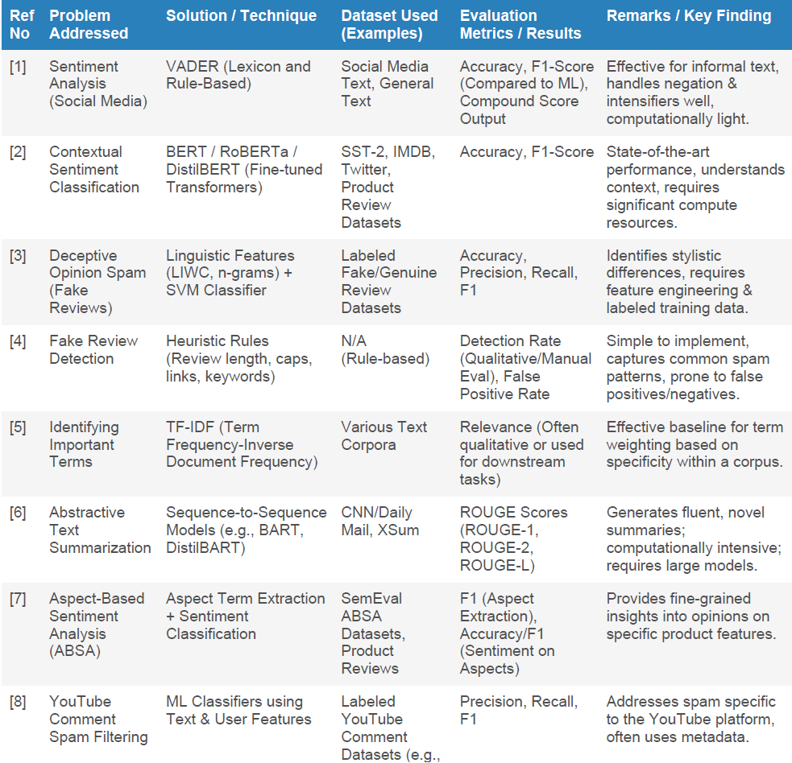

Table 1: Literature survey
E. Synthesis
Though individual techniques are the focus of much large-scale research on each component task, our contribution in this project is bringing all these methods together in a combined system that considers content from YouTube as well as e-commerce websites. It is a usable, conversational interface (Telegram bot) for the users to gain access to synthesized verdicts involving sentiment, category/topic information, content summaries, and simple reliability indicators (spam/fake estimates). This integrated, whole-system strategy, designed to bring actionable insight to users across multiple content types, solves the real-world problem of information overload in a new, integrated way, while also negotiating and reporting on the actual challenges of data gathering from these sources.

- SYSTEM ARCHITECUTRE
The system is implemented as a multi-component application provided via the Telegram messaging system, allowing users to ask for analysis of either YouTube videos or product reviews. The architecture, as shown in Figure 1, is modular, encouraging separation of concerns and enabling specialized processing pipelines per domain.
At its center, user interactions triggered through the Telegram application are brokered by the Telegram API. These requests are semantically intercepted by a Parent Bot Logic layer (which, in this version, may be implicitly managed by separate command/message handlers under the Telegram system). The main job of this layer is to direct the user's request—on the basis of command prefixes such as /youtube or the message type (plain text probably denoting a product name)—to the relevant downstream analysis module.

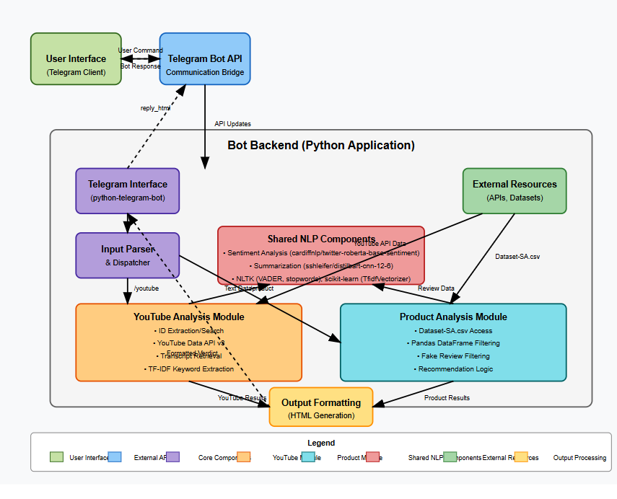
Fig1 Overviewof TeleNLP Bot

Two central analysis modules process the particular tasks:
YouTube Analysis Module: This module is invoked by commands against YouTube content.
Its Input Handler interprets the user's message to either retrieve a direct video ID from a URL using regular expressions or, if a search term is given, makes use of the YouTube API Interface to call the YouTube Data API v3 (google-api-python-client) to discover the most suitable video ID.
The YouTube API Interface subsequently retrieves required data: video metadata (title, description, channel, categoryId), comments, and tries to fetch transcripts (youtube-transcript-api), dealing with possible API errors or restrictions.
The NLP Pipeline (YouTube) utilizes a series of processing procedures: standard text preprocessing (NLTK), conversion of the returned categoryId to a human-readable name (YOUTUBE_CATEGORY_MAP), sentiment analysis of the comments using a DistilBERT model (distilbert-base-uncased-finetuned-sst-2-english from Hugging Face transformers), an extractive summary generated from the

description (NLTK sent_tokenize), and extracting keywords through TF-IDF (scikit-learn).
Lastly, the Output Formatter generates a response summarizing these results, presented as HTML to be rendered inside Telegram.
Product Review Analysis Module: This module analyzes
messages presumed to be product names.
The Input Handler receives the product name query.
A Data Storage Interface (via pandas) loads a predefined CSV dataset (Dataset-SA.csv) and filters it to discover reviews that have an exact match for the input product name (case-insensitive).
The NLP Pipeline (Product) performs a different process: it applies rule-based heuristic fake review filtering (predict_fake_heuristic) to the matched reviews first. Key, though, is that downstream NLP operations—sentiment analysis on a RoBERTa model (cardiffnlp/twitter-roberta-base-sentiment) and abstractive summarization on DistilBART (sshleifer/distilbart-cnn-12-6)—only run on
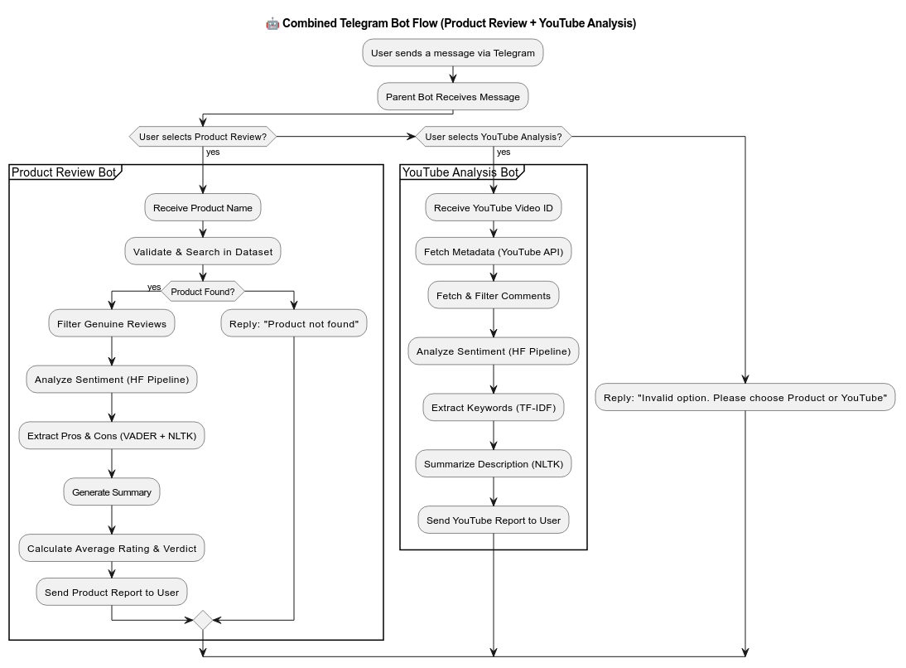
text from reviews that survive the filter. It also computes aggregate measures (average rating, overall decision) from this filtered set and runs pro/con extraction

Fig2: Detailed Flow Diagram

(extract_pros_cons_simple) based on VADER and NLTK on the raw summaries for the filtered reviews.
The Output Formatter outputs a response outlining the analysis of filtered reviews presented in MarkdownV2 (char escaping required) format.
Shared Resources and Libraries underlie both modules. These are the python-telegram-bot library for bot interaction, asyncio (with nest_asyncio for compatibility) for asynchronous operations handling, core NLP libraries such as NLTK (with downloaded data such as punkt, stopwords, vader_lexicon, wordnet, POS tagger models), transformers for Hugging Face model access, VADER, pandas for data manipulation, numpy for numerical computations, and scikit-learn for TF-IDF. Pre-trained models downloaded (DistilBERT, RoBERTa, DistilBART) are also included in these shared resources.
The general data flow starts from a user message, is passed to the right module, encompasses interaction with external APIs (YouTube) or local data (CSV), goes through customized NLP processing (with the important filtering step for products), formatting, and ends with the return of the analysis to the user through the Telegram API. The structure takes advantage of asynchronous programming in order to be responsive while performing potentially time-consuming API calls and model inferences. The use of a modular approach permits independent development and future extension of each analysis capability.

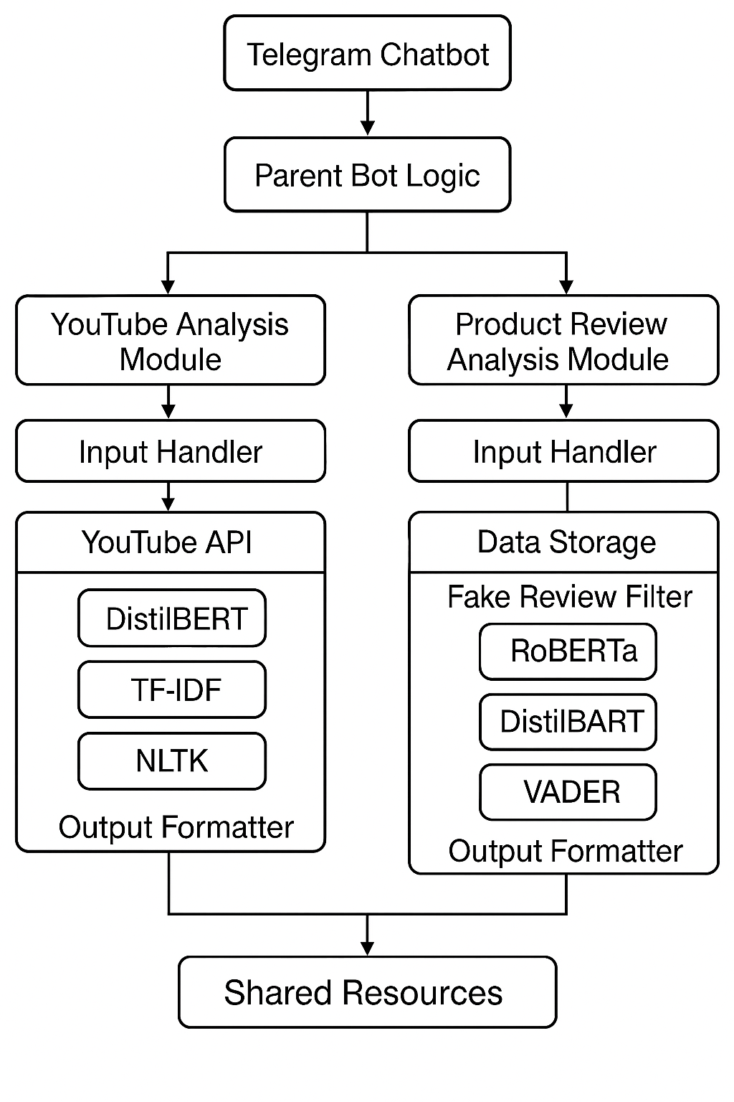
Fig3: System Architecutre
- PROPOSED METHODOLOGY AND IMPLEMENTATION
A. Text Preprocessing
All text data is subjected to standard preprocessing. This involves lowercasing text, removing URLs, punctuation, and digits, and whitespace normalization. Domain stopwords are used along with NLTK's built-in list of stopwords in keyword and aspect extraction. For product review pro/con extraction, NLTK's lemmatization is used to normalize word forms.
B. YouTube Video Analysis
Data Acquisition: YouTube video information is gathered by extracting or looking up video IDs. Information like metadata (videos.list), comments (commentThreads.list), and transcripts (through youtube-transcript-api) is fetched where possible.
Category Identification:
Each video's numeric categoryId (from videos.list) is translated to a human-readable category name through the pre-defined YOUTUBE_CATEGORY_MAP.
Comment Sentiment Analysis:
Each comment is analyzed for sentiment using the distilbert-base-uncased-finetuned-sst-2-english model from Hugging Face's Transformers library. The model is loaded via the pipeline("sentiment-analysis"), with GPU acceleration if possible. Comments are truncated as necessary and labeled as POSITIVE or NEGATIVE. As this model doesn't return a 'Neutral' label, neutrality is either omitted or inferred. A final overall sentiment verdict is decided based on the majority of labels.
Summarization (Description):A basic extractive approach is applied summarizing video descriptions. NLTK's sent_tokenize function, with the English Punkt model (english.pickle) as the initialization, tokenizes the description into sentences. The first N (e.g., 5) sentences are taken as the summary.
Keyword Extraction:TF-IDF is employed for keyword extraction from the video title, description, and comments. This is done through TfidfVectorizer from Scikit-learn with parameters max_df=0.90, min_df=2, and ngram_range=(1,2), with English stopwords. The top N terms according to TF-IDF score are selected as keywords.
C. Product Review Analysis
Data Acquisition:
Product reviews are extracted by matching the input product name (case-insensitive and whitespace-stripped) to the product_name column in the Dataset-SA.csv file using pandas.
Fake Review Filtering:A set of rule-based heuristics (predict_fake_heuristic) is used to detect and exclude likely fake reviews. A review is flagged if:
The system employs a set of heuristic rules to identify spam or fake content effectively. These include detecting reviews with fewer than four words, or those where more than 50% of the characters are uppercase in texts exceeding 30 characters. It also flags excessive punctuation usage, such as five or more consecutive exclamation or question marks, and instances of duplicate characters repeated five times in succession. Additionally, inconsistencies between the review rating and detected sentiment—such as a 1-star rating paired with a positive sentiment, or a 5-star rating with negative sentiment—are marked as suspicious. Entire reviews written in uppercase and exceeding 20 characters in length are also considered potential spam or inauthentic content.
Unflagged (original) reviews are considered only for downstream analysis.
Sentiment Analysis (Filtered Reviews):Filtered reviews are fed into a RoBERTa-based sentiment model (cardiffnlp/twitter-roberta-base-sentiment) via Hugging Face's pipeline. Each review is labeled as Positive, Negative, or Neutral. A final sentiment verdict is obtained from the sentiment distribution by applying a custom calculate overall verdict function.
Summarization (Filtered Reviews):The filtered review texts are concatenated and summarized with the DistilBART model (sshleifer/distilbart-cnn-12-6), which is an abstractive summarization model. The output summary length is constrained for coherence.
Pro/Con Extraction (Original Summaries):Pros and cons are taken out of the original Summary column by a hybrid method. Sentences are sentiment scored by VADER, and high/low scoring sentences are examined. By nltk.pos_tag and WordNetLemmatizer, nouns of these sentences are lemmatized and filtered to find top positive and negative points.
Average Rating:The average rating is determined through numpy.mean() on the Rate column of the filtered (actual) reviews.
D. Bot Integration
The system is integrated with a Telegram bot through python-telegram-bot and asyncio. nest_asyncio is utilized for enabling Colab compatibility. Commands and user messages are passed through CommandHandler and MessageHandler. Output is done in HTML format for YouTube responses and MarkdownV2 (with escaping through escape_markdown_v2) for product reviews.
- Results:
The system deployed works as a Telegram bot that offers multi-domain analysis. The YouTube module offers video metadata, category details, comment sentiment analysis (DistilBERT-based), extracted keywords, and a basic description summary. The product review module gives analysis based on reviews considered to be genuine by the heuristic filter, such as average rating, general sentiment (based on RoBERTa), counts reflecting how much filtering was done, pro/con aspects derived using heuristics, and an abstractive summary (based on DistilBART). The conversational interface presents these findings in easy-to-read form. Qualitative evaluation indicates the NLP elements work reasonably well: sentiment models pick up evident opinions, TF-IDF pulls out pertinent keywords, and DistilBART produces sensible summaries. The heuristic fake review filter effectively eliminates reviews with evident spam-like features (e.g., very short length, over-capitalization, evident rating/sentiment inconsistencies), thus presumably enhancing the reliability of the subsequent product analysis by eliminating noise. Nevertheless, this filter is by its nature limited against advanced fake reviews and will sometimes mislabel legitimate but exceptional reviews.
The pro/con extraction provides suggestive terms but is naive. One methodological flaw is the employment of contrasting sentiment models (DistilBERT for YT, RoBERTa for Product). Additional shortcomings are that the product dataset is static, that it is based on exact product name matching, that there may be API limitations (particularly YouTube transcript availability), that there are likely model biases, and that there is no explicit quantitative assessment (e.g., filter precision/recall, sentiment F1, summarization ROUGE values). In spite of these constraints, the system is able to effectively illustrate the combination of various NLP methods, such as simple reliability filtering, into an easy-to-use chatbot platform, illustrating the real-world application and implications of creating such a tool.

Output:
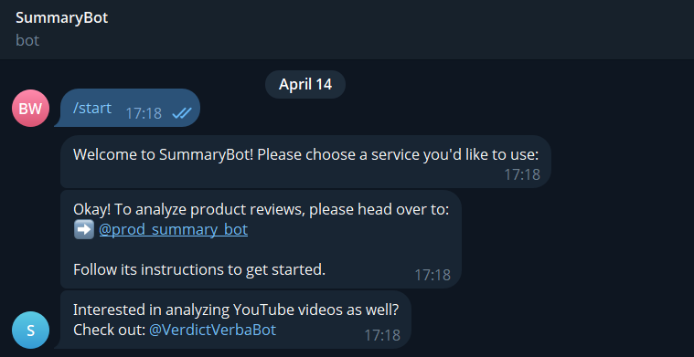
Fig 1: ParentBot
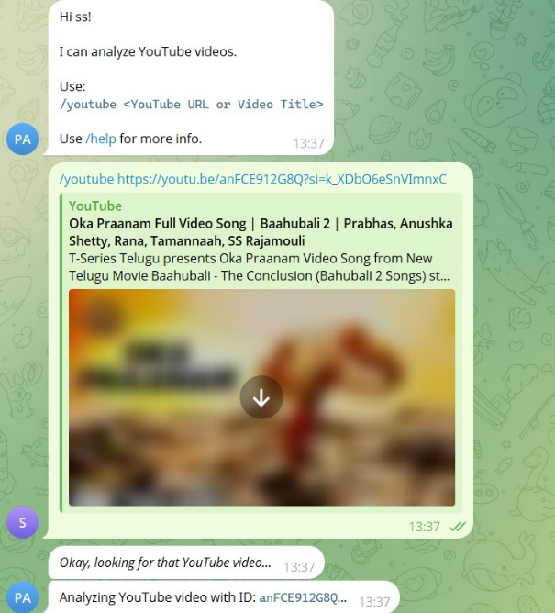
Fig 2: Youtube Video Analysis:
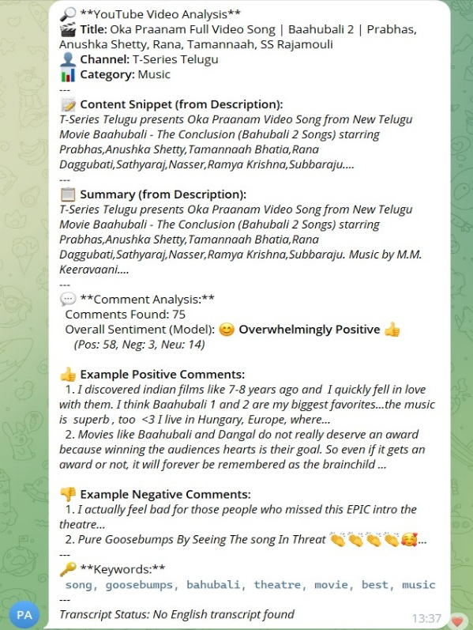
Fig3: final verdict for YouTube analysis

Product Review Analysis:
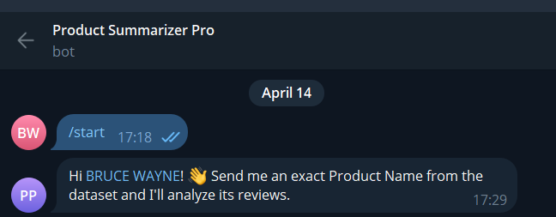
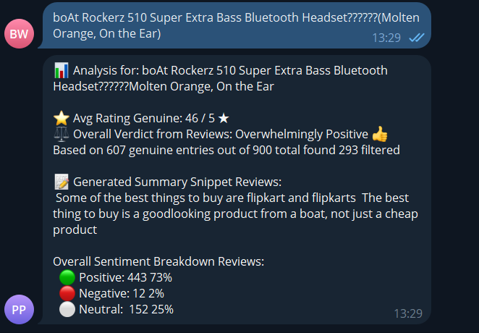
Fig 4 and 5: product Review Analysis

- Conclusion and Future work
This paper introduced "TeleNLP-Verdict," an integrated system that helps users sift through the sheer volume of online content by offering automated examination and synthesized verdicts both for YouTube videos and product reviews (drawn from a dataset), all presented via an easily accessible Telegram bot interface. Through the use of advanced NLP methods, such as Transformer-based models for sentiment analysis (cardiffnlp/twitter-roberta-base-sentiment) and abstractive summarization (sshleifer/distilbart-cnn-12-6), TF-IDF for keyword extraction, and heuristic-based filtering for possible spam/fake reviews, the system provides users multi-aspect insights into video content and product reviews. Major functionalities include determining official YouTube video categories, summarizing video descriptions and review corpora, determining overall comment/review sentiment distribution, extracting prominent keywords, and offering example positive/negative feedback snippets. The dataset-driven methodology for product analysis guaranteed uniform results and enabled solid NLP pipeline construction while avoiding the considerable difficulties of live web scraping across varied e-commerce sites, especially in cloud-based development environments such as Google Colab where IP blocking is common. The Telegram bot interface, using command menus and asynchronous processing, offers a convenient and accessible way to leverage these analytics.
The qualitative findings illustrate the system's capacity to process user requests on both platforms and produce informative, structured verdicts that effectively synthesize multiple analytical dimensions (sentiment, topic, category, summary). The utilization of official category IDs for YouTube was more dependable than rule-based guessing, and the Transformer models offered sophisticated sentiment analysis for user-generated text. Nevertheless, the project also illustrated significant limitations inherent in such systems. The lack of reliability of non-API based transcript acquisition for YouTube severely limits deep video content analysis so that it must be done depending on descriptions and comments. In addition, the heuristic approaches to spam/fake review filtering are initial and would need more advanced machine learning techniques and annotated data to achieve more precision. The product analysis module's use of a static dataset constrains its usefulness to only products included in it, sacrificing real-time analysis of any product page.
Future Work may continue along several promising paths:
Improved Product Analysis: The most important addition is moving away from the static dataset to live analysis. This requires building robust, site-specific web scrapers (preferably executed in a local or dedicated server environment) for target e-commerce websites like Amazon, Flipkart, etc., including pagination and anti-scraping management. Combining these scrapers would give really on-demand product insights.
Enhanced Fake/Spam Filtering: The use of machine learning models learned from labeled training sets for YouTube comment spam and fake product review spam would enhance filtering accuracy dramatically over the present heuristics.
Deeper Content Interpretation: Running Aspect-Based Sentiment Analysis (ABSA) on product review data would enable the system to output sentiment against certain product attributes (e.g., "battery life: Negative," "screen quality: Positive"). For YouTube, running topic modeling (LDA, BERTopic) on comments could uncover hidden thematic discussions. Employing NER could highlight highlighted entities mentioned.
Transcript Inclusion: If used in a context where transcript retrieval is trustworthy (local run, stable proxies, or yt-dlp integration), utilizing the entire transcript for summarization and keyword/topic extraction would significantly enhance the richness of YouTube video comprehension.
Advanced Bot Interaction: Using interactive features such as inline keyboards in Telegram to enable users to ask for additional information (e.g., "Show more negative comments," "Analyze sentiment for 'price' aspect") or to resolve unclear questions.
Quantitative Analysis: Benchmarking the sentiment model performance, fake review filters (in case ML models are used), and summarizers against the baseline datasets and metrics (Accuracy, F1-score, ROUGE) would give a quantitative estimate of component performance. A user study could also measure the perceived usability and usefulness of the output verdicts.
In summary, the TeleNLP-Verdict system is an important proof-of-concept for bringing multi-platform NLP analysis to an accessible conversational agent. Though there are still practical issues in data acquisition, especially for real-time product reviews, the shown framework effectively integrates a number of NLP tasks to present users with synthesized intelligence and alleviate information overload and decision-making difficulties in the intricate online content environment. More advanced NLP models and further work on strong data acquisition can make it even more powerful and useful in the real world.
- REFERENCES
[1] C. Hutto and E. Gilbert, "VADER: A Parsimonious Rule-based Model for Sentiment Analysis of Social Media Text," Proc. ICWSM, 2014.
[2] B. Pang, L. Lee, and S. Vaithyanathan, "Thumbs up? Sentiment Classification using Machine Learning Techniques," Proc. EMNLP, 2002.
[3] S. Hochreiter and J. Schmidhuber, "Long Short-Term Memory," Neural Computation, vol. 9, no. 8, 1997.
[4] A. Vaswani et al., "Attention Is All You Need," Proc. NeurIPS, 2017.
[5] J. Devlin, M. W. Chang, K. Lee, and K. Toutanova, "BERT: Pre-training of Deep Bidirectional Transformers for Language Understanding," Proc. NAACL-HLT, 2019.
[6] Y. Liu et al., "RoBERTa: A Robustly Optimized BERT Pretraining Approach," arXiv:1907.11692, 2019.
[7] V. Sanh, L. Debut, J. Chaumond, and T. Wolf, "DistilBERT, a distilled version of BERT: smaller, faster, cheaper and lighter," arXiv:1910.01108, 2019.
[8] M. T. Hoang, C. Bihorac, and A. Rouces, "BERT-based Sentiment Analysis for Product Reviews – A Comparison Study," Proc. CICLing, 2020.
[9] F. A. Barbieri et al., "TweetEval: Unified Benchmark and Comparative Evaluation for Tweet Classification," Proc. Findings of EMNLP, 2020.
[10] D. T. Nguyen, C. H. Nguyen, and P. N. Nguyen, "BERTweet: A pre-trained language model for English Tweets," Proc. EMNLP: System Demonstrations, 2020.
[11] B. Liu, "Sentiment Analysis and Opinion Mining," Synthesis Lectures on Human Language Technologies, 2012. [Focus on Opinion Spam Chapter]
[12] M. Ott, Y. Choi, C. Cardie, and J. T. Hancock, "Finding Deceptive Opinion Spam by Any Stretch of the Imagination," Proc. ACL, 2011.
[13] E. H. H. Shojaee, S. Murad, A. B. Azman, N. M. Sharef, and S. Nadali, "A Survey on Fake Review Detection Techniques: Data, Methods and Challenges," IEEE Access, vol. 11, pp. 45687-45713, 2023. [Example Survey Paper]
[14] A. Mukherjee, A. Kumar, B. Liu, J. Wang, M. Hsu, M. Castellanos, and R. Ghosh, "Spotting opinion spammers using behavioral footprints," Proc. KDD, 2013.
[15] K. Sparck Jones, "A statistical interpretation of term specificity and its application in retrieval," Journal of Documentation, vol. 28, no. 1, 1972.
[16] D. M. Blei, A. Y. Ng, and M. I. Jordan, "Latent Dirichlet Allocation," JMLR, vol. 3, 2003.
[17] A. Tuaricha, D. P. Kartikasari, and A. P. Wibawa, "Topic Modeling of YouTube Comments on Indonesia Tourism using Latent Dirichlet Allocation," Proc. Int. Conf. on Information Technology Systems and Innovation (ICITSI), 2019. [Example Application]
[18] Google Inc., "YouTube Data API Overview," Google Developers. [Online]. Available: https://developers.google.com/youtube/v3/docs/videos/list#snippet.categoryId [Accessed: YYYY-MM-DD].
[19] R. Nallapati, B. Zhou, C. Gulcehre, B. Xiang, "Abstractive Text Summarization using Sequence-to-sequence RNNs and Beyond," Proc. CoNLL, 2016. [Reference on summarization]
[20] M. Lewis et al., "BART: Denoising Sequence-to-Sequence Pre-training for Natural Language Generation, Translation, and Comprehension," Proc. ACL, 2020. [Example advanced summarization model]
[21] S. D. Serafin and T. Włodarczyk, "Sentiment Analysis of YouTube Comments," Information, vol. 12, no. 7, p. 278, 2021.
[22] T. C. Alberto, J. V. Lochter, and T. A. Almeida, "Tubespam: Comment spam filtering on YouTube," Proc. Int. Joint Conf. Neural Networks (IJCNN), 2015.
[23] M. Pontiki et al., "SemEval-2016 Task 5: Aspect Based Sentiment Analysis," Proc. SemEval, 2016. [Seminal ABSA task]
[24] B. Liu, "Aspect-Based Sentiment Analysis: A Survey," Proc. Int. Workshop Semantic Evaluation (SemEval), 2015. [Survey on ABSA]

