Secure Exam With End to End Encryption
Yash kakadiya
Information Technology Dept, Charotar University of Science & Technology,
Changa, India
Yashkakadiya008@gmail.com

Soham kansara
Information Technology Dept., Charotar University of Science & Technology,
Changa, India
Sohamkansara14@gmail.com

Jaimin Khunt
Information Technology Dept, Charotar University of Science & Technology,
Changa, India
khuntjaimin0@gmail.com

Abstract:
The rapid evolution of digital education has necessitated the development of secure, scalable, and user-friendly online examination platforms. This paper presents NextEDU, a comprehensive web-based solution designed to streamline the process of conducting, monitoring, and evaluating online examinations for educational institutions. NextEDU leverages a modern technology stack, featuring a React-based frontend and a Node.js/Express backend,integrated with MongoDB for robust data management.The platform supports multiple user roles, including administrators, institutes, and students, each with tailored interfaces and permissions. Key features include secure user authentication (with support for OAuth and JWT), dynamic exam creation, automated result processing, and real-time monitoring capabilities. Advanced security measures, such as session management, anti-cheating mechanisms, and role-based access control, are implemented to ensure the integrity of the examination process.NextEDU is designed with scalability and usability in mind, offering a responsive user interface, micro-animations for enhanced user experience, and glassmorphism-inspired aesthetics. The backend architecture follows the Model-View-Controller (MVC) pattern, ensuring maintainability and extensibility. This paper details the system architecture, core functionalities, and security considerations, demonstrating how NextEDU addresses the challenges of modern online assessments in educational environments.
Introduction:
The digital transformation of education has accelerated rapidly in recent years, driven by the need for flexible, accessible, and scalable learning environments. One of the most critical components of this transformation is the ability to conduct secure and efficient online examinations. Traditional examination methods, often reliant on physical presence and manual evaluation, present significant challenges in terms of scalability, accessibility, and security. The COVID-19 pandemic further highlighted the necessity for robust online assessment platforms that can support remote learning and evaluation without compromising academic integrity.
NextEDU is developed as a response to these challenges, providing a comprehensive online examination platform tailored for educational institutions, instructors, and students. The platform is designed to facilitate the entire examination lifecycle—from exam creation and scheduling to real-time monitoring, automated evaluation, and result analysis. By leveraging modern web technologies, NextEDU ensures a seamless and intuitive user experience while maintaining high standards of security and reliability.
The system architecture of NextEDU is based on a modular and scalable approach. The frontend is built using React, offering a responsive and interactive interface enhanced with modern design principles such as glassmorphism and micro-animations. The backend, powered by Node.js and Express, implements a RESTful API and follows the Model-View-Controller (MVC) pattern for maintainability and extensibility. MongoDB serves as the primary data store, providing flexibility in handling diverse data structures associated with users, exams, and results.
NextEDU supports multiple user roles, including administrators, institutes, and students, each with distinct permissions and workflows. Security is a core focus, with features such as JWT-based authentication, OAuth integration, session management, and anti-cheating mechanisms. The platform also incorporates real-time monitoring and analytics, enabling educators to gain insights into student performance and examination trends.
This paper presents the design, implementation, and key features of NextEDU, highlighting how it addresses the current needs and challenges of online assessments. The following sections detail the system architecture, core functionalities, security considerations, and the innovative aspects that distinguish NextEDU as a modern solution for digital examinations.

- ARCHITECTURE OVERVIEW

NextEDU is architected as a modern, full-stack web application, designed to deliver a secure, scalable, and user-friendly online examination experience. The system follows a modular architecture, separating concerns across the frontend, backend, and database layers, and adheres to industry best practices for maintainability, extensibility, and security.

- System Components

Frontend (Client-Side)
- Technology: React.js, Tailwind CSS, Framer Motion
- Responsibilities:
  - Provides a responsive, interactive user interface for all user roles (admin, institute, student).
  - Implements glassmorphism-inspired design and micro-animations for a modern look and feel.
  - Handles client-side routing, form validation, and state management.
  - Communicates with the backend via RESTful API calls.

b. Backend (Server-Side)
- Technology: Node.js, Express.js, Passport.js
- Responsibilities:
  - Exposes a RESTful API for all core functionalities (user management, exam management, result processing, etc.).
  - Implements business logic, input validation, and error handling.
  - Manages authentication and authorization using JWT and OAuth (Google).
  - Handles session management and role-based access control.
  - Integrates with third-party services (e.g., email notifications).

c. Database
- Technology: MongoDB (with Mongoose ODM)
- Responsibilities:
  - Stores persistent data including user profiles, exam definitions, questions, results, and session data.
  - Supports flexible schema design to accommodate evolving requirements.

Key Architectural Patterns

Model-View-Controller (MVC)
- The backend is organized using the MVC pattern, separating data models, business logic (controllers), and API endpoints (routes) for clarity and maintainability.

RESTful API
- All client-server communication is performed over a RESTful API, enabling stateless interactions and easy integration with other systems or future mobile clients.

Role-Based Access Control (RBAC)
- Middleware enforces permissions based on user roles (admin, institute, student), ensuring that sensitive operations are protected.

Session and Token Management
- Authentication is handled using JWT tokens for API security, with Passport.js managing OAuth and session-based authentication for third-party logins.

Security Considerations

Authentication & Authorization
- Secure login and registration using hashed passwords, JWT tokens, and OAuth for Google sign-in.

Input Validation & Sanitization
- All user inputs are validated and sanitized to prevent injection attacks.

Session Management
- Secure session handling with proper serialization and deserialization of user data.

CORS & Rate Limiting
- Cross-Origin Resource Sharing (CORS) and rate limiting are implemented to protect the API from unauthorized or abusive access.

Deployment & Scalability

Deployment
- The application is designed for deployment on cloud platforms (e.g., Vercel for frontend, Render/Heroku for backend), with environment-based configuration for flexibility.

Scalability
- Stateless API design and the use of MongoDB allow the system to scale horizontally as user demand grows.

Integration Points

Email Service
- For notifications and contact forms.

Analytics
- Integration with analytics services for monitoring usage and performance.

- FUNCTIONALITY AND FEATURES
NextEDU is designed to provide a comprehensive suite of features that address the needs of educational institutions, instructors, and students for secure and efficient online examinations. The platform’s functionality is organized around the core processes of user management, exam administration, real-time monitoring, automated evaluation, and result analytics.Admin Portal

- User Management

Multi-Role Support:
The system supports three primary user roles: Administrator, Institute, and Student. Each role has a dedicated dashboard and access to role-specific features.

Secure Registration and Authentication:
Users can register and log in using email/password or via Google OAuth. Passwords are securely hashed, and JWT tokens are used for session management.

Profile Management:
Users can view and update their personal information, including name, email, and password.

- Exam Management

Exam Creation and Scheduling:
Administrators and institutes can create new exams, define exam parameters (title, description, duration, start/end time), and assign them to specific student groups.

Question Bank:
Exams can include various question types, such as multiple-choice, true/false, and short answer. Questions can be created, edited, and reused across different exams.

Exam Publishing:
Exams can be published or unpublished, allowing for flexible scheduling and last-minute changes.

- Examination Process
Student Dashboard:
Students have access to a personalized dashboard displaying upcoming, ongoing, and completed exams.
Exam Participation:
Students can join exams at the scheduled time, answer questions within the allotted duration, and submit their responses securely.

Real-Time Monitoring:
The platform supports real-time monitoring of exam sessions, including time tracking and session validation to prevent cheating.

- Automated Evaluation and Result Processing

Auto-Grading:
Objective questions (e.g., multiple-choice) are automatically graded upon submission, providing instant.

Manual Review:
Subjective questions can be reviewed and graded by instructors or administrators.

Result Calculation:
The system calculates total scores, grades, and provides detailed breakdowns of performance.

- Analytics and Reporting

Performance Analytics:
Instructors and administrators can access analytics dashboards that visualize student performance, exam.

Result Export:
Results and analytics can be exported for record-keeping or further analysis.

Notifications:
Automated notifications inform users about exam schedules, results, and important updates.

- Security and Integrity

Role-Based Access Control:
Middleware ensures that only authorized users can access sensitive features and data.

Session Management:
Secure session handling prevents unauthorized access and session hijacking.

Anti-Cheating Measures:
Features such as time tracking, session validation, and monitoring help maintain exam integrity.

- User Experience

Modern UI/UX:
The frontend features a modern, responsive design with glassmorphism effects and micro-animations for an engaging user experience.
Accessibility:
The platform is designed to be accessible on both desktop and mobile devices, ensuring usability for all
users.

- Technical Implementation

1. System Architecture

1.1 Architecture Overview
NextEdu implements a multi-tier architecture separating concerns between presentation, business logic, and data persistence:
- Client Tier: React-based single-page application (SPA)
- API Tier: RESTful services providing business logic and data access
- Data Tier: Database system storing application data
The system follows a client-server model with stateless communication over HTTP/HTTPS, enabling scalability and maintainability. This architecture allows each tier to evolve independently while maintaining clear interfaces between components.

1.2 Frontend Architecture
1.2.1 Component-Based Design
The frontend implements a hierarchical component architecture following the Atomic Design methodology:
- Atoms: Basic UI elements (buttons, inputs, icons)
- Molecules: Combinations of atoms forming functional UI units
- Organisms: Complex UI sections combining multiple molecules
- Templates: Page layouts defining content structure
- Pages: Complete views implementing business logic
1.2.2 State Management Architecture
The state management follows the Flux architecture pattern with unidirectional data flow:
- Global State: Managed through Redux with a centralized store
- Component State: Local state for UI-specific concerns
- Context API: Theme and specialized shared state
- Persistence Layer: Browser storage integration
1.2.3 Routing Architecture
The routing system implements a hierarchical structure with:
- Public Routes: Accessible without authentication
- Protected Routes: Requiring authentication with role-based access
- Specialized Routes: Role-specific route protections (Admin, Institute, Student)

1.3 API Integration Architecture
The frontend-backend communication follows a request-response pattern with:
- Service Layer: Abstraction for all API interactions
- Caching Strategy: Optimized data fetching with TTL policies
- Request Lifecycle Management: Loading states, error handling, retry mechanisms
- Data Transformation Layer: Adapters to convert between API and UI data models

2. Authentication System

2.1 Authentication Architecture
The authentication system implements a hybrid token-based architecture:
- JWT Tokens: Short-lived access tokens for API authorization
- HTTP-Only Cookies: Secure token storage preventing XSS attacks
- Refresh Token Mechanism: Automatic token renewal without user disruption
- Session Management: Server-side tracking for additional security
2.2 Authorization Framework
The application implements a Role-Based Access Control (RBAC) system with:
- Role Hierarchy: Admin > Institute > Teacher > Student
- Permission Matrix: Granular control over resource access
- Component-Level Authorization: UI elements conditionally rendered based on permissions
- Route-Level Authorization: Navigation paths restricted according to user roles
2.3 Session Management
Session handling utilizes a stateless architecture with:
- Client-Side Session Tracking: Redux store maintains session state
- Session Persistence: Browser storage integration for session continuity
- Inactivity Detection: Automatic session expiration on user inactivity
- Secure Logout Process: Multi-step cleanup ensuring complete session termination

3. UI Implementation Strategy

3.1 Design System Architecture
The UI follows a systematic design architecture with:
- Design Tokens: Foundational values (colors, spacing, typography)
- Utility-First CSS: Composition-based styling approach
- Responsive Framework: Mobile-first design methodology
- Theming Engine: Dynamic theme switching with context propagation
3.2 Component Architecture
Components follow a composite pattern with:
- Presentational-Container Separation: UI rendering decoupled from business logic
- Composition Over Inheritance: Component functionality built through composition
- Prop Drilling Minimization: Context API for deeply nested component communication
- Render-Props Pattern: For complex component behavior sharing
3.3 Animation Framework
The motion design system implements:
- Physics-Based Animations: Natural motion following physical principles
- Animation Orchestration: Coordinated animations across component hierarchies
- Performance Optimization: GPU-accelerated transitions
- Accessibility Considerations: Respecting user motion preferences

4. Feature Implementation Approaches

4.1 Admin Dashboard Implementation
The administrative interface follows a command-control paradigm with:
- Multi-Panel Dashboard: Segmented information architecture for different administrative functions
- Real-Time Data Visualization: Streaming updates for system activities
- Batch Operations Framework: Efficient handling of bulk administrative actions
- Approval Workflow Engine: Multi-stage process for content/exam approval
4.2 Exam System Implementation
The examination system implements a secure testing architecture:
- Exam State Machine: Well-defined exam lifecycle (creation, approval, scheduling, activation, completion, analysis)
- Question Bank System: Hierarchical organization of assessment items
- Anti-Cheating Framework: Multiple security measures preventing examination fraud
- Real-Time Proctoring: Basic monitoring during examination sessions
- Automatic Evaluation Engine: Immediate grading for objective questions
4.3 User Management System
User administration follows a multi-tenant architecture with:
- User Hierarchy: Organizational structure reflecting educational institutions
- Profile Management: Self-service and administrative user data maintenance
- Invitation System: Secure onboarding process for new users
- Activity Tracking: Audit trails for security-sensitive operations

5. Security Implementation

5.1 Frontend Security Architecture
Client-side security implements multiple defensive layers:
- Input Validation: Client-side validation before submission
- Output Sanitization: Prevention of XSS through proper content rendering
- CSRF Protection: Token-based request validation
- Content Security Policy: Restrictions on resource loading
- Secure Storage Practices: Sensitive data handling guidelines
5.2 API Security Measures
The API communication security includes:
- Transport Layer Security: HTTPS-only communication
- Authentication Headers: Standardized authorization mechanisms
- Rate Limiting: Protection against brute force and DoS attacks
- Request Validation: Comprehensive payload verification
5.3 Exam Security Framework
The examination security architecture includes:
- Content Encryption: End-to-end encryption for exam materials
- Secure Viewing Environment: Browser lockdown during examinations
- Multi-Factor Authentication: Additional verification for high-stakes exams
- Integrity Verification: Checksums and validation of submission data

6. Performance Optimization Strategy

6.1 Frontend Performance Architecture
Performance optimization follows a comprehensive approach:
- Code Splitting Architecture: Dynamic module loading based on routes and features
- Progressive Loading Strategy: Critical path rendering for faster perceived performance
- Asset Optimization Pipeline: Compression and delivery optimization for static resources
- Runtime Performance Monitoring: Metrics collection for performance regression detection
6.2 Caching Architecture
The caching strategy implements multiple layers:
- HTTP Caching: Browser-level resource caching
- Application Caching: In-memory data retention for frequently accessed information
- Query Caching: Storage of API responses with invalidation strategies
- Prefetching Logic: Anticipatory data loading for expected user journeys

7. Development Infrastructure

7.1 Build System Architecture
The build pipeline follows modern development practices:
- Module Bundling: Optimized asset generation for production
- Tree Shaking: Elimination of unused code
- Differential Loading: Browser-specific bundles for optimal compatibility
- Asset Optimization: Minification and compression of resources
7.2 Quality Assurance Architecture
Code quality is maintained through:
- Static Analysis: Automated code quality verification
- Component Testing Framework: Isolated testing of UI components
- Integration Testing Approach: Verification of component interaction
- End-to-End Testing Strategy: Complete user flow validation

8. Deployment Architecture
The deployment strategy follows modern DevOps practices:
- Containerization: Application packaging for consistent environments
- Continuous Integration: Automated build and test processes
- Continuous Deployment: Automated release pipeline
- Infrastructure as Code: Version-controlled environment definitions
- Environment Promotion: Staged deployment across development, testing, and production

- Security Considerations

1. Multi-Layered Security Architecture

1.1 Defense-in-Depth Approach
NextEdu implements a defense-in-depth security strategy, establishing multiple security layers to protect the examination ecosystem. This approach acknowledges that no single security control is infallible, thus creating a comprehensive security posture where multiple defensive mechanisms must be compromised for a security breach to occur.The security architecture is stratified into:

- Perimeter Security: Network-level protections including firewalls and DDoS mitigation
- Application Security: Application-level controls for input validation and session management
- Data Security: Encryption mechanisms for data at rest and in transit
- User Security: Authentication and authorization frameworks
- Operational Security: Monitoring, auditing, and incident response protocols
This multi-faceted approach ensures that vulnerability in one security layer does not compromise the entire system, significantly enhancing the platform's overall security resilience.

2. Authentication and Authorization Framework

2.1 Multi-Factor Authentication (MFA)
The platform employs a contextual multi-factor authentication framework that dynamically adjusts authentication requirements based on risk assessment. This risk-adaptive authentication considers:
- Geographic location anomalies
- Device recognition patterns
- Behavioral biometrics
- Access request timing
- Resource sensitivity classification
MFA implementations include:
- Knowledge factors (passwords, security questions)
- Possession factors (email verification, SMS codes)
- Inherence factors (biometric verification where available)
2.2 Role-Based Access Control (RBAC)
NextEdu implements a granular RBAC system with hierarchical permission structures. The authorization framework operates on the principle of least privilege, ensuring users can only access the minimum resources necessary for their designated functions.The RBAC architecture includes:
- Role Hierarchy: Structured permission inheritance from admin to student
- Dynamic Permission Adjustment: Context-sensitive permission elevation for specific operational needs
- Temporal Access Controls: Time-bound permissions for examination periods
- Resource-Based Permissions: Fine-grained control over specific system functions
- Segregation of Duties: Critical operations requiring multiple role authorizations
2.3 Session Management
Session security is maintained through:
- Secure Session Tokens: Cryptographically strong session identifiers
- HTTP-Only and Secure Flags: Cookie hardening to prevent client-side access
- Session Timeout Mechanisms: Automatic invalidation after periods of inactivity
- Concurrent Session Controls: Limiting simultaneous access from multiple locations
- Session Binding: Tying sessions to original authentication factors

3. Data Protection Mechanisms

3.1 Encryption Strategy
NextEdu employs a comprehensive encryption framework protecting data across its lifecycle:
- Data at Rest:
- Database Encryption: Sensitive fields encrypted using AES-256 with proper key management
- Content Encryption: Examination materials encrypted with unique keys per examination
- Key Rotation Policies: Regular cryptographic key rotation to limit exposure
- Secure Key Management: Hardware Security Module (HSM) integration for key protection
Data in Transit:
- Transport Layer Security: TLS 1.3 with Perfect Forward Secrecy
- Certificate Pinning: Prevention of man-in-the-middle attacks
- Secure API Communications: Encrypted payloads with additional application-layer encryption
- Secure Real-time Communications: WebSocket security with message-level encryption
3.2 Data Isolation
The platform implements logical and physical data isolation:
- Multi-tenancy Controls: Strict separation between different institutional data
- Data Classification Framework: Tiered protection based on sensitivity levels
- Access Control Lists: Granular permissions at the data element level
- Database Partitioning: Physical separation of high-sensitivity data

4. Examination-Specific Security Controls

4.1 Secure Examination Delivery
NextEdu implements specialized security measures for the examination process:
Exam Content Protection:
- Just-in-Time Decryption: Examination materials decrypted only when needed
- Watermarking Technology: Dynamic watermarks tied to student identifiers
- Selective Content Disclosure: Question-by-question unveiling preventing full exam access
- Digital Rights Management: Controls preventing unauthorized copying or distribution
Examination Environment Security:
- Browser Security Extensions:
- Specialized lockdown mechanisms preventing:
- Tab switching
- Screen capture/recording
- Clipboard operations
- External communications
- Device Environment Scanning: Detection of virtualization or remote access technologies
- Network Traffic Analysis: Identification of suspicious communication patterns
- Local Resource Restrictions: Prevention of access to local files and applications
4.2 Anti-Cheating Framework
The anti-cheating system employs multiple detection methodologies:
- Behavioral Analysis: Anomaly detection in user interactions
- Temporal Pattern Recognition: Identification of statistically improbable response patterns
- Environmental Monitoring: Audio and visual proctoring capabilities
- Device Integrity Verification: Detection of prohibited software or hardware
- Collaboration Detection: Identification of similar answer patterns across examinees

5. Network and Infrastructure Security

5.1 Network Security Architecture
The network security implementation includes:
- Segmentation: Logical separation between application tiers
- Web Application Firewall: Protection against OWASP Top 10 vulnerabilities
- Rate Limiting: Prevention of brute force and denial of service attacks
- API Gateway Security: Request validation, sanitization, and transformation
- Intrusion Detection/Prevention Systems: Real-time threat monitoring and mitigation
5.2 Cloud Security Posture
For cloud deployments, NextEdu implements:
- Secure Configuration Management: Infrastructure-as-Code with security benchmarks
- Identity and Access Management: Principle of least privilege for service accounts
- Resource Isolation: Private networking with controlled ingress/egress
- Vulnerability Management: Continuous scanning and remediation
- Secure CI/CD Pipeline: Automated security testing during deployment

6. Compliance and Standards Adherence

6.1 Regulatory Compliance Framework
NextEdu is designed to accommodate various regulatory requirements:
- Data Protection Regulations: GDPR, CCPA, and regional privacy laws
- Educational Standards: Compliance with academic integrity guidelines
- Accessibility Standards: WCAG 2.1 compliance for inclusive access
- Industry Best Practices: NIST Cybersecurity Framework and ISO 27001
6.2 Security Certification Alignment
The security architecture is aligned with recognized security certifications:
- SOC 2: Controls for security, availability, and confidentiality
- ISO/IEC 27001: Information security management system framework
- Cloud Security Alliance: Cloud control matrix implementation

7. Threat Modeling and Risk Management

7.1 Comprehensive Threat Model
NextEdu employs the STRIDE threat modeling methodology addressing:
- Spoofing: Identity verification controls
- Tampering: Data integrity mechanisms
- Repudiation: Comprehensive audit logging
- Information Disclosure: Data protection controls
- Denial of Service: Resilience and scalability measures
- Elevation of Privilege: Authorization boundary enforcement
7.2 Risk Assessment Methodology
Security implementation is guided by:
- Quantitative Risk Analysis: Impact and probability assessments
- Threat Intelligence Integration: Leveraging industry-specific threat data
- Regular Security Assessments: Penetration testing and vulnerability scanning
- Third-Party Security Reviews: Independent security validation

8. Security Monitoring and Incident Response

8.1 Continuous Security Monitoring
The platform implements comprehensive monitoring:
- Security Information and Event Management (SIEM): Centralized security event correlation
- User and Entity Behavior Analytics: Anomaly detection for user activities
- Real-time Alert Mechanisms: Immediate notification of suspicious activities
- Security Metrics Dashboard: Visualization of security posture
8.2 Incident Response Framework
A structured incident response process includes:
- Incident Classification Matrix: Severity-based response protocols
- Containment Strategies: Predefined actions to limit impact
- Forensic Readiness: Capabilities for post-incident analysis
- Communication Protocols: Notification procedures for affected parties
- Recovery Procedures: Business continuity and disaster recovery integration

9. Secure Development Lifecycle

9.1 Security by Design Principles
Security is embedded throughout the development process:
- Threat Modeling: Early identification of security requirements
- Secure Coding Standards: Language-specific security guidelines
- Security Testing: Automated and manual security verification
- Code Review Protocols: Security-focused peer review processes
- Component Security Analysis: Third-party dependency verification
9.2 Continuous Security Improvement
The security posture evolves through:
- Security Maturity Assessment: Regular evaluation against security capability models
- Lessons Learned Integration: Feedback loops from security incidents
- Emerging Threat Adaptation: Proactive security control adjustments
Security Research Monitoring: Tracking of new vulnerability classes and attack vectors

- Performance Optimization
1. Introduction
Performance optimization is a critical aspect of the NextEdu online examination platform, ensuring a seamless, responsive, and scalable user experience for students, educators, and administrators. The system is designed to handle high concurrency, minimize latency, and efficiently utilize client and server resources. The following outlines the key strategies and architectural decisions made to optimize performance across the platform.

2. Frontend Performance Optimization

2.1 Code Splitting and Lazy Loading
NextEdu employs code splitting and lazy loading techniques to reduce the initial load time of the application. By dividing the application into smaller bundles and loading them on demand (e.g., per route or feature), the platform ensures that users only download the code necessary for their current interaction. This results in faster initial rendering and improved perceived performance, especially on slower networks.
2.2 Efficient State Management
The use of Redux Toolkit and RTK Query provides efficient state management and data fetching. RTK Query automatically caches API responses, reducing redundant network requests and ensuring that frequently accessed data is readily available. This minimizes data fetching overhead and improves responsiveness.
2.3 Optimized Asset Delivery
Static assets such as images, fonts, and icons are optimized and served via modern build tools (e.g., Vite). Techniques such as image compression, SVG usage for icons, and font subsetting are employed to reduce asset sizes. The use of a content delivery network (CDN) further accelerates asset delivery by serving resources from geographically distributed servers.
2.4 Responsive and Adaptive Design
The UI is built with a mobile-first, responsive design using Tailwind CSS. This ensures that the application adapts efficiently to various device sizes and resolutions, providing a consistent and performant experience across desktops, tablets, and smartphones.
2.5 Animation and Rendering Optimization
Animations are implemented using Framer Motion, which leverages hardware acceleration and efficient rendering techniques. Care is taken to avoid layout thrashing and excessive re-renders, ensuring smooth transitions without compromising performance.

3. Backend and API Performance Optimization

3.1 RESTful API Design
The backend APIs are designed following RESTful principles, enabling stateless interactions and efficient resource management. Endpoints are structured to minimize payload sizes and support pagination for large datasets, reducing server load and client processing time.
3.2 Caching Strategies
Multiple layers of caching are implemented:
- Client-Side Caching: RTK Query caches API responses in the browser.
- Server-Side Caching: Frequently accessed data and computed results are cached on the server, reducing database load and response times.
- HTTP Caching: Proper cache headers are set for static resources and API responses where appropriate.
3.3 Database Optimization
Database queries are optimized through indexing, query optimization, and denormalization where necessary. Read-heavy operations are further accelerated using in-memory data stores or read replicas, ensuring low-latency access to critical data.
3.4 Asynchronous Processing
Long-running or resource-intensive operations (such as report generation or bulk data processing) are handled asynchronously using background jobs or message queues. This prevents blocking of user-facing requests and maintains a responsive system.

4. Scalability and Load Handling

4.1 Horizontal Scaling
The system is designed for horizontal scalability, allowing multiple instances of the frontend and backend services to run concurrently. Load balancers distribute incoming traffic evenly, ensuring high availability and fault tolerance.
4.2 Cloud-Native Deployment
Deployment on cloud infrastructure enables dynamic resource allocation based on demand. Auto-scaling policies ensure that the system can handle peak loads during examination periods without performance degradation.
4.3 Monitoring and Profiling
Comprehensive monitoring tools track system performance metrics such as response times, error rates, and resource utilization. Profiling tools are used during development and production to identify and address performance bottlenecks proactively.

5. Progressive Enhancement and Graceful Degradation
NextEdu is built with progressive enhancement in mind, ensuring that core functionalities remain accessible even on lower-end devices or under suboptimal network conditions. Non-essential features and animations degrade gracefully, maintaining usability without sacrificing performance.

6. Conclusion
Through a combination of modern frontend and backend optimization techniques, efficient state and data management, scalable infrastructure, and continuous monitoring, NextEdu delivers a high-performance online examination experience. These strategies ensure that the platform remains responsive, reliable, and scalable, even under heavy usage scenarios.

- Conclusion
NextEdu represents a comprehensive and forward- thinking approach to online examination management, integrating modern web technologies and best practices in software engineering. The platform’s architecture is designed for scalability, maintainability, and security, ensuring that it can meet the evolving needs of educational institutions and their stakeholders.
By adopting a modular, component-based frontend with React and Redux Toolkit, NextEdu achieves a high degree of reusability and consistency across its user interface. The use of RTK Query for data fetching and caching, combined with efficient state management, results in a responsive and robust user experience. Tailwind CSS and Framer Motion further enhance the platform’s visual appeal and interactivity, while maintaining performance across devices.
On the backend, the system’s RESTful API design, layered caching strategies, and asynchronous processing capabilities enable efficient handling of large volumes of data and concurrent users. Security is woven into every layer of the application, from secure authentication and role-based access control to data encryption and anti-cheating mechanisms, safeguarding both user data and the integrity of the examination process.
erformance optimization is a continuous focus, with strategies such as code splitting, lazy loading, and cloud-native deployment ensuring that the platform remains fast and reliable even during peak usage. Comprehensive monitoring and automated testing further contribute to the system’s resilience and quality.
In summary, NextEdu not only addresses the technical challenges of online examination delivery but also prioritizes accessibility, user trust, and operational efficiency. Its flexible design allows for easy adaptation to diverse educational environments, and its strong foundation positions it well for future enhancements and integration with emerging technologies. As digital education continues to expand, NextEdu stands as a model for secure, scalable, and user-centric online assessment solutions.


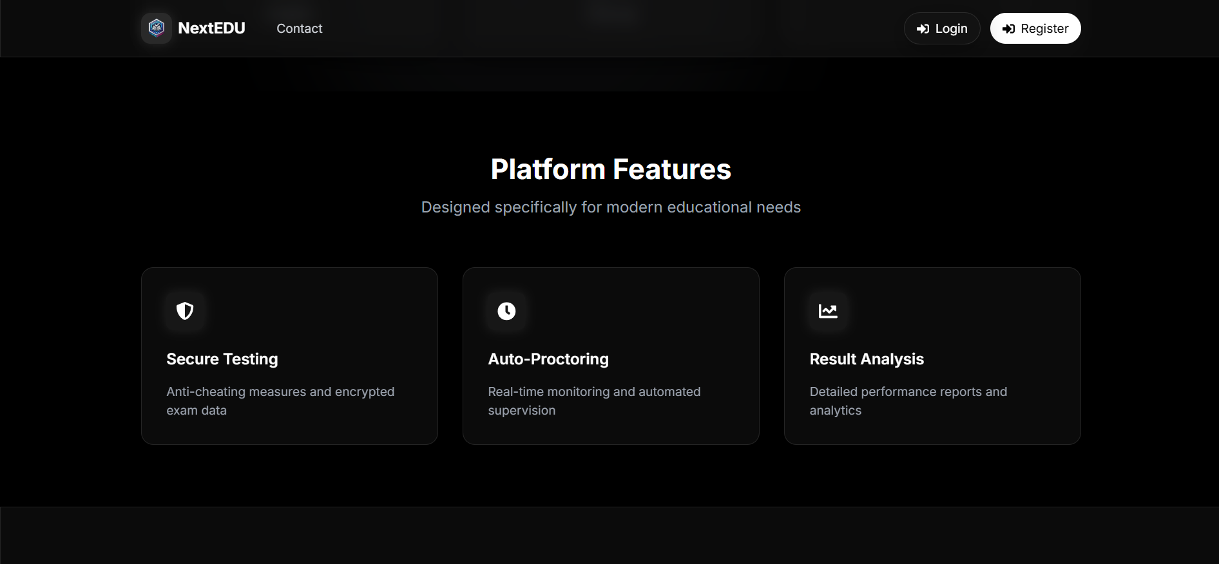

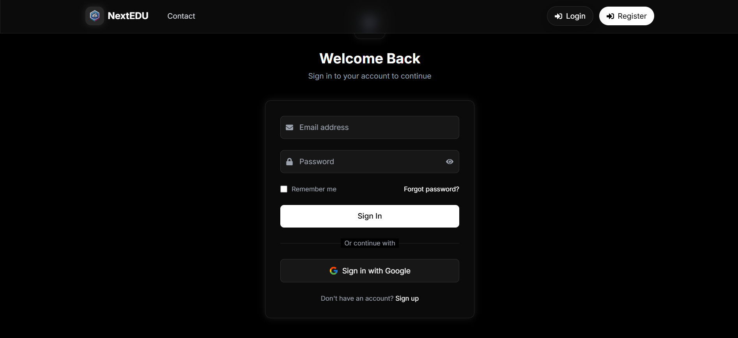
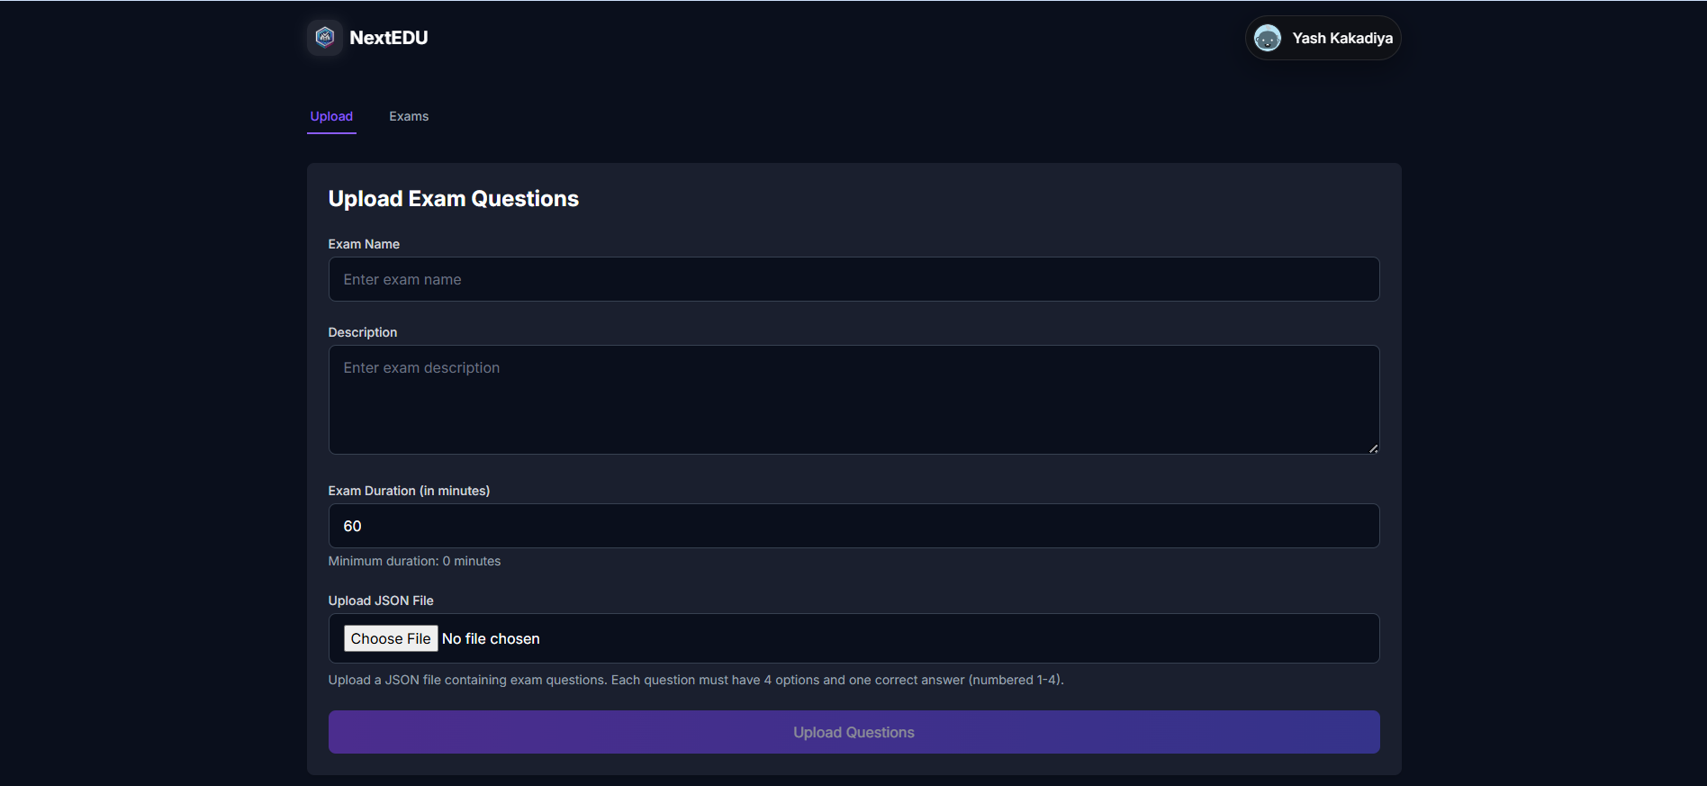

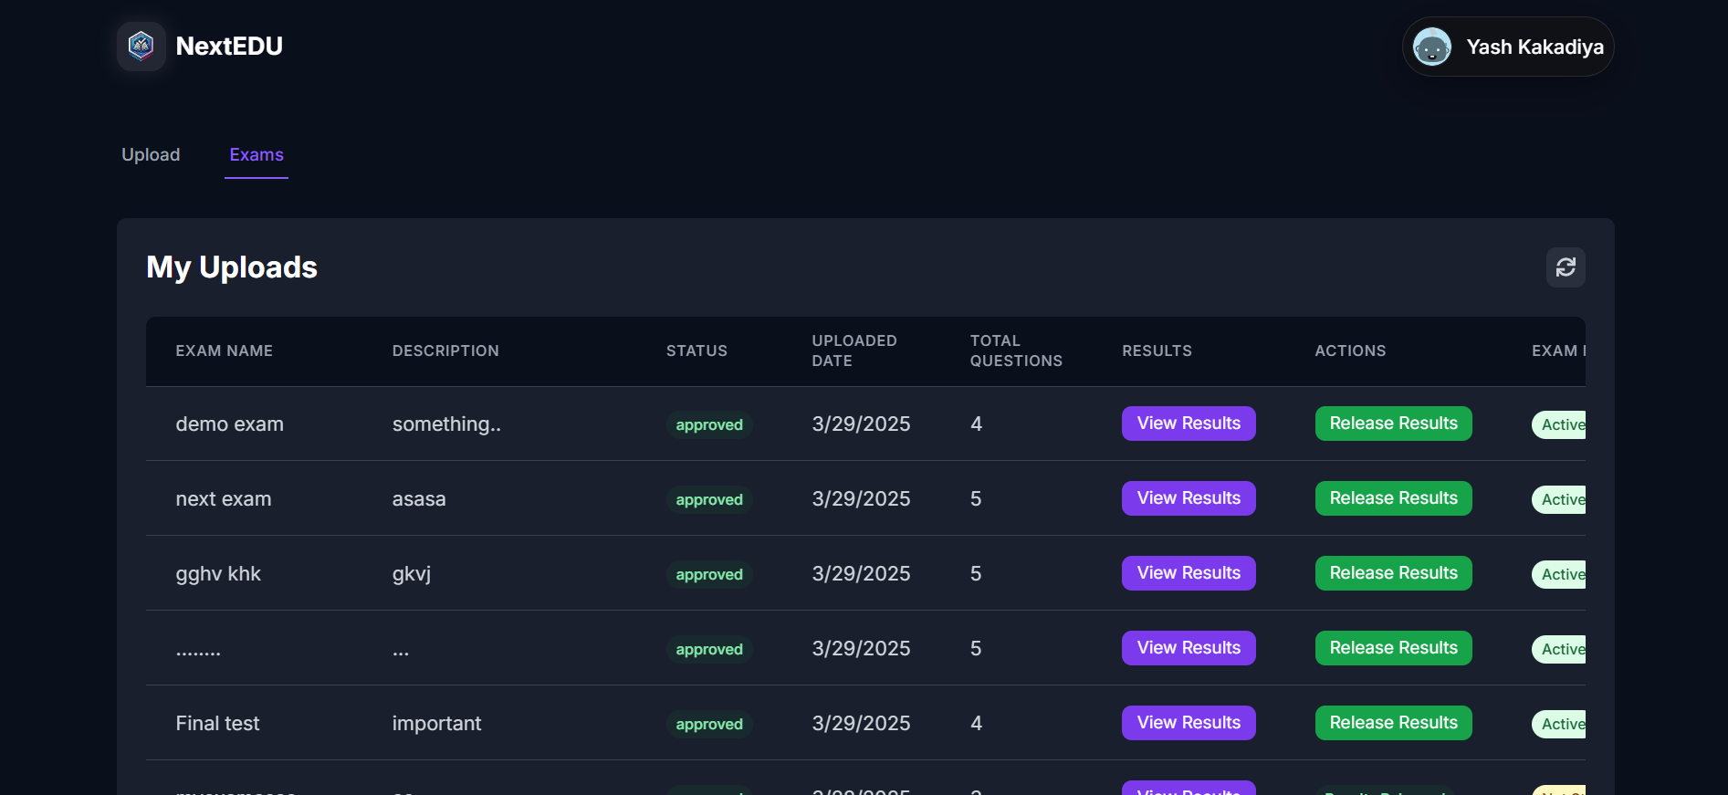

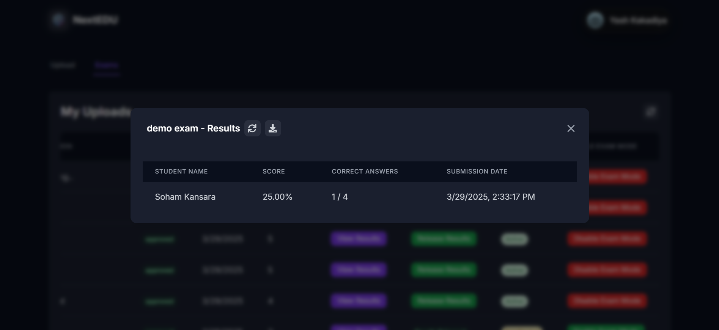
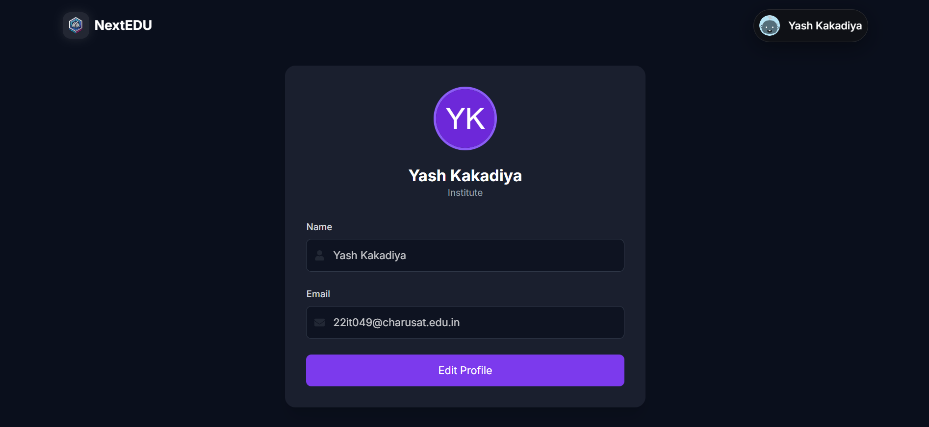

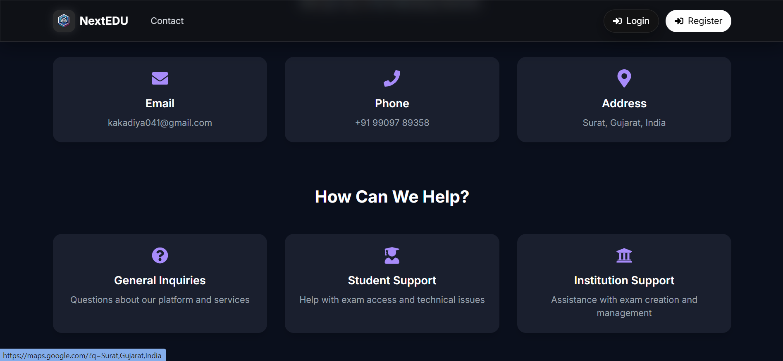
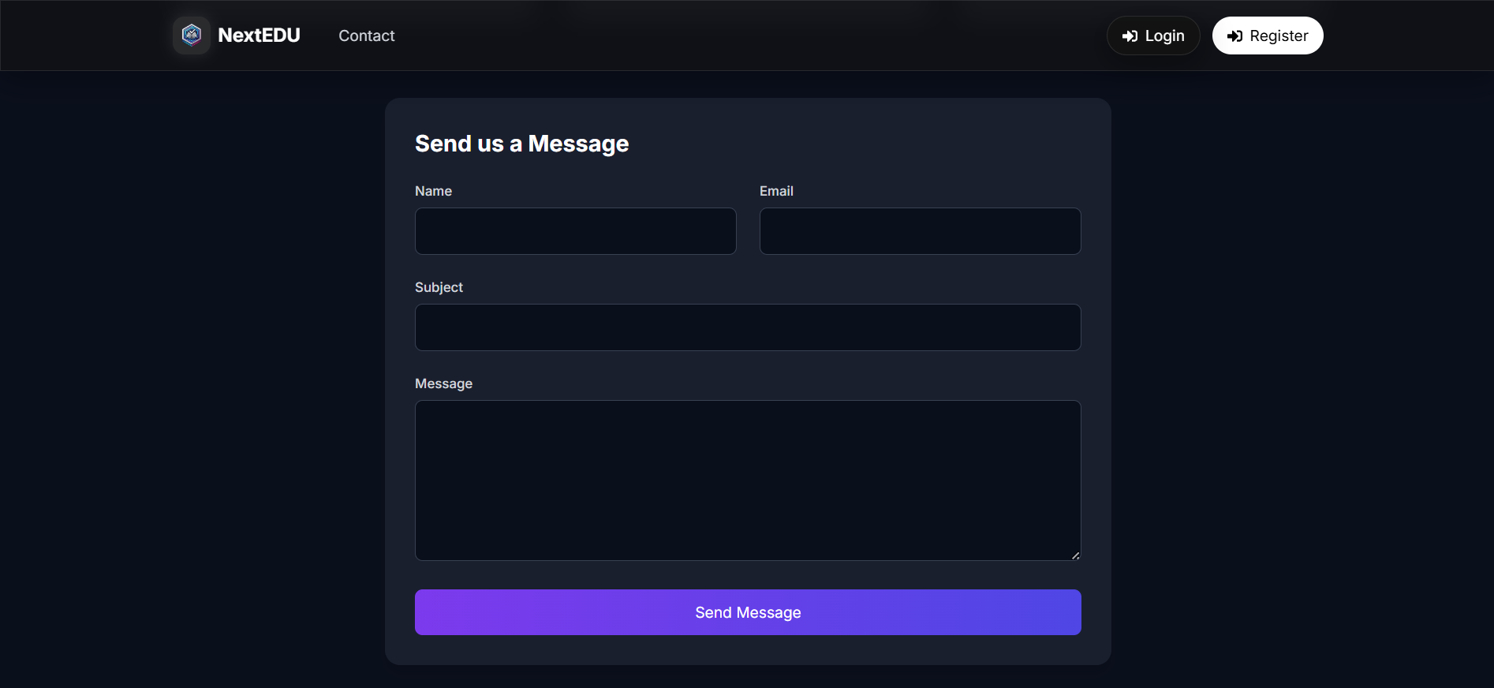

- REFERENCES

1. Facebook. "React Documentation." Meta Platforms, Inc., 2023. Retrieved from: https://reactjs.org/
(Comprehensive documentation for React.js, a JavaScript library for building user interfaces, including components, hooks, and state management)

2. Vite. "Vite Documentation." Vite, 2023. Retrieved from: https://vitejs.dev/
(Documentation for Vite, a next-generation frontend tooling that significantly improves the development experience for modern web applications)

3. MongoDB. "MongoDB Documentation." MongoDB, Inc., 2023. Retrieved from: https://www.mongodb.com/docs/
(Official documentation for MongoDB, a NoSQL database used for storing and retrieving data in the application)

4. Express.js. "Express Documentation." OpenJS Foundation, 2023. Retrieved from: https://expressjs.com/
(Documentation for Express.js, a minimal and flexible Node.js web application framework that provides a robust set of features for web and mobile applications)

5. Tailwind CSS. "Tailwind CSS Documentation." Tailwind Labs, Inc., 2023. Retrieved from: https://tailwindcss.com/
(Documentation for Tailwind CSS, a utility-first CSS framework for rapidly building custom user interfaces)

6. Passport.js. "Passport Documentation." Jared Hanson, 2023. Retrieved from: http://www.passportjs.org/
(Documentation for Passport.js, an authentication middleware for Node.js that supports various authentication strategies including Google OAuth)

7. Ethers.js. "Ethers.js Documentation." Richard Moore, 2023. Retrieved from: https://docs.ethers.org/
(Documentation for ethers.js, a complete Ethereum library and wallet implementation in JavaScript)

8. Pinata. "Pinata API Documentation." Pinata, 2023. Retrieved from: https://pinata.cloud/documentation
(Documentation for Pinata, a service for storing and managing files on IPFS, used for decentralized file storage in the application)

9. MetaMask. "MetaMask Documentation." ConsenSys, 2023. Retrieved from: https://metamask.io/
(Documentation for MetaMask, a cryptocurrency wallet used for blockchain authentication and transaction management)

10. Headless UI. "Headless UI Documentation." Tailwind Labs, Inc., 2023. Retrieved from: https://headlessui.dev/
(Documentation for Headless UI, a set of completely unstyled, fully accessible UI components for React)

11. React PDF. "React PDF Documentation." Wojciech Maj, 2023. Retrieved from: https://react-pdf.org/
(Documentation for React PDF, a library for rendering PDF documents in React applications)

12. Framer Motion. "Framer Motion Documentation." Framer, 2023. Retrieved from: https://www.framer.com/motion/
(Documentation for Framer Motion, a production-ready motion library for React that makes creating animations easy)

13. Redux Toolkit. "Redux Toolkit Documentation." Redux, 2023. Retrieved from: https://redux-toolkit.js.org/
(Documentation for Redux Toolkit, the official, opinionated, batteries-included toolset for efficient Redux development)

14. Nodemailer. "Nodemailer Documentation." Nodemailer, 2023. Retrieved from: https://nodemailer.com/
(Documentation for Nodemailer, a module for Node.js applications to allow easy email sending)

15. Mongoose. "Mongoose Documentation." Mongoose, 2023. Retrieved from: https://mongoosejs.com/docs/
(Documentation for Mongoose, an MongoDB object modeling tool designed to work in an asynchronous environment)

16. JWT. "JSON Web Tokens." Auth0, 2023. Retrieved from: https://jwt.io/
(Information about JSON Web Tokens, a compact, URL-safe means of representing claims between parties)

17. Helmet.js. "Helmet Documentation." Helmet, 2023. Retrieved from: https://helmetjs.github.io/
(Documentation for Helmet, a collection of middleware functions that help secure Express apps by setting various HTTP headers)

18. ESLint. "ESLint Documentation." OpenJS Foundation, 2023. Retrieved from: https://eslint.org/
(Documentation for ESLint, a static code analysis tool for identifying problematic patterns in JavaScript code)

19. DiceBear. "DiceBear Documentation." DiceBear, 2023. Retrieved from: https://www.dicebear.com/
(Documentation for DiceBear, a library for generating avatar images)

20. Axios. "Axios Documentation." Axios, 2023. Retrieved from: https://axios-http.com/
(Documentation for Axios, a promise-based HTTP client for the browser and Node.js)

