EXERCISE NO: 5

DATE:13.10.2020

AIM:

To write a python program to print the missing characters to make the string pangram.

**PROGRAM:**

def pangram(string):

alphabets = "abcdefghijklmnopqrstuvwxyz"

for letter in alphabets:

if letter not in string.lower():

print(letter,end = "")

string = input()

pangram(string)

**LINK:**

<http://103.53.53.18/mod/vpl/forms/edit.php?id=235&userid=1741#vpl_file0>

**OUTPUT:**

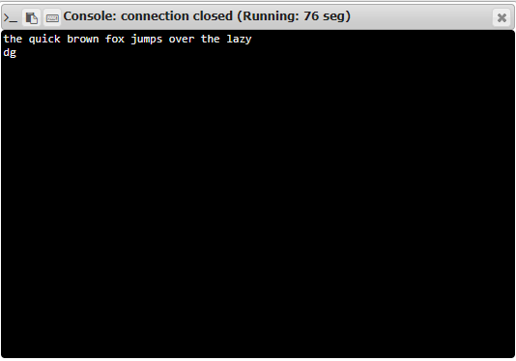

**RESULT:**

Finding the missing characters is done and the output is verified*.*